Name: Rahul Sharma
Student Number: 300019592
Course: GNG1105[B]
Assignment 5

Answer 1:
The following programming model contains in its code memory the indicated C program composed of a main function. You will be showing how the working memory is used during the execution of this function. Show how the given C program affects the contents of the working memory:
- Show how the array and variables occupy space in the working memory.
- Show how the variables and arrays are initialized and updated by the loop.
- Show the values are assigned the variable and elements in the array by the assignment instructions. Be sure to show all values that are assigned and replaced. Record successive assignments to variables/parameters as follows (the ? shows an unknown value):
varName
?, 2, 6, 4, 10

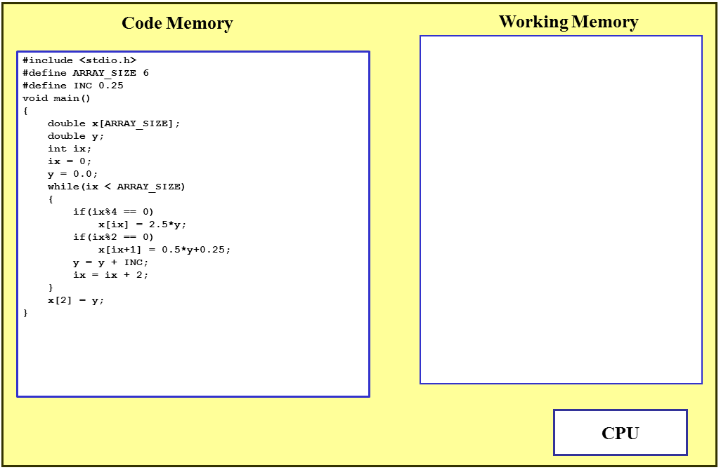
y = ? 0.0 0.25
ix = ? 0 2
ix = 0.0 + 2
= 2
y = 0.0 + 0.25
= 0.25
x
[1]:0.0
[2]:0.0 0.25
[3]:0.0
[4]:0.0
[5]:0.0
[6]:0.0

Answer 2 (10 marks)
Outputs:

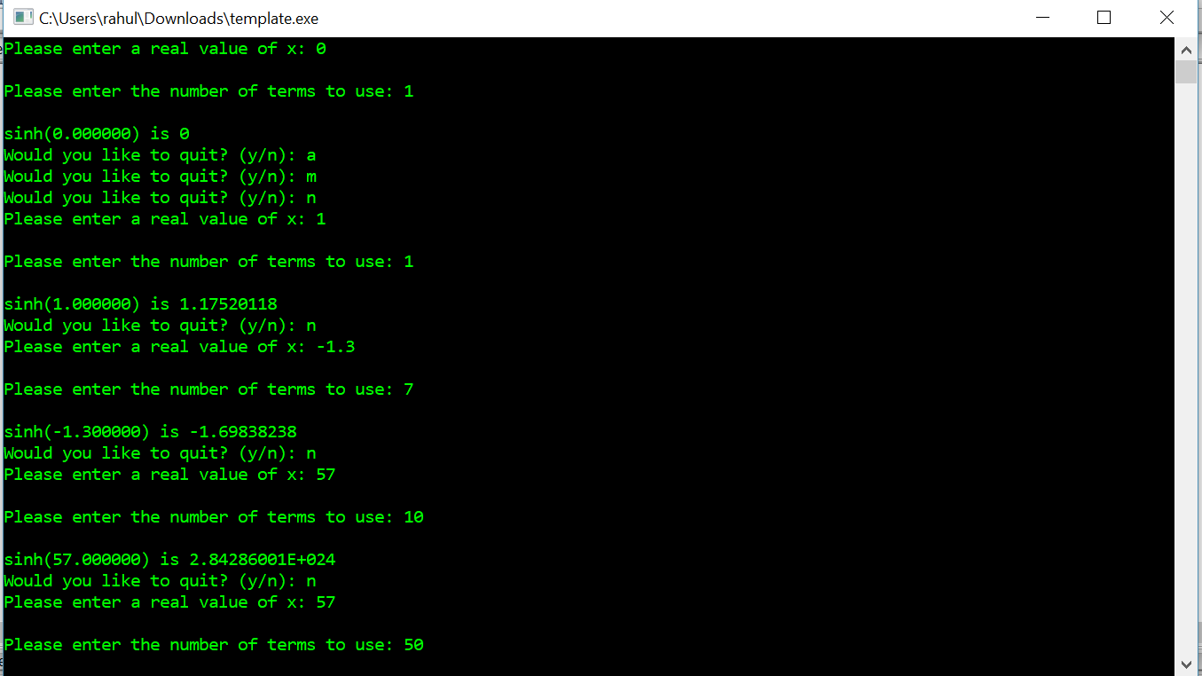

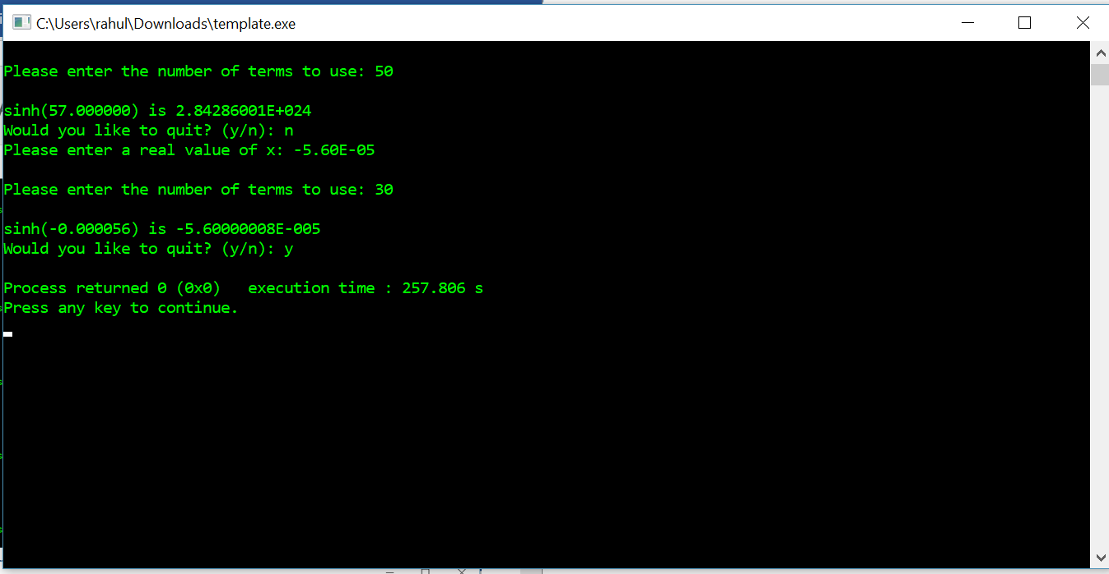

Answer 3
Outputs:


