Laboratory Report

Experiment 1: Verification of Boyle’s Law

CHM 1311 – Section D

Instructor:

September 19th 2017

Introduction:
Boyle’s law is a relation between pressure (compression and expansion) of a gas at constant temperature. It was formulated by Robert Boyle.
It states that; the pressure of an ideal gas, of a fixed amount, is inversely proportional to the volume at constant temperature.
P ∝ 1/V
P = k/V [P = pressure, V = volume, k = constant]
This experiment is done to verify Boyle’s law. We do this using a syringe, Gas Pressure Sensor and LabQuest2.

Procedure:
Refer lab manual for full detailed procedure.
Independent variable was volume. Dependant variable was pressure, as pressure changes when we change the volume.
Initial volume of gas in syringe was kept at 6mL. The syringe was pulled by intervals of 2mL for each reading. Syringe was pulled as it was easier than compressing it. Final volume reading was 20mL in syringe. Reading of initial volume was again taken at the end.
Graph was obtained by using LabQuest2.
We underwent 2 trials for this experiment.

Observations:
Volume (mL) | Pressure (kPa) [Run 1] | Constant (k₁) | Pressure (kPa) [Run 2] | Constant (k₂)
6.80 | 101.89 | 693 | 102.25 | 695
8.80 | 77.48 | 682 | 77.37 | 681
10.80 | 62.43 | 674 | 63.15 | 682
12.80 | 52.31 | 670 | 52.78 | 676
14.80 | 45.32 | 671 | 46.03 | 681
16.80 | 39.97 | 671 | 40.53 | 681
18.80 | 35.68 | 671 | 36.18 | 680
20.80 | 32.82 | 682 | 32.98 | 686
6.80 (Final reading) | 103.23 | 701 | 104.25 | 708

Data:

Figure 1. Graph of Pressure (kPa) vs Volume (mL) [RUN 1]
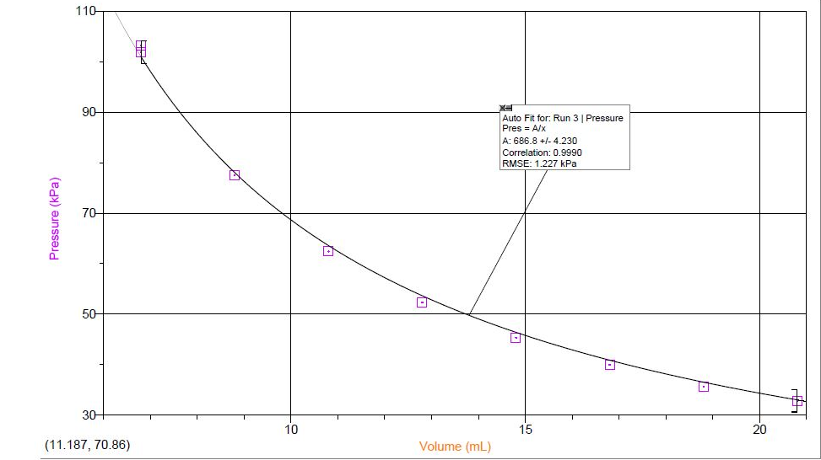

Figure 2. Graph of Pressure (kPa) vs Volume (mL) [RUN 2]
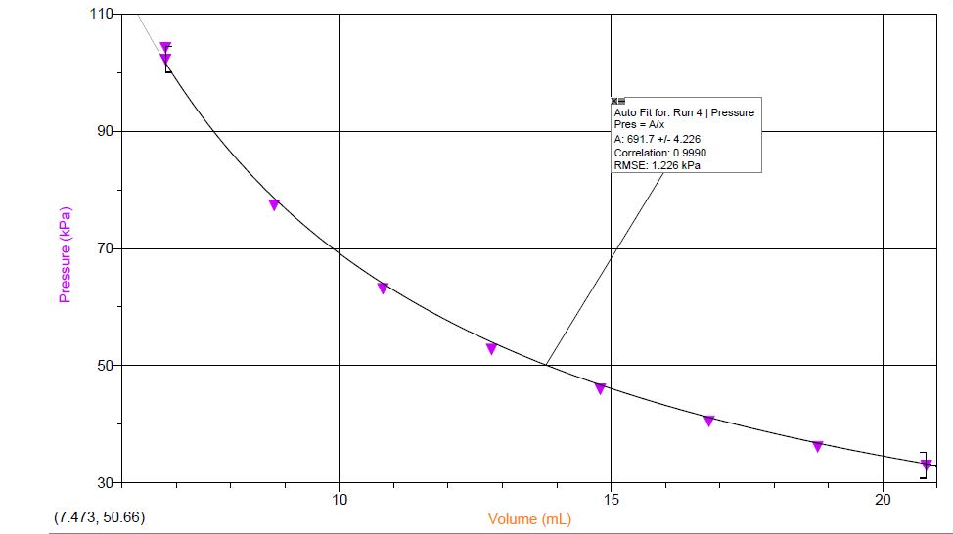

Calculation:
Boyle’s law constant:
P = k/V
k = P*V = (62.43)*(10.80) = 674.24 kPa/mL

Discussion:
There are few possible sources of errors in this experiment. The apparatus-induced errors could be that the Gas Pressure Sensor may not have been calibrated properly with LabQuest2. Human errors could include, handling the syringe incorrectly resulting in incorrect readings. This can be avoided or reduced by pulling the syringe when taking readings, instead of compressing it.
The syringe showed measurements of value from 0-20mL of a scale of 1mL. Nonetheless, the volume shown in this experiment had 0.8mL added to it. This was to account for the air in the Gas Pressure Sensor.
As we increased the volume in the syringe, we observed the pressure decreasing. This indicated that the pressure is inversely proportional to volume.
The relation of Boyle’s law can be verified by the graph shown in Fig. 1 and Fig. 2 (in “Data” section). The graph indicates that Pressure and Volume are inversely proportional. This holds true to the statement of Boyle’s law. Furthermore, we calculated the Boyle’s law constant which was 674 = k.
There may be more observational errors because Boyle’s law applies to an ideal gas. We assume that the gas we use (air) is ideal to complete the experiment. This could be a reason why there was a difference in pressure for the same initial volume reading (6.80 mL).

Data Analysis:
- Boyle’s law constant = 674.24
Calculation shown above
- Mathematical relationship of Boyle’s law:
P ∝ 1/V
Equation for Boyle’s Law:
P = 674/V
- Multiple readings of the dependant variable for the same value of independent variable is important to highlight an assumption we made in the hypothesis of this experiment. The assumption was we considered the gas to be ideal (but air is not ideal gas). Hence the 2 readings of the dependant variable for the same dependant variable, were not the same.
- The certain conditions were that the temperature should be constant and the syringe contain a fixed amount of gas. But they were not taken into consideration as Boyle’s law only stated the relation between pressure and volume and not temperature nor amount of gas (no. of moles). The laboratory was kept at room temperature, to ensure it didn’t change. It could have affected the experimented (one of the many reasons) because the readings from Run 1 and 2 were not the same.
- Graphs were made using Logger pro.

Conclusion:
From this experiment, we can conclude that for a fixed amount of an ideal gas, kept at constant temperature, it’s pressure is inversely proportional to the volume of it’s container. Thus, this verifies Boyle’s law. Boyle’s law constant was found to be 674.

Raw data:

