CH | TITLE | PAGES
17 | Program Design for Resistance Training | 439 - 469
18 | Program Design & Technique for Plyometric Training | 471 - 520
19 | Program Design & Technique for Speed & Agility Training | 521 - 557
20 | Program Design & Technique for Aerobic Endurance Training | 559 - 581
5 | Adaptations to Anaerobic Training Programs | 87 - 113
4 | Endocrine Responses to Resistance Exercise | 65 - 86
- | Regulation of Skeletal Muscle Mass | PPT slides
11 | Performance-Enhancing Substances | 225 - 248

In addition, you should have read the following 3 review articles:

Laursen, P.B., and Jenkins, D.G. The scientific basis for high-intensity interval training: Optimising training programmes maximising performance in highly trained endurance athletes. Sports Medicine 32(1): 53-73, 2002.

Kraemer, W.J., and Ratamess, N.A. Hormonal responses and adaptations to resistance exercise and training. Sports Medicine 35(4): 339-361, 2005.

Franke, W.W., and Berendonk, B. Hormonal doping and androgenization of athletes: a secret program of the German Democratic Republic government. Clinical Chemistry 43(7): 1262-1279, 1997.

Chapter 17
Program Design for Resistance Training
(Pages 439 to 469)

- Principles of Anaerobic Exercise Prescription
Resistance training programs require attention to the principles of:
  - Specificity,
  - Overload, &
  - Progression

Specificity
- was 1st suggested by DeLorme in 1945.
- refers to the method whereby an athlete is trained in a specific manner to produce a specific adaptation or training outcome.
- is used interchangeably with the acronym SAID, Specific Adaptation to Imposed Demands.
- does not mean that that all aspects of the training must mimic that of the sporting skill.
- Resistance Training
  - Muscles involved
  - Movement pattern
  - Nature of the muscle action
    - Speed of movement
    - Force application
- also relates to the athlete’s sport season.

Overload
- refers to assigning a workout or training regimen of greater intensity than the athlete is accustomed to.
- Obvious Application
  - increase the load assignments of the resistance exercises.
  - Subtle Changes
  - increase the # of sessions/wk or day,
  - add exercises or sets,
  - emphasize complex over simple exercises, &/or
  - decrease the length of rest periods between sets & exercises.

Progression
- is needed to continue producing higher levels of performance.
- promotes long-term training benefits when applied properly.
- is based on the athlete’s training status.
- is introduced systematically & gradually.
- is applied by progressively increasing the training intensity.
- Examples of how to progressively increase resistance training intensity:
  - Increase resistance (load) used,
  - Raise the # of weekly training sessions,
  - Adding more drills or exercises/session,
  - Increase the training stimulus,
  - Change the type or technical requirements of the drills or exercises.

- Do not study STEP 1: NEEDS ANALYSIS

- STEP 2: EXERCISE SELECTION
  - Exercise Type
    - Core and Assistance Exercises
Core
- recruit 1 or more large muscle areas,
- involve two or more primary joints, &
- receive priority when one is selecting exercises because of their direct application to the sport.

Assistance
- usually recruit smaller muscle areas,
- involve only 1 primary joint, &
- are considered less important to improving sport performance.

    - Structural and Power Exercises
Structural Exercises
- emphasize loading the spine directly or indirectly.

Power Exercises
- are structural exercises that are performed very quickly or explosively.

  - Movement Analysis of the Sport
    - Sport-Specific Exercises
- The more similar the training activity is to the actual sport movement, the greater the likelihood that there will be a positive transfer to that sport.
- This is the specificity concept, also called SAID.

    - Table 17.3 Examples of Movement-Related Resistance Training Exercises
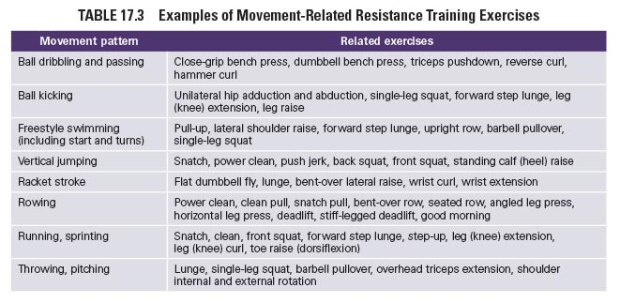
    - Muscle Balance
- Exercises selected for the specific demands of the sport should maintain a balance of muscular strength across joints & between opposing muscle groups (agonists & antagonists).
- does not always mean equal strength.
- is defined as a proper ratio of strength, power, or endurance of 1 muscle or muscle group relative to another muscle or muscle group.
- Muscle Imbalances
  - increase the risk of injury.
  - need to be corrected.
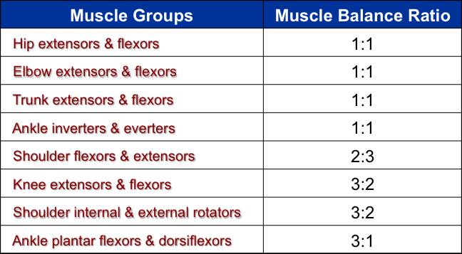
    - Exercises to Promote Recovery
  - Exercise Technique Experience
  - Do not assume that an athlete will perform an exercise correctly.
  - If there is any doubt, have the athlete demonstrate the exercise.
  - If the athlete uses incorrect techniques, the S & C professional should provide complete instruction.

  - Availability of Resistance Training Equipment
  - A lack of certain equipment may necessitate selecting exercises that are not as sport specific.

  - Available Training Time Per Session
  - Prioritize time-efficient exercises when time is limited.

- STEP 3: TRAINING FREQUENCY
  - Training Status
- Training status affects the number of rest days needed between sessions.
- Traditionally, 3 workouts per week are recommended for many athletes to allow sufficient recovery between sessions.
- As an athlete adapts to training & becomes better conditioned, it is appropriate to consider increasing the # of training days from 4 to 7 days/wk.
- General Guideline
  - Schedule training sessions so that there is at least 1 rest or recovery day—but not more than 3—between sessions that stress the same muscle groups.

    - Table 17.4 Resistance Training Frequency Based on Training Status
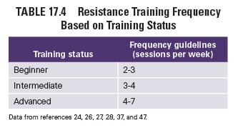
- More highly resistance-trained (intermediate or advanced) athletes can augment their training by using a split routine in which different muscle groups are trained on different days.

    - Table 17.5 Examples of Common Split Routines
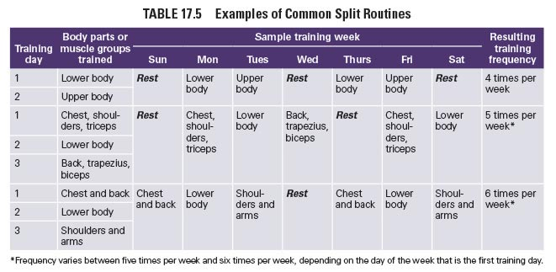
  - Sport Season
- Seasonal demands of the sport may limit the time available for resistance training.

    - Table 17.6 Resistance Training Frequency Based on the Sport Season for a Trained Athlete
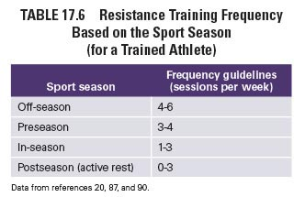
  - Training Load and Exercise Type
- Athletes who train with maximal or near-maximal loads require more recovery time prior to their next training session.
- Factors that May Affect Training Frequency
  - Alternating lighter & heavier training days may increase training frequency.
  - Upper-body muscles can recover more quickly from heavy-loading sessions than lower-body muscles.
  - Recovery from single-joint exercises is faster than from multi-joint exercises.

- Other Training
- Training frequency is influenced by the overall amount of physical stress.
- Consider the effects of:
  - other types of anaerobic training,
  - aerobic training,
  - sport skill practice, &
  - physically demanding occupations.

Ex. Of other concurrent training:
  - Sprinting
  - Agility
  - Speed-Endurance
  - Plyometrics
  - Sport Skill Practice

- STEP 4: EXERCISE ORDER
- Exercises are usually arranged so that an athlete’s maximal force capabilities are available (from a sufficient rest or recovery period) to complete a set with proper exercise technique.

  - Power, Other Core, Then Assistance Exercises
  - The literature also refers to this arrangement as MJ exercises & then SJ exercises or LM areas & then SM areas.
- Power exercises such as the snatch, hang clean, power clean, & push jerk should be performed first in a training session, followed by other nonpower core exercises and then assistance exercises.

  - Alternated Upper and Lower Body Exercises
- Provides the opportunity to recover more fully between exercises.
- Helpful for untrained individuals.
- If training time is limited, ALT UBLBE :
  - Minimizes the length of the rest periods required between exercises.
  - Maximizes the rest between body areas.
  - Decreases overall training time.
- Circuit Resistance Training
  - If the exercises are performed with minimal rest periods.
  - A nearly continuous training session.
  - May slightly improve CRE, although to a lesser degree than conventional aerobic exercise training.

  - Alternated Push and Pull Exercises
- is another method of improving recovery & recruitment between exercises.
- ensures that the same muscle group will not be used for 2 exercises, or in some cases, 2 sets, in succession, which will reduce fatigue in the involved muscles.
- is also used in circuit resistance training programs.
- is ideal for athletes beginning or returning to a resistance training program.

  - Supersets and Compound Sets
- The performance of 1 set of a pair of exercises with little or no rest between them.

- Superset
  - involves sequentially performing 2 exercises that stress 2 opposing muscles or muscle areas.
  - e.g., an agonist & its antagonist.

- Compound Set
  - involves sequentially performing 2 different exercises for the same muscle group.

  - Pre-exhaustion
- A “reverse” exercise arrangement where the athlete purposely fatigues a large muscle group as a result of performance of a single-joint exercise prior to a multijoint exercise involving the same muscle.

- STEP 5: TRAINING LOAD AND REPETITIONS
  - Terminology Used to Quantify and Qualify Mechanical Work
- To plan variation in the training program & to avoid the exhaustion phase of Selye’s GAS associated with overtraining, it is important to quantify the amount of mechanical work or degree of metabolic demand.
- Mechanical Work = Force x Displacement
  - = (100 weight units x 15 reps) x 2 distance units.
  - = 3,000 work units.
  - = volume-load x distance
- Volume-Load (Quantity)
  - is = total # sets x # reps/set x wt lifted/rep.
  - is a practical measure for the quantity of work performed in resistance training (concentric work).
  - is highly related to mechanical work & the associated metabolic energy demands & physiological stress.
  - should be considered as system mass volume-load in the calculation of resistance training in which the athlete or a mass is moved.
  - is also useful in quantifying the nature of the total resistance training:
    - Core Exercises, Assistance Exercises.
    - Hypertrophy, Maximal Strength, Power Training.
  - is not affected by the rep & set scheme of the resistance training:
    - 15 sets of 1 rep,
    - 5 sets of 3 reps,
    - 3 sets of 5 reps,
    - 1 set of 15 reps.
- Repetition-Volume (Quality)
  - is the total # of reps performed during a workout session.
  - is a practical measure for the quality of work performed in resistance training.
  - is proportional to time.
  - is related to mechanical or metabolic power or intensity:
    - Mechanical Power = Work / Time
    - Mechanical Power = (Force x Displacement) / Time
  - is affected by the rep & set scheme of the resistance training.
- Average weight lifted per repetition per workout session:
  - is related to intensity or the quality of work.
  - is a good approximation for mechanical & metabolic power output, which are true intensity or quality of work parameters.
  - = Load-Volume / Repetition-Volume.

  - Relationship Between Load and Repetitions
- The # of repetitions an exercise can be performed is inversely related to the load lifted.
- The heavier the load, the lower the # of repetitions that can be performed.
- Training goals affect the load & repetition regimen.
- Load is commonly described as:
  - a %age of a 1-repetition maximum (1RM) or
  - a repetition maximum (RM).
- Load
  - the amount of weight assigned to an exercise set.
  - often characterized as the most critical aspect of a resistance training program.
  - 1-Repetition Maximum (1RM)
  - the greatest amount of weight that can be lifted with proper technique for only 1 repetition.
  - Repetition Maximum (RM)
  - the most weight lifted for a specified number of repetitions.
  - e.g., 10RM.

    - Table 17.7 Percent of the 1RM and Repetitions Allowed (%1RM-Repetition Relationship)
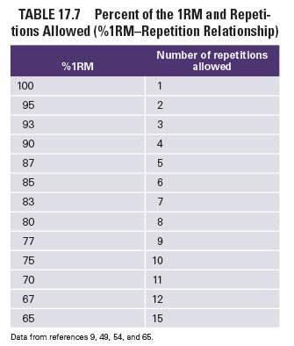
- %1RM –Repetition Tables
  - provide helpful guidelines for assigning an athlete’s training loads.
  - are not supported by research.
  - Refer to weaknesses of these tables that have been identified by research on the next slides.

The table’s weaknesses:
Assumption
- A linear relationship exists between the loads lifted & the reps performed.
- However, research shows a curvilinear relationship.
Resistance-Trained Athletes
- may be able to exceed the # of reps listed in the table at any given % of their 1-RM.
- especially in lower-body core exercises.

- The # of reps that can be performed at a certain %1RM is based on a single set.
- Athletes may not always perform the predicted number of reps at a specified %1RM.
- A certain %age of the 1RM assigned to a machine exercise can result in more repetitions at the same %age of the 1RM than a similar free-weight exercise.
- Exercises involving smaller muscle areas may not produce as many repetitions.
- Exercises recruiting large muscle areas are likely to result in more reps performed.
- The most accurate relationship between %ages of the 1RM & the maximum reps possible is for loads ≥ 75% 1RM & ≤ 10 reps.

  - 1RM and Multiple-RM Testing Options
    - Testing the 1RM
    - Do not study the 1RM Testing Protocol (Figure 17.1) on p. 453.
    - Estimating a 1RM
- 10RM testing protocol is similar to the 1RM testing protocol.
- Each set requires 10 reps.
- Sequential load changes are approximately ½ smaller than those used in direct 1RM testing (refer to Figure 17.1).
- Lower multiple-RM determinations using heavier loads are more accurate for assessing the 1RM than the 10RM test.
- Using a 1RM Table
  - Table 17.8 allows the estimation of 1RM & training loads.
  - The 1RM value is:
    - = 540 lb for a 10RM of 405 lb (75% 1RM).
    - = 280 lb for a 10RM of 210 lb (75% 1RM).

      - Table 17.8 Estimating 1RM and Training Loads
DO WE REALLY HAVE TO KNOW THIS???

    - Using Prediction Equations
- are available to predict the 1RM from multiple-RM loads.
- The accuracy of 1RM estimation using prediction equations is increased when:
  - heavier loads are used in multiple-RM testing.
  - the equations are based on loads ≤ 10 RM.
  - the athlete has been consistently training with low multiple-RM resistances & is tested at a matching low multiple-RM resistance.

    - Multiple-RM Testing Based on Goal Repetitions
- requires the S & C professional to 1st decide on the # of repetitions the athlete will perform in the actual program for the exercise being tested.
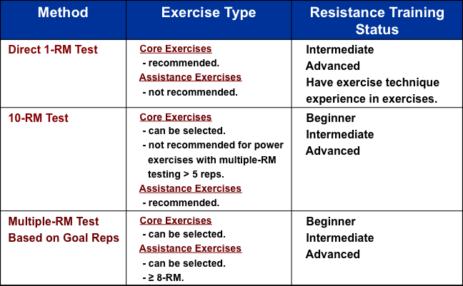
  - Assigning Load and Repetitions Based on the Training Goal
- Once the primary goal of the resistance training program has been established, it can be applied to determine specific load & repetition assignments via:
  - the RM continuum,
  - a percentage of the 1RM, or
  - the results of multiple-RM testing.

    - Figure 17.2 Summary of Testing and Assigning Training Loads and Repetitions
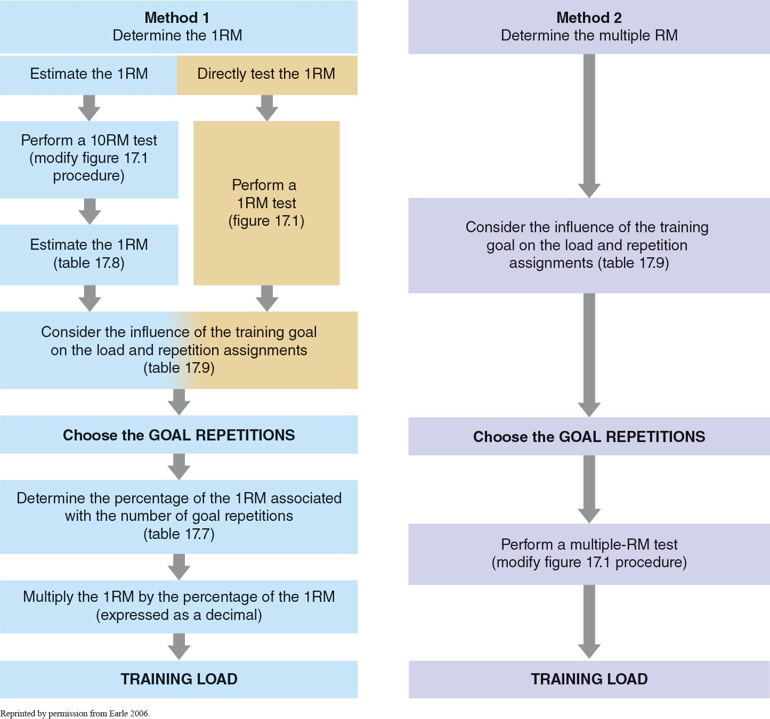
    - Table 17.9 Load and Repetition Assignments Based on the Training Goal

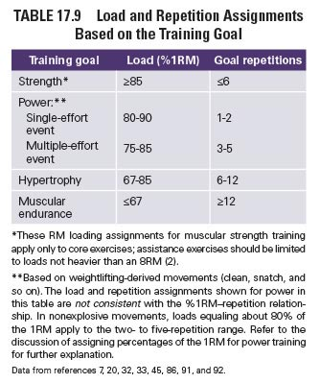

    - Repetition Maximum Continuum
- Goal: Strength or Power.
  - use relatively heavy loads.
- Goal: Hypertrophy.
  - use moderate loads.
- Goal: Muscular Endurance.
  - use light loads.
  - A certain RM emphasizes a specific outcome, but training benefits are blended at any given RM.

    - Percentage of the 1RM
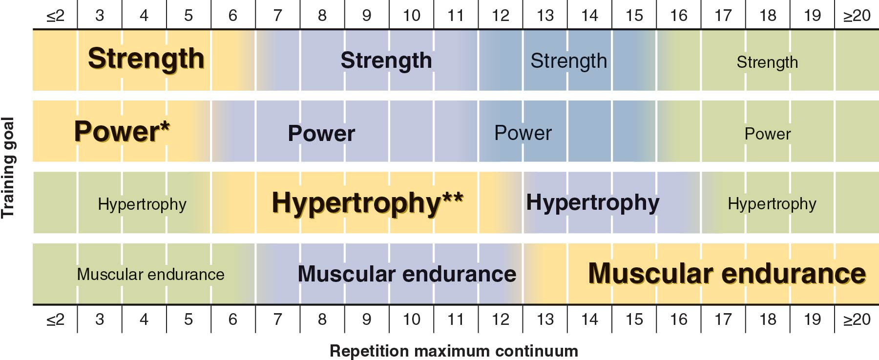
The relationship between the %age of the 1RM & the estimated # of reps that can be performed at a particular training load (Table 17.7) is used by S & C professionals to assign a specific resistance to be used in an exercise training session.

    - How to Calculate a Training Load
- What is the measured or estimated 1RM of the selected resistance exercise?
  - Bench Press 1RM = 220 lb.
  - What is the athlete’s training goal?
  - Muscular strength.
  - Refer to Table 17.9 to establish the load & rep assignments based on the athlete’s training goal.
  - Muscular strength: ≥ 85% 1RM & ≤ 6 reps.
- Refer to Table 17.7, the %1RM-repetition relationship, to establish the training load that will be assigned to the athlete’s resistance exercise.
- According to Table 17.7, the S & C professional can assign loads corresponding to:
- 85% 1RM = 85% (220 lb) = 187 lb for 6 reps,
- 87% 1RM = 87% (220 lb) = 191 lb for 5 reps,
- 90% 1RM = 90% (220 lb) = 198 lb for 4 reps,
- 93% 1RM = 93% (220 lb) = 205 lb for 3 reps, &
- 95% 1RM = 95% (220 lb) = 209 lb for 2 reps.

    - Assigning Percentages for Power Training
- Maximal Power is produced at intermediate velocities with the lifting of light to moderate, not maximal, loads.
- Power exercises cannot be maximally loaded at any repetition scheme, because the quality of the movement technique will decline before momentary fatigue defines a true multiple-RM set.
- For power training,
  - the most effective & practical application is to assign loads that are about 75% to 90% of the 1RM for resistance training exercises that can be heavily loaded & other weightlifting-derived movements.
  - 5 repetitions or fewer should be performed, but this will be determined by the type of power event the athlete is training for.
- The load & repetition assignments:
  - for athletes depend on whether they are training for single- or multiple-effort power events (see Table 17.9).
  - for power training in Table 17.9 are not consistent with the % 1RM-repetition relationship in Table 17.7.

    - Variation of the Training Load
- Strategy to counterbalance the overtraining associated with the heavy loads:
  - Incorporate light & medium training days into the athlete’s weekly resistance exercise training program.
  - Heavy Day Loads
    - are designed to be full repetition maximums, the greatest resistance that can be successfully lifted for the goal number of repetitions.
  - Other Training Day Loads
    - are reduced (intentionally) to provide recovery after the heavy day while still maintaining sufficient training frequency & volume.

    - Progression of the Training Load
      - Timing Load Increases
  - 2-for-2 Rule:
    - A conservative method that can be used to increase an athlete’s training loads.
    - If the athlete can perform 2 or more repetitions over his or her assigned repetition goal in the last set in 2 consecutive workouts for a given exercise, weight should be added to that exercise for the next training session.

      - Quantity of Load Increases
- Table 17.10 provides general recommendations based on the athlete’s strength (condition) & body area.
- Factors that greatly influence appropriate load increases:
  - Training status,
  - Volume-loads, &
  - Exercises (type & muscular involvement).
  - Relative load increases of 2.5% to 10% can be used in place of the absolute values to contend with the aforementioned factors that affect load increases.

      - Table 17.10 Examples of Load Increases
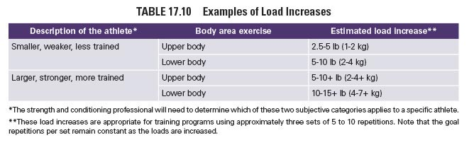

- STEP 6: VOLUME
- Volume
  - The total amount of weight lifted in a training session.
- Set
  - A group of repetitions sequentially performed before the athlete stops to rest.
- Repetition-Volume
  - The total number of repetitions performed during a workout session.
- Load-Volume
  - total # sets x # reps/set x weight lifted/rep.

  - Multiple Versus Single Sets
- Single-Set Training
  - may be appropriate for untrained individuals or during the 1st several months of training.
- Multiple-Set Training
  - many studies indicate that higher volumes are necessary to promote further gains in strength, especially for intermediate & advanced resistance-trained athletes.

  - Training Status
- Beginner
  - appropriate for an athlete to perform only 1 or 2 sets.
- Intermediate & Advanced
  - appropriate to add sets as the athlete becomes better trained.

  - Primary Resistance Training Goal
    - Table 17.11 Volume Assignments Based on the Training Goal
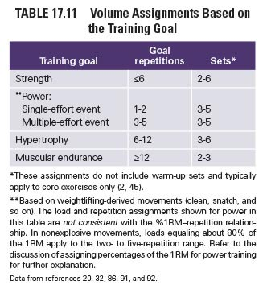
    - Strength and Power
  - Volume assignments for power training are typically lower than those for strength training to maximize the quality of exercise.

    - Hypertrophy
  - Increases in muscular size are associated with higher training volumes & performing 3 or more exercises per muscle group.

    - Muscular Endurance
  - Programs for muscular endurance involve many repetitions (12 or more) per set, lighter loads, & fewer sets.

- STEP 7: REST PERIODS
- The time dedicated to recovery between sets & exercises is called the rest period or interset rest.
- The length of this rest period is dependent on the:
  - goal of training,
  - relative load lifted,
  - amount of muscle mass involved in each exercise, &
  - athlete’s training status.

  - Table 17.12 Rest Period Length Assignments Based on the Training Goal
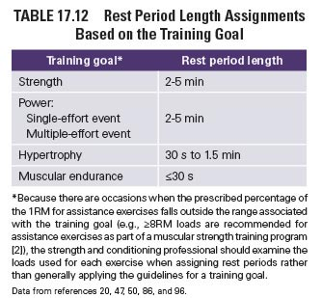
  - Strength and Power
  - Maximal or near-maximal loads require longer rest periods, especially for lower body or all-body structural exercises.
  - Common Guidelines: 2 to 5 minutes.

  - Hypertrophy
  - Short to moderate rest periods are used often.
  - Typical strategies: 30 seconds to 1.5 minutes.

  - Muscular Endurance
  - Very short rest periods, often less than or equal to 30 seconds.

Summary:
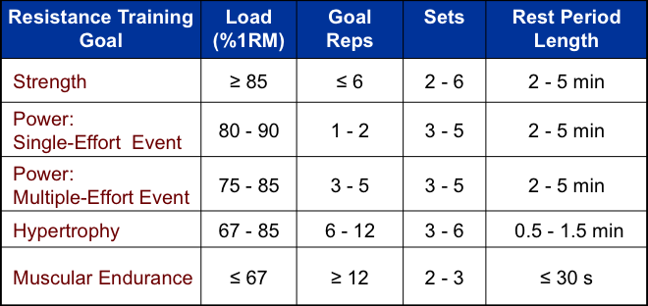

Chapter 18
Program Design & Technique for Plyometric Training
(Pages 471 to 520)

- PLYOMETRIC MECHANICS AND PHYSIOLOGY
- Practical Definition
  - is a quick, powerful movement using a pre-stretch, or countermovement, that involves the stretch shortening cycle (SSC).
  - Purpose
  - to increase the power of subsequent movements by using both the natural elastic components of muscle & tendon, & the stretch reflex.
Important to Understand
  - The mechanics & physiology of plyometric exercise.
  - The principles of plyometric training program design.
  - The methods of safely & effectively performing specific plyometric exercises.

  - Mechanical Model of Plyometric Exercise
- Performance of a rapid stretch
  - eccentric muscle action.
  - increases the elastic energy in the tendons & muscles.
  - elastic energy is briefly stored.
  - If a concentric muscle action follows immediately,
  - stored energy is released, increasing the total force production.
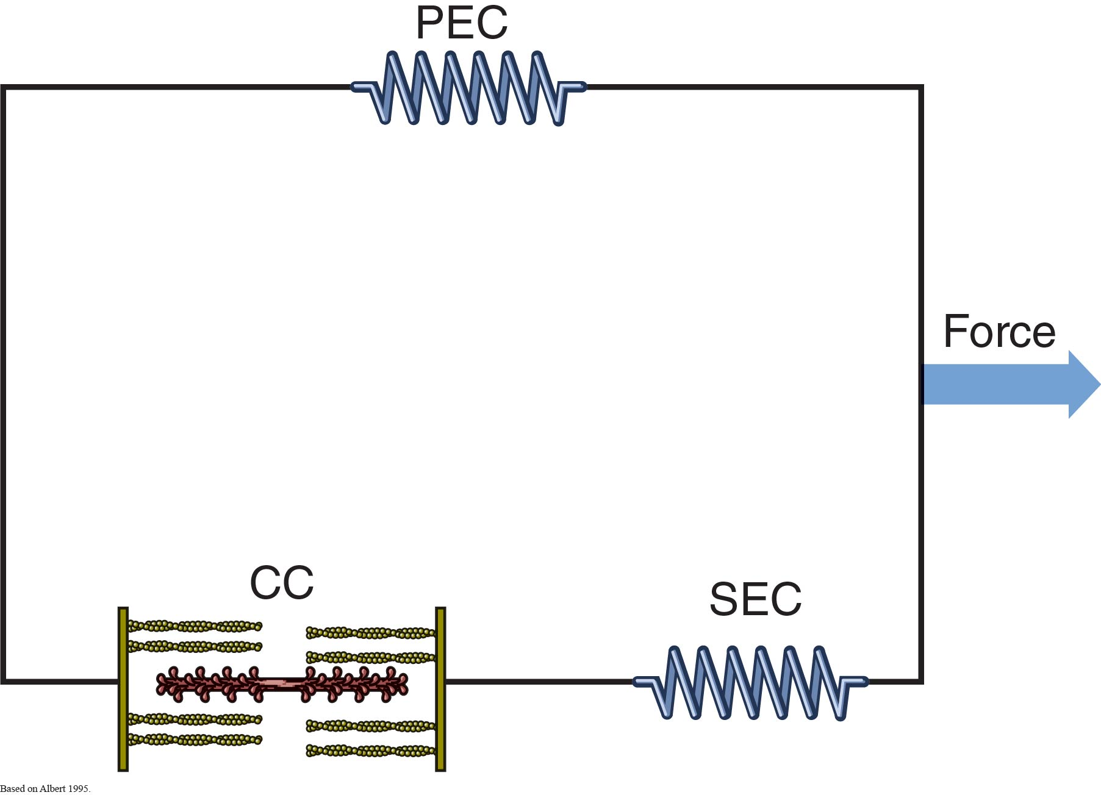
- The concentric muscle action does not occur immediately after the eccentric muscle action.
- The eccentric phase is too long.
- The eccentric phase requires too great a motion about the given joint.

  - Neurophysiological Model of Plyometric Exercise
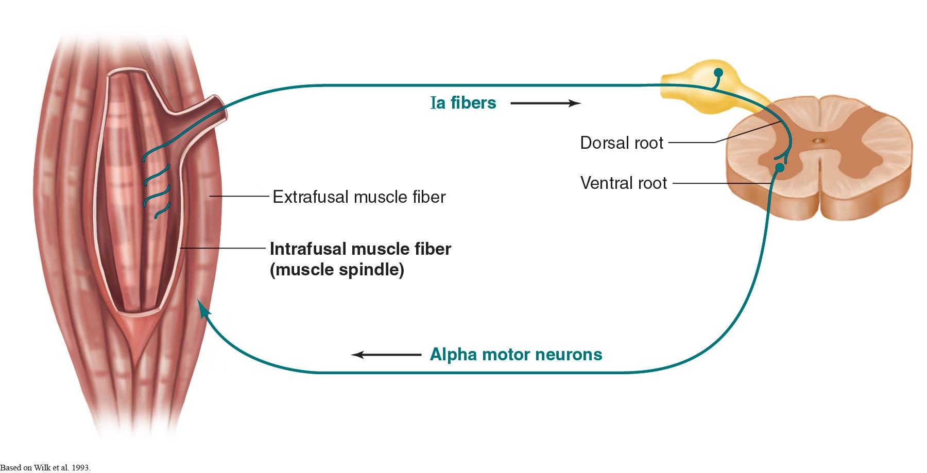
- involves potentiation (change in the force–velocity characteristics of the muscle’s contractile components caused by stretch) of the concentric muscle action by use of the stretch reflex.

    - Stretch-Shortening Cycle
- is the basis of plyometric exercise.
- combines mechanical & neurophysiological mechanisms.
- Employs both the energy storage capabilities of the SEC and stimulation of the stretch reflex to facilitate a maximal increase in muscle recruitment over a minimal amount of time.
- The rate of musculotendinous stretch is vital to plyometric exercise.
- A high stretch rate results in greater muscle recruitment & activity during the concentric phase of the SSC.
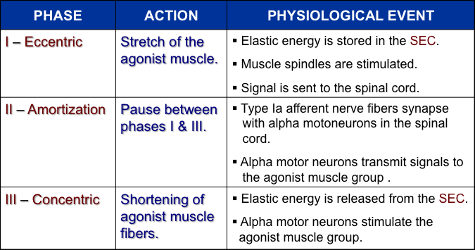

- PLYOMETRIC PROGRAM DESIGN
- Improves muscular power.
- Prepares athlete for the deceleration-acceleration & change-of-direction requirements in most sports.
- Been shown to decrease athletic injury rates.
- May improve work performance.

  - Needs Analysis
- Age
- Training Experience & Current Level of Training
  - Resistance Training
  - Plyometric Training
- Injury History
- Physical Testing Results
  - Current abilities, e.g., muscular power.
- Training Goals
  - Specific movements
  - Particular skills
- Incidence of Injury in an Athlete’s Sport

  - Mode
- is determined by the body region performing the given exercise:
  - Lower Body Plyometrics,
  - Upper Body Plyometrics,
  - Trunk Plyometrics.

    - Lower Body Plyometrics
- are appropriate for virtually any athlete and any sport.
- a wide variety exist with various intensity levels & directional movements.
- Direction of movement varies by sport:
  - horizontal, lateral, and/or vertical movements.
  - Many sports
  - require athletes to produce a maximal amount of muscular force in a short amount of time.

      - Table 18.2 Lower Body Plyometric Drills
Type of drill | Rationale
Jumps in place | These drills involve jumping and landing in the same spot. Jumps in place emphasize the vertical component of  jumping and are performed repeatedly, without rest between jumps; the time between jumps is the stretch–  shortening cycle’s amortization phase. Examples of jumps in place include the squat jump and tuck jump.
Standing jumps | These emphasize either horizontal or vertical components. Standing jumps are maximal efforts with recovery  between repetitions. The vertical jump and jumps over barriers are examples of standing jumps.
Multiple hops and jumps | Multiple hops and jumps involve repeated movement and may be viewed as a combination of jumps in place and  standing jumps. One example of a multiple jump is the zigzag hop.
Bounds | Bounding drills involve exaggerated movements with greater horizontal speed than other drills. Volume for  bounding is typically measured by distance but may be measured by the number of repetitions performed.  Bounding drills normally cover distances greater than 98 feet (30 m) and may include single- and double-leg  bounds in addition to the alternate-leg bounds illustrated in this chapter.
Box drills | These drills increase the intensity of multiple hops and jumps by using a box. The box may be used to jump on  or off. The height of the box depends on the size of the athlete, the landing surface, and the goals of the program.  Box drills may involve one, both, or alternating legs.
Depth jumps | Depth jumps use gravity and the athlete’s weight to increase exercise intensity. The athlete assumes a position  on a box, steps off, lands, and immediately jumps vertically, horizontally, or to another box. The height of the  box depends on the size of the athlete, the landing surface, and the goals of the program. Depth jumps may  involve one or both legs.
Box Drills:
- Height of Box
  - athlete’s size, landing surface, & program goals.
  - 6-18 in (15-46 cm); 6-42 in (15-107 cm); 12-42 in (30-107 cm).
Double-Leg Jump To Box
- Low intensity
- Box Ht: 6-42 in (15-107 cm
Squat Box Jump
- Medium intensity
- Box Ht: 6-42 in (15-107 cm)
Depth Jumps:
- Height of Box
  - athlete’s size, landing surface, & program goals.
  - 12 to 42 in (30-107 cm).
Depth Jump
- High intensity
- Box Ht: 12-42 in (30-107 cm)
Squat Depth Jump
- High intensity
- Box Ht: 12-42 in (30-107 cm)

    - Upper Body Plyometrics
- Rapid, powerful upper-body movements are requisites for several sports & activities.
- Not used as often as lower-body plyometrics.
- Have been studied less extensively.
Drills:
- Two hand overhead throw (low intensity)
- Power drop (high)
- Depth push up (medium)

    - Trunk Plyometrics
Generally
  - it is difficult to perform true plyometric drills that directly target trunk musculature.
Reason
  - because all requisite plyometric elements may not be present.
  - It is assumed that the stretch reflex latencies of the abdominal muscles are shorter than for the limb muscles.
May be performed provided that movement modifications are made:
  - Shorten or quicken the exercise movements.
  - Decrease the ROM.

Drills:
- 45 degree sit up (medium intensity)

  - Intensity
- refers to the amount of stress placed on involved muscles, connective tissues, & joints.
- is low, medium, or high.
- is controlled by the:
  - Type of drill performed,
  - Points of contact,
  - Speed,
  - Height of the drill,
  - Body weight, &
  - External weight.

    - Table 18.3 Factors Affecting the Intensity of Lower Body Plyometric Drills
- Factor | Effect
Points of contact | The ground reaction force during single-leg lower body plyometric drills places more stress on an  extremity’s muscles, connective tissues, and joints than during double-leg plyometric drills.
Speed | Greater speed increases the intensity of the drill.
Height of the drill | The higher the body’s center of gravity, the greater the force on landing.
Body weight | The greater the athlete’s body weight, the more stress is placed on muscles, connective tissues, and  joints. External weight (in the form of weight vests, ankle weights, and wrist weights) can be  added to the body to increase a drill’s intensity.

  - Frequency
- is the # of plyometric training sessions/wk.
- Typically ranges from
  - 1 to 3 sessions/week.
- Optimal Frequency
  - is unknown.
  - limited research.
- Strength & Conditioning Professionals
  - often rely on practical experience.
- Many Authors
  - suggest relying more on the recovery time between training sessions.
  - Typical recovery time guideline:
    - 48-72 h between plyometric sessions.
    - allows the performance of 2 to 3 sessions/week.

- Depends on:
  - Demands of the given sport,
  - Intensity & volume of daily workouts,
  - Practical experience (athlete’s experience with plyometric training),
  - Recovery time between sessions, &
  - Time of (the training cycle) year.

  - Recovery
- Why is complete or adequate recovery from the performance of plyometric drills required of athletes?
  - Because plyometric drills involve maximal efforts to improve anaerobic power.
- Which factors determine the recovery time between sets?
  - Proper work-to-rest ratio (i.e.: 1:5 to 1:10),
  - Volume of drill performed, &
  - Type of drill performed.
- What is the adequate amount of recovery between workouts to prevent overtraining?
  - 2 to 4 days.
  - Which factors determine the recovery between workouts?
  - Demands of the given sport,
  - Intensity & volume of daily workouts,
  - Time of (the training cycle) year.
  - Should drills for a given body area be performed 2 days in succession?
  - No.

  - Volume
- Volume is typically expressed as the # of reps & sets performed during a given training session.
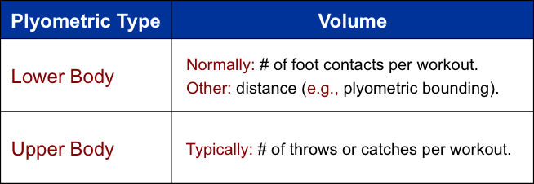
    - Table 18.4 Appropriate Plyometric Volumes
- Plyometric experience | Beginning volume*
Beginner (no experience) | 80 to 100
Intermediate (some experience) | 100 to 120
Advanced (considerable experience) | 120 to 140

  - Program Length
- Optimal plyometric training program length: yet to be determined by research.
- Most programs: 6 to 10 weeks.
- For sports requiring quick, powerful movements: it is beneficial to perform plyometric exercise throughout the macrocycle.

  - Progression
- Because plyometrics is a form of resistance training,
  - it must follow the principles of progressive overload.
- Progressive Overload
  - Low to Moderate volumes of low-intensity plyometrics to
  - L to M volumes of moderate-intensity plyometrics to
  - L to M volumes of moderate to high-intensity plyometrics.
Determinants of the training schedule & method of progressive over load:
- Sport
- Training Phase
- Time of year
- Design of the Strength & Conditioning Program
  - Resistance training
  - Running
  - Plyometrics

  - Warm-Up
- Plyometric Exercise Sessions
  - must begin with a general warm-up, stretching, & a specific warm-up.
- Specific Warm-Up
  - should consist of low-intensity, dynamic movements.

    - Table 18.5 Plyometric Warm-Up Drills
Marching | Mimics running movements  Emphasizes posture and movement technique  Enhances proper lower body movements for running
Jogging | Prepares for impact and high-intensity plyometric drills  • Toe jogging—not allowing heel to touch the ground (emphasizes quick reaction)  • Straight-leg jogging—not allowing or minimizing leg flexion in preparation for  impact of plyo-metric drills  • “Butt-kickers”—flexing knee to allow heel to touch the buttocks
Skipping | Exaggerated form of reciprocal upper and lower extremity movements  Emphasis on quick takeoff and landing, mimics plyometric activities
Footwork | Drills that target changes of direction  Preparation for changes of direction during plyometric drills  Examples: shuttle, shuffle, pattern, and stride drills
Lunging | Based on the forward step lunge exercise  May be multidirectional (e.g., forward, side, backward)

- AGE CONSIDERATIONS
  - Adolescents
- Prepubescent & Adolescent Children
  - May also benefit from training with plyometric & plyometric-like exercises.
- Benefits
  - Increased muscular power.
  - Increased bone strength.
  - Better preparation for the demands of sport practice & competition.
- Considerations
  - Both physical & emotional maturity.
- Contraindicated Exercises for Prepubescent Children
  - Depth jumps & other high-intensity lower body plyometric drills.
  - Epiphyseal plates.
- Primary Goal
  - is to develop neuromuscular control & the anaerobic skills that will carry over to safer participation in sport & athletics.
- Recommendations
  - Gradually progress from simple to more complex drills.
  - Focus on the quality of the movements to develop techniques that will be essential for more advanced exercises.
  - Adequate recovery time between workouts: Minimum = 2-3 days
  - Masters
- Masters athletes can perform plyometrics,
  - as long as modifications are made for orthopedic conditions & joint degeneration.
  - Design a plyometric program according to the same guidelines outlined for adult athletes with the following changes:
  - Low- to moderate-intensity exercises: ≤ 5.
  - Volume: < a standard plyometric training program.
  - Recovery: 3-4 days between plyometric workouts.

- PLYOMETRICS AND OTHER FORMS OF EXERCISE
  - Plyometric Exercise and Resistance Training
Complex Training
- is a combination of high-intensity resistance training followed by plyometrics.
- generally involves the execution of a resistance training exercise using a heavy load (1-5 RM) followed relatively quickly by the execution of a biomechanically similar plyometric exercise.
- Example of Complex Training
  - 5 reps of front squat using a 5RM load.
  - 6-8 vertical jumps or depth jumps.
- Adequate recovery is needed between plyometrics & other high-intensity training.

Advanced Forms of Complex Training
- is the combination of traditional resistance training exercises with plyometric movements.
- Example of an AFCT
  - perform a squat jump with about 30% 1RM as an external resistance.

Physiological Rationale Behind Complex Training
- Premise of Complex Training
  - The explosive capability of muscle is enhanced after it has just been subjected to maximal or near-maximal contractions.
  - This phenomenon has been referred to as postactivation potentiation (PAP).

2 possible PAP mechanisms:
Prestimulation Enhances Motor-Neuron Pool Excitability
  - Recruitment of more motor units.
  - Better motor unit synchronization.
  - A decrease in postsynaptic inhibition.
  - Greater central input to the motor neuron.

Phosphorylation of the Myosin Light Chain
  - Renders the actin-myosin interaction more sensitive to Ca²⁺ released from the SR.

Guidelines for Developing a Combined Plyometrics & Resistance Training Program
- Combine lower-body resistance training with upper-body plyometrics.
- Combine upper-body resistance training with lower-body plyometrics.
- It is not usually recommended for athletes to perform heavy resistance training & plyometrics on the same day.
- Some athletes may benefit from complex training.
- Only athletes that have previously participated in high intensity plyometric training programs should perform advanced forms of complex training.

    - Table 18.6 Sample Schedule for Integrating Resistance Training and Plyometrics
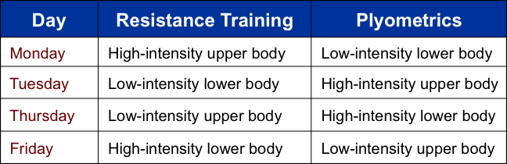
  - Plyometric and Aerobic Exercise
- Advisable
  - to perform plyometric exercise before aerobic endurance training.
- Reason
  - because aerobic exercise may have a negative effect on power production.

- SAFETY CONSIDERATIONS
  - Pretraining Evaluation of the Athlete
    - Technique
- Lower Body Plyometric Landing Technique
  - Shoulders should be over the knees.
  - Knees over the toes during landing.
  - Flexion of the ankles, knees, & hips.
- Dynamic Valgus
  - must not be observed.

    - Strength
- Although consideration of the athlete’s level of strength is necessary before the performance of plyometrics, technique may be a more important consideration.
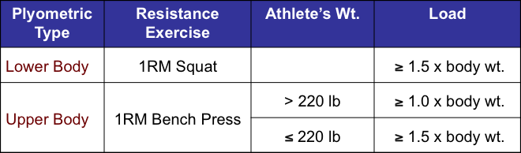
Alternative measure for prerequisite upper body strength: 5 consecutive clap push-ups

    - Speed
- Speed is another consideration before the performance of plyometrics.
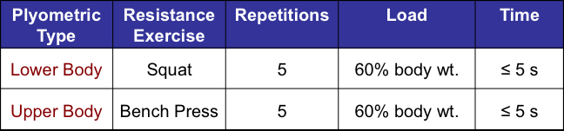
    - Balance
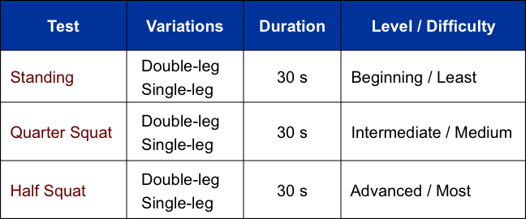
One must perform the balance tests on the same surface used in the plyometric drills.

    - Physical Characteristics
- Athletes who weigh > 220 lb (100 kg)
  - may be at an increased risk for injury when performing plyometric exercises.
  - should avoid high-volume, high-intensity plyometric exercises.
  - should not perform depth jumps from heights > 18 in (46 cm).
- Athletes with previous injuries or abnormalities of the spine, lower extremities, or upper extremities
  - should be cautious when beginning a plyometric training program.

  - Equipment and Facilities
    - Landing Surface
Must possess adequate shock-absorbing properties to prevent injuries.
Poor Surface Choices
  - Concrete, Asphalt, Tile, Hardwood, Exercise mats ≥ 6 in (15 cm), & Mini-trampolines.
Good Surface Choices
- Grass field, Suspended floor, & Rubber mats

    - Training Area
- Amount of Space Needed
  - depends on the drill.
- Most Bounding & Running drills
  - require at least 33 yd (30 m) of straightaway.
- Some drills
  - may require a 109 yd (100 m) straightaway.
- Most Standing, Box, & Depth Jumps
  - require a minimal surface area.
  - require an adequate ceiling height = 9.8 to 13.1 ft (3 to 4 m).

    - Equipment
- Boxes Used for Box & Depth Jumps
  - Must be sturdy:
    - 3/4 inch (1.9 cm) sturdy wood (plywood) or
    - heavy-gauge metal.
  - Height:
    - 6 to 42 in (15 to 107 cm).
  - Landing Surface:
    - ≥ 18 x 24 in (46 x 61 cm).
    - should have a nonslip top.

    - Proper Footwear
- Good ankle & foot support.
- Good lateral stability.
- With enough cushioning.
- Require wide, nonslip sole.
- Running shoes are unacceptable.

    - Supervision
- Monitor closely to ensure proper technique.
- Monitor athlete’s jumping & landing technique for lower extremity drills.
- Avoid extremes of lateral knee motion.
- Minimize contact time with the ground.

    - Depth Jumping
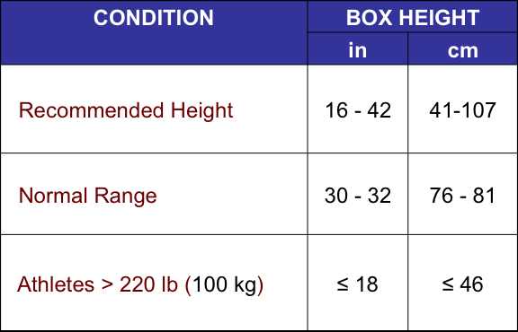

- What are the Steps for Implementing a Plyometric Training Program?
- Evaluate the athlete, including the athlete’s sport & training history.
- Establish sport-, position-, & sport-specific goals.
- Assign proper plyometric training program design variables, addressing intensity, frequency, recovery, volume, & program length.
- Teach the athlete proper jumping, landing, & throwing technique.
- Properly progress the plyometric training program.

- PLYOMETRIC DRILLS
  - You must be able to classify the plyometric exercises according to:
    - Mode
      - Lower body, Upper body, Trunk.
    - Type
      - Lower body
        - Jumps in Place, Standing Jumps, Multiple Hops & Jumps, Bounds, Box Drills, Depth Jumps
    - Intensity Level
      - How would you increase the intensity for the plyometric exercises while adhering to safety guidelines?
    - Direction
      - You are not expected to study the directions of the plyometric exercises.

  - To assist you in the classification of the plyometric exercises, refer to pages 483 to 519 in your textbook for their descriptions and download the tables summarizing the types of plyometric exercises according to their mode, type, and intensity from the corresponding file on Moodle.

- TYPES OF PLYOMETRIC EXERCISE
Plyometric Exercise | Mode | Jump Type | Intensity Level
Two-Foot Ankle Hop | Lower Body | Jumps in Place | Low
Single-Leg Ankle Hop | Lower Body | Jumps in Place | Medium
Squat Jump | Lower Body | Jumps in Place | Low
Jump & Reach | Lower Body | Jumps in Place | Low
Double-Leg Tuck Jump | Lower Body | Jumps in Place | Medium
Split Squat Jump | Lower Body | Jumps in Place | Medium
Cycled Split Squat Jump | Lower Body | Jumps in Place | High
Single-Leg Tuck Jump | Lower Body | Jumps in Place | High
Pike Jump | Lower Body | Jumps in Place | High
Double-Leg Vertical Jump | Lower Body | Standing Jumps | Low
Single-Leg Vertical Jump | Lower Body | Standing Jumps | High
Jump Over Barrier | Lower Body | Standing Jumps | Medium
Standing Long Jump | Lower Body | Standing Jumps | Low
Double-Leg Hop | Lower Body | Multiple Hops & Jumps | Medium
Double-Leg Zigzag Hop | Lower Body | Multiple Hops & Jumps | High
Single-Leg Hop | Lower Body | Multiple Hops & Jumps | High
Front Barrier Hop | Lower Body | Multiple Hops & Jumps | Medium
Lateral Barrier Hop | Lower Body | Multiple Hops & Jumps | Medium
4-Hurdle Drill | Lower Body | Multiple Hops & Jumps | High
- TYPES OF PLYOMETRIC EXERCISE
Plyometric Exercise | Mode | Jump Type | Intensity Level
Skip | Lower Body | Bounds | Low
Power Skip | Lower Body | Bounds | Low
Backward Skip | Lower Body | Bounds | Low
Side Skip | Lower Body | Bounds | Medium
Single-Arm Alternate-Leg Bound | Lower Body | Bounds | Medium
Double-Arm Alternate-Leg Bound | Lower Body | Bounds | Medium
Single-Leg Push-Off | Lower Body | Box Drills | Low
Alternate-Leg Push-Off | Lower Body | Box Drills | Low
Lateral Push-Off | Lower Body | Box Drills | Low
Side-to-Side Push-Off | Lower Body | Box Drills | Medium
Double-Leg Jump to Box | Lower Body | Box Drills | Low
Single-Leg Jump to Box | Lower Body | Box Drills | High
Squat Box Jump | Lower Body | Box Drills | Medium
Lateral Box Jump | Lower Body | Box Drills | Medium
Drop Freeze | Lower Body | Box Drills | Medium
- TYPES OF PLYOMETRIC EXERCISE
Plyometric Exercise | Mode | Jump Type | Intensity Level
Depth Jump | Lower Body | Depth Jumps | High
Depth Jump to Second Box | Lower Body | Depth Jumps | High
Squat Depth Jump | Lower Body | Depth Jumps | High
Depth Jump With Lateral Movement | Lower Body | Depth Jumps | High
Depth Jump With Standing Long Jump | Lower Body | Depth Jumps | High
Depth Jump to 180º Turn | Lower Body | Depth Jumps | High
Single-Leg Depth Jump | Lower Body | Depth Jumps | High
Plyometric Exercise | Mode | Type | Intensity Level
Chest Pass | Upper Body | Throws | Low
Two-Hand Overhead Throw | Upper Body | Throws | Low
Two-Hand Side-to-Side Throw | Upper Body | Throws | Low
Single-Arm Throw | Upper Body | Throws | Medium
Power Drop | Upper Body | Throws | High
Plyometric Exercise | Mode | Type | Intensity Level
Depth Push-Up | Upper Body | Plyometric Push-Ups | Medium
Plyometric Exercise | Mode | Type | Intensity Level
45º Sit-Up | Trunk | Sit-Ups | Medium

Chapter 19
Program Design & Technique for Speed & Agility Training
(Pages 521 to 557)

- SPEED & AGILITY MECHANICS
3 Important Aspects of Physical Performance Required for Athlete Development

Speed
- The skills & abilities needed to achieve high movement velocities.

Change of Direction
- The skills & abilities needed to explosively change movement direction, velocities, or modes.

Agility
- The skills & abilities needed to change direction, velocity, or mode in response to a stimulus.

Within sport, high-speed human locomotion can be categorized as:

Linear
- Sprinting
- Track and field events
- Game-based contexts (open-field running)

Multidirectional
- Team sports
- Changes of direction predominate

What limits speed, change of direction, & agility?
- The effective application of force.

Which factors affect an athlete’s success in the explosive movements involved in speed, change of direction, & agility?
- Athlete’s strength capacity, &
- Athlete’s ability to use this strength within the constraints of the activity.

Speed and agility mechanics:
- To execute movement techniques, athletes must apply Force (= Mass x Acceleration).
- During most athletic activities, there is a limited amount of time available to produce force.
- 2 Variables That Describe Force Relative to the Time Available to Produce Force
  - Rate of Force Development (RFD)
  - Impulse

Physics of sprinting, change of direction, and agility:

Force
  - a vector quantity (magnitude + direction).
  - represents the interaction of two physical objects.

Speed
  - a scalar quantity.
  - rate at which an object covers a distance.

Velocity
  - a vector quantity (magnitude + direction).
  - describes both how fast an object is traveling & in what direction.

Acceleration
  - rate at which an object’s velocity changes over time.
  - is the change in an object’s velocity due to movement of mass.

Deceleration
  - describes a change from a higher to a lower velocity.

  - Rate of Force Development
- is the development of maximal force in minimal time.
- is typically used as an index of explosive strength.
- can be described as the change in force divided by the change in time.
- may be a more useful measure of an athlete’s explosive ability in sport settings where success is restricted to timing of movement.
Performance of Functional Movements
  - force is typically applied very briefly.
  - often for 0.1 to 0.2 seconds.
Absolute Maximum Force Development
  - may require 0.6 to 0.8 seconds.
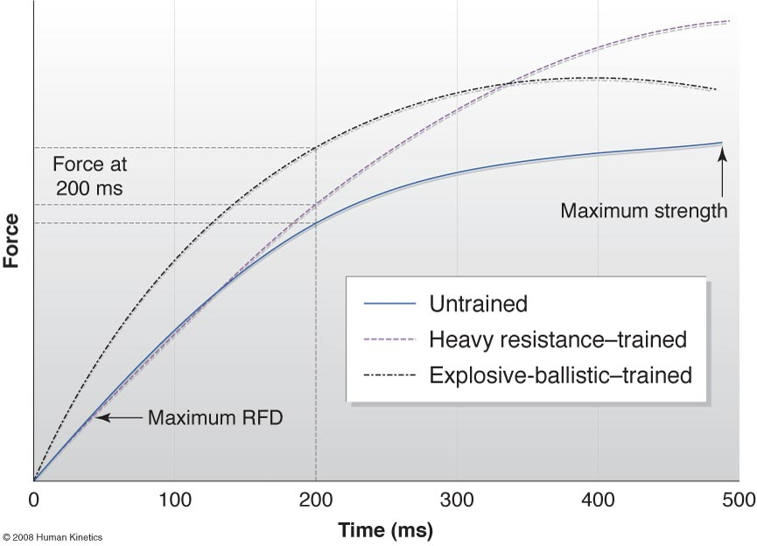
  - Impulse
F = m x a
F = m x (Δv / t)
F x t = [m x (Δv / t)] x t
F x t = m x Δv
Impulse = F x t = change in momentum
- is the change in momentum resulting from a force, where momentum = mass x velocity.
- = Force x Time.
- is measured as the area under the force-time curve.
- A Basic Objective of Training
  - To move the force–time curve up & to the left, generating greater impulse & momentum during the limited time over which force is applied.
- Athletes attempting to increase speed apply force to the running surface over a period of time in the stance phase of sprinting or in the plant phase of changing direction.
- Changes in impulse result in changes in the athlete’s momentum & therefore the ability to either accelerate or decelerate.

  - Figures 19.1 & 19.2
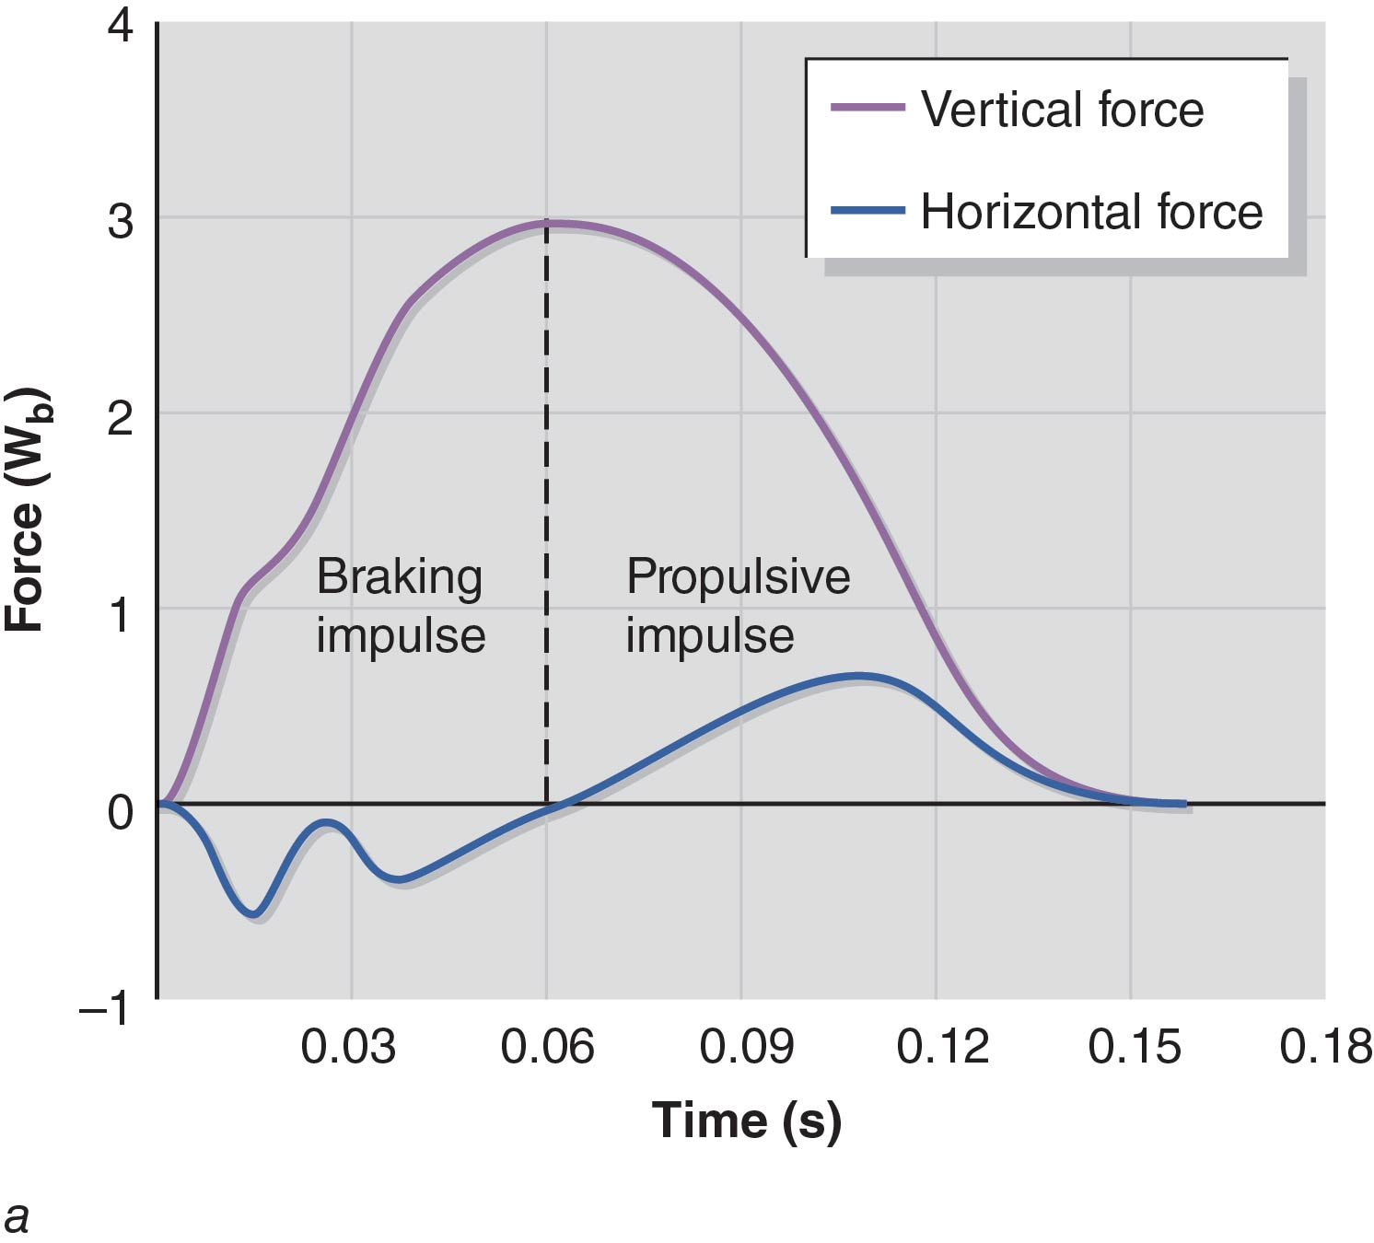
Braking Phase
- horizontal force.
Propulsive Phase
+ horizontal force.

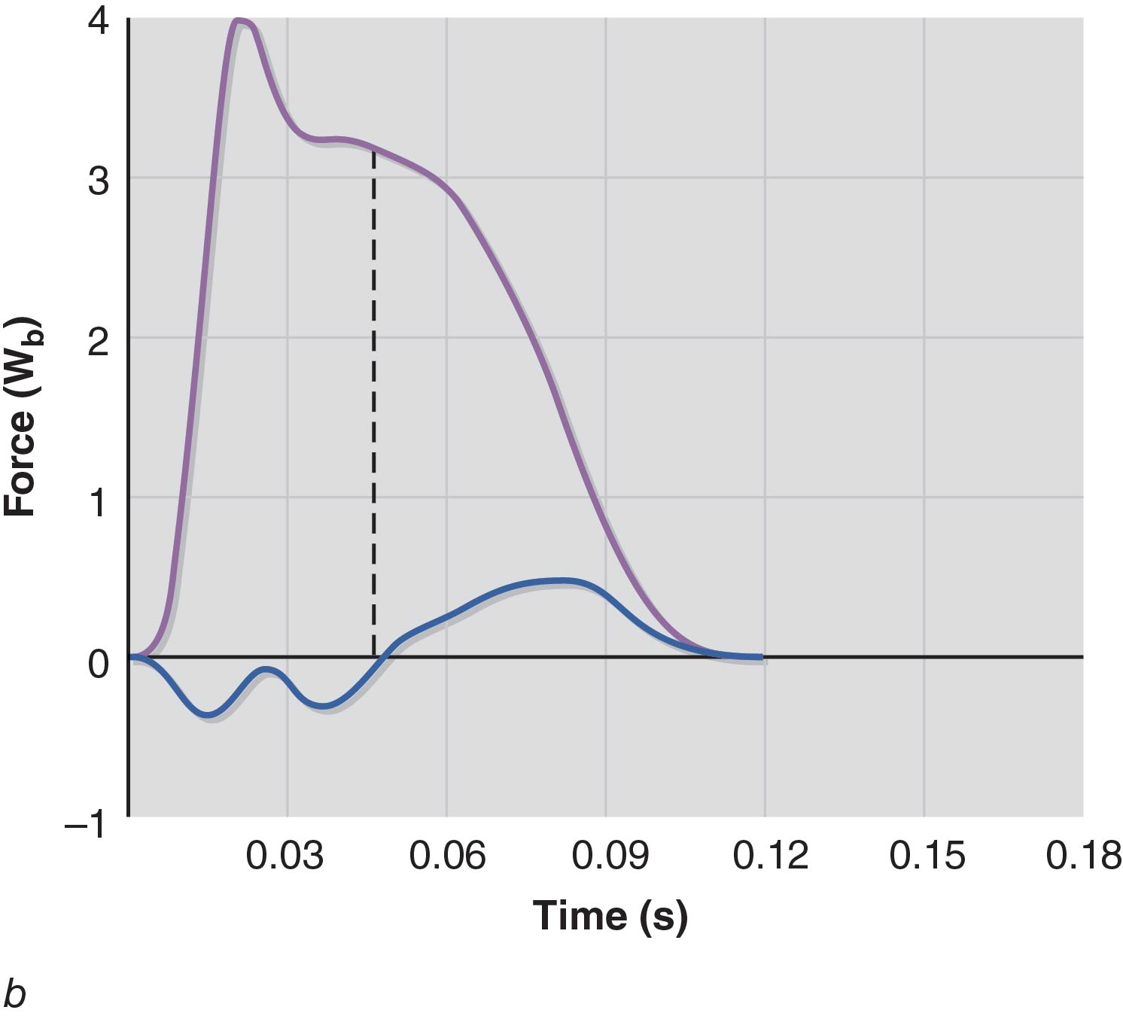
Asymmetrical production of force.
RFD is very high.
Shorter GCTs compared to the acceleration phase.

  - Power
- Is considered a mechanical construct that does not truly indicate maximal explosive performance.
- values do not provide insight into explosive performance that is fully useful to professionals because they can be affected by changes in force or velocity.
- Thus, direct measures such as force, RFD, & impulse are better indicators of maximal explosive performance.

  - Force-Velocity Curves
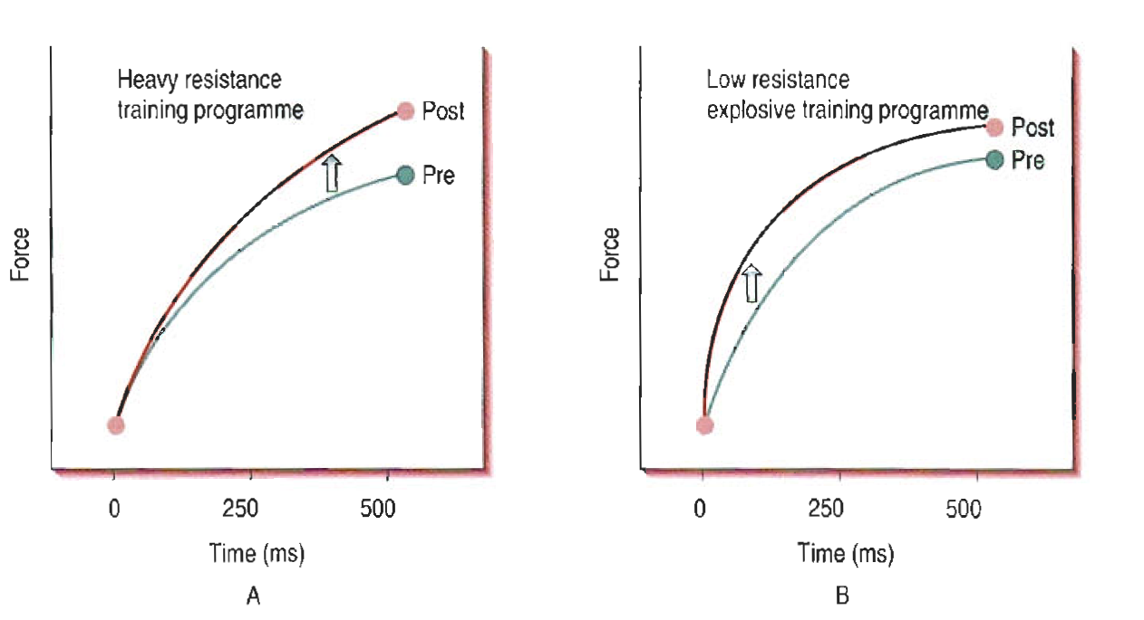
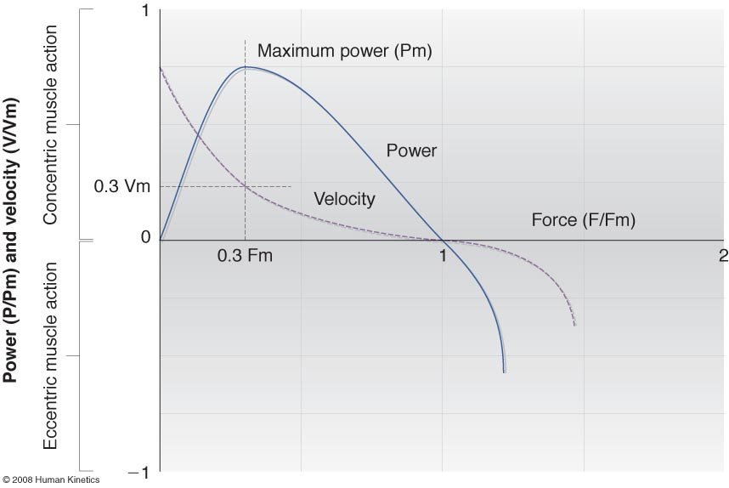
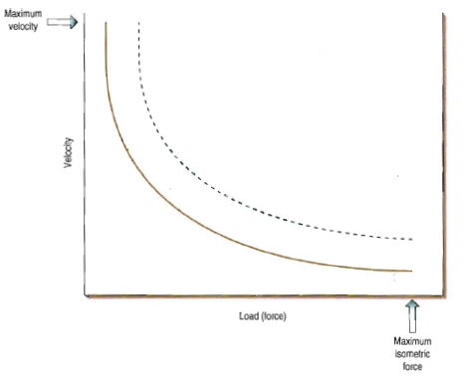
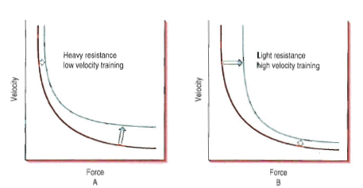
  - Practical Implications for Speed
Rate of Force Production
  - may be a more important factor for sprinting success.
Impulse
  - is an important underlying factor for sprinting success since forces must be produced within a short period of time.

  - Practical Implications for Change of Direction & Agility
- In addition to the requirement for acceleration,
  - the production of braking forces over certain periods of time, termed braking impulse, should be considered during change-of-direction and agility maneuvers.

- NEUROPHYSIOLOGICAL BASIS FOR SPEED
  - Nervous System
- Research has shown that the combination of strength, plyometric, & sprint training produces several adaptations within the neuromuscular system that may contribute to improved sprint performance.
- Strength training
- enhances neural drive.
- an enhanced neural drive is related to increases in both muscular force production & the rate of force production.
  - Plyometric training
  - increases the excitability of high-threshold motor units, which increases neural drive.
  - Taken together, increases in neural drive
  - may contribute to increases in RFD & impulse generation.

  - Stretch-Shortening Cycle
- is an eccentric–concentric coupling phenomenon in which muscle–tendon complexes are rapidly & forcibly lengthened, or stretch loaded, and immediately shortened in a reactive or elastic manner.
- is a preparatory countermovement involving spring-like actions at the beginning of many functional tasks.
- actions are particularly prevalent in sports involving running, jumping, & other explosive changes in velocity.
- Acute Effects of SSC Actions
  - Tend to increase mechanical efficiency & impulse via elastic energy recovery.
- Chronic Effects of SSC Actions
  - Unregulate muscle stiffness & enhance neuromuscular activation.
- Training activities aimed at improving SSC performance should
- involve skillful, multijoint movements that transmit forces through the kinetic chain & exploit elastic-reflexive mechanisms.
- be structured around brief work bouts or clusters separated by frequent rest pauses to manage fatigue & emphasize work quality & technique.

  - Spring-Mass Model
- is a mathematical model that depicts sprinting as a type of human locomotion in which the displacement of a body mass is the aftereffect from energy produced & is delivered through the collective coiling & extension of spring-like actions within muscle architecture.

  - Figure 19.3
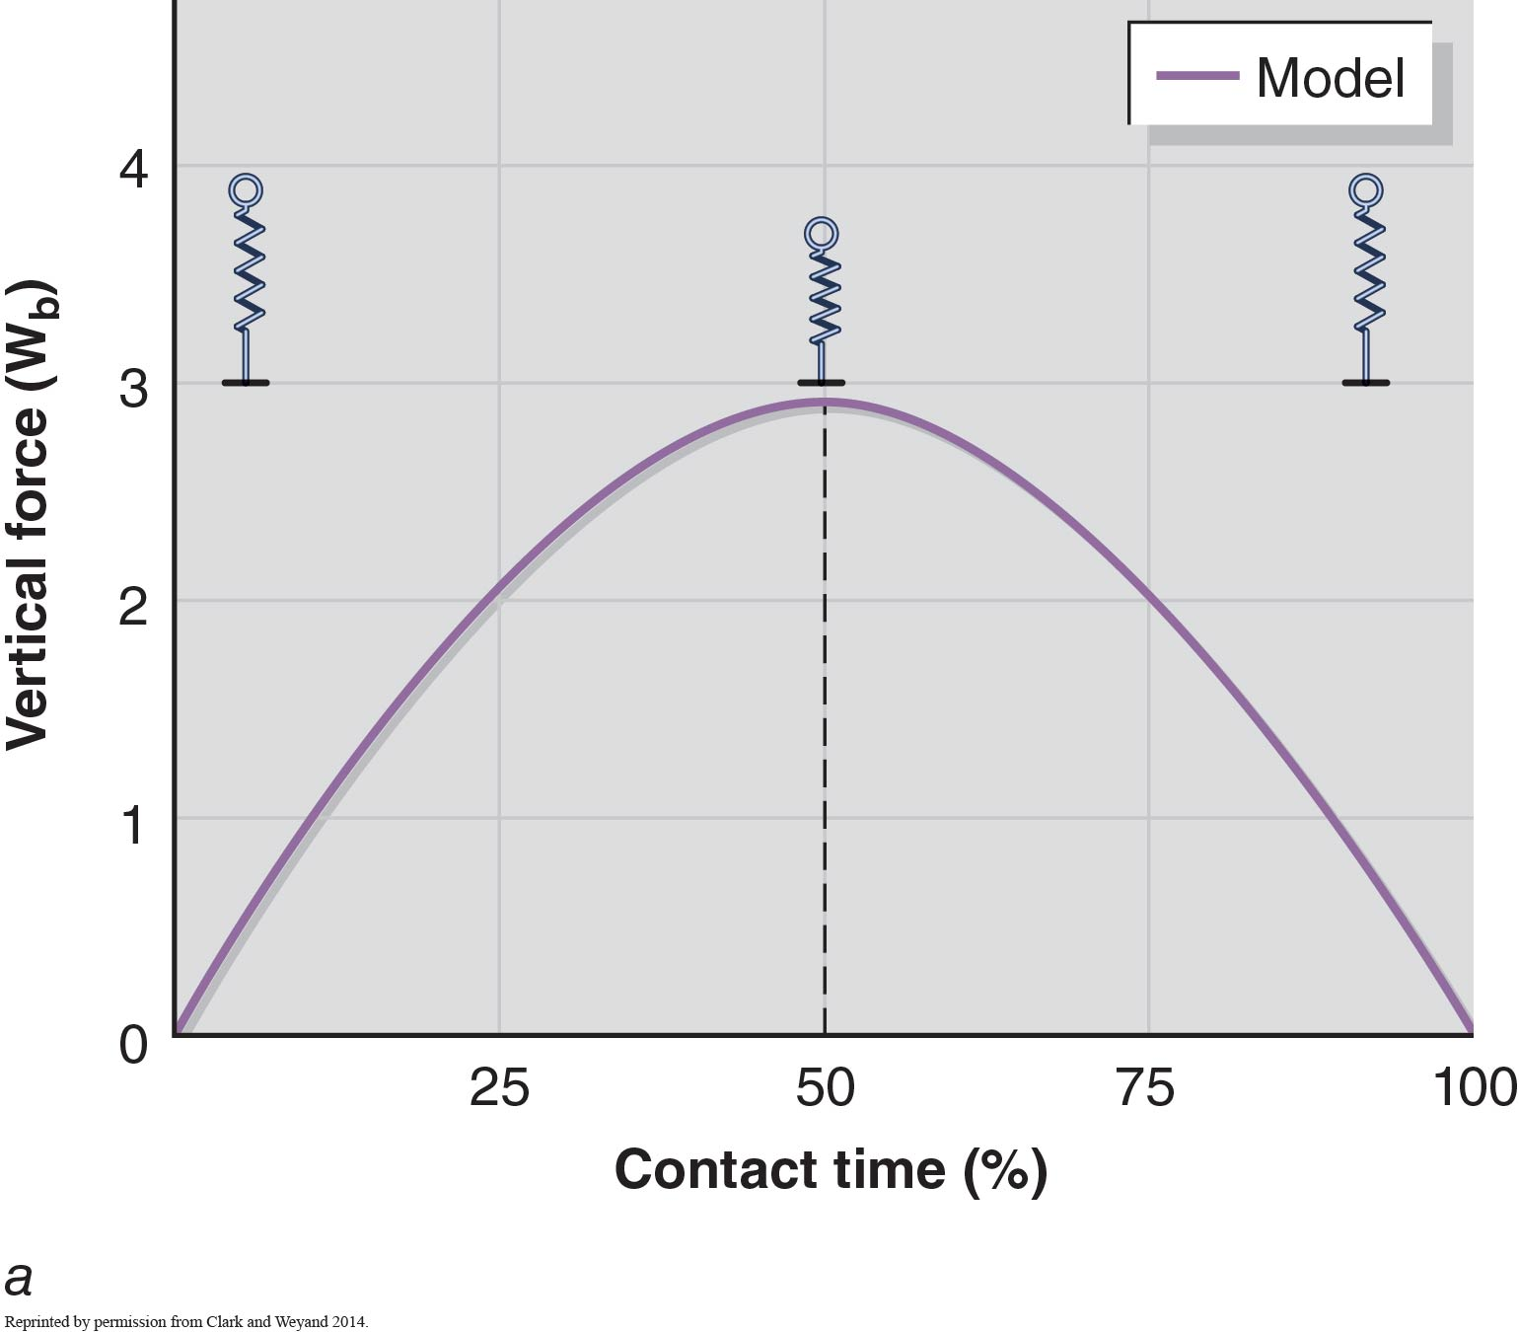
- Leg
- is represented as a
- spring.
- Initial stance
- uncompressed spring
- Midstance
- compressed spring

- Elite Sprinters
  - tend to deviate from a classic SMM during the maximal-velocity phase by producing much of their vertical force in the 1st half of a ground contact.
  - see Fig. 19.2 b.
- Most Non-elite Sprinters
  - such as those involved in many team or field-based sports.
  - display stance phases:
    - that are described by the SMM.
    - with more symmetrical vertical force curves.
  - see Figures 19.3 a and b.

As sprinting requires an athlete to move at high speeds, S & C Professionals should emphasize: the prescription of exercises that have been shown to increase neural drive while overloading musculature of the hip & knee regions involved in the SSC.

  - Additional Neurophysiological Considerations for Change-of-Direction & Agility Development
- Plant Phase
- of a C-O-D movement.
- termed stance phase in sprinting.
- is the point in a C-O-D movement
- that represents the transition
- between the deceleration &
- acceleration steps.
- Critical to Performance
  - Body positioning
  - Maintenance of strong trunk positions

  - Figure 19.4
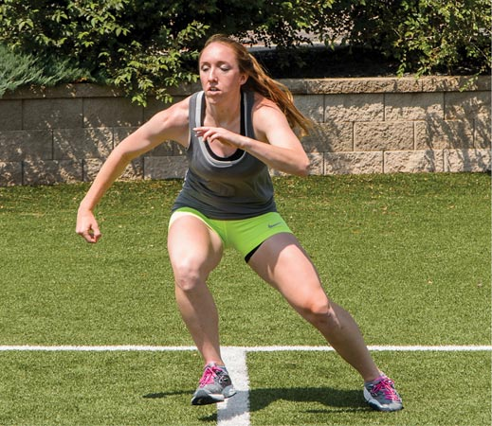
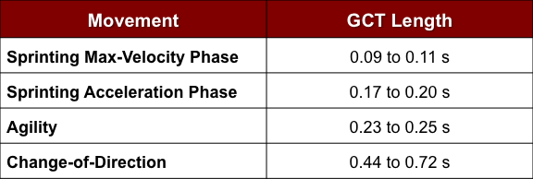
- Agility Performance Considerations
  - Effective breaking.
    - Neuromuscular development with respect to high-velocity & high-force eccentric contractions.

2 Reasons
      - Motor unit recruitment pathways called upon: eccentric contraction ≠ concentric contraction.
      - Eccentric training adaptations appear to be specific to the eccentric loading velocity.
  - Requires knowledge of perceptual-cognitive demands.
- The perceptual-cognitive demands on athletes are related to their abilities in the areas of:
- Visual search scanning,
- Anticipation,
- Decision making,
- Reaction time, &
- Tactical situation.

- RUNNING SPEED
Sprinting
  - is a series of coupled flight & support phases, known as strides, orchestrated in an attempt to displace the athlete’s body down the track at maximal acceleration or velocity, usually for brief distances.
  - has been described as rapid, unpaced, maximal-effort running of 15 s or less.
  - is classically defined based on the relationship between stride length & stride frequency.

  - Figures 19.5 and 19.6
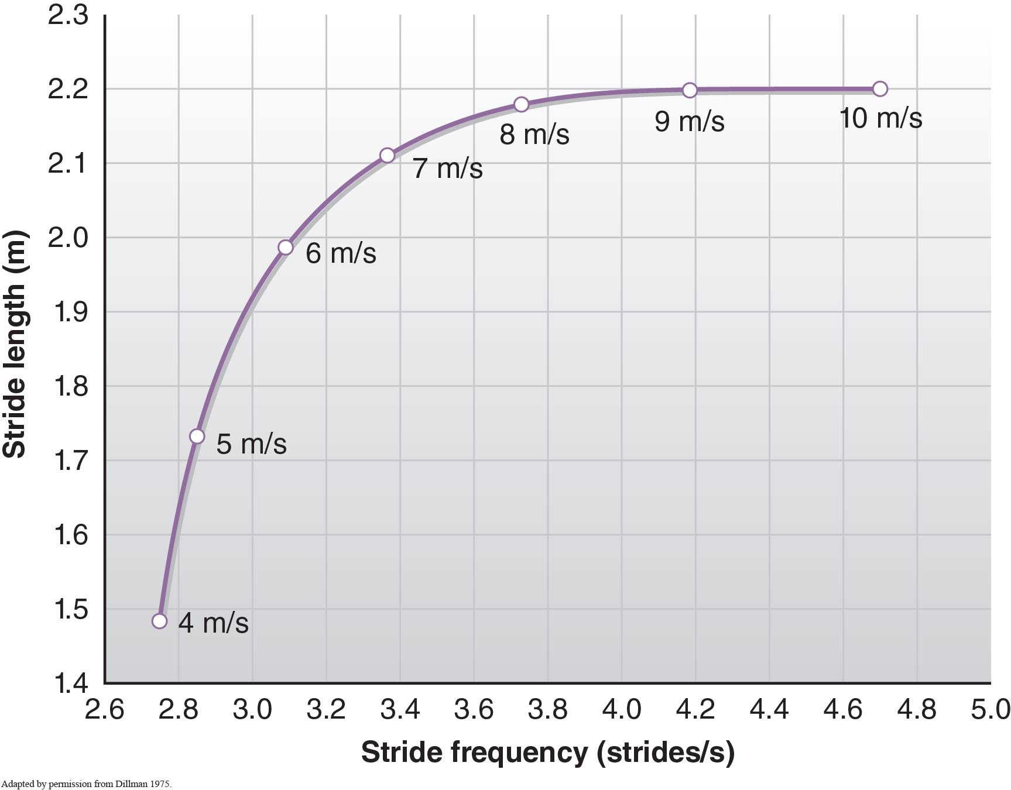

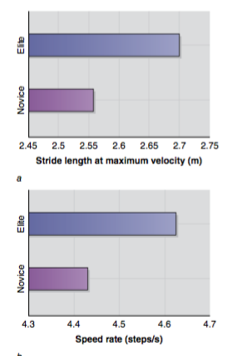
- Elite Male Sprinters vs Novice Male Sprinters
  - Stride Length at Maximum Velocity
    - Elite (2.70 m) > Novice (2.56 m)
  - Stride Frequency (Rate) at Maximum Velocity
    - Elite (4.63 steps/s) > Novice (4.43 steps/s)
  - Running Velocity
    - Elite (12.55 m/s) > Novice (11.25 m/s)
  - Ground Contact Time at Maximum Velocity
    - Elite (0.087 s) < Novice (0.101 s)
  - Time Spent in Air at Maximum Velocity
    - Elite > Novice
  - Directed Vertical Force
    - Elite sprinters are better than Novice sprinters due to an optimized knee height at maximal flexion of the recovering leg.
- Sprint speed
  - is determined by an athlete’s stride length & stride rate.
- More successful sprinters
  - tend to have longer stride lengths as a result of properly directed forces into the ground
  - while also demonstrating a more frequent stride rate.
- These findings suggest that
  - RFD & proper biomechanics are 2 of the primary limiting factors influencing sprint performance.

  - Sprinting Technique Guidelines
- Series of Subtasks of Linear Sprinting
  - Start
  - Acceleration
  - Maximum Velocity
- Phases of the Linear Sprinting Subtasks
  - Flight Phase
    - Recovery segment of the swing leg
    - Ground preparation of the swing leg
  - Stance (Support) Phase
    - Eccentric braking period
    - Concentric propulsive period

  - Do not study Figure 19.8
  - Technical Errors & Coaching (Table 19.1 – Maximum Velocity only)
Error Cause Coaching recommendations
Athlete is superficially attempting to maintain an acceleration phase when the shins are clearly vertical. | Improper understanding of movement patterns | Instruct the athlete that as the shins and hips come up to vertical,  so should the torso and head. Encourage the athlete to feel for  the rise in the hips so that the joints (shoulders to hips to ankles)  stay stacked or in line. This position allows for the proper  transmission of forces into the running surface.
Athlete is not displaying optimal front side mechan- ics with regard to the height of swing leg knee. | Inadequate force production | Recall that the swing leg’s knee height (traditionally called front  side mechanics) is purely a display of ground reaction forces.  Improper cueing an athlete to lift the knees may result in further  improper transmis- sion of forces and ultimately change the  musculature naturally used during the sprint event.
Athlete is overstriding. | Misunderstanding of force application | Success in sprint events results from the ability to produce high  vertical forces in a short amount of time. An athlete overstriding  is attempting to increase speed via larger ground contact times,  which ultimately dampens the effects of the stretch–shortening  cycle. Instruct athletes to “run in their lane” and maintain their  natural gait cycle.
Athlete is displaying chronic hamstring injury or pain. | Insufficient mobility, improper positioning of pelvis | A high likelihood of hamstring injury occurs during the swing  phase of the sprint event as a result of eccentric (lengthening)  forces. An athlete is further compromised when displaying  anterior pelvic tilt during the sprint event. Before training or  competition, mobility and soft tissue therapy may be warranted  in order to stabilize the pelvis in a neutral position.
Athlete is attempting to “cycle” the leg action, resulting in an increased time to complete the swing phase. This is made apparent by the open gap between the knees during the stance phase. | Improper force application | Instruct the athlete to drive the foot down and back into the track,  not paw. Due to the seemingly hori- zontal movement of the  foot during a sprint, coaches often miscue athletes to paw the  foot into the track. Pawing the foot horizontally against the track  prevents the athlete from using vertical forces, overloading the  stretch–shortening cycle to move down the track.
Athlete is displaying erroneous arm movement in the transverse plane. | Improper understanding of movement pattern | While traditionally coaches would claim that erratic arm  movement is a symptom of fatigue, much liter- ature suggests  that speed is limited by mechanical force application, not  metabolic efficiency. Under this newer model, coaches should  emphasize driving the arms down and back while maintaining  an upright torso. In addition, the coach should recommend to the  athlete that the arm swing recover near the midline of the body  in order to take advantage of the glenohumeral joint’s natural  range of motion.

  - Figure 19.9 – Acceleration & Maximum Velocity only
Acceleration (Figure 19.7)
Initial steps
  - During both the start clearance and initial steps of the acceleration, the recovery of the swing legs should be low to the ground to a point where the toes are barely off the ground.
  - Elite male sprinters display a stride rate of 5.26 steps/second during the second step compared to novice sprinters, who move at a rate of 3.45 steps/second.
  - Elite male sprinters display a stride length of 1.13 to 1.15 m during the first two steps of block clearance compared to novices, who average 1.21 to 1.50 m.
  - Stride length is shorter in elite sprinters due to the need for less flight time so that horizontal velocity is increased through more frequent ground contact times.
  - Elitemalesprintersaveragegroundtimesof~0.123secondsduringthesecondstepofstartclearance, while novice sprinters average 0.223 seconds.
  - By ~20 m, the body’s center of gravity has been raised to a point at which sprinting is nearly upright. The head is in a relaxed, neutral position and will rise at the same rate as the torso.
Maximum Velocity (Figure 19.8)
The sprinter displays stacked joints with the shoulders appearing to sit directly above the hips, which sit above the foot during stance phase. The head continues to stay in a relaxed, neutral position with eyes focused directly ahead. The shoulders stay down and relaxed to allow the arms to move at the same rate as legs cycle through the phases of stance and swing.
  - Elite male sprinters attain horizontal velocities ~12.55 m/s compared to novice sprinters, who reach velocities of 11.25 m/s.
  - At maximum velocity, top sprinters display higher stride rates than their competitors. Specifically, elite males demonstrate a stride rate of 4.63 steps/second while novice sprinters take 4.43 steps/second.
  - Elite male sprinters produce stride lengths of 2.70 m at maximum velocity compared to their novice counterparts, who achieve 2.56 m per stride.
  - Elite male sprinters minimize ground contact time to 0.087 seconds, while novice sprinters maintain ground contact times of 0.101 during maximum velocity.
  - Training Goals
Overarching Goal of Sprinting
  - To achieve optimal stride length & stride frequency through the correct application of force.
Transmission of high forces
  - must occur within a short stance phase (ground contact time).
Fundamental Training Objectives to Enhance Performance & Prevent Injury During the Development of Speed in Practical Settings:
- Emphasize brief ground support times as a means of achieving rapid stride rate.
- Requires high levels of explosive strength
- Consistent exposure to speed training
- Properly designed strength training program
- Emphasize the further development of the SSC as a means to increase the amplitude of impulse for each step of the sprint.

  - Do not study Figure 19.10

- AGILITY PERFORMANCE & CHANGE-OF-DIRECTION ABILITY
- Field & Court Sports
- Baseball, Softball, American football, Basketball, Handball, Rugby, & Soccer.
- have a substantial number of preplanned C-O-D movements.
- also include rapid changes of direction in response to the ball, the game, opponents, or tactical situations.
- offensive or defensive scenarios.
- physical movement & perceptual-cognitive aspects

  - Factors Affecting Change-of-Direction & Perceptual-Cognitive Ability
- Plant phase of C-O-D & Agility Movements
  - Shallow cutting angles (< 75º)
    - GCT < 250 ms
    - Benefit from training similar to speed training
    - Perceptual-cognitive training
  - Aggressive cutting angles (> 75º)
    - GCT > 250 ms
    - Greater breaking requirements
    - Train for eccentric strength, maximal strength, & concentric explosiveness.

  - Figure 19.11
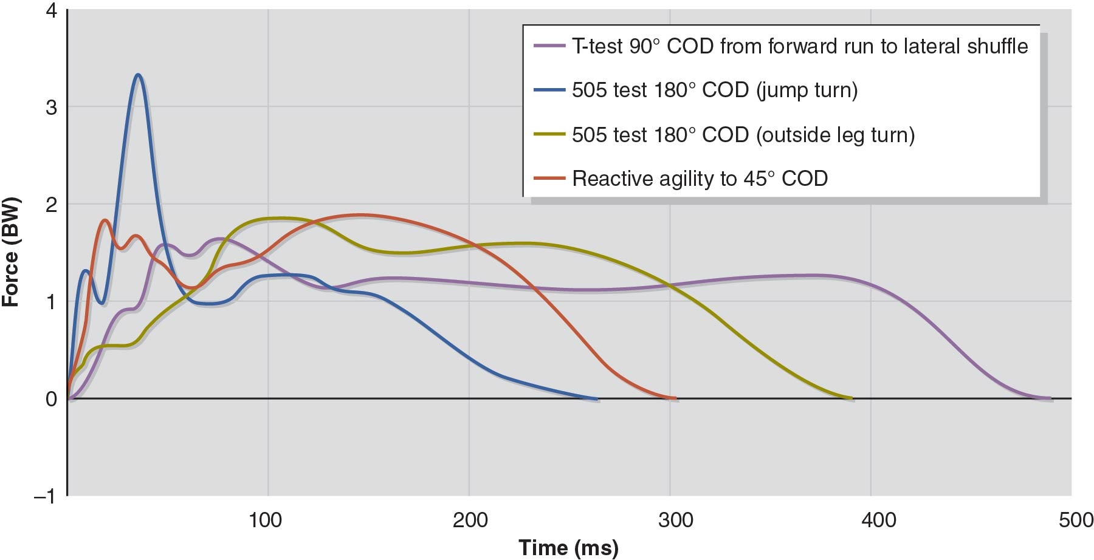
The effect of changing direction on ground contact time (GCT) and ground reaction force (GRF).

Handball-Specific Reactive Agility Test
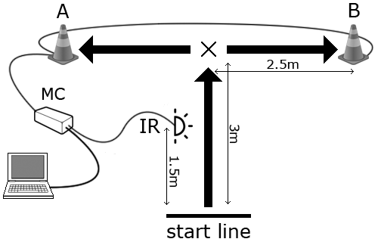

505 Agility Test
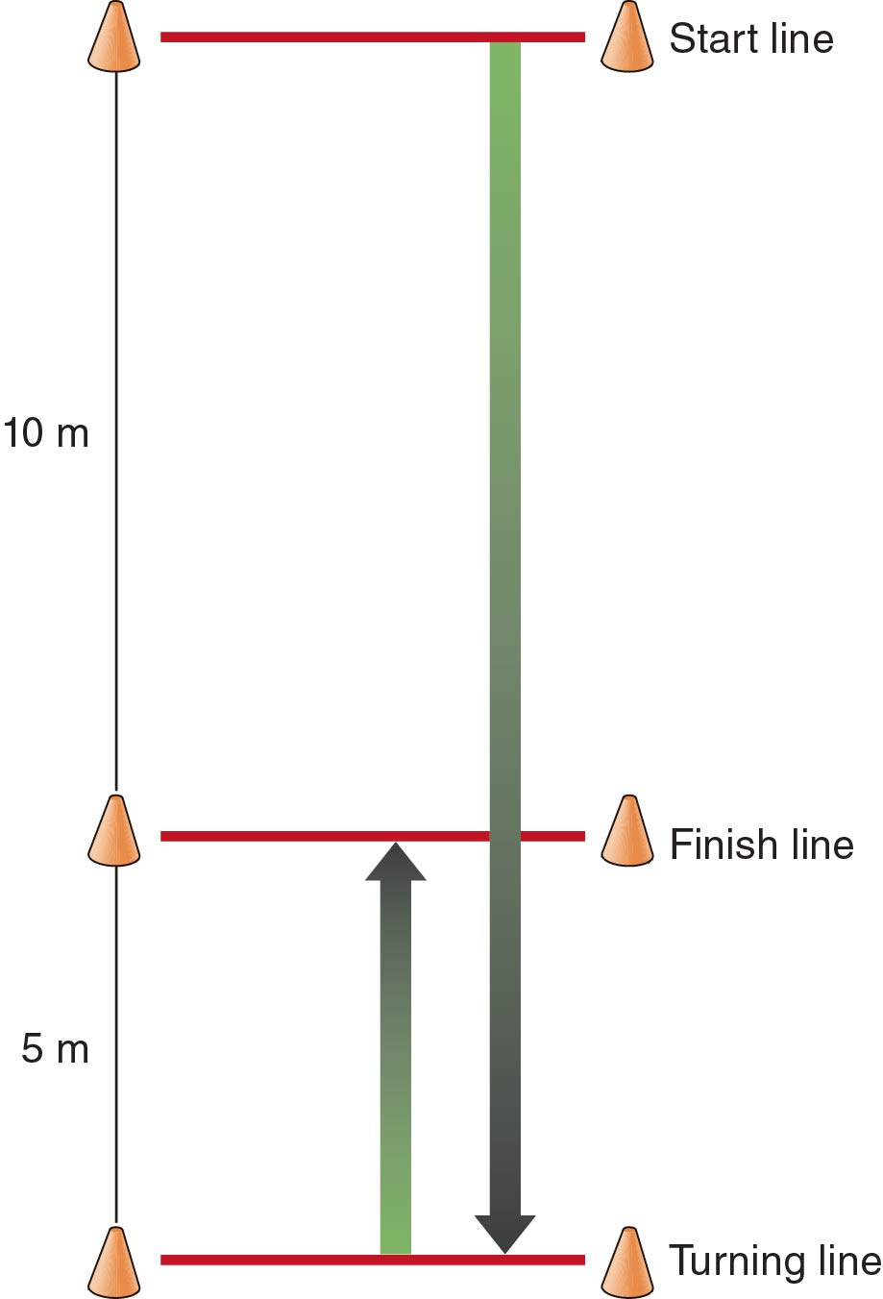

Pro Agility Test
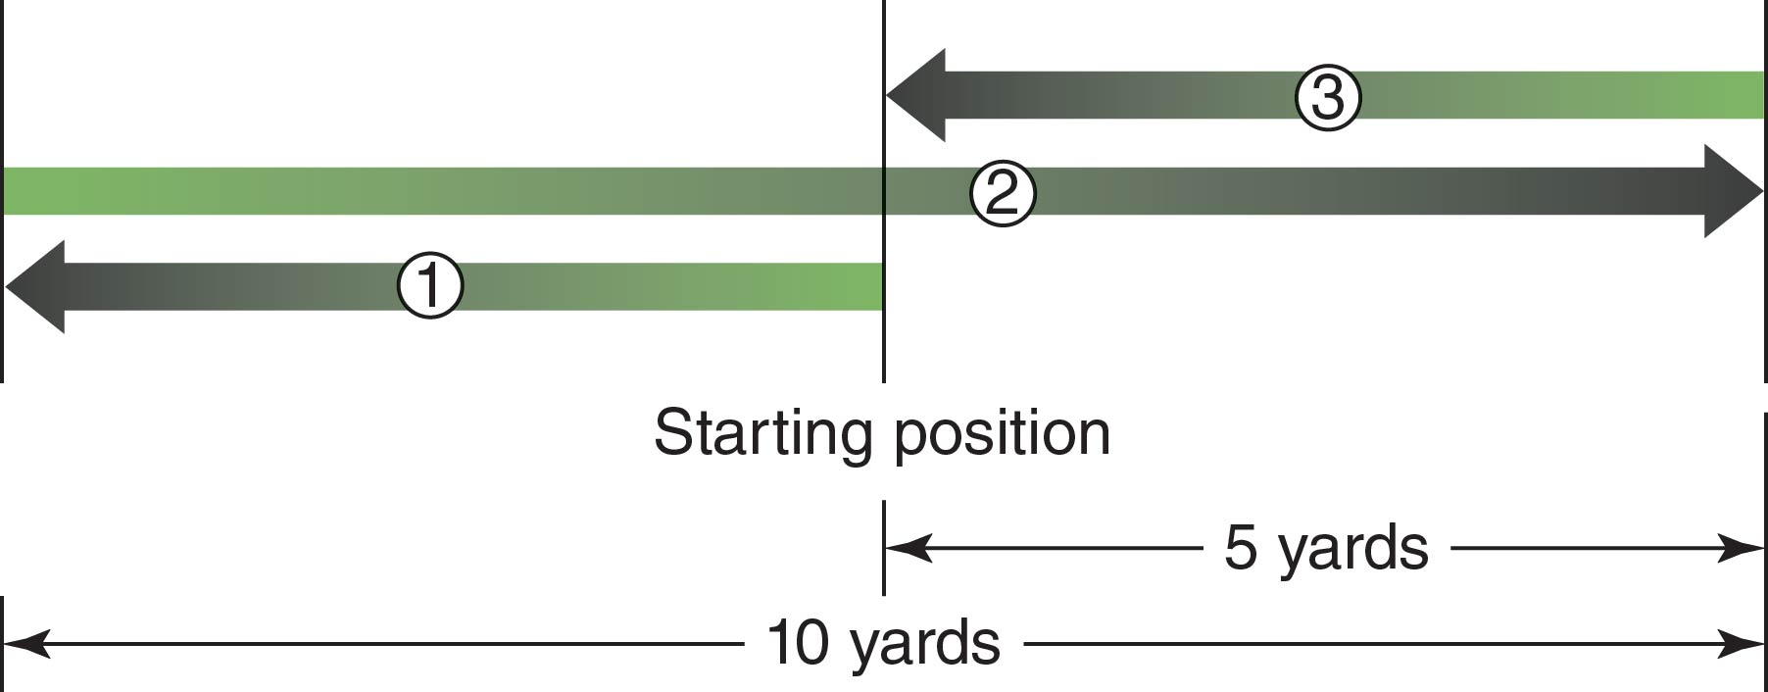

T-Test
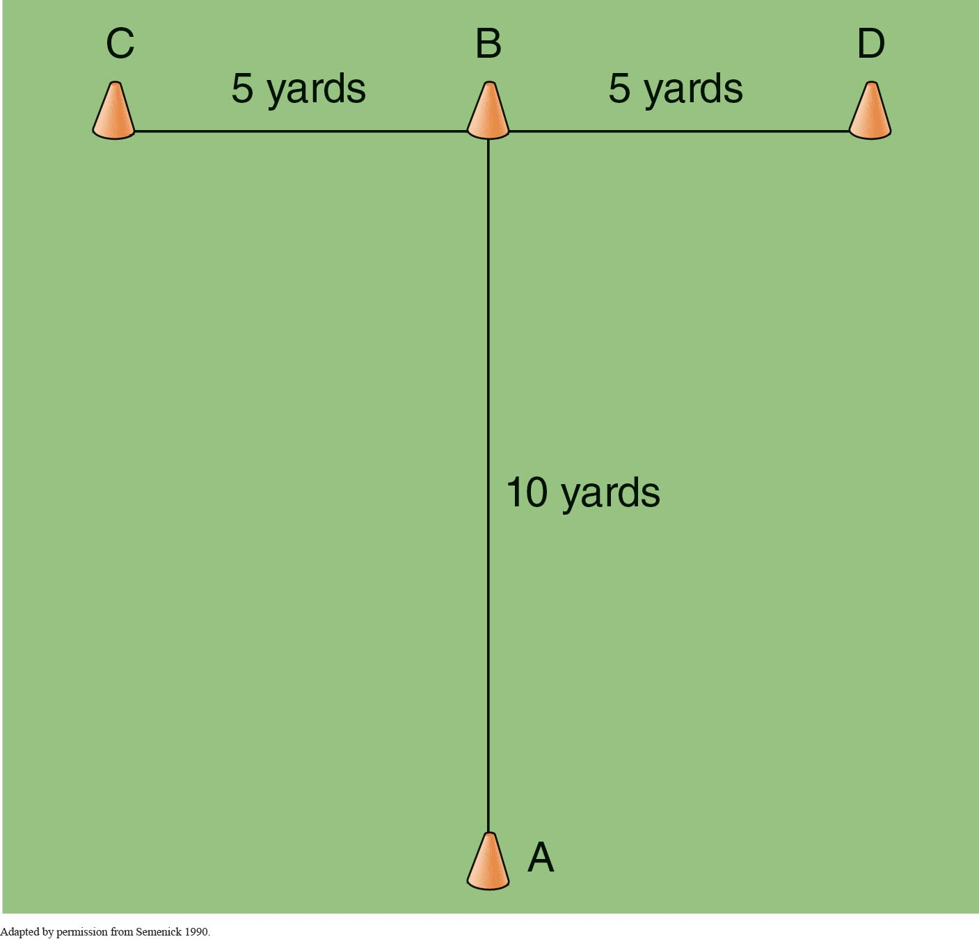

Illinois Agility Test
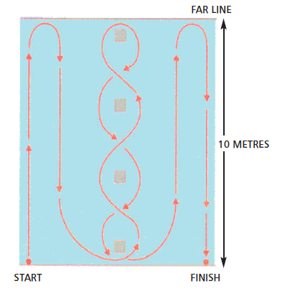

L-Run Agility Test
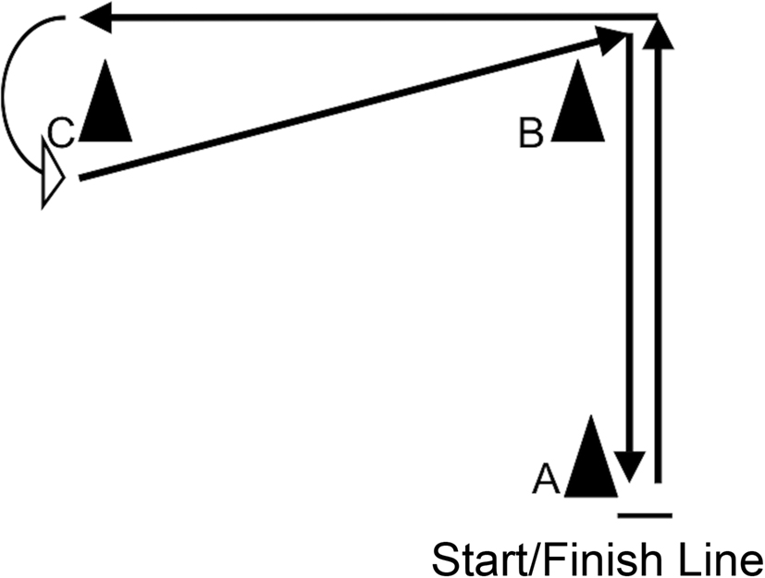

  - Change-of-Direction Ability
An athlete’s measured C-O-D ability
- may vary depending on the demand imposed by the chosen C-O-D test.
Combination of factors that truly determines C-O-D ability:
- the ability to decelerate,
- the ability to reorient the body to face or partially face the direction of intended travel, &
- the ability to explosively reaccelerate.

  - Perceptual-Cognitive Ability
    - Components of Perceptual-Cognitive Ability
      - Visual scanning,
      - Anticipation,
      - Pattern recognition,
      - Knowledge of the situation,
      - Decision-making time & accuracy, &
      - Reaction time.
    - Many of these aspects of development are sport specific.

  - Technical Guidelines & Coaching
    - Visual Focus
  - Athlete should focus on the shoulders, trunk, & hip of the opponent when changing direction in response to an offensive or defensive opponent.
  - Then, the athlete should quickly redirect attention to a new area to help lead the transition of the body.
  - However, in some instances an athlete may have to use deception to camouflage their intended change of direction.

    - Body Position During Braking & Reacceleration
  - Decrease large amounts of trunk motion leading into the deceleration.
  - During the stance phase, reorient the hips toward the direction of intended travel.
  - Body lean is paramount because it allows proper force application through the ground.
  - Enter & exit changes in direction with a lower center of mass.

    - Leg Action
  - Ensure that the athlete can effectively dissipate or tolerate the eccentric breaking loads through an effective ROM at the knee.
  - Avoid a stiff-legged braking style.
  - Emphasize “pushing the ground away,” especially during the performance of closed drills.
  - The athlete should concentrate on the ground instead of a body part.

    - Arm Action
  - The athlete should use powerful arm actions to facilitate leg drive.
  - Ensure that the arm actions do not cause a decrease in speed or efficiency during the transition period between changes of direction.

  - Training Goals
3 Goals of Agility Performance
  - Enhanced perceptual–cognitive ability in various situations & tactical scenarios.
  - Effective & rapid braking of one’s momentum.
  - Rapid reacceleration toward the new direction of travel.

- METHODS OF DEVELOPING SPEED
  - Sprinting
  - Maximum-Velocity Sprinting: is the best exercise to improve running velocity.
  - Sprint technique drills
  - Weightlifting movements
  - Jump training
  - Plyometric training
  - Resisted Sprint Training
  - Assisted Sprint Training

    - Sprint Technique
- is a major limiting factor for running fast.
- makes the motions more fluid, efficient, & faster.
- prevents injuries.

    - Sprint Technique Drills
- Used to break down the sprinting motion into more manageable components.
- Master sprinting skills at slow speed first, then fast speed.
- Transfer the techniques of the parts to the whole.
- Not a substitute for sprinting.
- Performed at much slower velocities than sprinting.
- Do not duplicate sprinting kinematics.
- Would be useful as warm-up exercises.

Categories of drills used to teach sprinting motion:
Arm-Swing Drills
  - important & often overlooked aspect of technique training.
- Arms act in opposition to the legs.
- Prevent upper-body rotation.
- Avoid arms crossing the midline.
- Hands travel from the hip to the shoulder.
- Stretch reflex at the shoulder will recover the arms forward
  - if the arms are driven back forcefully.

Ankling Drills
- Teaches
  - how to lift the feet off the ground.
  - how to put the feet down during sprinting.
- The foot will be driven forward from the hips, &
  - the outside of the forefoot will make contact with the ground & will pull the body over it.
- Casting
  - Refers to dorsiflexing the ankle to ~ 90 degrees while pulling the big toe up.
- Proper foot positioning will minimize:
- time spent on the ground.
- power lost into the ground by providing a more rigid ankle joint.
- injuries that could be caused by improper foot placement.

Heel Kicks
- Designed to
  - build upon the mechanics taught by ankling drills.
- Teaches
  - the athlete to bring the heel to the hip immediately following plantarflexion.

High-Knee Drills
- Helps teach
  - frontside mechanics while reinforcing casting of the foot.
  - frontside running mechanics
    - e.g., high knee, dorsiflexion.
- Also help to condition the hip flexors.

A Drills
- Combine
  - high-knee drills with heel kicks.
- Once the drill is perfected
  - the athlete can begin to alternate between the 2 sides.
- Advanced athletes
  - will perform the drill with a skip.

B Drills
- Combine
  - the A Drill with an active foot strike.
- Teaches
  - how to exert more force against the ground.
  - An advanced sprinting exercise.
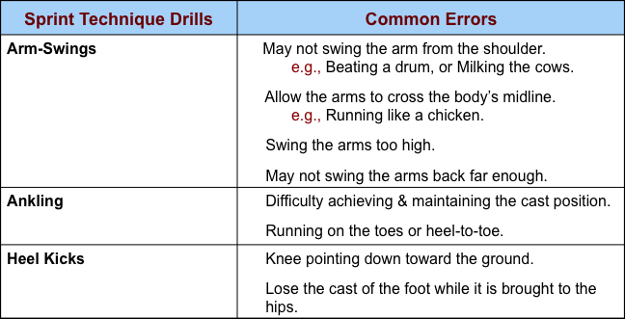
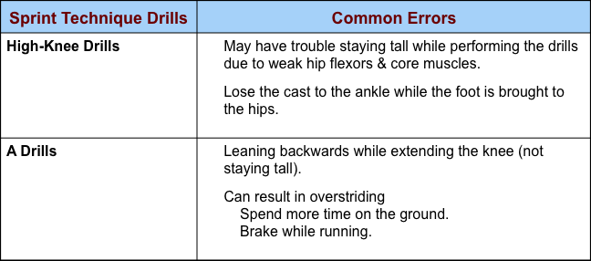
    - Sprint Technique Drill Progressions
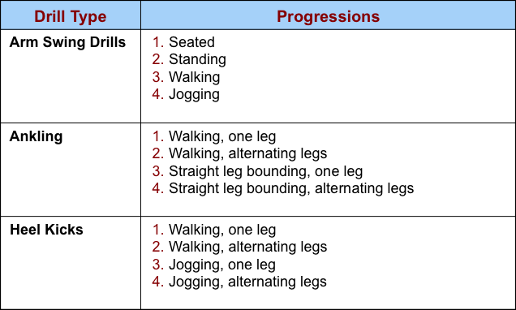
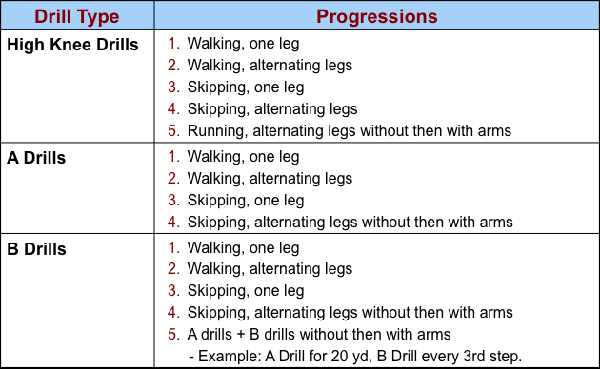
    - Sprint Resistance
- Also called resisted sprints.
- Sprints performed with resistance.
- The sprinting motion is made more difficult.
- Main Objective
  - To use resistive methods without arresting the athlete’s running mechanics, primarily as a means of improving speed-strength & stride length.
- Emphasizes 2 Aspects of Normal Running Mechanics for Desired Training Effect:
  - Explosive arm & knee punching action.
  - Explosive leg drive off the ground.
Theory:
- Recruit more muscle fibers.
- Require more neural activation.
- Over time this will be transferred to nonresisted sprints.
- Leads to an increased speed.

Forms:
- Sled
- Tire
- Harness
- Parachute
- Weighted vest
- Gravity-resisted sprinting
  - Running uphill
  - Running up stairs
  - Upstairs sprinting
  - Upgrade sprinting
  - Running in sand
- Running in water

Guidelines for sprint resistance:
- The resistance should not slow down the athlete by 10% or more.
- Resisted sprints
  - should cover 15 to 20 m.
  - should provide for gradual release to free running for 20 to 25 m.
- Proper sprinting mechanics
  - must be emphasized throughout the exercise performance.
- A ≥ 10% change in external resistance
  - has detrimental effects on movement kinetics, kinematics, & overall technique.
- Too much resistance may alter running kinematics which will:
  - lower running velocity,
  - decrease stride length,
  - increase trunk lean, &
  - increase ground contact.

    - Sprint Assistance
- Also called assisted sprints.
- Sprints performed with assistance.
- Allows the athlete to run faster than his/her normal capability.
- Can improve elastic energy production.
- Main Objective: To provide assistance without significantly altering the athlete’s running mechanics, primarily as a means of improving stride rate.
- Emphasizes 3 Aspects of Normal Running Mechanics for Desired Training Effect:
  - Arm & leg turnover rate.
  - Foot plant directly underneath the hips.
  - Aggressively exploding through the movement in an effort to find “5th gear.”
Theory:
- Allows the athlete’s body to learn how to run at greater stride frequencies.
- This should then transfer to nonassisted sprints.

Forms:
- Gravity-assisted running
  - Downgrade sprinting
  - Downhill sprinting
- High-speed towing
  - Harness
  - Stretch cord
  - Sprinting on a high-speed treadmill

Guidelines:
- Downhill Sprints
  - should be performed on a shallow slope (3 to 7º) to prevent changes in mechanics:
    - excessive stride length.
    - increased braking.
- Towing
  - distances should not cover > 30 to 40 m.
- Speeds
  - should exceed maximum velocity by ≤ 10% (2-3 mph, or 3-5 km/h) to prevent changes in running mechanics.
- Sound technique must be emphasized.

  - Strength
  - Importance of weight training.
  - The transfer of strength improvements to sprinting may require an emphasis on the specificity of training.
    - Select exercises & movements that provide opportunities to display forces & velocities similar to those found in sprinting.
  - Maximal strength & speed-strength qualities.
  - The transfer-of-training effect deals with the degree of performance adaptation & may result from the similarities between the:
    - movement patterns,
    - peak force,
    - RFD,
    - acceleration, & velocity patterns of an exercise & the sporting environment.

  - Mobility
  - is the freedom of an athlete’s limb to move through a desired range of motion, whereas flexibility is a joint’s total range of motion.
  - With an understanding that positional characteristics are among several limiting factors in performance, coaches should ensure that proper postural integrity is in place before practice or competition.
  - Insufficient mobility
    - may limit the sprinter’s position in flight,
    - which will result in misplaced forces, leading to a decrease in sprint speed & an increase in the chance for injury.

  - Table 19.3 – read this material, but the corresponding content in the slides takes precedence:
    - Part 2 - slides 36 to 46.
Type of training | Example exercise modalities | Potential benefits | Potential disadvantages | Practical use suggestion
Assistance training (e.g., overspeed training) | Inclusive of modalities such as rope towing, bungee cord pulls, or downhill running with the intention of allowing the athlete to run at supramaximal speeds | Theoretically, these training tools are used in hopes of exposing the athlete to higher velocities than one can achieve in unassisted sprinting by inducing an increased stride rate. This increased stride rate is hypothesized to have potential for neuromuscular adaptations to increase maxi- mal sprint velocity. | Assisted sprinting may prematurely rush an athlete’s stance phase, thus removing time needed to exert proper forces, and has been shown to result in decreased muscle activation and propulsive force production in comparison to maximal running (55). Therefore what can be described as “chop” steps may often be observed.  Exercises that rely on the towing of athletes may increase braking forces in comparison to maximal running (55) as athletes attempt to tolerate velocities they cannot naturally create or accommodate to as a result of biomechanical efficiency, training state, or both. Downhill sprinting may expose the athlete to unnecessary eccentric forces through a modi- fied stance leg that results from having to “find the ground.” This may also affect the SSC, which is optimized through the foot place- ment occurring just in front of the center of mass upon ground contact in flat-surface upright sprinting (55).  To date, very little research sup- ports the implementation of over- speed training, as sprint success results from an athlete’s ability  to produce large forces in a short ground contact time. | Top-speed sprinting  should be developed  through more natural  and safer training tools  that consider an athlete’s  training status and  support optimal biomechanics.  Coaches should carefully  assess the implications of  assistance modalities  before implementation.
Resistance training | Inclusive of training modalities such as sled towing, wind resistance, incline sprinting, and sled pushing with the intention of improving an athlete’s accelera- tive abilities | Accentuates the biome- chanics of the acceler- ation phase by placing the athlete in a position that promotes lowered torso, hips, and shin angles.  Resisted sprinting may optimize an athlete’s ability to cover short distances quickly by overloading the accel- eration phase, resulting in ground contact times that produce higher propulsive forces. Improving acceleration, which is a change in velocity, may lead to an increase in top speed through enhanced rate of force development. | Sprint efforts against a load that is too great may lead to longer ground contact times in addition to shorter stride lengths that are not task specific (49).  Slopes of incline that are too great may modify proper sprint- ing biomechanics, resulting in rehearsal of improper technique and thus limiting transfer of train- ing effect. Sled pushing may alter the natural sprinting gait cycle due to the removal of arm action that syn- chronizes and counterbalances the leg action occurring at the hip. | Coaches and athletes  attempting to improve the  acceleration phase of a  sprint may adopt  resistance training  modalities that maintain  normal biomechanics  involved in unresisted sprints.  Loads should be chosen  based on the sporting  context while also  considering the athlete’s  physical status. For  instance, track and field  sprinters may use loads  that do not decrease  running velocity by more  than 10% to 12%  (2, 39, 51, 42).  In contrast, field sport  athletes who overcome  external resistance while  blocking, tackling, and  scrimmaging can use  loads 20% to 30% of  body weight to improve  the initial 5-10 m of  movement (20, 42).

- METHODS OF DEVELOPING AGILITY
  - Strength
  - Emphasize relative strength.
  - Emphasize a variety of speed-strength qualities along the force-velocity spectrum.
  - Additional development of eccentric strength.
    - Resistance training
    - Squat jumps
    - Countermovement jumps
    - Drop jumps
    - C-O-D drills
    - Agility drills

- Change-of-Direction Ability

Z-drill to develop multidirectional strength.
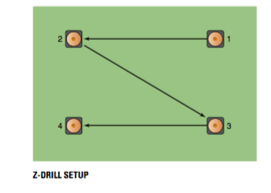

  - Perceptual-Cognitive Ability
  - Agility activities should begin by adding a perceptual-cognitive component (generic stimulus) to common closed skill C-O-D drills such as the Z-drill:
    - a whistle,
    - a coach command, or
    - a flashing arrow or light.
  - Progression to sport-specific stimuli:
    - Evasive drills
    - Small-sided games
  - Generic & specific stimuli within a given agility drill:
    - Increase their difficulty through progressive increases in temporal (time) or spatial (space or area) stress.

  - Tables 19.4 &19.5
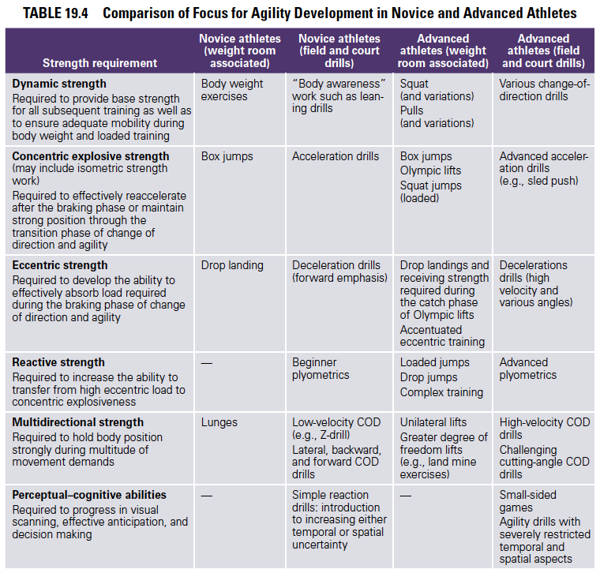
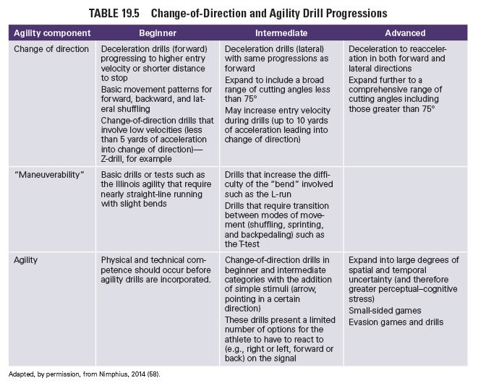

- PROGRAM DESIGN
Periodization
  - process is guided by information collected during the athlete monitoring process.
Individual athlete training responses,
  - which athlete monitoring reveals, should be used in the manipulation of the variables used to design the athlete’s training program.
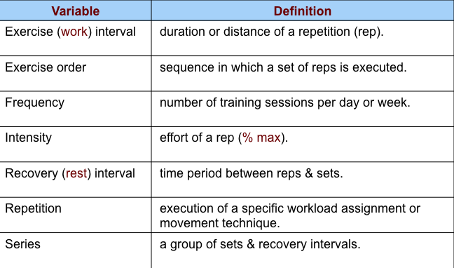
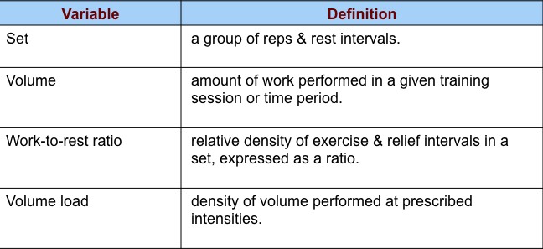
- SPEED DEVELOPMENT STRATEGIES
  - An athlete’s capability to sprint can be improved through the incorporation of training periods that are designed to fully maximize & saturate a fitness quality, which may bolster the effects of future training agendas.
  - Acceleration Hold
    - is a sprint drill for which the coach places a cone on the track near or slightly before the point at which an athlete’s shin typically rises to a vertical position, which is indicative of upright sprinting.
    - the athlete is then instructed to maintain the speed achieved up to the cone through the remainder of the sprint.
  - Example of a 40-m Acceleration Hold
    - a cone is placed at 20 m, which means the athlete can only accelerate up to 20 m.
    - upon reaching the cone at 20 m, the athlete must maintain his or her speed from 20 to 40 m.
  - An acceleration hold
    - is used to begin to focus on improving transitional mechanics as well as a method to introduce speed endurance.
  - Speed-Endurance
    - the ability to maintain maximal movement velocities or repeatedly achieve maximal accelerations & velocities.
    - provides the metabolic conditioning needed to support the maintenance of running speed, C-O-D, & agility over an extended period (6+ seconds) or to achieve maximum acceleration or speed during repetitive sprints. [Baechle & Earle, 2008]
  - Special Endurance
    - The ability to repeatedly perform maximal or near-maximal efforts in competition–specific exercise:relief patterns, commonly called work:rest ratios.
    - Requires 2 qualities:
      - Metabolic power to execute specific techniques at the targeted effort level.
      - Metabolic capacity to do so repetitively.

  - Application of Speed Development Strategies for a 100-m Sprinter on pages 541-542.

  - Monitoring Sprint Ability
Methods of Assessing an Athlete’s Speed
  - A Test of Maximal-Effort Linear Sprinting
    - typically used method.
    - Example: 40-yd dash.
    - based on time to completion, which does not consider an athlete’s progression toward race or field readiness.
  - High-Speed Cameras
  - Optical Timing Systems
    - use interruptions of infrared light to capture data from an athlete’s collective foot strike.

  - Table 19.6 Monitoring Speed Development
- Measure | Description | interpretation
Ground contact time | The total time allotted for a single stance phase. | In general, decreased ground contact times coupled with  improved sprint completion times may suggest that an athlete  has improved the ability to generate high rates of force in a  shorter amount of time. However, an athlete may demonstrate  slightly longer ground contact times at the initial stages of the  sprint due to accelera- tion mechanics.
Step length | The distance between the toe and heel of two consecutive footsteps. Example: centimeters between the  heel of right foot and the heel of left foot. | Improvements in step length (increases in distance covered) may  occur through improved sprint mechanics or posture and  ultimately enhanced force output.
Stride length | The distance between the heel in two consecutive steps of the same foot. Example: meters between the heel of  the right foot and the heel of the next ground contact made by the right foot. | Improvements in stride length (increases in distance covered by  two successive steps) may occur through improved sprint  mechanics or posture, and ultimately enhanced force output.
Flight time | The duration of time that an athlete is not in contact with the ground. This occurs between the end of one  step and the beginning of the subsequent step. | Increases in flight time can be interpreted two ways:  (1) An athlete is producing higher vertical forces over a shorter  amount of time, resulting in proper horizontal displacement of  the athlete’s mass down the track.  (2) An athlete is producing higher forces over a longer amount  of time, which may result in unnecessary vertical amplitude of  the center of mass.
Stride angle | The angle at which the foot leaves the track. | The angle of stride may provide the coach with an ability to  determine if the athlete is producing forces at the right moment,  which is achieved through proper sprint mechanics.  Furthermore, data on the stride angle elucidate what stage of  sprint the athlete is attaining (acceleratory, transitory, maximum  speed) and may relate to ground contact times.
Speed | The relationship between steps and the sum of the first step’s ground con- tact time and the flight time leading to the subsequent ground contact. | Speed dictates how fast an athlete can move the body mass over  a specific distance.
Acceleration | The change in speed as determined by the delta of two steps (e.g., right heel to left heel) and the sum of ground contact times and flight times of each step. | Acceleration provides insight into how well the athlete changes  speed (increasing velocity in a direction) over a pre- scribed  distance. For most athletes, furthering the length an athlete can  accelerate will lead to higher top speed, provided that postural  integrity and mechanics are sound.

- AGILITY DEVELOPMENT STRATEGIES
Periodized Programming Method
  - best method to achieve the development of agility.
Random Programming Method
  - not as effective as periodization.
Sport-Specific Methods
  - not as effective as periodization.
  - e.g.: Small-sided games.

- Recommended Progression for Agility Development
  - Preplanned C-O-D drills
  - Increase the physical demands of the preplanned C-O-D drills
  - Agility drills: are drills with perceptual-cognitive stress.

Maneuverability drills: may be selected depending on the additional movement requirements of the athlete’s sport.

Steps for designing agility design program:
- Perform a needs analysis of the sport & match tests appropriately to assess these qualities.
- Determine strengths & weaknesses by comparing results as a standardized score to performance standards or team mean.
- Plan the development of a primary area of need & a secondary area of need for the athlete.
- Distribute the time available for this development based on need identification.
  - Provide a preliminary plan for transition of percent distribution through the training blocks.

  - Sample Program of Agility Development on page 544.
  - Application of Agility Development Strategies on page 545.
  - Monitoring Agility & Change-of-Direction Ability
- Methods of Assessing C-O-D or Agility Ability
  - Time to Completion of a Test
    - does not isolate the physical quality or perceptual-cognitive quality that one is trying to examine.
  - 3-Dimensional Motion Analysis Equipment
    - used in biomechanics.
  - High-Speed Cameras
    - in combination with the usual hand or electronic timing methods.

  - Table 19.7 Monitoring Agility Development
- Measure | Description | interpretation
Change-of- direction deficit | The difference in time between a straight-line sprint and a change-of-direction test of equal length. | Assessing the COD deficit provides insight into the  additional amount of time required by the athlete due to the  demands of change of direction. An example is subtraction  of 10 m sprint time from 505 change-of-direction time  (a common COD test 10 m in length).
Ground contact time | The total time the foot is in contact with the ground during the change of direction (length of the plant phase). | Assessing the ground contact time in conjunction with other  variables can determine if the athlete is effectively improving  the actual change of direction independent of the total time  required to complete a COD test, which usu- ally requires a  greater percentage of straight-line sprinting.
Exit velocity | The horizontal velocity of the athlete during the initial step out of the plant of the change in direction. Considered the first step of reaccel- eration from toe-off of the plant foot to foot strike of subsequent step. | Unlike the situation for total time, using a high-speed video  camera to assess the velocity of the athlete (at the hip or  center of mass) can give a direct measure of the ability to  change direction. Improved exit velocity in conjunction with  either the same or faster ground contact times implies greater  rate of force development relevant to improving change-of-  direction ability.
Entry velocity | Velocity of the athlete before the plant phase; can be measured over several steps or as the last step is entering the plant phase of the change of direction. | Similar methods can be used by practitioners to assess entry  velocity as suggested for exit velocity. This allows the coach  to understand the demand of the change of direction that  should be considered when tracking the exit velocity.
Decision- making time | Measurement of the time between two events is considered decision- making time and can either be a positive or a negative value. Decision-making time can be broken down into two different orientations to comprehensively assess how ath- letes respond during game scenar- ios: (1) defensive (move in the same direction as the stimulus); (2) offen- sive (move in the opposite direction to the stimulus). | Similar to the measurement of entry and exit velocity, a  high-speed camera can be positioned to the side of the  directional change to capture both the stimulus and the  athlete’s first definitive foot plant to change direction in  response. If the decision-making time is negative, this  indicates that the athlete anticipated the directional change  before the stimulus finalized the movement. Negative  decision-making time is observed only during response to  movements of another person (video or human stimulus),  highlighting the importance of stimulus specificity during  agility protocols. The  measurement of decision-making time in both defensive and  offensive situations allows coaches to identify whether  athletes need to develop perceptual–cognitive ability in a  specific game scenario.

Chapter 20
Program Design & Technique for Aerobic
Endurance Training
(Pages 559 to 581)

- FACTORS RELATED TO AEROBIC ENDURANCE PERFORMANCE
  - Maximal Aerobic Capacity (MAC):
- AKA VO2max. Higher = better.
- Ability to sustain higher velocities may have a higher impact on performance HIIT (high intensity interval training)
  - Lactate Threshold (LT):
- is the speed of movement/ %age of VO2max at which a specific blood lactate concentration is observed.
- is Exercise intensity/ relative intensity at which blood lactate concentration begins to increase above resting/baseline levels
- is the highest O2 consumption/ exercise intensity achieved w/ less than 1.0mM increase in blood lactate concentration above pre-exercise level
- Represents an increasing reliance on anaerobic mechanisms
- Often used as a marker of anaerobic threshold
- Normally begins at 50-60% VO2max in untrained, 70-80% in trained
- In endurance events, best competitor = athlete who can sustain aerobic energy production at the highest VO2max possible without accumulating large amounts of lactic acid in muscle & blood
- Studies show: lactate threshold appears to be a better indicator of aerobic performance than VO2max
  - Maximal Lactate Steady State (MLSS):
- The exercise intensity at [maximal lactate production = maximal lactate clearance]
- Considered by many to be a better indication of aerobic performance than LT & VO2max
  - Onset of Blood Lactate Accumulation (OBLA):
- is a second increase in the rate of lactate accumulation that has been observed at higher relative exercise intensities.
- Onset of blood lactate accumulation occurs when reaching 4.0mM
- Is the exercise intensity at which the blood concentration reaches 4.0mM

  - Exercise Economy
- Measure of energy cost of an activity at given velocity
- High exercise economy = less energy expended
- Better exercise economy = improved maximal aerobic power & lactate threshold
- Ex: Better aerobic endurance performers have slightly shorter stride length & greater stride frequency (compared to less successful athletes)
- Factors that affect exercise economy during cycling: body mass, aerodynamic positioning, cycling velocity
  - Fuel Utilization
- At higher exercise intensity (> than 70%VO2max), Body relies more on CHOs for fuel than fats
- In trained aerobic endurance athletes, fat utilization for energy = greater than untrained
- Benefit of using more fat = greater conservation of muscle & liver glycogen
- Potential limitation during prolonged exercise = CHO availability
- CHO ingestion during exercise = improves endurance performance in events lasting longer than 60min
  - Fiber Type Characteristics
- Type 1 muscle fibers = predominant in endurance athletes
- They have a high capacity for aerobic metabolism
- Have a high mitochondrial density & oxidative enzyme capacity
- Appear critical for endurance athletes
- DESIGNING AN AEROBIC ENDURANCE PROGRAM
  - Aerobic Endurance Training Program Design Variables (5)
  - Step 1: Exercise Mode:
- To improve endurance performance use activities that closely mimic the movement pattern of the sport
- Selecting proper training ensures that proper energy systems are being trained
  - Step 2: Training Frequency:
Depends on:
- Exercise duration & intensity
- athlete’s training status
- specific sport season
Recovery essential = sufficient rest, relaxation, rehydration & post exercise nutrition
Too much training = increase injury risk > 5x per week.
  - Step 3: Training Intensity
- Critical to successful program = regulation of exercise intensity
- Most accurate ways to measure intensity:
- (1) measure oxygen consumption VO2Max %
- (2) Measure blood lactate to see relationship between it & lactic threshold
- Methods used to measure intensity if VO2max unavailable:
- 1-Heart Rate, 2-Ratings of Perceived Exertion (RPE), 3-Metabolic Equivalents,
4-Exercise Velocity, 5-Power measurement
    - Heart rate:
- Most used because close relationship between HR & O2 consumption between 50-90% VO2max
- Most accurate way to regulate intensity with HR = Determine specific HR associated with the desired VO2max % OR determine HR associated with lactate threshold Both require lab testing
- Less accurate means: Karvonen method & percentage of MHR method used without lab
      - Karvonen Method:
Target Heart Rate = ((max HR − resting HR) × %Intensity) + resting HR
      - Percentage of Maximal Heart Rate Method:
= Age – 220 * % of HR desired
      - Do not study Table 20.1 Relationship Between VO₂max, HRR, and MHR.
      - You are not responsible for studying the Target Heart Rate Calculations on page 564.
    - Ratings of Perceived Exertion (RPE):
- Valid monitoring tool for aerobic exercise intensity
- Lab testing needed to ensure accuracy between exercise intensities & RPE scale
- Factors that influence RPE: age, gender, training status, fitness level, listening to music, watching tv, temperature, altitude, nutritional considerations, external feedback
    - Metabolic Equivalents:
Assigning MET values as part of exercise prescription requires athlete’s VO2max
Obtain VO2max by: (1) lab testing (treadmill w/ spirometry), (2) Estimation of VO2max (submax or max testing), (3) field test
    - Exercise Velocity:
Exercise pace can regulate intensity
Involves comparing velocity to recent competition velocities
    - Power Measurement:
- Used in cycling Cause close relationship between metabolic rate & mechanical power production. Ex: power measuring cranks & hubs
- Allows reproducible intensity efforts are independent of environmental conditions unlike HR, RPE, & training velocity
  - Step 4: Exercise Duration:
  - Step 5: Exercise Progression:
General Recommendations:
- Allow 1 active rest/recovery day each week
- Frequency, intensity, and duration should not increase more than 10% each week
- When frequency & duration cant be increased increase intensity
- Monitor progression to prevent overtraining

- TYPES OF AEROBIC ENDURANCE TRAINING PROGRAMS
  - Long, Slow Distance Training (LSD):
- Lower intensity during LSD than competition may be disadvantage if used too much
- Disadvantages: doesn’t train specific energy systems used in competition lead to adaptations in muscle fibers not used in competition
Benefits:
- Enhanced CV & thermoregulatory function.
- Improved mitochondrial energy production.
- Improved oxidative capacity of skeletal muscle.
- Increased utilization of fat as fuel.
- Likely improvement of the lactate threshold intensity.
- Eventual shift of Type IIx fibers to Type I fibers.

  - Pace/Tempo Training:
- Purpose: stress athlete at specific intensity to improve energy production from both aerobic & anaerobic energy systems
- 2 types:
(1) steady state pace: continuous training conducted at equal intensity to lactate thresholds for 20-30min duration
(2) Intermittent pace: AKA tempo intervals, cruise intervals, or threshold intervals. Training session composed of a series of work: recovery periods. Work = shorter, intensity = steady threshold workout. Recovery periods = brief
Benefits:
- Improved running economy.
- Increased lactate threshold.

  - Interval training:
- Should not be performed to until firm base of aerobic training has been achieved
- Very stressful on athlete, should be used sparingly
Benefits:
- Increased VO₂max.
- Enhanced anaerobic metabolism.
- Improved running economy.

  - High-Intensity Interval Training (Refer to textbook & slides for this content.):
- Repeated high intensity exercise bouts interspersed with brief recovery periods
- Athletes need to spend several minutes above 90% VO2max for optimal stimulus
- Short (<45s) & long (2-4min) intervals can be used
- Need proper rest between bouts
- Frequency: 1x per week
- Ex: Intensity: > 90%, interval: 2-3min, rest: <2min
Benefits:
- Improved:
- running speed.
- running economy.
- ventilatory threshold.
- buffering of hydrogen ions.
- utilization of fat as a fuel source
- final kick or push at the end of an aerobic endurance race.

  - Fartlek Training:
- Combo of: LSD, pace/tempo & interval training
- Can be adapted for swimming, cycling
- Ex: easy running (70% VO2max) combined with either: hill work or short fast bursts of running (85-90%) for short time periods
Benefits:
- Likely to:
- enhance VO₂max.
- increase the lactate threshold.
- improve running economy.
- improve fuel utilization.

  - You should be able to distinguish between the types of aerobic endurance training programs according to their frequency, duration, & intensity. Textbook pages: 569-570
  - Also, you should know what these programs may or can improve.

- APPLICATION OF PROGRAM DESIGN TO TRAINING SEASONS
  - Table 20.5 Sport Season Objectives and Program Design Assignments Slide 46
  - Off-Season (Base Training):
- Develop conditioning base
- Frequency: 5-6x per week
- Duration: Long (increase 5-10% per week)
- Intensity: low - moderate
  - Preseason:
- Improve factors important to endurance performance
- Frequency: 6-7x per week
- Duration: moderate - long
- Intensity: moderate - high
  - In-Season (Competition):
- Maintain factors important to endurance performance
- Frequency: 5-6x per week (Training & racing)
- Duration: short training, race distance
- Intensity: low – training, high - distance
  - Post-Season (Active Rest):
- Recovery from competitive season
- Frequency: 3-5x per week
- Duration: short
- Intensity: low

A sound program should include: all types of aerobic endurance training into weekly, monthly, & yearly training schedule
Year round program should be divided into sports seasons with specific goals & objectives to improve performance gradually & progressively

- SPECIAL ISSUES RELATED TO AEROBIC ENDURANCE TRAINING
  - Cross-Training:
- Mode of training used to maintain general conditioning in athletes during periods of recovery from training OR periods of reduced training due to injury
- Possible reduction in overuse injuries
- Multiple event athletes maximize performance in swimming, running & cycling
- Single event athletes (performing another training mode) maintenance of VO2max cross training intensity & duration = primary exercise mode training & duration
  - Detraining:
- Occurs when reduction in training frequency, intensity, duration or stops altogether
- Can be minimized by continuing primary mode of exercise at a reduced intensity & frequency

  - Tapering:
- Systematic reduction of training duration & intensity combined with an increased emphasis on technique work & nutritional intervention
- Objective: to attain peak performance at the time of competition
- Typical tapering period: 7-28 days
- Benefits: helps facilitate recovery & rehydration, Promotes increases in muscle & liver glycogen stores
- Types of tapering models:
- Linear Tapering model: gradual overall decrease in daily training volume throughout duration of taper
- Step Tapering Model: abrupt & considerable reduction (>50%) in training volume that is maintained throughout taper without change
- Progressive Tapering Model: Combo of step & linear model. Rapid 10-15% immediate reduction in training volume, with smaller more gradual reductions in volume at each tier
  - Resistance Training:
- Important & often overlooked for aerobic endurance training
- Research is limited
Possible benefits:
--- Improvement in short-term exercise performance.
  - Faster recovery from injuries.
  - Prevention of overuse injuries.
  - Reduction of muscle imbalances.
- Can improve: hill climbing, bridging gaps between competitors during breakaways & final sprints
  - Altitude:
- Height above sea level: >500m - >5500m
- Acute Altitude Exposure: decrements in performance may begin at altitudes as low as 700m
- Acclimatization: May occur between 12-14 days at moderate alts up to 2300 m, but can take several months
- Recommendations for optimizing endurance at high alts:
- Arrive immediately before competition
- (get) up to 12 weeks of alt exposure (beforehand)
- Training at alt to produce Ergogenic Effect:
- Athletes must be exposed to hypoxic dose of training >/= 12hrs/day for min of 3 weeks at moderate alts of ~2100-2500m
- LIVE HIGH TRAIN LOW (LHTL):
- Common training method using alts
- Live at moderate alts (2000-3000m) and train at sea level
- May provide ergogenic effect

- Laursen, P.B., and Jenkins, D.G. The scientific basis for high-intensity interval training: Optimising training programmes maximising performance in highly trained endurance athletes. Sports Medicine 32(1): 53-73, 2002.
  - Slides 58 to 91 pertain mainly to the content in the review article by Laursen and Jenkins (2002). If you have read this article, it will allow you to understand these slides with greater ease.

- Although you do not have to study the review article by Myburgh (2003), you should read it.
  - Myburgh, K.H. What makes an endurance athlete world class? Not simply a physiological conundrum. Comparative Biochemistry and Physiology Part A 136: 171-190, 2003.

Chapter 5
Adaptations to Anaerobic Training Programs
(Pages 87 to 113)

- For this chapter, concentrate on the content on pages 88 to 97.

  - Table 5.2 Physiological Adaptations to Resistance Training.

- Variable | RT Adaptation
PERFORMANCE
Muscular strength | Increases
Muscular endurance | Increase for high power output
Aerobic power | NC or increased slightly
Anaerobic Power | Increases
RFP (rate of force production) | Increases
Vertical jump | Improved ability
Sprint speed | Improves

Variable | RT Adaptation
MUSCLE FIBERS
Fiber CSA | Increases
Capillary density | NC or decreases
Mitochondrial density | Decreases
Myofibrillar density | NC
Myofibrillar volume | Increases
Cytoplasmic density | Increases
MHC (myosin heavy chain) protein | Increases

Variable | RT Adaptation
ENZYME ACTIVITY
Creatine phosphokinase | Increases
Myokinase | Increases
Phosphofructokinase | Increases
Lactate dehydrogenase | NC or variable
Sodium-potassium ATPase | Increases

Variable | RT Adaptation
METABOLIC ENERGY STORES
Stored ATP | Increases
Stored CP (Creatine Phosphate) | Increases
Stored glycogen | Increases
Stored triglycerides | May increase

Variable | RT Adaptation
CONNECTIVE TISSUE
Ligament strength | May increase
Tendon strength | May increase
Collagen content | May increase
Body density | NC or increases

Variable | RT Adaptation
BODY COMPOSITION
% Body fat | Decreases
Fat-free mass | Increases

  - NEURAL ADAPTATIONS
- May elicit neural adaptations to higher brain centers & all the way to the individual neuromuscular fibers
- Neural adaptations: Central adaptations, adaptions of MUs, neuromuscular junction, neuromuscular reflex potentiation, anaerobic training & electromyography studies
    - Central Adaptations:
Motor cortex activity increases when:
- level of force developed increases
- new exercises or movements are being learned
Anaerobic Training:
- Many changes take place along the descending corticospinal tracts
Untrained individuals:
- Display limited ability to maximally recruit motor units
- Especially fast-twitch fibers
    - Adaptations of Motor Units
Gains in maximal power and strength of agonist muscles generally associated with:
- An increase in recruitment
- An increase in firing rate
- Greater synchronization of neural discharge
- Combo of all three
Size Principle:
Henneman’s size principle: a rule describing the orderly recruitment & decruitment of MUs
Type I Motor Units
Smaller diameter axons
Lower recruitment thresholds
Higher input resistance
More excitable
Typically recruited first
Type II Motor Units
Larger diameter axons
Higher recruitment thresholds
Lower input resistance
Less excitable
Typically recruited after Type 1 MUs
Low-threshold Motor Units:
Recruited first & have lower force capabilities than high-threshold MUs
Typically, to recruit the higher-threshold MUs, you will need to recruit all the low-threshold MUs first
Exceptions exist:
Especially for ballistic, explosive contractions that can selectively recruit high-threshold MUs to rapidly achieve more force & power
With heavy resistance:
All muscles get larger because MUs are recruited in a sequential order by their size to produce high levels of force
In advanced lifters:
CNS might adapt by allowing these athletes to recruit some MUs in a non-consecutive order, by recruiting larger ones first to promote greater power or speed of movement

Adaptations of MUs
- Increased recruitment of motor units.
- Increased recruitment of high-threshold motor units.
- Recruitment of high-threshold motor units at higher firing rates.
- Selective recruitment of fast-twitch (high-threshold) motor units:
  - inhibition of slow-twitch (low-threshold) motor units.
- Increased rate of motor unit firing.
- Increased synchronization of motor units:
  - the firing of 2 or more motor units at a fixed interval.

    - Neuromuscular Junction:
- Most studies examining the adaptability of the NMJ to exercise training have used cardiorespiratory endurance training modes to produce morphological & physiological changes in the NMJ
- The majority of these studies used animals
- Deschenes et al. (1993) examined the effects of high-intensity (HIT) & low intensity (LIT) treadmill exercise training on NMJ in rat soleus muscle.
- Variable | HIT | LIT
Program Duration | 12 wks | 12 wks
Frequency | 5 sessions/wk | 5 sessions/wk
Mode | treadmill running | treadmill running
Speed | 24 m/min | 24 m/min
Grade | 0% to 25% | 0%
Duration | 20 min | 20 min to 90 min
Results:
  - Total area of rat, soleus NMJ: increased by both HIT & LIT
  - Dispersed, irregular-shaped synapses: HIT > LIT
  - Total length of nerve terminal branching: HIT > LIT
  - Average length per branch: HIT > LIT
  - Number of secondary (finer) branches): HIT > LIT
Resistance Training:
  - In contrast, to date, only 1 study by Deschenes et al. (2000) has used resistance training to produce changes in the NMJ of rat soleus muscle.
    - Program duration: 7 weeks
    - Frequency: 3 sessions / week (Monday, Wednesday,& Friday)
    - Load: climbing a 1-m–long ladder set at an 85° angle, with a weight attached to a tail sleeve.
    - Repetitions / session: 10
    - Inter-repetition rest interval: 2 min
    - Progressive overload: 50 g, during the 1st session, to 535 g at the end of the training program.
- In the study, resistance exercise training significantly increased:
  - endplate perimeter length,
  - endplate area, &
  - the dispersion of ACh receptors within the endplate region.

    - Neuromuscular Reflex Potentiation:
- Anaerobic training enhances the reflex response increased reflex potentiation (ex: stretch reflex)
- Thereby enhancing the magnitude & rate of force development

    - Anaerobic Training and Electromyography Studies:
- An increase in EMG
  - indicates greater neural activation.
- Several EMG studies have shown
  - strength & power increases of up to 73%.
- Dramatic increases in neural adaptations take place early in the training program:
  - 6-10 weeks.
- As the duration of training increases, muscle hypertrophy eventually occurs:
  - > 10 weeks.
- The onset of muscle hypertrophy
  - Is associated with a decline in EMG activity.
- Neural factors are especially important for strength gains:
  - in programs that use training intensities > 85% 1RM.
- Higher post-training EMG activity
  - has been observed in training programs designed to improve muscular power.
Cross-Education :
- Training 1 limb can result in an increase in strength & neural activity in the untrained limb
- Greater EMG activity in the untrained limb
Bilateral Deficit :
- Force produced by both limbs contracting < sum of forces produced by the limbs contracting unilaterally
- EMG activity is lower during bilateral contractions
- Is reduced in untrained individuals using bilateral training
Co-contraction of Antagonist Muscles:
- is reduced

  - MUSCULAR ADAPTATIONS
    - Muscular Growth:
Skeletal muscle adaptations to anaerobic training:
  - primarily by increasing its size,
  - facilitating fiber type transitions, &
  - enhancing its biochemical & ultrastructural components.
These changes result in:
- Enhanced muscular strength, power and endurance
Muscular adaptations include :
- Muscular Growth
- Fiber Size Changes
- Fiber Type Transitions
- Structural & Architectural Changes
- Other Muscular Adaptations
Muscle Hypertrophy
  - is primarily due to an increase in the CSA of the existing fibers.
Process of muscle hypertrophy involves an increase in the:
  - net accretion of the contractile proteins actin & myosin within the myofibril.
  - number of myofibrils within a muscle fiber.
  - synthesis of structural proteins such as titin & nebulin.

Proteins responsive to mechanical deformation of muscle:
  - Protein kinase B (Akt) / mTOR pathway,
  - Adenosine monophosphate activated protein kinase (AMPK) pathway, &
  - Mitogen-activated protein kinase (MAPK) pathway

Exercise-Induced Muscle Damage (EIMD) & disruption of myofibrils = Muscular Growth
Caused by proper training stimulus Acute prescription of program training variables
Appropriate training periodization will apply:
- Mechanical Factors: heavy loads, eccentric muscle actions, low-mod training volumes
- Metabolic Factors: low-mod intensity OR moderately high intensity, high volumes & short rest intervals
Alteration of the activity of genes
Acute Anabolic hormone response:
Testosterone & growth Hormone
Down-regulation of inhibitory growth factors: Myostatin
Up-regulation of stimulatory growth factors: IGF-1

Protein Synthesis:
- Is elevated after acute resistance exercise
- Remains elevated for up to 48hrs
Magnitude of Protein Synthesis depends on:
- CHO & Protein intake
- Timing of nutrient intake
- Mechanical Stress of the weight training workout
- Muscle cell hydration levels
- Anabolic Hormonal responses
- Subsequent receptor response
    - Fiber Size Changes
- Resistance training = Increase in both type-1 & type-2 muscle fibers area
- Type-2 fibers have a greater increase in size vs type-1
Relationship between (%) Relative hypertrophy of type-1 fibers & relative intensity (% 1RM) relative intensity accounts for 18% of explained variance (Fry, 2004)
Relationship between (%) Relative hypertrophy of type-2 fibers & relative intensity (% 1RM) relative intensity accounts for 35% of explained variance (Fry, 2004)
    - Fiber Type Transitions
There is a continuum of fiber types: I, Ic, IIc, IIac, IIa, IIax, IIx
Training & activation of high threshold MUs:
Results in transition of type-IIx to type-IIa muscle fibers
Which means that a shift of the of the type of myosin-ATPase & heavy chains takes place during training
Sharon et al. 1994: used a high intensity resistance training program
Results: (1) A significant decrease in type-IIx percentage in men & women
(2) IIx MHCs (myosin heavy chain proteins) were replaced with IIa MHCs early on in training
    - Structural and Architectural Changes
- Resistance training = increase angle of pennation in pennate muscle
- Combo of resistance, sprint & jump training = increase fascicle length of rectus femoris
- Sprint & jump training = increase fascicle length of vastus lateralis muscle
    - Other Muscular Adaptations
Resistance training has shown increases in:
- Myofribrillar volume
- Cytoplasmic density
- Sarcoplasmic Reticulum density
- T-tubule density
- Na-K ATPase activity
Sprint training has been shown to:
- Enhance Calcium release
Heavy resistance training has been shown to:
- Reduce mitochondrial density
Resistance training has shown to:
Decrease capillary density
Increase resting CP & ATP concentrations
Increase glycogen content
High intensity interval training has shown to:
Increase buffering capacity (acid-base balance) by 16-38%

- You do not have to study most of the following content on pages 97 to 110 (see exceptions that follow this list):

  - Table 5.1 Primary Metabolic Demands of Various Sports
  - CONNECTIVE TISSUE ADAPTATIONS
  - ENDOCRINE RESPONSES AND ADAPTATIONS TO ANAEROBIC TRAINING
  - CARDIOVASCULAR AND RESPIRATORY RESPONSES TO ANAEROBIC EXERCISE
  - COMPATIBILITY OF AEROBIC AND ANAEROBIC MODES OF TRAINING
  - OVERTRAINING
  - DETRAINING

- However, you need to study the following content on pages 99, 101, 103, and 104:

  - How Can Athletes Stimulate Bone Formation?
- Select Multi-Joint (MJ) exercises that involve many muscle groups at once
- Select exercises that direct axial force vectors through the spine & hip
- Use the principle of progressive overload to stress the musculoskeletal system
- Use heavy load exercise with ballistic or high impact exercises to expose the bone to different intensities of force
- Vary the exercise selection to change the distribution of force insults & to present a unique stimulus for new bone formation

  - How Can Athletes Stimulate Connective Tissue (ligaments, Tendons, fascia, cartilage) Adaptations?
These recommendations are for ligaments, tendons & fascia
- High intensity loads/exercises should be used because they markedly change the collagen content of connective tissue
- Forces should be exerted throughout the whole range of motion of a joint
- MJ exercises should be used whenever possible
These recommendations are for Cartilage:
- Moderate intensity anaerobic exercise seems adequate for increasing cartilage thickness
- Strenuous exercise doesn’t seem to cause degenerative joint disease when progressive overload is applied appropriately
- Adopt a variety of exercise modalities & ensure that the load is applied throughout the Range of motion to maintain tissue viability

  - Acute Cardiovascular Responses to Anaerobic Exercise:
Magnitude of CV responses depend on:
- Intensity & volume of exercise
- Muscle mass involvement
- Rest period length
- Contraction Velocity

Acute Bout of anaerobic exercise significantly increases CV responses in (all are increased):
- Heart Rate (increases non-linearly, higher in concentric phase vs eccentric) No changes on resting blood pressure though
- Stroke Volume
- Cardiac Output
- Blood Pressure
Heavy resistance training decreases blood flow to the working muscles. Depends on:
- Intensity of resistance
- Length of time of effort (# of sets)
- Size of muscle mass activated
The reason there is a decrease in blood flow to the working muscles is because of the contracted muscle tissues clamping down on capillaries & creating a localized occlusion

Chapter 4
Endocrine Responses to Resistance Exercise
(Pages 65 to 86)

- Read the following textbook content on pages 66 to 72 to fully comprehend the material on pages 72 to 86:
  - SYNTHESIS, STORAGE, AND SECRETION OF HORMONES
  - MUSCLE AS THE TARGET FOR HORMONE INTERACTIONS
  - ROLE OF RECEPTORS IN MEDIATING HORMONAL CHANGES
  - CATEGORIES OF HORMONES
    - Steroid Hormone Interactions
    - Polypeptide Hormone Interactions
    - Amine Hormone Interactions

- Focus your studying on the following topics in this chapter:
  - HEAVY RESISTANCE EXERCISE AND HORMONAL INCREASES
    - The increase in anabolic hormone concentrations observed consequent to the performance of heavy resistance exercise is one signal that can increase hormonal interactions with various target tissues including skeletal muscle. On stimulation of a motor unit by the motor cortex, various signals (electrical, chemical, and hormonal) are sent from the brain and activated muscles to a number of endocrine glands. A key concept is that physiological systems, including the endocrine system, are sensitive to the needs of activated muscle, and therefore the type of exercise protocol conducted will determine the extent of a given system’s involvement.
    - Following a resistance exercise session, remodeling of the muscle tissue takes place in the environment of hormonal secretions and other molecular signaling mechanisms that provide for anabolic actions. However, if the stress is too great, catabolic actions in the muscle may exceed anabolic actions as a result of, among other factors, the inability of anabolic hormones to bind to their receptors or the downregulation of receptors in the muscle tissue
  - MECHANISMS OF HORMONAL INTERACTIONS
    - Fluid Volume Shifts exercise tends to push fluid from the blood to the intercellular compartment
    - Tissue Clearance Rates time spent in a tissue
    - Hormonal Degradation
    - Venous Pooling of the Blood
    - Interactions with Binding Proteins in the Blood
  - These mechanisms interact to produce a certain concentration of a hormone in the blood, which influences the potential for interaction with the receptors in target tissue and their subsequent secondary effects, leading to the final effect of the hormone on a cell. Thus, when one is determining the specific effects of exercise on hormones, one must consider many different interpretations. An increase in hormonal concentrations in the blood is not a prerequisite for seeing gains in muscle size or strength but does represent an increased activation for hormonal release of the endocrine gland involved.
  - HORMONAL CHANGES IN PERIPHERAL BLOOD
  - Various physiological mechanisms interact to produce certain concentrations of hormones in the blood, which influences the potential for interaction with receptors.
  - Peripheral concentrations of hormones in the blood:
  - do not indicate the status of the various receptor populations, or
  - the effects of a hormone within the cell.
  - Hormone secretion
  - Uptake into target tissue receptors
  - Hormonal degradation
  - Circadian pattern
  - Tissue clearance rates
  - Fluid volume shifts
  - Venous pooling of blood
  - Hormone Interactions with binding proteins in the blood

  - ADAPTATIONS IN THE ENDOCRINE SYSTEM
  - Amount of synthesis & storage of hormones.
  - Transport of hormones via binding proteins.
  - Time needed for the clearance of hormones through liver & other tissues.
  - Amount of hormonal degradation that takes place over a given period of time.
  - The amount of blood-to-tissue fluid shift that occurs with exercise stress.
  - The degree of affinity of the hormone for its receptor.
  - The number of receptors in the tissue.
  - The change in the content & in some cases the size of the secretory cells in the gland.
  - The magnitude of the signal sent to the cell nucleus by the H-RC or secondary messenger.
  - The degree of interaction with the cell nucleus.

  - PRIMARY ANABOLIC HORMONES
    - Testosterone
    - is the primary androgen hormone that interacts with skeletal muscle tissue.
    - stimulates growth.
    - increases protein anabolism.
    - develops & maintains male sex characteristics.
    - In men
    - secreted from the testes.
    - In women
    - secreted from the ovaries & adrenal glands.
    - Transport protein
    - sex hormone-binding globulin (SHBG).
    - albumin.
    - Receptor
    - binds to the nuclear androgen receptors in its target tissues.
    - Indirect Effects on Muscle Tissue
    - increases GH release from the pituitary gland, which can influence protein synthesis in muscle.
    - can interact with receptors on motor neurons.
    - can increase the amounts of neurotransmitters.
    - can influence structural protein changes.
    - Direct Effects on Muscle Tissue
    - interacts directly skeletal muscle via the nuclear androgen receptors.
      - Free Testosterone and Sex Hormone-Binding Globulin
      - Free testosterone
      - accounts for only 0.5% to 2.0% of total testosterone.
      - Resistance Exercise: Younger men > Older men.
      - A higher total testosterone concentration
      - allows for the potential of more free testosterone.
      - Free Hormone Hypothesis
      - states that only the free hormone interacts with target tissues.
      - Rosner (1990) suggests
      - that the binding protein for testosterone, SHBG, may act as a hormone with biological activity.
      - Testosterone Responses in Women
      - have 15- to 20-fold lower concentrations of testosterone than men.
      - If acute increases occur after a resistance training workout,
      - they are usually small.
      - However, the testosterone concentration can vary substantially between individual women,
      - as some women secrete higher concentrations of adrenal androgens.
      - Training Adaptations of Testosterone
      - Hakkinen et al. (1988)
      - demonstrated increases in resting serum testosterone concentrations in athletes, even elite weightlifters, over the course of 2 years.
      - Resistance Exercise & Training
      - have shown both increases & decreases muscle androgen receptor content.
      - in general, appears to increase muscle androgen receptor content.

    - Growth Hormone
    - is secreted by the anterior pituitary gland.
    - is also called somatotropin.
    - stimulates growth, protein synthesis & metabolism.
    - exerts its effects on various body tissues directly & indirectly.
    - stimulates insulin-like growth factor-1 (IGF-1).
    - binds to transport proteins called GH-specific binding proteins (GHBP).
    - binds to receptors located in the cell membrane of the target tissue. 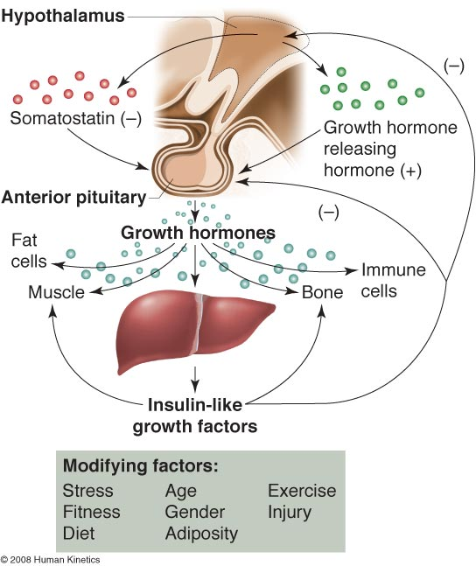
      - Efficacy of Pharmacological Growth Hormone
      - Pharmacological use of GH
      - has unknown & unpredictable results.
      - Review by Rogol (1989)
      - GH treatment alone is not effective in causing strength increases & that total involvement of the total motor unit is probably necessary.
      - Exercise-induced hypertrophy
      - is apparently quite different from the hypertrophy resulting from injections of GH.
      - results in greater force production than occurs with GH injections.
      - Growth Hormone Response to Stress
      - Resistance exercise has been shown to elevate:
      - many of the GH variants.
      - human GH concentration through 30 min post-exercise similarly in men & women (Pierce et al., 1993).
      - GH response depends on
      - load, rest, & volume of resistance exercise.
      - Total Work
      - GH Response
      - Multiple-set protocol > Single-set protocol.
      - Protocols that elicit high blood lactate values
      - tend to produce the most substantial GH responses.
      - Proposal
      - H+ accumulation produced by lactic acidosis may be the primary factor influencing GH release.
      - Growth Hormone Responses in Women
      - Throughout the menstrual cycle
      - Rest: [GH] women > [GH] men.
      - due to greater frequency & amplitude of secretion.
      - GH concentrations & responses to exercise
      - vary with menstrual phase.
      - In response to acute resistance exercise
      - Postexercise: [GH] women = [GH] men.
      - In response to acute aerobic endurance exercise
      - Postexercise: [GH] women > [GH] men.
      - Training Adaptations of Growth Hormone
      - GH response to resistance training
      - little change in single measurements of resting GH concentrations in elite lifters.
      - Typical trends for training-related changes in GH appear to be:
      - a reduction in 22 kDa GH response to an absolute exercise stress.
      - alterations in 22 kDa GH pulsatility characteristics.

    - Insulin-Like Growth Factors
    - are structurally related to insulin.
    - are also called somatomedins.
    - mediate many of the actions of GH.
    - are small polypeptide hormones.
    - IGF-1 (70 amino acids) is studied the most.
    - IGF-2 (67 amino acids).
    - are secreted as they are produced by the liver in response to GH-stimulated DNA synthesis:
    - this process takes about 8 to 24 hours.
    - exist in skeletal muscle as 2 isoforms:
    - IGF-1Ea
    - is similar to the circulating hepatic (liver) IGF-1.
    - MGF
    - is mechano growth factor.
    - are transported in the blood by IGF binding proteins (IGFBPs):
    - IGFBP-1, IGFBP-2, IGFBP-3, IGFBP-4, IGFBP-5, & IGFBP-6.
    - increase protein synthesis in cells.
      - Exercise Responses of Insulin-Like Growth Factors
      - IGF-1
      - has been the primary IGF studied in the context of exercise.
      - has been shown to be responsive to resistance exercise in men & women with lower starting concentrations of IGF, but not with higher starting concentrations of IGF (Kraemer et al., 1985; 1990; 1991).
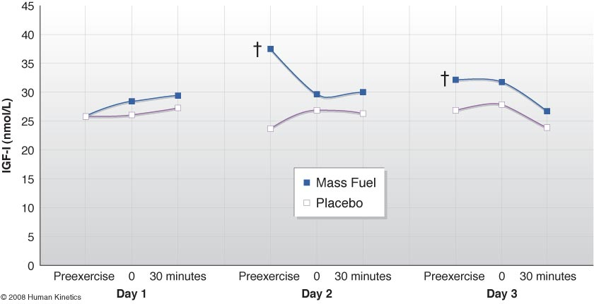
Protein-CHO supplementation before & during the 1-hr recovery period
      - Training Adaptations of Insulin-Like Growth Factors
      - Responses of IGF-1 to heavy resistance training:
remain unclear.
      - Changes in IGF-1 appear to be based on the starting concentrations before training:
      - Low basal concentrations
        - IGF-1 increases.
      - High basal concentrations
        - IGF-1 decreases.

  - ADRENAL HORMONES
    - Cortisol
      - Role of Cortisol
      - is a primary signal hormone for carbohydrate metabolism.
      - converts amino acids to carbohydrates
        - gluconeogenesis.
      - increases the level of proteolytic enzymes.
      - stimulates protein degradation.
      - inhibits protein synthesis.
        - inhibits amino acid incorporation into proteins.
      - promotes the use of fat.
        - stimulates lipolysis in adipose cells.
      - accounts for about 95% of all glucocorticoid activity.
      - effects are mediated through interactions with glucocorticoid receptors.
      - Circulates in the blood:
        - freely (10%),
        - bound to albumin (15%), &
        - bound to corticosteroid-binding globulin (75%).
      - Resistance Exercise Responses of Cortisol
      - Resistance Exercise
      - Protocols using high volume, large muscle groups, & short rest periods result in increased serum cortisol values.
      - Acute increases of cortisol may contribute to the muscle tissue remodeling.
      - Resistance Exercise Training
      - has shown inconsistent patterns of cortisol secretion in men & women.
    - Catecholamines
      - Role of Catecholamines
      - Increase force production via central mechanisms.
      - Increase metabolic enzyme activity.
      - Increase muscle contraction rate.
      - Increase blood pressure.
      - Increase energy availability.
      - Increase blood flow.
      - Augment secretion rates of other hormones such as testosterone.
      - Training Adaptations of Catecholamines
      - Training protocols must be varied to:
      - allow the adrenal gland to engage in recovery processes.
      - prevent the secondary responses of cortisol, which can have negative effects on the immune system & protein structures.

  - How Can Athletes Manipulate the Endocrine System with Resistance Training? (Page 85)
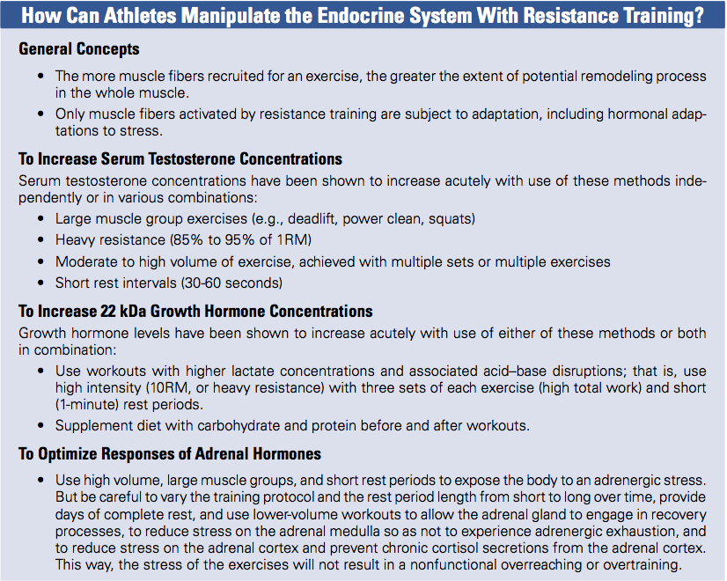
  - Do not study OTHER HORMONAL CONSIDERATIONS

- Kraemer, W.J., and Ratamess, N.A. Hormonal responses and adaptations to resistance exercise and training. Sports Medicine 35(4): 339-361, 2005.

  - Content from the review article by Kraemer and Ratamess (2005) is important and has been included in some of the PowerPoint slides for Chapter 4.
Acute Responses of Testosterone to Resistance Exercise
- Intensity & Volume
  - Moderate load, high volume, short rest periods (bodybuilding program) has been shown to produce greater acute testosterone responses than high load, low volume, long rest periods (traditional heavy resistance training program) [Kraemer et al. 1990, 1991].
Acute Responses of Growth Hormone to Resistance Exercise
- In men
  - Moderate- to high-intensity, high volume programmes (bodybuilding program) using short rest periods have shown the greatest acute GH response compared with high-intensity, low repetition programmes using long rest intervals (conventional strength or power training) [Kraemer et al., 1990; 1991].
- Kraemer et al. (1990)
  - Subjects: 9 healthy males.
  - Age: 24.66 ± 4.27 yrs.
  - Height: 178.4 ± 7.77 cm.
  - Body mass: 81.08 ± 12.03 kg.
  - Resistance training experience: recreational.
  - Exercise: 6 different heavy resistance exercise protocols.
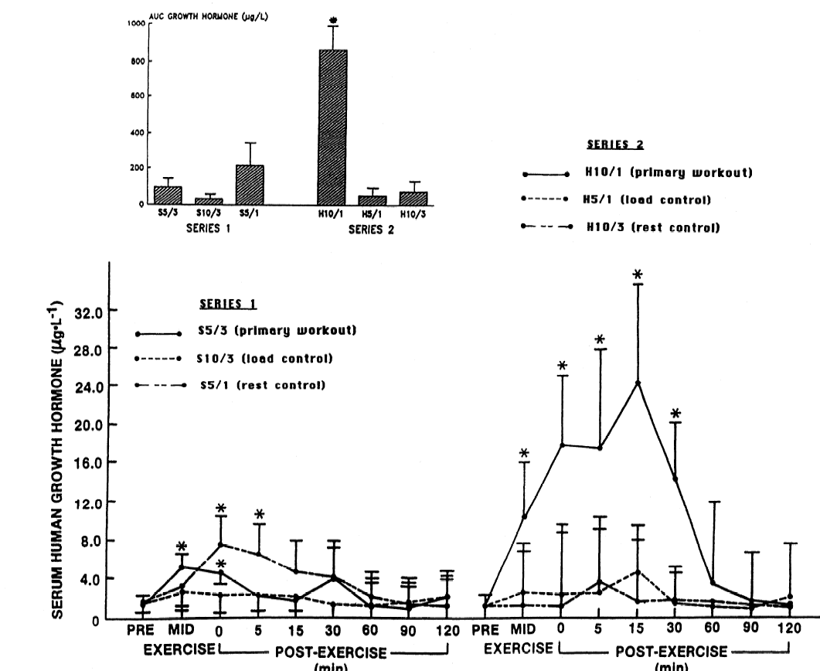

Growth Hormone Responses in Women
- Kraemer et al. (1993)
  - Subjects: 9 healthy females.
  - Age: 24.1 ± 4.3 yrs.
  - Height: 161.6 ± 7.6 cm.
  - Body mass: 63.4 ± 11.9 kg.
  - Resistance training experience: recreational.
  - Exercise: 6 different heavy resistance exercise protocols.
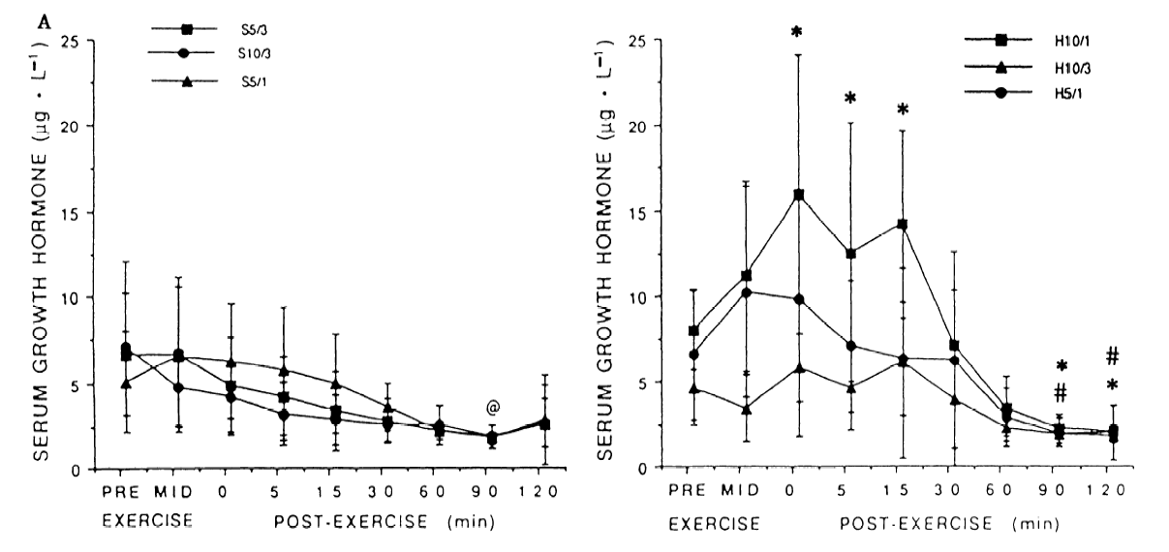
  - If you are having difficulty comprehending some of the slides refer to the introduction of this review article, and the sections discussing the following hormones:
    - Testosterone
    - Growth Hormone
    - Insulin-Like Growth Factors
    - Cortisol
    - Catecholamines
Regulation of Skeletal Muscle Mass
(PowerPoint Slides 1 to 53)

- What factors can influence the size or mass of skeletal mass?
  - Nutrition: type & amount of amino acids, protein digestive properties, timing of nutrient intake in relation to exercise, timing of nutrient intake in relation to other nutrients and total energy intake
  - Resistance Exercise Training: insulin-like growth factor I (IGF-I) and growth and differentiation factor 8 (GDF-8), play a role in the hypertrophic adaptation of muscle to heavy-resistance strength training. Heavy strength training increases the gene expression of IGF-I, decreases the gene expression of GDF-8 in the skeletal muscle of young adults
  - Genetics,
  - Hormones, &
  - Growth & Differentiation Factors.

- What proteins may play a role in the hypertrophic adaptation of muscle to resistance strength training?
  - GDF-8 most commonly called myostatin, negative growth regulator
  - IGF-I, positive growth regulator
- What is myostatin?
  - is a member of the transforming growth factor beta (TGF-β) superfamily of secreted growth & differentiation factors that is essential for proper regulation of skeletal muscle mass.
  - Regulation of embryonic development.
  - Maintain homeostasis of tissues in adult animals.
- Is myostatin conserved across species?
  - GDF-8 is found in several species; mice, rats, cattle, humans, etc.
- Where is myostatin expressed in the body?
  - Large amounts in skeletal muscle, very small amounts in adipose tissue
- What are the main results and conclusions of the McPherron et al. (1997) study?
GDF-8/Myostatin is:
  - Secreted molecule.
  - Conserved across species.
  - Mainly expressed in skeletal muscle.
  - Loss of this factor
  - increases the mass of tissues producing this factor, in particular, skeletal muscle.
  - The increase in skeletal muscle mass is due to
  - hypertrophy & hyperplasia.
  - The results suggest that
  - it functions specifically as a negative regulator of skeletal muscle mass during development & growth.
- What was demonstrated in studies that followed the landmark study by McPherron et al. (1997)?
  - myostatin is synthesized in skeletal muscle.
  - myostain secretion (release) is required throughout development (before & after birth) and during adulthood.
  - myostatin regulates skeletal muscle mass from development to adulthood.
  - mutations in the myostatin gene of several cattle breeds exist.
  - blood concentrations of the myostatin protein are increased in HIV-infected men.
  - the injection of an antibody that binds to myostatin in adult mice blocks its signal, resulting in an increase in muscle size.
  - blocking or inhibiting the myostatin signaling pathway may be useful for the prevention or treatment of obesity & type 2 diabetes.
- What are the possible applications of myostatin, especially with respect to musculodegenerative diseases and resistance training?
  - The development of drugs that block the signaling pathway of myostatin (GDF-8) may be used to treat a variety of musculodegenerative diseases:
  - Muscular dystrophy,
  - Neuromuscular diseases, &
  - Cachexia.
- What are the historical aspects of the Belgian Blue and Piedmontese breeds of cattle?
  - Belgian Blue breed originally resulted from cross-breeding Dutch Friesans & English Shorthorns with native cattle around 1850.
  - These breeds are also known as double-muscled cattle.
  - Double-muscled cattle provide large cuts of low-fat meat that are characteristically tender.
  - Piedmontese are believed to have resulted from the fusion of Zebu & Aurochs cattle followed by 25,000 years of evolution.
- Do myostatin mutations exist in humans?
  - Yes, a former professional athlete gave birth to a son. Stimulus-induced myoclonus developed several hours after birth. He appeared extraordinarily muscular. He continued to have increased muscle bulk & strength at the age of 4.5 years. Was able to hold two 3kg dumbbells in horizingtal suspension with his arms extended. Identified a myostatin mutation in this child which provides strong evidence that myostatin does play an important role in regulating muscle mass in humans.
- What were the main results of Roth et al.’s (2003) study?
  - a 37% decrease in the expression of the myostatin gene was observed in the skeletal muscle of sedentary, healthy, young & elderly humans (men & women) after they had completed a 9-week heavy-resistance training program by performing knee extensions using a resistance machine 3 days per week
  - Furthermore, there were no significant relationships observed between myostatin expression & muscle strength or volume.
  - The small number of subjects in this study may partly explain the lack of a correlation between these variables.
- What were the results and conclusions of the Whittemore et al. (2003) study?
  - These researchers developed an antibody that inhibits or blocks the effects of myostatin and injected it into adult mice of varying ages for 2 to 15 weeks.
  - They noticed that mice treated with the myostatin inhibitor gained 10% more weight than the control mice.
  - Also, 13% to 30% increases in the skeletal muscle mass were observed in the antibody-treated mice.
- In the Whittemore et al. (2003) study, what contributed to the muscle hypertrophy, muscle fiber hypertrophy and/or hyperplasia?
  - Also, the skeletal muscle hypertrophy observed in the antibody-treated mice was the result of muscle fiber hypertrophy only.
  - Finally, the grip strength of the antibody-treated mice was greater than that observed in the control mice.

Chapter 11
Performance-Enhancing Substances & Methods
(Pages 225 to 248)

- TYPES OF PEFORMANCE-ENHANCING SUBSTANCES
  - Definition of Products That Can Be Sold as Dietary Supplements
- A product (other than tobacco) intended to supplement the diet that contains one or more of the following dietary ingredients:
  - a vitamin,
  - a mineral,
  - an herb or other botanical,
  - an amino acid,
  - a dietary substance for use by humans to supplement
the diet by increasing the total dietary intake, or
  - a concentrate, metabolite, constituent, extract or combination of any ingredient identified above.
- The product must also be intended for ingestion & cannot be advertised for use as a conventional food or as the sole item within a meal or diet.

  - Do not study Figure 11.1 The 2013-2014 NCAA Banned Drug Classes
- HORMONES
  - Anabolic Steroids
The synthetic derivatives of the male sex hormone, testosterone.
    - Dosing
- Stacking Regimen
  - typically used by athletes.
  - they administer several different drugs simultaneously.

- Rationale for Stacking
  - The potency of one anabolic agent may be enhanced when it is consumed simultaneously with another anabolic agent.
- Use both oral & injectable compounds.
- Cyclic pattern of anabolic steroid use:
  - Pyramid (Step-Up) Pattern
    - Dosages are steadily increased over several weeks.
  - Steps-Down
    - To reduce the likelihood of negative side effects.
    - Discontinue drug use or initiate another cycle of different drugs that may increase endogenous testosterone production.
- Typical Anabolic Steroid Regimen
- Average # of agents
  - 3.1.
- Typical Cycle Duration
  - 5 to 10 weeks.
- Dose Administered
  - 5 to 29 times greater than physiological replacement doses.

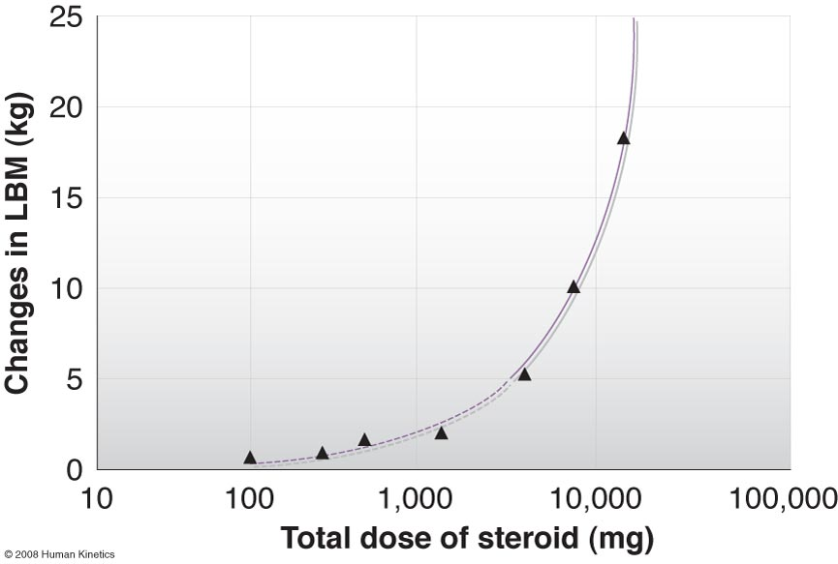
Dose-Response Curve of Anabolic Steroids & Change in Lean Body Mass

    - Who Uses Anabolic Steroids?
    - Olympic athletes
    - Professional athletes
    - Collegiate athletes
    - High school athletes
    - Strength athletes
    - Bodybuilders
    - Individuals outside organized sport
  - use steroids to enhance appearance.

    - Efficacy (Ergogenic Benefits)
      - Muscle Mass and Strength
Increased muscle mass and strength
People with “Muscle Dysmorphia” (also called reverse anorexia nervosa) refers to a subset of bodybuilders with an altered self-image
      - Athletic Performance
  - Significant strength gains have been consistently reported in experienced resistance-trained athletes that have been administered exogenous androgens.
  - The strength gains in strength-trained athletes using anabolic steroids may be 2- to 3-fold higher than those typically observed in similarly trained athletes who are not using anabolic steroids.
      - Physiological Effects
      - Increases in aggression.
      - Hostility
      - Depression.
      - Elevations in arousal & self-esteem.
      - Mania.
      - Associated with mood swings & psychotic episodes.
      - Psychosis
      - may occur in some susceptible individuals.
      - Adverse Effects
        - Study slides 36 to 37 in Part 1 rather than Table 11.2 in the textbook.
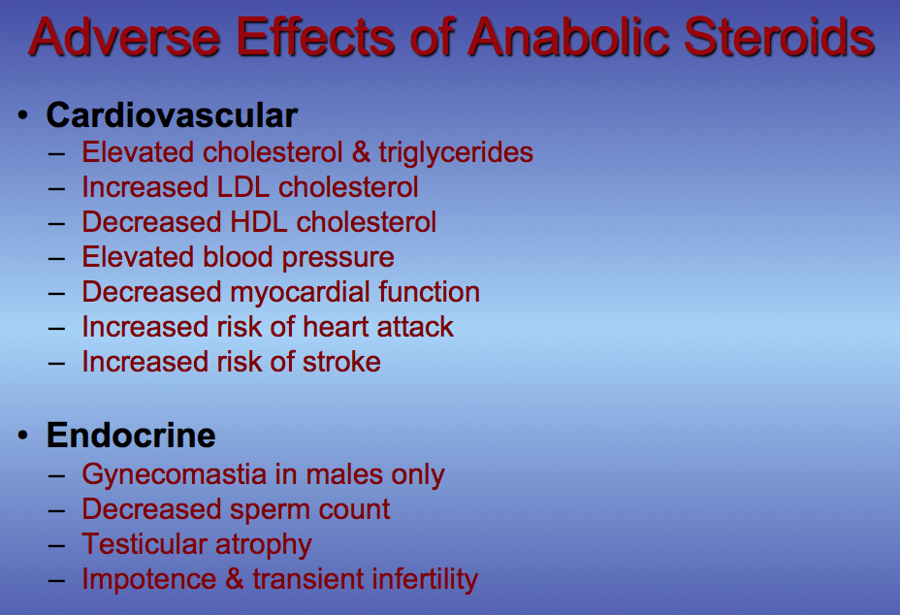
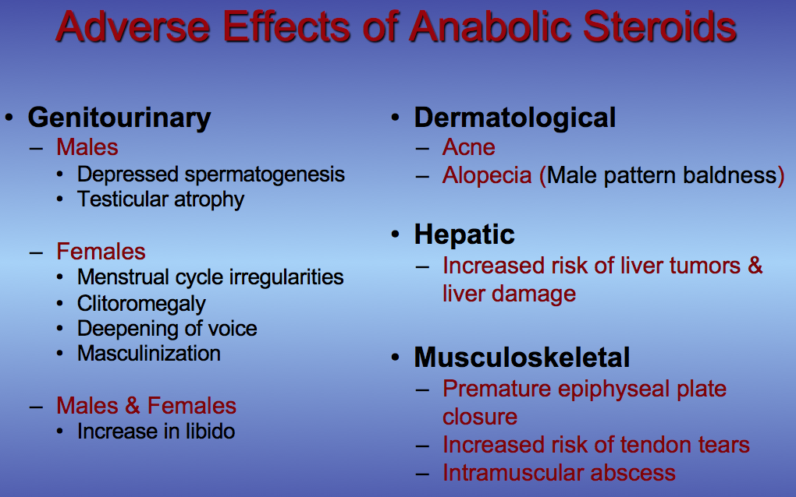

  - Testosterone Precursors (Prohormones)
    - Part 1: slides 38 to 54.
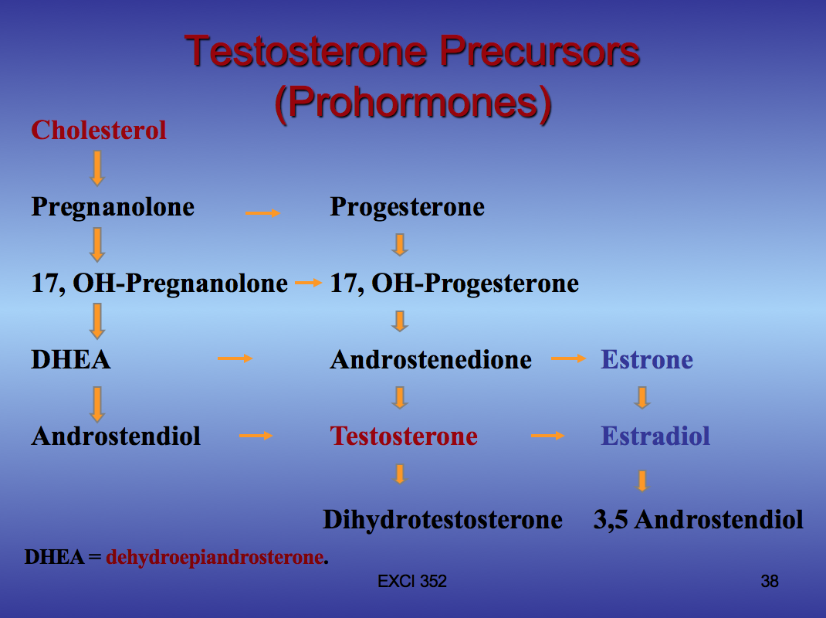
Supplement Manufacturer’s Marketing Claims for Prohormones
- Improve blood testosterone concentrations.
- Increase muscular strength.
- Increase muscle mass or size.
- Help reduce body fatness.
- Improve sexual performance.
Prohormones
- Structurally similar prohormones:
  - 4-Androstenedione
  - 4-Androstenediol
  - 5-Androstenedione
  - 5-Androstenediol
  - 19-Nor-4-Androstenedione
  - 19-Nor-4-Androstenediol
  - Dehydroepiandrosterone (DHEA).
Androstenedione Supplementation
- In 1962
  - Mahesh & Greenblatt examined the effects of oral androstenedione supplementation in 2 women.
  - After ingesting 100 mg of androstenedione, there was a 4- to 7-fold increase in blood testosterone concentrations in the women.
- Studies by Kicman et al. (2003) & Brown et al. (2004):
  - demonstrate that blood testosterone concentrations of women are increased greatly after the oral consumption of 100 & 300 mg of androstenedione.
  - the blood testosterone concentrations observed were similar to those encountered in the abuse of testosterone for the purpose of increasing muscle mass & strength.
- Horton & Tait (1966)
  - demonstrated that with intravenous administration of androstenedione & testosterone:
    - women preferentially convert androstenedione into testosterone.
    - men preferentially convert testosterone into androstenedione.
- In December 1996
  - it became available for over-the-counter (OTC) sales in the United States.
- were promoted as a natural way to help increase muscle strength & muscle mass.
- were promoted to combat the effects of the aging process in older men.
- In 1998
  - use by youngster’s increased 5-fold after a pro baseball player named Mark McGwire admitted using it.
- March 11, 2004
  - The FDA pronounced that dietary supplement products containing androstenedione were adulterated new dietary ingredients under the DSHEA of 1994.
- Result of the FDA’s Pronouncement
  - Retailers, manufacturers, & distributors ceased to sell products containing androstenedione.
- Anabolic Steroid Act of 2004
  - The Controlled Substances Act was amended to include androstenedione to the list of the updated list of schedule III drugs.
- Tables 1 & 2
  - summarize the results of many prohormone studies.
  - several important observations are evident with respect to oral androstenedione supplementation in healthy men of various ages.

Table 1
- The majority of studies indicate that
  - acute or chronic oral androstenedione supplementation at single doses of at least 100 mg leads to increased androstenedione concentrations in the blood of healthy young, middle-aged, and older men.
- Very few studies have shown
  - an increase in the concentration of testosterone in the blood of healthy men after chronic oral androstenedione supplementation.
- Increases in blood testosterone levels have been observed at a
  - multiple 100-mg dose (Brown et al., 2000a).
  - single 300-mg dose (Leder et al., 2000).
- However, the testosterone increases that have been observed
  - are moderate.

Table 2
- Chronic oral androstenedione supplementation:
  - resulted in a significant, yet abnormal, increase in the measured concentration of the estrogens, estrone & estradiol, in the blood of healthy young, middle-aged, & older men.
- Chronic oral androstenedione supplementation:
  - has been shown to decrease the concentration of HDL cholesterol in the blood of healthy young, middle-aged, & older men, which effectively increases the risk for cardiovascular disease.
  - has no effect on body composition, muscle size, & muscle strength in healthy men of various ages.

Potential Side Effects of Chronic Oral Androstenedione Supplementation
- Chronic use of androstenedione may increase the risk of developing the following conditions:
  - Cardiovascular disease,
  - Impaired liver function,
  - Gynecomastia (breast growth) in men,
  - Breast cancer in women,
  - Pancreatic cancer in men,
  - Prostate cancer in men.

Contamination of Androstenedione Dietary Supplements
- Catlin, D.H., B.Z. Leder, B. Ahrens, B. Starcevic, C.K. Hatton, G.A. Green, & J.S. Finkelstein.

- Trace contamination of over-the-counter androstenedione and positive urine test results for a nandrolone metabolite.
- This study suggested that trace contamination of androstenedione with 19-norandrostenedione is sufficient to cause urine test results positive for:
- 19-norandrosterone, the major but inactive metabolite of nandrolone.

  - IOC cutoffs for 19-norandrosterone:
  - Males = 2 ng/mL.
  - Females = 5 ng/mL.
- Of the 7 brands of androstenedione analyzed at the 1% level:
  - 1 contained no androstenedione,
  - 1 contained 10 mg of testosterone,
  - 4 more contained 90% or less of the amount of androstenedione stated on the label.
  - Therefore, some androstenedione brands were grossly mislabeled.
  - Human Chorionic Gonadotropin (HCG)
  - is a hormone obtained from the placenta of pregnant women.
  - is very closely related in structure & function to luteinizing hormone.
  - injected into men can increase testicular testosterone production.
  - is primarily used by athletes who are finishing a cycle of anabolic steroids.
  - is supposed to stabilize the T/E.

  - Insulin
  - is a potent, anabolic, peptide hormone.
  - facilitates the uptake of glucose & amino acids into the cell.
  - increases protein synthesis.
  - cannot be detected in the urine.
  - rumored to potentiate the effects of GH & IGFs.
Possible Outcome in Previously Healthy Athletes
  - immediate death, coma, or development of insulin-dependent diabetes.

  - Human Growth Hormone (HGH)
  - Stimulates bone growth.
  - Stimulates skeletal muscle growth.
  - Maintains blood glucose concentration.
  - Increases the uptake of glucose & amino acids into muscle cells.
  - Stimulates the release of fatty acids from the fat cells.
    - Efficacy
    - There appear to be no studies on the efficacy of HGH in athletic populations.
    - HGH Replacement Therapy
    - GH-deficient adults or children.
    - Increases in lean body tissue.
    - Decreases in body fat.
    - Anecdotal reports
    - suggest impressive musculoskeletal performance changes in athletes using HGH.
    - Adverse Effects
    - Potential Health Risks
    - Gigantism
    - Excessive secretion of GH during childhood.
    - Acromegaly
    - Excessive secretion of GH, after puberty, once linear growth has ceased.
    - Widening of bones, arthritis, organ enlargement, & metabolic abnormalities.
    - Adverse Side-Effects for HGH Abuse
    - Diabetes in prone individuals.
    - Cardiovascular dysfunction
    - Muscle, joint, & bone pain
    - Hypertension
    - Abnormal growth of organs
    - Accelerated osteoarthritis
    - Detection of Illicit HGH Use
      - Part 2: slides 8 to 11.
- World Anti-Doping Agency (WADA)
  - prohibits the use of HGH both in- and out-of-competition.
- Test to Detect HGH Abuse
  - was 1st introduced at the 2004 Summer Olympic Games in Athens, Greece.
  - is a blood test.
  - involves the use of immunoassays (antibodies) that preferentially recognize pituitary HGH (pHGH) & recombinant HGH (rHGH).
- Test to Detect HGH Abuse
  - allows the quantification of the 22 kDa isoform that is derived from rHGH.
  - allows the quantification of the other isoforms derived from naturally occurring HGH, pHGH.
  - when rHGH is administered, the secretion of HGH from the pituitary gland is inhibited:
    - as a consequence, the ratio of 22 kDa to total GH increases.
    - this occurs because of an increase in the concentration of the 22 kDa isoform & a reduction in the concentrations of the non-22-kDa isoforms.
Direct Isoform Method
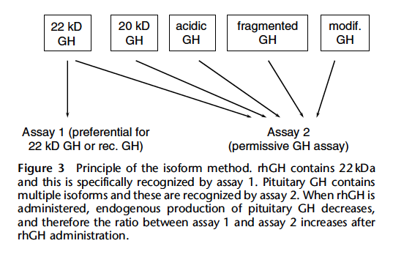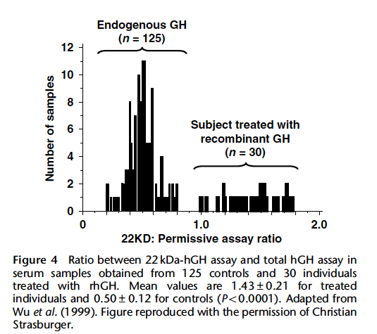

Methods Used to Elevate the O₂-Carrying Capacity of the Blood
  - Erythropoietin (EPO)
  - is a protein hormone produced in the kidneys that stimulates the production of new RBCs.
  - can be produced by recombinant DNA technology.
  - level increases in response to aerobic endurance training.
  - is used to treat certain types of anemia.
  - Injections of EPO for 6 weeks in normal men:
  - Elevated hematocrit,
  - Elevated of hemoglobin concentration,
  - Increased aerobic capacity,
  - Improved time to exhaustion,
  - Enhanced oxygen-carrying capacity.
  - Primary Risk of EPO
  - Its lack of predictability.
  - Health Risks
  - Increased blood viscosity.
  - Increased risk of blood clotting.
  - Increased risk of heart attack or stroke.
  - Increased risk of cerebral or pulmonary embolism.
  - Elevated systolic blood pressure.

  - B-Adrenergic Agonists
  - are substances chemically related to epinephrine.
  - originally developed for the treatment of asthma.
  - Effects
  - have been shown to increase lean mass & decrease stored fat.
  - Examples
  - Clenbuterol
  - Cimaterol
  - Ractopamine
  - Potential Side Effects
  - Transient tachycardia, hyperthermia, tremors, dizziness, palpitations, & insomnia.

  - B-Blockers
  - are a class of drugs that block β-adrenergic receptors.
  - prevent the attachment of catecholamines to these receptors.
  - are generally prescribed to treat a wide variety of CVDs.
  - Proposed Ergogenic Benefit
  - Reduce anxiety & tremors during performance.
  - e.g., marksmen, or archers.
  - Several Studies
  - have shown that they can improve both slow & fast shooting accuracy.
  - Ergolytic Effect
  - Impair CV response to exercise by reducing maximal heart rate, oxygen consumption, & 10 km race time performance.
  - Risks
  - Bronchospasms
  - Heart failure
  - Prolonged hypoglycemia
  - Bradycardia
  - Heart block
  - Intermittent claudication
- DIETARY SUPPLEMENTS
  - Essential Amino Acids (EAA)

  - Isoleucine
  - Leucine
  - Valine
  - Lysine
  - Histidine
- Methionine
- Phenylalanine
- Threonine
- Tryptophan

  - The consumption of EAA before & after resistance exercise augments muscle protein synthesis in healthy human subjects.
  - Amount of Protein Consumption
  - 6-12 g of EAA, which is equivalent to 10-20 g of a high quality (complete) protein source.
  - Timing of Protein Consumption
  - 30 to 60 minutes before exercise, or
  - within the first 2 to 3 hours after exercise, or
  - both.
  - Consumption of Carbohydrate with Protein Before Exercise
  - Tipton et al. (2001).
  - Consumption of 6 g EAA + 36 g sugar before or after resistance exercise.
  - The anabolic response was 158% greater when EAA + sugar was consumed 30 min before resistance exercise than when it was consumed after exercise.
  - Branched-Chain Amino Acids (BCAAs)
  - are isoleucine, leucine, & valine.
  - are responsible for increasing muscle protein synthesis (MPS) & it appears that leucine is the key amino acid for stimulating MPS through increased activation of the Akt/mTOR pathway in skeletal muscle (see figure on next slide).
  - 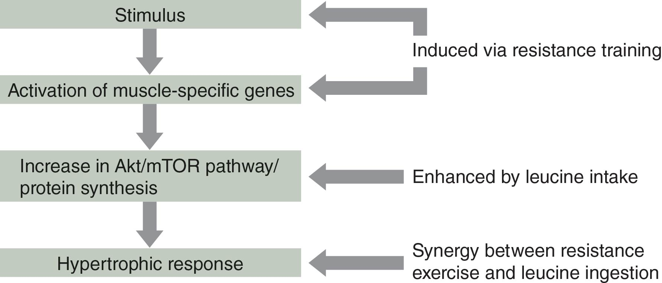
  - Arginine
  - is a conditionally essential amino acid.
  - is required for the synthesis of protein & creatine.
  - metabolism results in the production of nitric oxide.
  - Nitric oxide (NO)
  - which is increased during exercise, is important physiologically because it is essential for vasodilation.
  - Claims Often Attributed to Arginine Supplementation
  - Ability to elevate nitric oxide levels
  - Increase in muscle blood flow
  - Improves exercise performance
  - The scientific evidence does not support
  - any of these claims that are directed to athletes & physically active individuals.

  - B-Hydroxy-B-Methylbutyrate
  - is a derivative of the EAA leucine & leucine’s metabolite alpha-ketoisocaproate.
  - Evidence
  - shows that HMB stimulates protein synthesis & decreases protein breakdown.
  - Limited Research
  - previously untrained subjects.
  - 4 to 8 weeks of resistance training.
  - the group of subjects using HMB demonstrated significantly greater improvements in strength & LBM.
  - Ergogenic effects
  - in trained athletes are less conclusive due to the way the studies were designed.
  - many of the studies were less than 5 wks & they did not use periodized, high-intensity training programs.
  - In a recent study by Wilson et al (2014)
  - significant improvements in total strength & LBM were observed in highly resistance-trained males performing a periodized resistance training program & ingesting a HMB supplement compared to a placebo group using an identical training program
  - Conclusions
  - HMB is most effective when an adequate training stimulus is provided.
  - A high-intensity, high-volume resistance training program is likely needed for benefits to be realized with HMB supplementation in trained athletes, but not untrained individuals.

  - Nutritional Muscle Buffers (Muscle Buffering Capacity (MBC)
    - B-Alanine
    - is a nonessential amino acid.
    - has limited ergogenic properties by itself.
    - is the rate-limiting substrate for carnosine synthesis in muscle cells.
    - Carnosine
    - is a dipeptide composed of the non-EAA β-alanine & the EAA histidine.
    - is found primarily in fast-twitch skeletal muscle.
    - is estimated to contribute up to 40% of the skeletal MBC of H⁺ produced during intense anaerobic exercise.
    - Theory
    - Increase the level of carnosine in skeletal muscle:
    - chronic training,
    - β-alanine supplementation, or
    - both.
    - Should improve:
    - MBC
    - Anaerobic performance.
    - Carnosine Concentrations in Athletes
    - Sprinters & bodybuilders > marathoners, untrained individuals, elderly people.
    - Adverse Effects
    - Amounts of β-Alanine ingestion range from 2.4 to 6.4 g/day, which are divided into 2-to-4 smaller doses.
    - Paresthesia (tingling, pricking, or numbness of the skin) may occur if a high, acute dose is consumed.
    - Sodium Bicarbonate
    - is an antacid.
    - Supplementation has been shown to
    - increase blood pH.
    - improve MBC.
    - improve high-intensity exercise performance.
    - Dosage
    - 0.3 g/kg or 136 mg/lb mass ingested approximately 60 to 90 min before activity
    - improves short-duration, high-intensity exercise performance.
    - > 0.3 g/kg (136 mg/lb mass)
    - Side effects = diarrhea, cramping, nausea, & vomiting.
    - 0.2 g/kg (90 mg/lb body mass)
    - does not improve exercise performance.
    - reduces side effects.
    - Sodium Citrate
    - is not actually a base.
    - can increase blood pH without GI distress.
    - Belief
    - SC breaks down into bicarbonate once in the blood.
    - Based on available research,
    - SC supplementation does not appear to have ergogenic effects on short-duration, high-intensity exercise.
    - Doses
    - of 0.4 to 0.6 g/kg body mass have the potential to cause GI distress.

  - L-Carnitine
    - is synthesized from the EAAs lysine & methionine.
    - is responsible for the transport of long-chain fatty acids (LCFAs) from the cytosol into the mitochondria to be oxidized for energy.
    - Dietary Supplement Manufacturer
    - claims that it enhances exercise performance by increasing fat utilization & sparing muscle glycogen.
    - markets it as a fat burner or fat reducer.
    - Studies examining
    - its role as an ergogenic aid for increasing lipid oxidation have not shown clear efficacy.
    - Several studies
    - have suggested that it may enhance recovery from exercise.
    - Proposed Mechanisms
    - Enhanced vasodilation reduces the magnitude of exercise-induced hypoxia.
    - Upregulation of androgen receptors.
    - Increased IGF-I binding proteins.

  - Creatine
  - is composed of the AAs
  - methionine, arginine, & glycine.
  - Sources
  - Endogenous
  - is synthesized primarily by the liver, but also in smaller amounts in the kidneys, & pancreas.
  - Exogenous
  - Dietary sources = meat & fish.
  - Stored
  - Skeletal muscle: 98%; where 40% is C & 60% is CP
  - Heart
  - Brain
  - Testes.
    - Importance of Creatine to Exercise
    - is part of the immediate energy system.
    - is especially important during short-duration, high-intensity exercise.
    - is a substrate for the formation of ATP.
    - ability to rephosphorylate ADP depends on:
    - Creatine kinase, &
    - CP stored in muscle.
    - Primary mechanism leading to fatigue during high-intensity exercise:
    - depletion of muscle CP.
    - Creatine Supplementation
    - Increases the creatine content of muscles:
    - by approximately 20%.
    - Saturation limit for creatine in muscle:
    - 150-160 mmol/kg dry weight.
    - Typical Cr Supplementation Regimen:
    - Loading Dose
    - 20-25 g/day for 5 days or 0.3 g/kg body mass.
    - Maintenance Dose
    - 2 g/day or 0.03 g/kg body mass.
    - Ergogenic Benefits of Creatine
    - Increases strength
    - in bench press, squat, & power clean performed by trained athletes.
    - May improve training in experienced strength athletes by
    - reducing fatigue.
    - enhancing post-workout recovery.
    - Significant improvements in jump & power performance
    - with 28-84 days of Cr supplementation.
    - not with 3-5 days of Cr supplementation.
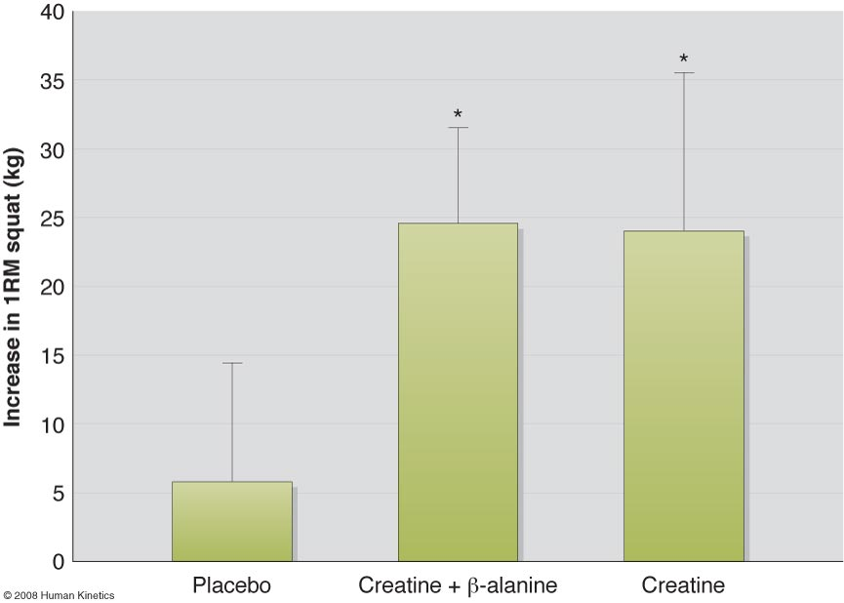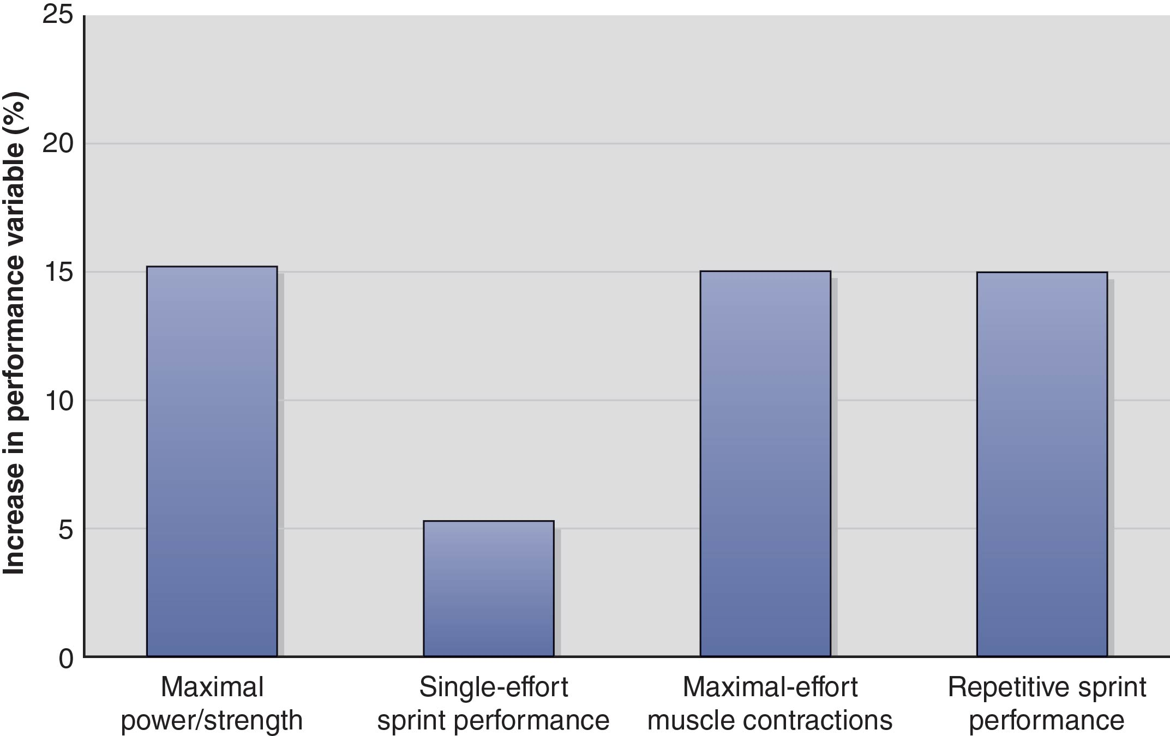

    - Creatine Supplementation & Body Mass Changes
    - Prolonged Creatine Supplementation
    - increases body weight:
    - appears to be primarily related to an increase in fat-free mass.
    - is believed to be partly related to an increase in total body water.
    - Creatine supplementation during training
    - is typically a 1- to 4.5 lb greater increase in BM or FFM over several weeks to several months.
    - Adverse Effects of Creatine
    - Increase in body mass
    - is an unwanted side effect for some athletes.
    - Anecdotal Reports
    - GI, CV, & muscular problems.
    - e.g., gas, mild diarrhea, & muscle cramps.
    - Long-Term Health Effects
    - Renal dysfunction has never been reported for either short-term or long-term use.

  - Stimulants
  - Effects
  - Reduced fatigue
  - Increased alertness
  - Increased confidence
  - Euphoria
    - Caffeine is a CNS stimulant popular among both endurance & resistance training athletes
      - Efficacy
      - Improves Aerobic Endurance Performance
      - Improvement in time to exhaustion during cycling at 80% VO₂ max: 75 to 96 minutes.
      - Doses: 3 to 9 mg/kg.
      - Short-duration, High-Intensity Exercise
      - 5 minutes.
      - improved performance.
      - May improve sprint & power performance
      - inconclusive.
      - no improvement in power performance in recreational athletes, but improvements in peak power have been observed in Judo athletes.
      - Improved Aerobic Endurance Performance
      - Food Source
      - Coffee
      - Anhydrous Caffeine
      - Caffeine tablets
      - Caffeine tablets > Coffee
      - Adverse Effects
      - Greater risk for side effects
      - Caffeine intake > 9 mg/kg.
      - Side Effects
      - Anxiety
      - Gastrointestinal disturbances
      - Restlessness
      - Insomnia
      - Tremors
      - Heart arrhythmias
      - Diuretic
      - Increases the risk for heat illness
      - Physically addictive
      - Withdrawal Symptoms
      - Headache
      - Fatigue
      - Dysphoric mood
      - Difficulty concentrating
      - Flu-like somatic symptoms
      - Caffeine Overdose
      - Lethal dose
      - Typically in excess of 5 g of caffeine
      - About 42 cups of coffee at 120 mg of caffeine per cup
      - Twenty-five 200-mg tablets of caffeine
    - Pre-workout Energy Drinks are among the most popular dietary supplements consumed by young people in the United States.
      - Efficacy
      - Effective for increasing resistance training volume performance.
      - Not effective with other types of anaerobic exercise including Wingate tests & speed/agility performance.
      - Improves cardiorespiratory endurance exercise performance.
      - improve cycling & running performance in trained cyclists & recreationally active individuals who consumed energy drinks containing about 2 mg of caffeine/kg body mass within an hour before exercise,
      - Adverse Effects
      - Due to the presence of caffeine, the same potential adverse effects that exist for caffeine also exist for energy drinks.
      - Most energy drinks contain only moderate amounts of caffeine, typically less than 300 mg.
    - Ephedrine
    - is a β-agonist or sympathomimetic.
    - is thought to possess a strong thermogenic effect.
    - is used by athletes to reduce body fat.
    - is often used as a stacking agent with caffeine.
    - is believed to increase fat oxidation & spare muscle glycogen.
      - Efficacy
      - is effective only when it is combined with caffeine:
      - improves aerobic endurance performance.
      - Adverse Effects
      - Side Effects
      - vomiting & nausea with 5 mg/kg caffeine + 1 mg/kg ephedrine, but not with 4 mg/kg caffeine + 0.8 mg/kg ephedrine.
      - Nausea
      - Vomiting
      - Psychiatric symptoms
      - Anxiety & mood change
      - Autonomic hyperactivity
      - Palpitations
      - Death.
    - Citrus Aurantium
      - Efficacy
      - is a mild stimulant.
      - is often used as an Asian herbal medicine to treat digestive problems.
      - is thought to contribute to:
      - appetite suppression,
      - increased metabolic rate, &
      - lipolysis.
      - contains synephrine.
      - Synephrine
      - is a sympathomimetic agent.
      - is thought to stimulate:
      - β-3 adrenergic receptors
      - increases lipolysis.
      - Peripheral α-1 adrenergic receptors
      - results in vasoconstriction & elevations in blood pressure.
      - Citrus Aurantium + Caffeine or Other Herbal Products
      - significant improvements in time to fatigue.
      - Adverse Effects
      - None?!

- Summary of Ergogenic & Non-Ergogenic Dietary Supplements & Their Application
- Franke, W.W., and Berendonk, B. Hormonal doping and androgenization of athletes: a secret program of the German Democratic Republic government. Clinical Chemistry 43(7): 1262-1279, 1997.
- After reading the GDR article, you should be able to answer the following questions:
  - Which institutions and individuals were involved in systematic doping program of the GDR? Government promoted use of androgenic steroids in high performance sports. Scientists and physicians and top-ranking professors
  - What types of documentation contained information regarding the GDR’s systematic doping system? Classified documents, scientific reports and protocol books saved after the collapse of the German Democratic Republic (GDR). The secret (military classification Vertrauliche Verschlußsache) doctoral theses (for the degrees of Doctor of Medicine or Doctor of Medical Sciences) that report the results of the effects, side effects, and damages observed during controlled administrations of steroids and certain peptide hormones to students, world-class athletes, and minors.
  - How did the GDR avoid detection or what methods were used to avoid detection?
  - the GDR contributed to the development of methods of drug administration that would evade detection by international doping controls.
  - a general strategy and a centrally organized system were developed to secure both efficient hormonal doping and evasion of detection.
  - be further developed and optimized by research on doping in high-performance sports, with special emphasis on the development of new substances and the most efficient patterns of administration, considering both the requirements of the specific sporting event, the time of drug administration and withdrawal, and other methods to avoid detection at international meetings;
  - What was the first doping substance used by the GDR?
  - Oral-Turinabol an adrogenic-anabolic steroid
  - What doping substance did the GDR use most often?
  - Testosterone esters
  - What were the major doping substances used in high-performance sport in the GDR?
  - Androgenic-anabolic steroids
  - Testosterone synthesis stimulants
  - Neuropeptides (Lysine-vassopressin, Oxytocin, Substance P)
  - Stimulants (Amphetamine, Methamphetamine)
  - Neurotropics, psychotropics
  - Human growth hormone (HGH)
  - What proposals were made to avoid testosterone detection after 1981 and 1982 when the IOC indicated that it would introduce doping tests for exogenous testosterone?
  - At the 1981 meeting, the following was proposed and agreed to:
1) to determine alternatives to the exogenous application of testosterone,
2) to replace testosterone by its precursor, androstenedione, various forms of dihydrotestosterone, dihydroandrostenedione, or dehydroepiandrosterone (DHEA), and
3) to administer testosterone as well as dihydrotestosterone by nasal spray[6 ], especially in those events in which the psychotropic effects of testosterone, such as increased aggressiveness, are considered important, as well as to evade the doping tests

  - What were the health consequences (i.e., side-effects) of anabolic steroid use in the GDR?
Steroid acne, deepened voice, ovarian cyst, increased body hair growth, disturbances in libido, malformations in fetus of pregnant subjects, more susceptible to liver damage when increased alcohol consumption, breast enlargement in men, growth arrest and long term amenorrhea
  - What was the contribution of scientists to cheating in the GDR system?
Development of methods of drug administration that would evade detection by international doping controls
  - What were the main objectives of the GDR doping system? Administer performance enhancing drugs to their athletes that could evade detection in order to win Olympic sporting events
  - Were the girls treated differently than the boys with respect to doping in the GDR?
Women were forced to take the drug or leave the competitive sport
  - Did the women receive different anabolic steroids or different doses of steroids than the men?
  - Since the early 1970s many athletes of the GDR, notably females, were given not only oral androgenic steroids but also injections with androgenic hormones, including nandrolone esters or, most frequently, testosterone esters.

Study well and good luck!

Sincerely,

Robert Panenic

Robert Panenic

