The best coffee in town
Coffee Shop
Word Assignment- INTE 290

TJ’s Coffee Shop where you will always be greeted with a smile!

Table of Contents

The project description 3
The timeline and deliverables 4
The location of your prospective business/ organization 5
The budget 5
The potential value of business/organization 7

The Project Description:
TJ’s Coffee shop is a business which focuses on delivering quick and speedy coffee service for a neighbourhood cliental. The main focus is customer service and making sure customers are content and get everything they need. We also want to make sure that we reflect a cozy and friendly experience which differentiates us from the chain coffee shops which are popping up everywhere. There are 26,736 Starbucks in the world, we want to provide a neighbourhood with a spot that brings people together. There are 3 main components to TJ’s Coffee
- Supporting Local businesses by allowing them to show case products.

- Only having the best coffee beans, which were farmed and roasted in humane ways.
- Providing a safe neighbourhood hangout, with amazing staff.
Coffee tastes best when shared

The Timeline and Deliverables
Coffee shop timeline:

- Finding a space for the coffee shop, in a family neighbourhood.
- Create a floor plan, the space has to have a place to line up, comfortable seating and somewhere for the coffee preparation.
- Shop around for everything look for the best prices on everything from comfy chairs to espresso machines.
- Network, having a hot location and brewing superior coffee will only help so much. You need to network to maintain a connection to the area and to attract more customers
- Open TJ’s Coffee Shop

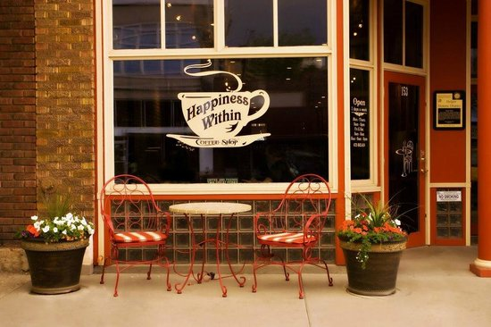

The Location of Prospective Business:
Montreal


TJ’s Coffee Shop will be located in the heart of Montreal’s Villeray Neighbourhood. As a location on the rise in popularity for young professionals and parents, Villeray will be the perfect location to open up shop. There are many schools, parks and local businesses as well as the family centric atmosphere of the area. There are mostly chain coffee shops around the area such as McDonald’s, Starbucks and Tim Horton’s which provides an opportunity to create a more intimate and home grown coffee shop , which connects with local artists and food produces to showcase their products. The intersection of these features make the ideal place to have a profitable business with a range of cliental an opportunity for growth

Little Italy-Villeray

The Budget:
The budget will range depending on how large the property is. To break it down, Location, equipment, renovation and inventory. The lease price is based on the average price for commercial property per square foot a month. Renovation costs include cosmetic as well as plumbing and electric and inventory is based on 100 g measures before beans are ground.
Location lease | 3,000/month
Equipment | 22,000
Renovations | 5,900
Inventory | 2,000
 | Subtotal: 32,900

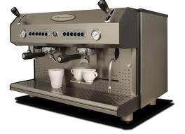

The Potential Value of the Business:
This Company Hopes to add to the culture of an up and coming area for young families. The potential value of this business is big because not only does the business add to the local economy it is also a good example of entrepreneurship in the community. Over 50% of the population drinks coffee, this means the more than half the population drinks coffee.

It is essential to provide timely services, to make sure customers receive the best service from friendly staff as well as having a safe space to do work or just catch up with friends. As stated above the coffee shop would also work as a space for local artists and food producers to showcase and possibly have their products featured on the menu, not only does this create a distinct neighbourhood aesthetic within the café it supports local talent which would otherwise not be as broadly seen. Over all TJ’s Coffee Shop will not only be adding to the Villeray Community culturally as a place to try amazing coffee as well as local foods while feeling at home it will also work to help the community function as stated above over 50% of the population drinks coffee to wake up in the morning and throughout the day, the coffee shop will also be adding to the community’s economy.

Bibliography

“ 25 interesting Starbucks Facts and Statistics”. DMR Stats, August 2017.
https://expandedramblings.com/index.php/starbucks-statistics/ - .WeO1qhNSxAY

“13 Tips to Open a Successful Coffee Shop”. B Plans.
http://articles.bplans.com/13-tips-open-successful-coffee-shop/

Commercial Space for Rent Villeray
http://realestate.louer.com/parc-extension-commercial-space-for-rent/leasing-commercial-spaces
“Coffee Drinking Statistics”. Statistic Brain, September 1st 2016.

http://www.statisticbrain.com/coffee-drinking-statistics/

