WRoman Gladiators and Roman Recreation

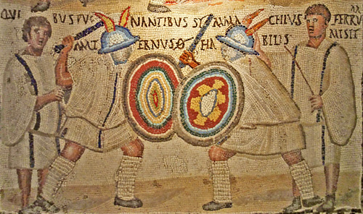
Types of Imperial Gladiators
- Equites - Horsemen/Knights
  - Only fought other horsemen
  - Opening act for Gladiatorial Combat
  - White Tunics, brimmed helmet, manica (arm guard) sword and shield
- Provacator – challenger
  - Type of imperial gladiator from era of Republic
  - Attire:
Figure 1 Madrid Mosaic, 2 Equites, 2 referees
    - Non brimmed visored helmet
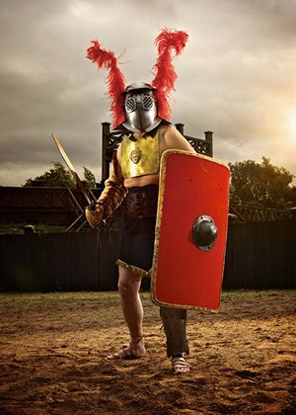
    - Neck guard in back
    - Subligaculum – loincloth
    - Greave on left leg
    - Concave rectangular shield
    - Breastplate (only type to have breastplate)
- Threax - Thracian
Figure 2 Provacator
  - Only Ethnic type of Gladiator in Imperial period
  - Equipment:
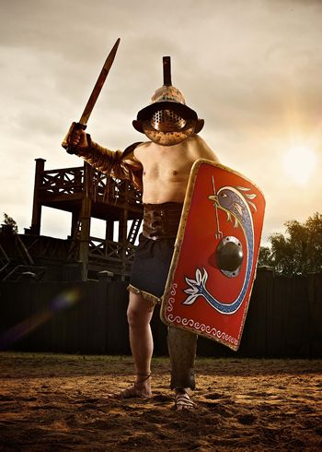
    - Curved sword (sica)
Figure 3 Murmillo
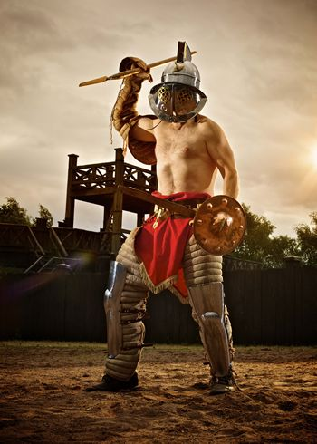
    - Small oblong shield
Figure 3 Hoplomachos
    - Manica on right arm
    - Brimmed helmet with griffin on top
    - Extra long quilted leggings
- Hoplomachos – from Greek “hoplite”
  - Equipment:
    - Manica on right arm
    - Extra long quilted leggings
    - Small shield – circular and concave
    - Dagger and Spear as weapons
- Murmillo
  - One of the most heavily armed
  - Helmet with angular crest
  - Large Oblong shield
  - Fan based fighting between Parmalarii (those who cheer for Gladiators with little shields) and Scutarii (those who cheer for big shields)
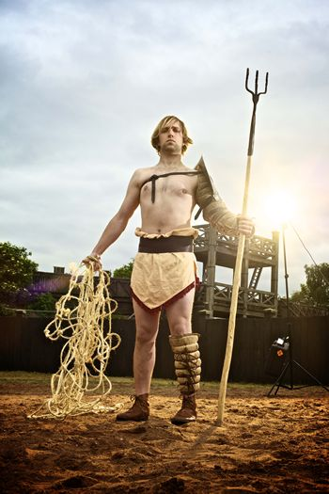
  - Parmalarii – cheer for the underdog (Thraex and others with small shields usually lose)
Figure 5 Retiarisu
- Retiarisu – Net Man
  - Not based on military garb
  - Armed with
    - Fuscina-trdent
    - Net
    - Dagger
    - Galerus – protector for shoulder
    - Manica on left arm
    - Greaves
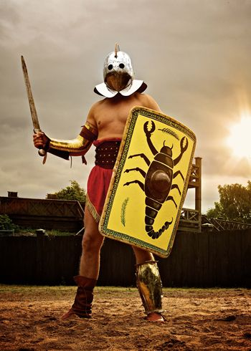
- Had to rely on speed and agility to fatigue his more heavily armed opponents
- Secutor (Pursuer)
  - Created as opponent to Retiarius; another name = contraretarius
  - Same equipment as murmillo except helmet
  - Brimless helmet with 2 small eyeholes
  - Retiarius vs. Secutor became the most popular pairing
Death of a Gladiator
- Types of Missio (Release from Death/forgiveness)
  - Missio requested by raising the left arm and left index finger (and some other gesture of defeat
Figure 6 Secutor
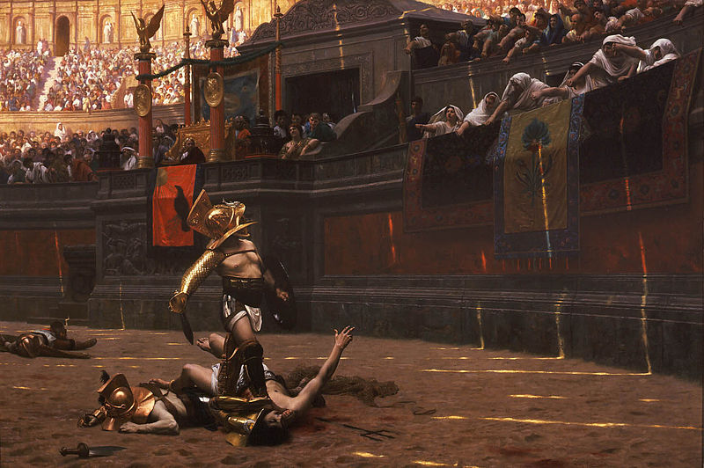
  - Stans [missus]: released while still standing
  - Missus: release while not standing
Death of a Gladiator: Thumbs Up or Down?
Latin – Pollice Verso
- Those erstwhile players of horns, those perpetual friends
- Of public arenas, noted through all the towns for their rounded cheeks, now mount shows themselves and kill
Figure 7 Pollice Verso, Jean-Leon Gerome 1872
To please when the mob demand it with a turned thumb (pollice verso). – Juvenal, Satire 3
History Behind Gladiator (The Movie)
- Commodus (son of Marcus Aurelius), Emperor
  - Cassius Dio, Roman Historian called Commodus’ reign a descent “from a kingdom of gold to one of iron and rust”
  - Commodus presented himself in the image of Heracles
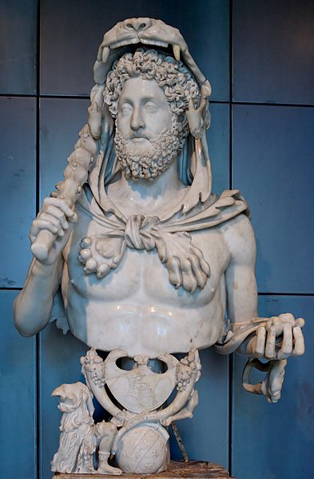
The Munus of Emperor Commodus 192 CE
- “After lunch Commodus would fight as a gladiator. The form of contest that he practiced and the armour that he used were those of the secutores, as they were called: he held the shield in his right hand and the wooden sword in his left, and indeed took great pride in the fact that he was left-handed. His antagonist would be some athlete or perchance a gladiator armed wit ha stick; sometimes it was a man that he himself had challenged, sometimes one chosen by the people, for in this as well as in other matters he put himself on an equal footing with the other gladiators, except for the fact that they enter the lists for a very small sum, whereas Commodus received a million sesterces from the gladiatorial fund each day.” – Cassius Dio Senator and Eye Witness
Figure 8 Commodus
The Death of Commodus – 192 CE
- End of Commodus’ Munus with mock death of Commodus, Senators dressed in black and Commodus’ helmet taken out of the Porta Libitiensis (Gateway of death)
- Commodus planned to kill the new consuls the day they took office, dressed as secutor
- Senate, Praetorian Prefect, and mistress conspired against him
  - Poisoned, but it did not kill him
  - Death by Personal Trainer (Strangled in his bath)
Roman Recreation/Leisure
- Roman Otium – leisure time in contrast to Negotium (Business) = not otium
- Otium is the primary concept, not work
- Otium – could be retirement after a political career, Goal: Otium cum dignitate
Otium cum Dignitate
- “As I frequently contemplate and call to mind the times of old, those in general seem to me, brother Quintus, to have been supremely happy, who, while they were distinguished with honours and the glory of their actions in the best days of the republic, were enabled to pursue such a course of life, that they could continue wither in employment without danger, or in leisure with dignity. To myself, also, there was a time when I thought that a season for relaxation, and for turning my thoughts again to the noble studies once pursued by both of us, would be fairly allowable, and be concede by almost every one; if the infinite labour of forensic business and the occupations of ambition should be brought to a stand, either by the completion of my course of honours (cursus honorum), or by the decline of age.” – Cicero De Oratore
The Ambiguity of “Free Time” – Otium as means of self-definition
- “For it is by a man’s pleasures – his pleaures indeed – that his sense of dignity, integrity and moderation can best be judged. For who is so dissolute that no trace of seriousness is to be found in his pastimes? Our leisure (otium) gives us away.” – Pliny, Panegyric (for Emperor Trajan)
Disdain for the Otium of Fitness (Living by bath, Brain versus Brawn, Negative effects of being an athelete
- “Here I am, surrounded by all kinds of noise (my lodgings overlook a Bath). Conjure up in your imagination all the sounds that make one hate one’s ears. I hear the grunts of musclemen exercising and jerking those heavy weights around; they are working hard, or pretending to. I hear their sharp hissing when they release their pent breath. If there happens to be a lazy fellow content with a simple massage I hear the slap of hand on shoulder; you can tell whether it’s hitting a flat or a hollow. If a ball-player comes up and starts calling out his score, I’m done for. Add to this the racket of cocky bastard, a thief caught in the act, and a fellow who likes the sound of his own voice in the bat, plus those who plunge into the pool with a huge splash of water. Besides those who just have loud voices, imagine the skinny armpit-hair plucker whose cries are so shrill so as to draw people’s attention and never stop except when he’s doing his job and making someone else shriek for him.” – Seneca, Letter to Lucius
Weightlifting
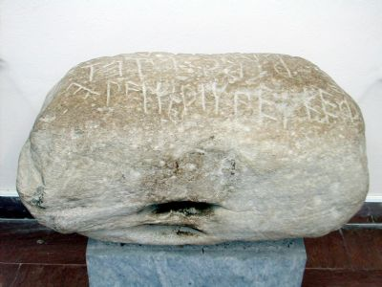
- Olympia, “Bubo lifted me over his head with one hand”
- Rock weighing 143kg = 315 lbs
Roman Ball Games
Figure 9 "Baubo" Rock from Olympia
- Harpastum – “small ball game” – Ancient Rugby?
- Trigon – three players, each had a scorer (to keep score) and a ball boy
  - Scorer counted missed catches and the winner was the player with the smallest score
Women and Sport in Rome
- “Sparta, we are amazed at the rules of your wrestling schools, and particularly at the young women athletes: for your girls, there is no shame in working out, naked among the men wrestling … The Roman Woman, on the other hand, goes around in a huge crowd – you can’t get anywhere near her, can’t find out what she’s really like or find a way to talk to her. Rome, if you would adopt the rules of wrestling from Sparta, you would be even dearer to me.” – Elegy, The Fantasy of Sparta
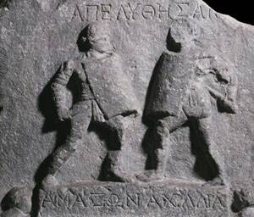
Roman Gladiatrix: Fear of a Strong Woman?
Figure 10 Relief of two Gladiatrices (Female Gladiators) Named Achillea and Amazonia Halicarnassus
- “Who doesn’t know about the purple athlete’s cloacks, and the ladies’ wrestling ointment? Who hasn’t seen the wounds on the palus, which they’ve gouged with the rudis and beated with the shield? … What decency can a woman show wearing a helmet, when she leaves her own sex behind? She wants to be strong like a man, but does not want to turn into a man: after all, we men have such little pleasure.” – Juvenal, Satire 6
  - Women occasionally performed gladiator combat in the Arena (Nero forced women and senators to fight)
Critics of Physical Exercise: Brain versus Brawn
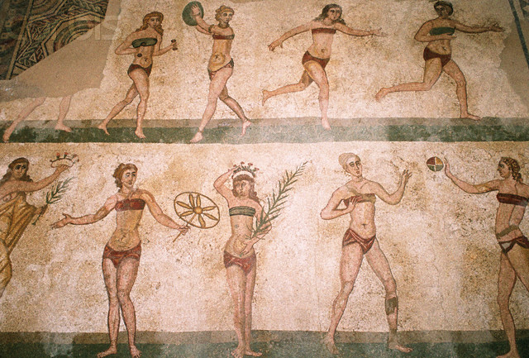
- “For it is silly, my dead Lucilius, and no way for an educated man to behave, to spend one’s time exercising the biceps, broadening the neck and shoulders and developing the lungs. Even when the extra feeding has produced gratifying results and you’ve put on a lot of muscle, you’ll never match the strength of the weight of a prized bull. Moreover, the more weight you put on, the more constricted and sluggish your mind becomes. You ought therefore to reduce your body and give more play on your mind.” – Senaca
- “There are numerous disadvantages to being an athlete. There is first of all the laborious training, which exhausts a man’s vitality and disqualifies him from concentration and serious study. Then there is the sheer size of a training meal, enough to deprive a mind of its agility. There are the slave-coaches, dreadful men who behave like tyrants. … A perfect day for them is one in which they have had a really good sweat and, to make good the loss, take a good swig of liquor, which will sink the deeper if they have had nothing to eat. Drinking and sweating – this is the life to which those people are condemned.” – Seneca’s criticism, continued
Figure 11 "Bikini Girls" "Mosaic, Sicily, 4th Century CE
Mens Sana in Corpore Sano (A Healthy Mind in a Healthy Body)
- You should pray for a healthy mind in a healthy body
Ask for a stout heart that has no fear of death,
And deems length of days the least of Nature’s gifts
That can endure any kind of toil,
That knows neither wrath nor desire and thinks
The woes and hard labors of Hercules bette than the loves and banquets and downy cushions of Sardanapalus
What I commend to you, you can give to yourself;
For assuredly, the only road to a life of peace is virtue (virtus). – Juvenal, Satire 10
  - Juvena’s take is anti-pleasure and otium
- Virtus – derive from Latin word for “Man” – Vir; Virtue = manliness

Roman Baths

First Roman Baths
- Balnea – small privately owned facilities, open to the public for a small fee
- 1st century BCE – 170 Balnea in Rome
- By the end of Roman Empire – 1,000 Balnea in Rome
- Primary function: Hygeine, since most people did not have private access to running water
Large-Scale Public Baths: Thermae
- From the Greek word thermos = hot
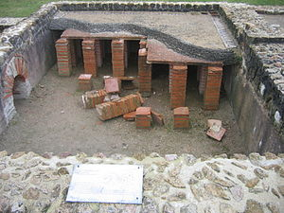
- Romans began building Thermae on the grand scale, due to advances in engineering that made warm water possible
- The first hot-water swimming pool given to the Roman people by Gaius Maecenas, patron of the arts during the Augustan era
How to Heat the Baths: Hypocaust
- From Greek Hupo = under and caust = burn
Figure 12 Hypocaust from a Roman Villa
- Floor was raised above the ground, supported by ‘pilae stacks’ – layers of tile and concrete
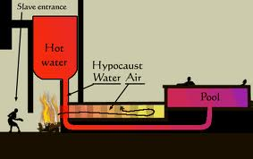
- Hot air supplied from a furnace would circulate under the floor and rise through tunnels in the walls, and out of flutes in the roof
First Thermae in Rome: Baths of Agrippa
- Built by Agrippa, general to Augustus and responsible for most of Augustus’ military vicotires
- Originally had a “hot air bath” i.e. Sauna, and cold plunge
- 19 BCE – Roman Aqueduct, Aqua Virgo, completed by Agrippa
- Aqua Virgo supplied water for Baths of Agrippa
- Agrippa died in 12 BCE, and he left the Baths to people of Rome
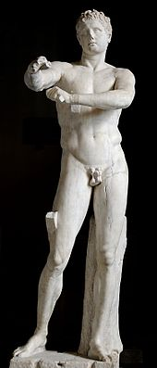
The Apoxyomenos of Lysippos
- Greek sculpture made around 330 BCE in Bronze
- Stood in front of the Baths of Agrippa
- “It was dedicated by Marcus Agrippa in front of his Baths. [The emperor] Tiberius, so much admired this statue […] and removed the Apozyomenos to his bedroom, substituting a copy. But the people of Rome were so indignant about this that they staged a protest in the theater, shouting “Bring back the Apoxyomenos!” And so despite his passion for it, Tiberius was obliged to replace the original statue.” – Pliny the Elder
Baths of Titus
- Built in 81 CE by Emperor Titus, son of Vespasian, who completed the Colosseum
- Like the Colosseum, Baths of Titus built in the park area of Nero’s Domus Aurea
- Baths, like the Colosseum, as gift to the people – from the land of Nero
Martial, On Spectacles 2
- Where now the Sun’s Colossus has its closer view of the stars
And towering scaffolds loom above the street,
The hated entrance halls of that wild king once gleamed
And a single dwelling stood in all the city
Where now the venerable mass of the Amphitheater rises
High above Rome, the pond of Nero spread
Where now we gaze in wonder on the sudden Baths of Titus,
A haughty estate deprived the people of homes
Where now the Claudian colonnade unfolds its spreading shade
The furthest part of the palace came to an end
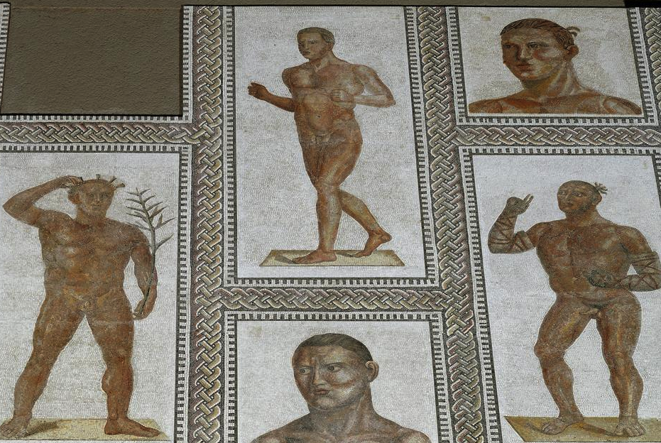
Rome has been restored to Rome, Titus, with you as her defender
And pleasures grabbed by a tyrant return to the people
Baths of Trajan
- Built 104-109 CE, by the Emperor Trajan
- Largest Baths in Rome at the time
- May have included a library, with section for Greek Literature and separate section for Latin
Baths of Caracalla
Figure 13 Mosaic of Victorious Roman Athletes
- Perhaps constructed between 211-217 BCE; perhaps started during the reign of Septimus Severus
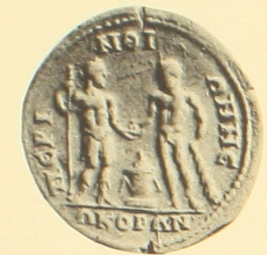
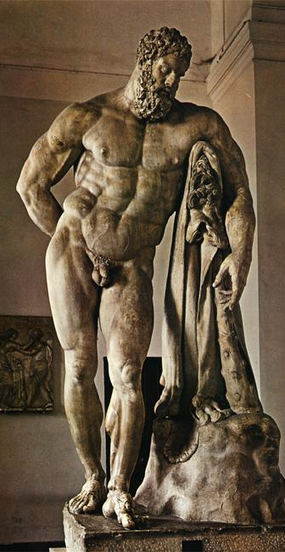
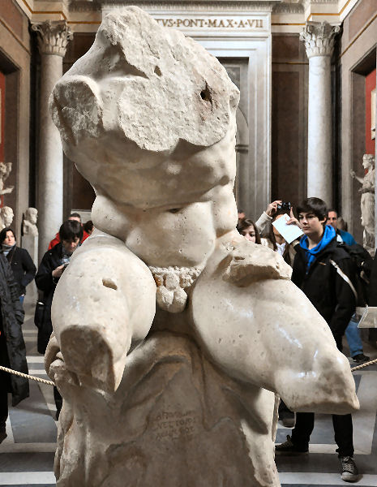
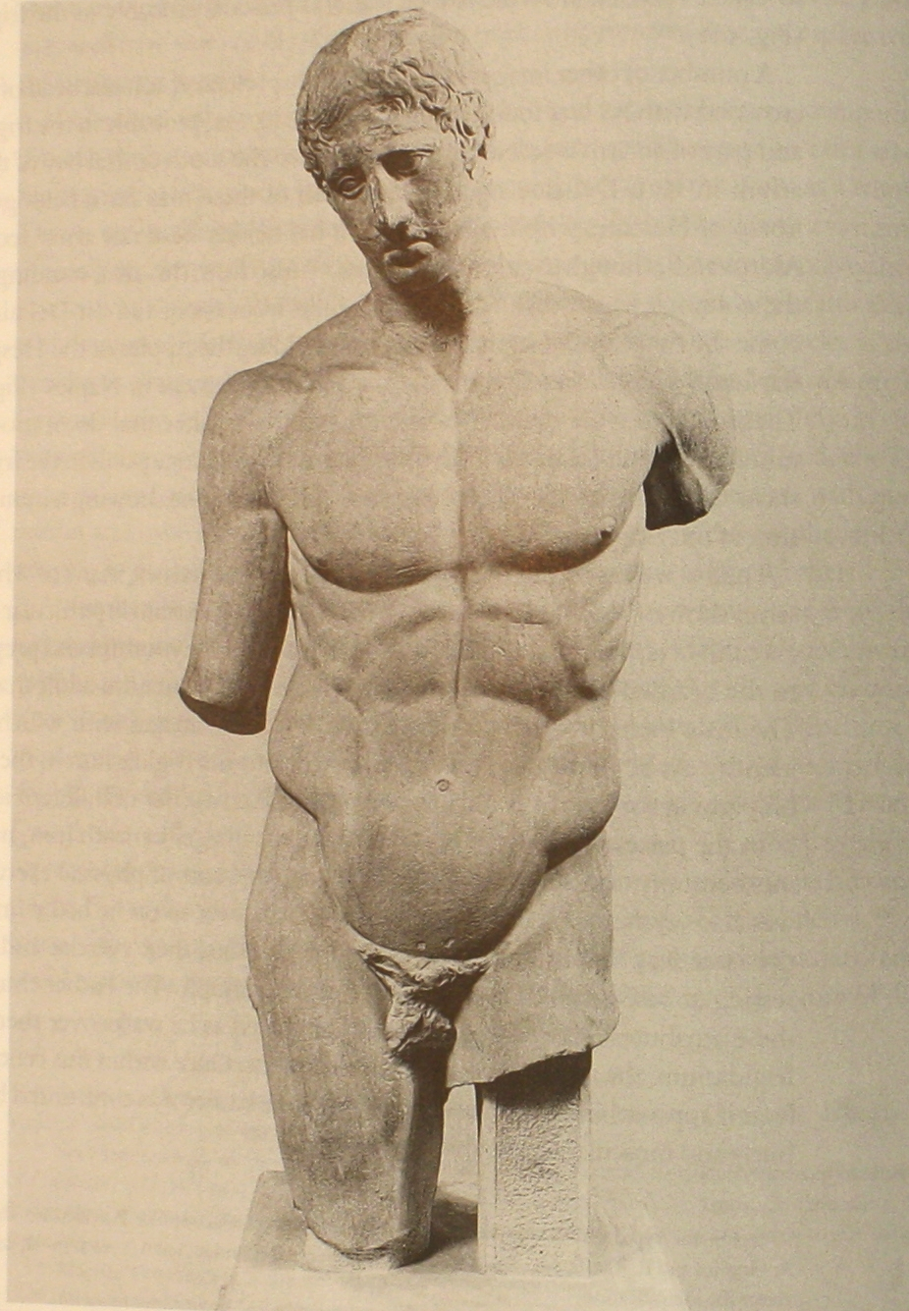
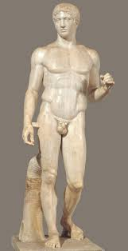
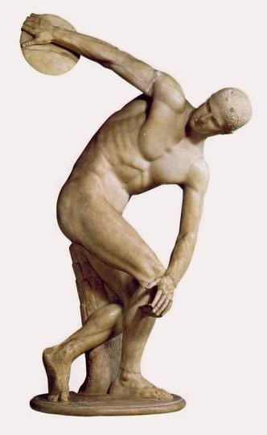
Figure 14 Coin from Perionthos, depicting Caracalla receiving the apples of Hesperides from Heracles
Figure 14 Farnese Heracles - Heracles at Rest
Figure 14 Seated Heracles (Heracles Torso)
Figure 14 Polycleitus' "Heracles"?
Figure 14 Polyclietus' Dorphorus
Figure 14 Myron's Discobolus

Roman Attitudes Against Greek Athletics
- “The Romans used to be very suspicious of anointing, and they believed that nothing has been responsible for the slavery and softness of the Greeks as the gymnasia and palaestra, which give rise to a great deal of leisure of idleness, mischief, and pederasty, and the ruin of young men’s bodies by sleeping, strolling about, performing rhythmic exercises, and following strict diets. Influenced by these things, they have unconsciously left behind their weapons and prefer to be called not good warriors and knights, but rather nimble and beautiful athletes.” – Plutarch, Roman Questions
Nero: In Imitation of the Greeks
- Neroneia Began by Nero in 60 CE
  - “Nero was the first who instituted, an imitation of the Greeks, a trial of skill in the three several excercises of music, wrestling, and horse-racing, to be performed at Rome every 5 years, and which he called the Neroneia.”
    - 3 parts, music, wrestling, horse racing
- Took place only 1 more time, in 65 CE, but ceased upon his death
- After Neroneia, Nero went on to compete in Greece
Tacitus, Annales (On Nero’s Hellenizing Influence)
- “As it was, the morality of their fathers, which had by degrees been forgotten was utterly subverted by the introduction of a lax tone, so that all which could suffer or produce corruption was to be seen at Rome, and a degeneracy bred by foreign tastes was infecting the youth who devoted themselves to athletic sports, to idle loungings and low intrigues, with the encouragement of the emperor and Senate, who not only granted license to vice, but even applied to a compulsion to drive Roman nobles into disgracing themselves on the stage, under the pretense of being orators and poets. What remained for them but to strip themselves naked, put on the boxing-glove, and practice such battles instead of the arms of legitimate warfare?”
The Capitoline Games
- Instituted in 86 CE by Roman Emperor Domitian
- Took place every 4 years
- In imitation of Neroneia, Captoline Games had a tripartite structure: Gymnic, Equestrian, and Musical events
- Capitoline games also included footraces for women
Professional Athletes in the Roman Empire
- Synods/ Greek – Synodoi: Official, Professional Athletic Guilds began in the 1st century BCE
Stipends for the Iselastic Games
- Iselastic Games:
  - Greek Iselasis – formal entry into the city, through the wall
  - Tradition – when a city has such victors, there is no need of walls
- Emperor Trajan to Pliny the Younger:
  - “The Stipend appointed for the victor in the Iselastic games ought not, I think, to commence till he makes his triumphant entry into his city. Nor are the prizes, at those combats which I thought proper to make Iselastic, to be extended backwards to those who were victors before that alteration took place”
Civic Games in the Greek East
- 4 Types of Games in the Greek East
  - Stephantitic/Crown Games
  - 7 total crown games in Roman Periodos:
    - Captioline Games
    - Actaian Games
    - Sebastan Games in Naples
    - Olympic Games, Olympia
    - Pythian Games
    - Nemean Games
    - Isthmian Games
  - Iselastic Games
  - Ecumenical Games/ or “Iso-Games”; i.e. Iso-Olympics – Alexandrian Games in Egypt
  - Private games put on by wealthy patrons

Lucian, Anacharsis - The Strangeness of Sport

Lucian
- Rhetorician and Satirist
- Lived in the 2nd century CE (125-after180 CE)
Solon
- An Athenian Stateman, lawmaker and poet
- Responsible for major constitutional reforms in the city of Athens
  - Example: abolished all debts for Athenian citizen (including debt slavery)
  - Divided Athenian citizens into 4 classes based on wealth and production of agriculture: pentakosiomedimnoi (500); Hippeis (300); Zeugitai (200); Thetes (less than 200)
  - Prevented export of all agricultural products, except olive oil
- After Solon’s Reforms, he left Athens and traveled as a wise man
- Solon’s laws could not be changed for 10 years
Questioning the value of the Athlon (prize)
- “Oh dear no; your prize-list is the most imposing; the givers may well plume themselves on their munificence, and the competitors be monstrous keen on winning Who would not go through this amount of preparatory toil, and take his chance of a choking or a dislocation, for apples or parsley? It is obviously impossible for any one who has a fancy to a supply of apples, or a wreath of parsley or pine, to get them without a mud plaster on his face, or a kick in the stomach from his competitor.” – Anacharsis
The Symbolic Value of Victory – No Pain, No Fame
- “My dear sir, is it not the things’ intrinsic value that we look at. They are the symbols of victory, labels of the winners; it is the reputation (doxa) attaching to them that is worth any price to their holders; that is why the man whose quest for fame (eukleia) leads through toil (ponos) is content to take his kicks. No pain, no fame; he who covets fame must start with enduring hardship; when he has done that, he may begin to look for the pleasure and profit his labours are to bring.” – Solon
Solon: Atheltic Training as Political Education
- “Our view is not bounded by the contests, and directed to their carrying off prizes there – of course only a small proportion of them ever reach that point; no; the indirect benefit that we secure for their city and themselves is of more important. There is another contest in which all good citizens get prizes, and its wreaths are not of pine or wild olive or parsley, but of complete human happiness (eudaimonia), including individual freedom and political independence, wealth and repute, enjoyment of our ancient ritual, security of our dear ones, and all the choicest boons a man might ask of Heaven. I t is of these materials that the wreath I tell you of is woven; and they are provided by that contest for which this training and these toils are the preparation.” – Solon
Theories of Energy: Conservation or Use
- “I fancy you conceive of force as something similar to wine or water or liquid of some sort. You are afraid of its dribbling away in exercise as those might from an earthenware jar, and by its disappearance leaving the body, which is supposed to have no internal reserves, empty and dry.” – Solon
Fire – Greek Theory of Energy
- “That is not the case; the greater the drain upon it in the course of exercise, the greater the supply; did you ever hear a story about the Hydra? Cut off one of its heads, and two immediately sprang up in its place. No, it is the unexercised and fibreless, in whom no adequate store of material has ever been laid up, that will peak and pine under toil. There is a similar difference between a fire and a lamp; the same breath that kindles the formed and soon excites it to greater heat will put out the latter which is but ill provided to resist the blast.” – Solon
Athens vs. Sparta
- “If you go to Sparta, remember not to laugh at them either …”
“Still worse, you may see them being scourged at the altar, streaming with blood, while their parents look on – the mothers, far from being distressed by the sight, actually making them hold out with threats, imploring them to endure pain to the last extremity and not be unmanned by suffering. There are many instances of their dying under the trail; while they had life and their people’s eyes were on them, they would not give up, nor concede anything to bodily pain; and you will find their staitues there, set up honoris causa by the Spartan state. Seeing these things, never take them for madmen.” Anacharsis

Epictetus, Stoic Philosopher (55-135 CE)
“So you wish to conquer in the Olympic Games, my friend? And I, too... But first mark the conditions and the consequences. You will have to put yourself under discipline; to eat by rule, to avoid cakes and sweetmeats; to take exercise at the appointed hour whether you like it or not, in cold and heat; to abstain from cold drinks and wine at your will. Then, in the conflict itself you are likely enough to dislocate your wrist or twist your ankle, to swallow a great deal of dust, to be severely thrashed, and after all of these things, to be defeated.”

Ancient Medicine and Athletics
Ancient Greek Medicine
- Hippocrates of Cos – “The Father of Western Medicine;” Most famous ancient Greek doctor 460 – 370 BCE
  - First major physician who attributed diseases primarily to natural causes rather than “the gods”
  - First to describe many diseases and medical conditions
Galen of Pergamon
- 129-200/216 CE
- Humoral theory: body has four humors, which vary in quantity in the body and determine levels of health and mental disposition (sanguine, choleric, melancholic, phlegmatic)
Galen’s Protrepticus: An exhortation to study the arts/skills
- Ancient Greek term: Techne
  - Skill, craft, form of expertise in knowledge of a given subject
- Galen, Introduction to the Protrepticus:
- “The crucial difference between animals and humans, is seen in the great variety of technai which this latter animal (human) performs, and from the fact that the human alone has the capcity for knowledge: he can learn whichever technai he wishes.” – Galen, Introduction to Protrepticus
Tuche vs. Techne (Chance vs. Skill)
- Tuche – the blind helmswoman
- “On a ship that is fiercely tossed by a storm and flooded by waves that threaten to sink her, you would be a fool to hand the rudder over to a blind person.”
- “Those who follow Tuche you will find to be idle and ignorant of technai; they are born by hopes, they run with the spirit as she runs, some near her and some further away …”

- The other group is a band of fine humans: the practitioners of technai
- They do not run, nor do they shout, nor fight each other
- In their midst is the god, and about him they are arranged in order
Levels of Techne around “the god”
- Those nearest the god:
  - Geometers, mathematicians, philsophers, doctors, astronomers, and scholars
- 2nd level:
  - Painters, sculptors, grammarians, carpenters, architects
- 3rd level:
  - All other forms of technai
A call to Techne, except Atheltics (Gymnastike)
- Athletics (gymnastike) is not a techne
Skill (Techne) over Beauty
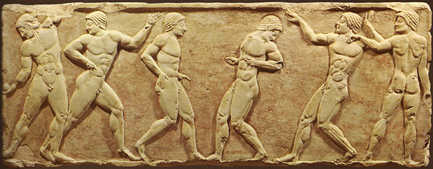
- “That man might be more feeble of body, but when the god bestows on him words, al ldelight as they see him. Surely he speaks, and softly, with grace, and wins out among them. As he goes through the town they think him a god.” – Galen quotes Odyssey, Book 8 (mind vs. body)
Earlier “Anti-Athletic” Traditions In Greece
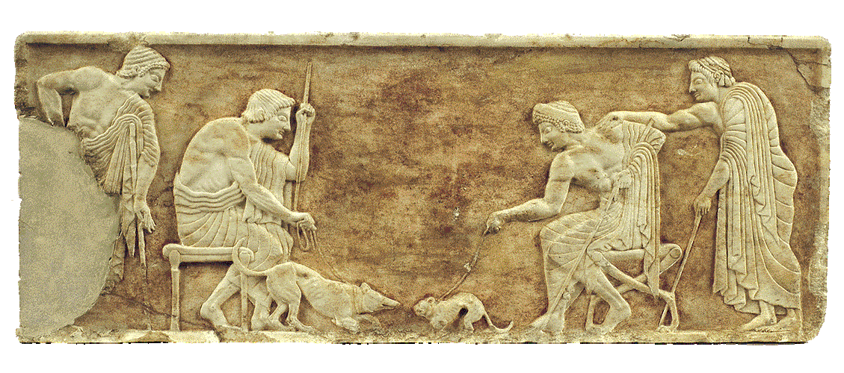
- “Of every evil in this land of Greece, there is none worse than the tribe of athletes. First, they are ignorant of how to live, unable, too – for how could such a man, attain a living to support his life, [who is] the slave of his mouth, victim of his stomach? Yet ill prepare for chance and poverty, trained in bad habits from the first, such men are lost and helpless when they suffer change.” – Euripides, Autolykos (lost play)
No Pain No Gain?
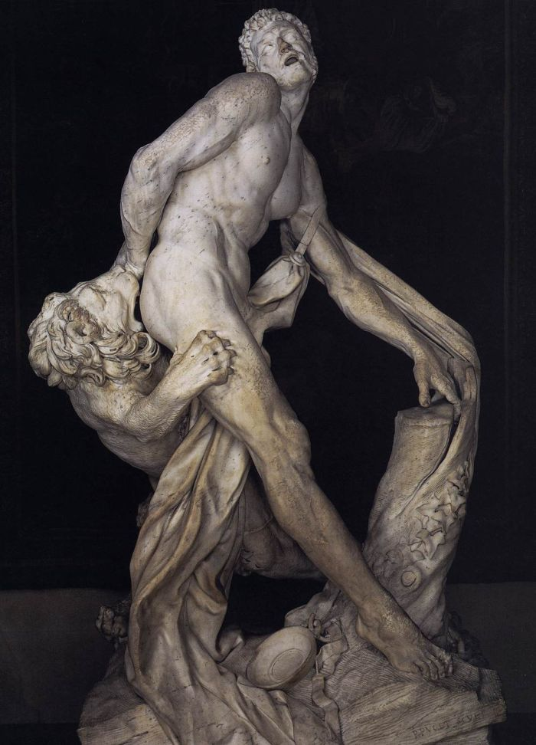
- “In ters of health of the body, then, it is clear that no other breed of men is as badly off as that of the athletes. One might, in fact surmise that athletes had been well named – from the word athlios – or that this word for “miserable” had derived from the word “athlete” – or perhaps that both take their name from a common source, the term athliotes, misery.” – Galen, Protrepticus
Figure 20 Base of a Funerary Kouros (both sides: young vs. injured athletes)
The Stupidity of Milo of Croton
- “Milo’s death bore witness to his stupidity. One day Milo saw a youth chopping wood lengthwise by the application of wedges. He laughed at the fellow and pushed him aside, reckoning to split it with his bare hands … in the end, failing to move quickly enough, Milo got his hands stuck as the two parts of the wood came together again. First of all, his hands were crushed; later they were the cause of Milo’s won miserable end. Much good his lifting of the dead bull in the stadium did to prevent his suffering!” – Galen, Protrepticus
  - An example of athletics does not cultivate intelligence
Two Types of Techne (Mental vs. Manual)
Figure 20 Milo of Croton, Puget 1682 CE
- “There are the high technai which are associated with reason, and there are less respected technai which are performed by bodily labour – the technai generally known as banausic or manual. The latter tends to give out when its practitioner reaches old age.” – Galen, Protrepticus

Philostratus’ Gymnasticus – The “Art of Athletics”
Philostratus’ Gymnasticus
- Philostratus (172 – 250 CE) part of the “Second Sophistic Movement”
- Gymnasticus is response to Galen’s attack on athletics
Introduction to Philostratus’ Gynasnticus – Not just Techne (Skill), but Sophia (knowledge)
- “Let us consider Sophia the following, namely philosophy, rhetoric, as well as an understanding of poetics, music, and geometry, and even astronomy, as long as it is within reason. But Sophia is also the ordering of an army, and still also such things as all forms of medicine and painting and sculpture, including the forms of statues both as shaped stone and hollow iron.
But concerning physical crafts, let techne be given to them also, a techne by which some instrument (or) object fulfills its purpose correctly. But still let Sophia be reserved for those practices alone, which I have named.
But concerning athletic training (gymnastike), let us consider it a Sophia less than no other techne,in so far as it has been established in treatises for those wishing to practice athletics.”
  - Gymnasticus claims that athletics (gymnastike) is not just a Techne (skill), but a Sophia (form of wisdom/knowledge)
- The Problem of the Tetrad
Gymnasticus 47“No attention should be given to the Tetrads of the training experts (gymnastai), because of which all aspects of gymnastikê have been destroyed.”
- “Coming into the gymnasium on the next day, he conceded to his coach that he was raw and badly disposed. But the coach was annoyed and listened with anger and, because the athlete relaxed and interrupted the tetrads, the coach was harsh with him until he killed him in his ignorance of training.” Death of gerenus

The Techne of Gymnastike – Between Trainer and Doctor
- “What should one know about gymnastike? What else other than that it be considered a Sophia composed from the crafts (technai) of medicine and Paidotribike, being more complete than the latter and a potion of the former.” – Gymnasticus
  - Gymnastike is a Sophia combined from the Technai of medicine and Paidotribike (physical education of the young)

The End of Ancient Athletics?

How do you reconcile Early Christianity with Roman Spectacle?
- Roman Spectacle was a major venue for Christian persecution; Damnatio ad Bestias
- Persecution began in 1st century CE with Nero
  - Tunica Molesta, people wrapped in animal skins thrown to dogs
  - Persecution moved to Arena, where punishment of Christians equivalent to the worst criminal offenders

- Christianity becomes the official religion of the Roman Empire under Emperor Constantine
How does Early Christianity reconcile with Roman Spectacle?
- “The entire apparatus of the spectacles originates from idolatry.”
“No one ever approaches a pleasure such as this without passion; no one experiences this passion without its damaging effects.” - Tertulian, De Spectaculis
- “Strength which is harmful or useless will never please you, and neither will body-building that goes beyond God’s creation … and wrestling is the work of the devil: he was the first to strike at men. He has the moves of a snake, he is tenacious at holding on, good at twisting and building up, but fluid at slipping away.” - Tertulian, De Spectaculis
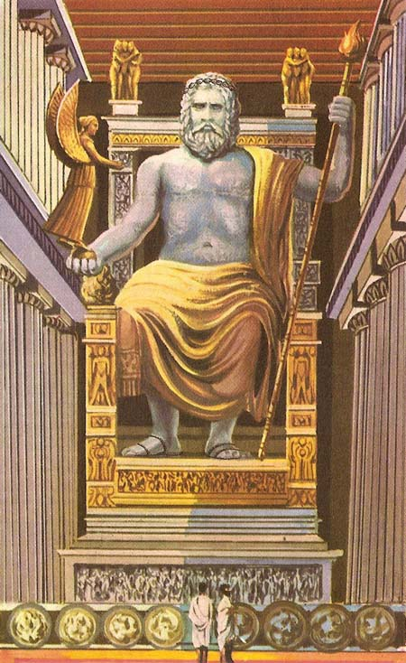
Religious Dimension of Ancient Athletics: Intolerance of Polytheistic Worship
- Constantine orders all gold, silver, and other precious metal to be removed from “pagan temples”
- Edict of 346 CE:
  - The closure of temples “in all places and in all cities” and threatening death and the confiscation of property for anyone who sacrificed.
- Similar policy by Theodosius I, the last emperor before split of Roman Empire
- 394/383 CE: popular date for end of Olympics
  - Based on Credenus, Byzantine Historian, writing in the 11th century CE
Figure 22 Pheidia's Zeus at Olympia
  - ‘Games ceased’ at the time when Theodosius I died
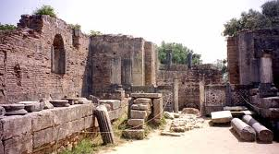
  - But it seems that games continued and only religious ceremonies ended
  - Statue of Olympian Zeus moved to Constantinole (Istanbul) to the Palace of Lausus (Early use of Greek religious iconography as “art”)
Alternative End Date for the Olympics
- 450 CE (Death of Theodosius II)
- “And the Olympics endured in first place down from the judges of the Hebrews until Theodosius the Younger. For a fire having broken out in the temple of Olympia, the assembly of the Elians abandoned it.”
Figure 23 Byzantine Church on site of Pheidias' Workshop
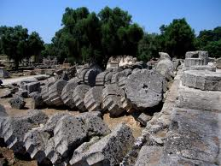
  - 450 CE is the alternative end date for Olympics, when a fire caused Eleans to abandon the site
Figure 24 Fallen Pillars at Temple of Olympian Zeus
- Earthquakes at Olympia: 522, 551 CE – caused Olympia to be completely abandoned
Continuation of Roman Spectacle?
- Gladiatorial Combat (Munera) decreased in popularity; chariot racing increased in popularity and became an Empire-sponsored spectacle (Teams no longer owned by private factions)
- Because Chariot Racing was linked to Imperial power, the church did not attack chariot racing
- Chariot racing continued in Constantinople (new capital of Roman empire starting with Constantine) until 4th crusade (“Sac of Constantionple) of 1204 CE
Figure 25 Victory monument for Porphyrius
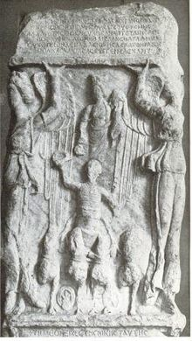
- Famous Byzantine Charioteer: Porphyrius
  - First charioteer to have victory monument while still living
  - Abused his popularity for politics?

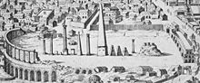
The Olympic Revival
Figure 26 Ruins of the Hippodrome in Constantinople
Greek War for Independence, 1821 – 1833
- War waged by Greek Revolutionaries in order for Greece to gain independence from the Ottoman Empire
- Greece was aided by Russia, United Kingdom, France, and others
- Greek War of Independence facilitated Philhellenism: “Love of Greece”
First Calls for Olympic Revival: Panagiotis Soustos
- Panagiotis Soustos, Poet and Reporter
- 1833 Poem: Dialogue of the Dead
- Leonidas: “You have matched us ancients in the bravery of the battle. Now match the old times in education and culture.
Bring back to your land the days of Miltiades and Themistocles.
Bring back the glorious days of Pericles …
And let the only contests that you have be those nation games, the Olympics, to which the olive branch once summoned the sons of Greece in ancient times.”
- 1851, another call for Olympics by Panagiotis: “England has made its influence known on the two hemispheres through its industrial expositions. Greece happens to have no power for that competition. But if Greece would reeastblish the Olympic Games … then the peoples of the world would respect Greece.”
  - Greece’s glory through sport vs. London’s power of industry
Olympic Inspiration in England
- 1850 – William Penny Brookes holds sporting event of “Olympian class” in England (but not revival per se)
Olympic Revival and Internationalization
- 1858 – Brooks reads about revival of Olympic Games in Greece, inspired by Soustos and Zappas
  - First Zappas Olympics (official revival)
  - Other Olympic-inspired events held in England and Athens
- 1880, Brookes formally proposes International Olympics: Athletes of various nations “contending in a generous rivalry with athletes of other nations in the time-consecrated stadium at Athens”
Pierre De Coubertin and “Physical Education”
- Pierre de Coubertin (eventually) takes up Brookes’ pursuit for International Olympics
Coubertin and Olympic Revival
- 1894 – Congress of Paris, framed as a call for reform
- 1896 - Creation of the international Olympic Committee and decision made to hold first Olympics in Athens
The First Modern Olympics – Athens, 1896
- Most notable Men’s athletic even: Men’s Marathon (from Marathon to Athens)
- Winner: Spyridon Louis (Greece)
An Unacknowledged Female Athlete
- Women were not allowed to compete in the 1896 Olympics
- On April 11th, day after the official Marathon: Stamata Revithi ran the Marathon course (5 hours and 30 minutes)
- Women not part of the official Olympic Marathon until 1984
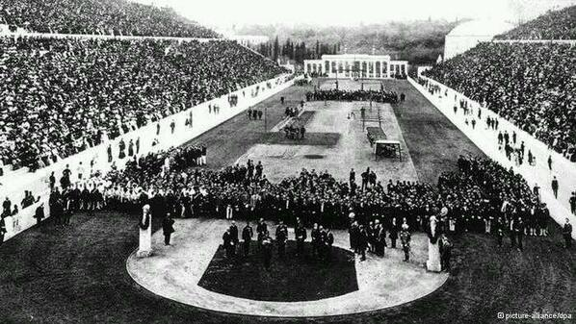
“Athletics” at the 1896 Olympics (Track and Field)
Figure 27 Panathenaic Stadium
- First ever International Competition in Discus
- Robert Garratt (USA, Princeton Student) – 1st place
  - Trained with 10kg discuss and gave up b/c it was too heavy
  - Entered the competition when he discovered that competition discus was only 2kg
Other Events at the 1896 Olympics
- An Exception to principle of Amateurism: Fencing
  - Professionals allowed to compete in separate event
The Medal Ceremony of 1896 Olympics
- Victors did not receive Gold, Silver, and Bronze medals
- 1896 victors received Silver Medal, Olive Branch, and Diploma
- Medals: Zeus holding Nike, goddess of Victory; reverse side: Athenian Acropolis
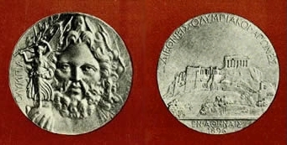
Pierre De Coubertin Closing Thoughts on the Games: From Panhellenism to Internationalism
- “The Olympic Games which recently took place in Athens were modern in character, not only because of their programs, which substituted bicycle for chariot races and fencing for the brutalities of pugilism, but because in their origin and regulations they were international and universal, and consequently adapted to the conditions in which athletics have developed to the present day.”
Olympism: A Modern Religion of the Body
- “The primary, fundamental characteristic of ancient Olympism, and of moderm Olympism as well, is that it is a religion. By chiseling his body through exercise as a sculptor does a statue, the ancient athlete “honored the gods”. In doing likewise, the modern athlete honors his country, his ace, and his flag. Therefore, I believe that I was right to restore, from the very beginning of modern Olympism, a religious sentiment transformed and expanded by the internationalism and democracy that are distinguishing features of our day. Yet this is the same religious sentiment that led the young Hellenes, eager for the victory of their muscles, to the foot of the altars of Zeus.” – Coubertin, The Philosophic Foundation of Modern Olympism
Coubertin’s “Olympism”
- Themes of Olympism from Pierre De Coubertin
  - Hellenism required as an antidote to the ugliness of the industrial age
  - Modern Religion of the Body: “By chiseling his body through exercise as a sculptor does a statue, the ancient athlete “honored the gods”. In doing likewise, the modern athlete honors his country, his race, and his flag.”
  - Eurythmia: Proper proportion and Balance (similar to symmetrical. Olympism as eurythmia of life.
  - Male Elitism: Pierre de Coubertin against female participation in the Olympics: First Female compeittions: 1900; Alternative Body Culture: Bodybuilding
Eugen Sandow – “Living Greek Sculpture”
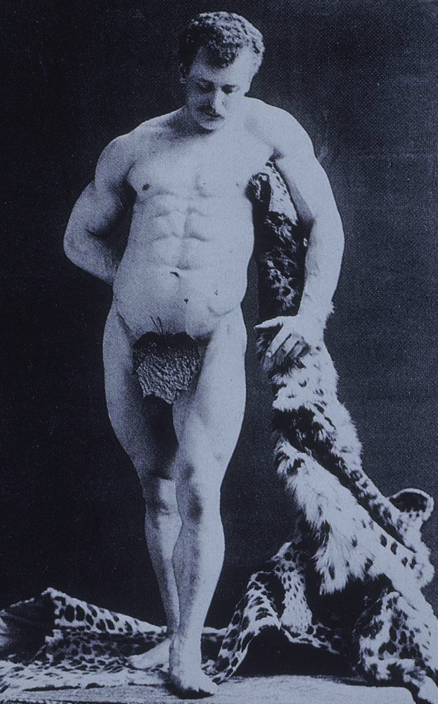
Figure 28 Sandow as the Farnese Heracles, 1893
Sandow on Physical Training (1894)
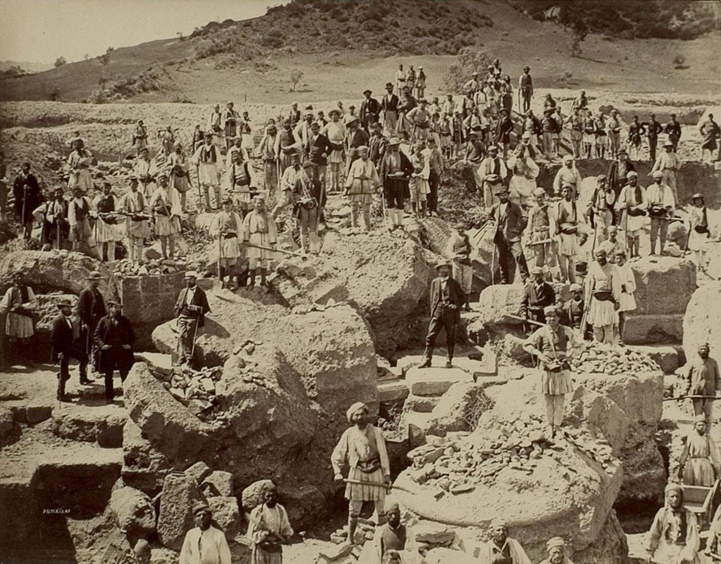
- “My notion about the ancients – and remember, their wrestling is just as we have it in all results – is that they were not a bit better men than there are now living, but that occasionally they found a man incomparably better than his fellows. The classical statues are all idealized – the complete dream of the artist who found in individuals some perfect parts, and shaped a form in which no ingenuity could pick a flaw. Of course, that a Hercules or Venus may have been is not impossible: in beauty or strength nothing is impossible, but we don’t see such men or women everywhere.”
Germany and Olympia
- From 1875 – 1881, Major Excavations of Olympia began in the by the German Archeaological Institute at Athens
Leni Riefenstahl’s Olympia
- Documentary of the 1936 Olympics
- Beings with ruins in Athens; Statues; Myron’s Discobolus -> German Athlete
International Olympic Committee: Olympic Torch Relay
- Berlin 1936 Olympics – First Torch Relay for the Olympics
- Symbol of world piece or another piece of Nazi propaganda?
The First Olympic Torch Relay – The Nazi Interpretation
- “In a few minutes the torch bearer will appear to light the Olympic fire on his tripod, when it will rise flaming to heaven, for the weeks of the festival. It creates a real and spiritual bond of fire between out German faterhland and the sacred places of Greece founded nearly 4,000 years ago by Nordic immigrants.” – Dr. Theodor Lewald, Chair of German Olympic Organizing Committee
The First Olympic Torch Relay – Coubertin’s Interpretation
- “The route begins, moreover, in the most illustrious of all places, under the sign of eternal Hellenism that continues to shine on the path of ages, whose ancient solutions still apply today to many a present day problem.” – Coubertin
Jesse Owens
- Major Athletic (and ideological) victories in Berlin 1936 Olympics
- 1st day: Hitler shook hands with German victors but no one else) – IOC demanded he greet all or none
- Jesse Owens: “Hitler didn’t snub me – it was FDR who snubbed me. The president didn’t even send me a telegram.”
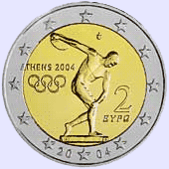
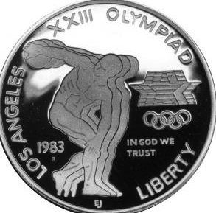
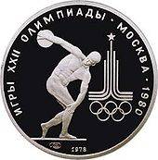
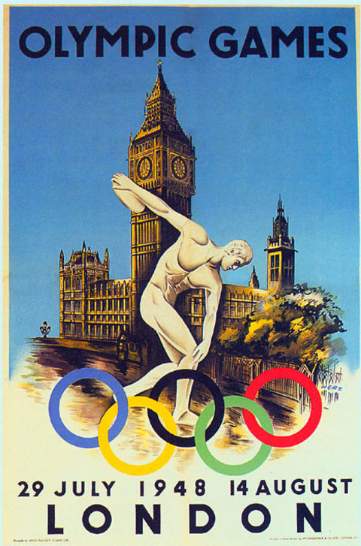
Figure 29 Coin from 2004 Olympics
Figure 29 Coin from 1984 Olympics
Figure 29 Coin from 1980 Olympics
Figure 29 London 1948 Olympics - Discobolus in front of Big Ben

- Cold War Games: Moscow 1980 Olympics vs. Los Angeles 1984 Olympics
Athens 2004 Olympics: Reclaiming Hellenism
- Athens and the Debt Jaques Rogge, IOC President: “You can fairly say that the 2004 Games played their part. If you look at the external debt of Greece, there could be up to 2 to 3 percent of that which could be attributed to the Games.”

