Cycle 3: Pre-Lecture Reading

Mechanisms that Correct Replication Errors
- DNA polymerases make very few errors as they assemble new molecules.
- The errors that do occur are called base-pair mismatches.
- Base-pair mismatches are an error in the assembly of a new nucleotide chain in which bases other than the correct ones pair together.
- Corrected either by a proofreading mechanism carried out during replication by DNA polymerases themselves or by a DNA repair mechanism that corrects mismatched base pairs after replication is complete.

PROOFREADING

- The proofreading mechanism is a mechanism of DNA polymerase to back up and remove mispaired nucleotides from a newly synthesized DNA strand.
- First proposed by Arthur Kornberg and Douglas L. Brutlag.
- Depends on the ability of DNA polymerases to back up and remove mispaired nucleotides from a DNA strand.
- DNA polymerases can only add nucleotides to a growing chain when the most recently added base is correctly paired with its complementary base on the template strand.
- The correct pairs allow fully stabilizing hydrogen bonds to form.
- If it’s mismatched, the DNA polymerase reverses using a built-in deoxyribonuclease to remove the newly added incorrect nucleotide.
- The enzyme resumes working forward, now inserting the correct nucleotide.

DNA REPAIR
- DNA repair corrects errors that escape proofreading.
- DNA repair mechanisms are a mechanism to correct base-pair mismatches that escape proofreading.
- Mispaired bases are too large or small to maintain the correct separation, and they cannot form the hydrogen bonds characteristic of the normal base pairs.
- Therefore, base mismatches distort the structure of the DNA helix.
- These distortions provide recognition sites for the enzymes catalyzing mismatch repair.
- The repair enzymes move along the double helix, “scanning” the DNA for distortions in the newly synthesized nucleotide chain.
- If the enzymes encounter a distortion, they remove a portion of the chain, including the mismatched nucleotides.
- The gap left by the removal is then filled by a DNA polymerase, using the template strand as a guide.
- The repair is completed by a DNA ligase, which seals the nucleotide chain into a continuous DNA molecule.
- The same repair mechanisms also detect and correct alterations in DNA caused by damaging effects of chemicals and radiation (UV light in sunlight).
- Replication errors that remain in DNA after proofreading and DNA repair are a primary source of mutations, differences in DNA sequence that appear and remain in the replicated copies.
- Mutations are spontaneous and heritable changes in DNA.
- When a mutation occurs in a gene, it can alter the property of the protein encoded by the gene, which, in turn, may alter how the organism functions.
- Mutations are highly important to the evolutionary process because they are the ultimate source of the variability in offspring acted on by natural selection.

MOBILE ELEMENTS
- All organisms appear to contain particular segments of DNA, called mobile elements, that can move from one place to another.
- They cut and paste sections of DNA using a type of recombination that does not necessarily require homology.
- The elements normally move from place to place within the genome of a given cell.

INSERTION SEQUENCE ELEMENTS AND TRANSPOSONS
- Insertion sequence elements and transposons are the two major types of prokaryotic mobile elements.
- Mobile elements are also known by the more specific term transposable elements (TEs).
- Their mechanism of movement, involving nonhomologous recombination, is called transposition.
- Transposition usually occurs at a low frequency in either of two ways:
  - A cut and paste process, in which the TE leaves its original location and transposes to a new location.
  - A copy and paste process, in which a copy of a TE transposes to a new location, leaving the original TE behind.
- For most TEs, transposition starts with contact between the TE and the target site.
- Therefore, TEs do not exist free of the DNA in which they are integrated; hence, the popular name jumping genes is actually inaccurate.
  - TEs are never in the air between one location and another.
  - TEs are important because of the genetic changes they cause.
  - TEs are biological mutagens that increase genetic variability.
- There are two major types of bacterial TEs:
  - Insertion sequences (ISs)
  - Transposons
- Insertion sequences are the simplest TEs. They are small and contain only genes for their transposition, notably the gene for transposase, an enzyme that catalyzes some of the recombination reactions for inserting or removing the TE from DNA.
- At each of the two ends of an IS is a short inverted repeat sequence - the same DNA sequence running in opposite directions.
- Inverted repeat enables the transposase enzyme to identify the ends of the transposable element when it catalyzes transposition.
- The second type - Transposons have an inverted repeat sequence at each end enclosing a central region with one or more genes.
- In a number of bacterial transposons, the inverted repeat sequences are insertion sequences, which provide the transposase for movement of the element.
- Additional genes in the central region typically code for antibiotic resistance - they can originate from the main bacterial chromosome or from plasmids.
- The non-IS genes included in transposons are carried along as the TEs move from place to place.
- Many antibiotics which were once successful in curing bacterial infections have lost much of their effectiveness because of resistance genes carried in transposons.
- Movements of the transposons, particularly to plasmids that can be transferred by conjugation within and between bacterial species, greatly increase the spread of genes, providing antibiotic resistance to infecting cells.

DISCOVERY OF TRANSPOSABLE ELEMENTS
- TEs were first discovered in Eukaryotes.
- They were first discovered in a eukaryote, maize (corn), in the 1940s by Barbara McClintock.
- McClintock noted that some mutations affecting kernel and leaf colour appeared and disappeared rapidly under certain conditions.
- Mapping the alleles by linkage studies produced a surprising result: the map positions changed frequently, indicating that the alleles could move from place to place in the corn chromosomes.

TWO TYPES OF EUKARYOTIC TRANSPOSABLE ELEMENTS
- Eukaryotic TEs fall into two major classes:
  - Transposons
  - Retrotransposons
- Distinguished by the way the TE sequence moves from place to place in the DNA.
- Eukaryotic transposons are similar to bacterial transposons in their general structure and in the ways they transpose.
- Retrotransposons are transposable elements that transpose via an intermediate RNA copy of the transposable DNA
- Retrotransposons transpose by a copy-and-paste mechanism that is unlike any of the other TEs we have discussed.
- Retrotransposons are named this because transposition occurs via an intermediate RNA copy of the TE:
  - First, the retrotransposon, which is a DNA element integrated into the chromosomal DNA, is transcribed into a complementary RNA copy.
  - Next, an enzyme called reverse transcriptase, which is encoded by one of the genes of the retrotransposon, uses the RNA as a template to make a DNA copy of the retrotransposon.
  - The DNA copy is then inserted into the DNA at a new location, leaving the original in place. This step involves breaking and rejoining DNA backbones.
  - Once TEs are inserted into chromosomes, they become more or less permanent residents, duplicated and passed on during cell division along with the rest of the DNA.
  - TEs inserted into the DNA of reproductive cells may be inherited, thereby becoming a permanent part of the genetic material of a species.

RETROTRANSPOSONS ARE SIMILAR TO RETROVIRUSES
- The RNA to DNA reverse transcription associated with retrotransposon movement is strikingly similar to that employed by a class of eukaryotic viruses called retroviruses.
- A retrovirus is a virus with an RNA genome that replicates via a DNA intermediate,
- When a retrovirus infects a host cell, a reverse transcriptase carried in the virus particle is released and copies the single-stranded RNA genome into a double-stranded DNA copy.
- The viral DNA is then inserted into the host DNA (by genetic recombination), where it is replicated and passed to progeny cells during cell division.
- Similar to the prophage of bacteria, the inserted viral DNA is known as provirus.
- Some retroviruses cause DNA rearrangements such as deletions and translocations.
- Such changes may alter the relative position of DNA sequences on the chromosome and, in turn, disturb the normal regulation of gene expression.

MECHANISM OF GENETIC RECOMBINATION
- Genetic recombination requires the following:
  - Two DNA molecules that differ from one another
  - A mechanism for bringing the DNA molecules into close proximity
  - A collection of enzymes to “cut”, “exchange”, and “paste” the DNA back together
- Most of the recombination discussed occurs between regions of DNA that are very similar, but not identical, in the sequence of bases. Such regions, which may be as short as a few base pairs or as long as an entire chromosome, are called homologous.
- Homology allows different DNA molecules to line up and recombine precisely.
- Once homologous regions of DNA are paired, enzymes break a covalent bond in each of the four sugar-phosphate backbones. The free ends of each backbone are then exchanged and reattached to those of the other DNA molecule.
- The result is two recombined molecules in which the original red DNA is now covalently bound to the blue DNA, and vice versa.

GENETIC RECOMBINATION IN EUKARYOTES: MEIOSIS
- Sexual production is the mode of reproduction in which male and female parents produce offspring through the union of egg and sperm generated by meiosis.
- Gamete is a haploid cell; an egg or sperm. Haploid cells fuse during sexual reproduction to form a diploid zygote.
- Meiosis is a specialized process of cell division that recombines DNA sequences and produces cells with half the number of chromosomes present in the somatic cells of a species.
- The somatic cells are any of the cells of an organism’s body other than reproductive cells.
- At fertilization, the nuclei of an egg and a sperm cell fuse, producing a cell called the zygote, in which the chromosome number typical of the species is restored.
- A zygote is a fertilized egg.
- Both meiosis and fertilization also mix genetic information into new combinations; thus, none of the offspring of a mating pair are likely to be genetically identical to either their parents or their siblings.

MEIOSIS OCCURS IN DIFFERENT PLACES IN DIFFERENT ORGANISMAL LIFE CYCLES
ANIMALS
- Diploid phase dominates the life cycle.
- The haploid phase is reduced.
- Meiosis is followed directly by gamete formation.
- In male animals, each of the four nuclei produced by meiosis is enclosed in a separate cell by cytoplasmic divisions, and each of the four cells differentiates into a functional sperm cell.
- In female animals, only one of the four nuclei becomes functional as an egg cell nucleus.
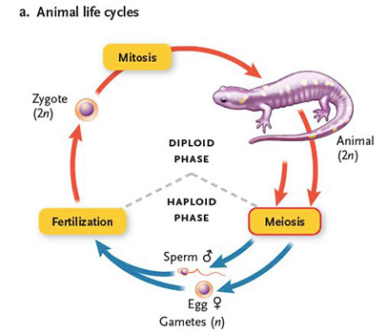
- Fertilization restores the diploid phase of the life cycle.
- Thus, animals are haploids only as sperm or eggs.
- No mitotic divisions occur during the haploid phase of the life cycle.

MOST PLANTS AND SOME FUNGI
- These organisms alternate between haploid and diploid generations in which, depending on the organism, either generation may dominate the life cycle.
- Mitotic divisions occur in both phases.
- Fertilization produces the diploid generation, in which the individuals are called sporophytes.
- A sporophyte is an individual of the diploid generation produced through fertilization in organisms that undergo alternation of generations; it produces halpoid spores.
- After the sporophytes grow to maturity by mitotic divisions, some of their cells undergo meiosis, producing haploid, genetically different, reproductive cells called spores.
- A spore is a haploid reproductive structure, usually a single cell, that can develop into a new individual without fusing with another cell; found in plants, fungi, and certain protists.
- The spores are not gametes; they germinate and grow directly by mitotic divisions into a generation of haploid individuals called gametophytes.
- A gametophyte is an individual of the haploid generation produced when a spore germinates and grows directly by mitotic divisions in organisms that undergo alternation of generations.
- At maturity, the nuclei of some cells in gametophytes develop into egg or sperm nuclei.
- All the egg/sperm nuclei produced by a particular gametophyte are genetically identical because they arise through mitosis - meiosis does not occur in gametophytes.
- Fusion of a haploid egg and sperm nucleus produces a diploid zygote nucleus that divides by mitosis to produce the diploid sporophyte generation again.
- In all plants (except bryophytes), the diploid sporophyte generation is the most visible part of the plant.
- The gametophyte generation is reduced to an almost microscopic stage that develops in the reproductive parts of the sporophytes - in flowering plants, in the structures of the flower.
- The female gametophyte remains in the flower; the male gametophyte is released from flowers as microscopic pollen grains.
- When pollen contacts a flower of the same species, it releases a haploid nucleus that fertilizes a haploid egg cell of a female gametophyte in the flower.
- The resulting cell, the zygote, reproduces by mitosis to form a sporophyte.
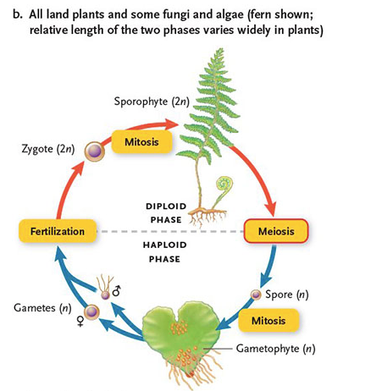
- Ex: Sphagnum moss is a good example of a plant in which the gametophyte is the most visible and familiar stage of the life cycle.

Most fungi
- Life cycle of most fungi and algae follows the third life cycle pattern.
- The diploid phase is limited to a single cell, the zygote, produced by fertilization.
- Immediately after fertilization, the diploid zygote undergoes meiosis to produce the haploid phase.
- Mitotic divisions only occur in the haploid phase.
- “Haploid life cycle”
- During fertilization, two haploid gametes, usually designated simply as positive (+) and negative (-) because they are similar in structure, fuse to form a diploid nucleus.
- This nucleus immediately enters meiosis.
- Produces four haploid cells.
- These cells develop directly or after one or more mitotic divisions into haploid spores.
- These spores germinate to produce haploid individuals which grow or increase in number by mitotic divisions.
- Eventually positive and negative gametes are formed in these individuals by differentiation of some of the cells produced by the mitotic divisions.
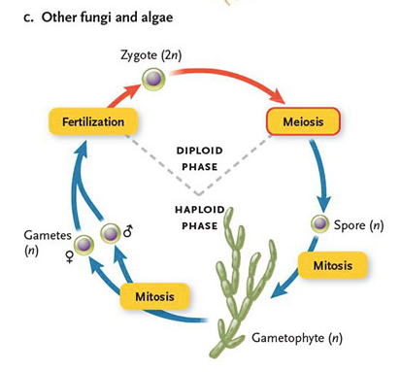
- Because the gametes are produced by mitosis, they’re all identical.

MEIOSIS CHANGES BOTH CHROMOSOME NUMBER AND DNA SEQUENCE

- Essence of mitotic cell division is sameness.
- I.e in mitosis they produce same number of chromosomes, with the same DNA sequence, as the cell that began the process.
- The essence of meiosis is difference - two kinds of difference:
  - Halved chromosome number
  - Recombined chromosomal DNA sequence
- Products of meiosis are not intended to contribute to the body of the organisms that make them.
- In multicellular animals and plants, you would find that meiosis occurs only in specialized tissues that produce gametes and spores.
- The two representatives of each chromosome in a diploid cell constitute a homologous pair - they have the same genes, arranged in the same order, in the DNA of the chromosomes.
- One chromosome of each homologous pair, the paternal chromosome, is derived from the male parent of the organism.
- The other chromosome, the maternal chromosome is derived from its female parent.
- Although two homologous chromosomes carry the same genes arranged in the same order, different versions of these genes - alleles - may be present on either chromosome.
- Meiosis reduces diploid to haploid (2n to n).
- Genetic recombination of the actual DNA sequence on chromosomes.
- Recombination involves the precise breaking of covalently bonded DNA backbones, exchanging the “ends” with those of the other homologue and reforming the bonds.
- As a result, each chromosome passed on to offspring is composed of a novel mixture of both maternal and paternal DNA sequence.

MEIOSIS PRODUCES FOUR GENETICALLY DIFFERENT DAUGHTER CELLS

- Meiocytes are cells that are destined to divide by meiosis.
- They move through their last turn of the cell cycle as usual, replicating DNA and making more chromosomal proteins during S phase.
- The resulting G2 cells carry replicated chromosomes, each composed of two identical sister chromatids.
- Following this eremitic interphase, cells enter the first of the two meiotic divisions: meiosis I and meiosis II.
- During meiosis I, chromosomes behave dramatically differently than they do during mitosis.
- In early meiosis I, homologous chromosomes find their partners and pair lengthwise, gene for gene, in a process called synapsis.
- During this intimate pairing, recombination occurs, and chromosomal segments are exchanged.
- As the meiocyte continues through to the end of the first division, the members of each homologous pair are moved into one or the other two daughter cells.
- These daughter cells still contain replicated chromosomes (composed of two chromatids each).
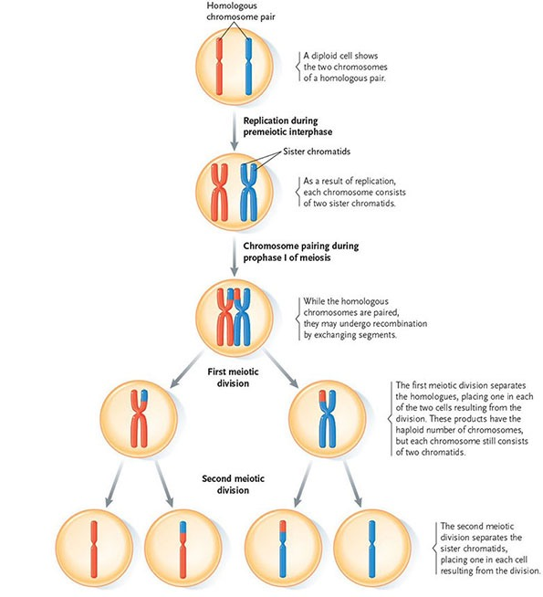
- However the number of such chromosomes is only half that of the original meiocyte.
- That is, the cells now have the haploid number of chromosomes but each chromosome still has two chromatids.
- During the second meiotic division, meiosis II, the sister chromatids are separated into different cells, further reducing the amount of DNA in each product of meiosis.
- A total of four cells, each with the haploid number of chromosomes and a novel collection of alleles, is the final result of the two meiotic divisions.
- A brief interphase called interkinesis separates the two meiotic divisions, but no DNA replication occurs.

prophase I

- At the beginning of prophase I, the replicated chromosomes, each consisting of two sister chromatids, begin to fold and condense into threadlike structures in the nucleus.
- The two chromosomes of each homologous pair then come together and line up side by side in a zipper like way; this process is called pairing or synapsis.
- The fully paired homologues are called tetrads, referring to the fact that each homologous pair consists of four chromatids.
- Note that chromosomes do not behave like this in mitosis.
- While they are paired, the chromatids of homologous chromosomes physically exchange segments.
- This physical exchange, genetic recombination, is the step that mixes the alleles of the homologous chromosomes into new combinations and contributes to the generation of variability in sexual reproduction.
- As prophase I finishes, a spindle forms in the cytoplasm.

proMETAPHASE i

- The nuclear envelope breaks down and the spindle enters the former nuclear area.
- The two chromosomes of each pair attach to kinetochore microtubules that are anchored to opposite spindle poles.
- That is, both sister chromatids of one homologue attach to microtubules leading to one spindle pole, whereas both sister chromatids of the other homologue attach to microtubules leading to the opposite poles.

METAPHASE I and ANAPHASE I

- At metaphase I, movements of the spindle microtubules have aligned the recombined tetrads on the equatorial plane - the metaphase plate - between the two spindle poles.
- Then, the two chromosomes of each homologous pair separate and move to opposite spindle poles during anaphase I.
- The movement segregates homologous pairs, delivering a haploid set of chromosomes to each pole of the spindle.
- However, all the chromosomes at the poles are still double structures composed of two sister chromatids joined at their centromeres.

TELOPHASE I AND INTERKINESIS

- Telophase I is a brief, transitory stage in which there is little or no change in the chromosomes.
- New nuclear envelopes form in some species but not in others.
- Followed by an interkinesis in which the single spindle of the first meiotic division disassembles and the microtubules reassemble into two new spindles for the second division.
- Recall that there is no DNA replication between the first and second division.

PROPHASE II, PROMETAPHASE II, AND METAPHASE II

- During prophase of meiosis II, the chromosomes condense.
- During pro metaphase II, the nuclear envelope breaks down, the spindle enters the former nuclear area, and spindle microtubules leading to opposite spindle poles attach to the two kinetochores of each chromosome.
- At metaphase II, movements of the chromosomes within the spindle bring them to rest at the metaphase plate.

ANAPHASE II AND TELOPHASE II

- Anaphase II begins as the sister chromatids of each chromosome separate from each other and move to opposite spindle poles.
- At the completion of anaphase II, the separated chromatids - now called chromosomes - have been segregated to the two poles.
- During telophase II, the chromatids decondense to the extended interphase state, the spindles disassemble, and new nuclear envelopes form around the masses of chromatin.
- The result is four haploid cells, each with a nucleus containing half the number of chromosomes present in the cell at the beginning of meiosis.

Failure in chromosome segregation

- Rarely, chromosome segregation fails at either meiosis I or II.
- Ex: during meiosis I, both chromosomes of a homologous pair may connect to the same spindle pole in anaphase I. In the resulting nondisjunction, as it is called, the spindle fails to separate the homologues chromosomes of the tetrad. As a result, one pole receives both chromosomes of the homologous pair, whereas the other pole has no copies of that chromosome. Meiosis II will proceed to separate the chromatids of the extra chromosome as usual, with the result that gametes will have two copies of this chromosome (instead of one).
- A failure at meiosis II, in which chromatids do not separate to opposite poles, also results in gametes with abnormal numbers of chromosomes.
- Zygotes that receive an extra chromosome from an abnormal gamete therefore have three copies of a given chromosome instead of two.
- In humans, most zygotes of this kind do not result in live births.
- One exception is Down Syndrome - three copies of chromosome 21.

SEX CHROMOSOMES

- One or more pairs of chromosomes, called the sex chromosomes, are different in male and female individuals of the same species.
- Ex: in fruit flies, the cells of females contain a pair of sex chromosomes called the XX pair. Male flies contain a pair of sex chromosomes that consist of on X chromosome and a smaller chromosome called the Y chromosome.

SEVERAL MECHANISMS CONTRIBUTE TO GENETIC DIVERSITY

- The variability produced by sexual reproduction is apparent all around us, particularly in the human population. Except for identical twins, no two humans look alike, act alike, or have identical biochemical and physiological characteristics, even if they are members of the same immediate family.
- Other species that reproduce sexually show equivalent variability arising from meiosis.
- During meiosis and fertilization, genetic variability arises from four sources:
  - Genetic recombination of homologous chromosomes
  - The differing combinations of maternal and paternal chromosomes segregated to the poles during anaphase I
  - The differing combinations of recombinant chromatids segregated to the poles during anaphase II
  - The particular sets of male and female gametes that unite in fertilization
- The four mechanisms, working together, produce so much total variability that no two products of meiosis produced by the same or different individuals and no two zygotes produced by union of the gametes are likely to have the same genetic makeup.
- Each of these sources of variability is discussed in further detail in the following sections.

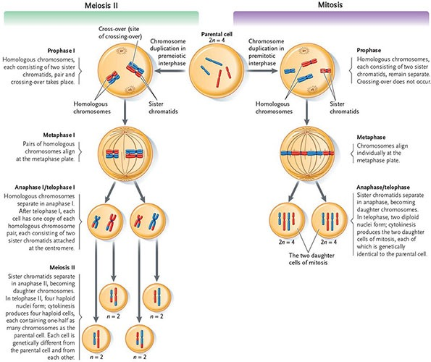
GENETIC RECOMBINATION
- Recombination is the key genetic event of prophase I.
- Starts when homologous chromosome pair.
- As the homologous chromosomes pair, they are held together tightly by a protein framework called the synaptonemal complex.
- Supported by this framework, regions of homologous chromatids exchange segments, producing new combinations of alleles.
- Recall that the exchange process is very precise and involves the breakage and rejoining of DNA molecules by enzymes.
- When the exchange is complete toward the end of prophase I, the synaptonemal complex disassembles and disappears.
- Each of the four resulting nuclei receives one of these four chromatids; two receive unchanged “parental chromatids” and two receive chromatids that have new combinations of alleles due to recombination - these are called recombinants.
- The physical effect of recombination can be seen later in prophase I, when increased condensation of the chromosomes thickens the chromosomes enough to make them visible under the light microscope.
- Regions in which nonsister chromatids cross one another, called cross-overs or chiasmata, clearly show that two of the four chromatids have exchanged segments.
- Because of the shape produced, the recombination process is also called crossing-over.

Random segregation

- Random segregation of chromosomes of maternal and paternal origin accounts for the second major source of genetic variability in meiosis.
- During pro metaphase I, spindle microtubules make connections to kinetochores.
- For each homologous pair, one chromosome makes spindle connections leading to one pole and the other chromosome connects to the opposite pole in a random choice.
- In making these connections, all the maternal chromosomes may connect to one pole and all the paternal chromosomes may connect to the opposite pole.
- Or, as is much more likely, a random combination of maternal and paternal chromosomes will be segregated to a given spindle pole.
- The number of possible random combinations depends on the number of chromosome pairs in a species.
- Ex: the 39 chromosome pairs in dogs allow 2^39 different combinations of maternal and paternal chromosomes to be delivered to the poles.
- This random partitioning of maternal and paternal chromosomes is responsible for the independent assortment of the alleles of two genes in Mendel’s experiments with garden peas.

Alternative combinations at meiosis ii

- If you look carefully at the cells drawn in metaphase II, you will see that the chromosomes are still replicated, and, as a result of recombination in prophase I, each chromosome carries one recombinant chromatid and one nonrecombinant chromatid.
- Notice that, in this case, the chromosomes have aligned at metaphase II with both recombinant chromatids attached to the same spindle pole.
- However, since the attachment of spindles to kinetochores is random at this stage, you should be able to see that it is just as likely that these chromosomes could have lined up, with the smaller chromosome sending its recombinant chromatid to one pole and the larger chromosome sending its recombinant chromatid to the opposite pole.
- The resulting daughter cells will be genetically different, depending on how the chromosomes align in metaphase II.

Random fertilization

- The haploid products of meiosis are genetically diverse.
- The random combination of these cells (or their descendants) during fertilization is a matter of chance that amplifies the variability of sexual reproduction.
- Through genetic recombination and random separation of maternal and paternal chromosomes, meiosis produces genetic variability in gametes; further variability is provided by the random combination of gametes in fertilization.

Mendel, Genes, and Inheritance
Mendel chose true-breeding garden peas for his experiments

- Mendel chose the garden pea for his research because the plant could be grown easily in the monastery garden, without elaborate equipment.
- Gametes are produced in structures of the flowers.
- The male gametes are sperm nuclei contained in the pollen, which is produced in the anthers of the flower.
- The female gametes are egg cells, produced in the carpel of the flowers.
- Normally, pea plants self-fertilize: sperm nuclei in pollen produced by anthers fertilize egg cells housed in the carpel of the same flower.
- However, for his experiments, Mendel prevented self-fertilization by cutting off the anthers.
- Pollen to fertilize these flowers then had to come from a different plant.
- This is called cross-pollination.
- To begin his experiments, Mendel chose pea plants that were known to be true-breeding, that is, when self-fertilized they passed traits without change from one generation to the next.

Mendel first worked with single character crosses

- Flower colour was among the seven characters Mendel selected for study; one true-breeding variety of peas had purple flowers, and the other had white flowers.
- Would these traits blend evenly if plants with purple flowers were cross-pollinated with plants with white flowers?
- The plants that develop from the seeds produced by the cross - the first generation of offspring (F1 generation).
- The plants used in the initial cross are called the parental or P generation.
- The plants that grew from the F1 seeds all formed purple flowers, as if the trait for white flowers had disappeared.
- He then created an F2 generation and got purple and white flowers.
- Ratio was 3:!, 75% purple flowered plants.

Mendel’S SINGLE CHARACTER CROSSES LED HIM TO PROPOSE THE PRINCIPLE OF SEGREGATION

- His first hypothesis was that the adult plants carry a pair of factors that govern the inheritance of each character.
- Mendel deduced that the trait that had seemed to disappear in the F1 generation was actually present but was masked in some way by the “stronger” allele.
- Mendel called the masking effect dominance.
- Second hypothesis: if an individual’s pair of genes consists of different alleles, one allele is dominant over the other, recessive, allele.
- Third hypothesis: the pairs of alleles that control a character segregate as gametes are formed; half the gametes carry one allele, and the other half carry the other allele.
- This hypothesis is now known as Mendel’s principle of segregation.
- During fertilization, fusion of the haploid maternal and paternal gametes produces a diploid nucleus called the zygote nucleus.
- The zygote nucleus receives on allele for the character from the male gamete and one allele for the same character from the female gamete, reuniting the pairs.
- An F1 heterozygote produced from a cross that involves a single character is called a monohybrid.
- A cross between two individuals that are each heterozygous for the same pair of alleles - Pp x Pp here - is called a monohybrid cross.
- Genotype refers to the genetic constitution of an organism.
- Phenotype refers to its outward appearance.
- Thus the results of Mendel’s crosses support his three hypotheses:
  - The genes that govern genetic characters are present in two copies in individuals.
  - If different alleles are present in an individual’s pair of genes, one allele is dominant over the other.
  - The two alleles of a gene segregate and enter gametes singly.

Mendel could predict both classes and proportions of offspring from his hypotheses

- The sex of one child has no effect on the sex of the next child; therefore, the probability of having four girls in a row is the product of their individual probabilities.

Mendel used a testcross to check the validity of his hypotheses

- Mendel realized that he could assess the validity of his hypotheses by determining whether they could be used successfully to predict the outcome of a cross of a different type than he had tried so far.
- A cross between an individual with the dominant phenotype and a homozygous recessive individual, such as the one described, is called a testcross.
- Genetics use a testcross as a standard test to determine whether an individual with a dominant trait is a heterozygote or a homozygote.
Mendel tested the independence of different genes in crosses

- Mendel next asked what happens in crosses when more than one character is involved. Would the alleles of different characters be inherited independently, or would they interact to alter their expected proportions in offspring?
- To answer these questions, Mendel crossed parental stocks that had differences in two of the hereditary characters he was studying: seed shape and seed colour.
- His single-character crosses had shown that each was controlled by a pair of alleles.
- A zygote produced from a cross that involves two characters (RR YY x rr yy) produces a dihybrid.
- Independent assortment is Mendel’s principle that the alleles of the genes that govern two characters segregate independently during formation of gametes.
- Mendel’s first three hypotheses provided a coherent explanation of the pattern of inheritance for alternative traits of the same character, such as purple and white for flower colour. His fourth hypothesis, independent assortment, addressed the inheritance of traits for different characters, such as seed shape, seed colour, and flower colour, and showed that, instead of being inherited together, the traits of different characters were distributed independently to offspring.

SUTTON’S CHROMOSOMES THEORY OF INHERITANCE RELATED MENDEL’S GENES TO CHROMOSOMES

- Walter Sutton recognized the similarities between the inheritance of the genes discovered by Mendel and the behaviour of chromosomes in meiosis and fertilization.
- Sutton drew all the necessary parallels between genes and chromosomes:
  - Chromosomes occur in pairs in sexually reproducing, diploid organisms, as do the alleles of each gene.
  - The chromosomes of each pair are separated and delivered singly to gametes, as are the alleles of a gene.
  - The separation of any pair of chromosomes in meiosis and gamete formation is independent of the separation of other pairs, as in the independent assortment of the alleles of different genes in Mendel’s dihybrid crosses.
  - Finally, one member of each chromosome pair is derived in fertilization from the male parent, and the other member is derived from the female parent, in an exact parallel with the two alleles of a gene.
- Sutton correctly concluded that genes and their alleles are carried on the chromosomes, a conclusion known today as the chromosome theory of inheritance.

In incomplete dominance, dominant alleles do not completely compensate for recessive alleles

- Incomplete dominance occurs when the effects of recessive alleles can be detected to some extent in heterozygotes.
- Flower colour in snapdragons shows incomplete dominance.
- Red and white = pink.

In codominance, the effects of different alleles are equally detectable in heterozygotes

- Codominance occurs when alleles have approximately equal effects in individuals, making the two alleles equally detectable in heterozygotes.
- Ex: inheritance of human blood types.

In multiple alleles, more than two alleles of a gene are present in a population

- One of Mendel’s major and most fundamental assumptions was that alleles occur in pairs in individuals; in the pairs, the alleles may be the same or different.
- It soon became apparent that although alleles do indeed occur in pairs in individuals, multiple alleles may be present if all the individuals of a population are taken into account.
- The multiple alleles of a gene each contain nucleotide differences at one or more locations in their DNA sequences, and these often cause detectable alterations in the structure and function of gene products encoded by the alleles.

HUMAN ABO BLOOD GROUP

- The human ABO blood group provides a real example of multiple alleles, in a system that also exhibits both dominance and codominance.
Blood type | Antigens | Antibodies | Blood types accepted in a transfusion
A | A | Anti-B | A or O
B | B | Anti-A | B or O
AB | A and B | None | A, B, AB, or O
O | None | Anti-A, anti-B | O

- The clumping was later found to depend on the action of an antibody in the blood serum.
- IAIA = type A
- IAi = type A
- IAIB = type AB
- IBIB = type B
- IBi = type B
- ii = type O

IN EPISTASIS, GENES INTERACT, WITH THE ACTIVITY OF ONE GENE INFLUENCING THE ACTIVITY OF ANOTHER GENE.

- In epistasis, genes interact, with one or more alleles of a gene at one locus inhibiting or masking the effects of one or more alleles of a gene at a different locus.
- The result of epistasis is that some expected phenotypes do not appear among offspring.

IN POLYGENIC INHERITANCE, A CHARACTER IS CONTROLLED BY THE COMMON EFFECTS OF SEVERAL GENES

- Some characters follow a pattern of inheritance in which there is a more or less even gradation of types, forming a continuous distribution, rather than an “on” or “off” (discontinuous) effects such as the production of only purple or white flowers in pea plants.
- Ex: human adults range from short to tall.
- Typically, a continuous distribution of this type is the result of polygenic inheritance, in which several to many different genes contribute to the same character.
- These characters are also known as quantitative traits.

IN PLEIOTROPY, TWO OR MORE CHARACTERS ARE AFFECTED BY A SINGLE GENE

- Single genes affecting more than one character of an organism in a process called pleiotropy.
- Ex: sickle cell disease is caused by a recessive allele of a single gene that affect hemoglobin structure and function.

Sex Linked Genes
- In many organisms, one or more pairs of chromosomes are different in males from those in females. Genes located on these chromosomes, the sex chromosomes are called sex-linked genes, they are inherited differently in males and females.
- Chromosomes other than the sex chromosomes are called autosomes; genes on these chromosomes have the same patterns of inheritance in both sexes.
- In humans, chromosomes 1 to 22 are the autosomes.

HUMAN SEX DETERMINATION DEPENDS ON THE SRYGENE

- One gene carried on the Y chromosome, SRY (for sex-determining region of the Y), appears to be the master switch that directs development toward maleness at an early point in embryonic development.
- Although the X and Y chromosomes are called sex chromosomes, only a few genes they carry have any influence on sex determination or sexual function.

Sex-linked genes were first discovered in drosophilia

- Since males and females have different sets of sex chromosomes, the genes carried on these chromosomes can be inherited in a distinctly non-Mendelian pattern called sex linkage.
- Sex linkage arises from two differences between males and females:
  - Males have one X chromosome and therefore one allele for each gene on this chromosome; females have two copies of the X chromosome and therefore two alleles for all genes on the X chromosome.
  - Males also have one copy of the Y chromosome and one allele for each gene on this chromosome; females have no Y chromosomes and therefore no Y alleles at all. Y chromosomes are present in males but not females.
- Morgan’s work showed that there is a distinctive pattern in the phenotypic ratios for reciprocal crosses in which the gene involved is on the X chromosome.
- A key indicator of this sex linkage is when all male offspring of a cross between a true-breeding mutant female and a wild-type male have this mutant phenotype.
- As we have seen, this occurs because a male receives his X chromosome from his female parent.

Sex-Linked genes in humans are inherited as they are in drosophia

- A pedigree shows all parents and offspring for as many generations as possible, the sex of individuals in the different generations, and the presence or absence of the trait of interest.
- Females are designated by a circle and males by a square.
- A solid circle or square indicates the presence of the trait.
- In humans sex-linked recessive traits appear more frequently among males than females because males need to receive only one copy of the allele on the X chromosome inherited from their mothers to develop the trait.
- Females must receive two copies of the recessive allele, one from each parent, to express the trait.
- Ex: red-green colour blindness and hemophilia.
INACTIVATION OF ONE X CHROMOSOME EVENS OUT GENE EFFECTS

- Although mammalian females have twice as many copies of genes carried on the x chromosomes as males, it is unlikely that they require twice as much of the products of those genes.
- Theoretically, products from genes on the X chromosome could be equalized in males and females if
  - Expression of genes on the single male X chromosome were doubled, or
  - Expression of genes on both female X chromosomes were halved, or
  - One X chromosome were “turned off” in females.
- Females with two X chromosomes inactivate most of the genes on one X chromosome or the other in most body cells.
- As a result of the equalizing mechanism, the activity of most genes carried on the X chromosome is essentially the same in the cells of males and females.
- The inactivation occurs by a condensation process that folds and packs the chromatin of one of the two X chromosomes into a tightly coiled state similar to the condensed state of chromosomes during cell division.
- The inactive, condensed X chromosome can be seen within the nucleus in cells of females as a dense mass of chromatin called the Barr body.
- The inactivation occurs during embryonic development.
- Which of the two X chromosomes becomes inactive in a particular embryonic cell line is a random event.
- But once one of the X chromosomes is inactivated in a cell, that same X is inactivated in all descendants of the cell.
- Thus, within one female, one of the X chromosomes is active in particular cells na inactive in others, and vice versa.
- If the two X chromosomes carry different alleles of a gene, one allele will be active in cell lines in which one X chromosome is active, and the other allele will be active in cell lines in which the other X chromosome is active.

Variation in Natural Populations
- Members of most populations look pretty much alike.
- But they’re not identical.
- The differences are examples of phenotypic variation.
- Phenotypic variation are differences in appearance or function among individuals of a population.
- If a difference is heritable it’s passed from generation to generation.

Phenotypic Variation

- Most characters exhibit quantitative variation.
- Quantitative variation is when individuals differ in small, incremental ways.
- Usually display data on quantitative variation in a bar graph, or as a curve.
- The width of the curve is proportional to the variability - the amount of variation - among individuals.
- The mean describes the average value of the character.
- Other characters - such as the ones Mendel studied - exhibit qualitative variation.
- Qualitative variation is when they exist in two or more discrete states, and intermediate forms are often absent.
- Ex: snow geese have either blue or white feathers.
- The existence of discrete variants of a character is called a polymorphism.
- Ex: human blood types (A, B, AB, O)
- We describe polymorphic traits by calculating the frequency of each trait.
- Phenotypic variation within populations may be caused by genetic differences between individuals, by differences in the environmental factors that individuals experience, or by an interaction between an individual’s genetics and the environment.
- Genetic and phenotypic variations may not be perfectly correlated.
- Organisms with different genotypes often exhibit the same phenotype.
- How can we determine whether phenotypic variation is caused by environmental factors or by genetic differences? We can test for an environmental cause experimentally by changing on environmental variable and measuring the effects on genetically similar subjects.
- Breeding experiments are not always practical particularly for organisms with long generation times.

Genetic variation

- An allele is one member of a gene pair that occupies a single location on a chromosome.
- A gene can have more than one possible allele.
- In diploid organisms, only two of these alleles are present in any gene pair, and haploid organisms only have one type of each allele.
- Genetic variation has two potential sources.
  - The production of new alleles
  - The rearrangement of existing alleles
- Most new alleles probably arise from small-scale mutations in DNA.
- The rearrangement of existing alleles into new combinations can result from larger-scale changes in chromosome structure or number, as well as several forms of genetic recombination, including:
  - Crossing-over between homologous chromosomes during meiosis
  - Independent assortment of non homologous chromosomes during meiosis
  - Random fertilizations between genetically different sperm and eggs.

NATURAL SELECTION AND PHENOTYPIC VARIATION

- Three modes of natural selection have been identified
  - Directional selection
  - Stabilizing selection
  - Disruptive selection

DIRECTIONAL SELECTION

- Traits undergo directional selection when individuals near one end of the phenotypic spectrum have the highest relative fitness.
- Directional selection shifts a trait away from the existing mean and toward the favoured extreme.
- After selection, the trait’s mean value is higher or lower than before, and variability in the trait may be reduced.
- Very common.
- Most cases of artificial selection are directional, aimed at increasing or decreasing a specific phenotypic trait.
- Use it to produce domestic animals and crops with desired characteristics.

STABILIZING SELECTION

- Traits undergo stabilizing selection when individuals expressing intermediate phenotypes have the highest relative fitness.
- By eliminating phenotypic extremes, it reduces genetic and phenotypic variation.
- Increases the frequency of intermediate phenotypes.
- Most common mode of natural selection, affecting familiar traits.
- Ex: very large and very small newborns are less likely to survive than those born at an intermediate trait.
- Can result from multiple selective forces acting on the same trait but in opposite directions.

DISRUPTIVE SELECTION

- Traits undergo disruptive selection when extreme phenotypes have higher relative fitness than intermediate phenotypes.
- Alleles producing extreme phenotypes become more common, promoting polymorphism.
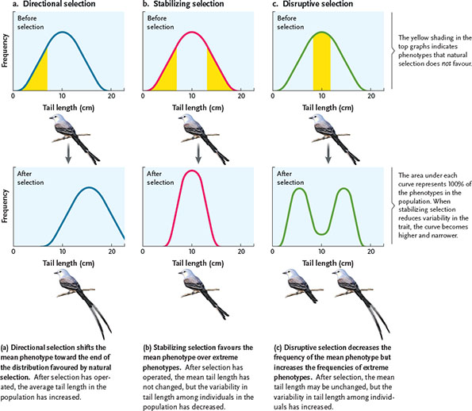
- Under natural conditions, disruptive selection is much less common.

Population Genetics
GENETIC STRUCTURE OF POPULATIONS

- Populations are made up of individuals of the same species, each with its own genotype.
- In diploid organisms with pairs of homologous chromosome, an individual’s genotype includes two alleles at each gene locus.
- The sum of all all alleles at all gene loci in all individuals is called the population’s gene pool.
- To describe the structure of a gene pool, scientists first identify the genotypes in a representative sample and calculate genotype frequencies.
- They can then calculate allele frequencies, and the relative abundances of the different allele.
- For a locus with two alleles, scientists use the symbol p to identify the frequency of one allele, and q to identify the frequency of the other allele.
- The calculation of genotype and allele frequencies for the two alleles at the gene locus governing flower colour in snapdragons is straightforward.
- This locus is easy to study because it exhibits incomplete dominance.
- Individuals that are homozygous for the Cr allele have red flowers.
- Those homozygous for the Cw allele have white flowers.
- CrCw = PINK
Flower colour phenotype | Genotype | Number of individuals | Genotype frequencies | Total number of Cr alleles | Total number of Cw alleles
Red | CrCr | 450 | 450/1000 = 0.45 | 2 x 450 = 900 | 0 x 450 = 0
Pink | CrCw | 500 | 500/1000 = 0.5 | 1 x 500 = 500 | 1 x 500 = 500
White | CwCw | 50 | 50/1000 = 0.05 | 0 x 0.05 = 0 | 2 x 50 = 100
 | Total | 1000 | 0.45 + 0.5 + 0 05 = 1.0 | 1400 | 600

p = frequency of Cr allele - 1400/2000 = 0.7
q = frequency of Cw allele = 600/2000 = 0.3
p + q = 0.7 + 0.3 = 1.0

tHE HARDY-WEINBERG PRINCIPLE

- In studies using observational rather than experimental data, there is often no suitable control.
- In such cases, investigators develop conceptual models, called null models.
- Null models predict what they would see if that particular factor had no effect.
- Null models serve as theoretical reference points.
- Geneticists used to be puzzled by the persistence of recessive traits because they assumed that natural selection replaced recessive or rare alleles with dominant or common ones.
- Hardy-Weinberg Principle specifies the conditions under which a population of diploid organisms achieves genetic equilibrium
- Genetic equilibrium is the point at which neither allele frequencies nor genotypic frequencies change in succeeding generations.
- Their work also showed that dominant alleles need not replace recessive ones and that the shuffling of genes in sexual reproduction does not in itself cause allele or genotype frequencies to change.
- Describes how genotype frequencies are established in sexually reproducing organisms.
- Genetic equilibrium is possible only if all of the following conditions are met:
  - No mutations are occurring
  - The population is closed to migration from other populations
  - The population is infinite in size - no genetic drift
  - All genotypes in the population survive and reproduce equally well
  - Individuals in the population mate randomly with respect to the trait being considered
- If all the conditions are met, the allele frequencies of the population for an identified gene locus will never change.
- The genotype frequencies will stop changing after one generation.
- The Hardy-Weinberg principle is thus a null model that serves as a reference point for evaluating the circumstances under which evolution may occur.
- If they don’t match the principle, evolution may be occuring.
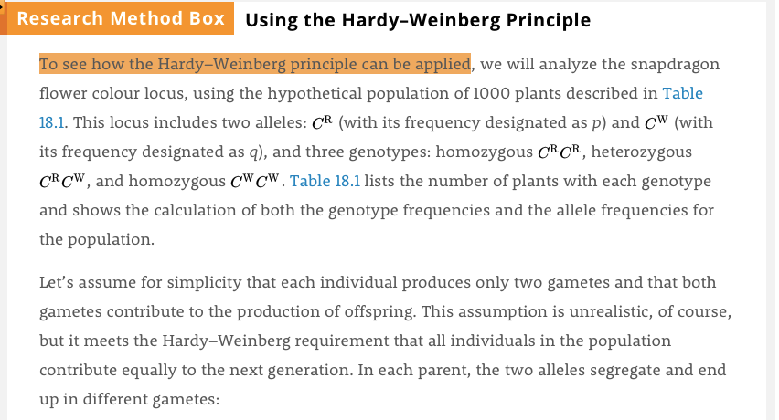
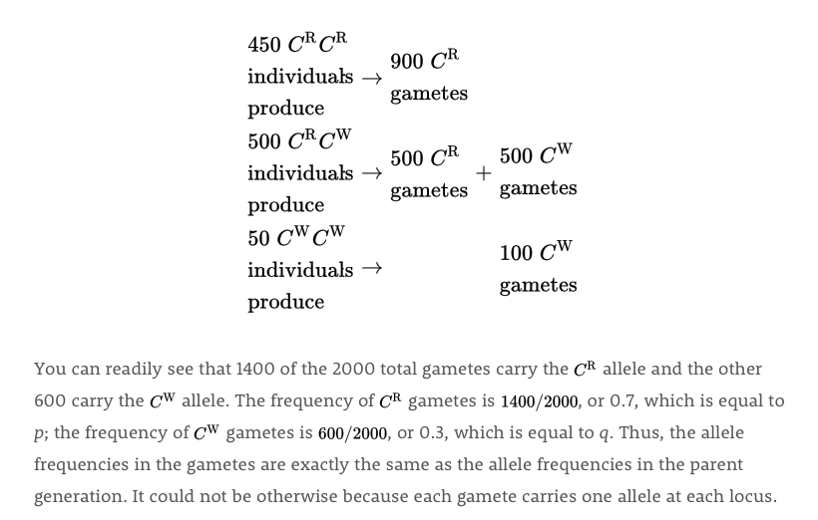
- If allele frequencies change over time, evolution is occuring.

Evolutionary agents
Mutations

- A mutation is a spontaneous heritable change in DNA.
- Rare events.
- For most animals, only mutations in the germ line (the cell lineage that produces gametes) are heritable; in other cell lineages they have no direct effect on the next generation.
- In plants mutations may occur in meristem cells, which eventually produce flowers as well as non reproductive structures. In such case, a mutation may be passed onto the next generation.
- Mutations can be advantageous, deleterious or neutral.
- Deleterious mutations alter an individual’s structure, function, or behaviour in harmful ways.
- Lethal mutations can cause great harm to organisms carrying them.
- Both homozygous and heterozygous carries will die.
- Neutral mutations are neither harmful or helpful.

gene flow

- Organisms or their genetic material move from one population to another.
- If the individuals reproduce they may introduce novel alleles into a population, shifting its allele and genotype frequencies.
- Shows that populations are not completely closed, but can be open to migration.
- Dispersal agents, pollen carrying wind or seed carrying animals are responsible for gene flow in most plant populations.
- Must reproduce in the new place they immigrate to.

GENETIC drift

- Chance events cause the allele frequencies in a population to change unpredictably.
- Dramatic effects on small populations.
- Violates the Hardy-Weinberg assumption of an indefinitely large population size.
- Two general circumstances foster genetic drift…

POPULATION BOTTLENECKS

- Stressful factor (disease, starvation, drought) kills a large proportion of the individuals in a population, producing a population bottleneck, a dramatic reduction in population size.
- Greatly reduces genetic variation.

FouNDER EFFECT

- When a few individuals colonize a distant locality and start a new population they carry only a small sample of the parent population’s genetic variation.
- This change in the gene pool is called the founder effect.
- Ex: Amish have high incidence causing dwarfism.

SMALL POPULATION IMPLICATIONS

- Genetic drift is more pronounced in small populations.
- Leads to loss of alleles and reduced genetic variability.
- Causes genotype frequencies and allele frequencies to differ from those predicted by the Hardy-Weinberg model.

CONSERVATION IMPLICATIONS

- Genetic drift has important implications for conservation biology.
- Endangered species experience severe population bottlenecks resulting in the loss of genetic variability.

GENETIC VARIATION IN POPULATIONS

- In the 1960’s evolutionary biologists began to use gel electrophoresis to identify biochemical polymorphisms in diverse organisms.
- Separates two or more forms of a given protein if they differ significantly in shape, mass, or net electrical charge, as a result of a mutation-induced changes in the underlying amino acid sequence.

NATURAL SELECTION AND GENETIC VARIABILITY

- Hardy-Weinberg model requires all genotypes in a population to survive and reproduce equally well.
- Natural selections violates a requirement of the Hardy-Weinberg equilibrium and causes allele and genotype frequencies to differ from those predicted.
- To evaluate reproductive success, evolutionary biologists consider relative fitness, the number of surviving offspring that an individual produces compared with the numbers left by others in the population.
- Natural selection tests fitness differences at nearly every stage of an organism’s life cycle.

NONRANDOM MATING

- Hardy Weinberg requires individuals to select mates randomly with respect to their genotype.
- This is often met.
- However, many organisms mate nonrandomly, selecting a mate with a particular phenotype.
- Ex: snow geese.
- Inbreeding is a form of nonrandom mating in which genetically individuals mate with each other.
- Self-fertilization in plants is an extreme example of inbreeding.
- Inbreeding increases the frequency of homozygous genotypes and decreases the frequency of heterozygotes.

DIPLOIDY

- Diploid condition reduces the effectiveness of natural selection on harmful recessive alleles.

BALANCED POLYMORPHISMS

- In balanced polymorphism, two or more phenotypes are maintained in fairly stable proportions over many generations.
- Natural selection preserves balanced polymorphisms when heterozygotes have higher relative fitness, when different alleles are favoured in different environments, and when the rarity of a phenotype provides an advantage.

Heterozygote advantage

- When heterozygotes have higher relative fitness than either homozygote.
- Apparently, heterozygous at many gene loci provides some advantage.
- The best-documented example of heterozygote advantage at a specific gene locus is the maintenance of the HbS (sickle cell) allele, which codes for a defective form of hemoglobin in humans. As you learned in Chapter 10, hemoglobin is an oxygen-transporting molecule in red blood cells. The hemoglobin produced by the HbS allele differs from normal hemoglobin (coded by the HbA allele) by just one amino acid. In HbS/HbS homozygotes, the faulty hemoglobin forms long, fibrous chains under low oxygen conditions, causing red blood cells to assume a sickle shape (as shown in Figure 10.1). Homozygous HbS/HbS individuals often die of sickle cell disease before reproducing. However, in tropical and subtropical Africa, HbS/HbA heterozygotes make up nearly 25% of many populations.
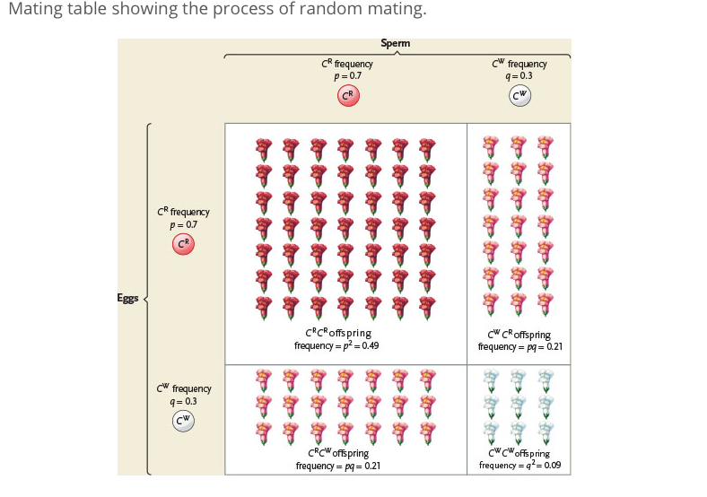
- Why is the harmful allele maintained at such high frequency in some populations? It turns out that sickle cell disease is common in regions where malaria is prevalent (Figure 18.8). Malaria is a disease transmitted by mosquitoes, in which parasites infect red blood cells. When heterozygous HbA/HbS individuals contract malaria, their infected red blood cells assume the same sickle shape as those of homozygous HbS/HbS individuals. The sickled cells lose potassium, killing the parasites, which limits their spread within the infected individual. Heterozygous individuals often survive malaria because the parasites do not multiply quickly inside them, their immune systems can effectively fight the infection, and they retain a large population of uninfected red blood cells. Homozygous HbA/HbA individuals are also subject to malarial infection, but because their infected cells do not sickle, the parasites multiply rapidly, causing a severe infection with a high mortality rate.

SELECTION IN DIFFERENT ENVIRONMENTS

- Genetic variability can also be maintained within a population when different alleles are favoured in different places or at different times.
- For example, the shells of European garden snails range in colour from nearly white to pink, yellow, or brown, and may be patterned by one to five coloured stripes (see Figure 18.1a). This polymorphism, which is relatively stable through time, is controlled by several gene loci. The variability in colour and striping pattern can be partially explained by selection for camouflage in different habitats.

THE EVOLUTION OF ADAPTIVE TRAITS

- An adaptive trait is any product of natural selection that increases the relative fitness of an organism in its environment.
- And adaptation is the accumulation of adaptive traits over time.
- For adaptation to occur there must first be phenotypic variation for selection to act on.
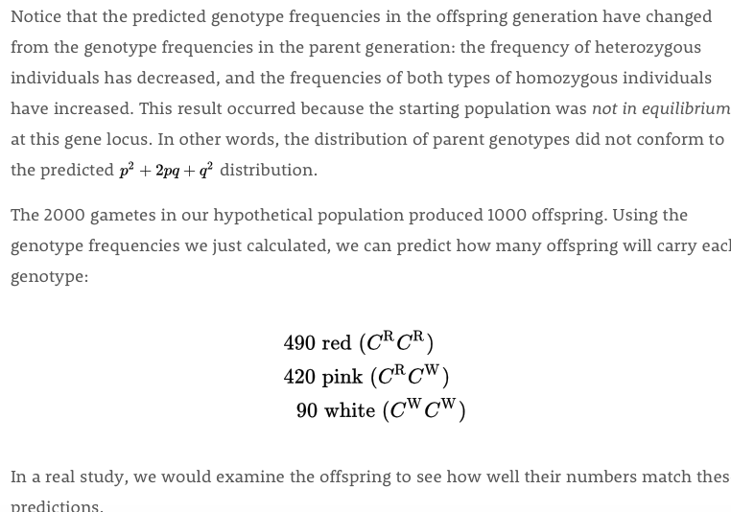
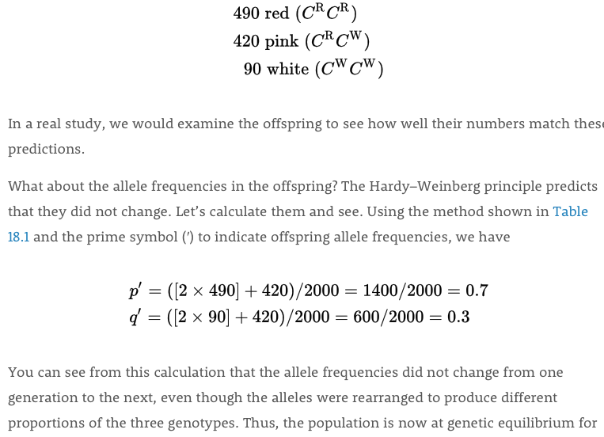
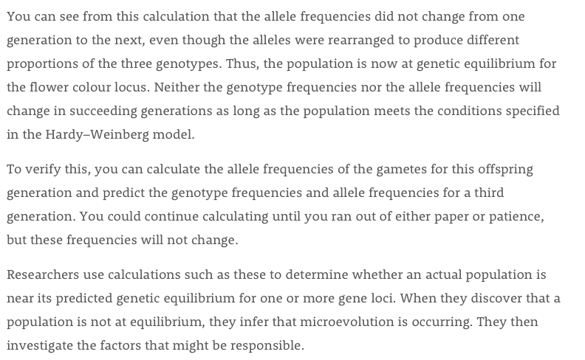
- We can concoct an adaptive explanation for almost every characteristic we see in nature.

FACTORS CONSTRAINING ADAPTIVE EVOLUTIONS

- The adaptive traits of most organisms are compromises produced by competing selection pressures.
- Sea turtles, for example, must lay their eggs on beaches because their embryos cannot acquire oxygen under water. Although flippers allow the females to crawl to nesting sites on beaches, they are not ideally suited for terrestrial locomotion. Their structure reflects their primary function, swimming.
- No organism can be perfectly adapted to its environment because environments change over time.
- Natural selection preserves alleles that are successful under the prevailing environmental conditions.
- Another constraint on the evolution of adaptive traits is historical/
- New mutations are rare so natural selection works primarily with alleles that have been present for many generations.
- Therefore adaptive changes in the morphology of an organism are often based on small modifications of existing structures.
Agent | Defintiion | Effect on genetic variation
Mutation | Heritable change in DNA | Introduces new genetic variation into population; doesn’t change allele frequencies quickly.
Gene Flow | Change in allele frequencies as individuals join a population and reproduce. | May introduce genetic variation from another population
Genetic Drift | Random changes in allele frequencies caused by change events. | Reduces genetic variation, especially in small populations; can eliminate rare alleles.
Natural Selection | Differential survivorship or reproduction of individuals with different phenotypes | One allele replacing another or allelic variation being preserved.
Non Random Mating | Choice of mates based on their phenotypes and genotypes. | Does not directly affect allele frequencies, but usually prevents genetic equilibirum.

