Week 1 – Jan 11 & 14
Gender Difference and Male Dominance

Human Beings: An Engendered Species
Chapter 1

Are Men and Women Different?
- ‘Interplanetary’ theory of gender difference:
  - Men are from Mars and women are from Venus
  - Men and women are ‘opposites’ who exhibit complete and universal gender difference
  - Questions assumptions by asking where is the evidence?
- The differences that we have are attributed to the different genders.
- Our conclusions are simply methods and are based on common sense knowledge.
  - There are two tasks of any study of gender:
  - Why do societies differentiate people on the basis of gender?
  - What are nearly all societies also based on male dominance?
All societies identify gender differences and use it to organize their societies
As western societies we introduce differences where men get more
Areas that women enter end up being de-valued i.e.dentistry
Women are responsible for reproducing society, so women should be in charge and be privileged, but they aren’t they end up being devalued

Why Different?
- Two schools of thought:
  - Biological determinism (Nature)
    - Biology can explain everything we are (biological composition)
  - Differential socialization (Nurture)
    - Politics of gender differentiation is everywhere
    - How are we socialized – we are not hardwired through biology
    - We aren’t hard-wired by nature and it is how we are socialized that makes us the way that we are.

  - Most arguments about gender difference begin with biology
  - Sex differences: anatomical, hormonal, chemical, and physical differences between men and women

Sex and Gender
- Most social and behavioural scientists differentiate between ‘Sex’ and ‘gender’
  - Sex: biological apparatus; chromosomal, chemical, anatomical organization
  - Gender: meanings attached to those differences within a culture
- ‘Sex’ is male and female
- ‘Gender’ is masculinity and femininity
  - How do you express your maleness or femaleness?
=====

Making Gender Visible
- Until the 1970s, studies of social life focused only on class and race
  - Prior to 1970 Functionalism – survival of the whole – society is based on consensus

- Last 30 years has seen an increasing study of women, gender, and now, men and masculinity

- Invisibility of masculinity
  - Before the 1970s, men had all the skills to exploit women in society until the waves of feminism began.
  - Privilege of invisibility: ‘power is often invisible to those who have it’
  - We see masculinity as universal way of being
  - Not seen as doing anything detrimental to women
  - Men were the ones in charge of the distribution of resources to society and they were the ones who assigned the gender roles.
  - This applies to other groups as well (group entitlement).
  - Those with privilege may be unaware of the inequality and may become defensive or angry when confronted with evidence of it.
  - Examples on privilege of invisibility:
    - Power to decide on roles within society
    - Distribution of resources (salary wage gap, positions of power)
  - Women became radical and started speaking up bout the inequalities that they faced which led to the evolution of families and the new found focus on the differences between women and men and the genders.

Gender and Power
- Hegemonic masculinity:
  - Only one version of masculinity operating in a culture is ‘culturally honoured’ or hegemonic; other masculinities are organized under it (hierarchically)

  - Emphasizes competition among men for power and dominance
    - Developed in 1980s by R.W. Connell to explain male gender ideology
    - If men cannot achieve their goal, they resort to violence and/or suicide.
    - Because this masculinity is embedded into their brain, even if the men were segregated from the women, there would still be competition and dominance over other men would ensue.

  - According to Connell, there is no ‘hegemonic’ version of femininity

  - Women’s gender expectations
    - Exaggerated ideal of femininity: ‘emphasized femininity’ stressing empathy and nurturance
    - Compliance with gender inequality in order to please men.
Gender Differences
- Many differences we observe between men and women are deceptive distinctions, not gender differences.

- Language and communication patterns are used differently, by men and women, in different situations.

- Money matters, workplace, family
  - Experience versus gender

- Differences are not as great as was once thought
- Examples:
  - Siblings – females are more male than the males in performance of roles
  - I.e. girls take out the garbage and boys do the dishes

Mean Differences
- Few differences between men and women are ‘hard-wired’
  - Differences aren’t differences they are socially constructed and they are assumptions, we can deconstruct them
- Gender differences are mean differences:
  - Differences in the average scores of men and women on standardized tests

- Differences among women and among men are far greater than mean differences between women and men
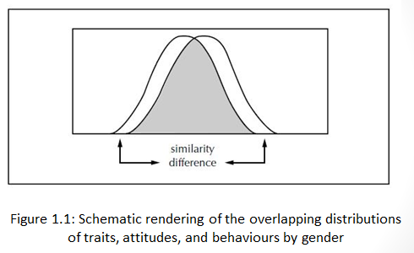
Difference and Domination
- Social institutions are gendered institutions
  - There are established ways of doing things in a certain context through the evolution of society
  - Mechanisms through which we reproduce society

- We become gendered selves in a gendered society:
  - Social institutions reproduce and reinforce dominant definitions of gender and ‘discipline’ those who deviate from these definitions

- Political and personal dilemmas:
  - Must women become ‘like men’ and sacrifice their femininity to succeed in the arenas that are established to reproduce masculinity? To succeed?

Paper - How we became who we are

Major Challenge and Solution
- Negative influence of “interplanetary” theory on proponents of biological determinism and differential socialization
  - There are differences between men and women (greater than among men and among women)
  - Differences between men and women:
    - Cannot be avoided
    - Is the source of domination and inequality

Social Constructionist Approach
- Alone does not explain gender Difference, domination and inequality can change
- Our bodies are not the sources of difference (biology)
- Differential socialization alone does not explain gender differences and domination
- Elimination of gender difference will reduce levels of other forms of inequality (e.g. race, class, ethnicity, age, sexuality etc.)

Week 2 – 18 January

Perspectives on Gender Difference: Biology
Ordained by Nature: Biology Constructs the Sexes

Outline
- Biology Constructs the Sexes
- Biological Differences, Then and Now

- The Evolutionary Imperative (perspective)
- Emergence of sociobiology
- Evolutionary psychology

- The Politics of Biological Essentialism
- Conclusion

Biology Constructs the Sexes

- Biological explanations are prominent in our views of gender difference and gender inequality

- Social and political inequalities flow from biologically based differences between the sexes
  - These differences can tell us much about our culture

Biological Differences, Then and Now
- Prior to the 19th century, most explanations of gender difference were theological
  - Laws of God – men and women for different purposes
    - Women were made from man’s rib and therefore owed him something and were always under man
    - People relied on God for everything good crops, weather, etc as well as God made us different and any change will offend God
- Charles Darwin’s Origin of Species (1859) and law of natural selection (species adapt) challenged theological explanations
  - No more law of God

- 1790s - Europeans scientists drew male and female skeletons with exaggeration of the pelvises (women) and crania (men) skull) – means men were more powerful
  - Scientists started drawing differences between men and women -

- 19th century Darwin’s work On the Origin of the species (1859) had a huge influence on science

- Biological determinism was ultimately discredited – was not based on real science – not empirical study – no real evidence

- Biology (two schools of thought)
  - Sociobiology -
  - Evolutionary psychology

The Evolutionary Imperative
- Emergence of sociobiology in 1970s revived evolutionary arguments
  - Sociobiologists stressed differences in male and female sexuality
    - They suggest that differences we observe between men and women have come from advantageous evolutionary choices

- Sociolobiology and support for / justification of:
- public/domestic divide (division of roles)
- parental investment in children (Cheap sperm and precious egg)
- monogamy and infant survival
- female orgasm and bonding in monogamy
- women’s interest in men’s political and economic resources (not their sexuality)
- Men’s interest in women’s physical appearance
Women’s reproductive role limits them

- Evolutionary psychology explains psychological traits as adaptations
  - Including differences between women and men
  - Can lead to reductionist patterns

- Contemporary mating strategies between the sexes differ, but love and kindness are highly valued by both men and women

- Which sex most ‘naturally’ tends towards monogamy?
  - Consider estrus, male/female orgasm, conception

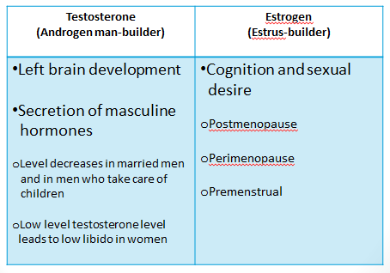
Valued aspects are attributed to men
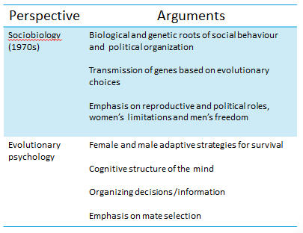

Sex Differences in Spatial and Verbal Skills
- Early 20th century debates over women’s intellectual aptitude now replaced by discussions of sex-based aptitudes (and gender roles)

- Variance within groups (male or female), far outweighs variance between the two

- A bewildering number of studies confirm some gender differences, but raise more questions than they answer

‘His’ Brain and ‘Her’ Brain
- Past brain research has fit into preconceived ideas about men’s and women’s roles

- ‘Lateralized’ brain and dominant hemisphere research from 1960s onwards
  - What is felt to be ‘superior’ in the research findings applied to men

- Little consistent evidence for significant brain differences
  - Palliative system justification motive allows us to justify and rationalize existing social arrangements

- Development of the brain

- Brain structure and size

- Gendered brain and difference in the use of spatial and language skills

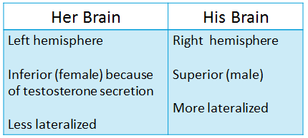

Hormonal Bases for Gender Difference
- Sex differentiation is most critical during fetal development and puberty
- Testosterone
    - Men have 10 times the levels of women
    - Varies greatly; some women have more than men
    - Varies from culture to culture
  - Linked to aggression, but not the cause – the social condition leads to aggression
    - ‘Permissive effect’ – facilitates existing aggression
    - Can affect sex drive in males and females in some instances
- Estrogen levels in women also fluctuate naturally

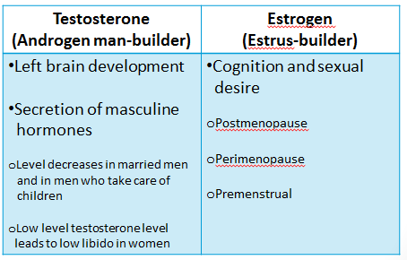

Gay Brains, Gay Genes, or Gay Hormones?

- Research attempted to prove stereotypes of gays and lesbians based not in cultural fears, but biological fact
- Some evidence exists for biological factors in sexual orientation, but brain, genes, and hormones do not fully explain
  - Many biological and cultural factors must be considered
- Female brain
- Prenatal stress
- War time and homosexual traits
- Length of fingers
- Size of penis
- Genes and sex hormones
- Study of twins
People who take the biological perspective are said to be conservative – they do not want things to change – Eve was created from Adam and was inferior to him – then sciences came along and men had to adapt and women could not adapt – they had to produce children and men had to hunt – then they said that women could not go to school, they had to stay home because if they went to school they would change how God made them (their uterus would shrink) and therefore only men should go to school. This view has no use for science – what God and biology has created is how we are. Biology is not the only way to discriminate against women. Gender inequality is the foundation of all inequality. (Biology, Society, Culture)

Hormonal and Chromosomal Abnormalities
- People affected by hormonal or chromosomal abnormalities are described as intersexed
    - Account for 1.7% of all births
  - Congenital adrenal hyperplasia (CAH)
(Masculinization of females /ambiguous genitalia)
- Androgen insensitivity syndrome (AIS)
(Ambiguous boy)
- Chromosomal abnormality and sex assignment
- Girls are receptive to the idea of sex change, but boys said they’ll kill themselves

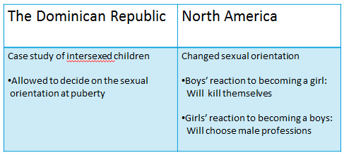

The Politics of Biological Essentialism
- Attempts to legislate changes in the gender order have been met with biological essentialism a system of oppression – if you are not part of a specifically defined category, the mainstream, you are oppressed. This is a source of power wielded by the mainstream group over all those that do not fit in.
  - Def.: an argument (mainstream) that rests on the naturalness of social relations and their rootedness in biology.
- Feminists (as well as some gay men and lesbians) have also adopted an essentialism of their own
- Some conservatives are now taking up ‘nurture’ theory of sexual orientation (based on differences) and asking for therapeutic measures for the conversion of homosexuals.
- Explanation are politically conservative – inequality is natural (it is enforced through customs, laws, traditions, threats of violence against deviants – why should we care about people who do not measure up against the mainstream? Why do we create laws against them or threaten them with violence? When we imbed these ideas and views into our culture and social structure (a hierarchy) then things remain the same and do not change
- Unchanging social arrangements – political, economic, social discrimination. If you do not fit into the mainstream, society does not want you to be involved into politics, or world economic or express social discriminations because you are ‘one of them’
- Difficulty in liberating minority groups – lesbians, gay men, trans-sexuals etc. we need skills to change society to help the minority groups be on the same hierarchy as those in mainstream

Conclusion
- Biological differences provide the raw materials from which we begin to create our identities within culture and society

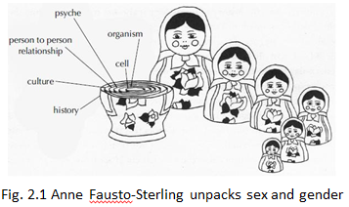

Essentialist
We are a sum of all our parts, of which our biology is only one

Discussion Questions
“Psychological Sex Differences through Sexual Selection” (Buss, 2015)

- Statement: “Female and male humans have evolved to behave in specific ways because their reproductive anatomy has led them to adapt via specific behaviours.”
Question: What is at stake in this statement? What does this statement leave out?

- What are the qualities of an evolutionarily successful man? An evolutionarily successful woman?

“testosterone Rules” (Sapolsky, 2015)
- Sapolsky makes a convincing argument regarding the methodology that scientists use to study biological factors in the regulation of human aggression. What does he mean when he says that ‘extreme conditions don’t tell us much about the real world” (P.11)

- What does Sapolsky mean when he writes that “inter-individual differences in testosterone levels don’t predict subsequent differences in aggressive behaviour among individuals’ (p12)? Where else might this notion be applied, and why might it be important for a sociologist?

Week 3 – 25 Jan 16
Now we are linking between the biological and the psychoanalytical

So That Explains It’: Psychoanalytic and Developmental Perspectives

PERSPECTIVES ON GENDER DIFFERENCE: PSYCHOANALYTIC AND DEVELOPMENTAL THEORIES

Outline
- Freud’s Theory of Psychosocial Development
- Cognitive Development Theory
- Social Learning (Bandura, 1986)
- Feminists and Other Challenges
- Developmental Differences

Freud’s Theory of Psychosocial Development

- Freud, founder of psychoanalysis:
Gender identity is developed in stages through experiences in infancy, as propelled by body

  - ‘Oedipal crisis’ for boys – boy learns to desire sex with women and t identify as a man
    - the boy achieves gender identity and sexual orientation at the same moment in time
    - boy desires sexual untion with his mother but if he does so his there is a fear that his father will castrate him and therefore it is in his best interest to identify with his father - boy has a crisis in this

  - Electra complex for girls – girls go through complex challenges while developing.
    - Girls must acknowledge that they are incapable of sexual realtions with mother because they haven’t got a penis – this creates “penis envy”
    - Girls understand that her only chance for sexual gratification is to regain identification with the mother and to be sexually possessed by a man

Element | Explanation
Id | - Biological drive  - Operates on pleasure principle
Ego | - Set limits for the id (controls the id)  - Rational problem solving to tame the ID’s desires
Super-ego | - Society’s moral standards – when and how to do things  - Conscience
The external world | - Social environment

*all of these together, ID, EGO, Super-Ego and external world make up our psychological constitution
From these four elements individuals fashion their psychological constitution: their drives for gratification, the limited possibilities offered by the world, the moralizing inner voice that tells us we do not deserve constant gratification, and the rational strategizer that tries to keep all these forces in balance.

Stages in the development of sexuality – Freud created these
- Before birth
- Oral
- Anal
- Phallic
- Latency -
- Genital

Stage | Boys | Girls
Before birth | Womb (luxurious) | Womb (luxurious)
Oral (0-18m) | Mother’s breast (food) | Mother’s breast (food)
Anal (18m-3yrs) | Urination and defecation | Urination and defecation
Phallic (3-5 yrs) | Genitals and masturbation | Genitals and masturbation
Latency (6yrs) | Sensual desires recede | Sensual desires recede
Genital – this is when they realize who they are. | Oedipus crisis  (Castration anxiety) | Electra complex  (Penis envy)

- Freud’s theory that normal gender identity and sexual preference were successfully acquired – or not – in childhood proved enormously influential.

Significance of Freud’s psychosocial theories of gender identity and sexuality development p. 63 of text
  - Root of psychosocial theories - Freud’s theories are the root
  - A shift from biology to social explanation – interaction with others determines the nature of the choices that we make.
  - Dislocates gender and sexuality from biology – now we are moving from biological to the social – nature alone is not responsible alone for the details of who we are
  - Links gender identity to sexual orientation (i. e., homosexuality is not a biological anomaly or an immoral issue but a developmental gender issue) – homosexuality is the failure of the child to adequately identify with the same-sex parent and therefore a problem of gender identity development.
  - Restates (supports) traditional gender stereotypes
- Why is one person superior to another and who should be valued and who should not. – this is a question that is still not answered.
- Freud reinforced stereotypes and who is superior to another
- Freud dislocates gender and sexuality from the realm of biology and links development to social

Limitations (pg 64 in text)
- Overgeneralization, universalistic and essentialist –
- Androcentric theory (dominated by or emphasizing masculine interests)
- Ahistorical explanations (ignored social conditions in Austria)
- Cannot be tested scientifically (based on narratives, sample was middle class and abused women with mental issues)

Criticisms
- Sees gender identity as an achievement (traumatic for boys / develops values of connectivity, intimacy and community in girls). – stereotyping – an achievement for boys – they achieved it and left the girl behind with her mother – she doesn’t’ have to achieve anything.
- Girls and their mothers belong to the same sex, so it is easier for them to develop their gender identity and good interpersonal relationships. – if people have commonalities it doesn’t mean they have the same orientation as their mother

Sex Role Theories

- Sex role theory analyzes individuals’ socialization into appropriate gender roles and identities – how? Codification and M-F test

- Codification of masculinity and femininity in the 1930s – into their component parts – traits, attitudes, and behaviours

- M-F test: empirical measure to determine how ‘masculine’ or ‘feminine’ an individual is
  - ‘masculinity overcompensation thesis’: Men with internal feminine identification adhere to more rigid norms in their external behavior - hyper masculinity
  - Male and female were on different ends of the spectrum –
*gender identity came to be associated with a particular bundle of attitudes, traits, and behaviours that could be seen as indicators of a successful gender acquisition (or deviation from) gender identity

Gendered Elements | Test
Knowledge | Colour combinations, source of coal, cooking
Feelings | Emotions in a continuum – a lot, little, some or none to test for pity, afraid and anger, wickedness etc.
Occupations | Career stereotyping, character trait – appearance, and children’s books that people like
People | Famous people an individual likes or not like (Bismarck, Lenin, Florence Nightingale), drawing of ships or flowers, traits such bathing, justice, talking etc.

- Gender deviants (MF, FM): Internal organization differs from external manifestations
(MF- Externally male, internally female) try to prove they are manly and sometimes over compensate (FM – Externally female, internally male)

- Examples: (pg 69 in text)
- MF -School bullies are insecure males with feminine external manifestations
- Insecure men supported the Iraq war, detest gay marriages, buy SUVs etc.
- FM men were creative, artistic, and intelligent
- Feminine girls were not worried about being masculine

Findings (Miller & Swanson)
- Similar to Freud’s developmental stages
- FF for both boys and girls with mothers – all children begin their lives - totally identified with and behaving like the mother
- FM Boys go through Oedipal stage where they continue to identify with the mother but begin to make a break from that identification while they simultaneously acquire superficial masculine traits and behaviours
- MM external and internal coincide – authoritarianism, racism, sexism, and homophobia might be seen as psychological immaturity
- MF was dropped by the study

Talcott Parsons
- Argued that the need to fulfill gender roles comes from society requiring individuals to fill two types of roles (sociological) not from individual need – established the societal necessity for masculinity and femininity

- Two types of major functions – production and reproduction = Instrumental & Expressive Roles
- Instrumental (Male) – occupational – demanded rationality, autonomy, and competitiveness
- Expressive (Female) – kinship – demanded tenderness and nurturing so that the next generation could be socialized

- Sociological explanation – need of society for individuals to fill specific slots – twp different types of people who were socialized to assume these two different roles

- Role allocation is not smooth (Nuclear family and public-domestic divide, boys stay longer with their mothers and remain identified with the mother for a longer period of time in western societies and do not have an appropriate role model as the father goes off to work, girls have their role model - mother) – the mother is in the boys life to influence him longer in this society

- Boys go through crisis in efforts to identify with their roles and reject femininity – bad boys, revolt against institutions – boys break with the mother and their need to establish their individuality and masculinity often were accompanied by violent protest against femininity, and angry repudiation of the feminine became a way for the boy to purge himself of feminine identification. He revolts against identification with his mother in the name of masculinity.

- Negative consequence: ‘Cult of compulsive masculinity’ -
Boys equate goodness with femininity, so that becoming a “bad boy’ becomes a positive goal. – negative consequences – adolescent type of assertively masculine behaviour and attitudes. Revolt against routine aspects of primarily institutionalized masculine role of responsibility and respect for right of others and tender affection towards women.

- Girls rebel against masculine superiority (not institutions, traits) and has to depend on man for her security. She may rebel against feminine roles because she shouldn’t be forced into these roles

Criticisms p. 71
- Simplistic binary model and politically conservative (dualisms – male-female, roles, system needs – change will disrupt society) – essentialist view.
- Involves coercion (I.e. roles not natural, people rebel and society enforces / demands them)

Bem’s gender schema theory argued that we learn a gender identity which becomes the basis for our individual views (schemas) of gender which are reinforced by society.
- Reacted against sex role theory and studied the content of sex role

- Bem’s Sex Role Inventory tests for masculinity and femininity (on a continuum, not opposites)

- People learn gender schema as children, but vary as adults as to how rigid their gender performance is

- Androgyny is healthier than rigid gender performance (I. e., M-F is best psychologically adjusted and intelligent individuals)

Bem’s gender schema theory provides further understanding of how gender is learned by individuals, how society influences that learning, and how individuals can vary in their adherence to rigid gender norms.
- A schema is a framework for organizing perceptions and interpretation of information (on individual basis)

- Gender schema vs. gender aschema -
Schema when it is well defined and approved by society – aschema is not approved by society and not well defined idea of yourself
- Gender appropriate behaviour has a cultural foundation

- Criticism: Androgyny is not the best gender type (wishy-washy non-personalities)

Pleck’s Male sex role strain model (MSRS)
  - Men were not the problem, but male sex role is contradictory, inconsistent and source of strain the problem was not that men were having a hard time fitting into a rational notion of masculinity, but rather that the role itself was internally contradictory and inconsistent-
  - Why are we focusing on men? – men are under pressure and male sex role itself was the source of strain, anxiety and male problems – this role shifted the understanding of the porobmes from the men themselves to the roles that they are forced to play.
  - Shifts problems from individual men to the roles they are forced to play in society
  - MSRI model separated into a discrete set of testable propositions
Criticisms
  - Roles are monolithic (There are other masculinities and femininities; ignores differences based on race, ethnicity, age, religion, region and sexuality) i.e. black masculinity, aboriginal femininity,

- Ignores differences in role expectations, power, and privilege
Focuses on gendered individual and ignores gendered institutions Institution = established ways of doing things

- Does not examine women’s and men’s situations and how they feel about them (Gender is relational) we understand what it means to be a man or woman in relation to the dominant models as well as to one another. Those who are marginalized by race, class, ethnicity, age sexuality, and the like also measure their gender identities against those dominant groups

Cognitive Development Theory – locates the trigger of gender development and gender identity formation slightly later in life than early childhood

Piaget: pg. 74 – examined the developmental sequences in children’s self-perception and their views of the world.
- Mental development takes place in orderly and discrete stages in childhood from birth to 11 years and up.
- Children:
- Learn in different ways from adults, and in a particular sequence and mental process.
- perceive things in their own way according to various ages.

Piaget’s stages of cognitive development (this slide is just for info)
- Sensori-motor (Birth-2 yrs)
- Pre-operational (2-7 years)
- Concrete operational (7-11 years)
- Formal operational (11 years and up)

Kohlberg (influenced by Piaget) -children learn gender roles according to their characteristic modes of cognition at different ages
- Children:
- ‘Learn’ gender cognitively based on the way they process information

- Are born gender neutral and acquire gender identity by filtering and interpreting information about gender (3 and 4 years) through self-socialization

- Learn through cues associated with the genders (dress, hairstyle, body size)

- Gender identity is fixed through the process, so identification as girl/boy is irreversible

- Develop gender constancy (the idea that gender identity is permanent and unchangeing and cannot be changed simply because, for instance, one ‘inappropriately’ holds a purse) by age five or six (Children see the world in gender terms after age six and engage in self-socialization)

- Have a gender label without content at age six because there is no relationship between gender identity and gender roles

Social Learning (Bandura, 1986) – reading?

- Preference for same-sex relations between 4-5 years.
- Acquisition of skills through: (1) external reinforcement and (2) modelling.
- Stimulus generalization and sex-typing and their significance.

Feminists and Other Challenges – pg. 76-77
- Women envy male dominance, not male anatomy – more political and social ‘privilege envy”
- Penis envy: meant thatwomen would always see themselves as inferior to men
- Womb envy: The origins of women’s subordination stem from men’s fears of women’s reproductive powers (in contrast to ‘penis envy’)

- Ethic of justice’: Abstract final stage of Kohlberg’s moral development theory – that abstract, universal ethical paradigm. – final stage of moral development

- ‘Ethic of care’: Moral perspective beyond justice, including intimacy and connectedness (more often followed by women, according to Gilligan) -stressing intimacy and connectedness, that seems to be followed more often by women.

- Psychoanalytic feminism are also ethnocentric and universalistic

Developmental Differences pg 79

- More variety among men and among women then there is between men and women
- Only consistent sex differences found by Maccoby/Jacklin:
  - Verbal ability (advantage: girls)
  - Visuospatial ability (advantage: boys)
  - Mathematical ability (advantage: boys)
  - Levels of aggression (consistently higher in boys)

- ‘Gender similarities hypothesis’: ‘Males and females are similar on most, but not all, psychological variables’ (Hyde)

- Gender typing comes from the environment surrounding the child, rather than from the child him- or herself –The social environment is a gendered society, filled with gendered messages and gendered activities. Even if the child possesses no fixed and permanent gender role, social arrangements will continually reinforce gender differences.

Questions “believing is seeing: Biology as Ideology” (Lorber, 2015)
  - In what ways do you think that the world of sport rests on a female/male binary. What separates all-female athletic competition from all-male competition? Is there anything distinct about either one?
  - When you closely observe your community, you may be able to identify many ways in which dominant messages about the existence of tow separate sexes are reinforced. Discuss some examples of the reinforcement of the male/female binary. What are the consequences of this binary for women?
  - Do you think it is possible for people to achieve equity within a society that upholds the mutually exclusive categories of male and female?

Week 4 –

PERSPECTIVES ON GENDER DIFFERENCE:
CULTURAL AND ANTHROPOLOGICAL

Outline
- Sex/Gender Differences and Male Domination: Explanations
- Variations in Definitions of Gender Norms
- Centrality of Gender Division of Labour
- Theories of Gender Differentiation
- Determinants of Women’s Status
- Rituals of Gender
- How Many Genders are There?
- The Values of Cross-Cultural Research
- Video: “Two spirit people” (YouTube)

- Chapter 4: “Spanning the World: Culture Constructs Gender Difference”

Sex/Gender Differences and Male Domination: Explanations

- Biological
- Psychological /psychosocial (shift from biology to society) (we acquire over time)
- Cultural/Anthropological (a way of life of a group of people)
  - Subculture – a group within a group
  - - a group that doesn’t agree with the mainstream culture
- Different definitions of masculinity and femininity in the different cultures

- Different expressions of aggression and violence despite similarities (anatomically)
  - How do men express their aggression?
  - Some women are aggressive and violent

Variations in Definitions of Gender Norms

- Margaret Mead: sex differences are learned, not biological, and are self-perpetuating (South Seas - Samoa, Polynesia and Indonesia)
- Mead’s findings challenged strict cultural gender norms in the US
- For instance, what is a norm in American culture is not in other cultures
- Femininity and masculinity are not the basis for organization of personality difference (E.g., New Guinea)

Society | Gender Norms
Arapesh | - Gender similarities / equality  - Gentle, passive, emotionally warm, shared childcare  confident, cooperation etc.  - Both are sexual, female infanticide and limited  polygamy  - Happy and content with marriage, even relationship
Mundugamor | - Gender similarities / equality  - Headhunters, cannibals, competitive, aggressive and  violent  - Little maternal instinct  - Father-son rivalry leads to male infanticide  - Sexually aggressive
Tchambuli | - Gender difference /equality  - Reversed gender roles  - Polygyny acceptable  - Women’s solidarity  - Women initiate sexual relations

Criticisms
  - Criticized for cultural determinism: Belief that the cultures in which we are raised determine our character, personalities, behaviours
  - Misinterpretation of cultures –
  - Demonstrated men and women are capable of similar or different temperaments, but did not explain why

Centrality of Gender Division of Labour

- Gender division of labour is almost universal—Why? Everywhere you go around the world you will find this. Functionalism explains this
- Functionalism: Gender division of labour is necessary for preservation of society - helps society function smoothly
  - BUT gender division of labour changes over time, and division of labour more varied than once assumed (E.g., New Guinea, the Aka, the Inca) – women and men divide work differently -

Theories of Gender Differentiation

- Private Property and the Materialism of Male Domination
  - Engels, 19th century: Development of private property led to ability to inherit, which caused issues with uncertainty of paternity, leading to nuclear family
  - Leacock continues in this tradition, showing how Innu women lost autonomy with the introduction of the fur trade (Became housewives instead of traders -Labrador peninsula)
  - Sacks (now Brodkin) showed how the introduction of a market economy shifted egalitarian roles toward male dominance in African cultures
- Warfare, Bonding, and Inequality
- Warrior societies
- Descent theorists
- Alliance theorists
  - Harris: Warrior societies use women to reward virtually all men in the society, leading to female subordination and patrilineality
  - Fathers and sons form the core of military activity
  - Women were used to reward men to prevent competition and weak bonding among men
  - Female population controlled through infanticide
  - Development of patriarchal religion (male dominance) to control resources
  - Descent theorists: Men form kinship bonds with other men through hunting (exclude women), providing a social connection to next generation in situations of paternal uncertainty
  - Men cannot bond with their children like women do
  - Male solidarity (bonding) and monogamy serves men’s desire for social connection
  - Alliance theorists: Men exchange women in order to cement alliances among men
  - Women are turned into sex objects for purposes of alliance building
  - (Descent and alliance theories ignore cross-cultural differences)

Determinants of Women’s Status

- Division of labour around child care
- Relationships between children and their parents
- Control over property, particularly after marriage
- Contribution to food supply
- Sex segregation

- Division of labour around child care
  - Women’s role in reproduction limits participation in the economy
  - The more men participate in child care, the more freedom women have and the higher their status
- Relationships between children and their parents
  - The closer the relationship between father and son, the higher the status of women is likely to be
  - Prevents sons’ definition of themselves in opposition (hyper-masculinity) to their mothers and other women
- Male dominance is lower with less sex segregation of work
- Male dominance is increased when men control property, political and ideological resources
- Male dominance is exacerbated under colonization
- Environmental stresses exaggerate male domination

Rituals of Gender

- Ritual segregation: Segregation of sexes through specific gender ritual
  - Circumcision: Excision of foreskin of a boy’s penis
  - Female genital mutilation/cutting (fgm/fgc): A number of practices from removal of clitoral hood to infibulation (removal of most external female genitalia)
  - Both occur in cultures where men’s dominance is high

Example | Rationale
Boys  - Initiation ceremonies  - Circumcision  - Couvade | - Rite of passage (masculinity)  - Men bond through scars  - Prevents excessive masturbation  - Initiation of men during the period of childbirth among indigenous South Americans in order to claim paternity
Girls  - Female genital mutilation / female genital cutting  - Purdah | - Rite of passage (femininity)  - Prevents female promiscuity  - Family honour  - Reinforces male dominance  - Seclusion of women for their women’s chastity and to preserve men’s honor

- Criticisms against elimination of FGM
- Imposition of Western cultural standards on non-Western women (Cultural domination)
- Influence of the West

How Many Genders are There?

- Some societies recognize more than two genders
- Berdaches or Two-Spirited: Members of one biological sex who adopt the gender identity of the other sex (usually biologically male)

Gender | Society
Nadle (M- W) | Navajo
Berdache | Asia and South Pacific
Nahane (females perform male roles) | BC and Yukon (Canada)
Alyha (M – W) and Hwane (W – M) | Mohave (US)
Muxes | Zapotect, Mexico (M –W)
Sworn virgins | Albernia
Hijras | India, Pakistan
Xanith | Omani, Middle East
Two Spirit People | First Nations and Aboriginal People (Canada, US)
Mahu (M-W) | Tahiti / Hawaii
Fa’afafine (M-W) | Samoa

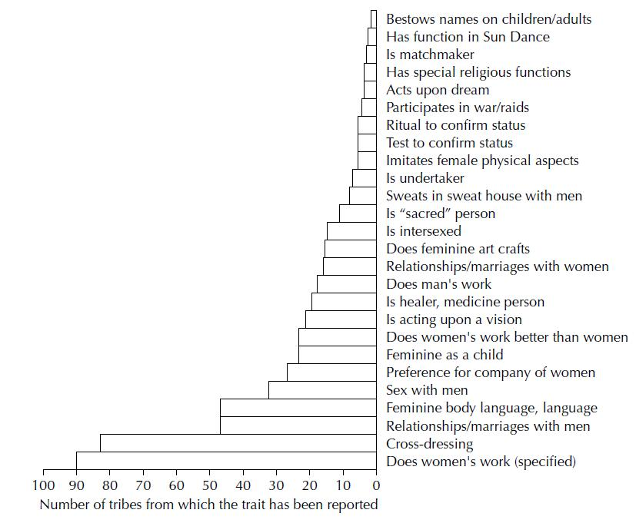
Figure 4.1 Components of the berdache role

- Gender is socially constructed because it is:
- Determined at birth
- Chosen in adulthood
- In response to family need

Sexual Diversity

- Studies of sexual variation complement gender diversity studies to argue for cultural construction of gender and sexuality
  - Homosexuality is consistent, but how homosexuals are treated in cultures is not
- Sexual customs are also greatly varied between cultures
- The percentage of homosexuals among North American Aboriginals is high
- Boys eat men’s semen to attain their masculinity
- Sodomy is acceptable and encouraged
- Homosexual (adolescents) and bisexual (married adults)
- Sexual customs
- Sex inside or outside
- Number of times to have sex
- Number of orgasms
- Foreplay
- Initiator
- Position

Anthropology as History
- Anthropological research has helped show that the universality of gender difference and male domination is not natural or inevitable

The Values of Cross-Cultural Research

- There is a rich diversity in human cultural arrangements, and in definitions of gender and sexuality
- Cultural relativism: The belief that any individual's beliefs and behaviours should be understood in the context of his or her own culture rather than as the product of innate or universal tendencies and values (E.g., FGM, the hijab)

Last week Questions “the Five Sexes: Why Male and Female are Not Enough” (Anne Fausto-Sterling)

- How does Fausto-Sterling’s notion of “many gradations running from female to male: (p. 25) disrupt the carefully maintained notion of a sexual binary? Which areas of your life would you need to rethink as part of breaking down this binary?

- Fausto-Sterling’s article was originally published in 1990. A quarter of a century later, occurrences of ambiguous genitalia are now collected under the umbrella term DSD (Disorders of sexual development) and medical professionals are moving away from conducting surgical interventions to ‘correct’ ambiguous genitalia in newborns. Why do you think these changes in medical best practices might have changed?

Week 5 –
The Social Construction of Gender Relations
Chapter 5

Outline
Sociology
- Social constructionist perspective
- Gender through life course
- Gender as an institution
- Doing Gender: the interactionist approach

Constructing gender: Feminist views and movement

Social construction of gender relations

The Social Construction of Gender Relations
- Sociology
  - The intersection of biography and history
  - Studies social structures and institutions – established ways of doing things
  - Assumes that individuals shape their lives within historical and social contexts
- Also began with a critique of biological determinism -

A Social Constructionist Perspective
- Social Constructionism: Definitions of masculinity and femininity vary:
  - From Culture to Culture
  - In any one culture over historical time
  - Over the course of a person’s life
  - Within any one culture at any time
- Social Constructionism thus adds specific dimensions to the exploration of gender.
- It contributes the elements that the social phycology of sex roles cannot explain adequately: difference, power, and the institutional dimensions of gender definitions; to explain power, it emphasizes the ways in which some definitions become normative through the struggles of different groups of power including power to define

Beyond the Sex Role Theory – p. 113
- Sex role theory minimizes the importance of gender – we learn our roles through socialization and then perform them for others. To make gender a role like any other role is to diminish its power in structuring our lives

- Sex role theory posits singular normative definitions of masculinity and femininity -if the meanings of masculinity and femininity vary across cultures, over historical time, among men within any one culture, and over the life course, we cannot speak oas though each were a constant, singular, universal essence – social constructionists speak of masculinities and femininities

- Sex role theory posits two separate spheres – it is not only plural but relational
  - Like herding cattle into different pens for branding – boys into one girls into another but suggests that one pen has virtually nothing to do with the other pen
  - The result is an abstract view of the differences between the sexes and their situations, not concrete one of the relations between them.
  - So we should talk about femininities and masculinities
  - Ignores that definition of masculinity relies on comparison with definition of femininity, vice-versa

- Sex role theory ignores that gender is situational
  - Boys may be boys but they express that identity differently in fraternity parties than in job interviews with a female manager.
  - Gender is thus not a property of individuals, some ‘thing’ one has, but rather a specific set of behaviours that is produced in specific social situations. And thus gender changes as the situation changes.

- Sex role theory depoliticizes gender
  - Makes gender a set of individual attributes and not an aspect of social structure
  - Implies that ‘the female role’ and ‘the male role’ are complimentary (separate or different but equal) – these terms are depoliticizing; they neglect questions of power and conflict

- Sex role theory is inadequate in comprehending the dynamics of change
  - Movements for social change, like feminism or gay liberation, become movements to expand role definitions and to change role expectations.
  - Their role is to expand role options for individual women and men, whose lives are constrained by stereotypes
  - Their role is also about the redistribution of power in society through reallocation of resources and an end to forms of inequality that are embedded in social institutions as well as sex role stereotypes

A Note About Power
- Power, like gender, is not the property of individuals, but a property of a group/social life
    - Gender is about difference and also about inequality, about power
    - At the level of gender relations, gender is about the power that men as a group have over women as a group, and it is also about the power that some men have over other men
    - It is impossible to explain gender without adequately understanding power – not because power is the consequence of gender difference, but rather because power is what produces those gender differences in the first place.

- Even though some men are not ‘in power’ or do not ‘feel powerful’, their group is in power, and this cannot be ignored, even though it is invisible to those most empowered
  - Like gender, power is not the property of individuals – a possession that one has or does not have- but rather a property of group life, of social life. Power is. It can neither be willed away nor ignored.

Gender through the Life Course
- Socialization: by family, school, and church?

- Peers and media are also major agents
  - Continues throughout the life course

Gender as an Institution – education, political, religion, economic. family
- Institutions themselves express a dynamic that reproduces gender relations and the gender order of hierarchy and power

- Gendered individuals occupy places within gendered institutions, and those institutions produce the differences we assume are the properties of individuals

- Acker’s Gendered Processes of institutions:
  - The production of gender divisions -in the very organization of work, gender divisions are produced and reinforced, and hierarchies are maintained – often despite the intentions of well-meaning managers and supervisors.
  - The construction of symbols and gender images – such advertisements, reproduce the gendering of positions so that the image of a successful manager or business executive is almost always an image of a well-dressed, powerful man
  - The interactions between individuals - all in forms that express dominance and submission.
  - The internal mental work of individuals – as they consciously construct their understandings of the organization’s gendered structure of work and opportunity and demands for gender-appropriate behaviour
  - The ongoing logic of organizations themselves – institutions that pass themselves as neutral are actually very gendered criteria masquerading as objective and gender-neutral

- Organizational gender neutrality is the vehicle by which the gender order is reproduced
  - the theory and practice of gender neutrality covers up obscures the underlying gender structure, allowing practices that perpetuate it to continue even as efforts to reduce gender inequality are under way.

‘Doing Gender’: The Interactionist Approach
- Gender is the product of interactions; it is performed in interaction with others – socialized to behave as masculine or feminine – if your performance is not up to people’s expectations, people will speak up and tell you that you are not conforming to your gender’s behaviour

- We generally see primary sex characteristics (those present at birth) as far more decisive than secondary sex characteristics (those that develop at puberty) for the assignment of gender role identity
  - But what you see are secondary sex characteristics, and the behavioural presentation of self

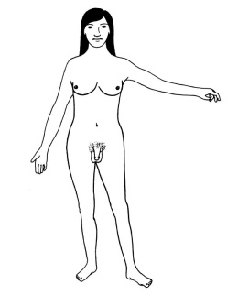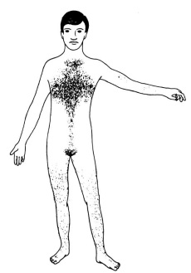

Constructing Gender: Feminist Views and Movements
- First-wave feminism: (1850–WWI) Emphasized women’s legal status and suffrage – western system has been very oppressive in terms of segregation of women

- Second-wave feminism: (1960s and 1970s) Discussed, analyzed, and protested power imbalances in personal and intimate relations – Western Europe as well –

- Liberal feminism: Focused on making society as gender-neutral as possible – remains the dominant approach in explaining women and their relationships. -focus on equality but need to focus on equity not equality – hoping to make a change in this already established social structure

- Marxist and socialist feminisms: Argued that the economy was at the heart of women’s oppression; economy, law, and culture all play roles in the subordination of women – change how these are organized and the relationships in society will be changed to benefit women

- Radical feminism: Argues patriarchy is the root of women’s second-class status, and that rape, domestic abuse, and warfare must be fought – women and children are vulnerable – no one takes them seriously because they are so radical – bra burners

- Multiracial and ethnic feminisms: Emphasize racial dimensions of gender inequality, criticizing racism within feminist movements – racialized groups speaking up against the middle class white feminists

- Post-colonial feminism: Analyzes colonialism, racism, and global capitalism in relation to status of women – these all needs to be considered when talking about feminism because they are very different from first world countries

- Post-modern feminism: (1990s) Argues that reality is constructed (primarily through language) – language is a source of power -

- Third-wave feminism: Celebrates ethnic diversity, complex identity, individual agency, self-expression (in sexuality, dress, and art) – express ourselves the way we want

- Intersectionality: One cannot analyze the category ‘women’ without recognizing that the category is complicated by issues of ethnicity, class, culture, sexuality, ability, etc. helps us to expose other axes of inequality – the more you put together the more complicated the other person’s experiences are.

The Social Construction of Gender Relations
- Gender as an identity is not a ‘thing’ that one possesses, but a set of activities that one does

- We do gender in every interaction, every situation, and every institution in which we find ourselves

- We do gender in a gendered world, in gendered institutions, not in a genderless vacuum

Wherer do we go from here?

Coming out
- Do you thing that to be trans necessarily means that you are challenging current binary thinding about gender and sex? Why or Why not?

- In what wys do we in thei society discriminate against and/or punish people or groups because of their gender identity and displays of gender?

