Chapter 1:

Fact -the conformation or validation of an event or object

Information age - the present time, during which infinite quantities of facts are widely available to anyone who can use a computer

Core Drivers of the Information Age

Data - raw facts that describe the characteristics of an event or object

Information - data converted into a meaningful and useful context

Business Intelligence - Information collected from multiple sources such as suppliers, customers, competition, partners, and industries that analyzes patterns, trends and relationships for strategic decision making

Knowledge - skills, experience, and expertise coupled with information and intelligence that creates a person’s intellectual resources

Knowledge Worker - individual valued for their ability to interpret and analyze information

Systems Thinking - a way of monitoring the entire system by viewing multiple inputs being processed or transformed to produce outputs while continuously gathering feedback on each part
Input -> Process -> Output

Feedback

IT Provides:
-communication
- sales
- etc.

Horizonal (Functional areas)
Vertical (Management levels)

IS
- Computer-based tools working with information and support the info and info processing needs
- Hardware, software, Trained Personnel,, Polices & Procedures& security & ethical measures
IT
- Acquiring, processing, storing and distributing of voice graphics, text and numbers and other information, and by combinations of telecommunications between networks in data

BPR - Business Process Redesign - scrapping the whole process and developing a new process that would be more efficient

Project Scope Study Competition Create New Processes Implement Idea
P S P I
MIS - a business function like accounting and human resources which moves information about people, products, and processes across the company to facilitate decision-making and problem-solving

IS before IT

Data Information, BI & Knowledge
Data (raw facts) - information (data in meaningful context) -> BI (information for strategic decision making Knowledge (skills, experience, intelligence)

CIO (Chief Information Officer) - oversees all uses of IT and ensures the strategic alignment of IT with business goals and objectives

CKO (Chief Knowledge Officer) - responsible for collecting and maintaining and distributing the organization’s knowledge

CPO (Chief Privacy Officer) - responsible for ensuring the ethical and legal use of information

CSO (Chief Security Officer) - responsible for ensuring the security of IT systems

CTO (Chief Technology Officer) - responsible for ensuring the throughput, speed, accuracy, availability and reliability of IT

People Process Information

Identifying Competitive Advantage

Business Strategy - a leadership plan that achieves a specific set of goals or objectives such as
- Developing new products or services
- Entering new markets
- Increasing customer loyalty
- Attracting new customers

Competitive Advantage - a product or service that an organization’s customers place a greater value on similar offerings than from a competitor

First-Mover Advantage - Occurs when an organization can significantly impact its market share by being first to the market with a competitive advantage

4 Business Strategies to Identify Competitive Advantage

Swot Analysis - evaluates an organization's Strengths, Weaknesses, Opportunities, and Threats to identify significant influences that work for or against business strategies

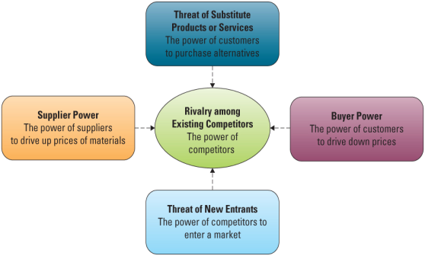

(Porter’s) The Five Forces Model - Evaluating Industry Attractiveness

Buy Power - the ability of buyers to affect the price of an item
High when many buy options, low when low buy options

Switching Cost - manipulating costs that make customers reluctant to switch to another product
Loyalty Program - rewards customers based on the amount of business they do with a particular organization

Supplier Power - the supplier’s ability to influence the prices they charge for supplies
- High when low buy options, low when high buy options

Supply Chain - consists of all parties involved in the procurement of a product or raw material Suppliers -> Company -> Customers

Entry Barrier - a feature of a product or service that customers have come to expect and entering competitors must offer the same for survival

Rivalry Among Existing Customers - high when competition is fierce and low when competitors are more complacent

Product Differentiation - occurs when a company develops unique differences in its products or services with the intent to influence demand

Three Generic Strategies - Choosing a Business Focus

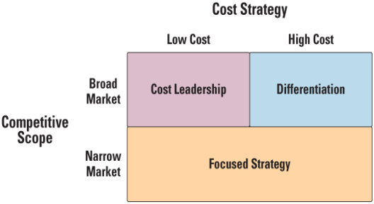

Primary value activities:

- Inbound logistics - Acquires raw materials and resources, and distributes

- Operations - Transforms raw materials or inputs into goods and services

- Outbound logistics - Distributes goods and services to customers

- Marketing and sales - Promotes, prices, and sells products to customers

- Service - Provides customer support

Support value activities:

-Firm infrastructure – Includes the company format or departmental structures, environment, and systems

-Human resource management – Provides employee training, hiring, and compensation

-Technology development – Applies MIS to processes to add value

-Procurement – Purchases inputs such as raw materials, resources, equipment, and supplies

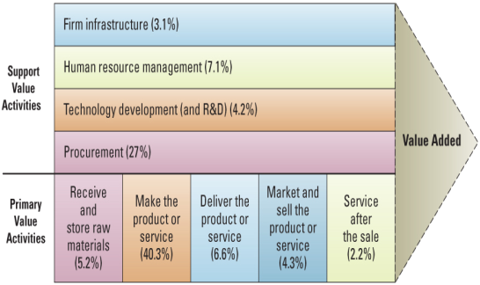

Chapter 2

Decision Making Process:

- Problem Identification
- Data Collection -
- Solution generation
- Solution test
- Solution selection
- Solution Implementation

Operational decision making - Employees develop control and maintain core business activities required to run day to day operations

Structured Decision - situations where established processes offer potential solutions

Managerial Decision Making - employees evaluate company operations to identify, adapt to and leverage change

Semistructured decisions - requiring some human judgment and at the same time with some agreement on the solution method

Strategic decision making - managers develop overall strategies goals and objectives

Unstructured decisions - occurs in situations in which no procedures or rules exist to guide decision makers toward the correct choice

Types of Information Processing-
OLTP: captures, stores, updates, and processs data according to deinfe rules
OLAP: aggrefation of raw data from trsaction systems, data transformed into information

Critical success factors (CSFs) - the crucial steps companies makes to perform to achieve their goals and objectives and implement strategies

- create high quality products
- retains competitive advantage
- reduce cost
- increase costumer satisfaction
- hire and retain the best professionals

Key Performance Indicators - Quantifiable metrics a company uses to evaluate process toward critical success factors

- turnover rates of employees
- number of product returns
- number of new customers
- average customer spending

BI
Consolidation: into groups and interrelated info
Drill Down: Details into successive levels of greater granularity
Slice and Dice: Data in different ways to offer differing perspectives

Chapter 3

Section 3.1 - Data, Information, Knowledge and Intelligence

Granularity - refers to the level of detail
- Course granularity - summarized data
- Fine granularity - often raw data

Levels —> Formats —> Granularities
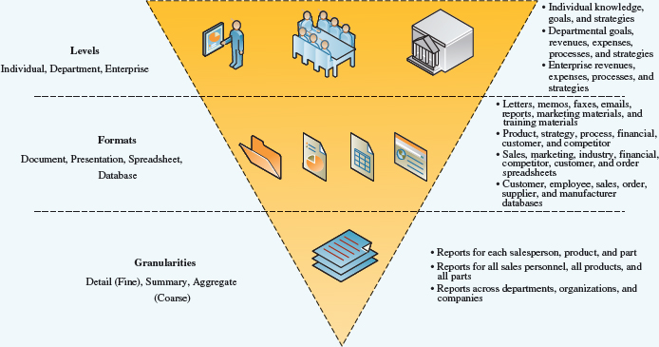

Transactional Data - Encompasses all of the information contained within a single business process or unit of work, and its primary purpose is to support the performing of daily operational tasks.

Analytical Information - Encompasses all summarized or aggregated transactional data; its primary purpose is to support the performing of higher-level analysis tasks.

Value of Timely Data and Information

Real time data and Real time information - immediate and up to date (data/information)
Permit:
- smaller inventories
- more efficient operations
- faster diagnosis and solutions to problems
- faster cycle times for cash, sales, deliveries and payments

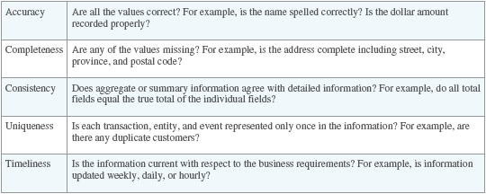
Data Governance - The way an organization manages the availability, usability, integrity, and security of its data.

Business are required to have policies specifying accountabilities for data quality, security privacy and as to who can access what data & information

Must comply with government laws, and regulations, and accounting and other professional policies and by-laws

Knowledge - actionable information that required
- understanding the information
- ability to make inferences between “tidbits” of information
- be able to apply the information in the appropriate context

Explicit Knowledge - that which can be documented (available to everyone)

Tacit Knowledge - contained in people’s heads (keeping to yourself)

Knowledge management - the process through which organizations generate value from their intellectual and knowledge-based assets
- codifying employees, partners and customers knowledge
- cultivating and promoting of use of organizational knowledge that resides within human experts

Knowledge Management Systems - capture, organize and disseminate knowledge

- foster innovation by encouraging the free flow of ideas
- improve customer service by streamlining response time
- boost revenues by getting products and services to the market faster
- enhance employee retention rate by recognizing the value of employees knowledge
- streamline operations and reducing costs by eliminating or removing redundant or unnecessary processes

Shadowing - involved less experienced person observing an expert

Join problem Solving - novice and expert networking together on a project

KM Technologies:
- Knowledge Repositories (Databases)
- expertise tools often involving some AI
- E-learning applications
- Discussion and Chat Technologies
- Search and data mining tools

Crowdsourcing - Getting needed services, ideas, or content by asking for input from a large group of people. The most common form of collective intelligence found outside the organization.

Asynchronous communications - Getting needed services, ideas, or content by asking for input from a large group of people. The most common form of collective intelligence found outside the organization.

Social networking analysis (SNA) - A process of mapping a group’s contacts (whether personal or professional) to identify who knows whom and who works with whom.
- displays remotely connected employees
- can identify experts in a required field
- can create “communities of practice”
- Identifies knowledge flows through an organization

Business intelligence (BI) - A broad term denoting information that people use to support their analytical and strategic decision-making efforts.

Big Data - Information collected from multiple sources such as suppliers, customers, competitors, partners, and industries that analyze patterns, trends, and relationships for strategic decision making.

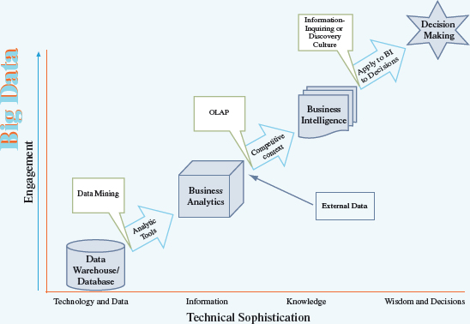
Business analytics (BA) - The practice of using iterative, methodical techniques to explore an organization’s data with emphasis on predictive, applied, and statistical analysis.

From Operational BI through Tactical BI to Strategic BI
- analysis becomes increasingly complex and less repetitive
- risks and rewards from the analysis increase
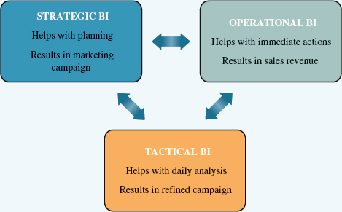

Data Latency - The time duration to make data ready for analysis (i.e., the time for extracting, transforming, cleansing, and loading the data into a database).

Analysis Latency - The time from when data are made available to when analysis is complete.

Decision Latency - The time it takes a human to comprehend the analytic result and determine an appropriate action.

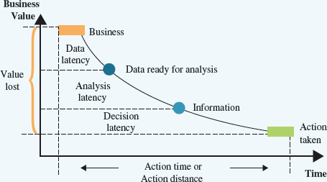

Direct Quantifiable Benefits
- measurable and observable benefits

Indirect Quantifiable Benefits
- measurable but observes through other events

Unpredictable benefits - unexpected benefits

Intangible benefits - not directly observable such as improved reputation or morale

Visual Business Intelligence

Infographics - charts and pictures representing data sheets
- easily understood comparisons

Data visualization and visualization tools - sophisticated mathematical models
- ranging from time series graphs to webs of networks and clusters formed from thousands of points
- identifying trends, emerging markets

Intelligence database - key decision data electronically displayed in multiple charts, graphs and other visualization tools
- dynamically updated in real time

Section 3.2 - Delivering Information Systems

Collaboration Systems - An IT-based set of tools that supports the work of teams by facilitating the sharing and flow of information.

- Unstructured Collaboration (informational collaboration) - Document exchange, shared whiteboards, discussion forums and emails

- Structured collaboration (process collaboration) - Participating in business processes such as workflow, where the way knowledge is used is hard-coded as rules

Core Competency - An organization’s key strength or business function that it does better than any of its

- Core Competency Strategy - Followed when an organization chooses to focus specifically on what it does best (its core competency) and forms partnerships and alliances with other specialist organizations to handle non-strategic business processes.

- Information Partnership - Occurs when two or more organizations cooperate by integrating their information systems, thereby providing customers with the best of what each can offer.

KM and Collaboration Tools
- Bring people and technology together.
- Use of AI and Social Media to help in knowledge sharing

Some of the tools Accenture suggests to improve content creation and sharing are:
-Wikis
-Discussion forums, personal spaces, activity feeds
-Visual navigation, rules-based inference engines (AI)
-Data mining tools to manage content designed through crowdsourcing for efficiency and accuracy

Content Management Systems - Provides tools to manage the creation, storage, editing, and publication of information in a collaborative environment.
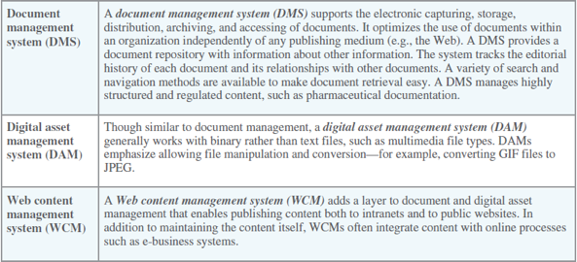
Workflow - All the steps or business rules, from beginning to end, required for a business process.

Workflow Management Systems - Facilitate the automation and management of business processes and control the movement of work through the business process

Messaging based workflow systems - Systems that send work assignments by email.

Data-Based Workflow Systems - Store documents in a central location and automatically ask the team members to access the document when it is their turn to edit the document.

Groupware - Software that supports team interaction and dynamics, including calendaring, scheduling, and videoconferencing.

Synchronous Groupware allows collaboration when team members work together at the same time
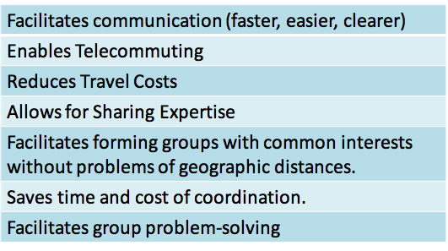
Asynchronous Groupware allows collaboration when group members are working at different times

Videoconferencing - The use of telecommunications to virtually bring people at different sites together for a meeting. It uses a set of interactive telecommunication technologies that allow persons at two or more locations to interact via two-way video and audio transmissions simultaneously.

Web conferencing - Blends audio, video, and document-sharing technologies to create virtual meeting rooms.

Enterprise Portals - Single-point Web browser interfaces used within an organization to promote the gathering, sharing, and dissemination of information throughout an enterprise.

A publishing facility on to which users post and index information
A automatic indexing facility that immediately indexes information
A subscription facility that notifies and distributes relevant information
Intelligence agents that understand user preferences to help him/her find relevant information and present it in a useful way

Text Messaging - A type of communications service that enables someone to create a kind of private chat room with another individual in order to communicate in real time over the Internet.
-Sharing web links and sound files
-Viewing images stored on someone else’s device
-Streaming content
-Talking
-Texting

M - Learning - The use of portable computing devices with wireless capability to enable mobile learning

From Power point

CHAPTER 3
Data Governance
- Refers to the overall management of the availability, usability, integrity, and security of organizational data
  - Businesses are required to have policies specifying accountabilities for data quality, security, privacy and as to who can access what data & information
  - Must comply with government laws and regulations, and accounting and other professional policies and by-laws

Knowledge Management (KM)
- The process through which organizations generate value from their intellectual and knowledge-based assets
- Cultivating and promoting of use of organizational knowledge that resides within human experts
Knowledge Management in Business
- Provides a competitive advantage when expertise can be accessed whenever it is needed
- Best practice for transferring tacit knowledge
  - – Codifying employees, partners & customer’s knowledge
  - – Accessing expertise/experts whenever it is needed
- Shadowing
  - – Involves less experienced person observing an expert
- Joint Problem Solving
  - – Novice and expert working together on a project
KM and KMS in Business
- KM Technologies – Knowledge repositories (Databases) – Expertise tools often involving some AI – Discussion and chat technologies – Search and data mining tools
- Knowledge Management Systems (KMS) – Capture, organize and disseminate knowledge
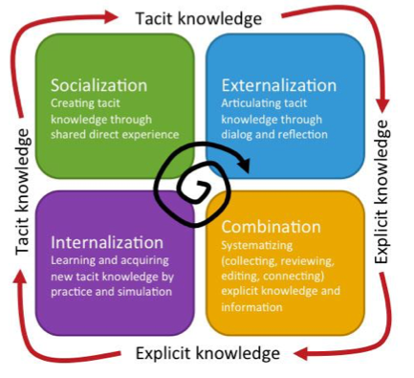
KM and KMS in Business
- SECI Model:
  - a model of knowledge creation that explains how tacit and explicit knowledge are converted into organizational knowledge
Crowdsourcing
- Collecting knowledge from outside the organization
- Examples
- Procter & Gamble
- Wisdom of crowds
- Wikipedia
- Prediction Market
- Amazon Mechanical Turk
- Kickstarter
Social Networking
- Social Networking Analysis (SNA) is a process of mapping a group’s contacts to identify who knows whom and who works with them
- Displays remotely connected employees
- Can identify experts in a required field
- Can create “communities of practice”
- Identifies knowledge flows through an organization

- Big Data
  - Vastquantitiesofdatacollectedfrommultiplesourcessuchassuppliers, customers, competitors etc.
  - Analyzed for patterns, trends and relationships for strategic decision-making
  - Term broadly encompasses analytics to data structures
- Business Analytics
  - iterative, methodical techniques to explore an organization’s data, with emphasis on predictive, applied, and statistical analysis

Big Data: A Visual Description
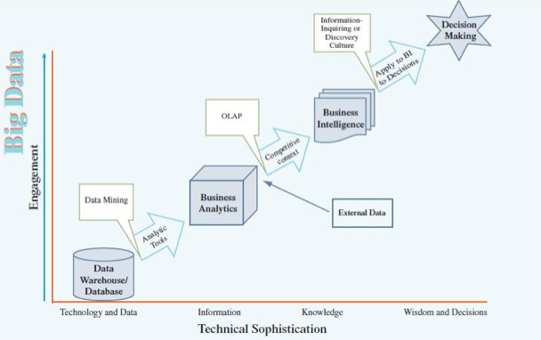

Three Integrated Forms of BI

From Operational BI, Tactical BI to Strategic BI
– Analysis becomes increasingly complex and less repetitive
– Risks and rewards from the analysis increase Data, Information, Knowledge, and Intelligence Three Forms of BI Must Work Toward a Common Goal

BI Benefits

Direct Quantifiable Benefits
- measurable and observable benefits

Indirect Quantifiable Benefits
- measurable but observes through other events

Unpredictable benefits - unexpected benefits

Intangible benefits - not directly observable such as improved reputation or morale

3.2

Delivering Information Systems

Collaboration Systems - An IT-based set of tools that supports the work of teams by facilitating the sharing and flow of information.

- Unstructured Collaboration (informational collaboration) - Document exchange, shared whiteboards, discussion forums and emails

- Structured collaboration (process collaboration) - Participating in business processes such as workflow, where the way knowledge is used is hard-coded as rules

Core Competency - An organization’s key strength or business function that it does better than any of its

- Core Competency Strategy - Followed when an organization chooses to focus specifically on what it does best (its core competency) and forms partnerships and alliances with other specialist organizations to handle non-strategic business processes.

- Information Partnership - Occurs when two or more organizations cooperate by integrating their information systems, thereby providing customers with the best of what each can offer.

Content Management Systems - Provides tools to manage the creation, storage, editing, and publication of information in a collaborative environment.

Data-Based Workflow Systems - Store documents in a central location and automatically ask the team members to access the document when it is their turn to edit the document.

Advantages of workflow systems – Unified format, process support, allows for communication and collaboration in a unified environment

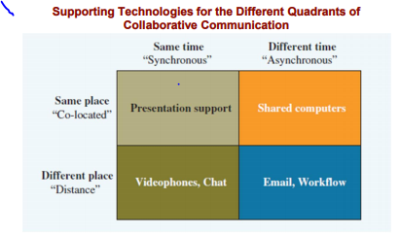

Advantages of groupware systems

Enterprise Portals - Single-point Web browser interfaces used within an organization to promote the gathering, sharing, and dissemination of information throughout an enterprise.

A publishing facility on to which users post and index information
A automatic indexing facility that immediately indexes information
A subscription facility that notifies and distributes relevant information
Intelligence agents that understand user preferences to help him/her find relevant information and present it in a useful way

Midterm Style Questions

1. Which of Porter’s Five Forces is the LCBO trying to use to establish and maintain its competitive advantage?
Ans: LCBO is a government organization with a near monopoly on liquor sales. It does have some private competition in wine sales, which sees it dealing with the bargaining power of buyers with the creation of vintages.com. Even as a near monopoly it must also consider the threat of substitutes.

2. What does the LCBO’s primary value chain look like, using specific examples of its value chain to describe it?
Ans: Liquor Distributors >> Warehousing >> Business Channels >> Ontario Bars, Hotels and Resellers >> Retail Channels>>Consumers

3. Which of the three generic strategies is the LCBO using?
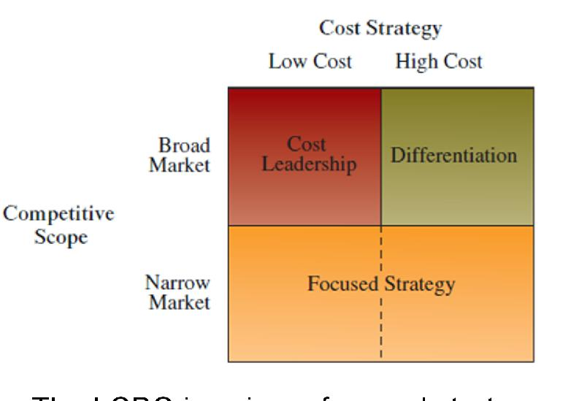
Ans: The LCBO is using a focused strategy with it wines sales as it has the most competition in the wine market but it is a narrow market. In the hard liquor the LCBO has an monopoly.
4. How does the fact that the LCBO is a monopoly affect its use of Porter’s Five Forces? Its use of the Three Generic Strategies?
Ans: The LCBO no longer is not a full monopoly. It does have a monopoly with hard liquor sales but not so with wine and beer. The new processes and channels being offered by the LCBO means that the LCBO is looking at Porter’s Five Forces and his generic strategies in developing its new marketing strategies.

.1 Business and the Internet

Digital darwinism - The principle that organizations unable to adapt to the new demands made on them for surviving in the information age are doomed to extinction.

Disruptive Technology - A new way of doing things that initially does not meet the needs of existing customers.

Sustaining Technology - Produces an improved product customers are eager to buy, such as a faster car or larger hard drive.

Internet - A global public network of computer networks that pass information from one to another using common computer protocols.

Protocols - Standards that specify the format of data as well as the rules to be followed during transmission.

WWW - A global hypertext system that uses the Internet as its transport mechanism.

HTTP - The Internet standard that supports the exchange of information on the World Wide Web.

Digital Divide - The situation of those with access to technology having great advantages over those without such access.

E-Commerce - The buying and selling of goods and services over the Internet.

E-Business Benefits
R.O.C.O.E
Reach, Open New Market, Cost, Operations and effectiveness

Interactivity - Measures the visitor interactions with the target ad.

Clickstream Data - Exact pattern of a consumer’s navigation through a site.

E-Business Model - An approach to conducting electronic business on the Internet

MRO - Materials that are necessary for running an organization but that do not relate to the company’s primary business activities.
E-Procurement - The B2B purchase and sale of supplies and services over the Internet.

Electronic Catalogue - Presents customers with information about goods and services offered for sale, bid, or auction on the Internet.

E-Business Challenges
Protecting Consumers
Leveraging Existing Systems- Integrating systems across business to avoid duplicate
functionality and maintain performance & reliability.
Providing Security Against- accidental or malicious misuse without restricting flexibility.
Protecting privacy and ensuring continuous service
Adhering to Taxation Rules

E-Business Security Methods

Encryption
Scrambles information into a secure form requiring a decoding key to enable reading.
Secure Socket Layer (SSL)
Creates a secure and private connection between sender and receiver and encrypts the information
Identified by a URL beginning with https
Secure Electronic Transaction (SET)
Encrypted information sent over a secure connection
Enables customer authentication for credit card purchases

Section 5.2

Web 2.0 -A set of economic, social, and technology trends that collectively form the basis for the
next generation of the Internet—a more mature, distinctive medium characterized by user
participation, openness, and network effects.

Mashups

Web Mashup - A website or Web application that uses content from more than one source to create a
completely new service.

Application Programming Interface - A set of routines, protocols, and tools for building software
applications.

Mashup - Software editing tool for mashups.

Web 3.0 - describes the evolution of web usage and interaction among several separate paths. These
include transforming the Web into a database, a move toward making content accessible by multiple non-
browser, the leveraging of artificial intelligence technologies, and the semantic Web

Semantic Web - an evolving extension of the World Wide Web in which content can be expressed not
only in natural language, but also in a format that can be read and used by software agents, thus
permitting them to find, share and integrate information more easily.

Service-Oriented Architecture - A business-driven IT architectural approach that supports
integrating business as linked, repeatable tasks or services

Intranet - An internalized portion of the Internet, protected from outside access, that allows an
organization to provide access to information and application software to only its employees.

Extranet - An intranet that is available to strategic allies (such as customers, suppliers, and
partners).

Portals- A website that offers a broad array of resources and services, such as email, online
discussion groups, search engines, and online shopping malls.

Kiosk - Publicly accessible computer system that has been set up to allow interactive information
browsing.

E-government - Involves the use of strategies and technologies to transform government(s) by improving
the delivery of services and enhancing the quality of interaction between the citizen-consumer within all
branches of government.

Mobile commerce - The ability to purchase goods and services through a wireless Internet-enabled
device.

Chapter 7
Legacy System - Older computer technology that remains in use even though there are newer systems available.

Functional System - Information systems that serve a single business unit, such as accounting.

Core ERP components - Traditional components included in most ERP systems that primarily focus on internal operations.

Extended ERP components - The extra components that meet the organizational needs not covered by the core components and that primarily focus on external operations.

CORE
1. Accounting and finance ERP components - Manage accounting data and financial processes within the enterprise with functions such as general ledger, accounts payable, accounts receivable, budgeting, and asset management.

2. Production and materials management ERP components - ERP components that handle the various aspects of production planning and execution, such as demand forecasting, production scheduling, job cost accounting, and quality control.

3. Human resources ERP components - Track employee data including payroll, benefits, compensation, and performance assessment, and assure compliance with the legal requirements of multiple jurisdictions and tax authorities.

Extended
1. Business Intelligence - A broad term denoting information that people use to support their analytical and strategic decision-making efforts.

2. Customer relationship management - Involves managing all aspects of a customer’s relationship with an organization to increase customer loyalty and retention, and an organization’s profitability.

3. Supply chain management - Involves the management of information flows between and among stages in a supply chain to maximize total supply chain effectiveness and profitability.
E-Logistics - Manages the transportation and storage of goods.

E-Procurement - The B2B purchase and sale of supplies and services over the Internet.

Integration tools

Middleware - Different types of software that sit in the middle of and provide connectivity between two or more software applications.

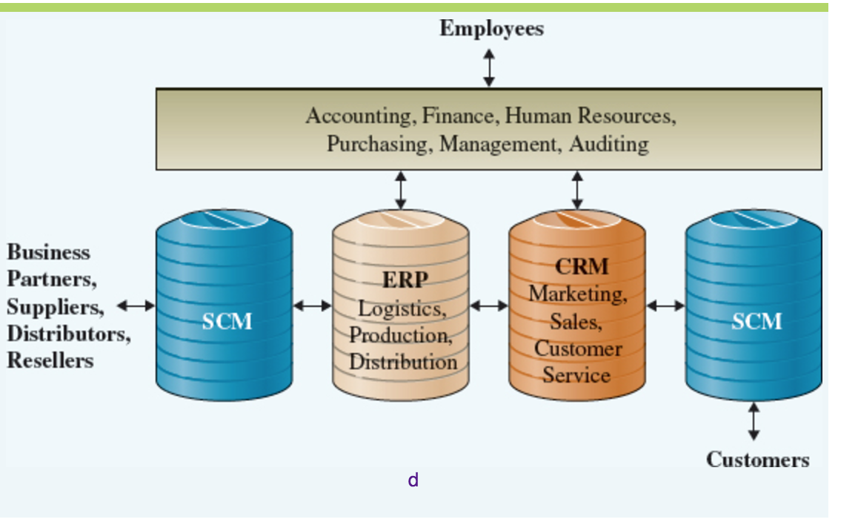
Enterprise application integration middleware - Represents a new approach to middleware by packaging together commonly used functionality, such as providing pre-built links to popular enterprise applications, which reduces the time necessary to develop solutions that integrate applications from multiple vendors.

Balanced Scorecard -A management system (not only a measurement system) that enables organizations to clarify their vision and strategy and translate them into action.

