Z-Unit Notes

Antibiotics
- Compounds produced by some species of bacteria and fungi that inhibit other organisms
- Usually function by: inhibition of cell wall synthesis (penicillin), alteration of membrane permeability (nystatin), inhibition of protein synthesis (kanamycin, tetracycline) or inhibition of nucleic acid synthesis (nalidixic acid, rifamycin)
- Resistant strains usually: enzymatically destroy antibiotic, decrease the membrane permeability of antibiotic, develop an altered molecular target that antibiotic no longer binds to, or develop an altered metabolic pathway to bypass antibiotic-induced block
Ampicillin
- Derived from penicillin (kills bacteria)
- Interferes with cell-wall synthesis
- A transpeptidase enzyme necessary for crosslinking new peptidoglycan chains in the growing cell wall is irreversibly inactivated by ampicillin binding (only effects growing cells)
Kanamycin
- Kills bacteria by binding irreversibly to the 70S subunit of ribosomes causing misreading of mRNA
- Resistance often conferred by genes coding for enzymes that modify the antibiotic molecule by adding a phosphate or acetyl group (can no longer bind to ribosome)

Independent Experimental Design

Antibiotic Physiology
- bacteria of a single strain are not all affected by an antibiotic; some survive the assault even though they are sensitive
- there is a lag before bacteria succumb to the effect of an antibiotic
- Minimal Inhibitory Concentration (MIC): can be determined for an antibiotic or virtually any liquid
Curing
- Plasmids may be lost from bacterial cells in growing cultures due to mistakes in replication or partitioning of plasmids to daughter cells
- A “cured” cell has lost plasmids and has a slight metabolic advantage over cells with plasmids (energy does not need to be used to replicate plasmid) and will be able to outgrow the plasmid-containing cells in selective medium
- Curing may be enhanced by the absence in the media of the antibiotic for which the plasmid has a resistance gene, heat, SDS, Novobiocin or UV radiation

UV Radiation and Mutagenesis
- Main result is thymine dimers (prevents DNA replication)
- UV-damaged plasmid might be able to enter cell but will not alter the cell’s phenotype
- Outer membrane permeability can be disrupted in a UV dose-dependent manner causing increased sensitivity of cells to various antibiotics and detergents
- irradiated cells are most affected by hydrophilic chemicals (ampicillin and carbenicillin) and less so by hydrophobic substances (SDS, rifamycin, Novobiocin, kanamycin)

Pipetting

Mohr Pipettes: usually have calibrated sub-divisions of 0.01 or 0.1 ml and the markings end a few cm from the tip

Serological Pipettes: resemble Mohr pipettes except they are graduated downward to the tip itself

Sterile glass or plastic pipettes: are provided in metal canisters

Micropipettes

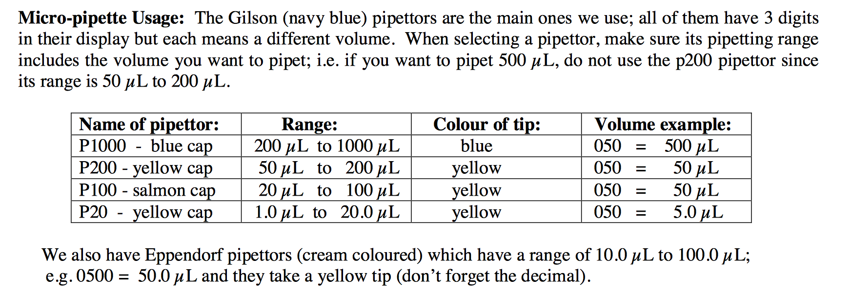

Plasmids
- Bacterial plasmids are typically extrachromosomal, circular, double-stranded supercoiled DNA molecules (self-replicating)
- Range in size from less than 10 to several hundred kb
- May be maintained in hundreds of copies per cell
- Many diverse functions
  - Conjugative genetic exchange
  - Resistance to antibiotics or heavy metals
  - Metabolism of hydrocarbons, carbohydrates and proteins
  - Production of antibiotics, toxins, photo-pigments, REs, and plant hormones
- Many bacterial species have “cryptic” plasmids that confer no obvious phenotype

Transformation of E. coli
- Cells of E. coli must be artificially induced to become competent for transformation by subjecting them to incubation in cold CaCl2 followed by a brief heat pulse at 42 degrees Celsius
- It is believed that large DNA molecules move through “Adhesion zones” where the inner and outer membranes are fused to pores in the bacterial cell wall
- Chilling the cells likely stabilizes the lipid membranes while positively charged calcium ions shield the negatively charged phosphates on the DNA backbone
- The heat pulse may create a thermal imbalance across the membrane that physically pumps DNA through the adhesion zones
- The time necessary for expression of newly acquired traits is called “phenotypic lag”

Suspensions, Solutions, Concentrations and Dilutions
- Suspensions are non-homogenous mixtures of two or more substances
  - Will eventually separate into their components
  - DO NOT describe a liquid volume containing cells as a solution
- Solutions are homogenous mixtures of two or more substances
  - Mixture will remain stable indefinitely
- Percent Concentration
  - Expressed as the amount of solute in a total volume of 100ml of solution
  - Ex: a 10% solution of KCl contains 10g KCl dissolved in enough water to bring the total solution volume to 100ml
- Molar Concentration
  - One mole of any substance contains 6.0247 x 10²³ molecules
  - Molarity = number of mol/L
  - m = MM(V)(c)
- Dilutions
  - Dilution factor = final volume/original volume
= [original]/[required]

Determining #cells/mL
- Take note of dilution
- Number colonies = number cells/specific micro-L
- Convert to mL (divide by value and multiply answer by dilution)
- Adjust decimals if necessary
Ex: Dilution 10⁻⁶, 12 colonies seen, 50 micro-L plated

Number colonies = 12 colonies/50 micro-L
= 12/0.05 mL
= 240 x 10⁶ cells/mL
= 2.40 x 10⁸ cells/mL

Develop a prediction, protocol, conclusion, and propose models to explain trends

Prediction
- a single sentence of the experiment (conjugation, transduction, or transformation) including cells, plasmids, phage, and/or antibiotic(s) used AND what are you measuring (number of conjugants, transductants, or transformants)
e.g. Increasing amounts of pGREEN (10 µL, 20 µL, and 40 µL) in the transformation E. coli JM101 will result in increasing number of transformants.

Conclusion
- single statement
- summary of data
- do the results agree or disagree with the prediction?
- experiment’s intent (conjugation, transduction, or transformation) including cells, plasmids, phage, and/or antibiotic(s) used AND what are you measuring (number of colonies)
e.g. Increasing amounts of pGREEN (10 µL, 20 µL, and 40 µL) in the transformation E. coli JM101 resulted in increasing number of transformants which agrees with the prediction.

Models/biological mechanism
- title that mentions experiment, bacteria, antibiotic if used, etc.
- propose a POSSIBLE biological mechanism or model to explain your data
- it can be your thoughts and/or researched information; i.e. what is going on in the cells to cause a change in the number of colonies in relation to your variable.
- do NOT include the “human error” aspect of the experiments.

Negative control
- no growth is expected
- negative controls are useful for answering questions
  - can the cells become resistant?
  - genetic or physiological resistance?
- To determine if there is any contamination (growth of fungus)

E.g. Bacteria treated with TE buffer on LB + Amp plates, E. coli Jm101 is sensitive to ampicillin so no growth is expected

Positive control
- Growth is expected
- To confirm that the bacteria are able to grow in the absence of the treatment and to make sure results have not been altered for other reasons
- Bacteria placed in ideal conditions

E.g. bacteria treated with TE buffer grown on LB plate. Confluent growth is expected in the absence of ampicillin

K Unit Notes

Scientific Method
- A logical, orderly arranged approach used to study nature and it is also a process used to gain new knowledge
- Observation
  - Detail
  - Question
- Experimentation: planned investigation, logical structure, tests a hypothesis about nature/life
  - Objective(s)
    - Statement of intent which provides specific and succinct details about an experiment that is being done to examine all or part of a topic you are investigating (what is your GOAL?)
  - Hypotheses
    - Simple statements designed to provide possible answers to posed questions (always testing the null hypothesis)
    - Made prior to design and implementation
    - Mention full Latin name(s) of organism(s) and the dependent and independent variables
  - Prediction
    - Specific directional statements predicting outcome
    - Don’t say “support”
  - Experimental Design
    - Based on control, replication and randomization
      - Control baseline for comparison
      - Replication repetitions of all treatments (including control), reduce experimental error and provide more reliable results, min replications = # treatments + 1 (control = treatment)
      - Randomization not on purpose, every individual has an equal chance of being represented in experiment
    - Sample size, choice of organism (experimental unit), treatments (IV), what will be measured (DV), experimental parameters, solutions, apparatus/materials
  - Implementing experiment
    - Conducting experiment and collecting data
    - Need to account for experimental error such as; micro-environmental variability in growth chamber, greenhouse, field, etc. and variability among co-workers
  - Statistical Analysis
    - Obtain results by comparing the treatments used (accept or reject Ho)
    - Statistical inference allows the scientist to make conclusions about the results
    - Predications are NEVER “supported” or “disproven”, only hypotheses are
    - “Do results match prediction is Ha is supported?”
- Communication
  - Poster, oral and paper

Defining Terms

Descriptive statistics: organizing and summarizing collected data.

Protocol: working documents developed in the lab to convey the structure or flow of an experiment. A protocol is a sequentially detailed and numbered account of your experiment.
- Always in the lab notebook (never published)
- Appropriate title that reflects the nature of the experiment
- Can be very comprehensive (diagrams, photos, labelling, tables, formulae, instructions for using equipment, calculations, references etc.)
- No rules for tens or person
- Last entry: citations and statistical techniques

Flow chart: a diagram of the separate steps of a process in sequential order. Information in each box allows us to see what action needs to be preformed in each step.

Importance of Statistical Techniques
- Designing various experiments
- Validating results
- Persuasive conclusions

SD or SE?
- SD when one value of measure/replicate
- SE when more than one value of measure/replicate
  - Take mean of measurements/replicate

Anova and Tukey Analysis
- Anova tests are used when we are testing the differences between means of 3 or more treatments and want to preform a parametric test (makes assumptions about the parameters of a population).
  - Data obtained from normal population, sampled populations have equal variance, treatment effects are additive
- Tukey tests (post hoc test) are used when a significant one-way Anova result is obtained i.e. an overall significant difference in group means was shown. Tukey test examines all pair wise comparisons of treatment means

Creating Tables and Figures
Title should include:
- Dependent variable (unit if applicable)
- Descriptive state of dependent variable e.g. ‘Mean’ (find in descriptive stats table)
- Statistical dispersion (SD or SE)
- Name of organism
- Description of independent variable (verb e.g. defoliated)
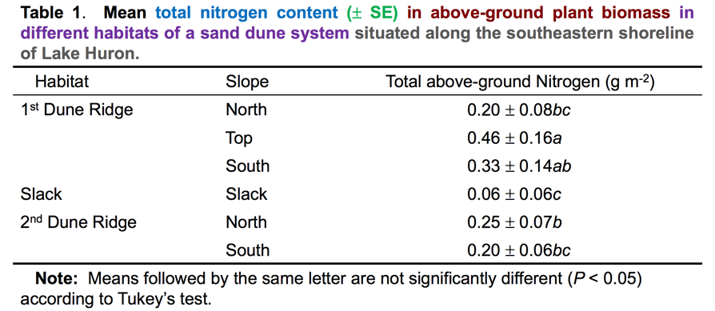

Writing Text of Results:
- Independent variable (treatment) and dependent response variable
- Direction of significance
- P value (The smaller the P value, the more significant the results)
- F value (Variance ratio: the larger it is, the greater the variation)
- Comparison with control
- Compare major results
- Refer to table number twice
- Don’t dwell on statistics
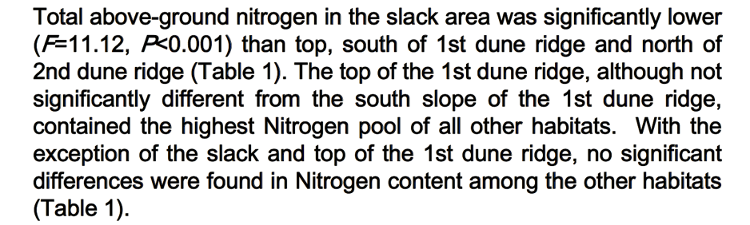
Figure Example
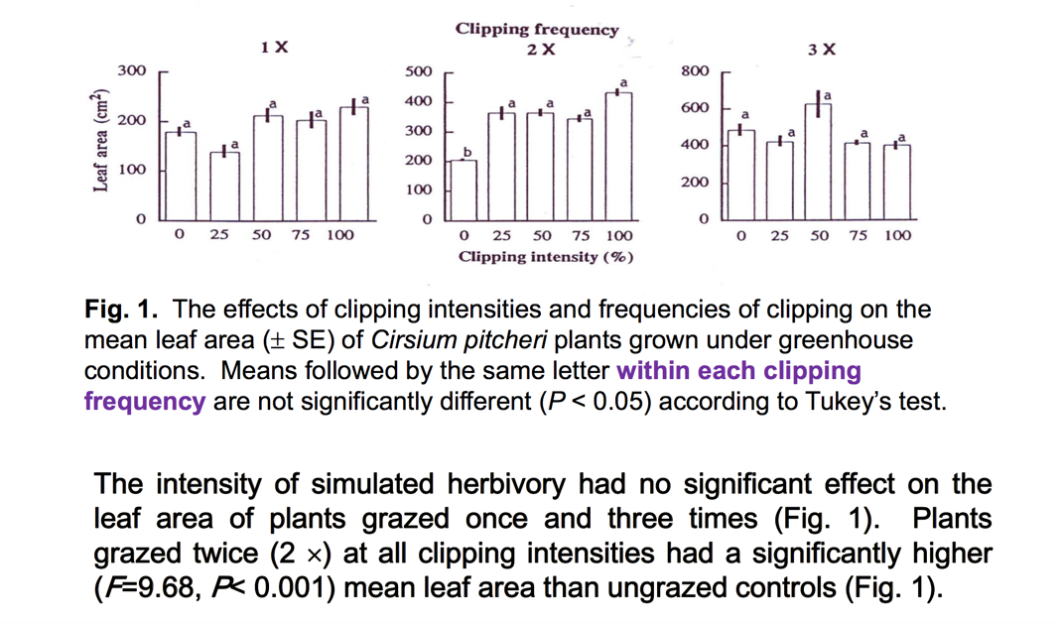
Sections of a Poster
Introduction
- Why its important to investigate this issue/aim/phenomenon/concept (using info from primary articles)
- What is already known/not known
- Organisms (scientific names and authorities), why these organisms were chosen and why they were important
- Objective (intent big picture)
- Hypothesis (alternate only)
- Prediction(s)
Methods
- Experimental design (not protocol very brief, extraneous detail eliminated)
- Photos cited
- Control
- Independent variable/unit of measure and concentration
- Replications
- Randomization
- Dependent variable (growth is not specific enough rather, ZOI)
- Subheading: statistical analyses
  - Brief description of how data were analyzed; which statistical techniques were used
  - Provide citation to stats
Results
- New knowledge
- Numbered tables and figures: summarized data
  - Results of statistical tests
- Text:
  - Data not repeated
  - General trends and patterns
  - Major differences addressed
  - No implications mentioned
  - Report test statistic and P value
  - Refer to every table and figure #
Discussion
- Interpretation of results in context of objectives or hypothesis and predictions
- Importance of findings
- Support all statements
- Biological mechanisms and/or theoretical implications addressed with respect to results
- Paraphrased information and comparisons to primary literature
- Unusual/ unexpected results: explained by biology
- How to take research forward?
- Conclusions of your work
Dean Unit Notes

Spectronic 20 Optical System (Spectrophotometer)
- Lamp: supplies radiant energy of wavelengths 340 – 900 nm
  - Light focuses onto diffraction grating
- Diffraction grating: splits light into its component wavelengths
  - Changing its position changes the wavelength of light that passes through the slit
- Phototube: transduces light energy transmitted by the sample into electric current
- Galvanometer: measures the current
- Scale/meter: shows percent transmittance and absorbance
- The amount of light transmitted (not absorbed) by a sample is compared with a reference blank to determine how much light has been absorbed by sample
- The spectrophotometer does NOT measure absorbance, it measures transmittance

Transmittance and Absorbance
- Transmittance (T) is the fraction of the incident light that passes through the sample

T = I/I_{o} = 10^{-A}
**where I_{o} = radiant power of incident light**
**Where I = radiant power of light passing through sample**

- Absorbance (A) is the amount of light absorbed by the sample
- Lambert’s Law: for a thin layer of sample, the same proportion of light is absorbed regardless of the radiant power of the incident light (I_{o})

A = log (1/T) = log(I_{o}/I)

- Beer’s Law: the absorbance of a solution is proportional to the number of absorbing particles (or concentration of absorbing material) in solution
  - There is a linear relationship between absorbance and solution concentration

A = E x l x c
**A = absorbance (no units)**
**E = absorption coefficient (L/mol/cm)**
**c = concentration of solutions (mol/L)**
**l = path length through spectrophotometer (usually 1cm)**

Appropriate “Blank” to Zero Spectrophotometer
- The blank should contain all of the substances in the sample except for the material whose absorbance is going to be measured
- The blank is placed in the sample holder and the meter adjusted to 100% T (100% transmittance control)
  - Compensates for any absorbance by the solvent in which the sample is dissolved and for the reflection of light from the surface of the tube which holds the sample
- Always adjust the spectrophotometer when ever the wavelength is changed

Principle Uses of the Spectrophotometer
- To identify or characterize compounds in solution by producing an absorption spectrum.
- To determine an unknown solution concentration if you first prepare a standard curve of known concentrations of that substance vs. absorbance.
- To determine the rate of a (bio)chemical reaction
  - The rate of electron flow from photosystem II in isolated chloroplasts (by measuring the reduction of DCPIP)
- To determine the number of cells/mL in a culture
Absorption Spectra
- An absorption spectrum is a graph of the absorbance values of a chemical compound in solution measured at a series of different wavelengths
- They are used to characterize different compounds in solutions
- To prepare an absorption spectrum:
  - Set up spectrophotometer
  - Record absorbance values of each solution at 20nm increments over the range of 360nm to 600nm
  - Plot data on a graph
Standard Curve of Absorbance vs. Concentration
- Use a stock solution to prepare a dilution series
- Use the spectrophotometer to measure the absorbance of each sample at λmax of the sample
- Calculate new concentrations of solution (C1V1 = C2V2)
- Plot absorption vs concentration on a graph
  - should be a straight line passing through the origin
  - exemplifies Beer’s law (up to a concentration limit)
    - Beer’s law assumes ideal conditions. When a substance is present at high concentrations, the molecules interact with one another, changing the properties of the molecules
  - absorption coefficient E can be calculated from the slope of the graph (E=A/c)
  - Change in absorbance illustrates kinetics of the reaction

Calculating Reaction Rates
Reaction rate = moles reduced per minute
- Use n = C x V and A = EC
∆C/min = $\frac{∆A/min }{E}$ R = ∆C/min x V = $\frac{∆A/min }{E}$ x V
**= mol/L “DCPIP” reduced/min** **V in L… mol “DCPIP” reduced/min**
Resolution in Microscopy
- Resolution (d) is the smallest distance by which two objects must be separated in order to allow them to be imaged as two separate objects
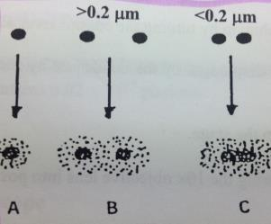
- Abbe’s Equation: provides the theoretical limit of resolution in an optical system
d = 0.612λ / ($n\sin{α}$)
**$n\sin{α}$ is the numerical aperture of the lens & $n$= refractive index**
- Maximum resolution with a light microscope (small d): λ should be minimized, and the numerical aperture should be maximized (substance with higher refractive index than air ($n$_{air} = 1) e.g. immersion oil; angle should be close to 90°)
Estimating the Number of Cells/mL
- Haemacytometer: type of microscope slide
  - Precisely etched lines that intersect to form squares of known area
  - A known volume of fluid is enclosed above each square (proper cover)
  - STEPS:
    - Pellet cells in centrifuge, discard supernatant/growth medium and re-suspend cells up to 5mL DI water
    - Dilute re-suspended cells (10-fold)
    - Make samples of dilute cells at different concentrations (by using compensating volumes of DI water)
    - Load a sample onto Haemacytometer
    - Count the number of cells you see in 10 of the 0.04 mm² squares
    - #cells/mL = Avg # of cells/square x 250,000
    - Measure the absorbance of each sample at 400nm and plot graph of A400 vs #of cells/mL (standard curve)
- Spectrophotometer
  - A beam of light passing through a suspension of cells is scattered in proportion to the turbidity of the suspension
  - Turbidity over a limited range of cell concentration is proportional to the number of cells/unit volume
  - It is first necessary to make a standard curve of absorbance at a given wavelength vs. number of cells/mL
    - # cells/mL must be determined another way (like Haemacytometer)
  - # cells/mL = “A400”/slope of standard curve
    - i.e. C = A/El (beer’s law)
Photon Fluence Rate
- photon fluence rate decreases as sample is moved away from lamp
- In photosynthesis there is a direct relationship between number of molecules photo-chemically altered & number of photon energy
- Essential to know number of photons that invade surface, rather than energy delivered
  - Preferred measurement of Photosynthetically Active Radiation (PAR) is photosynthetic photon flux.
  - Flux = rate of flow of particles
- Photosynthetic photon flux = number of photons in 380-700 nm range per unit of time on unit surface
  - Measured by quantum sensor
  - Photon flux unit = μ moles photons/m²/sec
pH Related Equations/Questions
- [H+] [OH⁻] = 1 × 10⁻¹⁴
- pH = - log[H+], [H+] = 10^{-pH}
- pH + pOH = 14
- K_{a} = [H⁺] [A⁻] / [HA]

- pOH = - log [OH⁻]
- [OH⁻] = 10^{-pOH}
- pH = pKa + log [Acid]/[Base]
- pKa = -logK_{a}

Buffer Solutions
- Purpose to maintain specific pH for experimental reactions
- When [HA] = [A⁻] pH= pKa buffering capacity of solution is at its greatest
  - The range in which the buffer is most effective lies between 1 pH unit on either side of the pKa value.
- Weak acids and bases resist pH change
  - Only slightly dissociate
  - HA ↔ A⁻ + H⁺
    - When H⁺ is added it reacts with A- and forms acid, equilibrium shifts to left
    - When OH- is added it reacts with H+ to form water and equilibrium shifts to the right
  - HB+ ↔ B + H+
    - When H+ is added it reacts with B and equilibrium shifts to the left
    - When OH- and reacts with H+, equilibrium shifts to the right
Making a Buffer Solution
- We will be making a buffer of volume 50 mL with:
  - 250mM tricine (0.05L)
  - 500mM sorbitol (maintain osmosis) (0.05L)
  - 100mM KCl (0.05L)
  - 25mM MgCl2●6H2O (0.05L)

- To make 50mL of chloroplast buffer you first need to calculate the weight of each component to be added (use a stock solution to get the required amount of MgCl₂ since its hygroscopic (it absorbs water from air) and hard to weigh)
􏰈 m = c x V x MM
- Using a magnetic stirrer and spin bar dissolve them in the 40ml of sorbitol solution.
- Add 1.0ml of 1.25M MgCl₂ and make sure the reagents are completely dissolved
- Add NaOH drop-wise until the pH of the buffer solution reaches 7.5
- Bring the volume of the solution to 50ml in a measuring cylinder
- Dilute 5 fold into a flask
Factors Influencing Choice of Buffer
- The pH of use of the buffer should lie within 1.0 pH unit on either side of the pKa for that buffer
- All components should be compatible (not react with each other)
- Buffer compound should not affect the biological system of interest
- Stock buffers should be adjusted for pH after dilution
  - If the acid is positively charged, dilution will decrease the pH
  - If the acid is negatively charged or uncharged, dilution will increase the pH
- Should be prepared at the temperatures at which they are to be used
- Additional salts (e.g. MgCl₂ and KCl) should be added before the pH and volume are adjusted

