Biochemistry Notes (Topics 9-24)

Topic 9: Carbohydrate Metabolism

Carbohydrate Storage as Glycogen
- Glucose-6-phosphate Glucose-1-phosphate (Glycogen synthase & UPT) Glycogen
- Reaction is driven by energy (UTP, like ATP)
- Delta G < 0 (for synthesis AND breakdown of glycogen)
- When we want to break down glycogen we use the enzyme glycogen phosphorylase (which is inhibited by ATP)
- Allosteric Regulation in Skeletal Muscles: AMP signals that the cell is in need of energy (each muscle cell has its own glycogen storage)
- Allosteric Regulation in Liver: Stores glycogen for bodily disperse (neither ATP/AMP are regulators since it isn’t being stored for the liver cells needs)
- Phosphorylation is regulated by hormones outside of the cell
- WHEN LOTS OF GLUCOSE: Phosphatase de-phosphorylates the glycogen synthase (making it active)/glycogen phosphorylase (making it inactive)
- Tissue: hormone causes this
- Liver: Insulin
- Muscle: Insulin
- WHEN IN NEED OF GLUCOSE: Kinase phosphorylates the glycogen synthase (making in inactive)/glycogen phosphorylase (making it active)
- Tissue: hormones causing this
- Liver: glucagon, epinephrine
- Muscle: epinephrine

Glycolysis
- Glucose + 2 ADP + 2pi + 2 NAD⁺ 2 Pyruvate + 2 ATP + 2 NADH
- two ATP produced (not efficient, uses only about 2% of energy from glucose)
- anaerobic process (BUT consumes NAD+, so without regeneration of NAD+ from NADH, glycolysis could not proceed)
- occurs in cytosol (reason why both eukaryotes and prokaryotes can do this)
- first step is usually conversion of glucose to glucose-6-phosphate and the addition of a charged group which traps it inside the cell (there is no mechanism for transport of glucose-6-phosphate across the membrane)
- 2 pyruvates have same number carbons as glucose but less free energy (since glucose was oxidized)
- Target the steps with negative delta G (NOT equilibrium), to control flux
- Hexokinase
- Phosphofructokinase (PFK)
- Commits the cell to metabolizing glucose as opposed to converting it to another sugar or storing it
- inhibited by ATP/citrate (pyruvate is not needed because citric acid cycle is not working well… not in need of ATP)
- Activated by AMP, ADP, Pi, fructose-2,6-bisphosphate (means insulin is high and therefore glucose is high)
- Pyruvate kinase

Fermentation
- Produces ATP without net oxidation (only makes 2 ATP)
- Formation of lactate: in active muscle cells
- Formation of ethanol: in yeast

Gluconeogenesis
- In liver and kidneys (happens in the cytosol)
- Makes glucose when glycogen stores run out (COSTS 6 ATP)
- Purpose is to maintain blood glucose levels (by making glucose from other molecules)
- Does this to make glucose for export to other tissues
- Pyruvate is the precursor we will consider, but glycerol, lactate, citric acid cycle intermediate and AAs can also be used as raw materials
- Even though the net reaction is the opposite of glycolysis, the steps are not just the opposite, they are very different!
- The final step of glycolysis is a point of regulation because it is the first step of gluconeogenesis
- Cell uses the same enzymes as glycolysis, except for the irreversible steps (1,3,10)
- 2 pyruvate + 4 ATP + 2 GTP + 2 NADH glucose + 4 ADP + 2 GDP + 6pi + 2 NAD⁺
- Points of Regulation
- Glucose-6-phosphate
- Fructose Bisphosphatase (reverse of step 3 of glycolysis)
- Glucagon relieves inhibition
- Inhibited by insulin (increases fructose-2,6-bisphosphate) and AMP
- **one time the liver actually puts itself before the rest of the body**
- Pyruvate Carboxylase

PENTOSE PHOSPHATE PATHWAY: oxidizes glucose-6-phosphate to make NADPH
- When ATP is needed:
(3 glucose-6-phosphate + 6 NADP⁺ ) (3CO₂ + 6 NADPH + 3C to glycolysis)
- When Ribose-5-phosphate is needed: **NO carbons go to glycolysis**
(glucose-6-phosphate + 2 NADP⁺) (CO₂ + 2 NADPH + 5C to ribose-5-phosphate)
**ribose-5-phosphate is required for nucleotide synthesis**

Topic 10: The Citric Acid Cycle

The Mitochondrion
- site of respiration for eukaryotes (occurs in cytosol and internal membranes for prokaryotes) **genome contains 37 genes – some code for subunits of ETC**
- Outer membrane: pretty large pores (soluble to most solutes of low weight)
- Inner membrane: more tightly regulated (cristae: increases SA for more ETC)
- Matrix: enclosed by inner membrane **site where pyruvate enters**

Cellular Respiration
- Pyruvate + O₂ CO₂ + H₂O (glucose ATP)
- Pyruvate Oxidation (decarboxylation): pyruvate dehydrogenase (60 polypeptide chains/3 different enzymes) decarboxylates pyruvate into Acetyl-CoA and CO₂ (Coenzyme A is a carrier molecule modified at –SH: high energy bond)
- Aerobic process
- no backwards reaction since there is no enzyme to do so **mammals can’t convert fats into carbohydrates**
- REGULATION: pyruvate dehydrogenase is NOT active when phosphorylated
- Phosphatase (de-phosphorylates): promoted by insulin (high insulin promotes glycolysis so therefore have lots of pyruvate that in turn activates the citric acid cycle – fatty acid metabolism) **presence of pyruvate presents phosphorylation in the first place**
- Kinase (phosphorylates): phosphorylation of the serine residue which inactivates the complex promoted by Acetyl-CoA and NADH
- Pyruvate + NAD⁺ + CoA Acetyl-CoA + CO₂ + NADH
- Citric Acid Cycle (TCA cycle, Krebs cycle): purpose is to harvest energy (in ATP and electron transporters)
- Two ATP produced
- Aerobic Process: O₂ is not directly involved but it is needed to reduce NAD⁺ and FAD and oxidize carbon molecules or else cycle would stop
- UNIDIRECTIONAL as not all steps have enzymes to complete the reverse reaction
- Happens twice because there are two pyruvates
- Acetyl-CoA + oxaloacetate citrate (4C6C)
- CO₂ is lost and NAD+ NADH (becomes 4C’s)(reduction)
- ATP and FADH₂ are produced
- H₂O + malate, NAD+ NADH (reduction)
- Back to oxaloacetate (cycle repeats)
- 1 turn of cycle produces 1 ATP, 3 NADH and 1 FADH₂
- Acetyl-CoA + 3 NAD⁺ + FAD + GDP + Pi 2CO₂ + CoA + 3 NADH + FADH₂ + GTP
- REGULATION: availability of substrates, competitive inhibition by products, allosteric regulation (inhibition by ATP/activation by ADP)

**As a result, there are 24H as electron carriers (not useful form of energy), and only 4 ATP have been made**

Topic 11: Oxidative Phosphorylation (ETC)

- Cofactor: protein-bound non-protein chemical
- Coenzyme: organic cofactor, often a reaction substrate
- Prosthetic Group: tightly bound cofactor (usually metal ion or coenzyme)

Electron Transport Chain
- oxidation of NADH and FADH₂ to pump H+ to harvest energy for ATP synthesis
- occurs in inner mitochondrial membrane (containing matrix)

- Electron Carriers: (lowest electron affinity to highest)
- FLAVINS: isoalloxazine ring (FADH₂) **3 rings + chain**
- Gets 2 electrons (cofactor that is usually bound to enzyme permanently... UNLIKE NADH)
- IRON-SULFUR CENTRES:
  - Clusters of iron/sulfur atoms covalently linked to proteins via cysteine residues
- Each centre can accept 1 electron (Fe³⁺ Fe²⁺)
- UBIQUINONE = Coenzyme Q = Q: lipid in inner mitochondrial membrane
- Accepts 2 electrons (1 at a time)
- Quite hydrophobic (not permanently bound to any protein)
- Oxidized form = Q … reduced form = QH₂
- CYTOCHROMES: heme-containing proteins (peripheral membrane proteins)
- Accepts 2 electrons
- Cytochrome C: Metal part is in the middle, outside is organic wrapping
- COPPER CENTRES: copper ions, usually bound to histidine
- EACH copper accepts 1 electrons (Cu²⁺ Cu⁺)
- If there is more than 1 copper in the centre, EACH can accept an electron (unlike iron centres where regardless of how many iron molecules only 1 electron is accepted)

- Protein Complexes
- 4 protein complexes, each increasing in electronegativity (so they can attract the electrons)
- Net ETC Reaction for:
Matrix NADH = 1 NADH: 10H+ pumped into IMS
Cystolic NADH = 1 NADH: 6H+ pumped into IMS
FADH₂ = 1 FADH₂: 6H+ pumped into IMS
- NADH Dehydrogenase: accepts electrons from NADH **proton pump**
- 1 Matrix NADH = 2.5 ATP (drives movement of 4H+)
- peripheral part accepts electrons
- NADH must be present in MATRIX
- Electrons are passed to flavin group, then to a series of iron-sulfur centres, and finally to ubiquinone (involves Q QH₂)
- NADH + Q + 5H+ (matrix) NAD+ + QH₂ + 4H+ (IMS)
- Succinate Dehydrogenase: accepts electrons from FADH₂ and 2H+
    - 1 FADH₂ = 1.5 ATP (DOES NOT pump protons from matrix into IMS… energy to do so hasn’t been harvested)
    - electrons move via iron-sulfur centres to Q QH₂
    - FADH₂ + Q FAD + QH₂
    - FADH₂ C II CoQ C III Cyt(c) C IV O₂
    - ENTIRE PROCESS: 2FADH₂ + O₂ + 12H+(matrix) 2FAD + 2H₂O + 12H+ (IMS)
- Cytochrome b-c₁ Complex: “Q cycle” (electrons transferred/protons pumped)
    - Contains three heme groups and one iron-sulfur centre
- 2QH₂ enters, 4 electrons go towards making Q and the other 2 electrons reduce cytochrome c molecules
- electrons that go to cytochrome c then go to complex 4
- QH₂ +2cyt(c)O + 2H+ (matrix) Q + 2cyt(c)R + 4H+ (IMS)
- Cytochrome Oxidase Complex:
- Accepts electrons from cytochrome c and passes them on to be oxidized (has 3 electron accepting sites) **for each O₂ that is reduced, 4 cytochrome c proteins give up their electrons**
- 8H+ brought in from matrix and 4H+ to IMS (from oxidation of cytochrome c)
- Final Electron Accepter = Oxygen (makes water)
- 4cyt(c)R + O₂ + 8H+(matrix) 4cyt(c)O + 2H₂O + 4H+(IMS)
- NADH C I CoQ C III Cyt(c) C IV O₂
- ENTIRE PROCESS: 2NADH + O₂ + 22H+(matrix) 2NAD+ +2H₂O + 20H+ (IMS)

- NADH made in Cytosol during Glycolysis (so how does complex I use it?)
- Freely diffuses into intermembrane space (for skeletal muscle/brain)
- NADH gives up electrons NAD+ (which goes to glycolysis)
- NADH from cytosol CAN’T give electrons directly to complex I so has to give them to FAD complex (no proton pumping occurs)
- Therefore, cytosolic NADH pumps 6 protons (rather than 10)

**[H+] is higher in the intermembrane space (pH ~ 7.2) than in the matrix (pH ~ 7.9 (represents potential energy) **chemiosmosis**

- Proton Motive Force: protons can’t freely diffuse back into the matrix because the membrane is not permeable to this
- Potential energy
- Due to membrane potential, electrochemical H+ gradient, and pH gradient

- F₁F₀ ATP Synthase: Driven by the voltage gradient (to bring ADP in and ATP out… Pi gets brought in by using chemical part, NOT electric part)
- protons only flow if there is substrate to make ATP (ADP and Pi)
- The F₀ section contains 8 c subunits that each bind 1 proton from IMS
- Flow of protons across gradient drives a rotor (protons bind to rotor subunits)
- Peripheral stalk holds everything in place and the shaft (central stalk) rotates
- Once they have completed a full rotation an exit channel allows them to leave to the other side of the membrane
- Energy stored in protons is converted into mechanical, rotational energy, which is transmitted via a shaft (attached to rotor), that penetrates into F1-ATPase (lolly-pop head), which catalyzes the formation of ATP (by pushing on the beta subunits – part of the F₁ section - to change their conformation and release energy)
- There are 3 ADP-Pi binding sites (for one rotation, 8H+ move across membrane and 3 ATP are made)

- In total, cellular respiration makes 30 ATP/glucose molecule
- 5 from glycolysis, 5 from pyruvate oxidation, 20 from krebs/ETC
- high end estimate – some are used to make AA
- Coupled reactions: concentration gradient couples ETC and ATP synthase
- can become uncoupled – use uncoupler (offer protons a second route to other side… ex: poke holes in membrane) **energy is released as heat**
- protein uncouplers: (UCP1,2,3 in humans)
- chemical uncouplers: (2,4 dinitrophenol) **pokes holes** weight lifters take this compound to lose weight, but would die if take too much (not producing ATP)

Topic 12: Fatty Acids, Ketone Bodies, and Biosynthesis

Adipocyte (fat cells) triacylglycerols
- function as a form of energy storage which can be utilized when needed
- In the presence of insulin (high blood glucose), lipase (enzyme that encourages the breakdown of triacylglycerols) is down regulated and fatty acid synthesis is stimulated.
- First, acetyl-coA is transported from the matrix into the cytosol via the tricarboxylate transport system (costs 2 ATP)
- Fatty acids are made in the cytosol (of liver cells), consuming NADPH and ATP, and are stored as triacylglycerols in adipocytes. **reductive process**
- Palmitate (16C fatty acid) is the main product
- 8 Acetyl-CoA + 14 NADPH + 7 ATP Palmitate + 8 CoA + 14 NADP⁺ + 7ADP/Pi
- In the presence of glucagon (low blood glucose), lipase is up regulated and triacylglycerol break down is stimulated.
- Triacylglycerols are broken down into glycerol and fatty acids, which can both be used in energy metabolism once further acted upon.
- Glycerol is converted into glucose in the liver via gluconeogenesis, which is then transported to the brain and other parts of the body.
- Fatty acids, once activated in the cytosol (requires ATP), are transported into the matrix of both liver and muscle cells, where they are converted from acyl-coA into acetyl-coA (NADH and FADH₂ are also produced) via beta-oxidation (an ATP independent “cycle” where acyl-coA continually loses two carbons at a time, until only two carbon molecules exist (acetyl-coA molecules) *7 cycles required*).
- The acetyl-coA molecules that are formed can be integrated into the citric acid cycle (which generates ATP), or can be converted by the liver into ketone bodies, which can cross the blood-brain barrier to provide energy for the brain and can also supply energy for muscles.
- Ketone Bodies: small molecules made in the liver from the breakdown of acetyl-coA, which can cross the blood-brain barrier (the brain can’t use energy from fatty acids directly but can in this way)
- In the unfed state, fatty acid oxidation is the major energy source in muscles and liver. Even though ketone body production increases in the first few days of the unfed state, ketone bodies are not the main source of energy for the brain during this period.

*Brain Fuel During Fasting*
- Breakdown glycogen into glucose (can only run on solely this for about 16 hours)
- Glucose from gluconeogenesis - breaking down of AA from muscle protein (doesn’t use up all of the muscle protein because person would die)
- Fatty acid breakdown – when ketone bodies are able to supply the brain with energy, gluconeogenesis will slow down (takes time to start – new enzymes must be synthesized)
- When fat reserves are gone the body is forced to consume protein again

Cholesterol Synthesis
- All carbons of cholesterol are from Acetyl-CoA
- Acetyl-CoA HMG-CoA (HMG-CoA Reductase) Mevalonate Cholesterol
- Regulate production via HMG-CoA Reductase (ex: “Lovastatin” drug, inhibits step)

Topic 13: Summary of Energy Metabolism

Fed State
- High insulin, therefore glucose broken down by glycolysis
- When ATP accumulates, citric acid cycle slows down
- Insulin tells body to store things like glycogen and triacylglycerol
- Lots of building blocks for biosynthesis (ex: protein synthesis)
Unfed State: Liver
- Breakdown of triacylglycerols (in adipocytes) to fatty acids/glycerol (further made into ketone bodies for export to other tissues, and eventually glucose for ATP)
Unfed State: Most Tissues
- Muscle breaks down glycogen into glucose
- Muscle breaks down proteins for gluconeogenesis
- Muscle picks up ketone bodies from the liver
Type 1 Diabetes
- Insulin is NOT produced
- Body behaves like you are under fed, so glucose levels stay high
- GENETIC

Type 2 Diabetes
- Cells producing insulin in pancreas lose effectiveness over time (less insulin produced)
- Tissues can become insulin resistant, therefore don’t react as much to insulin
- Develops later on in life, usually do to over eating/not exercising/old age

Topic 14: Nucleic Acid Structure

Ribonucleoside
- “nucleoside” = base + sugar
- base = cytosine…. Nucleoside = cytidine… sugar = ribose
- always beta configuration
- to number the carbons, number the base first and then go to the sugar using “prime”
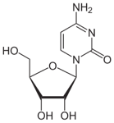
Ribonucleotide
- “tide” = nucleoside with at least 1 phosphate (ex: cytidine monophosphate)

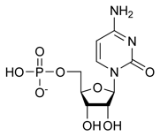
Deoxyribonucleotide
- “OH” is removed (ex: deoxycytidine triphosphate)

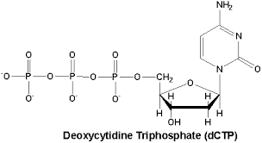
Nitrogenous Bases
- Purines: two rings
- Adenine (base) Adenosine (nucleoside)
- Guanine (base) Guanosine (nucleoside)
- Pyrimidines: one ring
- Cytosine (base) Cytidine (nucleoside) **DNA/RNA**
- Thymine (base) Thymidine (nucleoside) **DNA**
- Uracil (base) Uridine (nucleoside) **RNA**
- Same structure as thymidine except “R” group is replaced with an H
Polynucleotides
- Built with similar concept as polypeptide (backbone, side-chains)
- Nucleic Acids: composed of nucleotide monomers (sugar + nitrogenous base + phosphate)

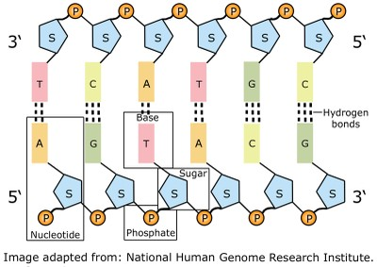
DNA Double Helix
- Proposed in 1953
- 3 main pieces of evidence
- Chargaff’s Rules: analysis of DNA (compares % of each base)
- Found that A&T are essentially the same and G&C are essentially the same
- X-Ray Diffraction Pattern: crystalize molecule and shoot rays at it, the diffraction pattern of DNA allowed for the discovery of base pairing & structure
- Correct Tautomeric Forms of Bases: were unsure which form of bases were used until Jerry told them which ones
- “B-DNA”: primary form that is in cells
- Bases are relatively hydrophobic so are in the core & phosphate groups are on the outside
- Right Handed Coil:

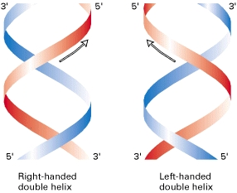

- Forces Stabilizing the double helix
- Base Stacking: the bases are planar aromatic rings which allows them to stack on top of each other; LDF are created (NO gap between bases)
- Base Pairing: H-bonds form between bases of 1 strand and bases of the other strand
- Watson-Crick base pairing: constant width creating by purine H-bonding with Pyrimidine… nothing special about these H-bonds, but water can’t compete because it can’t access the interior H-bonds of the double helix
- Features of Structure
- Rise (distance between consecutive bases) = 0.34nm
- 10 base pairs/turn
- 2nm wide
- major/minor grooves

Differences Between DNA and RNA

DNA | RNA
Deoxyribose | Ribose
Thymine | Uracil
Long | Short (only up to ~1000 nucleotides)
Double Stranded | Single Stranded (although tends to fold up on itself by self complementary)
Few base modifications | Many base modifications (lots of different types of RNA)

RNA Structure
- Self complementary sections are separated by “loops”
- RNA depends on primary sequence for its tertiary structure (similar to proteins, yet unlike DNA)

Types of RNA

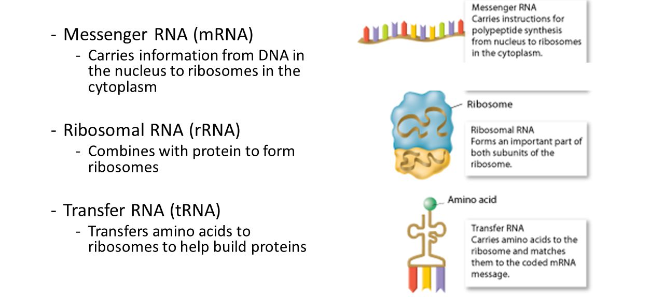

Condensing Human DNA
- Human DNA MUST be condensed (3x10⁹ base pairs & nucleus diameter is 6x10⁻⁴cm)
- Packaging is highly organized (as must remain accessible)
- Not permanent, can be undone
- Chromatin: DNA and all associated packaging proteins (eg: histones)
- Histones: rich in arginine and lysine (+ charged AAs)
- Their charges allow them to interact with the phosphates in the DNA backbone (- charged)
- H1 is the largest histone (binds where linker emerges from core particles – helps form regular structure)
- H4 (histone in eukaryotes) has been conserved… even though differences exist in different organisms, it is still very similar (proves that packaging is VERY important)
- Nucleosome Core Particles: DNA packages like a spool of thread (proteins in the middle and DNA is the thread) **each histone has a tail extending out**
- Nucleosomes = NCP + one linker (~200 BPs - linker region is about 3-80 BPs)
- like beads on a string
- (first level)
- 30nm chromatin fibres
- nucleosomes packed together
- H1 is required to do this
- Structure still controversial
- (second level)
- Higher Levels of DNA Packaging

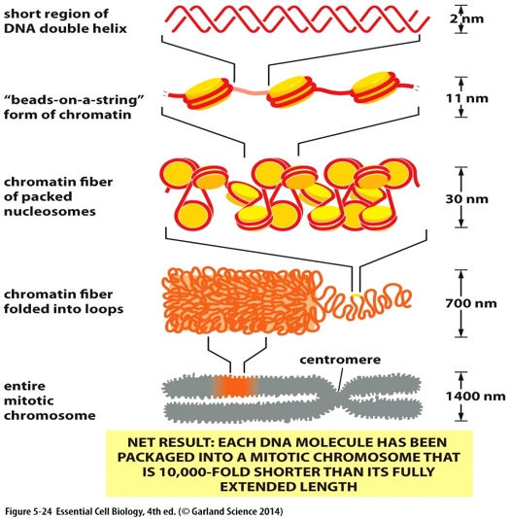
**30nm fibres form loops of 30-200 kbp**
(third level)

**Loops anchored to nuclear matrix**
(RNA and non-histone proteins)

**DNA is not usually this tightly packed as it must be accessible… only like this when separating**

Chromosome Remodeling Complexes
- Change nucleosome structure to allow transcription (ATP dependent)
- Chromosome Remodeling: influenced by covalent modification of histone tails
- Histone Code: the variation in the number of modifications of histone tails that can encourage chromosome remodeling

Topic 15: DNA Replication

Steps

- Initiation
- Replication starts at the replication origin (rich in AT pairs)
- Bacteria only has one replication origin but more complicated organisms have more
- Initiator proteins help to open the double helix
- Helicase then binds at the forks and continues to unwind the DNA consuming ATP as it does so (replication bubble)
- SS-binding proteins prevent the DNA from winding back together or from making a secondary structure with itself

- Priming
- Primase synthesizes a small primer (10-20 nucleotides) composed of RNA
- This is necessary because DNA polymerase can’t synthesize DNA without a primer

- DNA Synthesis
- DNA polymerase extends the primer from its 3’ end
- The incoming nucleotide reacts with the 3’ OH when complementarity of the template strand is good (promotes 5’ 3’ growth)
- Two polymerases associate with each helicase (one for lagging and one for leading strand)
- Sliding Clamp binds to DNA polymerase to keep it on the template
- Leading Strand is synthesized towards the replication fork (continuous synthesis)
- Lagging Strand is synthesized away from the replication fork (Okazaki Fragments)
- Primase has to keep adding RNA primers for new segments of DNA to be synthesized
- When polymerase is finished replicated an Okazaki fragment, it detaches and reattaches to a primer near by (reason why a “loop like” structure forms)

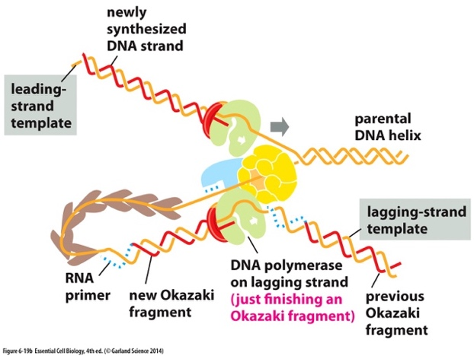

- Proofreading: there is an error every 1 in 10⁵ bases for humans
- caused by mismatch, addition of a base (forms bulge), or skipping of a base (makes 1 strand too long)
- must happen before the next nucleotide is laid down
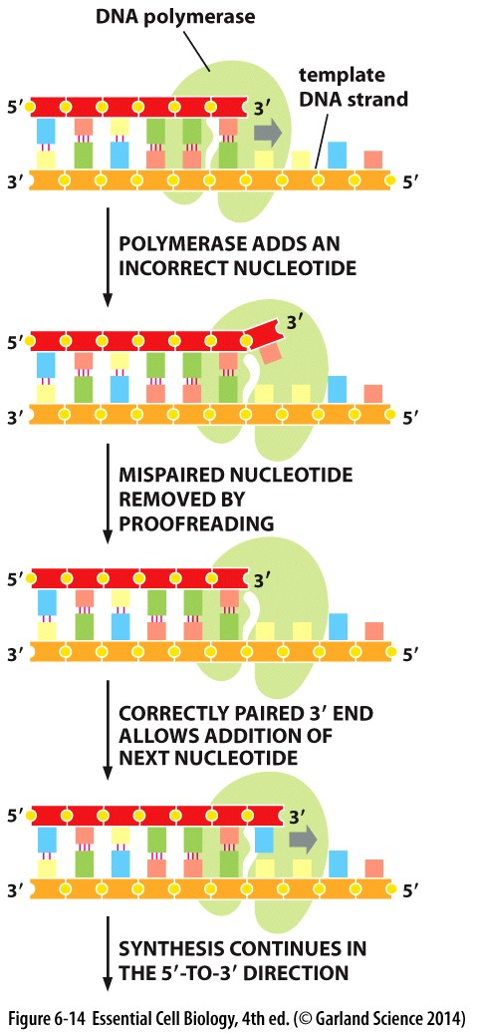
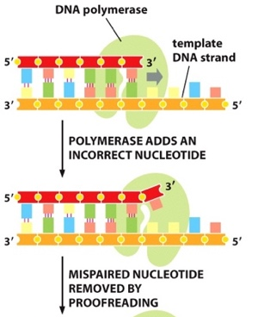

- Ligation in Bacteria
- DNA fragments from the lagging strand must be joined together
- DNA polymerase III dissociated and DNA polymerase I binds
- DNA polymerase I degrades the primer (5’3’ exonuclease) and synthesizes replacement DNA (the “nick” is moved around)
- The “nick” is sealed by DNA ligase
- The energy needed to do this comes from ATP hydrolysis

Telomeres
- Protein-DNA structures at ends of linear chromosomes that protect coding sequences (5000-15000 BP of NT repeats)
- Act as a signal that the chromosome did NOT break and that it is truly just the end of the chromosome (DS breaks are really bad) **3’ overhang is still present**
- Replication Problem: telomerase expression stops after birth (except in gametes), so telomeres shorten with each cell generation
- Machinery falls off before synthesizing to the very end of the lagging strand
- Through evolution, chromosomes keep getting shorter
- Telomerase: special DNA polymerase, composed of protein and RNA in which the RNA acts as template to add DNA to 3’ end of the lagging strand… helps to maintain chromosome length

Antivirals (some target viral DNA synthesis)
- Incorporate molecules into DNA that look like nucleosides but DON’T have a free 3’ OH so replication is terminated
- Look enough like nucleosides that phosphates will be added to them
- Usually viral reverse transcriptase will pick these up (doesn’t proofread) and regular DNA will not
- Azido Thymidine (AZT): used to combat HIV…. Has an N₃ instead of a hydroxyl group at its 3’ carbon, therefore the next nucleotide can not be added and DNA synthesis stops **inhibits RT 100 times more effectively than DNA polymerase**

Topic 16: DNA Repair

DNA Damage
- Any unintended physical or chemical change in DNA (SS)
- Even though some DNA damage ends up being beneficial to cell, cells ALWAYS try to fix it

Causes of DNA Damage

- Copying Mistakes: DNA polymerase makes an error once every ~10⁷ nucleotides
- Mismatch, insertion, deletion
- If damage from a replication error is not repaired a mutation will result (DS)

- Depurination: loss of A or G base which blocks DNA replication
- Results in an A-basic site (no base) **polymerase has nothing to read**
- Cells go into damage control: DNA polymerase is removed and base is re-added by translesion DNA polymerase
- Translesion DNA polymerase is NOT used all of the time because its active site is not as accurate (strict) as normal DNA polymerase
- If damage from Depurination is not repaired the wrong base may be incorporated opposite to the a-basic site

- Deamination: conversion of amine to carbonyl
- Most common at C (result is the U substitutes for C)
- Happens spontaneously, not energy input is needed

- Pyrimidine Dimers: UV light causes ring formation between adjacent pyrimidines
- covalent bonds
- DNA replication is blocked because dimers don’t fit well
- Overcome by translesion polymerases

- Other Environmental Factors
- Ionizing radiation
- Chemical mutagens
- Mechanical stress
- RESULT: chemical changes in bases or breakage of sugar-phosphate backbone

DNA Repair Systems

- Proofreading during DNA Replication: catches about 99% of DNA polymerase mistakes

- Mismatch Repair (eukaryotes): repair of replication mistakes (DNA polymerase mistakes ONLY)
- “nicks” tell the body that the strand is newly synthesized (“nicks” are only left in for a limited amount of time)
- mismatch repair MUST happen when “nicks” are still present
- Mismatch repair proteins bind to the DNA damage and search for a “nick”
- exonuclease breaks down the strand from the “nick” all the way to the damage (gap is then repaired by DNA polymerase and ligase)
- Costs a lot of energy

- Base Excision Repair (BER): repair of modified bases, a-basic sites, SS-breaks
- Short Patch BER: for single base damage

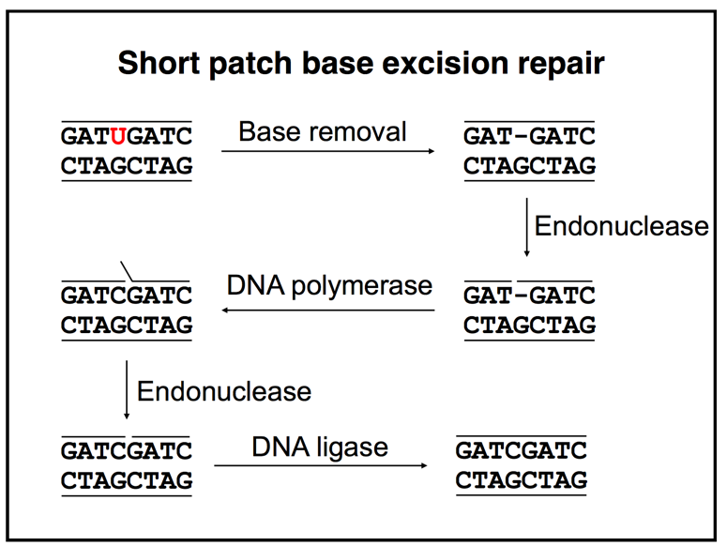

- Long Patch BER: for backbone damage

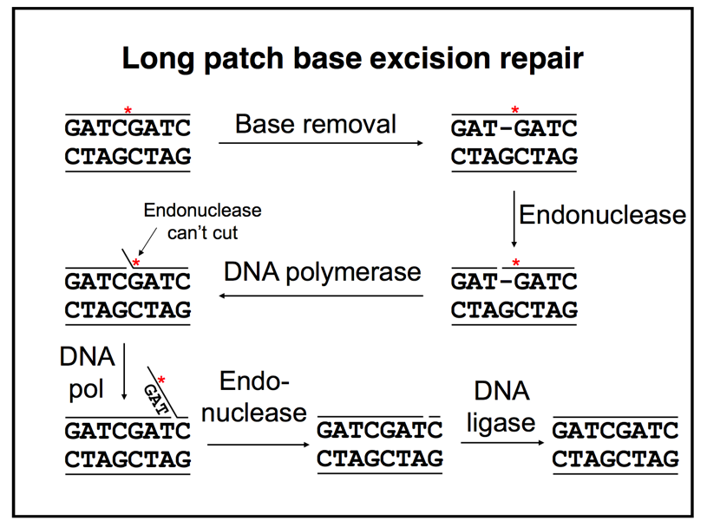

- Nucleotide Excision Repair (NER): repair of pyrimidine dimers and damage that disrupts the double helix (still only technically considered SS damage)
- For damage to more than 1 base: endonuclease makes “nicks” on both sides of the damage, helicase removes this section (gets degraded), DNA polymerase adds new, appropriate bases, and finally DNA ligase seals the “nick”

- For Double Stranded Breaks
- Non-homologous End Joining (NHEJ): strands are just slapped together; information is general lose
- Homologous Recombination: need other part of homologous chromosome near by… use it as a template to fix broken strands… information is NOT lost, but it isn’t likely that the homologous strand is near by to do this

Topic 17 & 18: Prokaryotic and Eukaryotic Transcription and Gene Regulation

Gene Expression
- Human genome encodes ~21,000 protein encoding genes
- Less than 10,000 are expressed in any cell
- Brain and liver have the same genes but do not express all of the same proteins
- Most diseases are caused by altered expression of 1 or more gene
- Steps where regulation can occur
- Transcription (initiationelongationtermination)
- Usually the most regulated step
- RNA processing (RNA editing, 5’ capping, splicing, 3’ polyadenation)
- mRNA export form nucleus to cytoplasm (active process)
- mRNA degradation
- Translation (initiation elongation termination)
- Protein modification (phosphorylation, acetylation, cleavage (insulin))
- Protein degradation

Prokaryotic Transcription
- Consensus Sequence: most frequent base at a position in a group of functionally related DNA elements (none of the elements actually have to be the consensus sequence)
- Bacterial Operon Structure:
- Promoter – about 100 BP (+1 site is where transcription starts, -10 & -35 are consensus sequences)

- Bacterial RNA polymerase: makes RNA using a DNA template and NTPs as substrates
- Multi-subunit enzyme (core enzyme can make RNA in test tube but doesn’t recognize promoters…. Need the sigma subunit to recognize promoters)
- Sigma recognizes -10 and -35 areas and then can bind to the promoter (DNA/protein interaction) **there is more than one sigma factor, each one recognizes different promoter sequences**
- Process:
- INITIATION
- RNAP Holoenzyme binds the promoter through interactions at -10 and -35 sites (closed complex)
- RNA Polymerase unwinds the DNA strands around the start site (open complex) **RNA polymerase does not need a primer**
- The first NTP is then brought to the template

- ELONGATION
- Using ATP, GTP, CTP, and UTP as substrates, the chain elongation proceeds in a 5’ 3’ direction (Phosphodiester bonds form)
- After the addition of 5-10 nucleotides, sigma falls off the Holoenzyme an core can move down to continue transcription (bubble moves)

- TERMINATION
- RNA synthesis proceeds until terminator is reached and RNA polymerase falls off
- Sigma then rebinds RNAP and cycle is repeated

- TRP Operon: Negative Regulation
- Expressed when there is little tryptophan in the environment
- TRP Operator: DNA sequence between the -10 and -35 that binds the TRP Repressor (protein) when there is a lot of tryptophan in the cell
- TRP Repressor: 107 bases made of 6 alpha helices – helix 4 & 5 recognize DNA and are helix-turn-helix motifs… works as a dimer (has two-fold symmetry) … tryptophan causes a conformational change in the repressor, which allows it to bind to the DNA
- TRP Repressor-Tryptophan Complex binds the operator (which blocks RNA polymerase from the promoter)

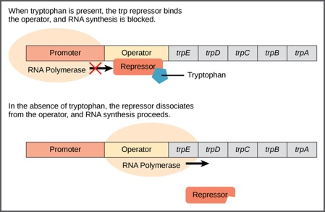
- Lac Operon: Negative/Positive Regulation
- Negative: Lac repressor (if bound to lactose will NOT bind to DNA)
- Positive: Catabolite activator protein (transcriptional activator)
- Operon is turned on when lactose is present but NOT glucose (cells would rather break down glucose) **low glucose means rising [cAMP]**
- CAP Binding Site: DNA element that binds CAP (regulated by [glucose])
- CAP binds cAMP and can then bind to the CAP binding site… which helps bring RNA polymerase to the promoter

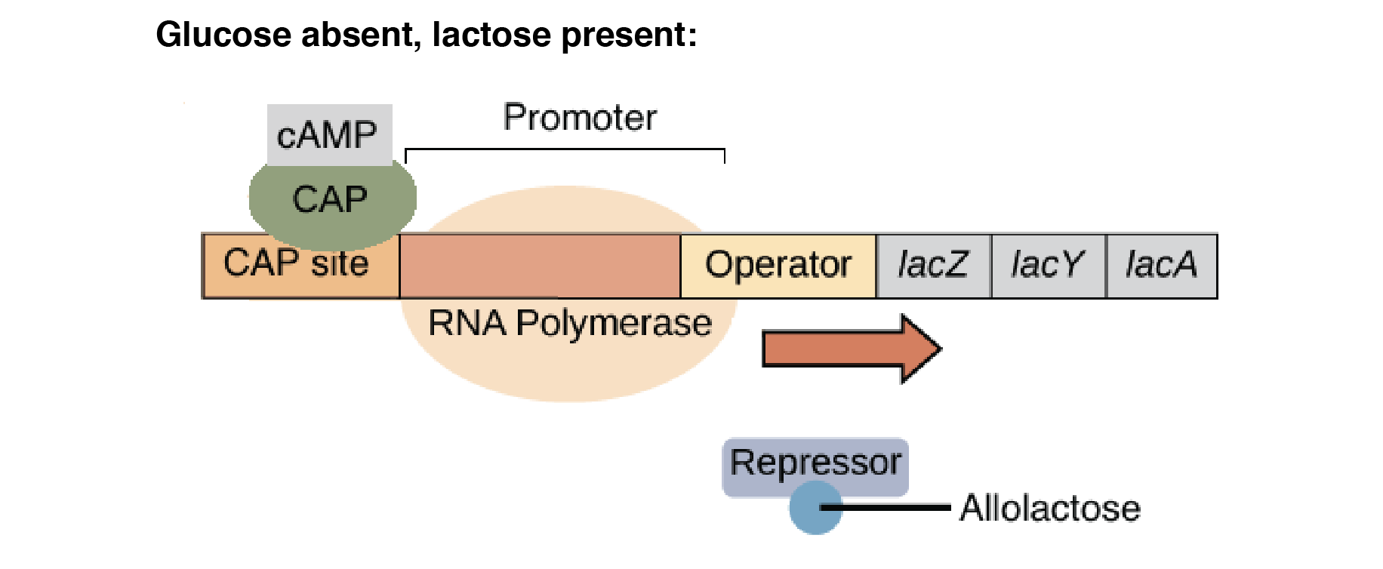

Glucose + Lactose | Operon off CAP not bound nothing is bound
Glucose ONLY | Operon off lac repressor bound CAP not bound
Lactose ONLY | Operon on lac repressor NOT bound CAP bound
No Glucose or Lactose | Operon off CAP and lac repressor are bound

Eukaryotic Transcription
- Regulation of the Genes Required for Galactose Metabolism in Yeast
- The genes required are GAL 1, GAL 2, GAL 10 and GAL 7… they are not found in an operon but rather each gene encodes its own mRNA
- Positive Regulation
- Genes required for galactose metabolism are turned on when yeast are grown in the presence of galactose
- GAL 4, as a dimer, specifically binds to a 17 BP sequence making contacts with bases in the MAJOR groove
- GAL 10 Promoter has 4 such GAL 4 recognition sites (UAS_{GAL}) which are upstream of the TATA box
- GAL 4 occupies UAS_{GAL} ALL OF THE TIME, but is only active in the presence of galactose (in the absence of galactose, GAL 4 is bound to a repressor called GAL 80)
- In the presence of galactose, GAL 4 becomes activated by GAL 3 (which frees GAL 4 from GAL 80), and then is able to stimulate transcription (through direct protein-protein interactions and by altering chromatin structure)

- Negative Regulation
- Catabolic Repression – process by which cells limit the expression of the genes required for metabolism of carbon sources in the presence of glucose
- MIG 1: binds to the GAL 10 Promoter in the presence of glucose… this complex recruits factors that modify the chromatin in the vicinity of GAL 10 in such a way as to inhibit transcription
- In the absence of glucose, MIG 1 is phosphorylated and therefore CAN’T enter the nucleus to bind the promoter

Difference Between Prokaryotic and Eukaryotic Transcription

- Three RNA polymerases in Eukaryotic (vs. 1 in prokaryotic)
- Pol I – most RNA genes (rRNA)
- Pol II – mRNAs
- Pol III – tRNAs, snRNA

- Eukaryotes don’t have Operons (monocistronic)
- Every gene has its own promoter (makes 1 protein)

- Promoter Structure
- Eukaryotes don’t have -10 and -35 OR sigma factors
- Have things like TATA box (recruits TATA binding protein which recruits other things to recruit RNA polymerase II)

- Eukaryotic Regulatory Proteins Often Bind DNA several thousand BPs from start site of Transcription
- DNA will bend to allow these far away elements to interact (DNA looping)

- Combinational Control
- Groups of proteins work together to determine the expression of a gene
- Eukaryotes have FINE control on promoter because many different factors influence… leads to a wide range of expression (unlike the on/off switch in prokaryotes)

- Nucleosomes and Higher Order Chromatin Structure Regulate Transcription in Eukaryotes
- Generally, they repress transcription
- Cell can pull DNA off nucleosome (takes a lot of energy), or nucleosomes can move away from the promoter
Topic 19: RNA Processing in Eukaryotes (pre-mRNA mRNA)

**occurs when transcription is going on (not after)**

5’ Capping: 7-methylguanosine
- Marks 5’ end of mRNA as being intact
- Required for export from nucleus and translation of mRNA

3’ Polyadenylation: Poly-A-tail
- 300 bases
- almost all eukaryotic mRNA has one
- sequence downstream of stop codon (acts as buffer from 3’ exonucleases)
- required for mRNA export and translation

RNA Splicing: Removal of Introns
- introns = junk
- exons = coding sequence (exon 1 is almost ALWAYS expressed)
- pre-mRNA mature mRNA
- splicing increases the coding capacity of the genome
- Differential Splicing: an RNA can be spliced in different ways to get different proteins (splicing pattern is often tissue specific)
- Mechanism of Splicing:
- requires specific sequences in RNA
- 5’ splice junction (includes part of exon + intron) *Acceptor site*
- 3’ splice junction (includes 1 base of exon + intron)
- branch point (in intron… must have ADENINE)
- introns are removed in 2 transesterification reactions (as result of the catalytic activity found in small nuclear ribonucleoprotein particles – snRNP’s)
- the RNA component of snRNP’s has a recognition function that acts through base pairing with the mRNA
- Spliceosome: assembly of snRNP’s that cause splicing
      - 1: cleavage at the exon 1-intron boundary results from the attack of the 5’ splice junction by the 2’ OH of the A nucleotide in the branch point (forms the lariat structure)
      - 2: the 3’ OH of exon 1 reacts with the 3’ splice junction cutting out the intron and joining the exons (the lariat is displaced and then degraded)
- Self-Splicing Introns: pre mRNA of protozoa, mitochondria and chloroplasts, snRNP’s are not required… the RNA is capable of catalyzing its own conversion to mRNA
- Abnormal splicing of beta-globin RNA can result in hemoglobin deficiency (anemia)

mRNA Export
- Nucleus cytoplasm
- Requires proteins that interact with 5’ CAP, poly-A-tail and specific protein carriers
- mRNA goes through nuclear pores
- proteins recognize components of pore
- proteins are exchanged prior to translation
- **protein-protein recognition**
- selective gates

Topic 20: Translation

- mRNA protein
- each codon is 3 bases because there are 20 AA… therefore need 20 codons
- some codons specify for the same AA (64 codons, yet only 20 AAs)
- Stop Codons: UAA, UAG, UGAA
- Start Codon: AUG
- Functionally related AA have similar codons
- Increases the chance of a functional protein in the case of a single base mutation
- Types of Mutations
- Missense: 1 base changes and AA changes
- Silent: 1 base changes but AA remains the same
- Frame Shift: insertion/deletion of a base (VERY problematic)
- Nonsense: 1 base changes and creates premature stop codon

tRNA
- Bring the AA to growing polypeptide chain
- About 80 bases
- Structure is due to internal base pairing
- Has non-conventional bases (put in AFTER transcription)
- Two key SS regions
- 3’ acceptor site: where AA is attached (CCA – phe)
- anticodon: base pairs with codon
- Wobble: for some tRNAs base pairing between anti-codon and codon only requires matching at TWO positions (rather than all three that exist)
- Base pairing interactions for the 2 phe codons (UUU, UUC) works with the same tRNA (GAA)
- Aminoacyl tRNA Synthetases: couple 3’ end of tRNA to it’s correct AA
- Generally, only 1 for each AA (therefore about 20)
- “charging of tRNAs” – store energy from ATP in high energy ester-linkage, found at the end of tRNA… many have proofreading function

Ribosomes
- catalyze protein synthesis (translation)
- really big molecules (have both RNA and protein) ~ 4.2 Mda
- have 2 subunits (large and small)
- 3 binding sites for tRNA (only 2 occupied at any one time)
- A site: binds aminoacyl-tRNA
- P site: binds peptidyl-tRNA
- E site: site which tRNA exits

Steps in Translation

- A peptidyl-tRNA is in the P-site of ribosome
- An aminoacyl-tRNA binds to the A-site (requires base pairing between tRNA and codon)
- CATALYTIC STAGE: energy from ester bond of peptidyl-tRNA in P-site is used to form new peptide bond between AAs in the A and P sites (RNA does catalyzing…. NOT protein)
- Peptide bond formation is coupled to conformational change in ribosomes pushing large subunit forward (changes position of tRNA to the E and P sites from the P and A sites)
- Small subunit moves downstream precisely 1 codon (3 bases) placing a new codon in the A-site and resulting in the release of the tRNA from the E-site

Initiating Translation in Eukaryotes
- Binding of MET to small subunit (initiator tRNA)
- This complex interacts with 5’ CAP (not to be confused with the bacterial transcription factor) of mRNA (recognition)
- Initiator tRNA moves 5’ 3’ until it finds first AUG (start codon)
- Once it finds AUG, initiator factors dissociate, large subunit binds, MET complex in P-site, and aminoacyl-tRNA binds to A-site
Initiating Translation in Prokaryotes
- Different than eukaryotes because there are multiple proteins encoded from COMMON mRNAs in bacteria (scanning mechanism doesn’t work because only first AUG would be picked up) **multiple open reading frames (ORFs)**
- Ribosomes recognize internal ribosome binding sites found just upstream from EACH functional AUG (sites are not all the same efficiencies)
Terminating Translation
- Requires 1 of 3 stop codons and specific termination factors
- Release Factor binds to A-site which causes the peptidyl transferase activity to catalyze the addition of water to chain (ribosome then falls off)
Antibiotics and Translation
- Many block translation (bacterial translation)
- Prime target because of its complexity
- The one notable exception is the penicillin/ampicillin family of antibiotics

Topic 21 & 22: Recombinant DNA Technology/Cloning Your Favourite Gene

Recombinant DNA Technology
- Can fix: global warming, food/water crisis, global pandemics (Ebola, SARS), antibiotic resistant bacteria
- Recombine DNA fragments from different sources
- Cloning introducing into E. coli purifying
- **use E. coli because it grows quickly, is inexpensive, protein extracts are easily made, and because multi-copy plasmids and strong promoters can drive expression**
- Synthetic Oligonucleotides: fragments of SS-DNA with defined sequences that are made synthetically (20-30 bases)
- Needed for hybridization probes, primers for DNA sequencing, PCR and mutagenesis

Process of Making Recombinant DNA (Cloning)

need a source of the gene (can be genomic DNA WITHOUT introns – since E. coli can’t process introns…. But there aren’t a lot of genomic DNA without introns so we use mRNA cDNA instead)

- Not all tissues express the desired gene so we use nucleic acid hybridization/northern blot to find a source with lots of the gene
- Nucleic Acid Hybridization
- DNA denaturation (using heat or OH-)
- Melting temperature (Tm) is the temperature at which 50% of the molecules are SS given a DNA at defined concentration
- Factors to determine Tm
    - Intrinsic: the more G:C the higher the Tm (as 2 vs. 3 H-bonds in the base pairing and increased base stacking), longer DNA has higher Tm, mismatch pairs make the Tm lower
    - Extrinsic: adding salts raises the Tm (positive charge shields phosphate backbone)
  - Hybridization – renaturation/annealing of 2 SS
    - Strands must be complementary (although some mismatch is tolerated)
    - Will detect complementary nucleic acid sequences
- Southern Blot: DNA on membrane (use to see if gene is in different organisms)
- Northern Blot: RNA on membrane
  - Isolate RNA from a group of tissues (lyse cells – disintegration of a cell by rupture of the cell wall or membrane, and purify mRNA)
  - Separate RNA by size by Gel Electrophoresis
  - Transfer RNA to nitrocellulose membrane (blotting)
  - Label the nucleic acid probe (radioactive label DNA that encodes portion of desired gene)
  - Incubate radioactive probe with filter… complementary strand will anneal
  - Wash away nonspecific bound probe
  - Expose nitrocellulose paper to x-ray film (bands appear for hybridization)

- cDNA: complementary DNA copy of a RNA (has NO introns)
- it is synthesized using RNA as a template and the enzyme reverse transcriptase (which requires a primer)
- anneal primer to mRNA add dNTPs and RT treat with alkali to degrade RNA and leave only SS-cDNA
- when using mRNA as the template, poly-dT is often used as the primmer for the synthesis of cDNA as it will anneal to the poly-A-tail

- Polymerase Chain Reaction (PCR): amplification of DNA
- DENATURE DNA TEMPLATE: 90-95 degrees
- ANNEAL TWO PRIMERS: 50-60 degrees (must have sequence information to make the primers)
- EXTEND PRIMERS: using DNA polymerase and the 4 dNTPs at 72 degrees
- REPEAT ~30x (# molecules = 2^{n} … n = round)
- Advances are as follows:
  - Thermostable DNA polymerases (Taq polymerase)
  - Thermocyclers (automatically oscillate between required temps)

- Purifying the PCR Product: using gel electrophoresis
- Separation of DNA is based on their different mobility in a matrix with very small pores (movement of molecules by electric field)
- DNA moves towards positive pole (as it is negatively charged)
- Detect DNA by staining it with ethidium bromide which fluoresces red under UV light… radioactively label the 5’ ends of the DNA fragments with ³²P using polynucleotide kinase, then expose it to x-ray film

- Introducing Gene into Plasmid: necessary to incorporate gene into E. coli
- Plasmid: small fragment of circular DNA that replicates independently of host chromosome (acts as a vector to allow gene into host organism)
- To be useful for cloning, the plasmid must:
- One or more restriction site at which gene can be inserted
- A selectable marker to allow the identification of the plasmid in bacteria (usually a gene encoding resistance to an antibiotic – ampicillin, tetracycline, kanamycin, chloramphenicol)
- An origin of replication to allow replication of the plasmid, independently of the host chromosome
- Restriction Enzymes (Type II Enzymes): Site specific DNA binding proteins that cleave palindromic sequences, usually 4, 6, or 8 base pairs **two-fold symmetry**
- Come from bacteria where their natural role is to act as anti-viral agents
- ecoR1 leaves sticky ends with 5’ overhangs
- sac1 leaves sticky ends with 3’ overhangs
- Sma1 leaves blunt ends
- Ligase will reseal compatible ends (preferably sticky ends over blunt ends… requires energy – T4 DNA Ligase hydrolyses ATP)
- Making Recombinant DNA:
  - Digest gene and plasmid vector with SAME restriction enzyme (or one that gives the same complimentary sticky ends)
  - Use electrophoresis to purify DNA
  - Incubate plasmid and gene in the presence of T4 DNA ligase and ATP (forms recombinant plasmid)

- Transformation: incorporating ligated plasmid into E. coli
  - Process by which cells take up DNA from the environment (natural process for some bacteria, but E. coli must be treated with chemicals – CaCl)
  - Plate the transformed bacteria onto agar plates containing appropriate antibiotic
  - Isolate plasmid DNA from individual transformants
  - Analyze the isolated plasmids by restriction mapping, blotting or DNA sequences to determine if they contain desired gene (about 1/10,000 will pick up desired gene for E. coli)
    - Not all of the plasmids contain the desired gene because they can re-circularize on their own (avoid this problem by adding more gene than plasmid, take 5’ phosphate off of plasmid, or use different RE on either side to cut)
    - The cloned gene provides us with the protein sequence, providing the starting point to produce the protein in abundance

Restriction Maps
- Maps the position of restriction sites through a series of single and double restriction digests, then the analysis of the sizes of these fragments by gel electrophoresis

DNA Sequencing: Dideoxy or Chain Termination Sequencing
- A primer is annealed to the template DNA
- A series of 4 extension reactions are setup (each contains one chain terminating ddNTP – don’t have 3’ OH so chain can’t be extended once incorporated)

Site Directed Mutagenesis (Protein Engineering)
- Creating a gene with altered sequence and in turn altered function
- Steps:
  - Denature strands (pass through virus/heat/etc.)
  - Anneal primer containing single base miss-match to complementary strand
  - Add DNA polymerase and ligase to synthesis new strand (creates recombinant molecule with miss-match)
  - Introduce into cells (like E. coli), some colonies will have the mutant gene and others will have the wild type

Transgenic Organisms (GMOs)
- Organism with genome permanently altered by genetic engineering
- Create GMOs using homologous recombination
- Three Types of Genetic Change
  - Gene replacement – only one mutant gene present
  - Gene knockout – no active gene present
  - Gene addition – both genes are active

DNA Microarrays and RNA Profiling
- Which genes are induced in a cell type in response to a change in condition?
- Allow the analysis of thousands of genes at a time
- DNA probes labeled with fluorescent tags are hybridized to DNA fragments fixed to a microscope slide
- Next-gen-sequencing has begun to replace microarrays in RNA profiling

Uses of PCR
- Rapid isolation of a gene
- Analysis of bacteria or viruses
- Diagnosis of disease (where sequence of the gene is known)
- Obtaining a genomic or cDNA clone
- DNA fingerprinting
  - Short Tandem Repeats (STRs) are about 4-40 times repeated
  - not clear what they do in our genome, if PCR reaction is performed with genetic DNA and a pair of primers flanking one STR locus then you usually see two bands because our genome is diploid (1 maternal, 1 paternal)
  - you need two pairs of primers for each STR locus
  - multiple loci are needed to do fingerprinting because it is possible for two individuals to have identical bands at a locus (1/1600 chance)

Topic 23: Sequencing Genomes

What it Involves
- Creating genomic DNA library (collection of cloned DNA fragments that represent all of the DNA in an organism’s genome)
  - Cleave DNA with restriction nuclease (makes fragments)
  - Clone the fragments (millions of clones for human genome)
- Putting sequence together
  - Sequence Contig (continuous DNA sequence assembled by a computer that represents a portion of the genome)
  - Computer searches for overlaps between sequence runs and aligns individual sequence runs into contigs
    - 20,000 clones 25,000 sequences 140 contigs (therefore there are 140 gaps to fill)
    - Sequence Gaps: can be filled by completing the sequence
    - Physical Gaps: not represented by clones in the original library
      - Occur because some DNA sequences are not easily cloned
      - can be filled using PCR with GENOMIC DNA as the template
      - Steps: make 2 primers for each contig (they point outwards from contig), PCR product forms if consecutive contigs make a product, use band from PCR gel to sequence it (allows gaps to be filled)

How are Protein Encoding Sequences Identified?
- Open Reading Frame (ORF) = start site, long string of codons, stop codon
- First step in annotating a genome is for a computer to scan the genomic sequence for ORF’s (any stretch of DNA has 6 potential ORFs)
- ORFs that encode proteins…
  - Usually 100+ codons
  - Show a codon usage typical for the organism (codon bias)
  - Related sequences, encoding similar proteins are usually found in other species (BLAST search)
  - Are expressed as mRNA (northern blot, microarray, RNA seq)
  - Contain appropriate regulatory sequences (-10 & -35 for bacteria and TATA box for eukaryotes)
  - Contain the chromatin signatures of expressed genes (nucleosome acetylation and methylation patterns)
  - Are found as proteins (western blot, mass spectroscopy)

Topic 24: Molecular Basis of Cancer

Tumor Types
- Benign: contained by capsule
- Malignant: not contained
  - Spread (metastasize)
  - Common sites are bone, liver, and lungs
  - Tumor breaks through basal lamina, invades capillaries, and travels to other places via blood
Cancer is a Genetic Disease
- Cancer causing genes can be inherited
  - Retinoblastoma: cancer of the eye
  - Xeroderma Pigmentosa: cancer of the skin
- DNA damaging agents cause cancer
  - Radiation (UV, x-rays)
  - Chemical mutagens

Development of Cancer
- A single mutation is NOT enough to cause cancer (successive rounds of mutations can cause cancer… this is why risk of cancer increases with age)
- Most cancers derive from a single abnormal cell
  - First mutation allows cells to grow more
  - Second mutation allows cells to grow in absence of the basil lamina
  - Third mutation allows cells to burst from basil lamina

Properties of Cancer Cells
- Divide in the absence of growth factors
- Are immortal
- Have lost cell cycle control (G1 – cell grows, S – synthesis, G2 – cell checks normality, M – mitosis)
  - If problem, cell sits in resting state (G0) until fixed, but cancer cells just continue through the cell cycle
- Genetically unstable (more point mutations, CNV, major chromosome abnormalities)
- Can multiply in abnormal places (metastasis)

Types of Cancer Causing Genes

- Oncogenes: mutant form of normal gene whose presence causes cancer
- DOMINANT = gain of function
- Normal gene = proto-oncogene
- Single mutation causes oncogene (point, gene amplification – too much protein around, chromosomal rearrangement)

- Tumor Suppressor Genes: gene whose absence causes cancer
- RECESSIVE = loss of function (ex: p53)
- Normal gene is mutated which inactivates tumor suppressor gene and second mutation inactivates second copy of the gene
  - Both copies of the gene must be inactivated for effect (two mutations)

Functions of Cancer Causing Genes/Proteins
- Growth factors receptors that are insensitive to normal signals and/or are constitutively active
- Enzymes in cell signalling cascades that are inappropriately active
- Molecules that directly control cell division and serve as normal “check point controls”
- Molecules that are normally involved in programmed cell death or in determining cellular longevity
- Molecules that are involved in repairing DNA damage or have a role in reducing DNA damage in respond to normal cellular oxidative stress
- Factors that are involved in expression of other genes… since cancer can be caused simply by the inappropriate expression of certain genes, many cancer causing genes are transcription factors

Cancer Treatment

- Surgery

- Radiation: stops cells from replicating by damaging the DNA

- Chemotherapy: stops cells from replicating by damaging the DNA OR by interfering with mitotic machinery (taxol) OR by reducing replication substrates (methotrexate)

Studies of Molecular Structures to Find Cures
- CML (chronic myelogenous leukemia) is caused by the fusion of Bcr with Abl
  - Fusion gene molecules make fusion protein Bcr/Abl
  - Abl (chromosome 9) is a protein kinase required for cell division, cell differentiation and cell growth
  - Bcr/Abl phosphorylates proteins that it shouldn’t… this inhibits apoptosis of hematopoietic cells (stems cells)
  - Gleevec blocks Bcr/Abl activity which prevents the cancer (knowing the Abl structure, allowed inhibitor to be designed)

