Lecture 2 / GEO1115
Plate Tectonics and geological time.
- Basic Concepts: (Earth’s formation)
A few hightlights:
    - 13.7 Ga Cosmic explosion (BIG BANG)
    - ~ 5 Ga solar nebula.
      - Proto-sun
      - Cosmic dust accretes (planetesimals)
    - ~4.5 Ga Moon formation/ Earth differentiates
    - ~4.28 Ga Oldest dated rock (Northern QC)
    - Ga = 1 000 000 000 years
    - These proto-planets will form the planets by accreting together.
- Planets of our solar system:
Terrestrial planets | Jovian planets
- Hard silicate rocky surface  - Close to sun  - Larger ones have atmostphere  - Dense metallic cores  - Few satellites  - Mercury to Mars | - Very large outer planets  - Turbulent  - Composed of gases H,He, NH3  - Very low density  - Many satellites  - Jupiter to Neptune

Differentiation of the Earth: heavy elements migrate towards the center
From a uniform composition

What are the components:
Chemical:
- Crust: light elements (O, Si, Na, K, AL)
  - Continental: 40 km, density: 2.7 g/cm3
  - Oceanic: 7 km, density: 3 g/cm3
- Mantle: rich in Fe and Mg, density: 4.5 g/cm3 (source of magma)
- Core: heavier elements (Fe, Ni), density: 13g/cm3

Physical/mechanical: (rheologic):
  - Lithosphere (solid)
  - Asthenosphere (plastic)
  - Mesosphere (solid)
  - Outer core (liquid) ** only liquid layer
  - Inner core (solid)
Lithosphere = rock layer oceanic and continental crust + rigid portion of the upper mantle

Tectonic plate:
Def: slabs of lithosphere moving in same direction.
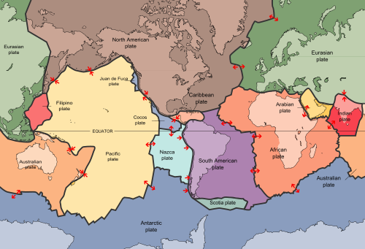
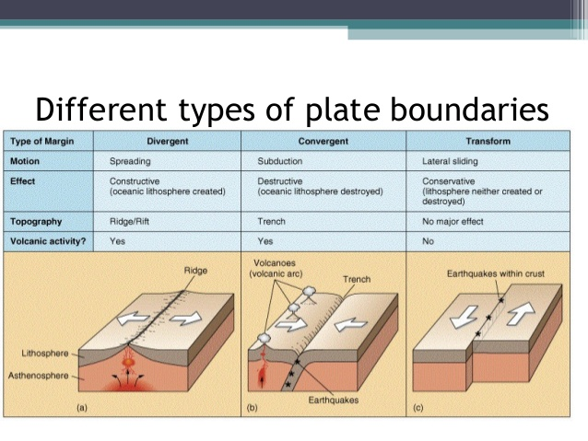

Continental Drift: (1912) – precursor hypothesis
- 4 lines of evidence:
  - Continental Fit = fits like a puzzle
  - Matching fossils = similar fossils on diff. continents
  - Geology = mountain chains
  - Glaciations = how to explain a ice sheet over india and southern Africa?
No driving mechanism?
Seafloor mapping/Paleomagnetic date (WW2/submarines) (1950/1960)
- Polar wandering (Rocks are magnetic)
- Magnetic reverse of seafloor sediments

Reversals can be the cause to some extinctions. (marine-wise)
Currently in a normal polarity.
Rock magnetism and paleomagnetism uses minerals magnetic alignment to determine the directions and distance to the magnetic pole.
- Steeper dip angles indicate rocks formed closer to the magnetic pole.
- Marine magnetic anomalies are bands of normal and reversed magnetic fields signatures:
  - Parallel magnetic bands preserved in rock under ocean
  - “bar-code” anomaly pattern reflects the plate motions away from ridge coupled with magnetic fields reversals.
Remember: topography exists beneath of the ocean
Youngest rock – highest relief from the bottom of the ocean
During WW2, we used sonar waves, to navigate in submarines. This opened the door to geology. Used compasses would switch headings abnormaly.

Plate are rigid (brittle) lithosphere slabs that float above a deformable (ductile) asthenosphere:
Unifying factors that can help locate a plate boundary:
- Earthquakes
- Volcanoes
- Mountain chains
- Rock deformation

Divergent boundaries:
These are boundaries where plates move away from each other, and where new oceanic crust and lithosphere are created. Magmas rising from the underlying asthenosphere intrude and erupt beneath and at an oceanic ridge to create new seafloor. This pushes the plates on either side away from each other in opposite directions. The margin itself becomes uplifted to form oceanic ridges, which are also called spreading centers, because oceanic lithosphere spreads away on each side of the boundary. While most diverging plate boundaries occur at the oceanic ridges, sometimes continents are split apart along zones called rift zones, where new oceanic lithosphere may eventually form. Volcanism and earthquakes are common along diverging plate boundaries
Convergent boundaries:
These are boundaries where two plates move toward each other. At such boundaries one of the plates must sink below the other in a process called subduction. Two types of convergent boundaries are known. All convergent boundaries are zones of frequent and powerful earthquakes.

Subduction Boundaries:
These occur where either oceanic lithosphere subducts beneath oceanic lithosphere
(ocean-ocean convergence), or where oceanic lithosphere subducts beneath continental
lithosphere (ocean-continent convergence). Where the two plates meet, an oceanic trench is formed on the seafloor, and this trench marks the plate boundary.

When two plates of oceanic lithosphere run into one another the subducting plate is pushed to depths where it causes melting to occur. These melts (magmas) rise to the surface to produce chains of islands known as island arcs. A good example of an island arc is the Caribbean islands.

When an plate made of oceanic lithosphere runs into a plate with continental lithosphere, the plate with oceanic lithosphere subducts because it has a higher density than continental lithosphere.
Again, the subducted lithosphere is pushed to depths where magmas are generated, and these magmas rise to the surface to produce, in this case, a volcanic arc, on the continental margin

Good examples of this type of volcanic arc are the Cascade mountains of the northwestern U.S. and the Andes mountains of South America.
Collision boundaries:
When two plates with continental lithosphere collide, subduction ceases and a mountain range is formed by squeezing together and uplifting the continental crust on both plates. The Himalayan mountains between India and China where formed in this way, as were the Appalachian Mountains about 300 million years ago. All convergent boundaries are zones of frequent and powerful earthquakes.
Transform boundaries:
When two plates slide past one another, the type of boundary occurs along a transform fault. These are also zones of frequent and powerful earthquakes, but generally not zones of volcanism. The famous San Andreas Fault of California is an example of a transform fault, forming one part of the boundary between the Pacific Plate and the North American Plate. Stress = (N/m^2)
What is the mechanism driving plate motion?:
- Mantle Convection
- Gravity (Push-pull)

Rock Cycle:

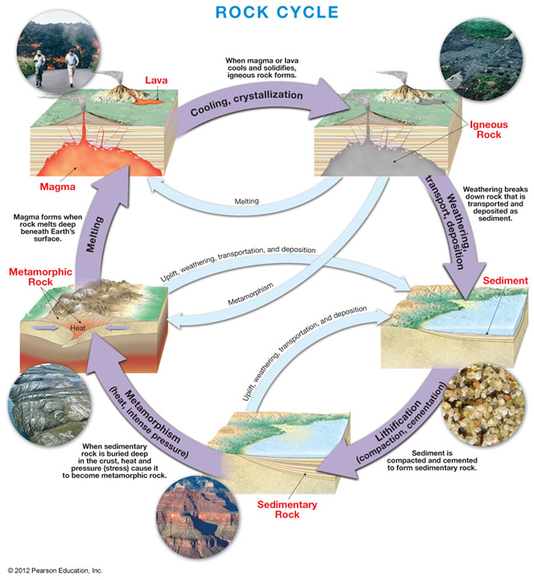

How do we know the chronology of the geological events and how do we date them (give them an age)?
TWO types of dating methods:
- Relative dating: age in relation to other geological events
- Absolute dating: precise age determined from analysis off radioactive elements such as uranium, potassium and carbon.

What is the sequence of events?

Geological time scale:
Divisions:
- EON: Phanerozoic (evident life), Precambrian (primitive)
- ERA: Cenozoic (recent life), Mesozoic (middle), Paleozoic (ancient life)
- PERIOD: Quaternary (Cenozoic), Jurassic (Mesozoic) Cambrien (Paleozoic) Ordovician (Paleozoic)
- EPOCH: Subdivisions of the Cenozoic Period (ex. Holocene) all end in cene

Precambrien is 90% of Earth’s history.
Evolution of life = geological time scale.
Evolution of life on Earth
65 Ma 248 Ma 543 Ma 4600 Ma
Cenozoic Mesozoic Paleozoic Precambrien
4600 Ma is age of Earth = 4.6 Ga
What about rocks of other periods?
  - Weathering
  - Erosion
  - Not in a good location for deposit

Precambrian:
CRATON: stable portion of the Earth’s crust. Largely of Precambrian age. Composed of a shield and platform portions.
SHIELD: exposed portion of the craton (central domal portion)
PLATFORM: sediment-covered portion of the craton (margins)
Precambrian rocks form the foundation of modern continental landmasses.
Primitive life – cyanobacteria, stromatolites (HOG’s BACK PARK)
First multicellular animal
Few fossils (mostly trace fossils)
Reason:
- Grenville orogeny of the Precambrian (last touch)
OROGENY:
Mountain building process; Possible mech: accretion (adition) or exotic terranes (lithos. Fragment)

PALEOZOIC
  - Appearance of the first hard shell organisms
  - Abundant life (cambrien explosion)
  - Early Paleozoic – life is restricted to the oceans
    - Fragmentation of the supercontinent (Rodinia)
    - Opening lapetus ocean
    - In Ottawa, marine invasion (Ottawa Embayment) – e.g Nepean Sandstone
    - Paleozoic, new ocean, sediments = sedimentary rocks.
    - Marine setting happened only for 67 Ma
    - Life in the shallow warm seas of the Ordovician = invertebrates with hard components = preserved in the rock record
  - Middle to late Paleozoic – colonization of the continents and great diversification (insects, plants, amphibians), collisions of N-America with the exoyiv terranes (portions of south american and africa) = the formation of the Appalachian Mountains.
  - Late Paleozoic – Mass extinction (climatic conditions)
- No rocks of the Mesozoic age? (in the Ottawa area)
  - Break up of Pangea
  - Opening of Atlantic Ocean
  - Rifting, volcanic activity
  - Ottawa-Bonnechere Graben
  - Rocky mts are added to the western margin of the continent
  - N-American migrates North
  - Birds and dinosaurs and the first mammals.
Failed rift: abandoned arm of rift system
Failed rift of the Ottawa River Valley?
What geological pattern explain this formation of rifts:
Basins, accumulate rain water, etc. = geological? Atlantic opened up evidence at Champlain lookout.
Graben: an elongated trough or basin, bounded on both sides by high angle normal faults that dip towards the interior of the trough.
RIFT: a regional scale graben

GLACIERS

- Thick, naturally accumulated ice mass that forms over hundreds or thousands of years, and deforms (flows) under the force of its own weight.

Radial movement outwards of the dome

Cryosphere

Atmosphere Hydrosphere solid earth biosphere

INPUTS | OUPUTS
Snow, ice, gas, rock debris, solar energy, geothermal heat | H₂O (ice, water, vapor)  Rock debris

Basic requirements to form a glacier;

- Precipitation (Snow, ice, frozen before hitting the ground)
- Not warm enough to melt (Preservation of snowfall)

Where do we get snow with good preservation potential?

High Latitude

High Altitude

  - Higher = colder
  - Water vapor stores energy, pressure decrease, concentration is small, therefore it cools down

How do we go from snow to ice?

Snow -> Granular ice -> Firm -> Glacial ice

90% air -> 50% air -> 25% air -> <20% of air
P= 0.05 g/cm3 …. 0.9 g/cm3

High porosity Low porosity
Low density High density

Glacier budget:
material < ablation = glacier retreat = melting, calving, sublimation
Accumulation = ablation
material > ablation = glacier advance = add snow

Calving: large pieces of glacier breaks into the water

Fluid; do not resist to deformation
HAVE the ability to FLOW

ICE IS A ROCK

Force that cause glaciers to move =Gravity = W= pgh \
Resisting force = friction

Deformation:
Elastic: returns to original shape
Plastic: permanent deformation
Brittle: breaks

Mechanisms of ice movement:
- Break (brittle)
- Flow (plastic)
- Slide (basal slip)

Dominant mech = plastic flow for dry-based glaciers (no meltwater)

Eskers
Stratified drift: drumlins ; tear drop sand and gravel rides, narrower downflow, 15-40 m high length to wide ratio is 1:3

Quaternary Period
- Geological History of the region (PART 2)
  - Wisconsinan glaciations
  - Glacial deposits
  - Landslide activity in Ottawa area*

Reminder (OLD-YOUNG)
- Precambrien = Grenville orogeny
- Paleozoic = marine setting / break up of Rodinia
- LATE Paleozoic = formation of Pangea
- Mesozoic
- Quaternary = mammals
  - Holocene

Highlights of Quaternary
- Last period; 1.8 MA to present
- Humans
- (Homos Sapiens 100 000 yrs ago)
- Divided in two epochs:
  - Holocene (10 000 years ago – present)
  - Pleistocene (1.8 Million years ago – 10 000 years ago) “ICE AGE”
Four continental-scale glaciations:
- Nebraskan
- Kansan
- Illinoan
- ???
Laurentide is the name of the ice sheet
Wisconsinan is the name of the event

20 ice age in earth’s history
Ice sheet: continental-scale ice cover (thickness = km)
80 Ka-> 18Ka(MAXIMUM) -> 10 Ka
Subsidence is caused by the weight of the glacier, but will be subject to uplift in the lithosphere after the retreat of the glacier to return to an equilibrium state.
As soon as the ice melts, the rebound is much faster than it is now.
Variation of Sea Level

Duration of the Champlain Sea = 12 Ka to 9.5 Ka (2.5 Ka)

What type of earth materials are associated with glaciers?

Gravel : > 2 mm
Sand: 0.062-2 mm
Clay: < 0.004 mmm

How do the gravel, sand and mud get deposited?
Unstratified glacial deposits are transported by ice
Meltwater will pick up different sized particles. Larger particles will be left behind if velocity decreases.
Sorted/Stratified deposits are transported by meltwater.
Till = another size of unstratified glacial deposit

Stratified glacial deposit;
  - Outwash fan (flow expansion and deposit) in a plain, fan delta
  - Subaqueous fan

Legacy of the Champlain Sea
LEDA “clay” and the Lemieux Landslide

CLAY:
  - Def. based on grain size: all clastic particles with size < 4 micrometer
  - Based on mineralogy: clays are mostly composed of phyllosilicate – layered silicate
- LEDA CLAY:
  - Glaciomarine clay deposited within the Champlain Sea basin
    - Grain size: dominated by silt (4-62 micrometers)
    - Minerals: 10-20% phyllosilicate (dominated by quartz and feldspar)
Grenville province sediments feed the Champlain Sea.

Leda clay is referred as a sensitive/quick clay because its resistance to deformation
Undisturbed clay
Remoulded clay

Conditions that favour sensitive clays:
- Glacial origins
- Little post depositional compaction
- Marine setting
- High fraction of non-clay minerals
Composition and structure of the Leda ‘clay’;
Clay sheets -> negative charge neutralized by cations
Champlain Sea s saline Na⁺Cl = binding agents
Fresh water (Post Champlain Sea) = cohesion loss (more easily remoulded)
Destabilization/disturbance causes clay to flow = landslide
Reasons;
- Earthquake
- Human induced = blastic
- Fresh water infiltrates the pores in the ground = high pore pressure
- Loads on top of slope, its weight is greater than the clays can hold
- Steep face of river erosion triggers landslide

