ECO2117 Final Study Guide
Content post Second Midterm
Gabriella Carrier
2016 W

Desirable properties of inequality measures
Anonymity Principle | Measure should NOT depend of who has higher income
Scale Independence Principle | Measure should NOT depend on size of the economy, or the way we measure income (dollars, rupees, etc.)
Population Independence Principle | Measure should NOT be based on number of
Transfer Principle | Measures should be sensitive to inequality reducing transfers  Lorenz curve, Gini coefficient

Monetary Poverty
Headcount Index  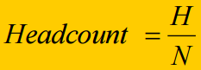 | Proportion of population with an income level below the poverty line  $$Headcount=\frac{\# of poor people}{Economy^{'}s Total Population}$$
Total Poverty Gap  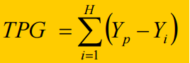  Where Y_{p} is the absolute poverty line; and Y_{i} the income of the ith poor person | 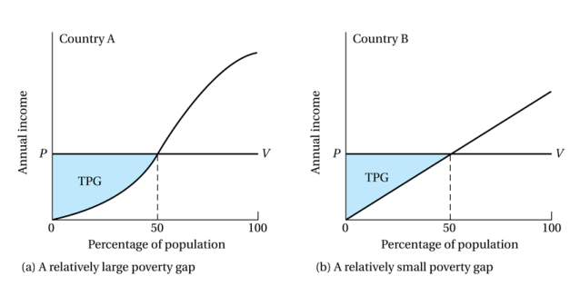  Total amount of income necessary to raise everyone who is below the poverty line up to that line
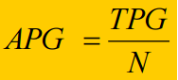  Average Poverty Gap | Amount of income necessary to raise everyone who is below the poverty line up to that line on a per capita basis
Normalized Poverty Gap  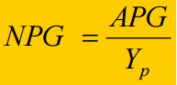 | Measures the size of the average poverty gap in relation to the poverty line  - Between 0 – 1  - Allows for easy comparison across countries
Maximizing Social Welfare: Increase income, decreasing inequality, decreasing poverty
W= W (Y, I, P) W = social welfare
+ - - Y = income per capita
I = (extreme) inequality
P = poverty

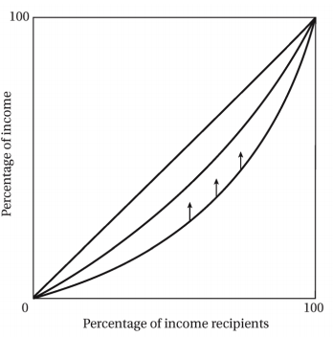
Traditional Sector Enrichment Growth
No growth modern sector. All benefits to traditional sector.

Outcome: Poor getting richer
∆ Y = +
∆ I = -
∆ P = -

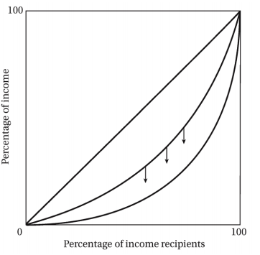
Modern Sector Enrichment Growth
Fixed modern labor force. Constant traditional wage.
Outcome:
- Richer getting richer
- Increasing inequality
∆ Y = +
∆ I = +
∆ P = 0

Modern Sector Enlargement Growth
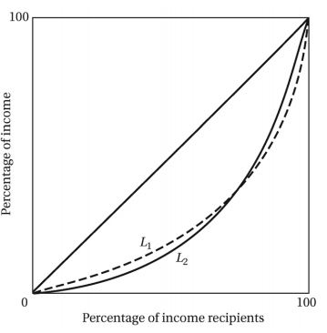
Constant wages. More modern workers.
Outcome:
- Entire income increases
- Remaining poor are relatively poorer
- Rich are relatively richer
∆ Y = +
∆ I = +/-
∆ P = -

Foster-Greer-Thorbecke (FGT) indices
Value of α determines which poverty measure is calculated
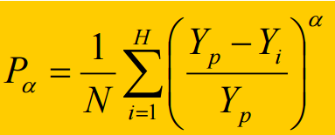
There are 10 people with the following incomes ($): [0, 0, 0, 2, 2, 2, 6, 6, 6, 6]
Poverty line = $4
You have $3 to give.
To decrease the # of individuals living below poverty line: You give all $3 to one person with a $2 income.
What should have been done: $1 given to each individual with an income of $0
Poverty Measure | α | $1 Given to $0 Income Individuals
Headcount | 0
Normalized Poverty Gap | 1 | NPG value remains the same before and after giving
Poverty Severity | ˃ 2 | Increase in income at ANY level is shown  - Impact on measured poverty of a gain in income by a poor person increases in proportion to the distance of the person from the poverty line

Headcount Index (P0) Average Poverty (P1) Poverty Severity (P2)
Desirable Properties of Poverty Measures
Anonymity Principle | Measure should not depend on WHO is rich and poor | P0, P1, P2
Population Independence Principle | Measure should not depend on if a country’s size | P0, P1, P2
Monotonicity Principle | If a person receives more income, the poverty measure should be no greater than what is was before | P0, P1, P2
Distributional Sensitivity | After an income transfer from a poor person to a rich person, a poverty measure should show an increase in poverty | P2  P1 ONLY IF:  $ transfers from poor → non-poor

Multidimensional Poverty Measures:
Headcount = H = How many are poor
Adjusted Headcount = HA = How many are really deprived
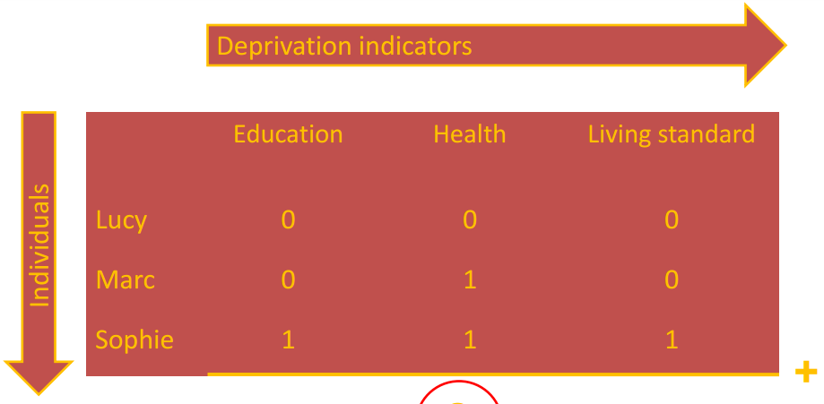
Identification of poverty status through dual cutoff
1. Within each dimension
2. # of dimensions which person is below a line (k)
Poverty Measure | k = 1 Mark & Sophie are poor | k = 2 Only Sophie is poor
Headcount (HA) | H = 2/3 | H = 1/3
Adjusted Headcount (HA) | HA = $\frac{\frac{1}{3}+\frac{2}{3}}{3}$ HA= 0.44 | HA = $\frac{\frac{3}{3}}{3}$ HA = 0.33

Multidimensional Poverty Index (MPI): 3 Components with equal weight
- Health (1/3)
- Education (1/3)
- Standard of Living (1/3)
Health: 2 Indicators with equal weight (1/6 each)
- Whether any child has died in the family
- Whether any adult or child in the family is malnourished
Education: 2 Indicators with equal weight (1/6 each)
- Whether no household member completed 5 years of schooling
- Whether any school-aged child is out of school for grades 1 through 8
Standard of Living: 6 deprivations with equal weight (1/18 each)
- Lack of electricity 5. Unimproved cooking fuel
- Insufficiently safe drinking water 6. Lack of more than one of 5 assets:
- Inadequate sanitation - Telephone, radio, TV, bicycle, motorbike
- Inadequate flooring
H_{M} = The % of people living in multidimensional poverty
H_{M}A = Average intensity of deprivation
- A = % of weighted indicators for which poor households are deprived on average
- Satisfies dimensional monotonicity
  - When a person deemed poor becomes deprived in another indicator, they becomes even poorer
The MPI approach:
- Takes into accounts multiplied or interactive harm done when multiple deprivations are experienced by individuals in the same family
- Helps us understand how poverty levels differ across and within countries and how the compositions of poverty can differ greatly in different settings
UNDP Reports:
- 1.6 billion people living in dimensional poverty ← Much more than # living on $1.25 a day or less
- Subsharan Africa has the highest proportion of people living in poverty
- South Asia has the largest number of people living in poverty

Lowering Extreme Poverty → Growth
- Widespread poverty creates conditions which poor have no access to credit
- The rich in many contemporary poor countries do not invest in their local economy
- Low incomes/low levels of living lead to lower health & education, thus lowering productivity
- Raising income levels of the poor will stimulate demand for locally produced necessity products
- Reducing poverty leads to economic expansion which leads to material and psychological motivation to participate in development process
Implement policies designed to:
- Correct factor price distortions
- Change the distribution of assets, power, and access to education and associated employment opportunities
- Progressively tax and directed transfer payments
- Build capabilities and human and social capital of the poor
Kuznets’ Inverted U Hypothesis
As a developing country grows, income inequality first RISES → Then FALLS
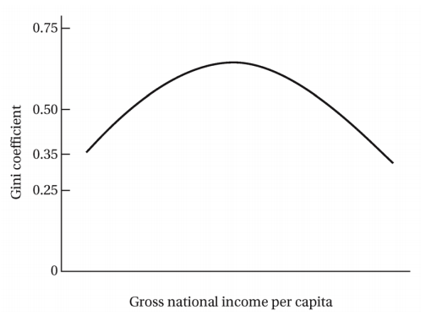

Population
- Every year more than 75 million people are added to the world’s population
- 97% of net population increase is in developing countries
- More than ¾ of the world lives in a developing country
- The annual world population growth rate seems to have peaked and is now falling
- Prior to the 19th century, annual world population growth rates averaged less than 0.5%
- Between 2003 and 2050, it is expected for the share of the world population to increase in Africa
Doubling Time
- Period that a given population takes to increase by its present size
Today’s population growth is a result of:
- Technological advancements that take control on things like malnutrition, plague, war
Demographic Transition: A country’s population growth starts low → increases → finally falls once again
Stage 1: High birthrates and death rates
Stage 2: Continued high birthrates, declining death rates
Stage 3: Falling birthrates and death rates, eventually stabilizing
Components of Population Growth:
- Natural Increases in Fertility & Mortality
  - Birth, fertility, death, under 5 mortality rates
  - Life expectancy
  - Age structure & dependency burdens
- Net International Migration
Trends:
- Declining fertility & mortality rates worldwide, but highest among less developed countries
- Higher levels of fertility rates in developing countries
  - Earlier + stronger reductions in mortality rates → Higher population growth
Youth Dependency Ratio
- The proportion of young people (0-15) to the working population (16-64) in a country
Hidden Momentum of Population Growth
- Population continues to increase after birth rates fall because the large existing youthful population expands the base of potential parents
  - 1. Birth rates cannot change quickly
  - 2. Population pyramid – Large declines in population growth in the lower middle income in developing countries, especially China

Malthusian Population Trap
Rising population and diminishing returns to fixed factors → Low levels of living
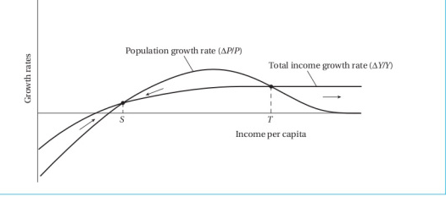
At point S population is growing faster than income
No crossing of the curves is possible due to technological progress
- Critique of Malthusian:
  - Currently there is no positive correlation between population growth and levels of per capita income
  - The microeconomic dynamic of a family’s size cannot serve as an aggregate variable
Microeconomic Household Theory of fertility
Demand for children & consumption in developing countries:
1st Child = Consumer Good, child has intrinsic value, parents enjoy starting a family
2nd, 3rd, 4th … Child = Investment Good, child can work on farm/serve as old age security
The Demand for Children:
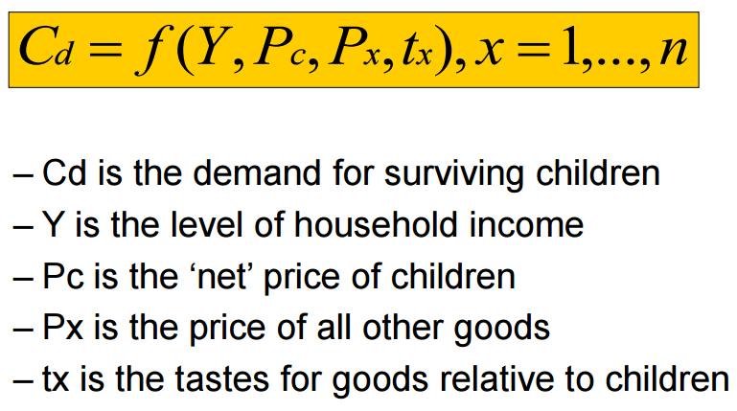
- An additional child is desired once benefits outweigh costs

‘Opportunity costs of children’ = The resources that could have been used to buy other goods rather child’s food, education, etc.

Child demand INCREASES when: Child demand DECREASES when:

- Household income rises - When the cost of having children rises
- When other goods become more expensive - Family values about many kids often change
Socioeconomic circumstances improve → Birth rates FALL
To promote smaller families in developing countries:
  - Improve women’s status, role, education
  - Increase non-farming jobs available to women to promote working over having kids
  - Rise in family income levels
  - Reduction in infant mortality
  - Development of old-age and social security
  - Expanded schooling opportunities
View #1: Population growth is not the real problem. The actual issues are:
- Underdevelopment
  - Family will serve as only source of security when people are impoverished & uneducated
- Depletion of world resources
  - High consumption needs from developed countries leave less resources for developing
- Population distribution
  - Viewing spread out populations in developing countries as lacking potential resources
- Subordination of women
  - Inferior roles, limited education, and lack of birth control make large families inevitable
Rich nations deliberately contrive population growth as a problem to maintain status quo
Population growth is a desirable phenomenon- it feels product demand
View #2: Population growth is a real problem
- Extremist: Population growth will send world into crisis and cause low levels of living
- Population poverty cycle
  - Population growth reduces savings at household and national level thus further reducing chances of developing country escaping poverty
- Empirical arguments:
  - Lowers per capita income growth
  - Poverty and Inequality
  - Adverse impact on education
  - Adverse impact on health of mother and child
  - Food issues
  - Impact on the environment
  - Increased International migration
How Developing Countries can Address Population Growth
- Persuasion through education
- Family planning programs
- Coercion is not a good option
- Raise the socioeconomic status of women
- Increase employment opportunities for women
How Developed Countries can Address Population Growth
- Help pay for contraceptives & family planning
- Start reducing consumption of natural resources
**Development policy must include investment in health and education**
- They are inputs into the aggregate output function
- They are unequally distributed
Human Capital
Human Capital Approach
- Human capital enhances peoples’ ability to produce, viewed as a factor of production
- Informs private and public investment decisions in health and education
- Increases income do not necessarily translate to better health and education
Good health + education → Can end development by expanding capabilities
Education
Staying in School
- A individual stays in school as long as the benefits outweigh the costs
- Direct costs: Books, tuition, transportation
- Opportunity cost: Less or no income while in school
- Benefit: More school leads to better jobs
Over the past 3 decades, average school enrollment rates have increased for the world AND for most developing regions
Tanzania: Opportunity cost of primary education is x3 more than average direct cost of education
Social & Private Costs of Education
Social benefits:
- Because education has positive externalities (i.e. positive spill-over effects) underinvestment in basic education is even more problematic
Social costs:
- Costs of education increase rapidly as students climb the educational ladder
  - Widens gap between social & private costs → Further increase in demand for education
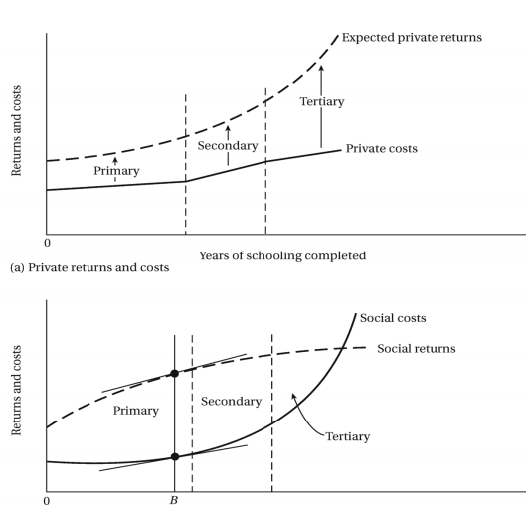
Private Costs

Social Costs

Demand for Education = Demand for higher wage/better jobs in modern sector
Supply for Education = Determined by political process/ indirectly by voters
- When countries expand their higher education too much, the primary and secondary education systems suffer
Private Returns to Education
$$\frac{Income with Education-Income without extra education}{{\left(1+Discount rate\right)}^{Year}}+Year 2+…=Private Returns$$
Example:
- 2 time periods
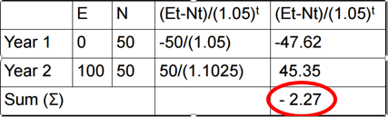
- Discount rate = 5% = 0.05
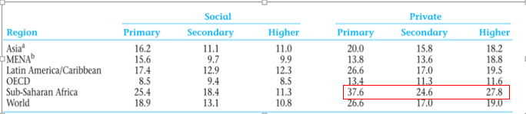
Negative sum = This person will NOT invest in an additional year of school

Suppose that in Sub Saharan Africa a person with no education has a salary of $100
With primary education: $100 x \left(1+ 0.376\right)=\$137.6$
With secondary education:$137.6 x \left(1+0.246\right)=\$171.4$
With higher education: $171.4 x \left(1+0.278\right)=\$219$ 129% return on tertiary education

Poor families have higher private costs of education, so poor students have less chance of finishing school
- RESULT: More middle & high income class students in (post) secondary education

Health Trend: Large gains in health outcomes but not evenly distributed
Why lower income/rural regions are not benefitting from improved health systems:
1. Higher disease burden
2. Better clinics in urban areas and/or private clinics which are too expensive for the poor
3. Fewer resources
4. Inefficient use of funds
Health & Productivity
- Higher wages allow purchasing better health
- Healthier workers get better paid jobs
HEIGHT is an indicator of general health status. Taller men earn more money.
Conditional Cash Transfers (CCTs)
Programs provide cash to poor households that meet specific conditions (i.e. school enrollment, vaccinations, etc.) or undertake certain actions

Change the trade-off between the costs & benefits of (additional) investments in human capital for poor families
Program objectives:
Short Term: Poverty Alleviation
Policy tools: Cash transfers, In-kind transfers, subsidies
Long Term: Break intergenerational poverty cycle by stimulating investments in human capital
Policy tools: CONDITIONS, In-kind transfers, subsidies
CCT Program Example: Progresa/Oportunidades
- Mexico – 20% of country benefitting
- Monthly $ transfers – up to 25% of household budget
- Larger impact on school enrolment than building new schools
- NO effect on supply of labor
Gender Gap
- Young females receive less education than young males in nearly every low and lower-middle income developing country
- Ultrasounds now allow gender reveal, so less girls are being born
Closing the educational gender gap is important:
– Social rate of return on women’s education is higher
– Education increases productivity, lowers fertility
– Educated mothers have a multiplier impact on future generations
– Education can break the vicious cycle of poverty and inadequate schooling for women
International Trade
- Larger countries (in terms of size) tend to be LESS OPEN (in terms of larger share of exports in GDP)
- Smaller countries and developing countries tend to be MORE OPEN than developed economies
Globalization
- Process by which economies in the world become increasingly integrated
Balance of Payments = (Current Account) + (Capital Account)
Current Account = (Exports) – (Imports)
Capital Account = (Loans + Investment) – (Debt repayments)
- East Asian countries (China, South Korea, Taiwan) have had success in manufacturing exports

- Less developed countries:

  - Dependent on primary products (coffee, oil, minerals) whose prices are falling/unstable
  - Suffer from balance of payment instability, imports need to financed
  - Intentionally run current account deficit to manipulate exchange rate
Elasticity of Demand  $$\frac{\% ∆ Q_{d}}{\%∆ Income}$$ | When elasticity of demand is LOW | Fall in the price of primary products  ↓  More exports needed to get same value of previous exports
Price Elasticity of Demand  $$\frac{\% ∆ Q_{d}}{\%∆ Price}$$ | When price elasticity of demand is LOW | A shift in the demand/supply curve results in:  - Large price flux  - Export earning instability

If income in the importing country rises by 1%, the quantity demanded of product X will rise by less than 1%
Comparative Advantage
Production of good at a lower opportunity cost than any of the alternative goods that could be produced
  - Countries specialize in goods which they have an comparative advantage
  - Opportunity costs determine relative costs
Absolute Advantage
When a person / country can produce a given good more cheaply
Theory of Comparative Advantage
Trade is beneficial because countries can produce goods at different relative costs
  - Not efficient to produce every good you need on your own
  - Exchange part of your production in exchange for others produced goods (trade)
  - Specializing & trading lowers cost per unit produced
Factor Endowment Trade Theory
- Trade is beneficial because: Countries have different endowments in production factors
AKA They are better ‘equipped’ to produce certain goods
- Countries specialize towards capital or labor intensive products and trade; producing the good they can produce more cheaply
- Countries well-endowed with capital will export capital-intensive products
- Countries well-endowed with labor will import capital-intensive products
Proposition 1
- Different products require different combo’s of production factors (capital, labor, capital / labor ratio to produce 1 unit of output)
Proposition 2
- Countries have different endowments in production factors (labour force, capital stock per worker)
Commodity Terms of Trade = $\frac{Export price}{Import price}$

- Exports provide source of income which can be used to finance imports

YEAR | Price Import | Price Export | Commodity Terms of Trade
1970 | 100 | 100 | 1
2000 | 125 | 150 | 0.83

The country needs to:
- Export more in 2000 in order to be able to buy the same amount of imports as before

Prebish-Singer Thesis: The commodity terms of trade for LDCs tend to decline over time
- The real non-oil commodity terms of trade have generally declined over time
- LDCs should pursue an import substation policy

Example 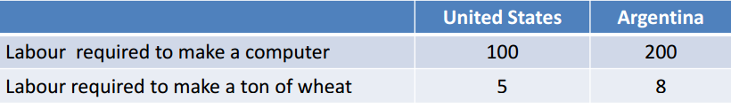
- US
  - Has absolute advantage in both
  - 20x more hours to make a computer than a ton of wheat (100/5)
  - Has comparative advantage in computers
- Argentina
  - 25x more hours to make a computer than a ton of wheat (200/8)
  - Has comparative advantage in wheat
Suppose each country has 1,000 units of labour.
• If each country shares labor equally between computers & wheat, (500 hours for US & 500 hours for Argentina)
- Total production will be:
  - 7.5 computers
  - 162.5 tons of wheat
    - US: 5 computers, 100 tons of wheat
    - Argentina: 2.5 computers, 62.5 tons of wheat
• If US reallocates 100 units of labor used in wheat to computers
- Can produce 1 more computer and less 20 tons of wheat
- In total 6 computers, 80 tons of wheat
• If Argentina decreases its production by 1 computer, 200 labor hours become available.
- Then the wheat production can increase by 25 tons of wheat
- In total 1.5 computers, 87.5 tons of wheat
• Thus, trade is beneficial because it allows countries to specialize in the production of goods for which they have a comparative advantage
- Even trade would have to involve one computer for 20-25 tons of wheat
A potential even trade: 1 computer/22.5 tons of wheat

Traditional Trade Arguments
- Trade stimulates economic growth
- Trade promotes equality by equalizing factor prices
- Trade stimulates development of sectors that have comparative advantage
- Countries should NOT interfere with trade
- Outward-looking international policy required
Critique of Traditional Trade Arguments
Production Factors
  - All are fixed in quantity and constant in quality
  - All are fully employed
Vent-for-Surplus Theory
Technology & Consumer Preferences
- Technology of production is fixed (Classical model)
- Technology of production is freely available (Factor endowment model)
- Consumer tastes are fixed and independent of producer influences
In reality: Technical substitution of primary products (wool, hides, etc.) reduces demand for of primary goods and thereby its relative price, Imitation of substitutes allowed less developed countries to move up product cycle of international trade
Within Nations
- Factors of production are freely mobile, economy exists in perfect competition, no risk
In reality: Tariffs & non-tariff barriers, economies of scale, specialization is risky
Government
- Has no role
- International forces set by supply/demand forces
Growth Poles: Regions that are more economically/socially advanced (e.g Urban centers)
Require government intervention: Stagnating Sectors → Government needs to redistribute gains from trade

Industrial Policy
- Guiding the market through strategic coordination of business investments to increase export market shares
North-South Model

Trade Balance
- Assumed to be balanced for all countries at all points of time
In reality: Current account and capital accounts deficits
Gains from Trade
- Benefit Nationals of Country
Enclave Economies: Small economically developed regions of a country where the rest of region has not
Foreign owned firms control production in an export sector and are transferred abroad
- Example: Foreign-owned tobacco-growing company sets up operations in a developing country, bringing with them their own capital and skilled labor, and hire local unskilled laborers
*** Many LDCs keep their exchange rates below free market rates is to: ***
Make IMPORTS of capital goods CHEAPER relative to exports of primary goods
Vent-for-Surplus Theory: Fixed resources, full employment, immobility of factors
Production factors (notably labor) are underemployed
Trade opportunities can be captured by employing underutilized factors of production to produce exports
But: Typically only few benefit and ignores long term dynamic inefficiencies
- Land owners of land used for commercial agriculture benefit
- Declining terms of trade of primary commodities
- Cumulative competitive advantage in manufacturing & high tech services
North-South Models: Fixed resources, full employment, immobility of factors
Factors of production are not fixed, nor are their prices:
• Relative factor endowments and comparative costs are constantly changing
Dynamic inefficiencies lead to increased dualism, thus calling for government intervention
- Monopoly power in the North/rich countries permits higher profits and thus higher growth rates
- Less developed countries have low income elasticity of LDC exports > declining terms of trade
Trade Strategies
Export Promotion
**Trade policy based on the benefits of free trade predicted by traditional trade theories**
Outward-looking development policy: Expand exports (strong) or free trade (weak)
- Primary products = Agriculture
  - Challenges: Limited demand, rigid supply, trade barriers make increasing earnings tough
  - Developing countries might be unable to respond smoothly to changing international price signals because of inelastic supply curves
- Secondary products = Manufacturing
  - Challenges: Often a lot of government intervention, many trade barriers
Import Substitution: - Tariffs, Infant industries, Theory of protection
Inward-looking development policy: Replace imported with domestically produced goods by raising trade barriers on exports & stimulating domestic production
Promoting domestic production of consumer goods
  - Reason 1: Infant industry : Newly established industry protected by tariff barrier
    - Gives domestic sector chance to become internationally competitive
    - It impossible that all industries in a developing country qualify as infant industries because you cannot have a comparative advantage in everything
    - Long-run social benefits of infant industry protection are more likely to be realized if investors believe the tariff barriers are transitionary
  - Reason 2: Limit imports – improvement balance of payments
NOT successful because:
- Infant industries lacked incentives to become successful
- Foreign companies benefitted more from joint ventures
- Overvalued exchange rate penalized exporters
Industrialization Strategy
** Policy reflects experiences of successful East Asian countries**
Outward oriented & export-led development
- Ensures adequate market size
- Coordinating role for government
  - Attempts to capture benefits from positive externalities:technology transfer to other firms, forward and backward linkages, move towards exporting more sophisticated goods
Challenges: Picking correct incentives, foreign investors can pick up and leave, WTO restricted “picking winners”
Economic Integration
Stimulate South-South trade by economic integration with other developing countries
Prerequisite: requires political cooperation between countries and thus strong and motivated leaders
Benefits
- Bigger market & a coordinated strategy towards third countries
Impact
- Trade diversion & trade creation
Trade Strategy Views
Eclectic view on domestic policy
- Select strategies that seem most promising given the specific constraints & opportunities
International view: Reduce trade barriers
Tariffs
Nontariff Trade Barrier = Non-tariff barrier example: quota, sanitary regulations
- Decrease foreign exchange earnings
Nominal Example: Bananas
Price on world market: $1.50
Import Tariff on Canada: 10%
Canada’s banana price: $1.50 → $1.65
$$\frac{1.65-1.50}{1.50}=0.10=10\%$$

- Reduce the quantity of goods exported
- Lower the effective price received for exports
Nominal Rate of Protection $t=\frac{p^{'}-p}{p}$
- What the price would be without tariffs
Ad valorem tariff rate = (Unit price w/tariff – Unit price w/o tariff)
Unit price without tariff rate

Effective Rate of Protection: The degree of protection added rather than monetary value
- The average level of effective protection has exceeded 300% in Pakistan and Uruguay
$g=\frac{v^{'}-v}{v}$ v’= The value added per unit with the tariff
v= The value added per unit under free trade
Example: USB Sticks
Nigeria produces USB sticks but they import most spare parts ($10 per USB)
– 1G USB sells for $15 on world market but for $20 in Nigeria
- Value added in Nigeria = 10 (20-10)
$Nominal Rate O.P=\frac{20-15}{15}=0.33=33\%$
$$Effective Rate O.P. =\frac{10-5}{5}=1=100\%$$

Blue box = revenue collected by government
Blue box = Government revenue from tariff
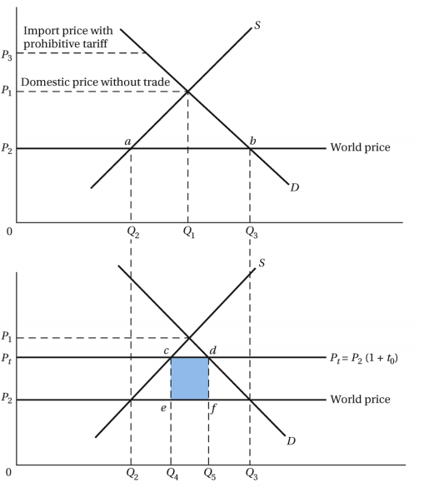

Blue square = Government revenue from tariff

