PS102 Term Test 1 Review

Chapter 1.4 – Twentieth-Century Approaches
Psychoanalysis: Psychology of the Unconscious
- Unconscious: hypothesized repository of thoughts, feelings, and sensations outside human awareness
  - Thought in some theories to have a strong bearing on human behaviour
  - State where information is not easily accessible to conscious awareness

Sigmund Freud
- The belief that people’s behaviours are based on their unconscious desires and conflicts
- Freud developed psychoanalysis, that aimed to resolve unconscious conflicts
- Psychoanalytic Theory: psychological theory that human mental processes are influenced by the competition among unconscious forces to come into awareness

Behaviourism: Psychology of Adaptation
- Behaviourism: branch of psychological thought arguing that psychology should study only directly observable behaviours rather than abstract mental processes
- Early behaviourists tended to focus on relationships between stimuli and responses
- Stimuli: elements of the environment that trigger changes in our internal or external states
- Responses: the way we react to stimuli
- Edward Thorndike: proposed research findings from the study that animals could help explain human behaviours
- Ivan Pavlov: found that dogs could learn to associate a bell with an automatic behaviour, such as salivating for food.
  - This is called classic conditioning
- John B. Watson: conducted the “Little Albert” experiment demonstrating that children (people) could be classically conditioned
- B.F. Skinner: developed operant conditioning to shape behaviour
  - Punishment and reinforcements
- Reinforcement: a learning process that increases the likelihood a given response will be repeated
- Punishment: an experience that produces a decrease in a particular behaviour
- Albert Bandura: described learning by social observation in children and several species of primates
  - A juvenile Bonobo chimpanzee observing the behaviour of an adult

Humanistic Psychology: A New Direction
- Humanistic Psychology: theory of psychology that sought to give greater prominence to the special and unique features of human functioning
- Carl Rogers: developed “client-centered therapy”, which said that people are innately good
- Abraham Maslow: developed a theory of motivation that consists of a hierarchy of needs
- Client-Centered Therapy: humanistic therapy designed to help clients experience unconditional positive regard and look at themselves honestly and acceptingly

Cognitive Psychology: Revitalization of Study of the Mind
- Cognitive Psychology: field of psychology studying mental processes as forms of information processing, or the ways in which information is stored and operated in our minds
- Information Processing: the means by which information is stored and operates internally
- Cultural Psychology: study of how cultural practices shape psychological and behavioural tendencies and influence human behaviour
- Cross-Cultural Psychology: the stud of what is generally and universally true about human beings, regardless of culture
- Ulric Neisser coined the term cognitive psychology as the study of information processing
- The role of mental processes in how people process information, develop language, decision making, learning, memory, language, solve problems, and think
- Cognitive psychologists compared the human mind to a computer

Psychobiology/Neuroscience: Exploring the Origins of the Mind
- Neuroscience: study of the brain and nervous system

Chapter 1.5 – Psychology Today
Branches of Psychology
- Academic Psychology: a branch of psychology focusing on research and instruction in the various areas or fields of study in psychology
- Applied Psychology: the branch of psychology applying psychological principles to practical problems in other fields, such as education, marketing, or industry
- Clinical and Counselling Psychology: the study of abnormal psychological behaviour and interventions designed to change that behaviour

Shared Values
- Psychology is:
  - Theory Driven: uses theories to explain behaviour
  - Empirical: based on research
  - Multi-Level: explained by the brain, the individual and social influences
  - Contextual: based on cultural context

Current Trends in Psychology
- Growing Diversity: more women and members of minority groups
- Advances in Technology: the development of computers and brain imaging techniques led to the new research in the fields of cognitive neuroscience and social neuroscience
- New Schools of Thought: positive psychology and positive psychotherapy focus on happiness and other positive emotions
- Collectivist Culture: a culture whose members focus more on the needs of the group and less on individual desires
- Individualist Culture: a culture that places the wants or desires of the person over the needs of the group

Chapter 2.3 – How Do Psychologists Conduct Research?
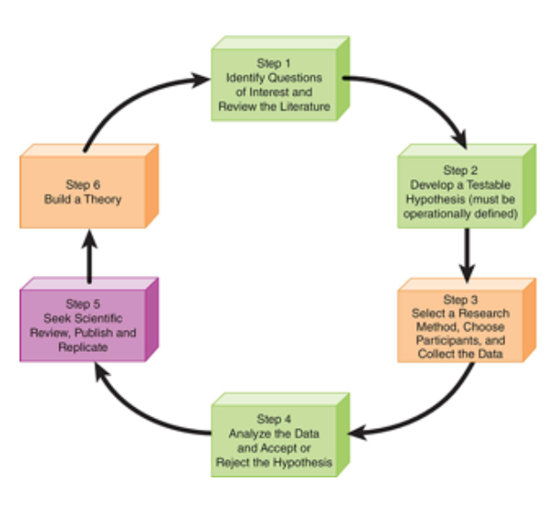
Identifying Variables
- Variable: condition, event, or situation that is studied in an experiment
- Independent Variable: condition or event that is thought to be a factor in changing another condition or event
- Dependent Variable: condition or event that you expect to change as a result of variations in the independent variable
- Operationalize: to develop a working definition of a variable that allows you to test it

Choosing Participants
- Sample: a group or set of people or items drawn from a larger population
- Random Selection: identifying a sample in a way that everyone in the population of interest has an equal chance of being involved in the study
- Experimental Group: group that is exposed to the independent variable
  - Gets the manipulation
- Control Group: group that hasn’t been or won’t be exposed to the independent variable
  - Equivalent BUT doesn’t get the manipulation/treatment
  - Eliminates extraneous/confounding variables
    - Ex. environmental condition

Picking a Research Method
- Descriptive Research Methods: studies that allow researchers to demonstrate a relationship between the variables of interest without specifying a causal relationship
  - Examines how one variable causes another to change
  - Also called correlation

Descriptive vs. Experimental Research
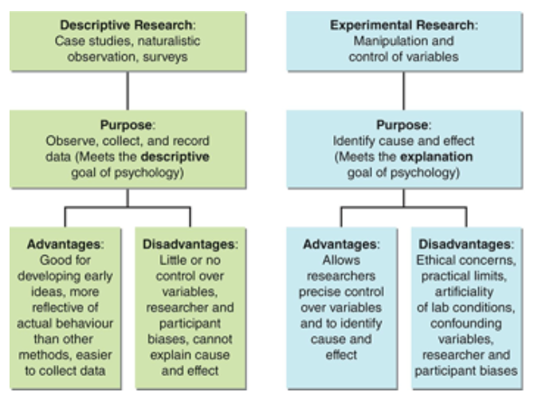
- Case Study: study focusing on a single person
- Naturalistic (Lab) Observations: study in which researchers observe people in a study behaving as they normally do
- Hawthorne Effect: people who are being observed will improve or change some of their behaviour because they are being watched or studied, not in response to an experimental manipulation
- Surveys: study where researchers give participants a questionnaire or interview them
  - Big samples, small report
- Experiments: controlled observation in which researchers manipulate the presence or amount of independent variable to see what effect it has on the dependent variable

Pros of Descriptive Methods
- Naturalistic Observation: seeing behaviour in natural setting, spontaneously produced
  - Ethical issues prevent other methods
- Laboratory Observations
  - More controlled

- Case Study
  - Select or limited populations

Cons of Descriptive Methods
- Naturalistic Observations
  - Have to wait for an event to happen
  - Observer bias
  - Hawthorne Effect
- Laboratory Observations
  - Loss of spontaneity
  - Same as Naturalistic Observations
- Case Studies
  - Limited sample size, low generalization
  - Researcher bias
- Surveys
  - Participant bias
- No Cause and Effect
  - Does not answer the “why” question

The Experimental Design
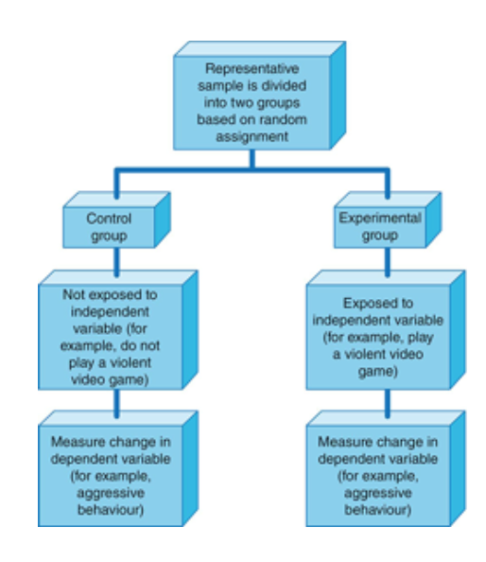
Specialized Method
- Double-Blind Procedure: study in which neither the participant nor the researcher knows what treatment or procedure the participant is receiving

Pros of Experimental Methods
- Can establish Cause and Effect
- Limitations to overcome
  - Selection Bias
- The Cure for Selection Bias:
  - Random selection
  - Random assignment

Cons of Experimental Methods
- Experimenter Bias
  - When researchers’ preconceived ideas cause them to find what they expect to find
  - Can influence the participant or the researcher
    - Ex. can be subtle – head nod, smile
- Placebo Effect
  - Response to the manipulation is due to the expectations not the manipulation
    - Ex. sugar pill
- The Cure for Experimenter Bias and Placebo Effect:
  - Blind and Double-Blind Techniques
    - Hire RAs and remove experimenter

Ch 2.4 – How do Psychologists Make Sense of Research Results?
Correlations: Measures of Relationships
- Psychologists uses statistics to describe and measure relationships between variables
- Correlation: predictable relationship between two or more variables
- Correlation Coefficient: statistic expressing the strength and nature of a relationship between two variables (can range from-1.00 to +1.00)
  - Positive Correlation: relationship in which on average, scores on two variables increase together
  - Negative Correlation: relationship in which on average, scores on one variable increase as the scores on another variable decrease
  - Larger the number, stronger the relationship and tighter packed the data cloud in the graph
  - Knowing a score on one variable tells you nothing about the score on another
  - The further a correlation coefficient gets from 0 (negative or positive), the stronger the relationship between two variables
    - 0 – 1 = positive
    - -1 – 0 = negative
  - Sign tells us direction, number tells us magnitude or strength of relationship between two variables
- Perfect Correlation: one in which two variables are exactly related, such that low, medium, and high scores on both variables are always exactly related

Chapter 5 – Sensation and Perception
Sensation and Perception
- Sensation: the process through which the senses detect visual, auditory, and other sensory stimuli and transmit them to the brain
- Perception: the process by which sensory information is actively organized and interpreted by the brain

Processing Sensory Information
- Bottom-Up Processing: perception that proceeds by transducing environmental stimuli into neural impulses that move successively into more complex brain regions
  - We are actually observing stimuli and feeding it into the brain
- Top-Down Processing: perception processes led by cognitive processes, such as memory or expectations
  - The brain is directing the senses – telling you what you are seeing
- Dual Process Theory: combines trichromatic and opponent-process theories
- Perceptual Sets: readiness to interpret a certain stimulus in a certain way
- Ambiguous Stimuli: stimuli that could be interpreted in different ways

Sensation and Perception – Types
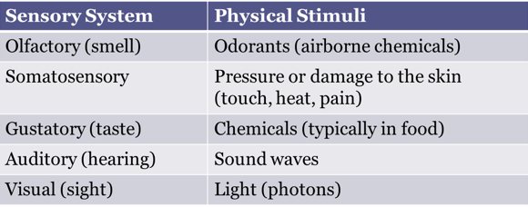
- Both sensation and perception are critical for our interpretation and interaction with our environment

Sensory Receptive Cells
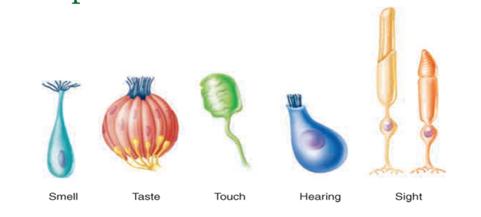
- Sensory Receptive Cells: specialized cells that convert a specific form of environmental stimuli into neural impulses
- Sensory Transduction: the process of converting a specific form of sensory data into a neural impulse that our brain can read

What Can We Sense?
- How much stimulation has to be out there before we can deduct that it is there?
  - Thresholds

Absolute Threshold
- The smallest amount of a stimulus that one can detect
  - Smell: a drop of perfume diffused throughout a six-room apartment
  - Taste: 5 mL of sugar in 9L of water
- The minimum amount of sensory stimulation that can be detected 50% of the time
- Detecting something from nothing

Difference Threshold (JND)
- The smallest increase or decrease in a physical stimulus that is required to produce the “just noticeable difference” (JND) in sensation that is detectable 50% of the time
- Detecting something more from something
  - Ex. when do you perceive a difference in change of volume in your ear?

Just Noticeable Difference
- Weber Fraction
- Amount of increase needed to make a difference
  - If you are carrying 2kg, 1 additional g will not make a difference
  - If you carry only 20 g, 1 g will make a difference

Signal Detection Theory
- Signal Detection Theory: detection of sensory stimulus involves noticing a stimulus from background noise and a decision about whether the stimulus is present
- Decision = probability of stimulus occurrence + potential gain or loss with deciding whether the stimulus was present or not
- Example:
  - Picking your cousin, whom you have never met, at the airport having only a description or old photo

Signal Detection Theory Matrix
 | Present | Absent
“Yes” | Hit | False Alarm
“No” | Miss | Correct Rejection

Sensory Adaptation
- Process of becoming less sensitive to an unchanging sensory stimulus over time
- Automatic process
- Allows us to shift attention
- Olfactory Adaptation: occurs when a change in sensitivity to a particular odour reaches a point where the odour cannot be distinguished after a prolonged exposure to it

The Visual Sense: Sight
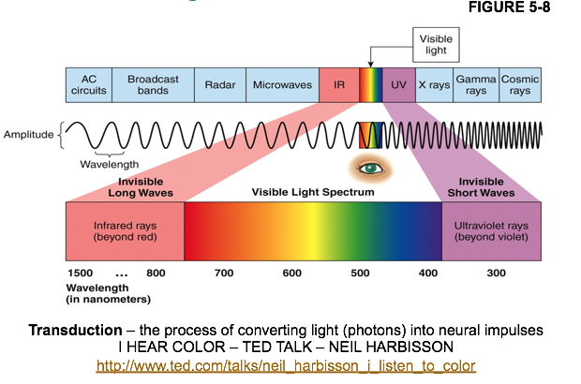
- Photons: particles that make up light
Seeing the Lights
- Retina: specialized sheet of nerve cells in the back of the eye containing sensory receptors for visions
- Transduction: process that involves converting stimulus energy into neural impulses that can be interpreted by the brain
- Photoreceptors: sensory cells for vision, located in retina
- Rods: photoreceptors most responsive to levels of light and dark
  - Used for periphery and night vision
  - Not as acute as cones
    - Ex. fuzzy vision
  - More rods than cones
    - Over 100 million
- Cones: photoreceptors responsive to colours
  - Used for central and colour vision
  - Very acute
    - Ex. clear
  - Not as many cones
    - 4-5 million
- Optic Nerve: bundle of axons of ganglion cells that carries visual information from the eye to the brain
  - From both eyes meet at optic chiasm – where some fibers go to the opposite side of the brain

- Blind Spot/Optic Disc: location where the optic nerve leaves the retina is therefore completely lacking in rods and cones
- Fovea: center of the retina, containing only cones, where visual is most clear

Seeing in Colour
- Hue: experience of colour based on the wavelength of light that the visual stimulus emits or reflects; wavelength
- Saturation: purity of a colour; how bright or vivid the colour appears
  - Desaturated: white or grey mixed into it
    - Ex. pure red is saturated and pink is more desaturated
  - Amplitude and Wavelength
- Brightness: how might light emanates or is reflected from the visual stimulus
  - Light intensity
  - Amplitude

How the Eye Works
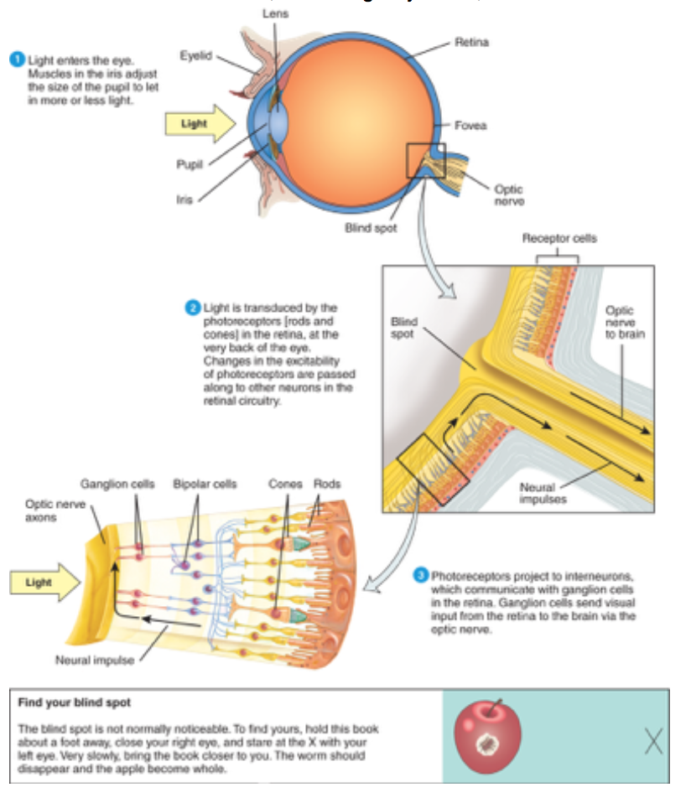
Seeing in Colour
- Hue: experience of colour based on the wavelength of light that the visual stimulus emits or reflects; wavelength
- Saturation: purity of a colour; how bright or vivid the colour appears
  - Desaturated: white or grey mixed into it
    - Ex. pure red is saturated and pink is more desaturated
  - Amplitude and Wavelength
- Brightness: how might light emanates or is reflected from the visual stimulus
  - Light intensity
  - Amplitude
Theories of Colour Perception
- Young-Helmholtz Trichromatic Theory: 3 different receptors for colour and each respond to a different range of wavelengths of light
  - Cones most sensitive to blue, green, red wavelengths
  - Visual system combines activity from these cells
  - Colours are perceived by additive mixture of impulses
  - If all are equally activated – white colour is produced
- So, what’s wrong with the trichromatic theory?
  - Trichromatic theory cannot explain
    - Red-green colour blind individuals should not be able to perceive yellow
      - Red + Green = Yellow
    - Afterimages
    - Stare at red – look away you’ll see green (same for blue and yellow)
- Opponent-Process Theory (Hering, 1870):
  - Colours pair to inhibit one another
  - 3 cone types/colour pairs (each type responds to 2 different wavelengths):
    - Red or Green
    - Blue or Yellow
    - Black or White
  - Explains Afterimages
    - Stare at certain colour and neural processes become fatigued
    - Have ‘rebound’ effect with receptor responding with its opponent opposite reaction
  - Retinal Ganglion Cells:
    - Project information from the retina to the brain via optic nerve and are arranged in opposing cells: red-green, yellow-blue, black-white
  - Support for this theory – we can’t see mixes of certain colours
    - Reddish green or blueish yellow
- Colour Blindness: unable to distinguish certain colour (more accurately called colour vision deficiency/CVD)
- Monochromatic: unable to see any colours at all and instead see a black and white and grey view
- Colour Weakness: suggests that people with this problem have a shortage of cones that respond to either greenish or reddish wavelengths

The Brain and Sight
- The optic nerve carries messages from each eye (visual field) to the visual cortex
  - Occipital lobes
- Visual Pathway:
  - The optic nerve contains the icons of 1 million cells
    - They exit the eye via blind spot
    - And project to the thalamus
  - From the thalamus, neurons project to the visual cortex
  - “What” and “Where” Pathways:
    - What an object is; where an object is
- 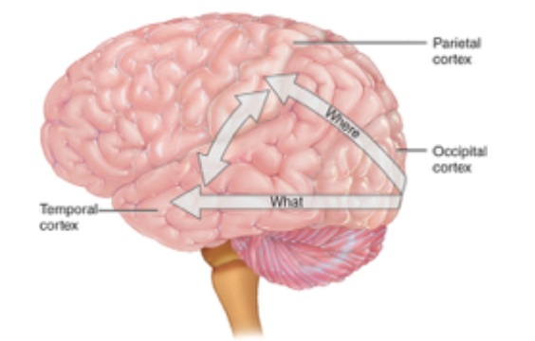
- Visual Agnosia: damage to the parts of the temporal cortex (house of “what” pathway) still have their vision in tact but can’t recognize objects visually
- Prosopagnosia: damage to certain part of “what” pathway where people can’t recognize faces
  - Sometimes can recognize familiar individuals by concentrating on some visual characteristics
- Hemi-Neglect: often ignore one side of their visual field; most apparent and long-lasting after damage to the right hemisphere
  - Damage to “where” pathway

Gestalt Principles of Perceptual Organization
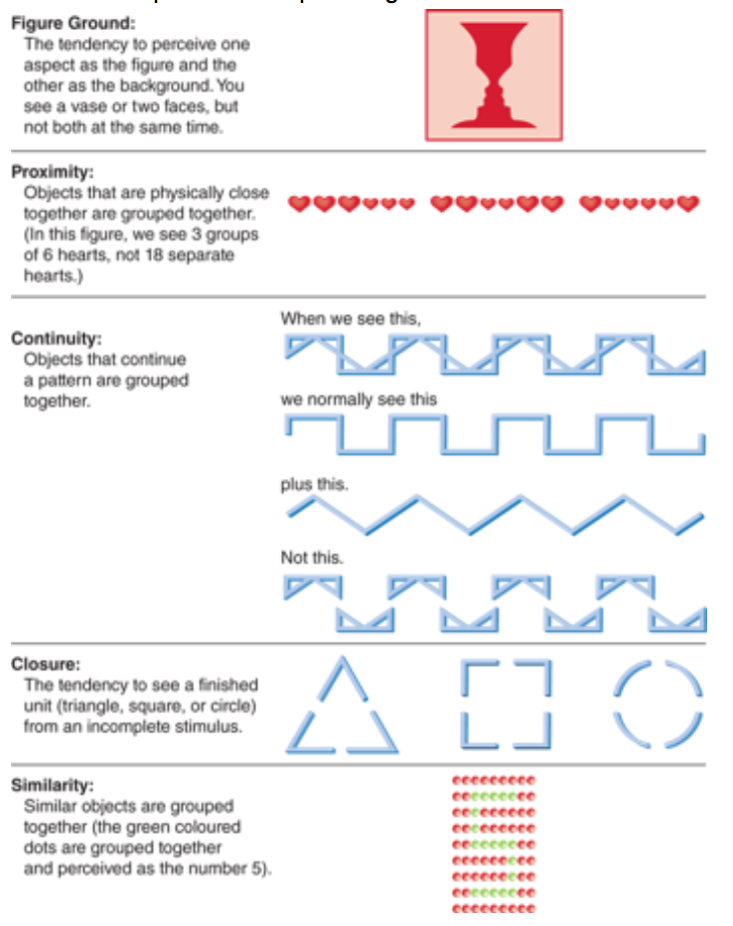
Getting in Deep: Binocular and Monocular Cues
- Retinal Disparity/Binocular Cue: slight difference in images processed by the retinas of each eye (depth perceived by 2 eyes working together)
- Convergence: inward movement of the eyes to view objects close to oneself
- Monocular Cue: visual clues about depth and distance that can be perceived using information from only one eye
  - Depth perceived by one eye only

Examples of Monocular Cues
- Interposition: when one object blocks part of another from our view, we see the blocked object as further away
- Relative Height (Elevation): seeing objects that are higher in our visual plane as further away than those that are lower in the visual plane
- Texture Gradient: see more details of textured surfaces when the object is closer to us; thus, the less distinct detail of the textured object, the further away we assume it to be
- Linear Perspective: parallel lines seem to get closer together (converge) as they recede, creating the illusion of depth/distance
- Light and Shadow: use light as a cue to distance; brighter perceived as closer, darker as further
- Clarity/Aerial Perspective: tend to see closer objects with more clarity than objects that are further
  - Referred to as fog/smog effect
- Familiar Size: when you learn the size of something (person, etc.), you assume they stay the same size, so objects that look smaller than usual must be further away
- Relative Size: when you look at 2 objects that you know are about the same size, if one seems smaller than the other, we see the smaller object as further away
- Motion Parallax: requires that the observer be moving, the relative movement of objects that are stationary against their background gives us an idea about their relative distance

Seeing What We Expect to See: Perceptual Constancies
- Perceptual Constancies: our top-down tendency to view objects as unchanging, despite shifts in the environmental stimuli we receive
- Size Constancy: helps in depth perception; we perceive objects as the same size regardless of the distance from which it is viewed
- Shape Constancy: we see an object as the same shape no matter from what angle it is viewed
- Brightness Constancy: we see an object as the same colour no matter full sunlight or in shade

Visual Loss
- Strabismus: eyes are misaligned; 2 different images are being sent to the brain, one from each eye
- Amblyopia: partial or complete loss of vision due to abnormal development of the brains visual cortex in infancy; caused by one eye focusing better than the other

The Other Senses: Vestibular and Kinesthetic Senses
- Kinesthetic Sense: information tells us whether we are still or moving in a particular direction without having a look
- Vestibular Sense: located in the semicircular canals of our inner ear where the fluid canals contain shifts as we move in space, standing, laying, etc.

The Chemical Senses: Smell and Taste
- Smell and taste are separate senses but together are usually called the chemical senses
- Olfactory Sense: sense of smell
- Gustatory Sense: sense of taste

Smell and Taste: How They Work
- Sensation in the smell or olfactory system begins when chemicals called odorants (airborne chemicals that are detected as odours) enter the nose
- Olfactory Receptor Neurons: sensory receptor cells that convert chemical signals from odorants into neural impulses that travel to the brain
  - Action potential/firing of neurons sends a message to other neurons and firing of olfactory receptor neurons is transmitted to brain

Types of Tastes
- Flavour: combination of smell and taste
  - What we call “taste” is actually flavor
- Papillae: bumps on the tongue that contain clumps of taste buds
- Taste Bud: clusters of sensory receptor cells that convert chemical signals from food into neural impulses that travel to the brain
  - About 9000 taste buds grouped in different regions and located on edges and back of the tongue
- Five Major Kinds of Taste Receptors:
- Sweet
- Sour
- Bitter
- Salty
- Umami (taste of MSG)

How the Brain Processes Smell and Taste
- Olfactory Bulb: first region where olfactory information reaches the brain on its way from the nose
- 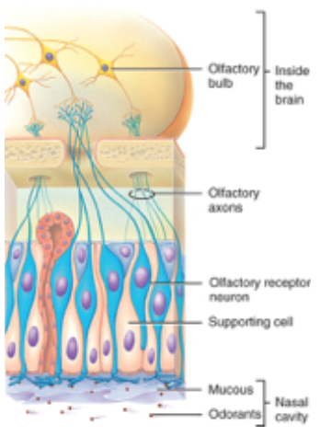
- Insula: part of the cortex that receives taste information and is associated with emotion of disgust

Smell and Taste Disorder
- Anosmia: inability to smell
  - Problem with olfactory causes this
- Agues: inability to taste
  - Can often taste the 5 receptors but can no longer detect other flavours that require info from the adroitness of food

Migraines, Epilepsy, and the Sensory Systems
- A specific odour can initiate a migraine
- Reflex Epilepsy: certain form of epilepsy where the person will experience a seizure only after exposure to a specific odour
- Auras: hallucinations that happen before or during migraine headaches or epileptic seizures

The Tactile or Cutaneous Senses: Touch, Pressure, Pain, Vibration
- Tactile: means “touch”
- Free Nerve Endings: sensory receptors that convert physical stimuli (detect) into touch, pressure, or pain impulses, temperature
  - Located mostly near surface of skin
- Meissner’s Corpuscles: sensory receptors that convert physical stimuli about sensory touch on the fingertips, lips, and palms
  - Found in hairless regions
- Merkel’s Discs: sensory receptors that convert information about light to moderate pressure on the skin
- Ruffini’s End-Organs: sensory receptors that respond to heavy pressure and joint movement
  - Located deep in the skin
- Pacinian Corpuscles: sensory receptors that respond to vibrations and heavy pressure
  - Also buried deep in the skin
- 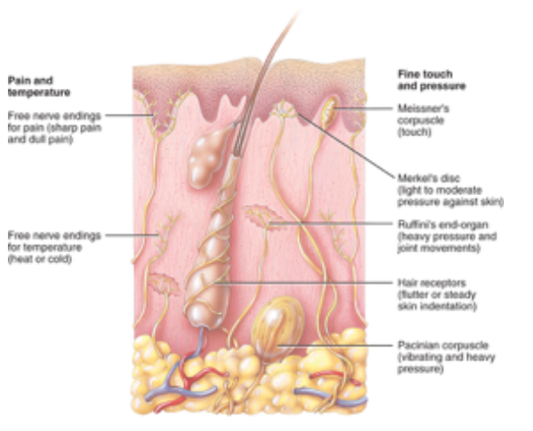

The Touching Brain
- Somatosensory Pathways in the CNS (Central Nervous System):
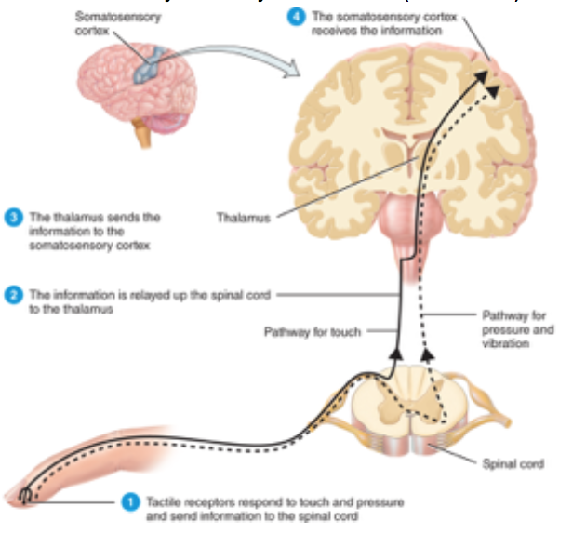
- Brain processes tactile information contra-laterally
  - Opposite side of the brain from the side of the body
    - Ex. left side touch, right side brain processes

Pain and the Brain
- Pain information travels to the brain via 2 different types of pain fibres:
- Fast Pathway: uses myelinated axons that carry signals faster than unmyelinated axons, moves directly up spinal cord to thalamus and areas of somatosensory cortex
  - More sharp pains
    - Ex. withdraw reflex
- Slower Pain Pathway: uses more unmyelinated axons, these inputs communicate with brain regions involved in processing emotion
  - More burning pains
    - Ex. spicy food

Tactile Senses: Individual Differences
- Gate Control Theory of Pain: suggesting that certain patterns of neural activity can close a “gate” to keep pain information from travelling to parts of the brain where it is perceived

Disorders of the Tactile Senses
- Chronic Pain:
  - Two groups of chemical naturally produced by our Nervous System that have pain-relieving properties:
    - Endorphins and Enkephalins
    - Both belong to the class Opiates
  - Endogenous Opiates: when opiates are naturally present in the Nervous System
- Acute Pain:
  - Gate Control Theory
- No Pain:
  - Familial Dysautonomia: inability to detect pain or temperature
- Phantom Limb Sensations:
  - Phantom Sensations: touch, pressure, vibration, pins, needles, hot, cold, and pain in the body part that no longer exists

The Auditory Sense: Hearing
- Sound Waves: vibrations of the air in the frequency of hearing
- Sound waves have 2 major qualities that produce our perceptions of different sounds:
- Frequency: refers to the number of cycles that the wave completes in a certain amount of time
    - Measured in Hertz/Hz
    - The frequency of a sound wave is responsible for producing the pitch of a sound
- Amplitude: refers to the strength of a given cycle (higher peaks and lower bottoms are of higher amplitude)
    - Amplitude is responsible for our detection of loudness
    - Measured in decibels/dB
- Detection of Sound:
  - Sound waves converted to neural impulses in the ear through several steps
- Tympanic Membrane: the ear drum
- Ossicles: tiny bones in the ear called Maleus (Hammer), Incus (Anvil), and Stapes (Stirrup)
- Oval Window: membrane separating the ossicles and the inner ear, defection of which causes a wave to form in the cochlea
- Cochlea: fluid-filled structure in the inner ear; contains the hair cells
- Basilar Membrane: structure in the cochlea where the hair cells are located
- Hair Cells: sensory receptors that convert sound waves into neural impulses
- Tonotopic Map: representation in the auditory cortex of different sound frequencies
  - Sound Brainstem Thalamus Auditory Cortex (Temporal Lobe)

Identifying Frequency and Pitch
- Frequency Theory: suggests that different sound frequencies are converted into different rates of action potentials or firing in our auditory nerves
- Place Theory: accounts for the greater degree of auditory perception
  - Differences in sound frequency activate different regions on the basilar membrane
- Absolute Pitch: ability to recognize or produce any notes on a musical scale
- Amusia: tone deafness
  - Result of damage to the auditory system

Drowning out the Noise
- Cocktail Party Effect: brain is able to attend to, and pick up on relevant sounds even in very noisy environments

Sounds in Space
- Determine which direction the sound is approaching, auditory uses cues:
  - General Loudness
  - Loudness in Each Ear
  - Timing
Hearing Loss
- Conduction Deafness: occurs when there is some sort of occlusion or break in the various processes by which sound is transmitted through the inner ear
- Nerve Deafness: results from damage or malformations of the auditory nerve in the brain
  - Congenital: from birth
- Deafness: loss or lack of hearing

Chapter 8 – Memory
What is Memory?
- Memory: faculty for recalling past events and past learning
- Memory involves 3 basic activities:
  - Encoding: recording of information in our brain
    - Getting information into memory
  - Storage: retention of information for later use
    - Retaining memories for future use
  - Retrieval: recovery of information when we need it later
- 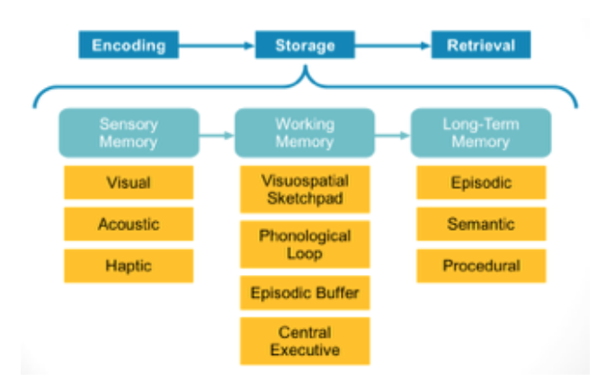
- Information-Processing Model: view of memory suggesting that information must pass through three stages, or systems, of mental functioning to become a firmly implanted memory
  - Sensory Memory
  - Working Memory
  - Long-Term Memory
- Iconic Memory/Visual Sensory Memory: small copy of the visual event we have just encountered
- Phonological Loop: “little voice” that keeps repeating what we want to remember
- Visuospatial Sketchpad: where we can temporarily store images and spatial locations we’re working with
- Executive Function: refers more directly to processing information as it relates to goal-directed behaviour (referred to as by neuropsychologists)
- Executive Attention: responsible for overseeing the maintenance of goals and for controlling for interference while a person is engaged in complex cognitive tasks
- Parallel Distributed Processing Model (PDP): theory of memory suggesting that information is represented in the brain as a pattern of activation across entire neural networks
- Connectionist Model: theory of memory suggesting that information is represented in the brain as a pattern of activation across entire neural networks
- Atkinson-Shiffrin Model (Store Model):
  - Information Processing Theory
  - 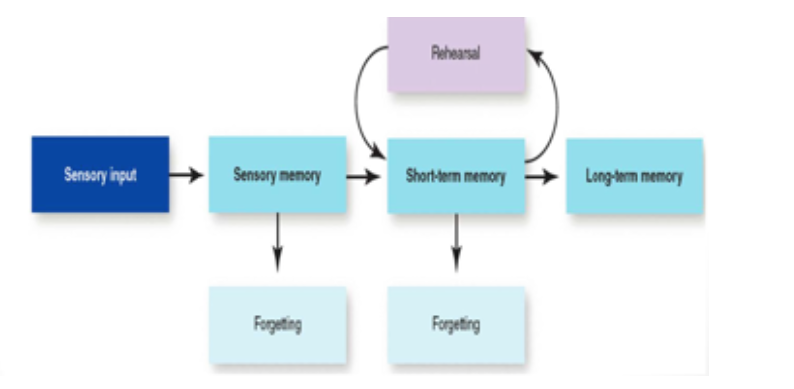

Using Automatic and Effortful Processing to Encode Information into Memory
- Automatic Processing: encoding of information with little conscious awareness or effort
- Effortful Processing: encoding of information through careful attention and conscious effort

Transferring from Sensory Memory into Working Memory
- Sensory Memory: memory involving detailed, brief sensory image or sound retained for a brief period of time
- Working Memory: short term memory consists of the things we are thinking of and working with consciously
  - Hold 5-9 items at once
  - Referred to as by experimental psychologists
- Rehearsal: conscious repetition of information in an attempt to make sure the information is encoded

Transferring from Working Memory into Long-Term Memory
- Long-Term Memory: the memory system in which we hold all of the information we have previously gathered available for retrieval and use in a new situation or task
- Spaced Practice Effect: facilitated encoding of material through rehearsal situations spread out over time

In What Form is Information Encoded?
- Phonological Code: repeating the sound of the thing you’re trying to remember
  - Better for encoding non-verbal information
- Visual Code: holding an image of what you’re trying to remember
  - Better for encoding non-verbal information
- Semantic Code: cognitive representation of information or an event based on the meaning of the information
  - Better for encoding verbal information

Meaning and Encoding
- Mnemonic Devices: techniques used to enhance the meaningfulness of information, as a way of making them more memorable

Organization and Encoding
- Schemas: knowledge bases that we develop based on prior exposure to similar experiences or other knowledge bases
  - Reflect most typical features of objects/situations
  - Organization of episodic memory, and possibly procedural memory
  - Schemas explain some of the mistakes we make in memories

The Storage Limits of Working Memory
- Memory Span: maximum number of items that can be recalled in correct order

Enhancing Working Memory
- Chunking: grouping bits of information together to enhance ability to that information in working memory

Storage in Long-Term Memory
- Some information previously acquired can’t be retrieved from long-term memory
- Capacity for long-term memory varies among people
- 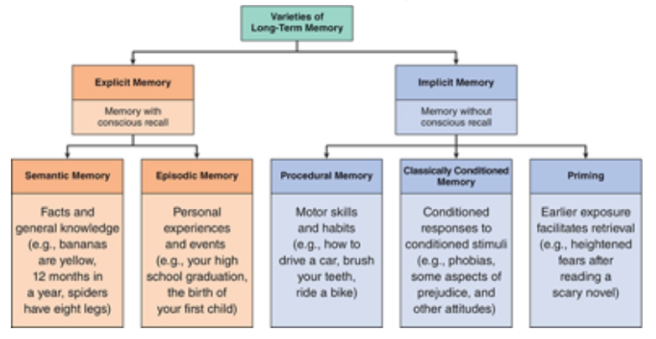

How Do We Retrieve Memories?
- Retrieval Cues: words, sights, or other stimuli that remind us of the information we need to retrieve from our memory

Priming and Retrieval
- Priming: activation of one piece of information, which in turn leads to activation of another piece, and ultimately to the retrieval of a specific memory
- Recognition Tasks: memory tasks in which people are asked to identify whether or not they have seen a particular item before
- Recall Tasks: memory tasks in which people are asked to produce information using no or few retrieval cues

Context and Retrieval
- Context: the original location where you first learned a concept or idea is rich with retrieval cues that will make it more likely you will be able to recall that information later if you are at the same location/context
- Encoding Specificity Principle: theoretical framework that asserts that memory retrieval is more efficient when the information available at retrieval is similar to the information available at the time of encoding

Specific Retrieval Cues
- State-Dependent Memory: memory retrieval facilitated by being in the same state of mind in which you encoded the memory in the first place
  - Ability to retrieve better when internal state at retrieval matches that at encoding
- Connect-Dependent Memory: easier to remember something in same environment where encoded
- Mood-Congruent Recall: tend to recall info or events congruent with current mood
- Cues: memories are formed by linking each item of information to other items
- Tip-of-the-Tongue: spreading activation explains that feeling when you can almost remember something but not quite

Emotional Memory: Rehearsal, Elaboration, and Organization
- Modulation Hypothesis: long-lasting emotional effects on memory can be attributed to the activation of the amygdala during the encoding of emotional events

Special Emotional Memory Mechanisms: Flashbulb Memories
- Flashbulb Memories: detailed and near-permanent memories of an emotionally significant event or of the circumstances surrounding the moment learned about event

Why do we Forget and Misremember?
- Forgetting: inability to recall information that was previously encoded into memory
- Encoding Failure: lack of attention, lack of deep processing

Theories of Forgetting: Decay
- Decay Theory: theory of forgetting, suggesting that memories fade over time due to neglect or failure to access over long periods of time
- Memory Trace: theory build on the notion that memories leave a physical trace in the brain

Theories of Forgetting: Interference
- Interference Theory: theory that forgetting is influenced by what happens to people before or after they take information
- Proactive Interference: competing information that is learned before the forgotten material, preventing subsequent recall
- Retroactive Interference: learning of new information that disrupts access to previously recalled information
- 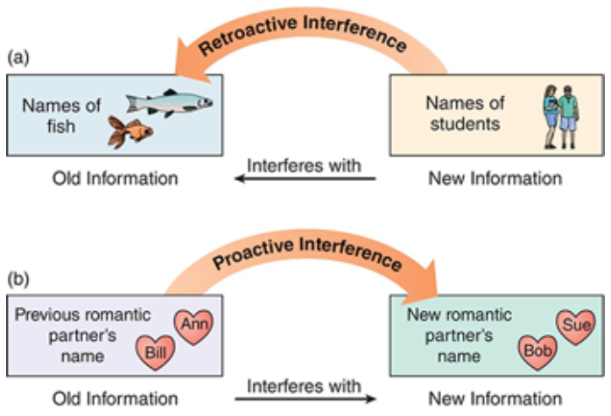

Distorted or Manufactured Memories
- Source Misattributions: remembering information, but not the source it came from
  - Can lead to remembering information from unreliable sources as true
  - Store information in long-term memory
- Exposure to Misinformation: can lead to distortion/false memories
- Imagination: memories can be distorted also by false information that comes from within/our imagination

What is the Anatomy of Memory?
- Prefrontal cortex is key for working memories
  - Formation and retrieval
  - Episodic memory
- Hippocampus is crucial for memory and is activated when people recall information about facts and events
  - Consolidation
- Cerebellum
  - Procedural memory
- Cerebral cortex
  - Semantic and autobiographical memory

What is the Biochemistry of Memory? – Neural Circuits
- Long-Term Potentiation (LTP): repeated stimulation of certain neurons increases the likelihood that these neurons/cells will respond to future stimulation of the same kind
  - Many neurons and neural circuits that use glutamate as their neurotransmitter are particularly likely to exhibit LTP
  - LTP commonly located in hippocampus and neocortex
    - Brain regions that play important roles in forming long-term memories

Memories in the Young and Old
- Prospective Memory: ability to remember content in the future
- Retrospective Memory: ability to remember content from the past

Organic Memory Disorders: Amnestic Disorders
- Amnestic Disorders: organic disorders in which memory loss is the primary symptom
- Infantile Amnesia: memory loss for early childhood experiences
  - Before 4 years old
- Retrograde Amnesia: inability to remember things that occurred before an organic event
- Anterograde Amnesia: ongoing inability to form new memories after an amnesia-inducing event
- 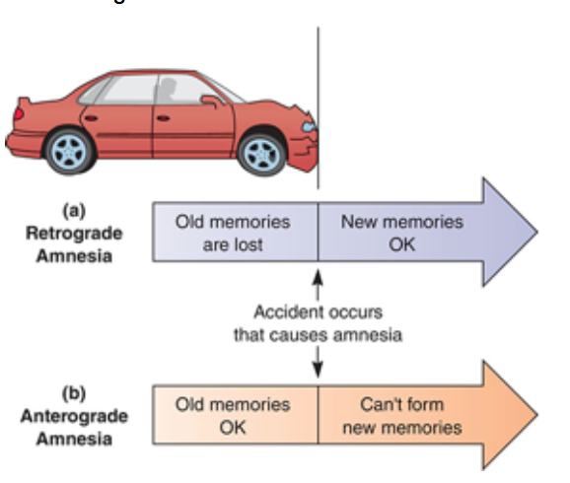

Organic Memory Disorders: Dementias
- Dementia: severe memory problems combined with losses in at least one other cognitive function, such as abstract thinking or language
- Alzheimer’s Disease: most common form of dementia, usually beginning with mild memory problems, lapses of attention, and problems in language, and progressing to difficulty with simple tasks and recall of long-held memories
- Neurofibrillary Tangles: twisted protein fibres found within the cells of the hippocampus and certain other brain areas
- Senile Plaques: sphere-shaped deposits of a protein known as beta-amyloid that form in the spaces between cells in the hippocampus, cerebral cortex, and certain other brain regions, also in some nearby blood vessels

Gender and Dementia
- Depending on your gender, you may be susceptible to different risk factors for dementia and Alzheimer’s disease
- Older women are more likely to develop dementia than men

Appendix B
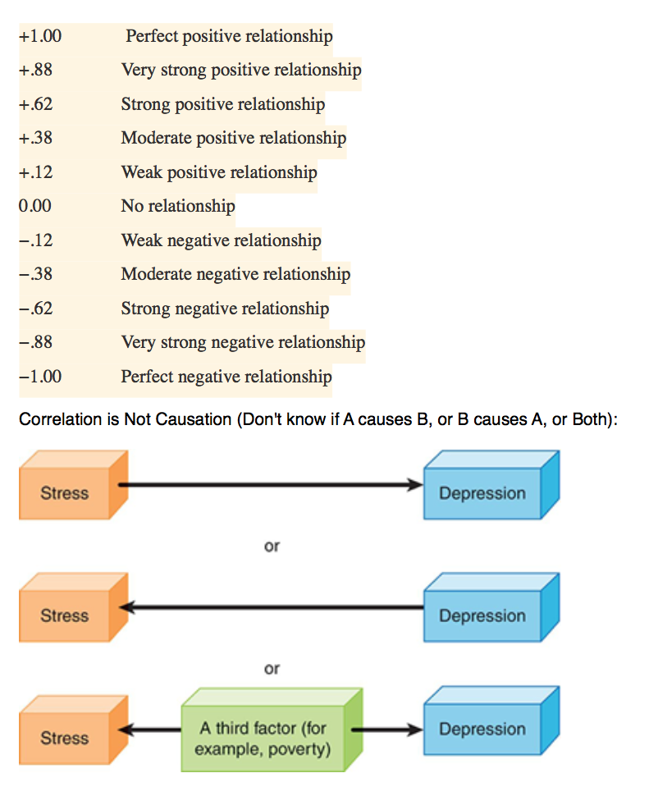

Analyzing Data
- Descriptive Statistics
  - Summarize actual study data
  - Determine correlations
    - If there is a relationship
- Inferential Statistics
  - Extend conclusions to larger population
  - Determine if the hypothesis has been supported or if there is a meaningful difference between the groups

Descriptive Statistics: One Variable
- Used to give basic info about what we find
- Provides a summary/frequency distribution or table
- Uses statistics:
  - Mean, Median, Mode
    - Measures of central tendency
  - Standard Deviation, Range
    - Measures of variability
  - Normal Distribution
    - Bell shaped/bell curve
  - Variability: gives how much variability a score has from the mean
    - Littler Variability: all bunches up close to the mean
    - Lots of Variability: wide curve

Measures of Central Tendency
- Mean: average
  - Add all scores, divide by number of scores
  - Can compare using T-tests/analysis of variance (for 2 groups)
  - Is more affected by outliers
- Median: middle score
  - The one that falls in the middle of the distribution
  - Is less affected by outliers
- Mode: most commonly/frequently occurring score

Reading Correlation Graphs
- Data Points
- Scatterplots
- Line of Best Fit
  - Angle of line reflects correlation

Why Correlation Studies?
- Because you can have access to two pieces of information but may not be able to manipulate the variables
- First step in the inferential process
Why Can’t You Infer Cause?
- Potential other factor
- “Third Variable”
  - Extraneous Variable

Inferential Statistics
- Used to test hypotheses
- Lots of different tests selected on the basis of characteristics of the study
  - Ex. analysis of variance, profile analysis, etc.
- Try to determine if the results are due to chance or not
- Statistical Significance: the probability that relationships between variables observed in the sample are due to experimental manipulations rather than due to chance
  - P-values of < 0.05
  - P-Value: tells you the probability that the results of your experiment are not due to chance

Experimental Analyses: Establishing Cause and Effect
- Example
  - If you have a p-value of less than 0.05, it means there is only a 5% likelihood (ie. less than 5 chances in 100) that your results occurred by chance
  - How about a p-value of lower than 0.01?
    - Less than 1 chance in 100 that you obtained the result by chance

Using Statistics to Evaluate and Plan Research
- Replication: repeated testing of a hypothesis to ensure the results you receive one experiment isn’t because of chance

