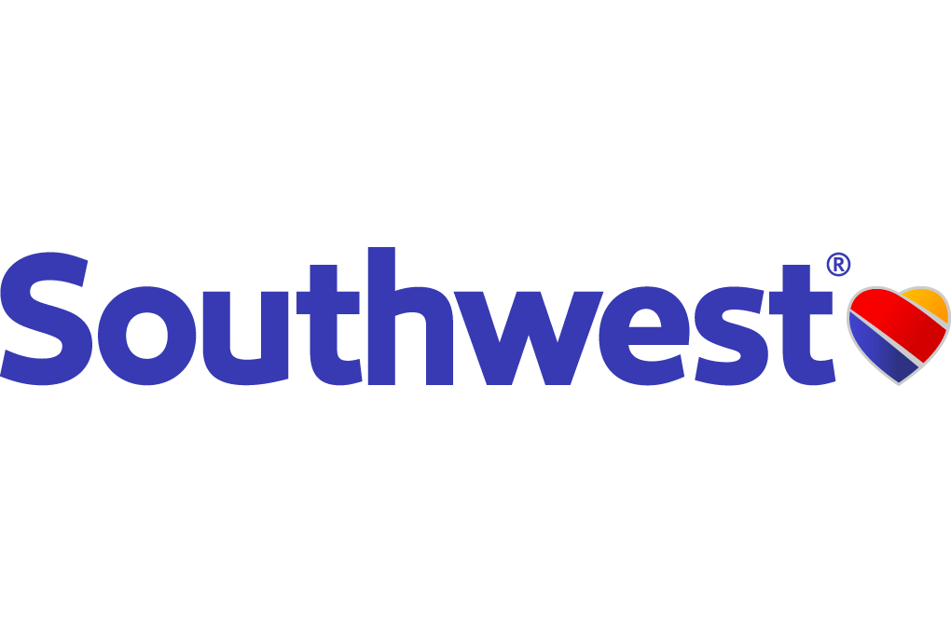

Southwest Airline

COMM 401 –Strategy and Competition

Presented to – Ehasn Derayati

Presented by – TszHo Chan
40070566

23 – 10 – 2017

Words: 1340
Introduction

Southwest airline is one of the major airlines in US. After stepped across a lot of barriers, Southwest began flying in 1971 and started to serve the citizen worldwide. After 45 years of services, Southwest is now the low cost leader, who keep earning profit since it’s first operation, among the industry. However, with the enforcement of the Airline Deregulation Act, the entry barriers of airline industry became more loosen which leads to the emergence of some of the potential competitors. The industry therefore came to a situation of feast price competition. Also, with the merge and acquisition of some of the existing airline among the industry, the market share of Southwest was weakened. Moreover, due the downturn of economy and the increased hire of employees, Southwest’s operation cost as well as labor cost is now increasing, which may have a negative influence on Southwest’s operation. All these incidents have put Southwest into a hard situation.

Problem Statement
The main problem statement is, “How can Southwest maintain its position as America’s most prosperous airline in a way that keeping lowering the cost, maintaining the strong and unique culture with the employees and growing profitably in the international market? ”

External Analysis
General Environment
Southwest’s operation is highly affected by the external environment. This can be seen from the PEST analysis (EXHIBT 1). Each component has it own effect on Southwest. In the technological perspective, with the development of Internet, several online traveling platforms are emerged. Southwest can grab this opportunity to increase it’s reputation by joining those platforms. Also, the introduction of electronic ticket has reduced the operation costs. In the economic side, the fall of price of oil, which is the major fuel for aircraft, in 2014 helped Southwest saved a lot of costs. In the social-cultural perspective, with the increased demand of traveling, customer prefer time-efficient travel. Any delay and turnaround time may cause customer dissatisfaction. In the political aspect, the adoption of Airline Deregulation Act enabled new entrances, which put Southwest in a highly competitive situation.

Industry Environment
Porter Five Forces model (EXHIBT 2) provide us with a deeper understanding of the external environment. The threat of new entrants is medium. The huge capital investment makes them not easy to start a business. Moreover, the supplier and buyer power are high since there are many strategic groups offering similar services in the industry. Also, the existing rivalry is high as well several competitors are imitating Southwest’s strategies. However, the threat of substitutes is relatively low as there are no vehicles that can travel faster than aircraft in the air.

Competitor Environment.
There are several strategic groups among the industry. They are United, Delta, American and JetBlue. All of them are offering similar services as Southwest. United, Delta and American are acting as the big three airlines in the US airline industry. And JetBlue is a low cost services provider who is using similar business level strategy similar to Southwest by offering low cost flight as well as differentiated customer services. Meanwhile, United is using corporate level strategy by expending its business to include the shuttle services. For Delta and American, they are using merging and acquisition strategy with other small airline to increase their market share.
Earning revenue is the strength for JetBlue and Delta. However, it is the weakness of American and United. This can be referring to the financial analysis of 2016 (EXHBIT 7). According to the revenue to operation cost ratio, American and United were making loss. Only, Delta and JetBlue can generate revenue higher then their cost. Meanwhile, JetBlue had a performance better than Southwest.

Internal Analysis
Resources
By looking at the micro part of the company, one should put more focus on the firm’s resources since they determine the firm success (EXHIBT 4). For the tangible resources that Southwest own, the two-tied pricing structure and the advanced Boeing 747 aircraft model which could support 6 fight and operate 11 hours per days assisted Southwest to generate a constructive amount of internal fund. Also, the online ticket system as well as those 50000 customer orientated staffs have provided customer with excellent traveling experience. Moreover, their reputation and the personality of the staff, which are the intangible resources, helped Southwest to generate sustainable competitive advantage and contained to be the leader over the industry.
Capabilities
Distribution: Apart from the cities that Southwest originally own, it tries to expand the market by acquiring Northwest areas and also entered Florid. Also, this expansion is highly controlled.
Marketing: Southwest is good at promoting itself. For example, the caption of “Nobody is going to shoot Southwest out of the sky for a lousy of $13” when it started selling the tickets for $13.
Management: the management style of southwest is the most special among the industry. Herb Kelleher drives the company success by adopting his own personality style into the management system. This management created new standard for the industry and is being considered as initiative and effective.
Human resources: Southwest have people with to continue the Southwest cultural relationship between management and employees are good at customer services.
Management information system: Online website of Southwest.

Core Competencies
Among the capabilities, the distribution, management and human resources are considered as core competencies for Southwest for three reasons. First, they are not easy to imitate by competitors. Then, they provide potential access to a wide range of markets. Lastly, they are directly contributed to the customer benefit. For marketing and Management Information System, they are too easily to be imitated.

Competitive Advantage
Just like core competencies, Distribution, Management and Human Resource are sustainable competitive advantage of Southwest as they are valuable, rare, costly to imitate and non-substitutable (EXHIBT 5).

Evaluation of current position
Among all the strategic groups, JetBlue is the only one that sits closely to Southwest (EXHIBT 6). JetBlue even offer better customer services than Southwest. This may highly affect Southwest’s position of being the most prosperous airline in US.

Business Strategies
Southwest is now using integrated low cost differentiation strategy. They offer services at relatively low price. Also, they differentiated their service by customization and employee attitude.
By analyzing the strength and weakness of Southwest, Southwest is good at providing services. Thus, it creates value from the value chain pre flight operation to after sales service. (EXHIBT 3) However, the first value chain is reservation is their weakness since booking flight online is not available online unless customer directly go to Southwest airline. To solve this problem, Southwest can join travelling to enable online booking.

Alternatives
Here are few alternatives available for Southwest:
- Do nothing
- Offer more services
- Acquisition with the major competitor
- Put more focus on the international market
The second alternative is base on Southwest’s strategy as always. To continue leading the market, Southwest may provide much more unique service. For example, wedding on the air service. This action can provide customer with differentiated experience.
The third option not only can help Southwest increase its market share, but also get the reputation from the major competitor and take possession of the services that the competitor offers previously.
The last option is based on the international aspect. Putting more focus on the markets, which have high growing potential, can help Southwest gain better reputation as well as more external funding from international investor.

Recommendation
My recommendation would be the third one, acquisition with the major competitor. This is the most effective way to avoid competitors keep expending and it is also the best method for Southwest to expend the market share in a short period of time. To implement, Southwest should identify the major competitor, which is JetBlue. For the short-term goal, Southwest should not buy too much controlling from JetBlue in preventing that the acquisition strategy does not achieve the initial aim. Therefore, 20- 30% controlling is reasonable. For the intermediate goal, Southwest should try offering JetBlue’s service to customer to test the customer acceptance. In the long term, Southwest can buy more controlling if the strategy is working.
Appendix: EXHIBIT 1 – PEST Analysis
Factor | Characteristics
Political | - Federal Aviation Administration mainly regulates southwest Airline’s operation.
Economics | - Violate fuel cost create airline difficulties in controlling costs.  - The industry is highly affected by financial crisis.
Social | - Customer service is highly valued by customer.  - Customers are highly dissatisfied with the delay of flight.
Technology | - Electronic tickets replace traditional paper ticket.

EXHIBIT 2 – Porter 5 Forces Model
Force | Threat | Comments
New Entrants | Medium | - The large amount of initial capital investment created high entry cost of new entrants.  - The Airline Deregulation Act has loosened the entry barrier for new entrants.  - The major airlines existing in the industry is enjoying First mover Advantages.
Supplier’s Power | High | - Only two suppliers in the industry.  - Southwest has a huge switching cost of switching from Boeing to Airbus after cooperated with Boeing for over 44 years.
Buyer’s Power | High | - The price transparence of different airlines is high over the internet and customers can easily make comparison of them.  - Since switching to other airline is relatively simple, the switching cost of customers is relatively low.  - Different airlines are offering similar services.
Threat of Substitutes | Low | - In terms of time, aircraft is the fastest among its substitutes.  - Airplane is the only transportation for people wants to travel through air.
Rivalry Among Competitors | High | - There are several low cost airline offering similar services with Southwest.  - Some Southwest’s major competitors are expending their market share through merge and acquisition.  - New startups with low cost show up.

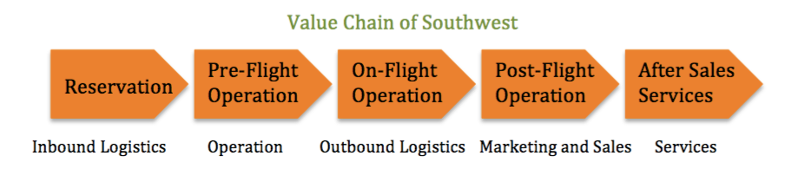
EXHIBIT 3 – Value Chain of Southwest

EXHIBT 4 - Resources
Category | Description
 | Tangible
Financial  Resources | The two-tiered pricing structure derived customer attentions and also help the southwest generated huge amount of revenue.
Physical Resources
Technological Resources | Southwest is the first one who introduce interne ticketing. Also, it encourages ticketless travel by promoting website boarding. Southwest also developed it’s own online reservation system.
Organizational Resources | Southwest has 50000 employees who are hired through the well-developed employee screening system. Also, the intense communication system as well as the staff-gathering event helps develop southwest sprit. Moreover, the use of a single type of aircraft also reduced management problems.
 | Intangible
Human Resources | Staffs of southwest contain personalities, which match the southwest sprit. Also, staffs are highly customer focused by providing them with Positively Outrageous Services. Then, management supported the employee initiative.
Innovation Resources | Southwest operates by maximizing the number of customer that each staff can handle and using customer feedback to improve the service. Also, no reserved seat is allowed in order to reduce the turnaround time.
Reputational Resources | Southwest is the lowest cost leader in the industry and providing excellent customer services. Also, it is the only airline that receives fewest complains.

EXHIBT 5 – VRIN Analysis
Core Competency | Is it valuable? | Is it rare? | Is it costly to intimate | Is it non-substitutable? | Competitive Consequence
Distribution | ✓ | ✓ | ✓ | ✓ | Sustainable Competitive Advantage
Marketing | ✗ | ✓ | ✗ | ✗ | Competitive Parity
Management | ✓ | ✓ | ✓ | ✓ | Sustainable Competitive Advantage
Human Recourse | ✓ | ✓ | ✓ | ✓ | Sustainable Competitive Advantage
Management Information System | ✗ | ✓ | ✗ | ✗ | Competitive Parity

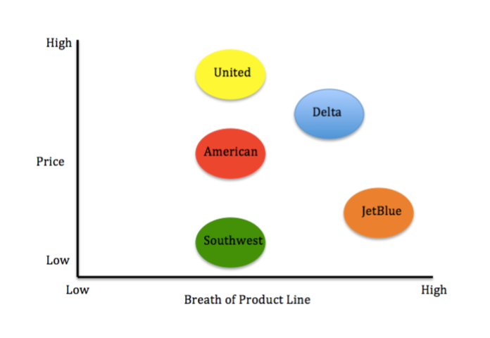
EXHIBT 6 – Strategic Group Map

EXHIBT 7 – Revenue to Operation Cost Ratio 2016
Ratio\Airline | American | Delta | JetBlue | Southwest | United
Revenue to Operation Cost ratio 2016 | 0.97 | 1.03 | 1.13 | 1.12 | 0.93
Calculations | 11.55/11.94 | 13.42/12.98 | 11.21/9.92 | 12.52/11.21 | 11.31/12.22

