COMM 217: Financial Accounting

Chapter 1
Financial Statements and Business Decisions

Investors (owners): individuals who buy small % of large corp gain from investment = dividends or sell share at higher price
Dividends: portion of what company earns in form of cash payment

Accounting: system that collects and processes (analyzes, measures, and records) financial info about an org and reports that info to decision makers
- Financial accounting system: periodic financial statements and related disclosures external decision makers (creditors, investors, suppliers, customers)
- Managerial accounting system: detailed plans and continuous performance reports internal decision makers (managers)

- The Four Basic Financial Statements: An Overview
Normally prepared by for-profit corp

  - The Statement of Financial Position:
Report financial position (assets, liabilities, shareholder’s equity) at particular point in time

- Structure:
Heading
- Name of entity
- Title of statement
- Specific date of statement
- Unit of measure

Accounting entity: org for which financial data are to be collected
Basic accounting equation: Assets = Liabilities + Shareholder’s Equity

- Elements:
- Assets: economic resources controlled by the entity as a result of past business events, and from which economic benefits can be obtained – depend on nature of operation
  - Cash (in bank accounts)
  - Trade receivables (amounts owed by customers)
  - Inventories
  - Prepayments (rend and insurance)
  - Property, plant, equipment
  - Goodwill (customer loyalty, quality products, reputation for good service)
  - Other assets
- Liabilities: entity’s obligations that result from business events (credit, borrowings)
  - Trade payables (amount owed to suppliers)
  - Short-term borrowings (amount owed to lenders within one year)
  - Provisions (estimated liabilities – amount and timing not known)
  - Long-term borrowings (owed on written debt contracts over one year)
  - Other liabilities
- Shareholders’ Equity:
  - Contributed capital (invested by shareholders)
  - Retained earnings (past earnings not distributed to shareholders)
  - Other components

- Note on Format:
Begin with most liquid asset
Liabilities increasing order of maturity (due date)
Include monetary sign beside first amount in group of items
Single underline below last item in a group before total or subtotal
Double underline below group totals

  - The Statement of Comprehensive Income:
Monitor firm’s net earnings reflects firm’s ability to sell goods and services for more than the cost to produce and deliver

- Structure:
Reports change in shareholders’ equity during a period from business activities, excluding exchanges with shareholders
2 parts = net earnings + other comprehensive income in one statement or two related statements
Accounting period: time period covered by the financial statements

Statement of earnings (income statement): revenues and expenses for a period
+ statement of comprehensive income reporting additional income and expense item that will affect net earnings in future

Equation: Revenues – Expenses = Net Earnings

- Elements:
- Revenues = sales of goods and services sold to customers (including trade receivables)
- Expenses = monetary value of resources the entity used up to earn revenues may require immediate payment of cash, payment of cash at a future date, or use of other resource – recognize all expenses incurred during specific period, regardless of timing of cash payment
  - Cost of sales (cost to produce)
  - Sales and marketing
  - Distribution
  - General & administrative
  - Finance cost (costs in connection with borrowing of funds)
- Net earnings before tax
- Income tax expense
- Net earnings (net income, profits) = excess of total revenues

  - The Statement of Changes in Equity:
Reinvestment of net earnings = important source of financing

- Structure:
Reports all changes to shareholder’s equity during accounting period
Reports way net earnings, distribution of net earnings (dividends) and other changes to shareholder’s equity affected company’s financial position

Retained earnings: reflect net earnings that have been generated since creation of company but not distributed yet to shareholders as dividends

Equation:
Beginning retained earnings + net earnings – dividends = ending retained earnings

- Elements:
- Balances at beginning of period – contributed capital, retained earnings, other equity components
- Net earnings for period added or subtracted

Ending balances of contributed capital and other components = also reported on statement of financial position
Statement of changes in equity shows link between comprehensive income and financial position

  - Statement of Cash Flow:
- Structure:
Reports cash inflows (receipts) & outflows (payments) related to operating, financing & investing during accounting period
Net earnings does not usually equal amount of cash received minus amount paid during period

+/- cash flow from operating activities +/- cash flows from investing activities +/- cash flows from financing activities = changes in cash

- Elements:
- Cash flows from operating activities (CFO): directly related to generating earnings
- Cash flows from investing activities (CFI): related to acquisition or sale of company’s productive assets
- Cash flows from financing activities (CFA): related to financing of company itself – receipts and payments of cash to investors and creditors

- Interpreting:
Predicting future cash flows available for payment of debt or dividends
Operating activities indicate company’s ability to generate cash from sales to meet current cash needs

  - Relationships among Four Financial Statements:
- Net earnings (statement of earnings) increase in ending retained earnings (statement of changes in equity)
- Ending retained earnings (statement changes in equity) components of shareholder’s equity (statement of financial position)
- Change in cash (statement of cash flows) + cash balance at beginning of year = balance at end of year (financial position at end of year)

  - Notes to Financial Statements:
Provide supplemental info about financial condition of company, without which the financial statement cannot be fully understood
- Descriptions of accounting rules applied in company’s statements
- Additional detail about a line in financial statements
- Additional financial disclosures about items not listed on statements

- Responsibilities for the Accounting Communication Process:
Effective comm = recipient understands what sender intends to convey
To use info in financial statement = understandability + know that amounts reported fairly represent what is claimed + understand measurement rules applied

International Financial Reporting Standards (IFRS): guidelines for the measurement rules used to develop the info in financial statements

  - International Financial Reporting Standards (IFRS):
- How Are Accounting Standards Determined?
Pacioli 1494
Securities Act 1933 + Securities exchange act 1934 – following 1929 stock market decline

Securities and Exchange Commission (SEC): US govt agency that determines the financial statements that public companies must provide to shareholders and the measurement rules that they must use in producing those statements

Ontario Securities Commission (OSC): most influential Canadian regulator of the flow of financial info provided by publicly traded companies in Canada
13 regulators in Canada = Canadian Securities Administrators

Accounting Standards Board (AcSB): private-sector body given the primary responsibility to set the detailed rules that become accepted accounting standards
2006 – converging Canadian principles with IFRS

International Accounting Standards Boards (IASB): independent standard-setting board responsible for development and publication of IFRS

- Why Are Accounting Standards Important to Managers and External Users?
Provide guidance
Prevent managers from deliberately manipulating and reporting values that serve personal interest
Enhance comparability + enables external users to assess quality of info

Economic consequences of publication of financial statements =
- Changes in selling price of company’s shares
- Changes to the amount of bonuses received by management and employees
- Loss of competitive advantage

  - Management Responsibility and the Demand for Auditing:
Steps to assure investors company’s records are accurate =
- Develop & maintain system of internal controls over records and assets
- Hire outside independent auditors to attest fairness of statement
- Form a committee of BoC to oversee integrity of 2 safeguards

Report to management (management certification): indicates management primary responsibility for financial statement info and steps to ensure accuracy of company’s records

Audit report (report of independent auditors): describes auditor’s opinion of fairness of financial statement presentations and the evidence gathered to support that opinion
Audit: examination of the financial reports to ensure they represent what they claim and conform to IFRS

Professional accountants Canada = chartered professional accountant CPA
Canadian Public Accountability Board = provide public oversight for auditors of public companies

  - Ethics, Reputation, and Legal Liability:
Professional code of ethics – broad principles supported by specific rules governing the performance of audits by members of professional accounting orgs
Failure to comply = penalties
Potential economic effects of damage to reputation and malpractice liability stronger incentives

Private enterprises not required to use IFRS – accounting standards for private enterprises ASPE
Income statement + statement of retained earnings + balance sheet + statement of cash flows

TYPES OF BUSINESS ENTITIES:
- Sole proprietorship: unincorporated business owned by one person – owner and business not separate entities
- Partnership: unincorporated business owned by two or more persons (partners) – partnership contract – business and owner not separate entities (unlimited liability)
- Corporation: business incorporated federally under the Canada Business Corporations Act – owners = shareholders or stockholders – ownership represented by shares of capital
Charter gives corp right to operate as legal entity, separate from owner = limited liability = shareholders can’t lose more than they paid for shares
Corp = dominant form of business org in Canada
Advantages:
- Limited liability shareholders
- Continuity of life
- Ease of transferring ownership
- Opportunities to raise large amounts of $ by selling shares to large # of ppl
Disadvantages:
- Loss of control by shareholders
- Complex reporting procedures for variety of govt agencies
- Potential for double taxation of earnings

Chapter 2
Investing and Financing Decisions and the Statement of Financial Position

- Overview of Accounting Concepts:
IASB Framework for the Preparation and Presentation of Financial Statements = conceptual framework

  - Concepts Emphasized in Chapter 2:
- Objective of Financial Reporting:
Primary objective of external financial reporting = provide financial info about business to help external parties make sound financial decisions
Users of accounting info = decisions makers
Interesting in info to assist in projecting future cash inflows and outflows of a business

- Qualitative Characteristics of Accounting info
Relevance: can influence a decision – has predictive or confirmatory value
Material amount = large enough to influence user’s decision

Faithful representation: info provided in financial statements must reflect the substance of the underlying transactions, which may differ from legal form
Information = complete, neutral, free from material error

- Enhancing Characteristics:
Comparability: enhanced when similar accounting methods have been applied

Verifiability: independent accountants can agree on nature and amount of a transaction

Timeliness: enhances info’s ability to predict future values and confirm past values

Understandability: quality of info that enables users to comprehend its meaning

- Cost Constraint of Accounting Measurement:
Suggest that info should be produced only if the perceived benefits of increased decision usefulness exceed the expected costs of providing that info

- Accounting Assumptions:
- Separate-entity assumption: activities of each business must be accounted for separately from activities of owners
- Unit-of-measure assumption: accounting info should be measured and reported in the national monetary unit
- Continuity (going-concern) assumption: businesses are assumed to continue to operate into the foreseeable future
- Periodicity assumption: provides guidance on measuring revenues and expenses (ch. 3)

- Basic Accounting Principles:
Historical cost principle: requires assets to be recorded at the historical cash-equivalent cost, which is cash paid + current monetary value of all non-cash considerations (assets, privileges, rights) also given on the date of exchange

Does not reflect change in market value
Rely on historical cost factual

- Elements of the Classified Statement of Financial Position:
  - Assets:
Economic resources controlled by an entity as a result of past transactions or events and form which future economic benefits may be obtained – resources
Classification of info make statements more useful
Consolidated = combined financial statements of a parent company and its subsidiaries
List in order of liquidity

- Current assets (assets that will be used or turned into cash, normally within one year)
  - Cash
  - Short-term investments (shares of other companies + other financial assets purchased as investments of excess cash)
  - Trade & other receivables
  - Inventories (goods held for sale to customers / goods used to produce goods and services for sale = ALWAYS a current asset)
  - Prepayments (insurance, rent reflect available benefits that company will use within one year)
  - Other current assets
- Non-current assets (considered long-term b/c will be used or turned into cash over period longer than a year)
  - Property, plant, equipment or capital assets or fixed assets– at cost less accumulated depreciation (land, buildings, machinery, tools, furniture that will be used for the production, packaging, and storage)
  - Financial assets
  - Goodwill (intangible that arises when company purchases another business to control its operating, financing and investing decisions not easily identifiable assets = customer confidence, quality of products, reputation)
  - Intangible assets (no physical substance = franchises, patents, trademarks, copyrights)
  - Other miscellaneous assets

  - Liabilities:
Present debts or obligations of the entity that result from past transactions and that will be paid with assets or services represent future outflows of assets (mainly cash)
Listed in order of time of maturity (how soon an obligation must be paid)

- Current liabilities (short-term – obligations that will be paid in cash (or other current asset) or satisfied by providing service within coming year)
  - Trade and other payables (amounts owed to suppliers of materials)
  - Short-term borrowings (short-term loans from bank)
  - Income taxes payable
  - Accrued liabilities (total amount owed to suppliers for various types of services – payroll, rent, other obligations)
  - Provisions (Estimated liabilities that are expected to be paid within one year – exact amount & date = not know)
  - Other current liabilities
- Non-Current Liabilities (company’s debts that have maturities extending beyond one year from date of statement of financial position)
  - Long-term borrowings
  - Deferred income tax liabilities (arises form differences between net earnings and taxable income)
  - Provisions
  - Other liabilities

  - Shareholder’s equity (owner’s equity or stockholder’s equity):
Financing provided by the owners and the operations of the business
Creditors = entitled to settlement of their claims before shareholders receive dividends

Shareholders invest in a company = expect to receive cash flow dividends + gain from selling investment for more than they paid

- Contributed capital: results from shareholders providing cash (and other assets) to the business
- Retained earnings: accumulated earnings of a company that are not distributed to shareholders and are reinvested in the business
- Other components (ch 6)

- What Types of Business Activities Cause Changes in Financial Statement Amounts?
  - Nature of Business Transactions:
Only economic resources & debts resulting from past transactions are recorded
Transaction = 2 types of events
- External events: exchange of assets, goods or services by one party for assets, services, or promises to pay (liabilities)
- Internal events: have direct and measurable effect on accounting entity (using up insurance paid in advance, using buildings and equipment over several years)

Because of their importance, long-term employment contracts, leases, and other commitments may need to be disclosed in notes

  - Accounts:
Standardized format that orgs use to accumulate the monetary effects of transactions on each financial statement item
Chart of accounts facilitate recording – organized by financial statement element (in order of liquidity)
Assets
Liabilities (in order of time to maturity)
Shareholders’ equity
Revenue
Expense

Accounts in financial statements = summations (aggregate) of number of specific accounts in company’s recordkeeping system

- Accounts receivable (always assets): amounts owed to the corp by customers, to be collected in future
- Accounts payable (liabilities): amounts owed by the corp to be paid to others in future
- Prepayments accounts (assets): amount paid by corp to others for future benefits (ex: insurance coverage, rental of property, advertising)
- Accounts deferred (liabilities): amounts paid in the past to corp by others who expect future goods and services from corp

- How Do Transactions Affect Accounts?
Managers’ business decisions often result in transactions affecting financial statements involve risks transaction analysis

  - Principles of Transaction Analysis:
Process of studying a transaction to determine its economic effect on the entity in terms of the accounting equation (A = L + SE)

- Dual effect concept: every transaction affects AT LEAST two accounts – correctly identify accounts + direction of effect
- Accounting equation must remain balanced

- Dual Effects:
External parties = exchange business entity receives something and gives up something in return

Not all business events result in transaction that affects financial statement signing contract involving exchange of promises to perform future transaction DOES NOT result in recorded transaction – until promise exchanged for goods

- Balancing the Accounting Equation:
Step 1 = identify and classify accounts and effects
- Identify accounts affected (what is received? What is given?)
- Classify each by type of account (A, L, SE)
- Determine direction of effect (+, -)
Step 2 = verify accounting equation A = L + SE is balanced

- How Do Companies Keep Track of Account Balances?
DURING THE PERIOD
Analyze transaction + record in general journal in chronological order + updated in general ledger
END OF PERIOD
Adjust revenues and expenses & related statement of financial position accounts
Prepare complete set of financial statements
Close revenues, gains, expenses, and losses to retained earnings

  - Direction of Transaction Effects:
T-account: tool for summarizing transaction effects for each account, determining balances, and drawing inferences about a company’s activities

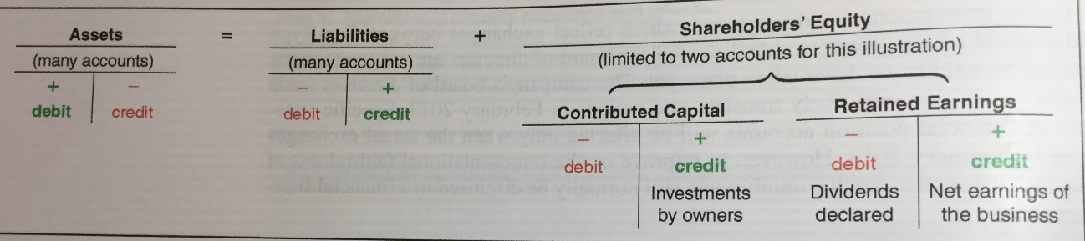
- Increase (+) is on left side of T accounts for assets
Increase (+) is on right side for liabilities and SE
- Debit (dr) = left side
Credit (cr) = right side

Assets increase with debits accounts have debit balances
Liabilities increase with credits accounts have credit balances
Shareholders’ equity increase with credits accounts have credit balances

Equality check debits=credits

  - Analytical Tools:
- Journal Entry:
Accounting method for expressing the effects of a transaction on various accounts, using double-entry bookkeeping system
Reference (date, number) – account titles (debited accounts on top, credited account bottom, indented) – amounts (debit left, credited right)

Compound entry: affects more than two accounts
Use symbol A, L, SE clarifies transactions
Example: increase cash (+A)

- T-Account:
Transfer monetary values to each account affected by the transaction to determine new account balances
Accounts = general ledger

If we enter and amount on the left side of T-account = account was debited
Enter and amount on right side of T-account = account was credited

- How is the Statement of Financial Position Prepared and Analyzed?
  - Classified Statement of Financial Position:
- Assets and liabilities classified into current and non-current
- Dollar signs at top and bottom of each section

  - Current ratio:
A company has liquidity if it has the ability to pay its current obligations
- Analytical question: does the company currently have resources to pay its short-term debt?
- Ratio & comparisons: current ratio = indicator of the amount of current assets available to satisfy current liabilities

$$Current ratio=\frac{Current Assets}{Current Liabilities}$$
- Interpretations:
Measure ability to pay short-term obligations with short-term assets
The higher the ratio, the more cushion a company has to pay its current obligations guideline = ratio between 1.0 and 2.0
Too high = inefficient use of resources

May be misleading if significant funds are tied up in assets that are not easily converted into cash

  - Some Misconceptions:
Confuse bookkeeping (routine data entry) with accounting
All transactions are subject to precise and objective measurement & that accounting results reported in financial statements are exactly what happened reality = influenced by estimates
Financial statements often thought of as inflexible accounting is a communication process

Chapter 3
Operating Decisions and the Statement of Earnings

- How Do Business Activities Affect the Statement of Earnings?
  - The Operating Cycle:
Turn cash into more cash – generated from operations
Operating (cash-to-cash) cycle: time it takes for a company to pay cash to suppliers, sell goods and services to customers, and collect cash from customers
Reducing time needed to turn cash into cash = higher net earnings + faster growth

Periodicity assumption: long life of a company can be reported in shorter periods
Recognition issues = WHEN should effects be recognized
Measurement issues = WHAT AMOUNTS should be recognized

  - Elements of the Statement of Earnings:
Results of continuing operations + results of discontinued operations = net earnings
Earnings per share

- Continuing Operations:

- Operating Revenues:
Revenues: increases in assets or settlements of liabilities from ongoing operations result from sales of goods and services
If cash received and services done in future = deferred revenue = liability

- Operating Expenses:
Expenses: decreases in assets or increases in liabilities to generate revenues during the period
≠ expenditures (outflow of cash for any purpose)

- Cost of sales: cost of products sold to customers (included in cost of asset inventories)
Gross profit (gross margin) = net sales – cost of sales
- Operating expenses: usual expenses incurred in operating a business during specific accounting period – classify by function (marketing, distribution, administrative) or by nature (materials, labour, property, equipment)
Earnings from operations = net sales – cost of sales & other expenses

- Non-Operating Items:
- Investment Income (investment, interest, dividend revenue): using excess cash to purchase shares in other corp
- Financing costs: incurring interest expense or earning investment income
- Gains (losses) on disposal of assets:
Gains = increases in assets or decreases in liabilities from peripheral transactions

Earnings before income taxes = revenues – expenses (except income tx)

- Income Tax Expense:
Percentage or earnings

- Discontinued Operations:
Discontinue a major component of a business net earnings/loss + gain/loss on subsequent disposal disclosed separately b/c of non-recurring nature

- Earnings per share:
Net earnings / average number of shares outstanding in the period

** stock market reactions to accounting announcements – make investment decisions

- How Are Operating Activities Recognized and Measured?
Local retailers, small business:
Cash basis accounting: records revenues when cash is received and expenses when cash is paid postpone or accelerate recognition or revenues and expenses long after or before goods & services are produced & delivered

  - Accrual Accounting:
IFRS require
Records revenues when earned and expenses when incurred regardless of timing of cash payments

  - The Revenue Principle:
- Entity has transferred to the buyer the significant risks & rewards of ownership of the goods (transfer of legal title)
- Entity retains neither continuing managerial involvement to the degree usually associated with ownership nor effective control over the goods sold
- Amount of revenue can be measured reliably (no uncertainty)
- It is probable that the economic benefits associated with the transaction will flow to the entity
- Costs incurred or to be incurred with respect to the transaction can be measured reliably

Cash received before company delivers goods or services = liability = deferred revenue
Cash is received on date = +A + SE
Cash received after goods and services delivered account receivable created

  - The Matching Process:
Expenses recorded when incurred in earning revenue all resources consumed in earning revenues during specific period = recognized in same period = matching costs with benefits
- Salaries to employees who worked DURING the period = wages expense
- Utilities for electricity used DURING the period = utilities expense
- Inventories used to produce goods sold DURING the period = cost of sales
- Facilities rented DURING the period = rent expense
- Use of building and equipment for production purposes DURING the period = depreciation expense

- The Expanded Transaction Analysis Model:
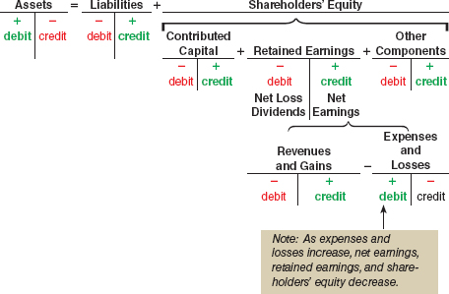

  - Transaction Analysis Rule:
- All accounts can decrease or increase
Account on left side of equation + on left on T account
Account on right side of equation + on right side of T account (except expenses, increase on left side of T account)
- Debits (dr) left side
Credits (cr) right side
- Every transactions affects at least 2 accounts
Revenues increase net earnings, retained earnings and SE do have credit balances – to increase a revenue account you CREDIT it = increases net earnings and retained earnings increase in asset or decreasing in liability
Expenses decrease net earnings, retained earnings and SE do have debit balances –increase an expense you DEBIT it = decreases net earnings and retained earnings decreasing asset or increase liability
Revenues exceed expenses = net earnings / increasing retained earnings and SE
When transaction occurs ask questions
Is a revenue earned? yes? Revenue account credited (increase)
Is an expense incurred? yes? Expense is debited (increase)
If a revenue was not earned or an expense was not incurred, what was received and given?

- How is the Statement of Earnings Prepared and Analyzed?
  - Classified Statement of Earnings:
Name of company
Statement of Earnings
Time period

Revenues
Sales Revenues
Service Revenues
Total Revenues
Cost of sales
Gross Profit

Operating Expenses
Distribution
General and administrative
Total operating expenses
Earnings from operations

Other revenues and gains (expense and losses)
Interest revenue
Gain on sale of land
Earnings before income taxes

**** Cash flows from operating activities
Direct method – cash receipts and cash disbursements
If transaction affects cash = reported in statement of cash flows

To remain business in long run generate positive cash flows from operations
If not? Sell non-current assets /or/ borrow from creditors /or/ issue additional shares

- Total Asset Turnover Ratio and Return on Assets:
  - Total Asset Turnover Ratio:
How effective is management at generating sales from assets (resources)?

$$Total asset turnover ratio= \frac{Sales revenues}{Average Total Assets}$$

$$Average total assets=\frac{beginning TA+ending TA}{2}$$

- Interpretation:
Measures sales generated per dollar of assets
High = efficient management of assets
Company’s products + business strategy contribute significantly to ratio strong financial performance improves ratio

  - Return on Assets (ROA): **ratio
How well has management used the total invested capital provided by debtholders and shareholders during period?

$$ROA= \frac{Net earnings+interest expense (net of tax)}{Average TA}$$

- Interpretations:
Measures how much the firm earned from use of its assets
Allows investors to compare management’s investment performance against alternative investment options

Chapter 4
Adjustments, Financial Statements, and the Quality of Earnings

- Adjusting Revenues and Expenses
  - Accounting cycle:
Process used by entities to analyze and record transactions, adjust records at end of period, prepare financial statements, and prepare the records for next cycle

  - Purpose of Adjustments:
Cash is NOT always received in period in which company incurs expense or not always paid in period in which company incurs expense =
Adjusting entries:
- Revenues recorded when earned (revenue principle)
- Expenses recorded when incurred to generate revenue during same period (matching process)
- Assets are reported at amounts that represent the probable future benefits remaining at end of period
- Liabilities are reported at amounts that represent the probable future sacrifices of assets or services owed at the end or period

  - Types of Adjustments:
Involve 2 entries:
- One to record cash receipt or payment during period
- One to record revenue or expense in proper period through adjusting entry prepared at end of period

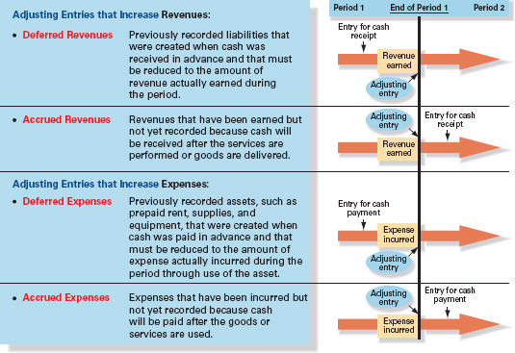

 | During period | End of period | Next period
 | Entry when cash is received before company earns revenue (performs | AJE b/c company earned revenue during period | Entry when cash is received after company earns revenue
Deferred revenue | Cash (+A)  Deferred fee revenue (+L) | Deferred fee revenue (-L)  Fee Revenue (+R, +SE)
Accrued revenue |  | Interest receivable (+A)  Interest revenue (+R, +SE) | Cash (+A)  Interest receivable (-A)

 | During period | End of period | Next period
 | Entry when cash is paid before company incurs expense | AJE b/c company incurred expense during period | Entry when cash is paid after company incurs expense
Deferred revenue | Prepayment (+A)  Cash (-A) | Something expense (+E, -SE)  Prepayment (-A)
Accrued revenue |  | Something expense (+E, -SE)  Payable (+L) | Payable (-L)  Cash (-A)

  - Adjustment Process:
Step 1: Was revenue earned or expense incurred that has not yet been recorded?
If yes: R or E must be increased

Step 2: was the related cash received/paid in past or will be received/paid in future?
If cash received in past (deferred R account): reduce deferred revenue recorded when cash received entire liability has been settled since then
If cash received in future: increase receivable account to record what is owed (accrued revenue)
If cash paid in past: (deferred expense asset account) reduce A account
If cash paid in future: increase payable account to record what is owed by company to others

Step 3: compute amount of revenue/expense earned/incurred + record AJE

- Unadjusted Trial Balance:
Trial balance: list of all accounts with their balances that provides check on the equality of the debits and credits – prepared for internal purposes
- Deferred Revenues: paid for in advance
- Accrued Revenues: paid for in the future (trade receivable)
- Deferred Expenses:
Prepayments
Property, plant, equipment – used over time to generate revenue = accumulated depreciation accumulated in contra-account XA (directly related but balance on opposite side of T-account)
Historical value – accumulated depreciation = carrying amount (net value)

- Accrued Expenses:
Salaries, utilities, interest
Income taxes payable
  - Materiality and Adjusting Entries:
Materiality: minor items that would not influence the decisions of financial statement users are to be treated in easiest and most convenient manner – allows accountant to estimate or ignore specific accounting principles
Item = immaterial if under 1 or 1.5% of total assets or sales / 5-10% of net earnings

- Preparing Financial Statements
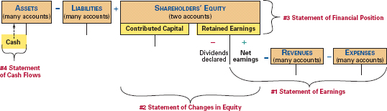

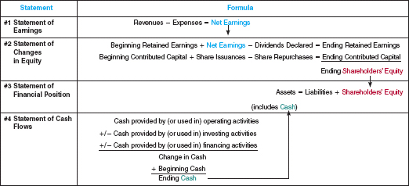
Before completing financial statements – update trial balances with adjustments

  - Statement of Earnings:
Earnings per share (EPS)
$$EPS=\frac{net earnings available to common shareholders}{Average number of shares oustanding for period }$$

  - Statement of Changes in Equity:
Net earnings = carried forward to retained earnings

  - Statement of Financial Position:
Ending balances for contributed capital & retained earnings = included
- Net Profit Margin Ratio
How effective is management at controlling revenues and expenses to generate more earnings?

$$Net profit margin ratio= \frac{Net earnings}{Net sales (operating revenues)}$$

$$Net sales=sales revenue-returns and other deductions$$

Interpretation:
How much profit is earned as % of revenues generated during period
Rising = more efficient management

- Return on Equity: **ratio
How well management used shareholder investment to generate net earnings during period?

$$ROE=\frac{net earnings }{Average shareholders^{'}equity }$$

$$Average shareholder equity=\frac{beginning SE-ending SE}{2}$$

Interpretation:
Measure how much firm earned as a % of shareholders’ investment
Firms with higher ROE = expected to have higher share prices
Assess effectiveness of company’s overall business strategy

- Closing the Books:
  - End of Accounting Cycle:
Permanent (real) accounts: statement of financial position accounts whose ending balances are carried to next period

Temporary (nominal) accounts: statement of earnings (and dividends declared) accounts that are closed to retained earnings at end of accounting period balances are transferred/closed to retained earnings
- Transfer balances in temporary accounts to RE
- Establish zero balance in each temporary accounts to start accumulation in next period

Income summary: temporary account used only during closing process to facilitate closing – used to close revenue, gain, expense and loss accounts
Credit balance debit total account to income summary
Debit balance credit total amount to income summary
Income summary balance = net earnings (or loss) closed to RE

Closing entries dated last day of accounting period

  - Post-Closing Trial Balance:
Prepared as last step of accounting cycle to check that debits = credits & that temporary accounts have been closed

Chapter 7
Reporting and Interpreting Sales Revenue, Receivables, and Cash

Gross profit = net sales – cost of sales

- Accounting for Sales Revenue
Revenue principle
For good sellers – point at which ownership changes hands = shipping terms in sales contract
Service companies record sales revenue when they have provided services

Appropriate amount of revenue to record = cash-equivalent sales price

  - Sales to Consumers:
Cash or credit card
Reasons for accepting credit cards as payment:
- Increasing customer traffic
- Avoiding costs of providing credit directly to customers (recordkeeping and bad debts)
- Lowering losses due to bad cheques
- Avoiding losses fro fraudulent credit card sales (credit card company absorbs losses)
- Receiving money faster
Credit card company charges a fee = credit card discount

Sales Revenue
Less: credit card discounts
= net sales

  - Sales Discount to Businesses:
Sales (cash) discount: discount offered to encourage prompt payment of a trade receivable
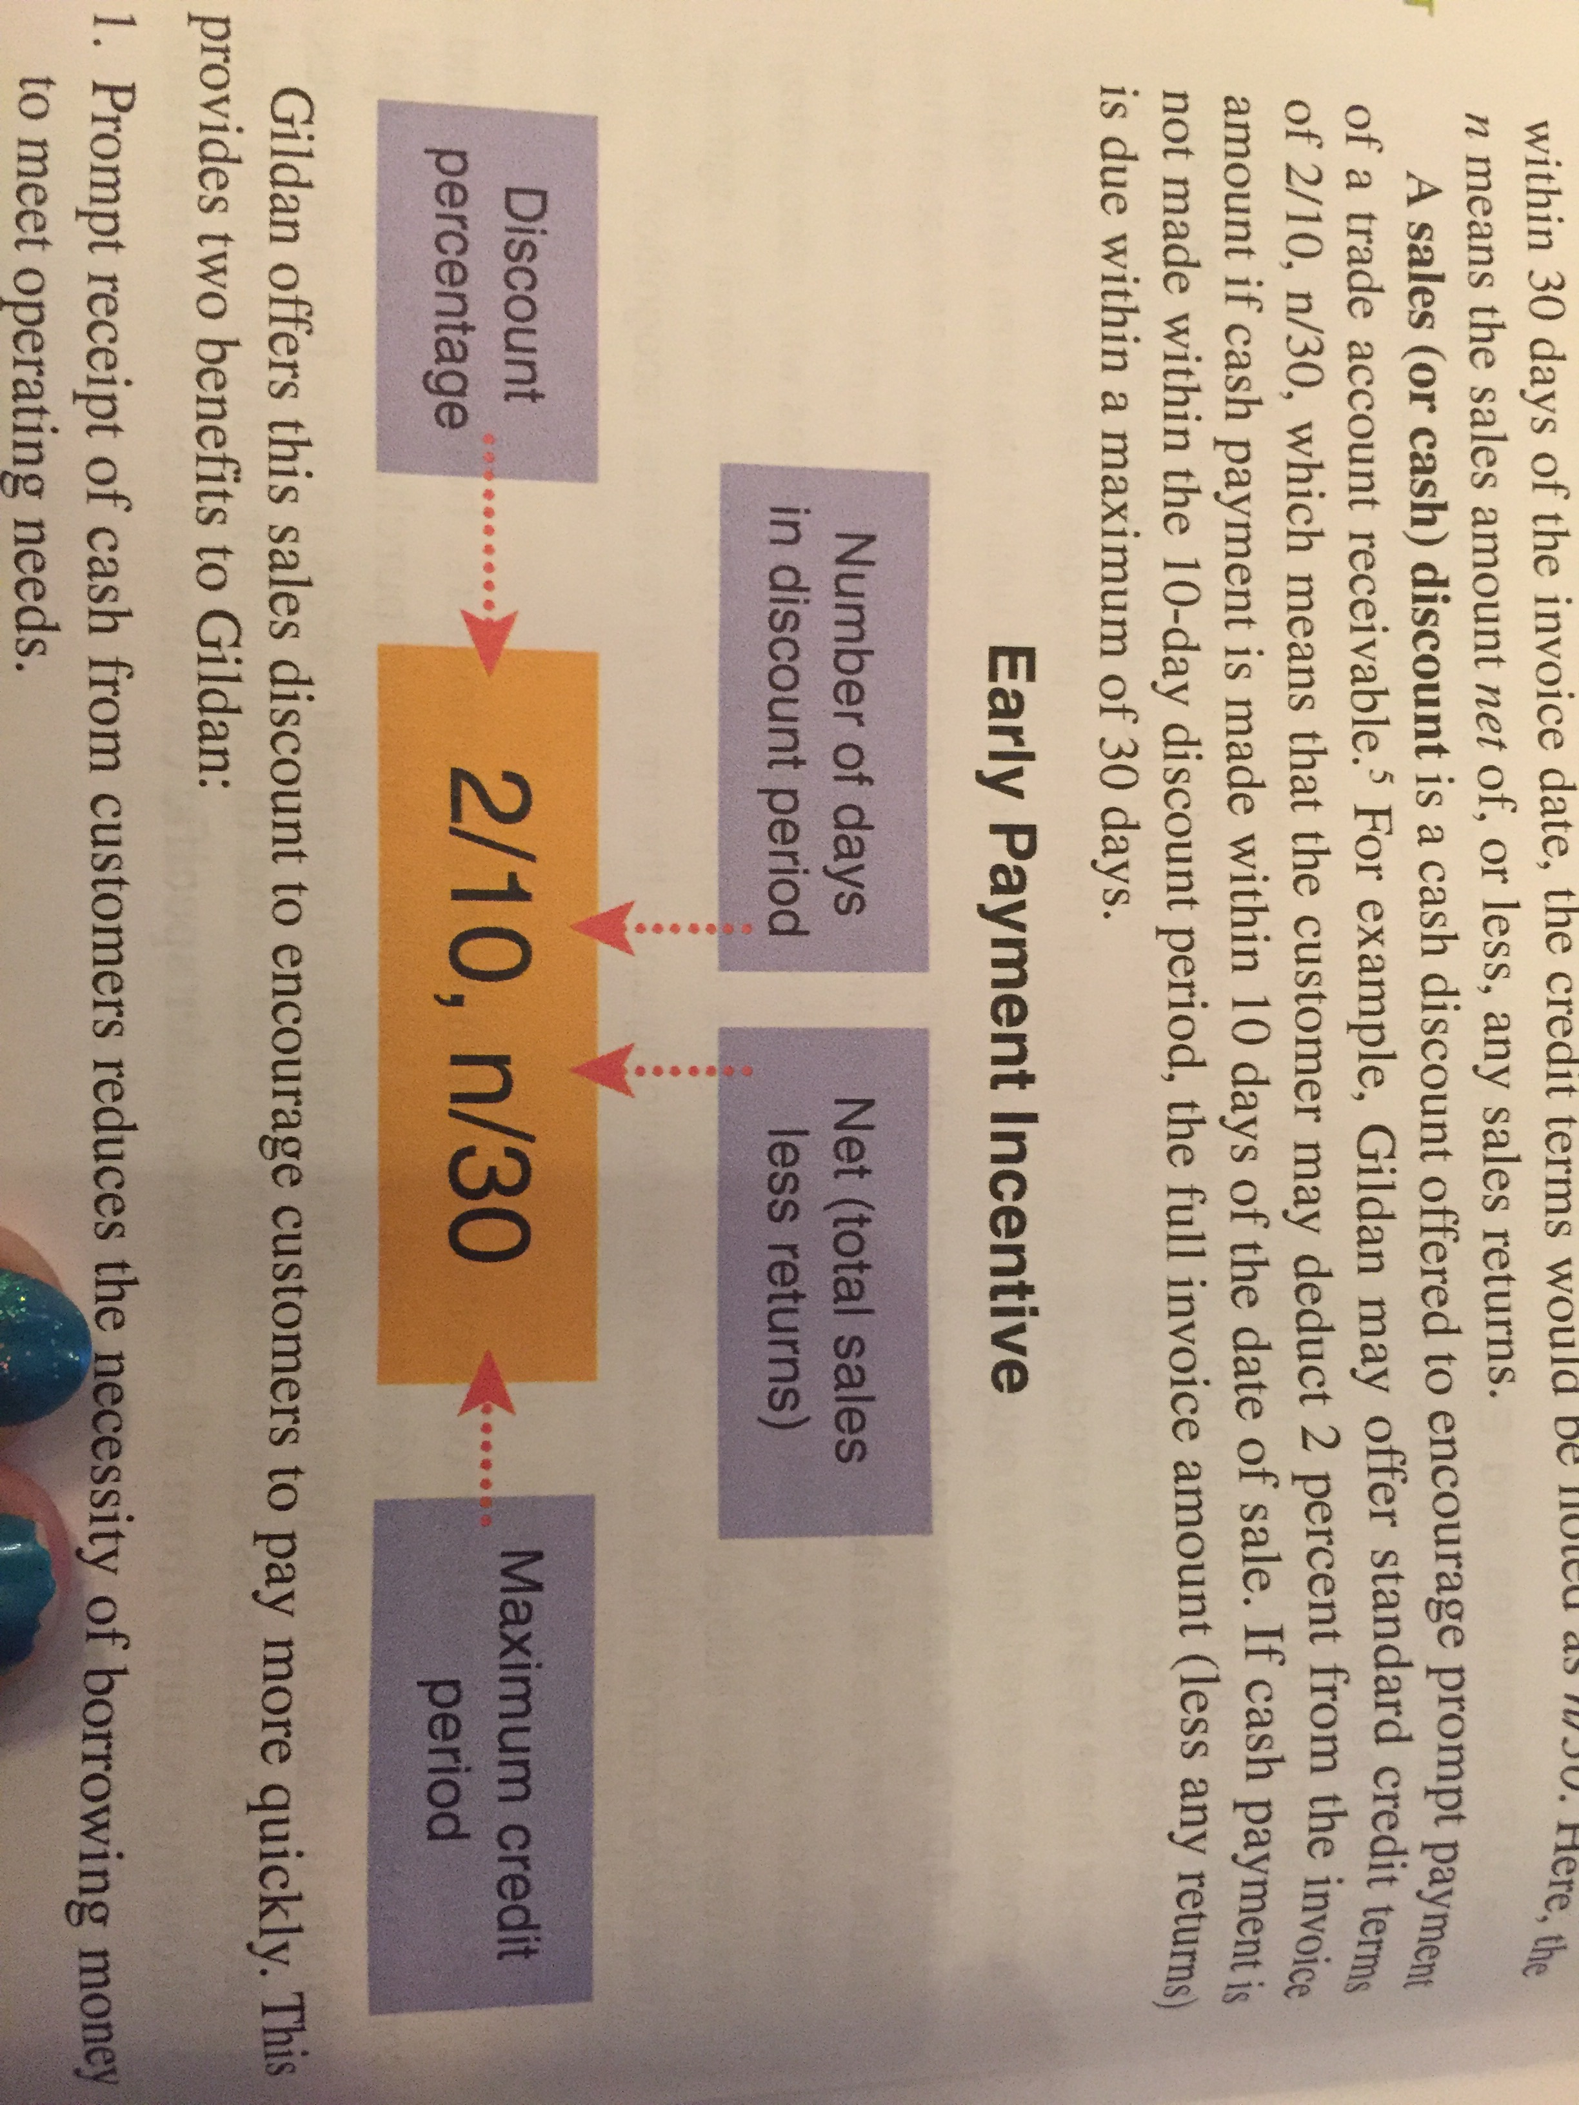

- Prompt receipt of cash from customers reduces necessity of borrowing money to meet operating needs
- Customers tend to pay invoices providing discount first decreases likelihood customer will run out of funds before invoice is paid

Sales Revenue
Less: sales discounts
= net sales
  - Sales Returns and Allowances:
Reduction of gross sales revenues for return of or allowances for unsatisfactory goods
Accumulated in separate account

Sales revenue
Less: sales returns
= net sales

  - Reporting Net Sales:
Sales revenue
Less: Credit card discounts
Sales discounts
Sales returns and allowances
= Net sales

- Gross Profit Percentage: **ratio
How effective is management at selling goods and services for more than the costs to purchase or produce them?

$$Gross profit percentage= \frac{Gross Profit}{Net Sales}$$

Interpretations:
Measures how much gross profit is generated from every sales dollar
Reflects ability to charge premium prices and produce goods and services at low cost
Higher gross profit = higher net earnings
Affected by business strategy

- Measuring and Reporting Receivables:
  - Classifying Receivables:
Trade receivables: open accounts owed to business by trade customers – when sale is on credit
Non-trade receivables: arise from transaction other than normal sale of merchandise or service

Account receivables: when sale of products on account or when company expects to receive payments from other parties
Note receivables: written promise that requires another party to pay business under specific conditions – specific amount = principal, at definite future date = maturity date, at specific amount of interest

Current receivables
Non-current receivables

  - Accounting for Bad Debts:
Credit policies based on trade-off between profit on additional sales and any additional bad debts
Changes in accounts of individual customers are recorded in subsidiary ledger
Bad debt must be recorded in same accounting as one when sales are made allowance method: bases bad debt expense on a estimate of uncollectible accounts
- Estimate & record bad debts expense
- Writing off specific accounts determined to be uncollectible during period

- Recording Bad Debt Expense Estimate:
Or doubtful account: expense associated with estimated uncollectible trade receivables
Recorded through adjusting entry
Decreases NE and SE
Debit bad debt expense – credit allowance for doubtful accounts (contra-asset) = subtracted from balance of asset Trade Receivables

- Impaired Receivables – Writing Off Specific Uncollectible Accounts:
When determined customer will not pay = impaired
Record AJE
Debit allowance for doubtful account – credit trade receivables

- Recovery of Accounts Previously Written Off:
Debit trade receivables – credit allowance for doubtful accounts
Debit cash – credit trade receivables
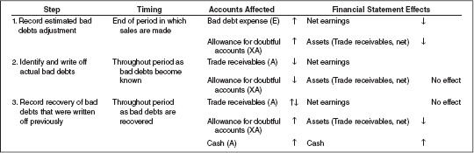

  - Estimating bad debts:

- Aging of Trade Receivables Method:
Estimates uncollectible accounts based on the age of each trade receivable
As TR become old and overdue – less likely to be collectible
Total amounts estimated to be uncollectible = balance that should be in the allowance for doubtful accounts at end of period estimated ending balance

- Actual Write-Offs Compared with Estimates:
Amount of uncollectible accounts actually written off rarely equal estimated amount recorded

- Prudence in the Valuation of Trade Receivables:
Prefer that companies follow financial strategies that result in reporting lower amounts for net earnings and assets and higher for liabilities

  - Internal Control and Management Responsibility:
Internal control: process by which company BoD, management, and other personnel provide reasonable assurance regarding the reliability of company’s financial reporting, the effectiveness and efficiency of its operations, and its compliance with applicable laws and regulations
Prevents inadvertent errors + removes opportunities to steal, misrepresent, defraud, embezzle

  - Control over Trade Receivables:
Minimize bad debts:
- Require approval of customers’ credit history by a person independent of sales and collection functions
- Monitor age of TR periodically – contact customers with overdue payments
- Reward both sales & collection personnel for speedy collection – work as a team

- Receivables Turnover Ratio:
How effective are credit granting and collection activities?

$$Receivables Turnover Ratio=\frac{Net Credit Sales}{Average Net Trade Receivables}$$

Interpretation:
Reflects how many times average trade accounts receivable are recorded and collected during period
Higher ratio = faster collection of receivables
Benefits company – can invest cash collected to earn interest income or reduce borrowings \

$$Average collection period= \frac{365}{receivables turnover }$$

- Reporting and Safeguarding Cash:
  - Cash and Cash Equivalents Defined:
Cash: money or any instrument that banks will accept for deposit and immediate credit to company’s account (cheque, money order, bank draft)

Cash equivalents: short-term, highly liquid investments that are readily convertible to known amounts of cash and that are subject to an insignificant risk of change in value (bank certificate of deposit, treasury bills)

  - Cash Management:
- Protecting cash from theft, fraud, loss
- Accurate accounting
- Controls to ensure enough cash is on hand to meet current operating needs, maturing liabilities and unexpected emergencies
- Prevention of accumulation of excess amounts of idle cash
  - Internal Control of Cash:
- Separation of duties related to cash handling and recordkeeping:
  - Complete separation of tasks of receiving cash and disbursing cash
  - Complete separation of procedures of accounting for cash receipts and cash disbursements
  - Complete separation of the physical handling of cash and all phases of accounting function
Deters theft – collusion needed

- Prescribed policies and procedures:
Work done by one = compared with results reported by other

  - Reconciliation of the Cash Accounts and the Bank Statements:
- Content of a Bank Statement:
Monthly report from bank
- Each deposit recorded by bank during period
- Each cheque cleared by bank during period
- Other debits and credits
- Running balance of company’s account
- Bank charges and deductions

- Need for Reconciliation:
Bank reconciliation: process of verifying accuracy of both bank statement and cash accounts of a business
Completed for each separate account at end of each month
Usually bank statement ≠ ending cash balance in cash ledger
- Bank service charges (not recorded in books)
- NSF cheques (must be deducted from company’s cash and recorded as receivable)
- Interest (paid by bank to company)
- Deposit in transit
- Outstanding cheques
- Errors

- 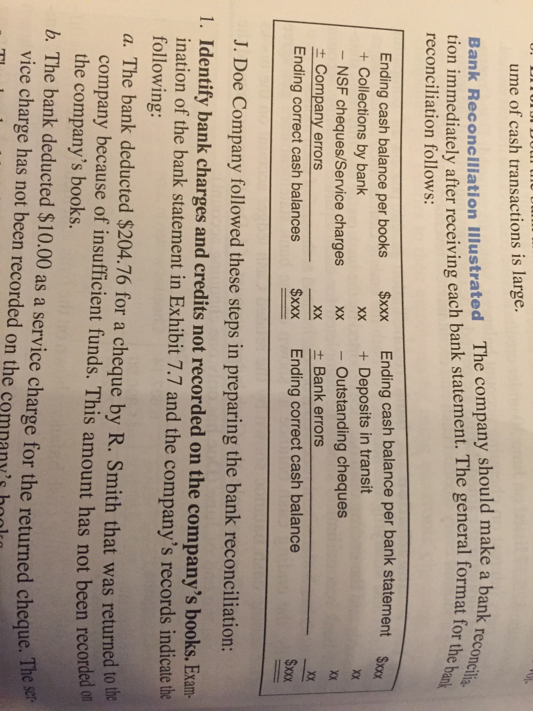Bank Reconciliation Illustrated:

- Identify bank charges and credits not recorded in company’s books
- Identify deposits in transit
- Identify outstanding cheques
- Determine impact of errors
Objectives of bank reconciliation:
- Check accuracy of bank balance and company cash records
- Identifies any previously unrecorded transaction or changes that are necessary to cause the company’s Cash accounts to show the correct cash balances journal entries

Chapter 8
Reporting and Interpreting Cost of Sales and Inventory

- Nature of Inventory and Cost of Sales
  - Items Included in Inventory:
Inventory: tangible property held for sale in the normal course of business or used in producing goods or services for sale – reported as current asset

Merchandisers = do not manufacture – simply purchase and sell to customers
- Merchandise inventory (goods held for resale in ordinary course of business)

Manufacturing businesses
- Raw materials inventory (items acquired for purpose of processing into finished goods)
- Work-in-process inventory (goods in the process of being manufactured)
- Finished goods inventory (manufactured foods that are complete and available for sale)

  - Costs Included in Inventory Purchases:
Cost principle
Included sum of the applicable expenditures and charges directly/indirectly incurred in bringing an article to a usable or saleable condition

  - Flow of Inventory Costs:

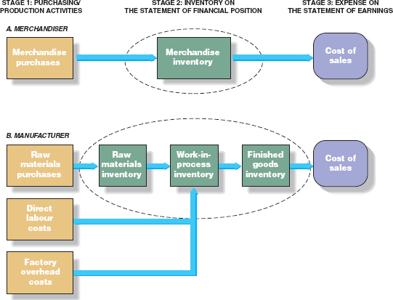

Direct labour: earnings of employees who work directly in products being manufactured
Factory overhead costs: includes manufacturing costs that are not raw material or direct labour costs

  - Nature of Cost of Sales:
COS = number of units sold * unit cost
Beginning inventory (BI)
New purchases (P)
Cost of goods available for sale = BI + P
Ending inventory (EI): what remains unsold at end of period

Cost of sales equation = BI + P – EI
Beginning inventory
Add: Purchases of merchandise during year
Cost of goods available for sale
Deduct: ending inventory
Cost of sales

- Control of Inventory:
  - Internal Control of Inventory:
- Separation of responsibilities for inventory accounting and physical handling of inventory
- Storage in a manner that protects from theft and damage
- Limiting access to authorized employees
- Maintaining perpetual inventory records
- Comparing perpetual records to periodic physical counts

  - Perpetual & Periodic Inventory Systems:
- Perpetual Inventory System:
Detailed inventory record is maintained
Units & costs of BI
Units & costs of each purchase
Units & costs of goods for each sale
Units & costs of goods on hand at any point in time

Transaction-by-transaction basis
When each sale is recorded – cost of sale entry is made (decreasing inventory + recording COS)

- Periodic Inventory System:
EI & COS are determined at end of accounting period – based on physical count
Inventory purchases = debited in temporary account purchases
Revenues = recorded at time of each sale
COS not recorded until inventory count is completed
- Perpetual Inventory Records in Practice:
Decisions to use perpetual or periodic = management’s need for timely info

  - Errors in Measuring Ending Inventory:
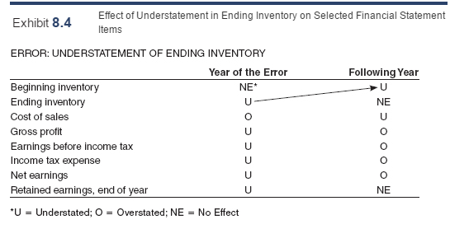
Measurement of EI affects net earnings for that period + next one

- Inventory Costing Methods:
Different ways to assign total COG available for sales between EI and COS
Select method that provides best correspondence between expenses and revenues

  - Specific Identification Method:
Identifies cost of specific item that was sold
Impractical when large quantities of similar items in stock (also prohibited by IFRS when inventory items are interchangeable)
Appropriate when dealing with very expensive items
Keep track of purchase cost of items (RFID)
- Coding purchase cost on each unit before placing in stock
- Keeping separate record of unit & identify with serial number

  - Cost Flow Assumptions (2):
NOT based on physical flow
FIFO or weighted average

  - First-In, First-Out Method:
First units in = first units sold, last goods purchased remain in inventory
Allocates oldest unit costs to COS & newest unit costs to EI

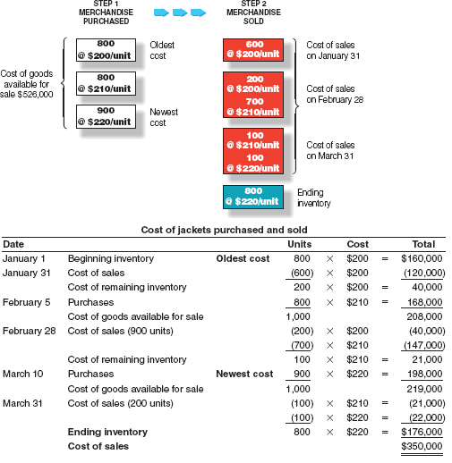
- Perpetual Inventory System:

- Periodic Inventory System:
COS and cost of EI = computed at end of period total same as perpetual system
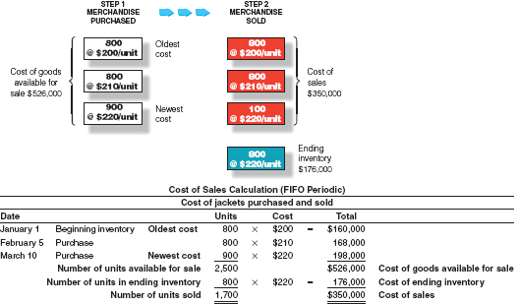

Perpetual | Periodic
Beginning inventory  + Purchases for period (accumulated in Inventory account)  = cost of goods available for sale  - COS (measured at every sale, perpetual record)  = ending inventory (perpetual record, updated every sale) | Beginning inventory  + purchases for the period (accumulated in purchases account)  = cost of goods available for sale  - ending inventory (measured end of period, physical count)  = COS (computed as residual amount)

  - Weighted-Average Cost Method:

- Perpetual Inventory System:
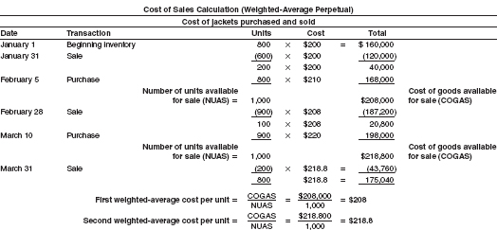
- Periodic Inventory System:
Average cost = cost of goods available for sale / total units available
Periodic COS always higher in period of rising prices
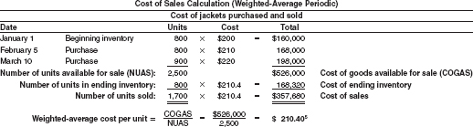

  - Financial Statement Effects of Inventory Costing Methods:
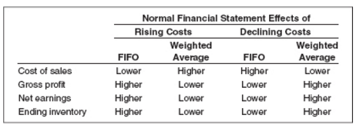

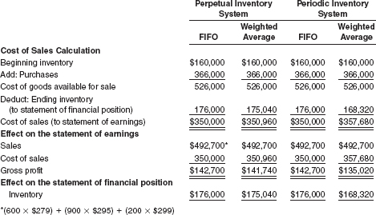

Weighted-average – newer unit costs are reflected in COS on statement of earnings
FIFO causes older units to be reflected in COS on statement of earnings
Weighted-average – ending inventory (financial position) reflects mix of unit costs (may be unrealistic)
FIFO – ending inventory based on newest costs

- Consistency in Use of Inventory Costing Methods:
Companies expected to select most representationally faithful method
Not required to use same inventory method for all items

  - Manager’s Choice of Inventory Costing Methods:
- Effect on net earnings prefer to report higher earnings for company
- Effect on income taxes pay least amount of taxes allowed, as late as possible
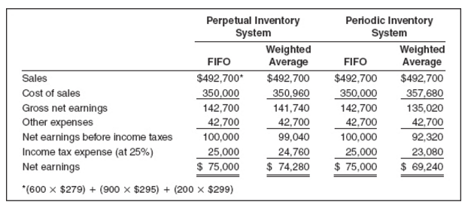
Can use different inventory method for financial reporting and tax reporting

Reporting method also affects calculation of several ratios

- Valuation at Lower of Cost and Net Realizable Value:
Inventories should be measured at acquisition cost cost may not be recoverable if selling prices declined, if damaged or if they have become obsolete lower amount should be used (reporting of inventory values don’t exceed amount that can be obtained from selling inventory)

Net realizable value = expected sales price – estimated selling costs
Lowe of cost and net realizable value (LCNRV): serves to recognize a loss when net realizable value drops below cost in the period
Loss = difference between purchase cost and net realizable value added to COS for the period

Particularly important for high-tech companies + seasonal goods
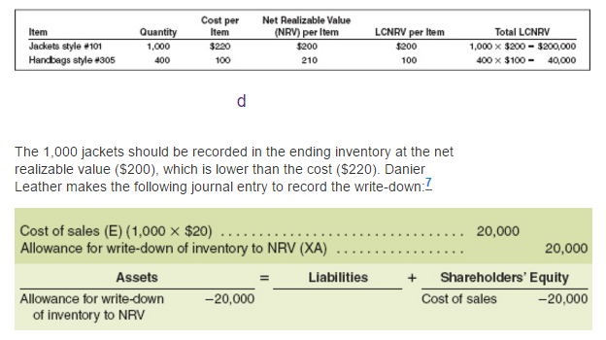

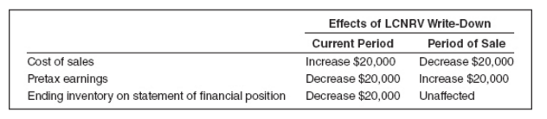

LCNRV accounts for added expense in current period, not period of sale
If net realizable value of inventory items that were written down increases subsequent accounting period amount of write-down is reversed to original cost – new carrying amount of the inventory is the lower of the cost and the revised net realizable value

- Evaluating Inventory Management:
  - Measuring Efficiency in Inventory Management:
Goals = have sufficient quantities of high-quality inventory available to customers + minimizing costs of carrying inventory (production, storage, obsolescence, financing)

INVENTORY TURNOVER RATIO
How efficient are inventory management activities?

$$Inventory turnover ratio= \frac{Cost of sales}{Average inventory*}$$

*$average inventory= \frac{beginning inventory+ending inventory}{2}$

- Interpretation:
Reflects how many times average inventory was produced and sold during period
Higher ratio = inventory moves quickly = reduce storage and obsolescence cost less money tied up in inventory excess invested to earn interest income or reduce borrowings = reduces interest expense

$$Average days to sell inventory= \frac{365}{Inventory turnover ratio}$$

  - Inventory and Cash Flows:
Increases in demand expand production increases amount of inventory on statement of financial position
Overestimate demand = produce too many units increase storage costs + interest costs on short-term borrowings that finance inventory

** Statement of cash flow
Reflects cash payments to suppliers
COS = more or less than amount paid
Buying inventory eventually decreases cash (Vice-versa)
Borrowing from suppliers increases trade payables = increases cash

- Decrease in inventory = COS exceeded cost of goods purchased decrease added to net earnings
- Increase in inventory = cost of goods purchased exceeded COS increase subtracted from net earnings
- Decrease in trade payables = payment to suppliers exceeded cost of goods purchased decrease subtracted from net earnings
- Increase in trade payables = cost of goods purchased exceeded payments to suppliers increase added to net earnings

- Additional Issues in Measuring Purchases:
  - Purchase Returns and Allowances:
Purchaser receives cash refund or reduction in the liability to the vendor
Trade payables ……. Debit
Inventory …….. Credit

Purchase returns and allowances = reduction in cost of purchases associated with unsatisfactory goods

  - Purchase Discounts:
Cash discount received for prompt payment of an account
Date of purchase
Inventory …. Debit
Trade payables …. Credit

Date of payment (within discount period)
Trade payables …. Debit
Inventory…. Credit
Cash…. Credit

Chapter 6
Communicating and Interpreting Accounting Information

When corporations offer shares to the public = gain access to capital markets provide corporations with funds necessary to pursue strategies such as expansion

Corporate governance: procedures designed to ensure that the company is managed in the interests of shareholders
- Players in the Accounting Communication Process
  - Regulators (CSA, AcSB, AASB, Stock Exchange):
Canadian Securities Administrators (CSA) = harmonize regulation of Canadian capital market protect investors from unfair, improper, or fraudulent practices + foster fair, efficient & vibrant capital market

Accounting Standards Board (AcSB) = responsible for establishing standards of accounting and reporting by Canadian companies

External auditors ensure companies prepare financial reports in accordance with standards guided by International Standards on Auditing = adopted by Canadian Auditing and Assurance Standards Board (AASB)

Stock exchange = quality assurance service by undertaking ongoing surveillance of reporting and trading activities
Suspect non-compliance Canada Revenue Agency (CRA) or RCMP

  - Managers (CEO, CFO, and Accounting Staff)
Personally certify the following on annual basis:
- Based on his or her knowledge, having exercised reasonable diligence, the annual filings do not contain any untrue statement of a material fact or omit to state a material fact, and the annual financial information together with other financial information included in the annual filings fairly presents, in all material respects, the financial condition, financial performance, and cash flows of the company.
- They have disclosed to the auditors and the audit committee of the board all significant deficiencies and material weaknesses in the design or operation of internal controls over financial reporting that are reasonably likely to adversely affect the company’s ability to record, process, summarize, and report financial information.
- They have disclosed to the auditors, the board, and the audit committee of the board any fraud involving management or other employees who have a significant role in the company’s internal control over financial reporting.

  - Board of Directors (Audit Committee):
Elected by shareholders to represent their interests – responsible for maintaining integrity of company’s financial reports
Audit committee of board = composed of non-management directors w/ financial literacy

  - Auditors:
Provincial securities commissions require publicly traded companies to have statements audited by professional independent accountants
Unqualified (clean) audit opinion: auditors’ declaration that financial statements are fair presentations in all material respects in conformity with IFRS

  - Information Intermediaries: Analysts and Information Services:

- Financial Analysts:
Receive accounting reports + other info about company form electronic info services + gather info through conversations with company executives & visits of company faculties
Analysts’ reports = forecasts of share price + future quarterly & annual EPS + buy/hold/sell recommendation for company shares + explanations earnings forecast (predictions of earnings for future accounting periods)

- Information Services:
System for Electronic Document Analysis and Retrieval (SEDAR) = official site for filing of documents by public companies
Lexis-Nexis, S&P Capital IQ, Westlaw Business, CanWest Interactive Inc, Factivia, Bloomberg, reuters, hoovers,

  - Users: Institutional & Private Investors, Creditors, and Others:
Institutional investors: managers of pension funds, mutual funds, endowment funds, and other funds that invest on behalf of others control majority of publicly traded shares of Canadian companies

Private investors: individuals who purchase shares in companies

Lenders/creditors: suppliers and financial institutions that lend money to companies

- The Disclosure Process:

  - Press Releases:
Written public news announcement normally distributed to major news services provide timely info to external users
Many companies follow press releases with a webcast conference senior manager presents results and answer questions from analysts

  - Annual Reports:
Annual reports of public companies = more complicated additional reporting requirements imposed + many companies use reports as PR tools
Split into 2 sections
Non-financial
- Letter to shareholders
- Descriptions of company’s management philosophy, products, successes, exciting prospects & challenges
Financial:
- Summarized financial data
- Management’s discussion & analysis (financial condition & results of operations) – MD&A
- Basic financial statements
- Notes
- Report of independent accountants (auditor’s opinion) + management report

  - Quarterly Reports:
Short letter to shareholders + condensed statement of earnings (unaudited) + condensed statement of financial position (unaudited)

  - Reports to Securities Commissions:
annual report
+ quarterly reports
+ annual information form (more-detailed description of business = corporate structure, industry, products & services, product & project development, sales & marketing, manufacturing, competition + list of properties owned + significant contracts)
+ information circular (legal doc forwarded to shareholders prior to annual general of special meeting)

  - Guiding Principles for Communicating Useful Information:
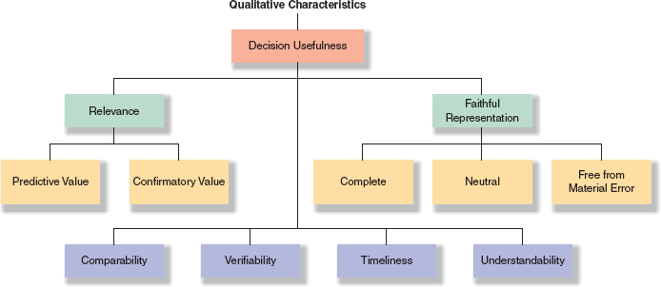

- Relevance:
Can influence users’ decisions by helping them assess the economic effect of past activities and/or predict future events

- Faithful representation:
Info provided must reflect substance of the underlying transactions
Complete, neutral (free from bias in measurement & presentation), free from material error

- Comparability:
Enhanced when similar accounting methods have been applied
Enables users to identify similarities and discrepancies

- Verifiability:
If independent accountants can agree on nature & amount of transaction

- Timeliness:
Enhances predictive and confirmatory value

- Understandability:
Quality of information that enables users to comprehend its meaning

  - Constraints of Accounting Measurement:

- Cost constraint:
Information should be produced only if the perceived benefits of increased decision usefulness exceed the expected costs of providing that info

- Prudence:
Care should be taken not to overstate assets & revenues or understate liabilities & expenses

- A Closer Look at Financial Statements:

- Financial Position

Assets
Current assets
Non-current assets
Total assets
Liabilities
Current liabilities
Non-current liabilities
Total liabilities
Shareholders’ equity
Contributed capital
Retained earnings
Accumulated other comprehensive income
Total SE
Total L + SE

- Earnings:
Net sales
- Cost of sales
= Gross profits
- Operating expenses
= Earnings from operations
+/- Non-operating revenues/expenses and gains/losses
= earnings before income taxes
- income tax expense
= Earnings from continuing operations
+/- earnings/loss from discontinued operations
= Net earnings

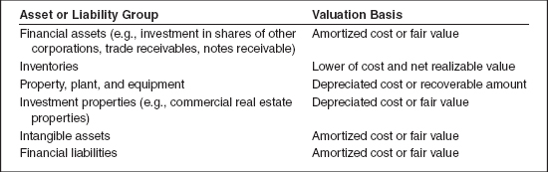

- Comprehensive income:
Additional components of income reflect financial effect of events that cause changes in SE, other than investment by shareholders or distributions to shareholders (include unrealized gains and losses)

- Changes in Equity:
Issuance of shares, repurchase of shares, declaration of dividends
+ net earnings or loss company realized from operating, investing & financing
+ adjustments to asset and liabilities values that are not reflected in net earnings or loss

- Cash Flows:
- From operating activities
- From investing activities = purchase and sale of productive assets (other than inventory) + investments in other companies
- From financing activities (through borrowing & repaying loans + issuances and repurchases of shares + dividends payments)

- A Closer Look at Notes:
Additional details
- Accounting policies applied to company’s statements:
- Additional Detail Supporting Reported Amounts:
Ex: revenues broken down by geographic region, describe unusual transactions

- Relevant financial information not disclosed on the statements:
Info on legal matters

RATIOS

- Current Ratio:
A company has liquidity if it has the ability to pay its current obligations

“Does the company currently have resources to pay its short-term debt?”
Current ratio = indicator of the amount of current assets available to satisfy current liabilities

$$Current ratio=\frac{Current Assets}{Current Liabilities}$$

Interpretations:
Measure ability to pay short-term obligations with short-term assets
The higher the ratio, the more cushion a company has to pay its current obligations guideline = ratio between 1.0 and 2.0
Too high = inefficient use of resources

May be misleading if significant funds are tied up in assets that are not easily converted into cash

- Total Asset Turnover Ratio:

“How effective is management at generating sales from assets (resources)?”

$$Total asset turnover ratio= \frac{Sales revenues}{Average Total Assets}$$

$$Average total assets=\frac{beginning TA+ending TA}{2}$$

Interpretation:
Measures sales generated per dollar of assets
High = efficient management of assets
Company’s products + business strategy contribute significantly to ratio strong financial performance improves ratio

- Return on Assets
“How well has management used the total invested capital provided by debtholders and shareholders during period?”

$$ROA= \frac{Net earnings+interest expense (net of tax)}{Average TA}$$

Interpretations:
Measures how much the firm earned from use of its assets
Allows investors to compare management’s investment performance against alternative investment options

- Net Profit Margin Ratio
“How effective is management at controlling revenues and expenses to generate more earnings?”

$$Net profit margin ratio= \frac{Net earnings}{Net sales (operating revenues)}$$

$$Net sales=sales revenue-returns and other deductions$$

Interpretation:
How much profit is earned as % of revenues generated during period
Rising = more efficient management

- Return on Equity
How well management used shareholder investment to generate net earnings during period?

$$ROE=\frac{net earnings }{Average shareholders^{'}equity }$$

$$Average shareholder equity=\frac{beginning SE-ending SE}{2}$$

Interpretation:
Measure how much firm earned as a % of shareholders’ investment
Firms with higher ROE = expected to have higher share prices
Assess effectiveness of company’s overall business strategy

- Inventory Turnover Ratio
“How efficient are inventory management activities?”

$$Inventory turnover ratio= \frac{Cost of sales}{Average inventory*}$$

*$average inventory= \frac{beginning inventory+ending inventory}{2}$

Interpretation:
Reflects how many times average inventory was produced and sold during period
Higher ratio = inventory moves quickly = reduce storage and obsolescence cost less money tied up in inventory excess invested to earn interest income or reduce borrowings = reduces interest expense

$$Average days to sell inventory= \frac{365}{Inventory turnover ratio}$$

Chapter 9
Reporting and Interpreting Property, Plant, and Equipment; Natural Resources; and Intangibles

- Acquisition and Maintenance of Property, Plant, and Equipment:

  - Classification of Long-Lived Assets:
Long-lived (or long term) assets (or capital): tangible or intangible resources owned by a business and used in its operations to produce benefits over several years (production, rental, administrative purposes, development, construction, maintenance, repair)

      - TANGIBLE ASSETS (fixed): have physical substance – property, plant and equipment
        - Land: Never depreciate – but may be impaired
        - Building, fixtures, and equipment:
        - Biological assets: Living animals or plants
        - Natural resources

      - INTANGIBLE ASSETS: no physical substance – often arise from intellectual effort = intellectual property (copyrights, patents, trademarks, software, franchise, subscription lists)

  - Measuring and Recording Acquisition Cost:
Cost principle: all reasonable & necessary costs incurred in acquiring a long-lived asset (placing it in operational setting + preparing it for use) = recorded in designated asset account costs are capitalized = when recorded as assets instead of expenses added to purchase price

When purchasing land, incidental costs (title fees, sales commission, legal fees, title insurance, delinquent taxes, surveying fees) = included in cost

Acquisition cost = net cash amount paid or fair market value of asset given or received (cash-equivalent price)

  - Various Acquisition Methods:

- For cash:
J/E
Asset xxx
Cash xxx

- For Debt:
J/E
Asset xxx
Note payable xxx

- For Equity (or Other Non-Cash Consideration):
Non-cash consideration (common shares or given right by company to seller to purchase company goods and services at special price) cash-equivalent cost or fair market value determined

J/E
Asset xxx
Cash xxx
Common shares xxx

- By Construction:
Self-constructed asset direct and indirect costs of constructions (including interest on loans) when asset available for use, accumulated construction cost depreciated over productive life

Capitalized interest: interest on borrowed funds directly attributable to construction until asset is ready for intended use

- As a Basket Purchase of Assets:
Basket purchase: acquisition of two or more assets in a single transaction for a single lump sum
Cost of each asset must be measured and recorded separately – use current market value

  - Repairs, Maintenance, and Betterments:
Expenditures = payment of money to acquire goods or services – recorded as assets or expenses

- Ordinary Repairs and Maintenance or Revenue Expenditures:
Maintain productive capacity or asset during current accounting period – normal maintenance or upkeep recurring in nature, small amounts
Cash outlays = expenses

- Extraordinary Repairs or Betterments:
Infrequent expenditures that increase the asset’s economic usefulness in the future
Capital expenditures: increase productive life, operating efficiency, or capacity of asset and are recorded as increases in asset accounts, not expenses

- Use, Impairment, and Disposal of Property, Plant and Equipment:

  - Depreciation Concepts:
Depreciation: process of allocating the acquisition cost of buildings and equipment over their useful lives by using a systematic and rational method

Depreciation expense xxx
Accumulated depreciation xxx

Carrying amount (book value) = acquisition cost of asset – accumulated depreciation (and any write-downs in asset value)

$$Asset remaining useful life= \frac{Carrying amount }{Acquisition cost }*Estimated useful life$$

Depreciation expense = ESTIMATE

- Estimated Useful Life:
Estimate of asset’s useful economic life to the company
Conform to continuity assumption – business will continue to pursue commercial objectives & will not liquidate in foreseeable future

- Residual (or salvage) Value:
Estimated amount to be recovered, less disposal costs, at the end of estimated useful life of an asset

Componentization of assets

  - Alternative Depreciation Methods:
chosen method applied consistently over time to enhance comparability

- Straight-Line Method:
Equal portion of an asset’s depreciable cost is allocated to each accounting period over estimated useful life

$$\left(Depreciable Cost\right)*\left(Straight line rate\right)=depreciation expense$$

$$Depreciable cost=Cost-residual value$$

$$straight line rate=\frac{1}{useful life}$$

Depreciation expense = constant amount = fixed expense
Accumulated depreciation increases equal amount each year
Carrying amount decreases by same amount each year until = estimated residual value

- Units-Of-Production (Activity) Method:
Allocates the cost of an asset over its useful life based on relation of its periodic output to its total estimated output

$$\left(Depreciation rate per unit\right)*\left(actual production\right)=Depreciation expense$$

$$Depreciation rate per unit= \frac{\left(Cost-Residual Value\right)}{Estimated total production}$$

Depreciation expense = variable expense

- Declining-Balance Method:
(asset considered to be more efficient or productive in earlier years, levelling off in later years) – reflect sharper reduction in economic benefits (cash flow) expected to be derived from asset in earlier rather than later years = accelerated depreciation
Allocates cost of an asset over its useful life based on a multiple of the straight-line rate (often two times)

$$\left(Carrying amount\right)*\left(declining balance rate\right)=depreciation expense$$

$$Carrying amount=Cost-accumulated depreciation$$

$$Declining balance rate= \frac{2}{useful life }$$

**Half-year rule

- In Summary:
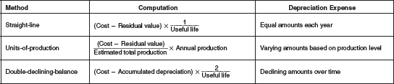

  - Changes in Depreciation Estimates:
Estimates may have to be revised to faithfully represent economic effect of using assets in operations
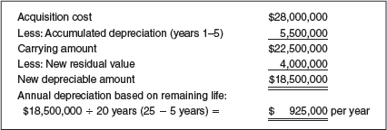

  - Manager’s Selection among Accounting Alternatives:

- Financial Reporting:
Select method that provides best matching of revenues and expenses
Benefits over time? Straight-line (most common method)
More revenue in early lives? Accelerated method

Decide if measure asset at historical cost (adjusted for depreciation) or revalue them to fair value at end of fiscal year – historical cost of an asset after 15-20 years = not relevant – inflation
Most company use cost method

- Tax Reporting:
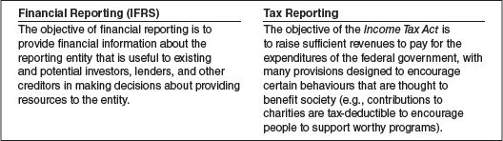

Income tax act: corporations can defer paying millions of dollars in taxes
Deferral of income tac to future years – in large due to differences between depreciation methods
Objective of domestic tac law = incentive for companies to invest in modern property, plant and equipment = retain global competitiveness

CCA schedules – calculate max annual expense used in computing taxable income according to tax rule and regulations – based on acceleration method – reduces taxable income more in early years

  - Measuring Asset Impairment:
Tangible and intangible assets
Long-lived asset = value in use: measured as the present value of future cash flows expected to be derived from the use of asset over time

Impairment: events or changed circumstances cause carrying amount of these assets to exceed their recoverable amount (=higher of its value in use and its fair value less costs to sell)

$$Carrying amount >recoverable amount,→asset impaired$$

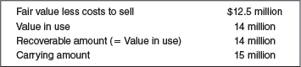 impaired 1 million $
Fair value determined based on quoted market prices, prices of similar assets for which recent transaction occurred, arm’s-length appraisal value, using specific valuation techniques

Impairment J/E
Loss due to impairment of assets xxx
Asset xxx

Asset impaired in previous period can be reversed

  - Disposal of Property, Plant and Equipment:
Voluntarily: sale, trade-in, retirement
Involuntarily: casualty (storm, fire, accident)

- Adjusting entry – update depreciation expense & acc dep
- Entry to record disposal – cost of asset + any acc dep at date must be removed from accounts
Gain/loss = revenue/expense from peripheral or incidental activities (from disposals) = difference between resources received and carrying amount
Sale
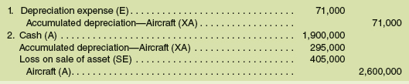

Trade-in
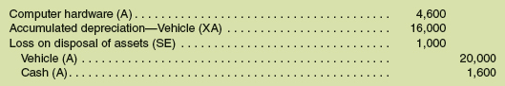

Retirement, same as trade-in but no effect in cash account = only a loss

- Natural Resources and Intangible Assets:

  - Acquisition and Depletion of Natural Resources:
Wasting assets – depleted (physically used up)
In Canada, companies that extract don’t own land – own rights = recorded in conformity with cost principle

Quantity of resources in reserve = carefully surveyed by sophisticated geological engineering methods initial reserve value depleted

Depletion: systematic and rational allocation of the cost of a natural resource over period of exploitation

Natural resource companies amortize the acquisition costs of intangible mineral rights – deplete their reserve values – depreciate exploration and development costs as well as self-constructed extraction facilities

Amount of natural resource depleted = capitalized as inventory (not expensed)
When inventory sold COS included as expense

$$Depletion rate=\frac{total acquisition \& development cost (-estimated residual value)}{estimated units that can be withdrawn economically from resource}$$

Depletion rate multiplied each period by actual number of units withdrawn

  - Acquisition and Amortization of Intangible Assets:
Intangible asset = has value b/c of certain rights & privileges conferred by law
Recorded at historical cost only if purchased
If developed internally – cost of development is normally recorded as an expense

- Definite Life:
Amortization: systematic and rational allocation of the acquisition cost of an intangible asset over its useful life

- Indefinite Life:
Not amortized
Tested annually for possible impairment – asset’s carrying amount decreased to its recoverable amount if impaired

  - Exampled of Intangible Assets:

- Goodwill:
Cost in excess of net assets acquired = excess of the purchase price of a business over the market value of its identifiable assets and liabilities
Customer confidence, reputation for quality product and services, financial standing

Goodwill = internally generated = not reported as asset (unless purchase another business)
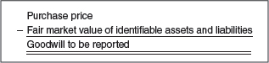

- Trademarks:
Exclusive legal right to use a special name, image or slogan
Renewed every 15 years throughout its life

Intangible assets not recorded unless purchased
Trademarks are developed = expense

- Patents:
Granted by federal government for an invention; exclusive right given to owner to use, manufacture, and sell the subject of the patent
For 20 years in Canada

Purchased patent = recorded at cost
Internally developed patent = recorded at registration and legal cost

- Copyrights:
Exclusive right to publish, use, and sell a literary musical, or artistic work – period not exceeding 50 years after author’s death

- Franchises:
Contractual right to sell certain products or services, use certain TM, or perform activities in a geographical region
Granted by a business or the govt

- Technology:
Include costs for computer software and Web development

- Licences and Operating Rights:
Obtained through agreements with governmental units and agencies, permit owners to use public property in performing their services

- Research and Development Expense – Not and Intangible Asset:
If intangible asset developed internally = cost of research recorded as expense
When company demonstrates that technical & commercial feasibility of resulting product or service = established development costs deferred or amortized over lifetime or commercialized product

- Leasehold:
Rights granted to a lessee under a lease contract
For a consideration called rent, the owner (lessor) extends to another party (lessee) certain rights to use specified property
*leasehold improvements – recorded as asset by lessee amortized over estimated useful life or related improvements or remaining life of lease

- Fixed Asset Turnover Ratio:
How effectively is management utilizing its property, plant and equipment to generate revenues?

$$Fixed Asset Turnover Ratio= \frac{Net Sales \left(operting revenues\right)}{Average net fixed assets}$$

Interpretation?
Measures sales dollars generated by each dollar of fixed asset used
High ratio = effective management

Chapter 10
Reporting and Interpreting Current Liabilities

Capital structure: mixture of debt and equity that finances the short- and long- term operating requirements of a company

- Liabilities Defined and Classified:
Liabilities: debts or obligations arising from past transactions that will be paid with assets or services
First recorded = measured in terms of current cash equivalent

Current liabilities: short-term obligations that will be paid within normal operating cycle or one year, whichever is longer
Liquidity: ability to pay current obligations
Usually grouped according to type of creditor

- Quick Ratio:
Does the company currently have resources to pay its short-term debt?
Quick assets = cash, short-term investments, net receivables

$$Quick ratio=\frac{Quick assets}{Current liabilities }$$

Interpretations?
High ratio suggests good liquidity – too high = inefficient use of resources

- Current Liabilities:

  - Trade Payables:
Inexpensive way to finance the purchase of inventory – interest doesn’t normally accrue

Trade Payables Turnover Ratio

How efficient is management at meeting its obligations to suppliers?
Measures how quickly management is paying trade creditors

$$Trade paybles turnover ratio= \frac{Cost of sales}{Average net trade payables}$$

$$Average age of payables= \frac{365}{average trade payables}$$

High = company paying suppliers timely manner

  - Accrued Liabilities:
Expenses that have been incurred but have not been paid at the end of the accounting period

- Income taxes payable:
Current (payable within prescribed time) and deferred portion (from differences between accounting rules for financial reporting and tax rules)

- Taxes Other than Income Taxes:
Required to collect and pay other types of taxes and fees
Add to cost of producing and selling – passed on to customers through higher sales prices (GST, PST, HST) – then remitted to federal and provincial govt

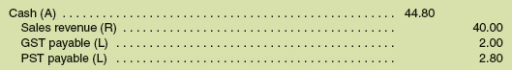
Unpaid amounts included at year-end included in CL

- Payroll Liabilities:
Unpaid salaries
Also report cost of unpaid benefits (retirement programs, vacation time, employment insurance, health insurance)
Remit income tax & other social benefit contributions on behalf of employees

- Employee Deduction:
Federal & provincial laws require employer to deduct appropriate amount of income tx each period from gross earnings of each employee
Amount of income tx = recorded as CL between date of deduction and date amount is remitted

Additional amount deducted = employment insurance (EI), Canada Pension Plan (CPP), Quebec Pension Plan (QPP)
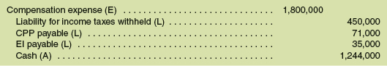

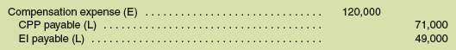

  - Notes Payable:
Borrow money to finance operations
Specifies amount borrowed, date by which it must be paid, interest rate associated

Time value of money: interest associated with use of money over time
Longer the borrowed money is held larger the dollar amount of interest expense
Borrower = interest is an expense
Creditor = interest is revenue
$$Interest=Principal*Annual Interest Rate*Time$$

Interest expense recorded when it is incurred

  - Current Portion of Long-Term Debt:
Provide accurate info concerning CL, company must reclassify long-term debt within a year of maturity date as CL

  - Deferred Revenues:
Revenues that have not been collected but not earned; they are liabilities until the g&s are provided

Gift cards/prepaid cards – amount perceived as liability until store delivers merchandise/service

  - Provisions Reported on the Statement of Financial Position:
Provision: liability of uncertain timing or amount
Recognized when:
- Entity has present obligations as result of past event
- Probable that cash or other assets will be required to settle obligation
- Reliable estimate can be made of the amount of the obligation
Warranty is an example
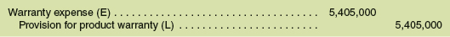
Utilization of warranty

Also made for legal and tax disputes that arise in ordinary course of business

- Contingent Liabilities and Commitments:
Contingent liability: possible liability that is created as a result of a past event; it is not an effective liability until some future event occurs
Ex: lawsuits, environmental problems, tax disputes
Depends on 2 factors:
- Probability of the future economic sacrifice
- Ability of management to estimate the amount of the liability reliably

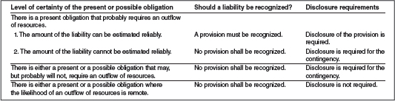

Commitments = contractual agreements to enter intro transactions with other parties

- Working Capital Management:
Working capital: difference between CA and CL – actively managed to achieve balance between costs and benefits

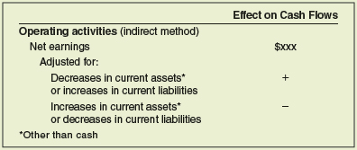

- Appendix 10A: Deferred Income Tax Assets and Liabilities:

Temporary differences of following types result in complex accounting – difference disappears in long run
- Product warranty costs recognized as liability & an expense for financial reporting purposes when products are sold – deductible for tax purposes only when payments under warranty made
- Long-lived assets: straight-line depreciation method for financial reporting purposes – accelerated depreciation method for tax purposes

Income tx expense is different from income tx payable recording economic liability = income tx currently payable, adjusted for effects of temporary differences = deferred income tx (can be both asset or liability)
Deferred income tx amount = settled when difference between CCA (Capital cost allowance) and depreciation expense reverses in the future

- Appendix 10B: Present Value Concepts:
Present value PV: current cash equivalent of an amount to be received in the future, or a future amount discounted for compound interest
* money received today is worth more than money to be received one year from today (b/c it can be used to earn interest)

Future value FV: sum to which an amount will increase as a result of compound interest

  - Present Value of a Single Amount:
Amount of cash you are willing to accept today in lieu of a cash receipt at some date in future

$$PV= \frac{1}{{\left(1+i\right)}^{n}}*Amount$$

  - Present Value of an Annuity:
Annuity: series of equal amounts of cash that are paid or received at equally distant points in time
- Equal dollar amount each interest period
- Interest periods of equal length
- Equal interest rate each interest period

- Interest Rates and Interest Periods:
When interest rates are less than a year, values of n and i must be restated

  - Accounting Application of Present Values:

See p. 561-563 for example

