Lecture 2
Tuesday, September 12, 2017
8:33 AM

  - DNA stores genetic information
  - Central dogma of molecular biology
  - Information is carried by the base sequence
  - Gene is the entire DNA sequence necessary for production of functional protein or RNA
    - Regulatory signals-sequences: Do not produce protein that’s not needed, waste of resources. Regulated for different cell types, development.
      - Some are use all the time, others in specific events
  - Replicates faithfully
  - Parental DNA separates -> templates for synthesis of new daughter strand by complementary base pairing
  - Replication is semiconservative (Stahl): One strand predicts the sequence of the other - Information is preserved
  - What happens if there is a mutation in ONE of the parental strands
    - The one strand dies, the other is able to continue replicating
  - Meselson and Stahl (1958) Thinking and planning:
    - If replication is:
    - Semisconservative: Each daughter duplex contains one old and one new strand
    - Conservative: Old duplex reassembled and new duplex composed of two new strands
    - Dispersive: Sections of the oldd duplex will be dispersed randomly to the two daughter duplexes
  - Has the ability to mutate
  - Alteration in protein product
  - Collinearity exists between DNA and mRNA
  - Mutation in regulatory sequences, What are possible consequences?
    - Constantly off or on; Waste of resources
  - Importance:
    - New alleles;
      - Altered product
      - No product
      - Altered regulation of expression
    - Drives evolution and selection

DNA and RNA Structure

Chemical Bonds
  - Covalent
    - Polar/nonpolar bonds -> Hydrogen bonding
    - Do not change in water: majority of cells already in water
  - Non Covalent
    - IONIC
      - Weak in water: Dissociates,
    - HYDROGEN BONDS
      - Partial positive with electronegative atom
      - Weak in water
      - But large amounts of water makes their strength
    - DNA: H-Bonds
      - G-T and A-C
    - Van der Waals Interactions
      - Formation of temporary dipoles -> systematic uniform distribution of charge
      - Works best when distance between atoms is equal
    - Hydrophobic Interactions
      - Entropy
  - Hydrogen bonds and Van derWaals interaction
    - Individually weak, together strong
  - Hydrophobic Interactions
    - Individually weak, but lots between molecules

Why do we talk about strength of water?
  - Cells contain ~70% water

Overview of Nucleic Acid Structure

Nitrogenous Bases
  - Purines: Adenine and Guanine (Contains Oxygen for h-bond)
  - Pyrimidine: Cytosine (amino group, deamination) and Thymine (Methyl group, demethylation and you get Uracil)
Ribose sugars
  - Ribose
  - 2-Deoxyribose (removal of oxygen on 2' C)
Phosphate
  - Attached to 5' end

Base + Sugar = Nucleoside + Phosphate = Nucleotide

The exact type of nucleotide is important
  - rNTP vs dNTP
  - rGTP vs dGTP
  - rCMP vs rCDP vs rCTP
  - In RNA vs DNA

Makeup of a polynucleotide chain
  - Repeating stucure
    - Nucleotide subunit
    - Sugar phosphate backbone
    - Nucleoside subunit
    - 5'-3' phosphodiester bonds
  - Beginning 5' to 3' end

Nucleotides have many functions
  - Informational molecules
    - Make polymers of DNA & RNA
  - High energy molecules
    - Provide energy for many cellular reactions - ATP
  - Coenzymes:
    - Cofactors for metabolic enzymes (ex CoA)
  - Regulatory Molecules
    - Cyclic AMP & GTP ( Signal transduction, protein synthesis)

Crick & Watson - 3D structure of DNA
  - DNA structure: Base vs. nucleoside vs. nucleotide
  - Chargaff's rule
  - #purines = # pyrimidines

Methods to Determine DNA structure
  - X-ray diffraction analysis
1953: They put together the puzzle
  - DNA is a aright handed double helix
  - Negatively charged backbones
  - Bases are parallel (0.34nm apart)
  - H-bonds
  - Purines pair with pyrimidine
  - A 2 hb with T, G 3 HB witch C
  - Antiparallel
  - Major groove and minor groove
  - One complete turn ever 10 nucleotides, or 3.4nm in length
  - Two chains are commentary (A to T, C to G)

Diameter of B-DNA is 20A: 2nm

The major and minor grooves
  - Is what different proteins are going to recognize what they are going to bind
  - Each nucleotide sequence "exposes" specific unique distribution of acceptors and donors
  - DNA binding proteins can differentiate A-T base airs from T-A base pairs if they bind from the major groove side, but not from the minor groove side
Right handed vs left handed DNA
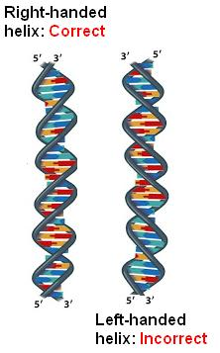

Forces that help form the DNA double helix
  - Rigid phosphate backbone: - charge
  - Ionic Interactions: salts (+ions) DNA shielding
  - Stacking interactions: Van der Waals interactions between bases (weak individually, but lots)
  - Hydrophobic interactions: High (-) phosphate backbone vs hydrophobic bases inside
  - H-Bonding: Complementary base pairing

Different forms of DNA
  - B-DNA
    - Approximately 10 base pairs per turn
    - Turn is every 3.4 nm
    - Bases are perpendicular to helix axes
    - Right Handed
    - Most of the in vivo DNA
  - A-DNA
    - 11pairs/turn
    - Turn every 2.8nm, right handed
    - Bases exhibit a tilt with respect to the helix axis (20 degrees)
    - In low water content
    - DNA-RNA and RNA-RNA helices in a test tube
    - A-like DNA found in dormant spores of Bacillus species

Non B-DNA conformations
  - Triplex (telomeres) , Z DNA

  - Z-DNA
    - Very High salt concentrations
    - First found in d(CG) polymers
    - 12 base pairs/turn
    - Turn every 4.5nm
    - Tilt 7 degrees
    - Left Handed
    - Role in regulation in gene expression: Discovery of proteins with Z-DNA binding domains
    - Z-DNA in promoter regions of some genes: REGULATION
    - Chromosomal breakages and large scale deletions/rearrangements
    - Transiently formed; repulsion of the negatively charge phosphate backbone sections in Z form which are much closer to each other than in B-DNA

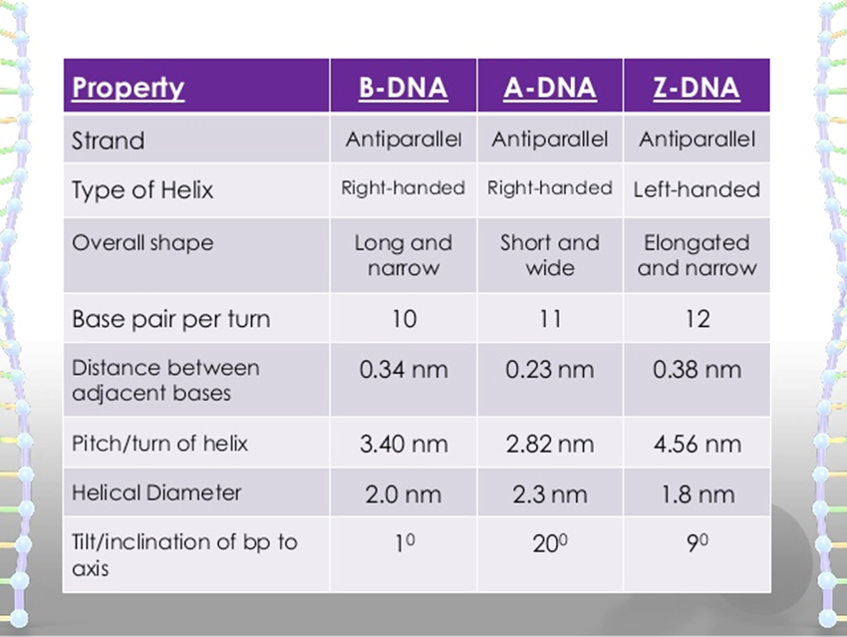

Triple-Helical DNA (H-DNA, H for hinge)
  - Formed when purines make one stand and pyrimidines the other
  - The third strand could be accommodated in the major groove
  - Gene expression
G-quadruplex
  - G-rich
  - Stacked planar G-tetrads, cyclically bound to each other through 8 h-bonds
  - G-rich sequences are frequently found in the promoter region of oncogenes in human telomeric DNA

Other unusual forms of DNA
  - Slipped or Cruciform structures
  - Consequences: Some information is skipped

Chromosomal DNA is a Dynamic Structure
  - Localized structural polymorphisms constantly occur.
  - Depend on:
    - Particular DNA sequence
    - Local Salt concentration
    - Presence/absence of specific proteins

  - Important because it can be recognized by certain proteins for regulation/repair or gene expression (transcription)

Denaturation of DNA
- What is denaturation?
  - Unwinding of double stranded dna
  - Important for RNA synthesis
  - Native state -> Single stranded denatured state -> Renatured state
    - Two sequences that are not complementary will not renature

- What is a hybrid molecule
  - Made of 2 different strands of DNA; different sources
- Recombination molecule
  - 2 double stranded DNA coming from 2 different sources

- Factors that denature DNA
  - Heat
    - Break hydrogen bonds
  - Low Ionic strength
    - Separates
    - Repulsion between negative phosphate backbones
  - Agents that enhance the solubility of hydrophobic substances
    - Organic solvents
  - Agents that influence H-Bonds
    - Competition (N-H and O=, urea and formamide)
    - Covalent modifications
      - Block formation of H bonds (Formaldehyde and glyoxal)
      - More permanent
  - High pH
    - Stripping of H+ shared between electronegative centers
Monitoring DNA denaturation
- Viscosity rarely used.. Too difficult
- Absorbance (A260 nm) commonly used (optical density)
  - dsDNA and ssDNA solutions have the same concentration t fin

How does absorption spectrophotometry work?
- Absorbance changes depending on whether the purines and pyrimidines are stacked
  - In double stranded DNA the bases are stacked and absorbance is reduced
  - In denatured single stranded DNA the bases are unstacked and absorbance is increased
- Hypochromic Effect:
  - Stacked bases have low absorbance
- Hyperchromic effect
  - Un-stacking of bases causes increase in absorbance

Denaturation and GC content
- More GC- higher Tm needed
- AT regions separate fisrt during denaturation
  - AT has 2 Hbonds compared to 3 in BC
- The Tm of DNA increases by 0.4C with every 1% increase in GC content under normal condition
- Higher salt will cause higher T_{M}
  - Preserves denaturation

Renaturation of DNA
- Renaturation and hybridization aren't always interchangeable
- Renaturation is the recombination of two complementary single stranded DNA
- Dependent on:
  - DNA concentration (chance to find pair)
  - Salt concentrations
    - + ions mask repulsion forces of -ve backbone
  - Temp (20-25 below Tm)
  - Reaction time
  - Size of DNA fragment (inversely proportional)
    - Larger the fragment, the harder to find a complimentary pair
  - Level of sequence complexity
    - Intrinsic characteristics of a DNA sequence (some faster than others)
    - Referring to the actual nucleotide sequence of the DNA
C₀t analysis
- Renaturation kinetics
- Rate of renaturation = measure of complexity of the DNA/genome
  - No
- Method: C_{o}t analysis
- C_{o} - starting concentration
- t - reaction time (seconds)
- C_{o}t_{1/2} - commonly used
- t_{1/2} - time needed for half of the DNA to get renatured

- Less complex sequences are repetitive sequences (renature quickly)
- More complex are unique (no repetition)
  - Units of complexity are measured in terms of # of nucleotides
- If a genome is all unique in sequence then
  - Complexity = # of nucleotides
- If a genome contains unique sequences and some repetitive sequences then:
  - Complexity = # of 'Unique' nucleotides + total # of nucleotides from one copy of each repetitive sequence
Examples
- ATATATATAT has a complexity of 2
- DNA composed of the repeating tetrameric sequence (ATGC)_{n} has a complexity of 4
- A DNA composed of 10⁵ nonrepeating nucleotide pairs in length has a complexity of 100 000

How is C_{o}t analysis carried out?
- Used to:
  - Explore genome structure in individual species
  - Look at genome similarities among organisms (evolution)
  - Evaluate diversity in ecological samples



- In general 3 types of sequences
  - Rapid, intermediate and slow
  - Highly repeated, moderately repeated, unique

Highly repetitive:
- 1000-1000000
- Find each other quick, fast renaturation
- Most located in centromere and telomere regions
Moderately repetitive
- 10-1000
- Little difficulty, need more time - middle renaturation
- Code for different protein families
  - Genes for Globin, immunoglobulin, histones, tRNAs and rRNAs
- Some are transposable genetic elements
Unique
- One to few copies
- Slow renaturation -> Difficulty finding each other during renaturation
- Mostly protein coding sequences

Renaturation of kinetics of ecoli
- No repetitive sequences
- Difficult to find, but one found fast reassociation
Renaturation kinetics of mammalian genome
- Time exponentially growing
- Sequences at the begging are almost instantaneous whereas later take 2min-2hours
- Starts with highly repetitive tot moderately repetitive to single copies
- Only about 60% unique
E. Coli vs mammalian genome:
- E.coli genome is much smaller, but number of nucleotides the same
- Calf (mammalian):
  - Lots of Highly reptitive (0.001-0.01 s, almost instant)
  - Some moderately repetitive sequences
    - Slower re-association at the beginning
    - Then slow unqiue sequence comparable to E. coli genome
  - ** 0% reassociated dsDNA = 100% denatured ssDNA** everything is still ss

Is the reassociation inversely proportional to the genome (DNA) size?
- Yes, where the sequences are unique, the complexity of the genome is the same as the genome size

Using C_{o}t analysis to determine genome size
- If you know the sequence of one unique genome to compare if the other one Is unique
- We can compare only those two DNA molecules that
  - Do not have repetitive sequences
  - Have similar C-G content

Determining genome size by cot analysis; Review example in ppt (slide 22)

Complexity of genome vs biological complexity of the organism
- C value (DNA content/haploid cell) Paradox:
  - There is no correlation between the amount of DNA and the biological complexity of an organism
- Prokaryotic genomes contain only non-repetitive DNA
- Proportions of different sequences types vary among eukaryotic genomes
- Absolute content of non-repetitive DNA in general increases with genome size,
- BUT it plateaus at 2x10⁹ bp
- Ok definition:
  - Biological complexity = size of functional and non-repetitive section of a genome
  - The size of the unique part of the genome is due to the positive feedback mechanism during evolution
    - Already present genes help establishment of new genes
    - Bog genomes= more recombination's = new genes
    - Complex metabolic pathways require more protein coding genes
- Splicing
In other words:
G-value paradox: the number of
protein-coding genes in animals does not change significantly with increasing biological complexity
Plants and Protists are especially of charts

Nucleic Acid Structure and Hybridization: Additional conformations of DNA

Circular DNA
- Prokaryotic and viral
- Circular genome composed of two strands of dna that form a double structure
- Chloroplast and Mitochondria also have a circular genome

Denaturation of circular DNA
- Can be similar to linear
- But two strands cannot unwind and separate like linear DNA
- 1⁰ structure :sugar phosphate chain
- 2⁰ structure helical structure
- Tertiary structure: supercoiling (histones)

Nucleic Acid Structure and Hybridization: Additional conformations of RNA

RNA
- Different types/functions of RNA
  - mRNA - specifies order of AAs during protein synth
  - tRNA - during translation mRNA info interpreted by tRNA
  - rRNA - combined with proteins, aid tRNA in translation
  - RNAS with enzymatic functions- ribozymes
  - Small RNAs - dif functions

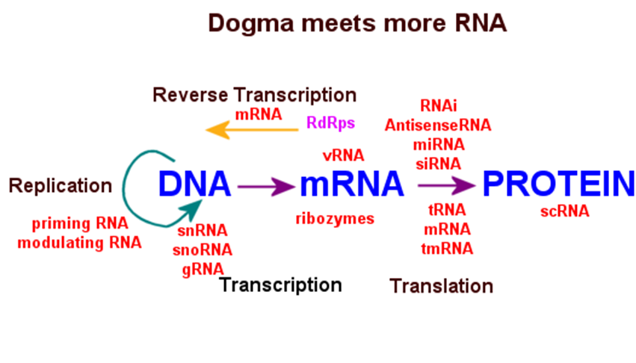

Conformations of RNA
- Primary structure similar to DNA
  - 2'OH groups prevent formation of B-Helix in 2s areas
    - A helix is formed
  - RNA, like DNA, can be single or double staded, linear or circular
  - Can exhibit different conformation (unlike DNA)
    - Permit RNAs to carry out specific functions of the cell
  - RNAs ability to carry out specific functions due to different conformations
- Secondary structure
  - G:U
    - Enhances potential for self complementarity in RNA
  - Areas of regular helices and discontinuous helices with stem-loops or hairpins

Stem-loop: | Typically > 50 nucleotides
Hairpin | Typically 4-10 nucleotides
- Tertiary structure in RNA
  - RNA has high degree of rotational freedom in backbone of its non-base-paired regions
    - Complex folding tertiary structures
  - Unconventional U:A:U or A:G:C base triple possible
  - Pseudoknots
    - Can form due to base-pairing sequences that are not adjacent

Structure of both circular and linear DNA:
- 1º Structure -sugar-phosphate "chain" with purine and pyrimidine bases as side chain(s)
- 2º structure - DH structure (hbond, stacking interactions; outside phosphate backbone)
- Tertiary or Higher order - dsDNA supercoils

Supercoils
- Supercoiling = coiling of a coil. Further condense, decrease entropy
- Release stress ndice by local DNA denaturation by tisting double helix
- DNA functions in replication and transcription depend on its topological state
  - DNA helix becomes topographically linearized (locally uncoiled)
    - Base pairing is interrupted
    - DNA molecule exibits supercoiling
- Topological isomers - DNA differing only in their states of supercoiling
- Strain is released mainly by writhing into superhelical turns
  - It is energetically favorable to bend long DNA then to untwist it

- One DNA supercoil forms in the dh for every 10bp opened for B-DNA

Lec 4

Catch up

In order to change L one or both strands of the DNA have to be cut. Then the DNA has to be wound

Revie:
- DNA packed in nucleus in cell
- Also has to be accessible to transcriptional and replicational machineries
  - Supercoiling: Coiling of double helix
  - + SC: DNA Overwound
  - -SC - DNA Underwound. Stored energy that can help seperation
  - L=T+W
  - L can only be changed by breaking one, or both strands. Winding them tighter or looser and rejoining the ends

Topoisomerases
- Enzymes regulate supercoiling and make cuts in DNA
  - Important role in rep an trans
- Prokaryotic
  - Topoisomerase 1
    - Cuts in one strand
    - Relaxes -SC
    - Does not use ATP

Topoisomerase 1
- Breaks DNA strand
- TYR residue attacks backbone of phosphate
- Formation of phosphotyrosine bond
- Passes the other stand through the break
- F

Type II topoisomerases
- Handles double strands
- Cut both strand of one dna pushing other strand through the cut
- Produces
- Changing the inking number by changing the writhing number

Eukaryote Chromatin Structure
- UNITS ARE IMPORTANT SHE WILL TEST
- Diameter of bacterial cell is around 1µm = 0.001mm
- DNA is arpund 4x10⁶ bp long; has to be packed into the cell
- 4x10⁶x0.34x10⁻⁹m = 1.36mm long circular DNA thread which is 2 nm long

Bacterial "chromosome" structure
- Nucleoid
- DNA organized in 50-100 loops/domains
- Circular moleciles compacted by association with
  - Polyamines (+ve )
  - HU proteins
  - SC

Supercoiling can occur in space, around proteins
- Restrained (wrapped around protein) vs unrestrained
- Trapping energy in SC and released when needed

Eukaryote
- Average size of chromsome:
  - 150Mbp=150x10^{3kbp=150x10}6bp
- .
- .
- .
- .
Eukaryotic Chromatin
- Genomes orgainized into chroosomes
- Single linear DNA molecule gets wrapped up and packed more or less tightly with the help of specific proteins and protein complexes: Nucleoproteins
- Long thin strands of nucleoprotein material of eukaryotic chromosomes re called Chromatin:
- Chromatin vs chromosome
Chromatin Organization
- Beads on a string
- Nucleosome
- Each contain histone proteins
- 146bp wrapped around core DNA
- 20-60bp of linker DNA between histones
Nucleosome: octet of histones & wrapped DNA
- Histones
  - Small proteins rivh in lysine and arginine
  - Electrostatic interactions with DNA
  - 5 major types
  - H1, H2A, H2B, H3 AND H4
  - H2A, H2B, H3 AND H4 form a complex of 8 protein (octet)
- DNA wrapped around octet ~1.65 times
- H1 associates with DNA and octet Iin linker region
  - Binds two distinct regions of the DNA duplex
- Core histone alone: 4-fold compaction
- Core histones +H1: 25 to 00 fold compaction
- Nucleosome is 10-11nm in diameter
- 10nm fiber is packed into 30nm diameter fiber
- Lower or higher salt concentration during isolation- different forms. Why?:
Higher salt concentration less repelling of DNA molecules. Phosphate group still stick out and repel, increase salt and they're not going to repel

- 10nm fiber:
  - Likely consequence of unfolding during extractionin bitro
  - H1 not required
- 30nm fiber
  - Basic constituent of interphase chromatin and involved in formation of mitotic chromosomes
  - Requires presence of H1

Morphology of chromatin/chromosomes
- Metaphase chromosome
  - 1400nm

Q2. Octet of histones bind to both the core DNA and the linker DNA
- True
- False

Chromosome territories

Chromatin (chromsome) structure
- Euchromatin:
  - Consists of transcriptionally active DNA
  - (in experiments is susceptible to Dnase digestion)
  - Dnase? Would cut the DNA if it was transcriptionally active. Not protected by being bound to histones
  - Dnase is not found in nucleus, only experimentally
- Heterochromatin
  - DNA is less susceptible to DNase digestion and transcriptionally inactive
  - Constitutive heterochromatin
    - Highly condensed inactive chromatin
    - Consists of reptitve DNA
    - Very few genes
  - Facultative heterochromatin
    - Not active in particular tissue
    - Forms under specific circumstances and/or in certain tissue to silence gene expression
      - x-chromsome inactivation (Barr body formation)
      - imprinting

- In pancreas euchromatin form.
Chromatin elements (incl. centromeres and telomeres)
- Elements are specific nucleotide sequences = DNA regions
- Locus control regions -
- Matrix and scaffold attachment regions
- Insulators
- Centromere
- Telomere
Centromere
- each sister chomatid has one.
- Site of attachment for microtubules (kinetochore)
- In situ hybridization of metaphase:
  - Chromosomes show satellite DNA at centromeres
    - Highlt rptitve sequences
- @ in metaphase chromosome
Telomeres
- Regions at end of chromosomes
- Repetitive
- Protect chromosomes from degradation
Nonhistone proteins
- Give me three non histone proteins (QUESTION ON MIDTERM)
  - Scaffolding Proteinaceous Structures
  - Topoisomerase II
  - SMC (structural maintenance of chromosome) proteins
  - DNA replication proteins; transcriptional factors, chaperone proteins etc..
- MARs and SARs
- M/SARs:
  - A:T rich (70%) but no consensus sequence
  - Binding sites for topisomerase II

Matrix attachment Regions (MARs)
- Isolated when experiments done on interphase chromsomes
  - Would be different among different cell types
Scaffold attachment Regions (SARs)
Isolated when experiments done on Metaphase chromsomes

Chromatin Organization
- Histone proteins
  - Highly conserved proteins especially H4
  - Evolutionary stability (UEP)
    - Change in 1% AA sequence in 1million years
  - Histone amino acid sequences very conserved. Why?:
    - Very good at packaging DNA
Nucleosome disassembly and reformation
- Chaperone proteins (- charged) attracted to - charged histones
- Present in chromatid
- Replication DNA is absolutely necessary for nucleosome assembly

Histone tails direct DNA to wrap around the optimal histone
- Stabilization of 30nm fiber by interacting with cells
- Important for regulation of gene expression
- Rich in lysine
- Modifications:
  - Acetylation of lysine in histone taile
    - Activationof Gene expression
  - Methylationof Histone tail (Argine and lysine)
    - May be associated with both active and inactive genes
  - Phosphorylation (serine)
    - Active gene (but not clear as histones are phosphorylated during mitosis)
- Phosphorylation, change phosphate to negative charge making it less tightly bound
  - Free dna for transcriptinoal proteins to bind

The Histone code hypothesis
- Serial modifications of histones tails are a "landmark" for proteins which read chromatin necessary for transcription, replication, repair and recombination

Acetylation and deacetylation of histone tails - enzymes histone acetylases and deacetylases
-Acetylated for is (-ve): H replaced by -ve acetyl group
- Affecrs chromatins condition
  - Necessary for activation of transcription

DNase 1 Test
- Isolate Nuclei from different cell types, put in dif groups, pipette dif conc of dna in each group; DNAase degrades DNase unbinding from histones.
- Then add restriction enzymes.
- Add gel
- 2 Possibilities
- No signal
  - Gene expression was in progress; DNA was free of histones and available
- Signal
  - No gene exression
  - Still tightly bound to DNA; digestion didn't occur

