Marketing

Marketing: Satisfying consumer needs and wants profitably.
- Marketing is a set of business practices designed to plan for and present an organizations products or services in ways that build effective customer relationships
- Marketing is the activity, set of institutions, and processes for creating, communicating, delivering, and exchanging offerings that have value for customers, clients, partners, and society at large.
- Personal selling
- Advertising
- Making products available in stores
- Managing relationship with customers
- Designing new products

Marketing Requirements
Two or more parties (individuals or organizations) with unsatisfied needs
A desire and ability on their part to be satisfied
A way for the parties to communicate
Something to exchange

Marketing entails an exchange
The exchange can occur between any two parties
Not simply a buyer and seller exchanging money for a good or service
Can be an exchange of information for convenience.

Key concepts in Marketing: Exchange and Relationship
Exchange: the act of obtaining a desired object from someone by offering something in return
Price: exchanged for the product
Marketing consists of actions taken to build and maintain desirable exchange relationships with target audiences involving a product, a service, and idea, etc...)
Need: basic necessities
Want: how to fulfull that need
Needs occur when a person feels physiologically deprived of necessities
Wants are needs shaped by culture and individual personality
Demands are needs/wants combined with buying power

Marketers discovering consumer needs
Market research/ new product development
Consumer behavior

The four P’s of marketing “Marketing Mix”
Price: Price Is everything the buyer gives up in exchange for the product
- Promotion: A means of communication to inform, persuade and remind potential buyers about product or service to influence their opinions or elicit a response.
Place: A means of getting the product into the consumer’s hands
Product: Anything that can be offered to a market for attention, acquisition, use, or consumption, that might satisfy a need or want.

The 4 p’s are the marketing mix
- Marketers create, communicate, transacting, and deliver value.

The Marketing environment
Uncontrollable events involving social, economic, technological, competitive, and regulatory forces.
Building Value
Build and maintain loyal customer base
Distinguish from competitors
Strong brand, customer appeal
Constantly need to protect the brand

Key concepts in marketing
The fundamental purpose of marketing is to create value for both the firm and customer.
Value is essence what you get for what you give up

Market: Set of actual and potential buyers of a product (and/or service)
A market is a physical place where buyers and sellers gathered to buy and sell good.

The four orientations of marketing
Product Orientation
- Consumers prefer the best product that offer the most quality, performance, or innovative features
- Focus on making superior products and improving them over time.
- Product orientation until the 1920s
- focus on production and economies of scale
- Profit is from production methods (“Focus on producing the best product”)
- Profits from quality of the product (“if we build it they will come”)
Market Orientation
- Focus on customer wants and needs (“we’re not satisfied until you are”)
- Focus on 4 P’s
- Deliver more effectively and efficiently than competitors
- Build long-term profitable relations with customers.
Sales Orientation
- The sales orientation up to the 1960’s
- Consumers, if let alone, will not buy enough of our products
- Focus on selling (selling techniques, Sell, sell, sell)

Value-based Orientation
- To compete successfully, firms focus on the triple bottome line:
- People (consumer needs and wants)
- Profits(Long-term profitable relationships)
- Planet (Social and Environmental responsibility)

Value and Satisfaction
- Customer Value: The unique combination of benefits received by the customer that include quality, price, convenience, on-time delivery, and both before sale and after-sale service.

Connect with social media
- Embrace social media to connect better with customers
- ¾ of North American companies now use social media for marketing purposes
- Users are driving the way brands and stores are interacting with social media

Lecture 2

Developing Strategies and a Marketing Plan

Marketing Strategy
Marketing strategy identifies:
- A firm target market
- A related marketing mix – the four P’s
- The bases upon which the firm plans to build a sustainable competitive advantage
Leads to sustainable competitive advantage

Sustainable Competitive Advantage
- Strong brand
- Technology
- Strong customer base
- Loyal customers

Customer Excellence
- Retain loyal customers
- Provide excellent customer service

Product Excellence
- High perceived value + Effective branding and positioning
Locational Excellence
- The three most important things in retailing are location, location, location.

Multiple sources of advantage
- Customer value
- Customer service
- Customer relations
- Great prices
Good service = Good value

Marketing Plan
- A marketing plan is a written document to give marketers
- A “road-map” for the company to market its product

Developing a marketing plan
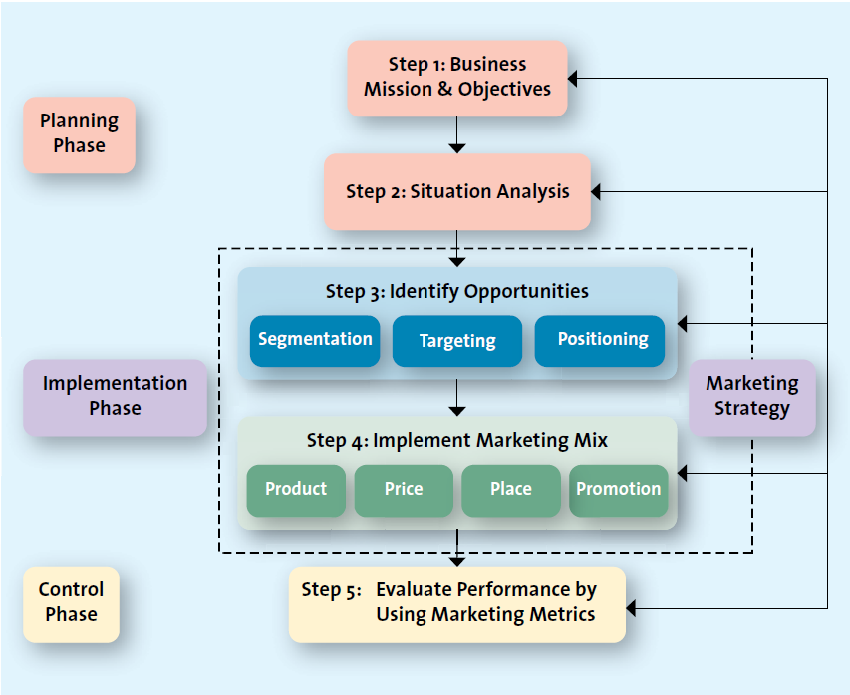

Step 1: Business mission and objectives
(Tim Hortons) Our guiding mission is to deliver superior quality products and services for our customers and communities through leadership, innovation and partnerships. Our vision is to be the quality leader in everything we do.

Business mission & Mission Statement
- Business mission
Provides reason for existence (“Why it exists”?) of the organization
Foundation of marketing plan The marketing plan focuses on accomplishing the mission
States the organizations purpose
Market and customer-oriented
Provides direction to internal stakeholders
- What is our business?
- Who is the customer?
- What does the customer value
EX. _____ Mission is to organize the world’s information and make it universally accessible and useful

- Business Mission Statement
A statement of the organization’s scope that often identifies its customers, markets, products, technology, and values

Marketing Objectives
- A statement of what is to be accomplished through marketing activities
- Basis of measuring success
- Marketing objective must be
- Specific
- Measurable
- Actionable
- Relevant
- Time specific

Step 2: Situational Analysis (SWOT)
- Where are we now?
- SWOT analysis and environmental scanning
Company: Own Company
Consumers: Present and future customers
Competitors: Industry trends, competitions
- Where do we want to go? (both situation and evaluation phases)
Business portfolio analysis (BCG)
Product-market growth analysis

SWOT Analysis
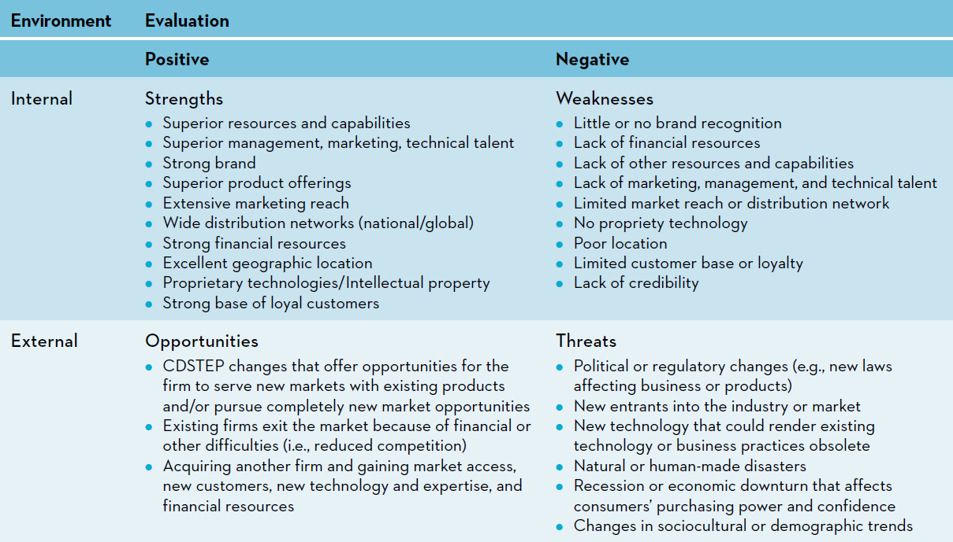
Location  of Factor | Type of Factor
Location  of Factor | Favorable | Unfavorable
Internal | Strengths | Weaknesses
External | Opportunities | Threats

Step 3: Identify Opportunities – Implementation Phase
- Obtain resources
- Design marketing organization
- Develop schedules
- Execute marketing program
- Identify opportunities
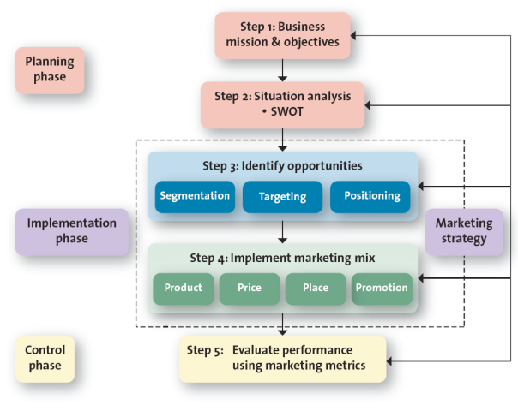

- S.T.P: effective marketing requires S.T.P
- S.T.P is about who and what

- Which products will be directed toward which customers? (The What and WHO of the strategic marketing process)
- S – Segment the market: WHO
- T – Select target market: WHO
- P – Positioning Product: WHAT

Step 4: Implement Marketing Mix
Development of the marketing mix (The How of the strategic marketing
- Product Strategy
- How does _____ deliver value based upon the product it creates??
- Price Strategy
- Exchange: product = Money
- Customer perception of value
- Promotion Strategy
- Television
- Radio
- Magazines
- Sales force
- New media
Place (distribution) strategy
- Online or in store
4 P’s ^^^^^^^^^

Step 5: Evaluation (Control Phase)
- Control Phase
- Compare results with marketing plan
- Exploit positive deviations
- Act on negative deviations

Business Portfolio Analysis (BCG)

- Stars
- Large profits but need a lot of cash
- Question Marks
- Need a lot of cash
- Have potential to become stars
- Cash Cows
- Generate strong cash flow
- Dogs
- Low growth potential and small market share
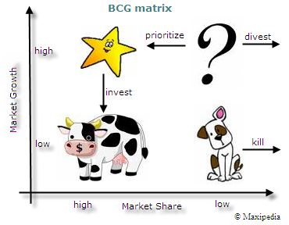
Four basic strategic options for the company’s future growth:
- Build
- Hold
- Harvest
- Divest

Growth Strategies (Market Product Analysis)
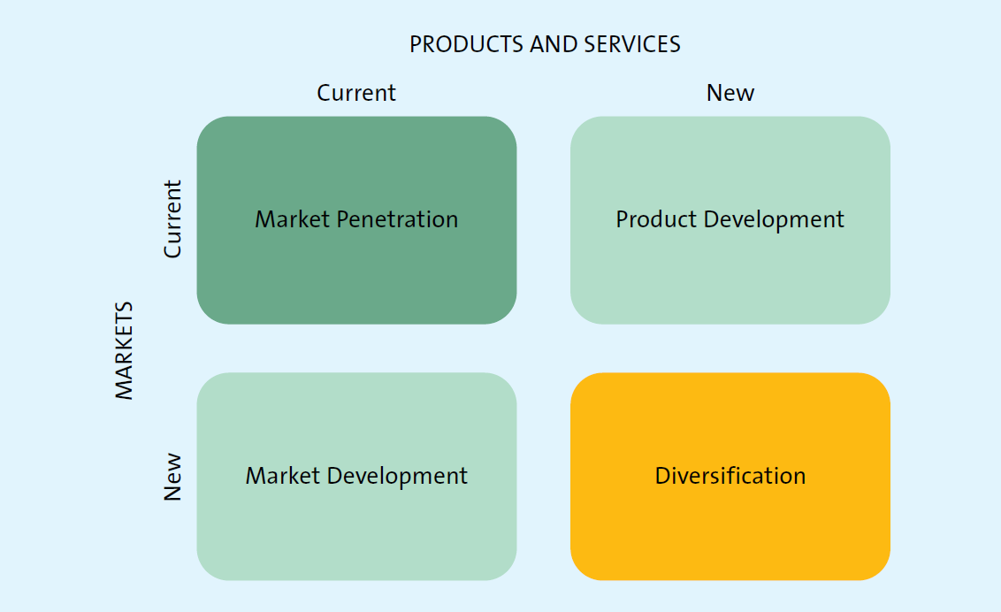

Marketing Penetration
- Existing marketing mix
- Existing customers
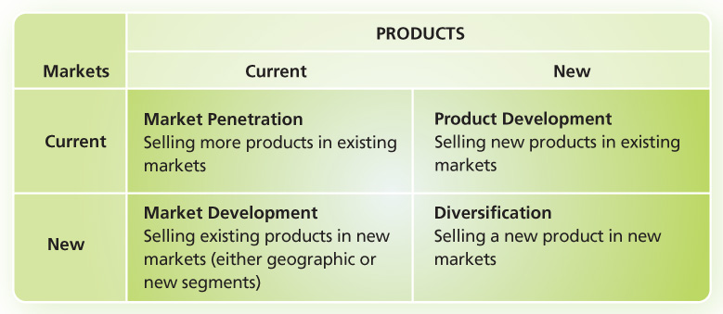

Market Development Strategy
- Existing marketing offering
- New market segments (domestic, international) not currently being served
Product Development
- New product/service
- Current target market

Diversification
- New product/service
- New market segment not currently being served

Growth Strategies: Market Product Analysis
Ex. Menchies

Markets | Products
Markets | Current | New
Current | Market Penetration  - Selling more products in existing markets (increasing promotion, distribution or price) | Product Development  - Selling new products in existing markets.
New | Market Development  - Selling existing products in new  - markets | Diversification  - Selling a new product in new markets.  - Related vs. unrelated diversification

Chapter 3 Analyzing the Market Environment

Environmental Scanning
- Tracking environment
- Changes in the environment can affect the organization as well as its suppliers and customers. Microenvironments are sources of opportunities and threats and need to be managed.
- SWOT analysis requires environmental scanning,
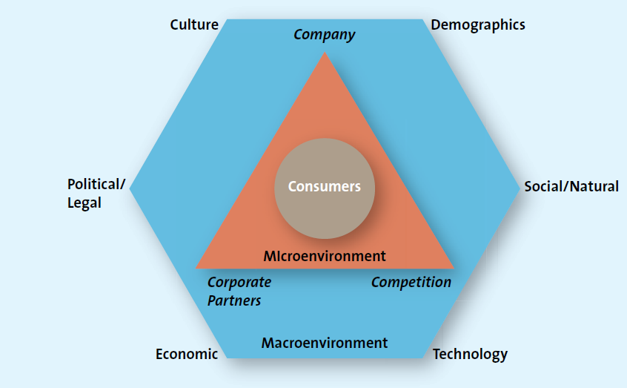

Company Capabilities
- Core competency + Satisfy customer needs
- Knowledge, facilities, patents, technology, people etc. APPLIED TO Target markets, products etc.
Competition
- Identify and analyze direct and indirect competitors
- Know strengths and weaknesses
- Competitive Intelligence (CI) used to collect and synthesize info

Corporate Partners
- Firms are part of alliances – few work in isolation
- Align with suppliers, corporate partners etc.
- Manufacturer to Retailer
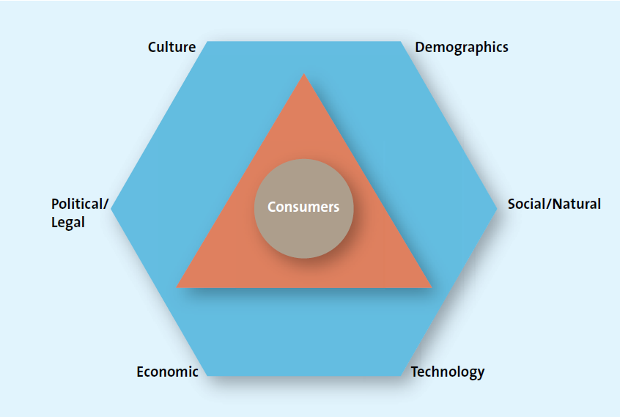
CDSTEP

Culture
- Country Culture vs Regional Subcultures

Demographics
- Characteristics of human populations & segments used to identify consumer markets
- Gender
- Ethnicity
- Age

Demographics: Generational Cohorts

Demographics: Income, Gender, Education
- Typical demographics
- Age, gender, income, education
- Demographic segmentation is probably the Common form of segmentation because the information is so widely available

Income
- Purchasing power is tied to income
- Statistics Canada tracks income
- Many middle class families feel the decline in purchasing power in recent years.

Gender
- Male/female roles have been shifting
- Marketing has changed to reflect these shifts

Education
- Education is related to income, which determines spending power.

Ethnicity
- Ethnic composition of Canada is changing
- 1/5 Canadians not born in Canada
- By 2030, population growth will be mainly attributed to immigration.

Social & Natural trends
- Greener consumers
- Privacy Concerns
- Time-poor society

Social Trends
- Greener consumers: Hybrid cars, Green bin program, water bottles
- Market to children: Be responsible to children
- Privacy Concerns
- The Time poor society

Greener Consumers
- Consumers who appreciate the efforts of companies to supply them with environmentally friendly merchandise

Entrepreneurial marketing 3.1 – turning trash into cash
- A compost crusader
- Growing city: a service to pick up food scraps from offices in Vancouver area
- 67% of waste comes from offices & industry
- In 2015, Organic materials will be band from landfills

Privacy Concerns
- Loss of privacy
- Identity theft
- Do not call
- Do not e-mail

Time-poor society
- In the majority of families, most parents work
- Consumers have many more choices regarding leisure time
- Many consumers multitask
Social
- Safety belts were perceived as a humiliation to drivers
- Auto companies were not big fans of seat belts
- In 1970, only 10% wore a seat belt when driving
- In 200, more than 80% wore a seat belt when driving

Environmental Forces | Example
Technological  - Impact on consumers  - Impact on marketers | - 75% of Canadians have internet broad-band access and use this to find better deals and prices.  - In 2015, because consumers seek lower prices, greater convenience and wider product offerings, value sales of media products (recorded music, films, video games) are expected to increase by 90%.
Economic  - Macroeconomic  - Microeconomic | - Late-2000s recession or Great Recession;  - If household debt was spread evenly across all Canadians, a family with two children would owe an estimated $176,461 in 2010.  - 78% of Canadians think they have the capacity to borrow more.  - Oil price dropped and the Bank of Canada cut the overnight rate
Political/Legal  - Protection of Consumers and Competition  - Self-Regulation | Legislation & regulations at 3 levels of government (federal, provincial & municipal)  Consist of provincial and/or federal laws  Competition act is designed to protect and to balance the interests of competitors and consumers.  Competitive forces

Technological Advances
Technology has impacted every aspect of marketing
- New products
- New forms of communication
- New retail channels

Paypal
- Technology and social trend
- Privacy concerns

Current Exchange Rate
- 1 cad = 0.8 USD
- If Canadian dollar appreciates then – 1 cad > 0.8 USD
- If Canadian dollar appreciates then – 1 Cad < 0.8 usd

Economic Situation
- Foreign currency fluctuations
- Combined with inflation and interest rates affect a firm’s ability to market goods and services.

Political/Regulatory Environment
- Competition act
- Consumer packaging and labelling act
- Food and drugs act
- Patent act
- North American free trade agreement (NAFTA)

Midterm 1-7 (7 only mc)
60 marks
office hours next Monday (class is cancelled)

