Concordia University
Department of Economics

ECON 303: Intermediate Macroeconomic Theory I,

STUDENT NAME___________________________________________________
STUDENT ID ____________________________
SECTION_________________________

Instructions: There are a total of 25 points. The exam has two sections. Section 1 is worth 11.5 points and section 2 is worth 13.5 points. Your answers must be concise and clearly derived.

Section 1:
- This question is related to various issues with business cycle.
- Define Business Cycle (1 point)
Business Cycles are Fluctuations about the trend in real GDP

(ii) In which case a variable is said to be volatile? (1 point)

When its fluctuations are unstable, high standard deviation or high variance

(iii) In which case a variable is said to be: procyclical (1 point), leading (1 point) Draw one graph explaining a leading and procyclical variable (1.5 points).

Procyclical: the deviations from trend are positively correlated with the deviations from trend in real GDP, positive coefficient of correlation

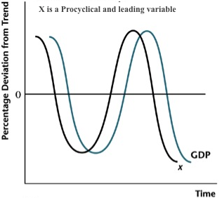

(iv) Why do we adjust seasonally the data (1 point)?

In order to remove predictable seasonal extra amounts (or seasonal changes), in the data

- Explain whether this statement is true, false or uncertain: “To ignore the production of intermediate goods when measuring the total product of a country is a mistake because it ignores the work, the efforts and the incomes of millions of citizens.” (1points)
False. The value of intermediate goods is captured in the value of the final good. Thus, the effort of intermediate goods producers is not ignored in the GDP numbers.
- What is the difference between real GDP and nominal GDP? (1 point)
The real indicator accounts for price-level changes, which means it gives a clearer picture of actual changes in output. Nominal GDP is simply price times quantity. Nominal GDP increases could be caused by price increases, output increases or a combination of the two.

- Give two reasons why real GDP per capita is not a good measure of the standard of living for a nation. (2points)
Real GDP per capita does not measure all of the nonmarket production that goes on in households. It also does not recognize the fact that income is not equally distributed among the nation’s citizens.
- You read the following headline: “Inflation Rate at 1.1%...Lowest Rate in 2 Decades.” (i) What is meant by inflation? (ii) How did the statisticians arrive at that result? (1 points)
- Inflation is the rate of increase in the average price level.
- They probably used the consumer price index. Inflation = [P(t) – P(t – 1)] / P(t – 1)

Section 2:
Suppose that the government imposes a proportional income tax on the representative consumer’s wage income. That is, the consumer’s wage income is $w(1-t)(h-l)$ where $w$ is real hourly wage rate, $t$ is the marginal tax rate, $h$ is the time endowment, say 24 hours for each household, and $l$ is time spent on leisure. The consumer also gets dividend income, which is denoted as $π$.

- What effect does a rise in the income tax rate $t$ have on consumption and labour supply, on leisure? Explain your results in terms of income and/or substitution effects. (2 points)

Answer: When the government imposes a proportional tax on wage in- come, the consumer’s budget constraint in period t is now given by: c = w(h-l)(1-t):
where t is the tax rate on wage income. The real wage rate is the relative price of leisure in terms of consumption goods, A proportional tax on wage income makes leisure cheaper, thus the substitution effect is that the consumer will consume less while enjoy more leisure.
The tax also has income effect which makes the consumer worse o§, in that he or she has less consumption and less leisure than before, because both consumption and leisure are normal goods.
The net effect of the tax is to reduce consumption, but the direction of the net effect on leisure is ambiguous. Although consumption must fall, hours worked may rise, fall, or remain the same.

- Now, assume that the consumer pays lump sump tax, T instate of the above that system. Write down the time and budget constraint of the consumer. Draw the budget line for the consumer. Why do we have a kink in the budget line when $T<π$? Can we have optimal consumption bundle at the kink? Why or why not? (2 points) (There is no answer provided for this question)

Consumer’s Budget Constraint when T < π

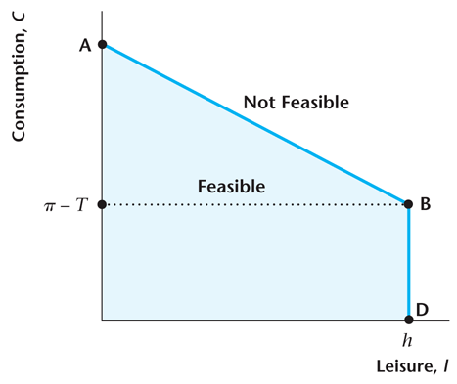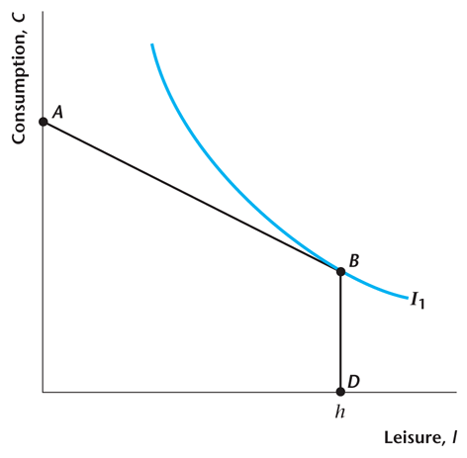

Assume the preferences of the above consumer is represented by the following utility function $U\left(c, l\right)={\frac{3}{2}c}^{2}l^{2}$. The representative firm has technology given by . The government sets its expenditure level at a value G.
- Define a Competitive Equilibrium for this economy. (2 points)

A Competitive Equilibrium for this economy is a set of endogenous variables (c, l, Y, w, Nd, Ns, T) such that, given the exogenous variables K, z, G, the following are satisfied:
  - Representative Consumer Maximizes Utility as given above, Subject to the following Budget Constraint C=wNs+$π$-T
  - Representative Firm Maximizes Profits $π=Y-wNs$
  - The labour market clears Ns=Nd
  - The Government budget constraint is satisfied, G=T
  - The consumption good market clears, Y=G+C

- Show that : ${MRS}_{l,c}=\frac{c}{l}$. and that . Show that the production function is monotonic? (3 points)
$${MRS}_{lc}=\frac{MUl}{MUc}=\frac{6/{2cl^{2}}}{6/{2lc^{2}}}=\frac{c}{l}$$
$${MP}_{N}=\frac{∂Y}{∂N}=zK^{0.5}\left(0.5N^{-0.5}\right)=0.5zK^{0.5}\frac{1}{N^{0.5}}=0.5z{\left(\frac{K}{N}\right)}^{0.5}$$

${MP}_{N}>0$, so increase in N, leads to increase in Y

So we can conclude that the above production function satisfies the monotonicity property

- Suppose that G=0, K=100, z=1, h=24. Solve for the Competitive Equilibrium (3 points)

$${MRS}_{lc}=\frac{c}{l}=w→wl=c→The Budget constraint becomes$$
$$wl=wh-wl+π-T →l=\frac{wh+π-T}{2w}$$
$$But gov. budget constraint G=T^{*}=o →l=\frac{24w+π}{2w}=12+\frac{π}{2w} (1)$$
$${MP}_{N}=0.5z{\left(\frac{K}{N}\right)}^{0.5}=0.5\left(1\right)\frac{10}{N^{0.5}}=\frac{5}{N^{0.5}}=5N^{-0.5}=w \left(2\right),$$
$\left(2\right)in (1) l=12+\frac{π}{10N^{-0.5}}$,

$$π=Y-wN=10N^{0.5}-\frac{5}{N^{0.5}}N=5N^{0.5} \left(3\right)$$
$$\left(3\right)in \left(1\right)l=12+\frac{5N^{0.5}}{10N^{-0.5}}, so l=12+\frac{1}{2} N, So h=24=N+12+\frac{1}{2} N, →\frac{3N}{2}=12, N^{*}=8 , l^{*}=16 , w^{*}=1.77, c^{*}=Y^{*}=28.32,$$

- Recall that leisure time in our model is intended to capture any time spent not working in the market, including caring for children. Suppose that the government were to provide free day-care for children and, for the purpose of analyzing the effects of this, assume that this has no effect on the market real wage, w. What is the effect on consumption and on leisure? Explain your results in terms of income and/or substitution effects. Illustrate your result with a graph. (1.5 point)

This is an increase in Gov. Spending G, then T increases as G=T, $π-T$decreases, then

C=wNs+$π$-T decreases, meaning income effect, unless the consumer decides to keep his consumtion by increasing Ns, which leads to decrease in l.
In sum, c decreases, l may fall or not.
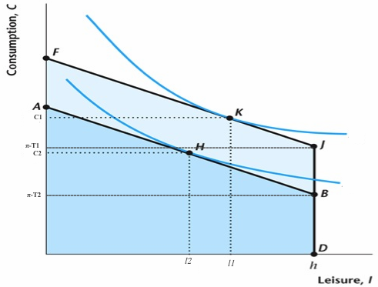

Bonus: (2 points). Suppose the government impose a producer tax. That is, the firm pays $τ$ units of consumption goods to the government for each unit of real output it produces. Determine the effect of this tax on the firm’s demand for labour.
The firm chooses its labor input, Nd, so as to maximize profits. When there is no tax, profits for the firm are given by π = zF(K;Nd)-wNd: That is, profits are the difference between revenue and costs. In the following top figure, the revenue function is zF(K;Nd) and the cost function is the straight line, wNd. The firm maximizes profits by choosing the quantity of labor such that MPN = w:
With a tax that is proportional to the firm’s output, the firm’s profits are given by:
π = zF(K;Nd)-wN- tzF(K;Nd) = (1-t)zF(K;Nd)-wNd:
where the term (1-t)zF(K;Nd) is the after-tax revenue function, and as before, wNd is the cost function. As before, the firm will maximize profits by equating marginal product of labor to marginal cost of labor, which becomes (1 t)MPN = w: So the tax acts to reduce the after-tax marginal product of labor, and the firm will hire less labor at any given real wage.

