- Suppose you were given the following price series in nominal (observed) terms and the CPI (Consumer Price Index) series. Calculate the real price series using 2009 as the base year. (5 marks)

Real Price=(Nominal Price/Current CPI)*(Base CPI)
Base CPI= 2009 CPI= 120.3
Year Nominal Price CPI Real Price (2009 dollars)
  - 1989 0.25 64.9 0.46
  - 1994 0.39 82.1 0.57
  - 1999 0.45 100.0 0.54
  - 2004 0.51 107.3 0.57
  - 2009 0.54 120.3 0.54
- In the world lentil market there is a very large producer, India, which is a net importer and the largest consuming country, but the largest exporter in the world is Canada. Answer the following three questions using excess supply and demand diagrams to illustrate your answers. (5*3=15 marks)
  - There is a large price spike in cereals (e.g., wheat, barley) in Canada, crops that are substitutes for lentils in production, and this reduces domestic lentil production by 40%. Show what this will do to the world price and to worldwide trade volumes.

Because domestic lentil production decrease, the supply decrease and the supply curve of Canada (export country) have a left shift (S1 to S2). That makes excess supply curve shift left too (ES1 to ES2) and world price higher and worldwide trade volumes lower.
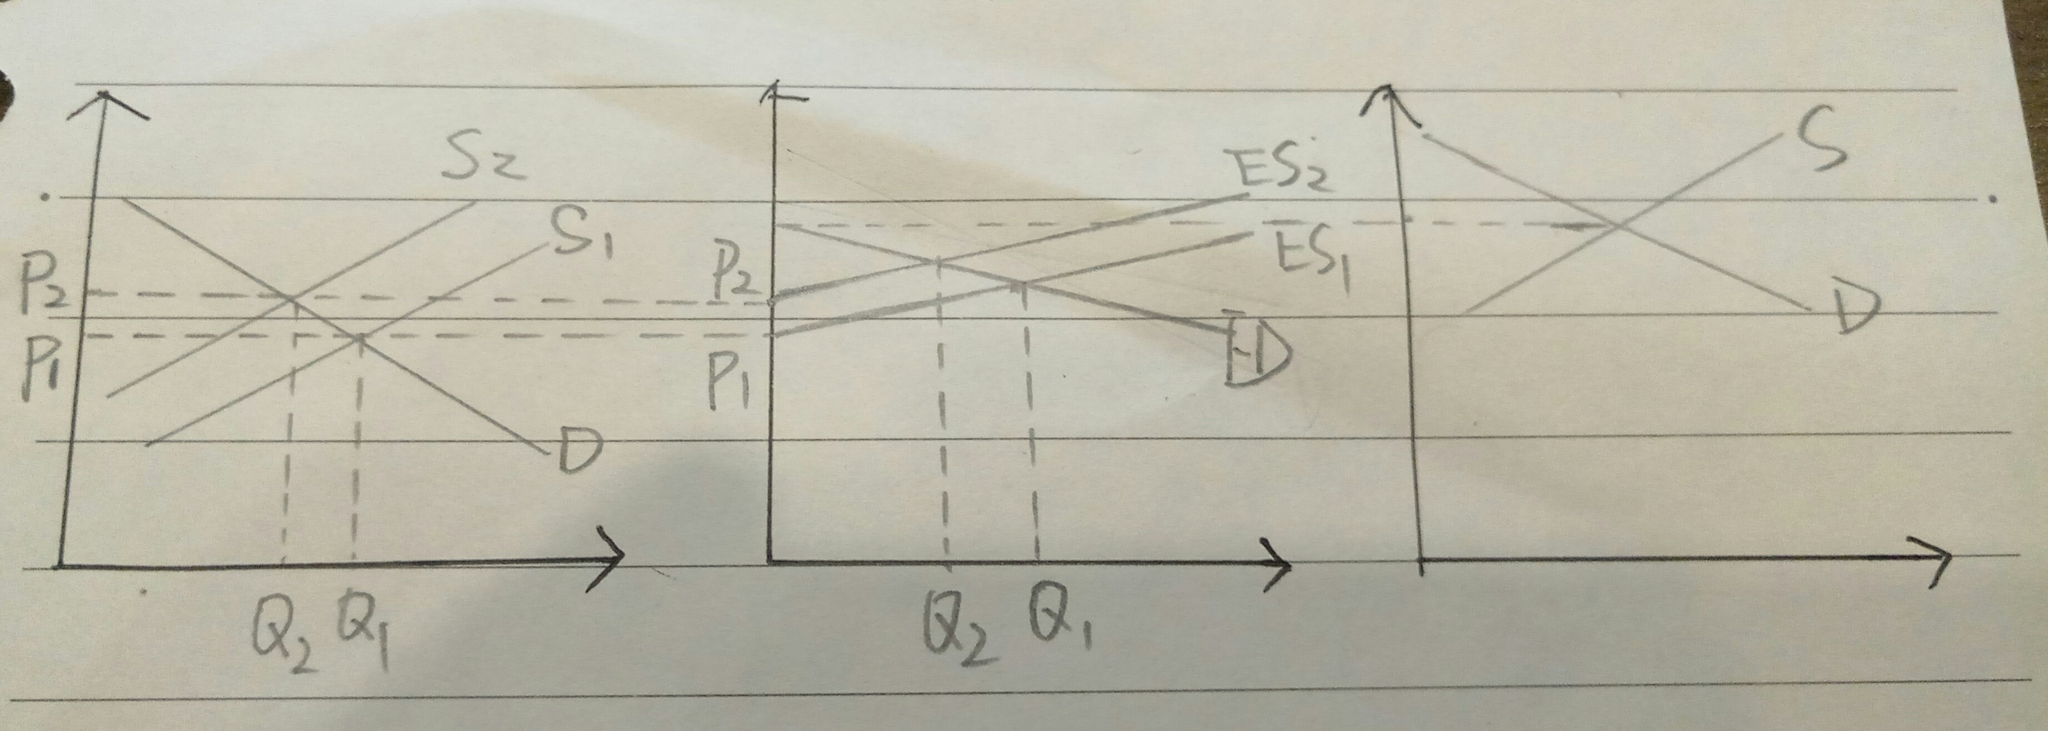
  - Suppose that Ethiopia invests heavily in new plantings and increased productivity so that it becomes one of the top 5 exporters and adds to world supply. Show what this will do to Canada’s export quantity.
It depends on the size of Ethiopia export quantity. Because become top 5 exporters doesn’t mean have export quantity as large as Canada. So it became two different situations:
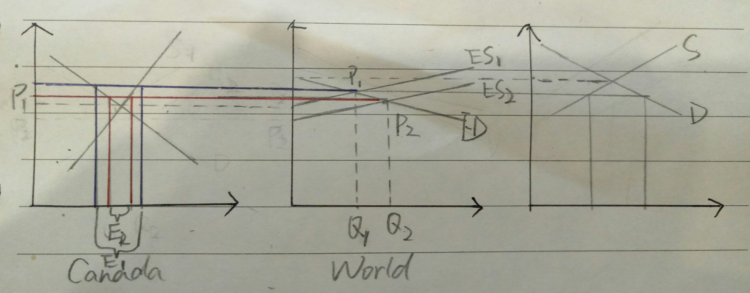
- Ethiopia increase export quantity a lot to become one of main world exporter, have influence to world market. Then makes supply increase and ES curve shift right (ES1 to ES2). World price go down and as a result Canada produce quantity decrease, domestic demand increase. Finally, Canada export fall.

- Although Ethiopia increase productivity, it still too small compare to Canada. So Canada still the only one can influence the world price. As this case, Ethiopia still the one of the import country, it shifts import country supply curve to right, and cause ED curve shift left (ED1 to ED2). Finally, world price fall and reduce Canadian export quantity.
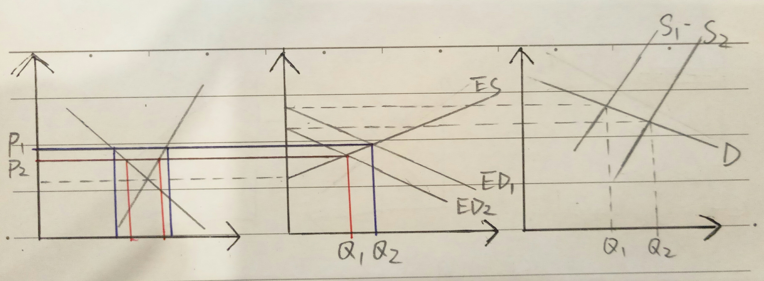

  - Consumers in Canada are learning to love lentils due to their high protein content, and domestic consumption of lentils increases significantly. Assuming Canada is a “small country” in its share of world lentil consumption, show what this increased domestic consumption will do to the price received by Canadian lentil growers who sell most of their crop onto the world market.
Because Canada is small country in world lentil consumption market, so it makes very little influence in world demand. Although domestic consumption increased, the price will not be change.

- Suppose there are three countries A, B and C that are equi-distant from each other, and transport costs depend only on distance. It is observed that shipments are moving from A to B. No other trade is observed. (6 marks)
B

A
C

- Assuming the transport cost from A to B is $100, write down the range of possible prices in Country C, expressed in terms of where P_{C} would be relative to PA and PB. (4 marks)

Because A to B have trade, we can compare PA – PC and PC – PB separately.
- If PC is lower than PA, then there will be trade from C to B. So PC>PA.
- If PB is lower than PC, then there will be trade from A to C. So PB>PC.
In conclusion, PB>PC>PA.
- Suppose B experiences a terrible drought. By how much would prices in B have to rise (at the minimum) for us to observe C exporting to B? (2 marks)

From (a) we know PA to PB is 100, for making trade from C to B, the price between C and B must higher than shipment cost, which means at least 1 can make export from C to B.

