COMM 222

Textbook Chapter Notes

CHAPTER 2: PERSONALITY & LEARNING

PERSONALITY

Personality: Relatively stable set of psychological characteristics that influence how individuals interact with their environment & how they think, feel, and behave.
- Determined by…
- Genetic predisposition
- One’s long-term learning history
- Susceptible to change through adult learning experiences

PERSONALITY & ORGANIZATIONAL BEHAVIOR

3 Approaches to “Person-Situation” Debate
- Dispositional
- Situational
- Interactionist

Dispositional Approach:
- FOCUS: Individual disposition (qualities of mind, character) & personality
  - “You DO based on WHO YOU ARE”
- Stable traits or characteristics that influence attitudes & behaviors
  - Thus, predisposed to behave in certain ways

Situational Approach:
- FOCUS: External situations & interventions
- “You DO based on WHERE YOU ARE & WHAT’S DONE TO YOU”
- Characteristics of the organizational setting influences people’s attitudes & behavior
  - Rewards & punishment
  - Characteristics of work tasks

Interactionist Approach:
- FOCUS: Organizational behavior is a function of BOTH dispositions & the situation
  - Traits + Environment = Behavior
- Most widely accepted perspective of organizational behavior

Examples of Interactionist Perspective:
- Situations can be “weak” or “strong”

“Weak” Situation:
- Unclear behavior expectations
- Roles loosely defined, few rules, weak reward & punishment contingencies
- Personality has MORE impact

“Strong” Situation:
- Clear behavior expectations
- Defined roles, rules, & contingencies
- Personality has LESS impact

Thus, personality influences behavior depending on the situation

Trait Activation Theory:
- Personality traits lead to certain behaviors only when the situation makes these traits salient (noticeable, important).
  - You won’t display a particular trait unless situation requires it

Fit Matters: Putting right person in right job, group, or organization.

FIVE-FACTOR MODEL OF PERSONALITY

OCEAN…
- Openness to experience
- Conscientiousness
- Extraversion
- Agreeableness
- Neuroticism

(1) Openness to experience: Extent to which a person thinks flexibly & is receptive to new ideas.
- Creativity & learning jobs

(2) Conscientiousness: Degree to which people are responsible & achievement-oriented.
- High job performance
  - Hard work & achievement

(3) Extraversion: Extent to which a person is outgoing vs. shy.
- Job with interpersonal interactions
  - Joyful, energetic, sociable, assertive
- Enjoy social situations (introverts avoid them)

(4) Agreeableness: Extent to which a person is friendly & approachable.
- Job performance contributor
  - Friendly, sympathetic, teamwork, cooperative…

(5) Neuroticism: Degree to which a person has appropriate emotional control.
- Low neuroticism (high emotional stability, high self-esteem)
  - Effective interactions with co-workers, customers
- High neuroticism (lower emotional stability, self-doubt, depression)

Research Findings:
- Each “Big Five” related to job performance & organizational citizen behavior
- Best predictors of job performance depend on occupation
- Conscientiousness stronger predictor of overall job performance
- “Big Five” related to…
  - Work motivation
  - Job satisfaction
  - Life satisfaction
  - Job research
  - Career success
- Effects of personality on career success = enduring

ADDITIONAL PERSONALITY TRAITS

Locus of Control: Set of beliefs that one’s behavior is controlled by internal & external forces.
- Internal: Behavior control resides within self
- External: Behavior determined by external forces

Internals:
- More job satisfied, more committed, earn more money, achieve higher positions
- Less stress, cope with stress better
- Less burnouts
- Careful career planning
- Less likely to be absent
- More satisfied with lives

Self-Monitoring: Extent to which people observe & regulate how they appear and behave in social settings and relationships.
- Tune into social & interpersonal cues
  - Regulate behavior according to cues
- Role-playing jobs, use of self-presentation skills
- Less committed, most likely to change jobs for more promotions
- Not comfortable in ambiguous situations

Self-Esteem: Degree to which a person has positive self-evaluation.
- Low self-esteem: More susceptible to external & social influences or easily influenced (behavioral plasticity theory)
- High self-esteem: Favorable self-image

Organizations & Self-Esteem:
- Org. can boost self-esteem by providing…
  - Participation
  - Autonomy
  - Interesting work

MORE PERSONALITY TRAITS

Positive Affectivity: Tendency to view world (self & others) in a positive light.
Negative Affectivity: Tendency to view world (self & others) in a negative light.

Proactive behavior: Taking initiative to improve current circumstances or creating new ones.
Proactive personality: Stable disposition toward proactive behavior. Unaffected by situational forces, act to change & influence environment.

General Self-Efficacy: An individual’s belief in their capacity to perform successfully in various situations.

Core self-evaluations: People’s evaluations of themselves & their self-worth.

LEARNING

Learning: Practice or experience that leads to a relatively permanent change in behavior.
- “Practice and experience” comes from feedback

WHAT DO EMPLOYEES LEARN?

4 Skills:
- Practical
- Intrapersonal
- Interpersonal
- Cultural awareness

(1) Practical Skills:
- Job-specific, knowledge, technical competence

(2) Intrapersonal Skills:
- Problem solving, critical thinking, finding alternatives, risk taking

(3) Interpersonal Skills:
- Communicating, teamwork, conflict resolution

(4) Cultural Awareness Skills:
- Social norms of organizations, company goals, business operations, expectations, priorities

HOW DO EMPLOYEES LEARN?

2 Theories:
- Operant Learning Theory
  - Consequences, punishment, external environment…
- Social Cognitive Theory
  - Acknowledgement, attention, praise…

Operant Learning Theory

- Operant Learning Theory: Learning to operate on the environment to achieve consequences.
  - OLT controlled by consequences that follow it
  - Connection b/w behavior & consequence

- OLT can be used to…
  - Increase probability of desired behaviors
  - Reduce/eliminate probability of undesirable behaviors

Increasing Probability of Behavior

- Reinforcement: Process by which stimuli strengthens behavior.
  - Reward w/o impact is NOT a reinforcer

- Positive Reinforcement: Application of a stimulus that increases or maintains probability of a behavior.
- Negative Reinforcement: Removal of a stimulus that increases or maintains probability of a behavior.
  - NR defined by what they do & how they work, not by unpleasantness
  - Removal = increased performance = negative reinforcer

Organizational Errors w/ Reinforcement:
- Confusing rewards w/ reinforcers
  - NO change in behavior = NOT a reinforcer

- Neglecting diversity in preferences for reinforcers
  - Must choose appropriate reinforcer for different types of employees

- Neglecting important sources of reinforcement
  - I.e. only reinforcing via financial incentives
    - Two Important Sources of Reinforcement: Performance feedback & social recognition

Two Important Sources of Reinforcement:

- Performance Feedback: Providing quantitative & qualitative information on past performance to either change or maintain performance.
- Social Recognition: Informal acknowledgement, attention, praise, approval, or genuine appreciation for work well done increases or maintain performance.

Reinforcement Strategies:
- Continuous vs. Partial
- Immediate vs. Delayed

Continuous + Immediate Reinforcement = Fast Acquisition of Behavior
Partial + Delayed Reinforcement = Persistent Behavior

Reducing Probability of a Behavior

- Learned behaviors can be detrimental to the operation of an organization & they need to be reduced or eliminated.

2 Strategies:
- Extinction
- Punishment

(1) Extinction: Removal of a positive reinforcer that maintains undesirable behavior.
- Works best with (new) reinforcement of substitute (desired) behavior

(2) Punishment: Applying unpleasant consequence reduces probability of undesired behavior.

- Difference b/w punishment & negative reinforcer
  - Punishment: Applying stimulus to reduce behavior
  - Negative Reinforcer: Removing stimulus to increase behavior

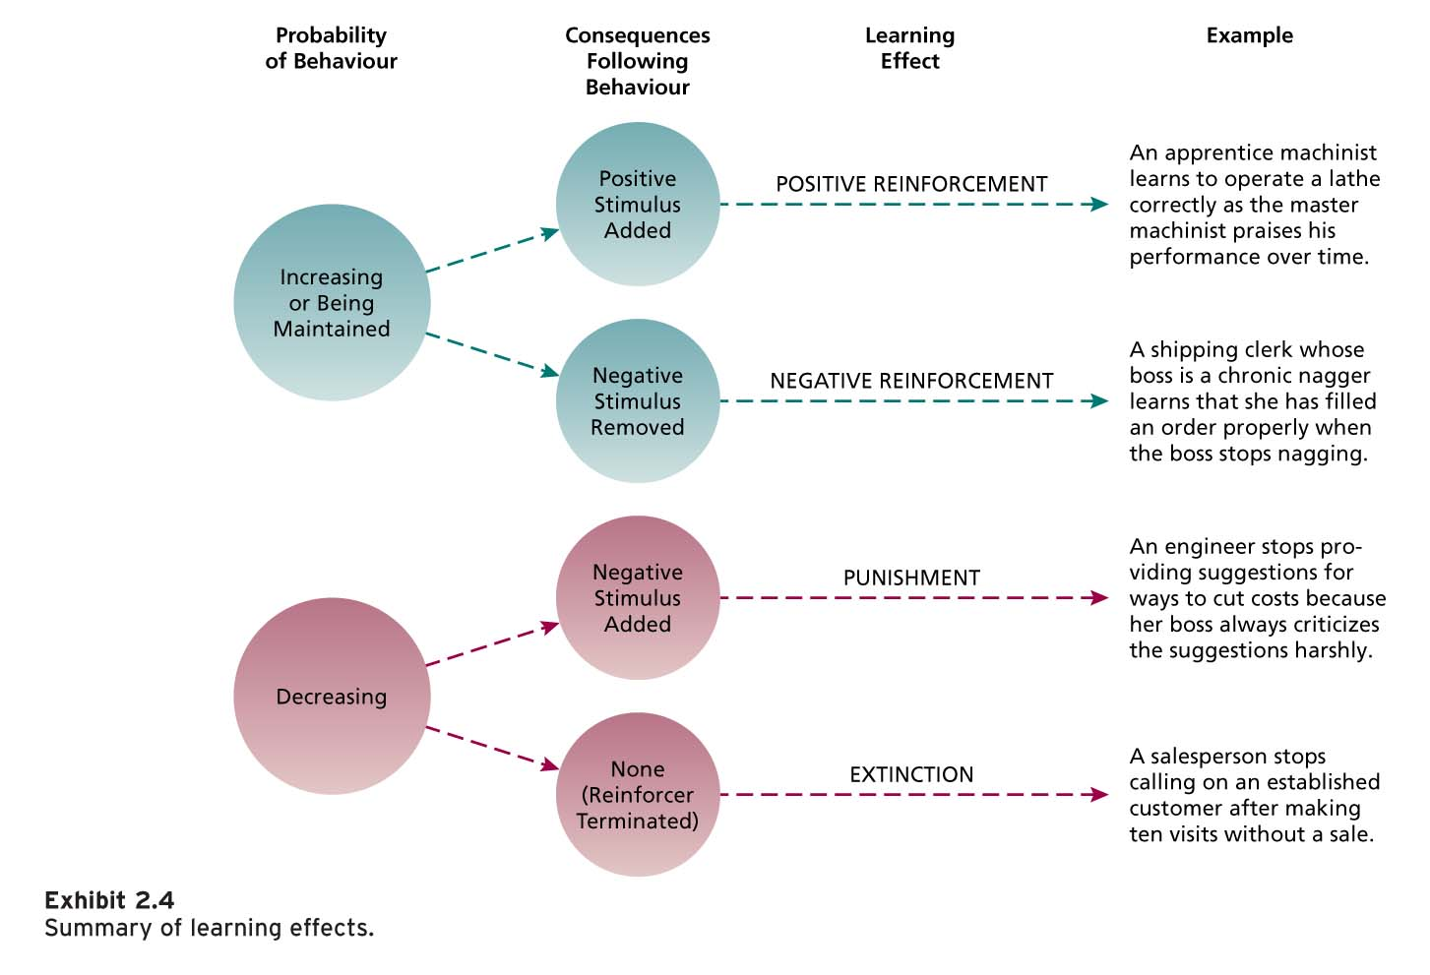

Problems w/ Punishment:
- Only indicates inappropriate behavior
  - Does not indicate which behavior should replace it
- Temporarily eliminates behavior
- Provokes strong emotional reactions

Using Punishment Effectively:
- Provide favorable alternative behavior
- Limit emotions involved in punishment
- Punishment must be truly aversive
- Punish immediately
- NO rewarding unwanted behavior
- NO punishment desirable behavior

Social Cognitive Theory

- Social Cognitive Theory: Role of cognitive processes in regulating behavior. People learn through observing the behavior of others.

- People can regulate own behavior by…
- Thinking about consequences of actions
- Setting performance goals
- Monitoring performance
- Rewarding themselves for goal accomplishment

SCT suggests that human behavior can be explained through…

Triadic Reciprocal Causation:
- Personal factors & environmental factors interact influence people’s behaviors.
- Behavior can influence personal factors & environment.

Personal Factors: Cognition, self-efficacy, motives, personality
Behavior: Complexity, duration, skill
Environment: Situation, roles, models, relationships

Components of Social Cognitive Theory:
- Observational learning
- Self-efficacy beliefs
- Self-regulation

Observational Learning: Process of observing and imitating the behavior of others.
- Examining others’ behavior
- Seeing consequences they experience
- Thinking what might happen if we act similarly
- Imitating behavior (if favorable)

Reinforcement – self-reinforcement
Model’s behavior must…
- Result in positive consequences
- Be vivid & memorable

Self-Efficacy Beliefs: Beliefs people have about their ability to successfully perform a task.
- Influenced by various sources of information…
  - Performance mastery
  - Observation
  - Verbal persuasion & social influence
  - Physiological state

Self-Regulation: Use of learning principles to regulate own behavior.
- Involves…
  - Observing own behavior
  - Comparing it to a standard
  - Rewarding oneself when behavior meets standard
- Pursuing self-set goals to guide behavior
- Discrepancy reduction: Lack of similarity b/w goal and performance motivates behavior change.
- Discrepancy production: When person attains goals, likely to set higher & more challenging goals.
Self-regulation process…
- Collect self-observation data
- Observe models
- Set goals
- Rehearse
- Self-reinforce

- Effective method of learning & training
- Improves learning & results in behavior change

ORGANIZATIONAL LEARNING PRACTICES

Organizational Behavior Modification (O.B. Mod): Use of learning principles to influence organizational behavior.

Employee Recognition Programs: Formal org. programs that publicly recognize & reward employees for specific behaviors.

Peer Recognition Programs: Formal programs in which employees can publicly acknowledge, recognize, & reward their co-workers for good performance.

Training & Development Programs: Training is planned organizational activities designed to ease knowledge & skill acquisition to change behavior & improve performance of current job. Development focuses of future job responsibilities.

CHAPTER 3: PERCEPTION, ATTRIBUTION, & DIVERSITY

WHAT IS PERCEPTION?

Perception: Process of interpreting the messages of our senses to provide order & meaning to the environment.
- People’s actions based on interpretation of reality

COMPONENTS OF PERCEPTION

Three Components:
- Perceiver
- Target being perceived
- Situational context (where perception is happening)

- Each component influences perceiver’s interpretation of target

(1) Perceiver:
- Experiences, needs, & emotions affect perception of target
  - Experiences: Developed expectations affect perception
  - Jvuh,,Needs: We perceive what we wish to perceive
  - Emotions: Anger, happiness, fear, all influence perception

Perceptual Defence: Tendency of perceptual system to defend perceiver against unpleasant emotions.

(2) Target:
- Perception involves interpretation & addition of meaning to the target.
  - Ambiguous targets susceptible to interpretation & addition of meaning
  - Reduced ambiguity not related to greater accuracy

(3) Situation:
- Perception occurs in situational context
- Situation adds information about target
- Perception of target can change w/ situation, even when perceived & target are unchanged

SOCIAL IDENTITY THEORY

Social Identity Theory: People form perceptions based on their personal characteristics & memberships in social groups.
- Personal Identity + Social Identity = Perceptions

BRUNER’S MODEL OF PERCEPTUAL PROCESS

Theory: The perceiver, when encountering an unfamiliar target, is open to informational cues in the target & the situation.

Perceptual Process Model:
- Unfamiliar target
- Openness to target cues
- Familiar cues encountered
- Target categorized
- Cue selectivity
- Categorization strengthened

Model shows three important characteristics of perceptual process…
- Perceptual selectivity
  - Uses not all available cues, hinders accuracy
- Perceptual constancy
  - Target always seen in same way
- Perceptual consistency
  - We select, ignore, distort cues to so that our perceptions of a target stay the same

BASIC BIASES IN PERSON PERCEPTION

Basic Biases in Person Perception (PRIPS): Impressions we form of others are susceptible to many perceptual biases…
- Primacy & Recency Effects
- Reliance on Central Traits
- Implicit Personal Traits
- Projection
- Stereotyping

(1) Primacy & Recency Effects:

Primacy Effect: Tendency of perceiver to rely on early cues or first impressions.
- Lasting impact Perceptual constancy

Recency Effect: Tendency of perceiver to rely on recent cues or last impressions.

(2) Reliance on Central Traits:

Central Traits: Perceiver relies on personal characteristics of a target person of interest.
- Centrality of traits depends on perceiver’s interest & situation
- Powerful influence on perception
- Physical appearance = common central trait in work settings
- Physical height = job performance, promotions, success
- Overweight = negative perception

(3) Implicit Personality Theories:

Implicit Personality Theories: Personal theories based on which personality characteristics go together.
- Inaccurate, basis for misunderstanding

(4) Projection:

Projection: Tendency for perceivers to attribute own thoughts & feelings to others.
- Sometimes efficient & sensible perceptual strategy
- Sometimes leads to perceptual difficulties
  - May serve as perceptual defense

(5) Stereotyping:

Stereotyping: Generalizing about people in certain social categories & ignore differences among them.
- Race, religion, age, gender, ethnic background, social class, occupation
- 3 Stereotyping Aspects:
  - Distinguish category
  - Assume individuals in category have certain specific traits
  - Perceive everyone in category to have same traits
- Incorrect, but quick & efficient

ATTRIBUTION: PERCEIVING CAUSES & MOTIVES

Attribution: The process by which we assign causes & motives to explain people’s behavior.
- Rewards & punishments based on judgments about what caused target to behave certain way

Behavior is caused by…
- Dispositional Attributions: Explanations for behavior based on actor’s personality or intellect.
  - Behavior caused by internal factors
- Situational Attributions: Explanations of behavior based on actor’s external situation or environment.
  - Behavior caused by external factors

Attribution Cues: We rely one external cues & make inferences from these cues when making attributions.
- Consistency cues
- Consensus cues
- Distinctiveness cues

- Consistency cues: Repetition of behavior over time.
  - High consistency = dispositional
  - Low consistency = situational
- Consensus cues: How behavior compares to others.
  - Low consensus = dispositional
- Distinctiveness cues: Variety of behavior in different situations.
  - Low distinctiveness = dispositional
  - High distinctiveness (only one situation) = situational

- Observers put information about consistency, consensus, & distinctiveness together to form attributions.

Biases in Attribution:
- Fundamental attribution error
- Actor-observer effect
- Self-serving bias

- Fundamental attribution error: Overemphasize dispositional explanations for behavior over situational explanations.
- Actor-observer effect: Actor sees behavior as a result of situational factors. Observer sees behavior as result of dispositional causes.
  - Actor AS Observer Effect
- Self-serving bias: Tendency to take credit for successful outcome & deny responsibility for failures.

PERSON PERCPETION & WORKFORCE DIVRSITY

Workforce diversity: Differences in members of an organization in characteristics such as… gender, race, age, cultural background, physical ability, religion, or sexual orientation.

Changing Workplace:
- Number of visible minorities in Canada = DOUBLE in 2017
- In less than a decade, 48% of pop. b/w 45-64
- Teamwork requires people from diff. cultures to interact

Valuing Diversity:
- When properly managed, diversity creates strategic & competitive advantages.
  - Improved recruiting & marketing
  - Improved competitiveness in global markets
- Diversity climate related to business-unit performance
- Gender-diverse management teams = superior financial performance

Managing Workforce Diversity:
- Diversity must be managed for positive impact on work behavior & organization
  - Select enough minority members
  - Encourage teamwork b/w minority & majority members
  - Ensure those making career decisions about employees have accurate info about them
  - Train people to be aware of stereotypes & to value diversity

Diversity Training Programs:
- Most common programs to manage workforce diversity
- Can cause disruption & bad feelings
- Awareness training + Skills training
- Org. must integrate diversity in ALL its policies & practices

PERCEPTIONS OF TRUST

Trust: Psychological state in which a person is willing to be vulnerable & take risks with respect to the actions of another party.

Trust Perceptions & Management:

Based on three distinct trust perceptions (ABI)…
- Ability
- Benevolence
- Integrity

Trust Model (CFCPR):
- Credibility
- Fairness
- Camaraderie
- Pride
- Respect

PERCEIVED ORGANIZATIONAL SUPPORT

Perceived Organizational Support (POS): Employees’ beliefs that their organization values their work & cares for their well-being.

Organizational Support Theory: Employees with strong POS feel an obligation care about organization’s welfare & help organization reach its objectives.
- Feel greater sense of purpose & meaning
- Feel obligated to reciprocate org’s care & support

Perceived Supervisor Support (PSS): Employees’ beliefs that supervisors value their work & care for their well-being.

What can organizations do to improve POS?
- Supportive human resources practices
  - Investment in employees
  - Recognition of employee contributions

CHAPTER 4: VALUES, ATTITUDES, & WORK BEHAVIOR

WHAT ARE VALUES?

Values: A broad tendency to prefer certain states of affairs over others.
- Good vs. Bad

Values are…
- Motivational: How we should & should not behave
- General: Do not predict behavior in specific situations

- People hold value structured around achievement, power, autonomy, conformity, tradition, & social welfare.

Generational Differences in Values

Generations in Workplace:
- Traditionalists (1922-1945)
- Baby Boomers (1946-1964)
- Generation X (1965-1980)
- Generation Y (1981-2000+)

Differences…
- Different socialization experiences = Different values
  - Shows differential workplace assets & preferences for leadership styles

Generational Differences in Values:
- Traditionalists
  - Respect authority, high work ethic
- Baby Boomers
  - Optimistic workaholics
- Generation X
  - Cynical, confident, pragmatic
- Generation Y
  - Confident, social, demanding of feedback, unfocused

Gen X & Y compared to Boomers:
- Gen X & Y more value for money, status, rapid career growth
- Gen X & Y see work as… less central, value leisure, work-life balance

Research:
- All work generations share same values, but express them differently
- Good “person-organization fit” = positive work attitudes & behaviors, reduced chances of quitting

Cultural Differences in Values:
- Lack of understanding of cross-cultural differences can cause…
  - Foreign assignments terminated early
  - Business negotiations fail

Work Centrality:
- People for whom work is central life interest, work more hours
- Work is valued diff. across cultures & nations
- Cross-cultural diff. in work centrality = adjustment problem for foreign employees/managers

HOFSTEDE RESEARCH:
- Work-related values differ across cultures

Basic dimensions:
- Power Distance
- Uncertainty Avoidance
- Masculinity/Femininity
- Individualism/Collectivism
- Long-term/Short-term Orientation (Michael Bond)*

(1) Power Distance: Extent to which unequal distribution of power is accepted by society members.

(2) Uncertainty Avoidance: Extent to which people are uncomfortable with uncertain & ambiguous situations.

(3) Masculinity/Femininity:
- Masculine cultures: Differentiate gender roles, male dominance, economic performance
- Feminine cultures: Fluid gender roles, sexual equality, life quality

(4) Individualism/Collectivism:
- Individualistic cultures: Independence, individual initiative, privacy
- Collective cultures: Interdependence, loyalty

(5) Long-term/Short-term Orientation:
- Long-term: Persistence, perseverance, thrift, status differences
- Short-term: Personal steadiness, stability, face-saving, social niceties

WHAT ARE ATTITUDES?

Attitude: A fairly stable evaluative tendency to respond consistently to some specific target.

- Evaluations directed towards specific targets
- More specific than values

Attitude Behavior
- Occurs when people have direct experience with target of attitude & when attitude is held confidently
- A not always consistent with B

Belief + Value = Attitude Behavior

Attitudes that Impact OB:
- Job Satisfaction
- Organizational Commitment

WHAT IS JOB SATISFACTION?

Job Satisfaction: A collection of attitudes workers have about their jobs.
- Facet Satisfaction
  - More or less satisfied with various aspects of job
- Overall Satisfaction
  - Summary indicator of persons’ attitude toward job that cuts across various facets

Job Descriptive Index (JDI): Measures job satisfaction.
Five facets of satisfaction…
- People
- Pay
- Supervision
- Promotion
- Work itself
- “Yes, no, ?” response to job descriptive words

Minnesota Satisfaction Questionnaire (MSQ): Measures job satisfaction.
- “Very satisfied” to “dissatisfied”

WHAT DETERMINES JOB SATISFACTION?

Job satisfaction stems from… DFDM
- Discrepancy (b/w job outcomes wanted & those received)
- Fairness & Equity
- Dispositional Factors
- Mood & Emotion

(1) Discrepancy: Discrepancy b/w the job outcomes wanted & the outcomes perceived to be obtained.

(2) Fairness & Equity:

- Distributive Fairness: When people receive the outcomes they think they deserve.
  - Equity Theory: Job satisfaction stems from…
    - My outcomes / My inputs = Others’ outcomes / Others’ inputs
    - Outcomes are tied to Inputs

- Procedural Fairness: When process used to determine work outcome is seen as reasonable.
  - HOW outcomes are decided/allocated
  - Performance evaluations, pay raises, promotions, layoffs

- Interactional Fairness: When people feel they have received respectful & informative communication about an outcome.

(3) Disposition: Some people are predisposed, by virtue of their personalities, to be more or less satisfied despite changes in discrepancy or fairness.

(4) Mood & Emotion:
- Affect… Broad label for feelings that include emotion & mood
- Emotion: Intense, often short-lived feelings caused by a particular event.
- Mood: Less intense, long-lived, & more diffuse feelings.

Affective Events Theory:
- Jobs consist of series of events & happenings that have potential to provoke emotions or to influence moods.
  - Depends how we appraise them
  - Emotions & moods influence job satisfaction

Emotional Contagion - How moods & emotions spread b/w people throughout a group.
Emotional Regulation – How people must conform to “display rules” in their job behavior, in spite of moods & emotions.

IMPACT OF JOB SATISFACTION

Facets that contribute to JS in North America…
- Mentally challenging work
- Adequate compensation
- Career opportunities
- People (friendly, helpful co-workers)

CONSEQUENCES OF JOB SATISFACTION

Consequences of JS/JD…
- Absence from work
- Turnover
- Performance
- Organizational citizenship behavior (OCB)
- Customer satisfaction & profit

Absence from work:
- Dissatisfied = more absent, satisfied = less absent

Turnover:
- Dissatisfied = quit, satisfied = stay
  - Unless shock stimulates turnover
  - Weak job market may keep employees from quitting
  - Community ties
Honeymoon-Hangover Effect: People who quit experience boost of job satisfaction on new job. With time, bad facets of new job decrease satisfaction.

Performance:
- JS = high performance, JD = low performance

Organizational citizenship behavior:
- Voluntary, informal behavior that contributes to organizational effectiveness.
  - Voluntary
  - Spontaneous
  - Contributes to org. effectiveness
  - Not rewarded by performance evaluation system
- Fairness is key (procedural + interactional are critical)
- OCB contributes to… org. productivity, efficiency & reduced turnover

Customer Satisfaction & Profit:
- Employee satisfaction leads to... customer satisfaction leads to… org. profitability

Progression of Withdrawal:
- Response to job dissatisfaction & reduced commitment
- Dissatisfied employees withdraw their attention or work effort
- Withdrawal: Reduced OCB Lateness Absenteeism Turnover

WHAT IS ORGANIZATIONAL COMMITMENT?

Organizational Commitment: An attitude that reflects strength of the link b/w an employee & an organization.

3 Types of Organizational Commitment (CAN):
- Affective (want to)
- Continuance (have to)
- Normative (should do so)

(1) Affective Commitment:
- A person’s identification & involvement in an organization (want to)

(2) Continuance Commitment:
- Costs incurred in leaving an organization (have to)

(3) Normative Commitment:
- Feeling of obligation toward organization (should do so)

- All 3 forms reduce turnover
- Affective = + performance
- Continuance = - performance
- High continuance + low affective commitment = BAD COMBO

Consequences of High Organizational Commitment:
- Conflict b/w family life & work life
- Unethical & illegal behavior
- Lack of innovation & prevent a change in culture when it is necessary

Impact of Changes in the Workplace:

(1) Changes in nature of employees’ commitment to organization (affective, continuance, normative)
- Levels of affective, continuance, & normative commitment can increase/decrease
- Challenging to maintain high levels of affective commitment
- Changes detrimental to employee well-being will damage affective commitment

(2) Changes in focus of employees’ commitment
- Employees have multiple commitments to others within & outside org.
- Focus of commitment may change due to workplace changes
- Changes that threaten employees’ future in org. may result in commitment shift

(3) Multiplicity of employer-employee relationships within organization
- Orgs’ need to be flexible to shrink & expand workforce
- Requires diff. relationships with employee groups
  - Core employees who perform key tasks = affective commitment
  - High affective commitment less important for employee with NO core tasks

CHAPTER 5: THEORIES OF WORK MOTIVATION

WHAT IS MOTIVATION?

Motivation: Extent of persistent effort directed toward a goal.

Basic characteristics of motivation:
- Effort
- Persistence
- Direction
- Goal

Effort:
- Strength of person’s work-related behavior
- Amount of energy, determination, & strength person exhibits on the job

Persistence:
- Tenacity, diligence, & endurance individuals exhibit in applying effort to their work

Direction:
- Extent to which individuals channel their persistent effort in a direction that benefits the organization.

Goal:
- All motivated behavior is directed toward a goal

Extrinsic & Intrinsic Motivation:

- Intrinsic Motivation: Motivation that stems from the direct relationships b/w the worker & the task. Self-applied.
  - Examples: Accomplishment, challenge, feelings of achievement

- Extrinsic Motivation: Motivation that stems from the environment external to the task. Applied by others.
  - Examples: Pay, benefits, company policies, supervision

Extrinsic vs. Intrinsic Motivators:
- Availability of extrinsic motivators can reduce intrinsic motivation that stems from the work itself.
- Easily avoidable

Self-Determination Theory: Uses extrinsic & intrinsic motivation to determine whether people’s motivation is autonomous or controlled.

- Autonomous Motivation: Occurs when people are self-motivated by intrinsic factors.
  - “WANT” to engage in task
  - Facilitates effective performance, positive attitudes, well-being
- Controlled Motivation: Occur when people are motivated to obtain an extrinsic reward.
  - “HAVE” to engage in task

MOTIVATION & PERFORMANCE

Performance: Extent of an employee’s contribution toward achieving the goals of the organization.
- Motivation is one out of many factors that influence performance (i.e. personality, intelligence)

(6) Factors Contributing to Job Performance:

Amount of Effort Personality
Persistence of Effort Motivation General Cognitive Ability Performance
Direction of Effort Task Understanding
Emotional Intelligence
Chance

General Cognitive Ability: Basic information-processing abilities & cognitive resources.
- Verbal, numerical, spatial

Emotional Intelligence (EI): Individual ability to manage own & others’ feelings and emotions.

Four-Branch Model of EI (Salovey & Mayer):
- Perceive emotions (own & others’)
- Integrate & assimilate emotions (use & assimilate to facilitate thinking)
- Understand emotions (understand emotions, emotional language, emotional signals)
- Manage emotions (own & others/ to attain goal)

EI Research:
- Predicts job & academic performance
- Predicts job performance > cognitive ability & Big Five personality factors
- Strong job performance in jobs that require high levels of emotional labor
- EI imp. for job performance w/ employee w/ low cognitive ability

Motivation-Performance Relationship:
- Performance can be low, even if, motivation is high
- Poor performance
  - Personality
  - EI
  - Cognitive ability
  - Poor understanding of task*
  - Chance factors*

MOTIVATION & NEEDS

McClelland’s Theory of Needs:
- Under certain conditions, needs result in patterns of motivation.

- Needs reflect relatively stable personality characteristics (OCEAN)

Three needs drive behavioral outcomes (APA):
- Achievement
- Affiliation
- Power

(1) Need for Achievement: Strong desire to properly perform challenging tasks.

(2) Need for Affiliation: Desire to establish & maintain friendly, compatible interpersonal relationships.

(3) Need for Power: Strong desire to influence or to make significant impact on others.

RESULT: McClelland predicts people will be motivated to seek out & perform well in jobs that match their needs.

- Most effective managers:
  - Low need for affiliation
  - High need for power
  - Ability to direct power toward organizational goals

Managerial Implications of Need Theories:

Effective management requires 2 key attributes to be motivational for employees:
- Appreciation of diversity of needs
- Appreciation of intrinsic motivation

PROCESS THEORIES OF WORK MOTIVATION

Motivation theories…
- Expectancy theory
- Equity theory
- Goal Setting theory

EXPECTANCY THEORY:

(1) Expectancy Theory: Motivation is determined by the outcomes that people expect to occur as a result of their actions on the job.

Basic Components (Victor Vroom):
- Outcomes
- Instrumentality (I)
- Valence (V)
- Expectancy (E)
- Force

Outcomes: Consequences following behavior.
Instrumentality: Probability that a first-level outcome will be followed by a second-level outcome.
Valence: Expected value of work outcomes. Extent to which they are attractive/unattractive.

Valence of First-Level Outcome
=
∑ (Instrumentalities X Second-Level Valences)

Expectancy: Probability that a first-level outcome can be achieved.
Force: Effort directed toward a first-level outcome.

  - First-level: High vs. Average productivity
  - Second-level: Money, sense of accomplishment, peer acceptance, fatigue

Force = First-Level Valence X Expectancy

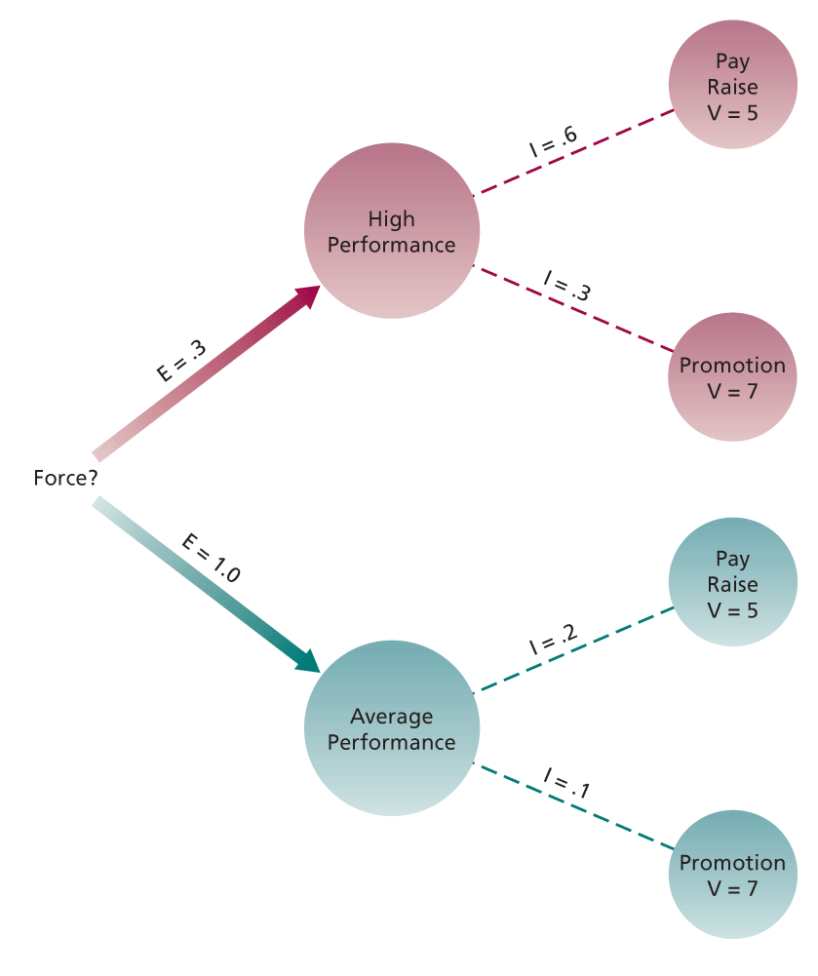
Managerial Implications of Expectancy Theory:

Implies a need to…
- Boost expectancies
  - Clarify path toward first-level outcome
- Clarify reward contingencies
  - Clarify path b/w first & second-level outcomes
- Appreciate diverse needs
  - Design individualized program to meet employee needs

EQUITY THEORY

Equity theory: Motivation stems from a comparison of inputs invested in a job & outcomes received in comparison to inputs & outcomes of others.

My Outcomes / My Inputs = Others’ Outcomes / Others’ Inputs

Reducing Inequity:
- Alter own inputs/outcomes
- Perceptually distort inputs/outcomes (of either participant)
- Leave exchange relationship

Research on Equity Theory:
- Perceived underpayment = negative motivational consequences for organization (i.e. low productivity, low quality, theft)

GOAL SETTING

Goal: Object or aim of action.

Goal Setting Theory: Goals are motivational when they are specific, challenging, and when org. members are committed to them & feedback about process toward goal attainment is provided.
- Specific
- Challenging
- Commitment
- Feedback

Why are they motivational?
- Direction to goal-relevant activities
- Greater effort
- Increase/prolong persistence
- Lead to task strategies for goal attainment

Mechanisms of Goal Setting:
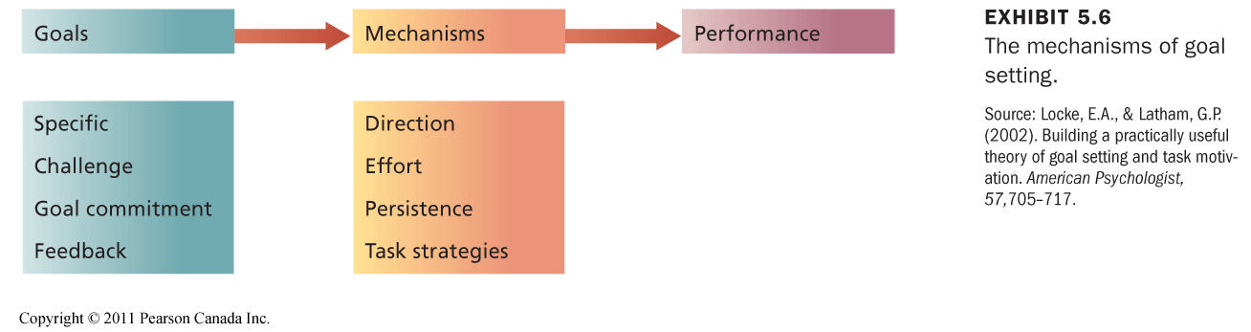

Enhancing Goal Commitment:
- Participation
- Rewards
- Management Support

Managerial Implications of Goal Setting Theory:
- Set specific, challenging goals
- Provide feedback of performance

MOTIVATION & CULTURE

- Equity theory differs across cultures (equity vs. equality)
- Expectancy theory very effective across cultures
- Goal setting is motivational across cultures
  - Goal setting process must be adjusted to culture
- Appreciating cultural diversity, critical to maximize motivation

CHAPTER 6: MOTIVATION IN PRACTICE

MONEY AS A MOTIVATOR

- Money motivates people!

JOB DESIGN AS A MOTIVATOR

Job Design: Structure, content, & configuration of a person’s works tasks & roles.

- Attempt to capitalize on intrinsic motivation
- Goal: Identify what makes tasks for motivating & capture this into job design

Job Scope & Motivation

Job Scope: Breadth & depth of a job.
- Breadth (# of activities performed)
- Depth (degree of autonomy, control)

Increasing Job Scope…
- Provide challenging opportunities to broaden skills, new responsibilities

Job Rotation…
- Employees are rotated to diff. tasks & jobs in org.
  - Opportunities to do different tasks = highly motivating

THE JOB CHARACTERISTICS MODEL

JCM: Several “core” job characteristics that have a psychological impact on workers.

- Moderators
Influence extent to which relationships hold true

Job Characteristics Model:

Job characteristics (5) Critical psychological states Outcomes

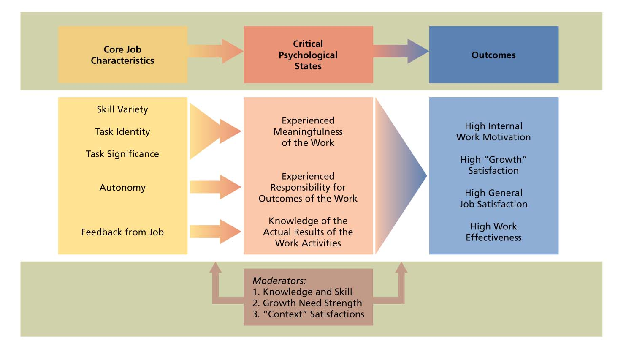

Core Job Characteristics:
- Skill variety
- Task identity
- Task significance
- Feedback
- Autonomy

Job Diagnostic Survey: Measure core job characteristics.

- Motivating Potential Score (MPS)
MPS = (Variety + Identity + Significance/3) X Autonomy X Feedback

Psychological States:
- Experience meaningfulness of work
  - Skill variety, task identity, task significance
- Experienced responsibility toward work outcomes
  - Autonomy
- Knowledge of result of work
  - Feedback

Outcomes:
- High intrinsic motivation
- High “growth” satisfatcion
- High general job satisfaction
- High work effectiveness
- Reduced absence & turnover

Moderators:
- Knowledge & skill
- Growth need strength
  - People desire to achieve high-order need satisfaction
- Context factors (i.e. dissatisfied w/ pay = less responsive to challenging work)

JOB ENRICHMENT

Job Enrichment: The design of jobs to enhance intrinsic motivation, quality of working life, & job involvement.

Job Involvement: Psychological identification with one’s job & importance of work to one’s total self-image.
- Core job characteristics & job involvement = related

Job Enrichment Procedures:
- Combine tasks
- Establish external client relationships
- Establish internal client relationships
- Reduce supervision or reliance on others
- Form work teams
- Direct feedback

Problem w/ Job Enrichment Procedures:
- Poor diagnosis
- Lack of desire or skill
- Demand for rewards
- Union resistance
- Supervisory resistance

Job enlargement: Increasing job breadth

MANAGEMENT BY OBJECTIVES (MBO)

Management by Objectives (MBO): Program designed to facilitate goal establishment, goal accomplishment, & employee development.

ALTERNATIVE WORK SCHEDULES

Alternative work schedules as motivators for a diverse workforce…

Most Common Alternative Work Schedules:
- Flex-time
  - Arrival/quitting times flexible
- Compressed workweek
  - A lot of hours, fewer days (40h, 4 days)
- Job & work sharing
  - Two part-time employees divide work of a full-time job
- Telecommuting
  - Working at home w/ communications technology

