Experiment 1: Verification of Boyle’s Law Through Experiment
Sirjan Singh Rekhi (300019180)
University of Ottawa

CHM1311 – F01

T.A. – Tom Burns (tburn035@uottawa.ca)
19th September 2017

Introduction

The gaseous state is one of the four main states of mater (solid, liquid, gas, plasma). It is composed of molecules that are in constant random motion. Gases have no fixed shape and will take on the shape of the container, hence, a gas is a fluid. But unlike liquids, the intermolecular forces in gases are very small enabling the gas to compress or expand depending on the surrounding pressure. Due to this, gases have no fixed volume.

The relation between volume and pressure of a gas can be studied without discrepancies by investigating and manipulating ideal gases. An ideal gas is a theoretical gas that is composed of many molecules moving randomly and constantly, and only interact when they collide elastically (elastic collision is when no energy is lost to the surroundings). These gas molecules are point sized, have no intermolecular forces and the gas satisfies the ideal gas law:
$$PV=nRT$$
Where, P = Pressure; V = Volume; n = Number of moles of substance; R = Ideal Gas constant = 8.314 J/mol$∙$K; T = Temperature (for the entirety of this report, these parameters will be denoted by their respectable variables in this equation). This equation is important as it allows to quantify the changes in real world gases to the nearest estimate.
Specific relationships between these parameters are explained through the Gas Laws, one of them being Boyle’s Law that relates Pressure of a gas with its Volume. Boyle’s Law states that for a fixed amount of an ideal gas kept at a fixed temperature, the pressure and volume are inversely proportional. The relation can be shown through the expression: $P∝\frac{1}{V}$or $P=\frac{k}{V}$; where k is the constant of proportionality. For a specific gas, the k value remains the same at fixed amount and temperature. Which implies $k=P∙V$. Therefore, changes in pressure and volume can be compared to each other as their product remains constant: $Pi∙Vi=Pf∙Vf$ , where i means initial value and f means final value.
Real gases only behave like ideal gases at lower temperatures and higher pressures. Due to this, the actual experimental values will vary as no gas is ideal and the conditions in which the experiment was conducted was insufficient to ensure ideal gas behavior.

Hypothesis
As per Boyle’s law, pressure is inversely proportional to volume therefore an increase in pressure will lead to a decrease in volume and vice versa.
Variables
- Independent: Volume (ml)
- Dependent: Pressure (KPa)
- Controlled: Amount of air (fixed, the vacuum between syringe and sensor keeps the amount of air fixed throughout the trials); Temperature (conducted at a constant room temperature)
Procedure
- Referred to the procedure as described in lab manual (“DO I DARE DISTURB THE UNIVERSE?”, T.S. Eliot, Experiment 1) for set up.
- The initial Value chosen was 16 ml (16.8ml total).
- The least value for volume was 2ml (2.8ml total).
- Wore appropriate safety equipment – Lab Coat and Safety Glasses.
- With the plug at 16ml, clicked play on lab quest and waited for value to stabilize. Once it did, clicked keep to save the value.
- Decreased the volume by 2ml by pushing in the syringe, held it there until the pressure stabilized and then pressed keep. Entered the value of volume (+0.8 of what was displayed on the syringe) for which the pressure was recorded.
- Repeated steps 4 – 5 until value was recorded for 2(+0.8)ml
- Repeated steps 2-6 for 2 more trials, resulting in 3 trials in total.
Data Collection
Raw Data Table 1: Volume (ml) Against Pressure (KPa) For Four Trials.
Volume (ml) | Pressure (KPa) | Volume (ml) | Pressure (KPa)
Trial 1: |  | Trial 3:
16.80 | 101.76 | 16.80 | 101.73
14.80 | 115.40 | 14.80 | 114.88
12.80 | 132.93 | 12.80 | 133.79
10.80 | 159.61 | 10.80 | 157.07
8.80 | 194.19 | 8.80 | 194.84
Trial 2:
16.80 | 101.04
14.80 | 115.51
12.80 | 132.12
10.80 | 158.71
8.8 | 194.23

Data Analysis
Calculating the average pressure obtained for every volume:
For 16.80 ml: $\frac{101.76+101.73+101.04}{3}=101.51$

Processed Data Table 1: Average Value of Pressure Obtained For Each Volume Value Against Volume.
Volume (ml) | Pressure
16.80 | 101.51
14.80 | 115.26
12.80 | 132.95
10.80 | 158.46
8.80 | 194.42
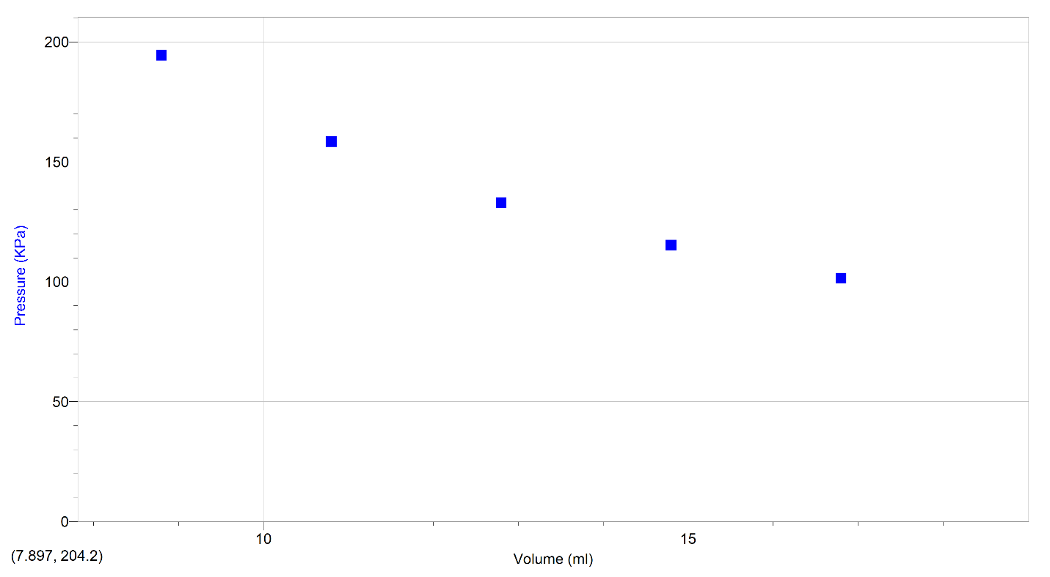
Graph 1: Graph of Processed Data Table 1, Average Pressure against Volume
Using Boyle’s law to find the constant: $k=P∙V$; Constant for 16.8 ml:
$$16.80∙101.5=1705 ml∙KPa$$
Processed Data Table 2: Boyle’s Law Constant Obtained For Each Volume Against Volume
Volume (ml) | Constant
16.80 | 1705
14.80 | 1706
12.80 | 1702
10.80 | 1711
8.80 | 1710

Calculating the Constant (Average of all constants obtained): $\frac{1705+1706+1702+1711+1710}{5}=1707$
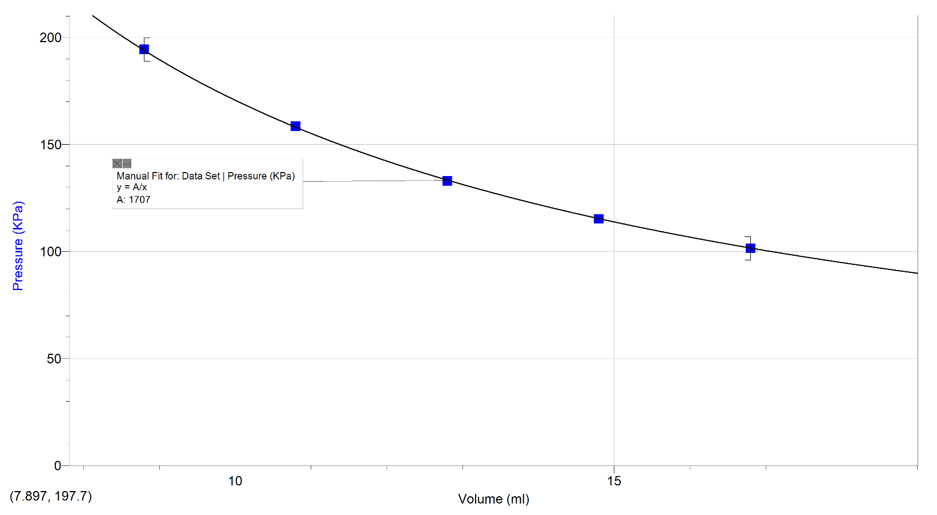
Therefore, equation for Boyle’s law = $k=P∙V$; Therefore $1707=P∙V$; $P=\frac{1707}{V}$
Graph 2: Using the Derived Equation To Add A Line Of Best Fit To Obtained Values

Calculating Values from derived equation: V = 16.80 ml; P = $\frac{1707}{16.80}=101.6$
Comparing theoretical values with experimental and finding percentage error:
$$\left(\frac{101.6-101.51}{101.51}\right)∙100=0.0886\%$$

Processed Data Table 3: Experimental Values Compared With Theoretical Values, Along With Their Respective Percentage Errors.
Theoretical (KPa) | Experimental (KPa) | Error (%)
101.6 | 101.51 | 0.0886
115.3 | 115.26 | 0.0347
133.4 | 132.95 | 0.3384
158.1 | 158.46 | 0.2272
193.9 | 194.42 | 0.2675

Calculating Average Error: $\frac{0.0886+0.3347+0.3384+0.2272+0.2675}{5}=0.2513$%
Observations
- The relation between Pressure and volume is indeed inverse, decrease in volume increases pressure and vice versa
- The Hypothesis holds true
- The value of the constant is 1707 ml$∙$KPa
- The equation for the relation between pressure and volume = $P=\frac{1707}{V}$
- The average percentage error is 0.2513% ~ 0.25%
- As volume decreases, pressure increases and it becomes harder to press down the syringe as it is pushed back
- Values fluctuate more at higher pressure as hands do not remain perfectly still at higher pressures.

Discussion
Sources of error:
Since hands moved more at higher pressures, accurate values may not have been obtained as volume couldn’t be kept constant for longer periods of time. This was a form of observational random error, caused by the inability to measure an accurate value
The derived equation was based on gases acting like ideal gases however real gases do not act like ideal gases. Due to this, discrepancies between theoretical and experimental values were observed. This was a Theoretical Systematic Error, caused by the simplification of the real gas situation and approximation due to the ideal gas equation being applied to a real gas.
The Conditions to make real gases act as close as possible to ideal gases (low temperature, high pressure) were not met; another form of systematic error.
The temperature was assumed to be constant since the experiment was conducted in a closed room, however it wasn’t being monitored and any fluctuations would’ve added to the error.
Sources of improvement:
Elastic clamps to hold together the syringe would’ve kept the volume stable resulting in more accurate measurements of pressure for the desired volume.
Accounting for the differences in real and ideal gas due to difference in environmental conditions
Monitoring the temperature and keeping it constant would’ve reduced discrepancies to some degree as the law requires the temperature to be constant. If blunders or inconsistencies were to happen, they would’ve been identified and corrected due to multiple trials for one condition

Conclusion
Boyle’s law is verified through the experiment as the hypothesis that pressure values will increase when volume decreases holds true throughout all Trials and conditions. The inverse relationship is proven through the changes in pressure as well as the line of best fit for the graph of the experiment. Error margins were minimal at ~0.25% which could have been reduced to some extent through procedural changes mentioned above. Overall, the experiment was a success.

References
Haider, Karrar Dr. Syed. & Zafar, Hamza. (2013). Investigation of Ideal Gas Laws by Using the Pressure Sensor and Thermistor Sensors. Journal of Natural Sciences, 1(1), pp. 08-14.
Olmsted, J. A., Williams, G. M., & Burk, Chemistry, 3rd Canadian Edition



