>> VOLCANOES <<
- Formation
  - Wherever magma and gas leak out from the Earth’s crust/mantle and reaches the surface
  - Extrudes as lava, explodes as pyroclastic material
- Magma vs. Lava
  - Magma: melted rock in the Earth
    - Below the Earth’s surface: melt + crystals + bubbles
    - Hotter than lava
  - Lava: melted rock exposed at the Earth’s surface
- Volcanic System
  - 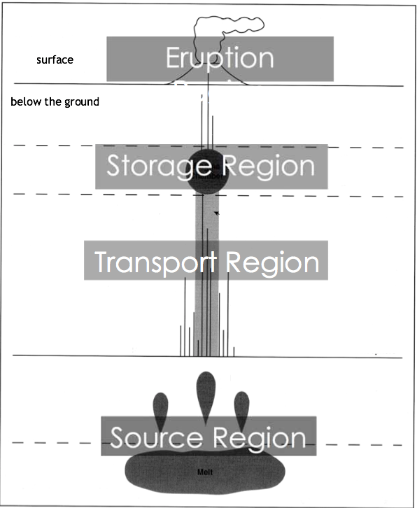
  - Source region
    - Mantle is melting into magma
  - Transport Region
    - Magma channels: magma moves along cracks in the Earth’s crust forming dikes and sills
    - Dikes = vertical
Sill = horizontal
  - Storage Region
    - Magma chamber: magma ponds below the Earth’s surface in large chambers
  - Eruptive Region
    - At the surface : explosion
- Magma Properties
  - Density: 2.5-3.3g/cm³ (around the same density as the crust; less dense than mantle)
  - Viscosity
    - dependent on temperature, gas content, crystal content
    - controls flow & eruption style
    - Pahoehoe lava = low viscosity
A’a lava = high viscosity
  - Silica Content
    - Felsic = high
Mafic low
  - Magma Temperature
    - Felsic = cool
Mafic = hot
  - Magma gas contents
    - Felsic = 4-6 wt.% dissolved volatiles
Mafic = 0.1-1 wt. % dissolved volatiles
  - Explosivity
    - Felsic = high gas content + high viscosity = explosive eruptions
    - Mafic = low gas content + low viscosity = effusive eruptions
  - 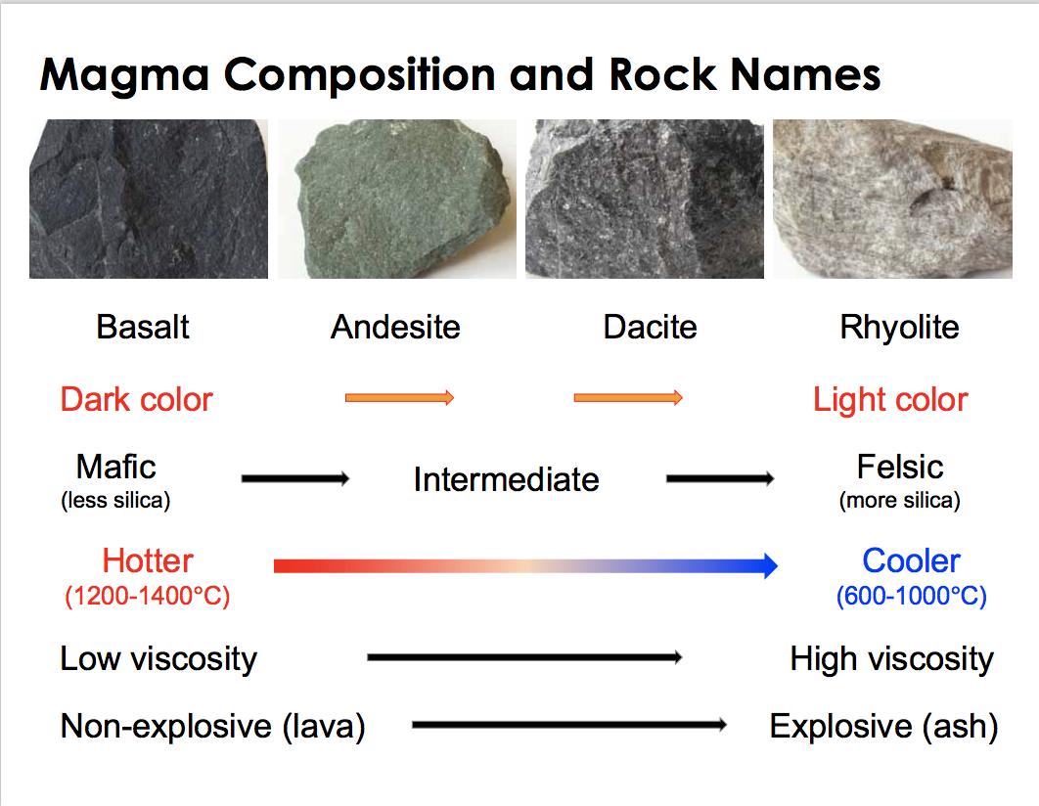
- Igneous Rock Formation
  - Cooled at the surface = extrusive/volcanic, small crystals, rapid cooling
Cooled below the surface = intrusive/plutonic, large crystals, slow cooling
- Where do Volcanoes Occur?
  - Plate boundaries
    - Divergent & Convergent subduction zones
      - Crust composition and melt origin will strongly influence the type of volcanism
      - At continent-ocean collision boundaries & ocean-ocean collision boundaries
    - Mid-ocean ridges
      - reduction of pressure in the asthenosphere brings magma to the surface and from new oceanic pull resulting in lots of volcanic activity and small earthquakes
  - Hot Spots (random volcanoes inside plates)
    - Under continental or oceanic crust
    - Mafic magma from a plume of hot mantle
    - Plumes are stationary and pulsatory
- Melting Mechanisms
  - Divergent
    - Mantle material rises in a dike, pressure decreases
    - Mafic magma may melt overlying crust
  - Subduction Zones
    - Hydration of the mantle by subducting plate
    - Mafic magma melts overlying crust
  - Hot Spots
    - Mantle material rises in cylindrical plume, pressure decrease
    - Mafic magma melts overlying crust
- Magma Types
  - On/beneath/under continental crust: mafic-int.-felsic
Between/beneath/under oceanic crust: mafic
- Types of Volcanoes
  - Cinder Cones
    - Mafic, frequently explosive
    - Layers of pyroclastic ejecta
    - Angle of response= 30-40
    - “Short and small volcanoes that never grow up and usually erupt for a few years and then never again”
  - Shield Volcanoes
    - Mafic, non-explosive but erupts often/continuous
    - Lava (pahoehoe followed by A’a) erupts from fissure, runs down gentle slopes, cooling
    - Eg. Mauna Loa

  - Stratovolcanoes
    - Intermediate-felsic, frequently explosive (viscous magma) and may stay ative for 100,000 years
    - Interbedded lava flows, pyroclastic flows, lahars
    - Eg. Mt St Helens; Mt Garibaldi; Mt Baker
  - Calderas (Supervolcanoes)
    - Felsic, most explosive but rare
    - Large (10’s of km across) explosions of felsic pyroclastic material
    - Created when the roof of the magma chamber collapses
    - Eg. Yellowstone, Wyoming, Crater Lake
- Volcanic Eruptions
  - Effusive
    - Low viscosity & low gas content
    - Outpouring of molten magma (lava) from the vent
    - Passive eruption of magma
      - Lava flows (felsic, low silica)
        - Lava flows downslope, ponds in topographic lows
      - Lava domes (mafic, high silica, high velocity)
      - Gravitational collapse of lava flows/domes (pyroclastic flows)
  - Explosive
    - High viscosity & high gas content
    - Gas driven violent eruptions (pyroclastic deposits) ⇒ comparable to shaking a bottle of champagne
    - Buoyant eruption column of ash
    - Pyroclastic airfall
      - Large eruption columns
      - Widespread distribution of ash in the downwind direction
      - Ash blankets topography
    - Pyroclastic flows
      - Gas-pyroclast mixtures
      - Gravity driven flows
      - Flow down slope, channelled in valleys
      - Velocity = 40 to > 400km/h
      - Temperatures = 100-600 C
    - Block and bombs proximal to vent
  - Key to explosive volcano
    - Gas content + melt velocity
      - Magma produces bubbles during ascent that expand as the magma rises = foaming ⇒ Explosivity
      - Pressure rises inside the bubbles until the strength of the liquid magma is overcome ⇒ Fragmentation occurs and pyroclastic material is made
      - High viscosity promotes explosivity
    - Silica content and viscosity of magma because bubbles cannot easily escape from highly viscous magma
- Types of Explosive Eruptions
  - Hawaiian
    - Low viscosity basaltic magma
    - Low explosivity (effusive)
      - Lava flows, fire fountaining
  - Strombolian
    - Basaltic/andesitic magma
    - Mildly explosive
    - Bombs, lavas
  - Vulcanian
    - Viscous andesitic/rhyolitic magma
    - Very explosive
    - Sustained explosions of ash
      - Ash plumes and ash rain
    - High silica content
  - Plinian
    - Andesitic/rhyolitic ash
    - Violently explosive
    - Sustained column of ash
      - Ash plume and ash rain
    - Pyroclastic flows
  - Phreatomagmatic
    - Contact between water & magma
      - Increases explosivity due to rapid heating of water
    - Water flashes to steam
    - Violently explosive
    - Surtseyan and Phreatoplinan
    - Water vapour clouds, compressed ash, crater, and water
- Volcanic Explosivity Index
  - Describes the size of an explosive volcanic eruption
    - Volume of ash produced
    - Height of eruption cloud above the vent
    - Duration of the eruption
    - Increase in 1 unit = 10x more volume erupted
- Volcanic Hazards
  - Erupted magma is either
    - Quietly like lava or violently as pyroclastics
  - Lava flows
    - Slow
    - Usually not dangerous
    - Easy to predict
    - Mafic + low viscosity
  - Fire fountaining
    - If basaltic, lava is gas-rich
    - Some explosive eruptions form fire fountains
    - As liquid drops fall to the ground, they may coalesce to form a lava flow
  - Pyroclastic Flows
    - Avalanche of pyroclastic material, air, and gas
    - Driven by gravity
    - Velocity = 40=400km/h
    - Origins
      - Collapse of volcanic column
      - Explosive collapse of lava domes
    - Has dense core of boulders which is hidden by billows of ash
    - Usually stays in valleys but can flow over ridges if big enough
  - Lahars
    - “volcanic debris flow”
    - flows of water + loose volcanic debris
    - Prevalent at snowclad and ice cold volcanoes
    - Very hazardous
      - Can travel very far
      - Can occur without an eruption

  - Sector Collapse – Debris avalanche
    - Collapse of the volcano = debris avalanche
    - Landslide (500km/h) triggered an explosive eruption
    - Lateral blast was comparatively cool
  - Volcanic Gases
    - Typically acidic and toxic
    - Consists of water, carbon dioxide, hydrochloric acid, sulphuric acid
- Hazards to people
  - Breathing in ash
  - Total darkness
  - Roofs collapse
- Hazards to aircrafts
  - Engines suck in ash and stop
  - Windshields are scratched and break
  - Turbulence
- Volcanic Hazard vs. Risk
  - Hazard: any potentially dangerous volcanic process
  - Risk: any potential loss or damage as a result of the volcanic hazard
- Volcanic Monitoring & Prediction
  - Hazard maps
    - Map volcanic deposits
    - Determine deposit type (lava flow, mud flow, pyroclastic flow, etc) and distribution
    - Determine age of deposits and eruption frequency
    - Consider the risk
    - 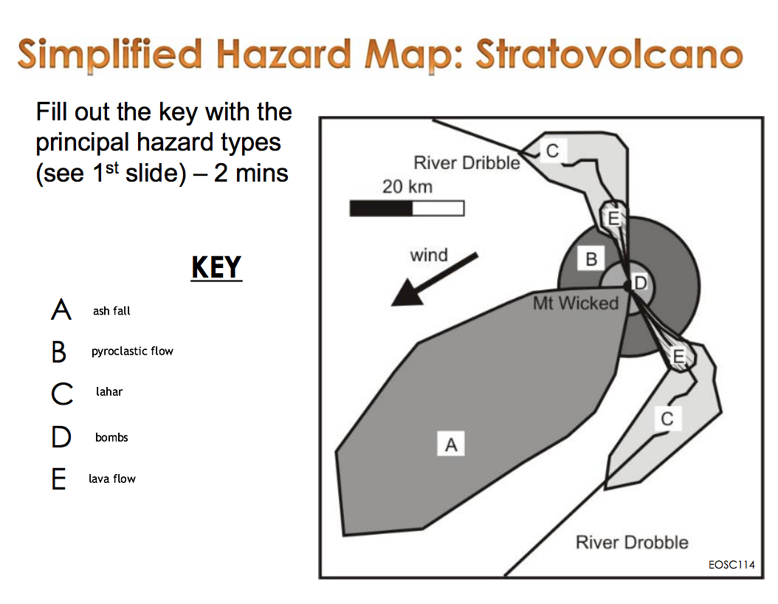
  - Monitoring
    - Seismology – earthquakes
    - Ground deformation
      - GPS & TM (measures changes in angle of slope)
      - InSAR
        - Measurements by satellites to detect changes in elevation
    - Gas emission
      - Fumaroles
        - Measures amounts of CO₂ and SO₂
    - Thermal imaging
      - Monitoring temperature range and change
        - Infrared monitoring instruments
    - Lahar flow detection
      - Monitoring of lahar and debris flow channels
        - Seismic or motion sensing systems
          - Real-time warning
    - Satellite observation
      - Global coverage
      - Rapid repeat instruments
      - Ideal for early warning & remote areas
  - Prediction, Hazard analysis, and Mitigation
    - Sensible zoning/ regulation for population
    - Safe distance from different hazards
    - Warning systems/ procedures
- Mount Baker
  - Stratovolcano
  - Dormant, but hot
  - Dominantly intermediate magma composition: potential for explosive activity
  - Glacier-covered: Potential for lahars
>> LANDSLIDES <<
- Landslide Impacts
  - Human and economic impacts of landslides are broadly governed by:
    - Population density
    - Cost of infrastructure
    - Population preparedness
- Classification of Landslides
  - Type of material
    - Rock, Soil/Earth, Mud, Debris
  - Type of movement
    - Falls, Slides (cohesive block moves on a failure surface) [rotational or translational], flows, complex movements
  - Rate of movement
- Mass Movements
  - Falls
    - Occur on very steep slopes
    - Material detaches because of weakness
    - Falls due to gravity
    - Very fast
  - Slides
    - Vary from slow to fast
    - Usually soil, rock, or debris
    - Material moves as a coherent mass along a surface of failure
      - Rotational Slide (curved fault)
        - Intermediate speed
        - Usually weak material
        - Rotation of material on a curved failure plane
      - Translational Slide (flat fault)
        - Slow to fast
        - Usually strong material on planes of weakness
        - Cohesive motion of material along a flat surface
  - Flows
    - Very slow to very fast
    - Soil, mud, wet debris
    - Water is usually very important
    - Fluid or plastic flow of material
  - Complex movements
    - Combination of mass movements
- Angle of Repose
  - Steepest angle a slope can maintain without collapsing
  - The exact angle varies depending on material
- Stability of Slopes
  - Driving force
    - Gravity
    - Manifests as Shear stress
      - “Shearing” is motion from side to side parallel to the slope
  - Resisting forces
    - Friction
      - Resistance to sliding (proportional to normal force)
    - Cohesion
      - How materials hold together
    - Manifests as shear strength
      - “the slope’s ability to resist shearing motion”
  - When shear strength is surpassed by shear stress, the slope will fail
- Average material strength
Material | Friction | Cohesion | Shear Strength
Crystalline Rock (Igneous or Metamorphic) | Moderate | Very High | High (if cohesive)
Sedimentary Rock | Moderate | High to Moderate | Moderate
Sediment | Low – Moderate | Low | Low

- Causes vs. Trigger
  - Causes
    - Long term factors that lead to the instability of a given slope
    - Reduce the shear strength or increase shear stress
    - DO NOT initiate movement
  - Triggers
    - Short term factors that translate into motion
  - Maybe multiple causes but only ONE trigger
  - Eg, earthquakes, snow melt, heavy rainfall, rain or snow, loud noises, vehicles, volcanic eruptions, excavation, skiing, jumping up and down
- Causes of Mass Movements
  - External causes
    - Factors outside the slope that can affect stability
      - Slope angle
        - You must have a slope to have mass movement
        - Steeper slopes = more movement
        - The cause of most landslides
      - Undercutting
        - The lower part of the slope is removed
        - Removes material supporting the slope
      - Overloading
        - Adding weight
      - Vegetation
        - Roots bind loose material
        - Removal of vegetation can make slopes unstable
        - Heavy trees can increase instability (also overloading)
      - Climate
        - High rainfall
          - More water
          - Increased weathering of rocks
            - More fractures, soil, etc

  - Internal Causes
    - Factors inside the slope that affect stability
      - Water content
        - Adds weight (overloading)
        - Decreases normal force and friction
        - Increases weathering
        - Act as a medium for flows
        - Can hinder cohesion in sediment (loose rocks, sand, silt, and clay)
        - Frost wedging/Freeze thaw
          - Water gets into cracks and freezes & expands forcing the fractures apart
      - Inherently weak materials
        - Weak materials fail at relatively and/or very low angles
        - Eg. Volcanic rock, “quick clay”
          - Clay particles stick together very well, very small particles (Van Der Waals interactions), responsible for quick clay slides
      - Bad geological structures
        - Unfortunate bedding or fracture orientation
        - Structures angles in an instable direction or layered precariously
  - Mass Wasting
    - Water content
      - In sediment
        - No water – low angle of repose
        - Some water – high angle
        - Too much water – very low angle
      - In solid rock
        - Water reduces shear strength along planes of weakness
- Mitigation
  - Investigation
    - Geostatistics
      - Frequency and magnitude
      - Look at history and develop statistics
    - Geological mapping
      - Map materials and properties on site
    - Modeling
  - Avoidance
    - Move to a different area, avoid the problem
    - Very expensive (buying all property in a town, moving a completed highway)
  - Prevention
    - Do something to make sure landslides don’t occur or don’t occur when people are there
    - Removal of material
      - Simple
      - 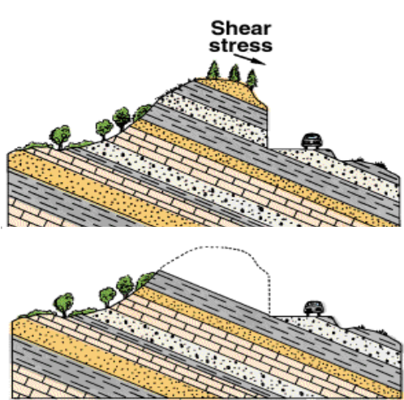
    - Stabilizing slopes
      - Undercut slope: retaining walls or gabions
      - Sliding rock: rock bolts
      - Too much water: drainage
  - Protection
    - Armour or strengthen the area that might be affected if landslides happened (minimize hazard) – control where the landslides go
    - Falling rocks: rock fence, rock net, rockfall shed
    - Debris flow retention structures
      - Removal of debris from debris flow = water

