STUDY SET 05

MULTIVIEWS AND VISUALIZATION

PROBLEMS FOR LABORATORY WORK

5.1 Workbook Problem 5.5 Multiview Sketching 2
Sketch the front, top, and right side views using gridded space.
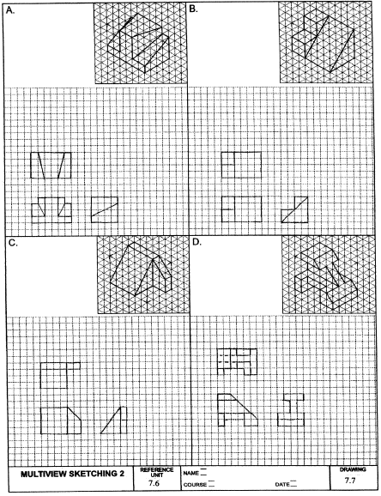

5.2 Problem 5.5 (Figure 5.122)
Sketch or draw with CAD multiviews of the objects shown in the pictorials.
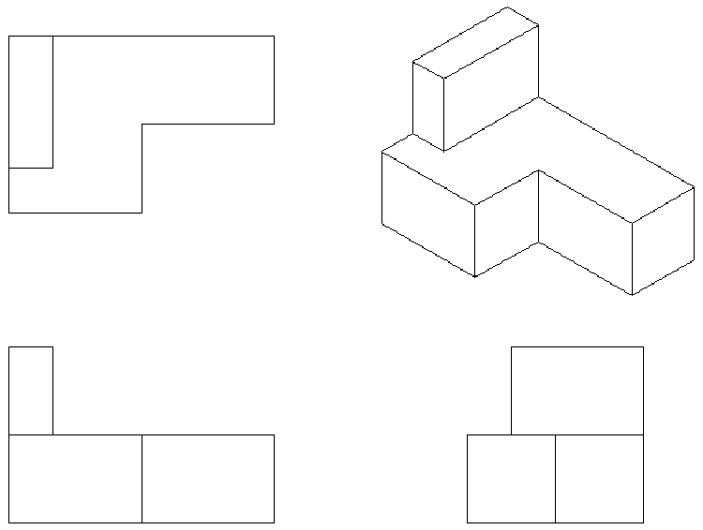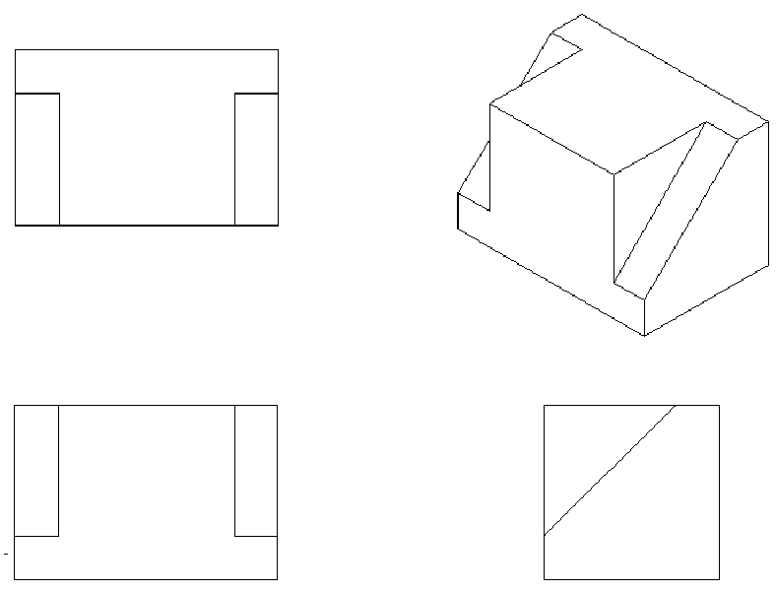
Figure 5.122 (6) Figure 5.122 (18)
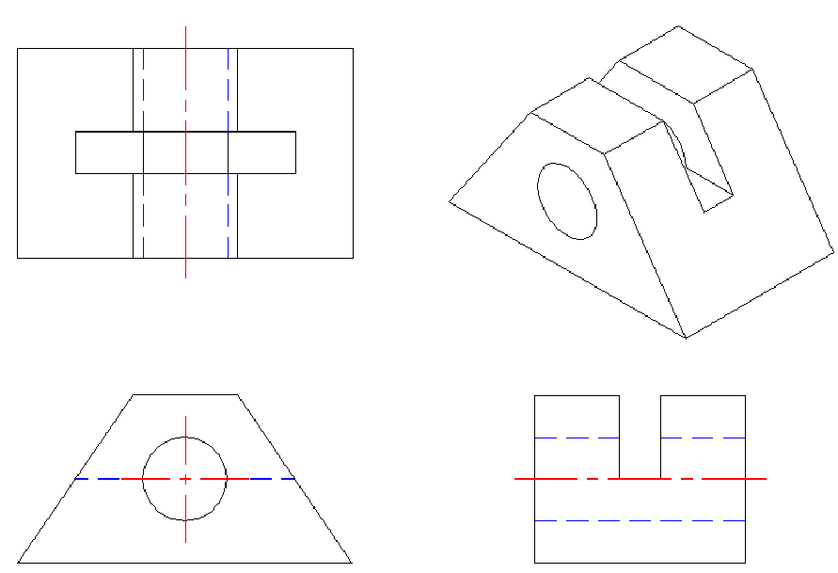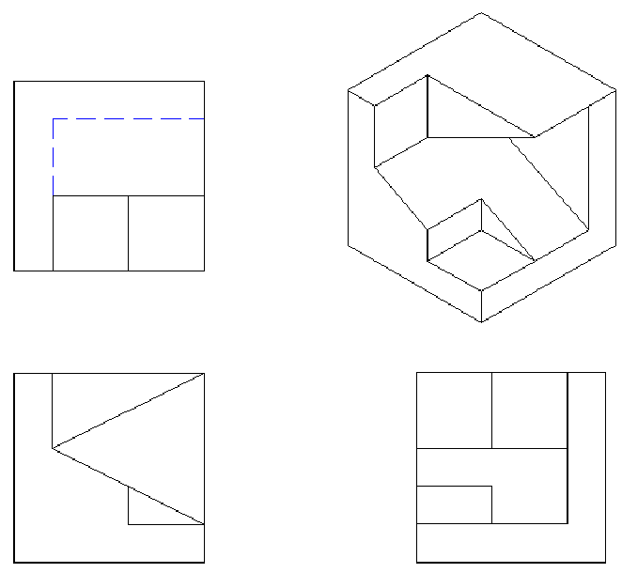
Figure 5.122 (90) Figure 5.122 (95)

5.3 Problem 5.21 (Figure 161.A)
Match the given surface letter from the pictorial drawing with the corresponding surface number from the multiview drawing for each view.
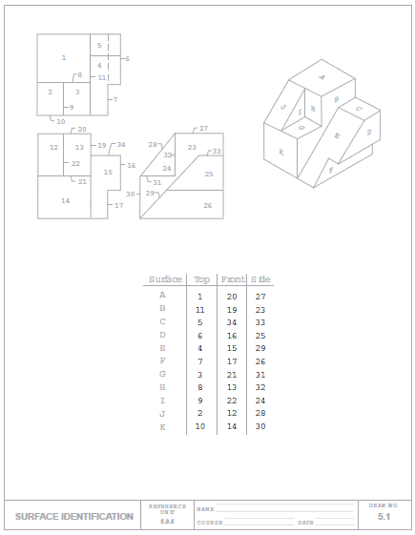

5.4 Problem 5.7 (Figure 5.130) Motor Plate
Given the pictorial, sketch or draw using CAD the multiviews and 3-D CAD model.
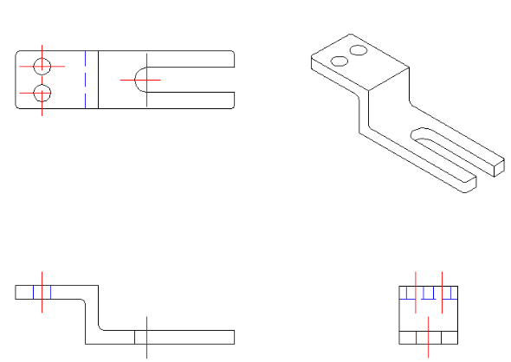

5.5 Problem 5.7 (Figure 5.131) Seat
Given the pictorials, sketch or draw using CAD the multiviews and 3-D CAD model.
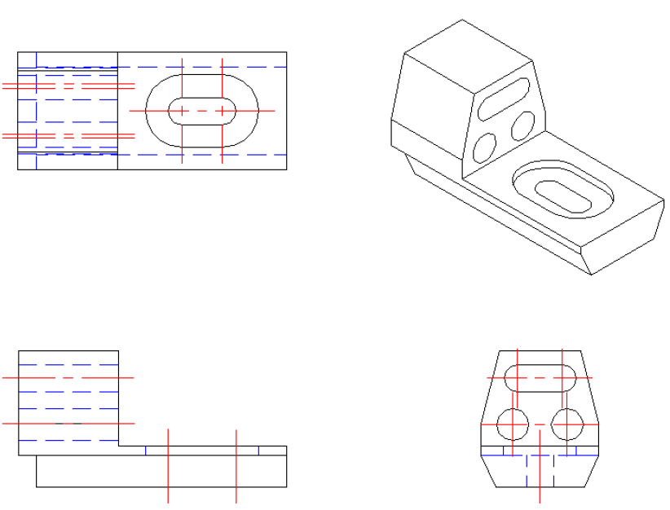

5.6 Problem 5.7 (Figure 5.154) Bearing Plate
Given the pictorials, sketch or draw using CAD the multiviews and 3-D CAD model.
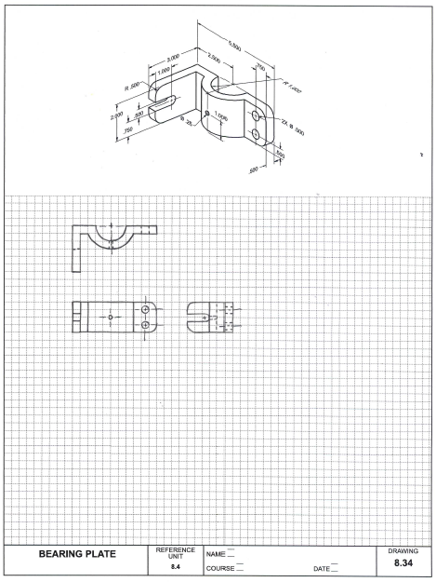

5.7 Problem 5.3 (Figure 5.120)
Given the two views of a multi-view drawing of an object, sketch or draw the given views or use CAD, and then add the missing view. As an additional exercise, create a pictorial sketch of the object.
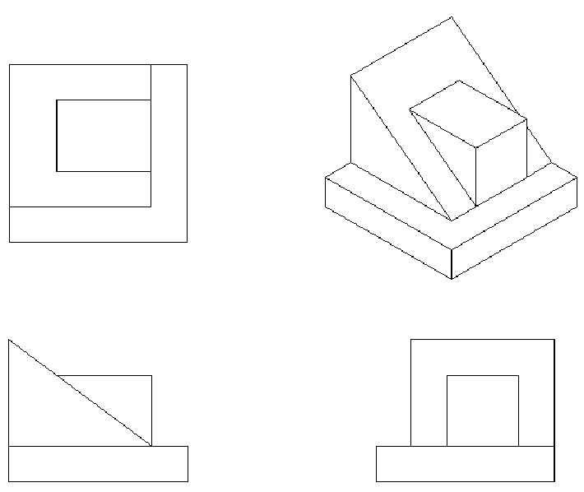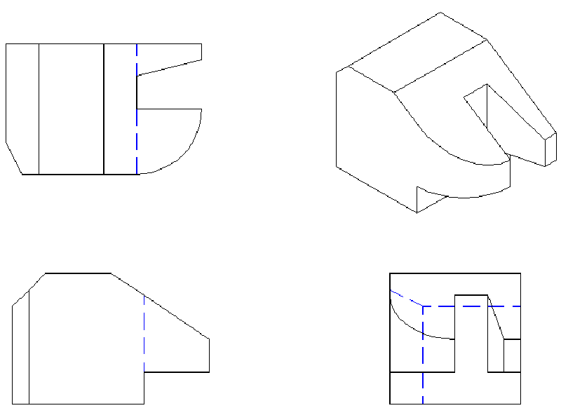
Figure 5.120 (2) Figure 5.120 (14)

5.8 Problem 5.4 (Figure 5.121)
Given the three incomplete views of a multi-view drawing of an object, sketch or draw the given views or use CAD, and then add the missing line or lines. As an additional exercise, create a pictorial sketch of the object.
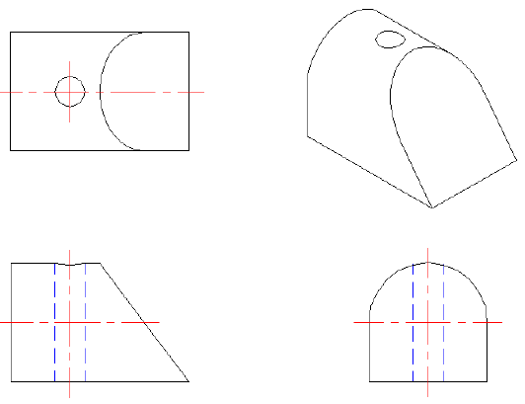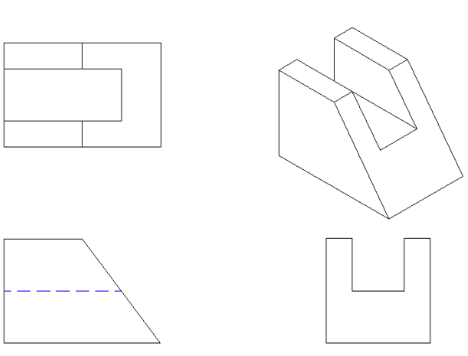
Figure 5.121 (14) Figure 5.121 (24)

SELECTEDPROBLEMS

5.1 Problem 5.5 (Figure 5.122)
Sketch or draw with CAD multiviews of the objects shown in the pictorials.
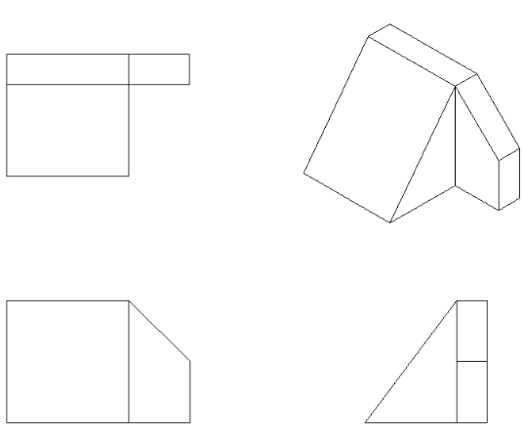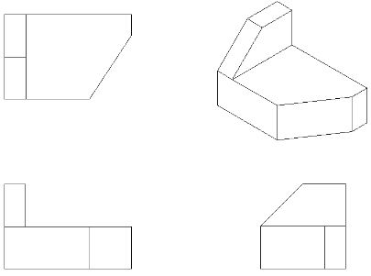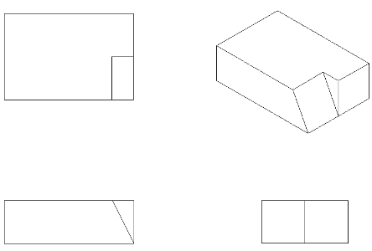
Figure 5.122 (25) Figure 5.122 (26) Figure 5.122 (27)
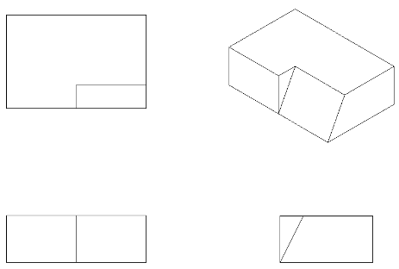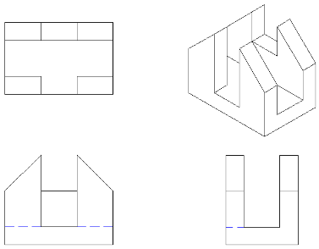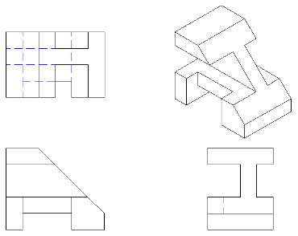
Figure 5.122 (28) Figure 5.122 (29) Figure 5.122 (30)
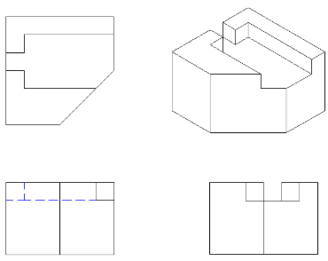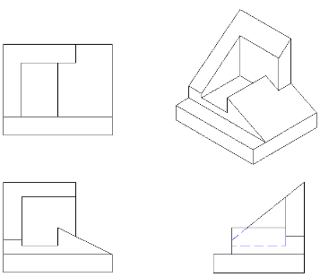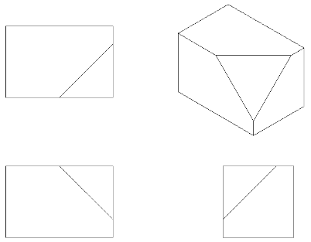
Figure 5.122 (31) Figure 5.122 (32) Figure 5.122 (33)
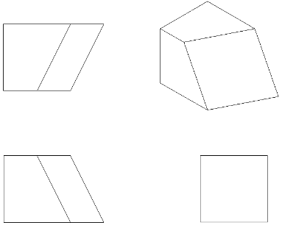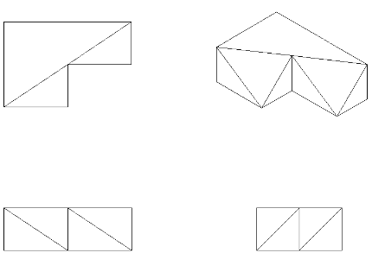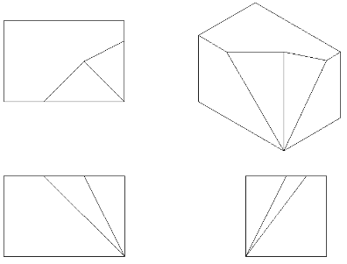
Figure 5.122 (34) Figure 5.122 (35) Figure 5.122 (36)
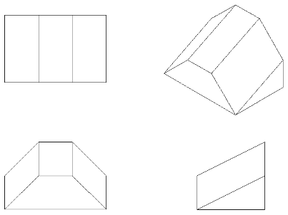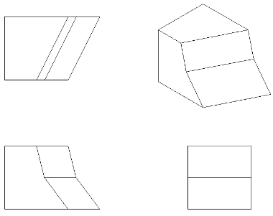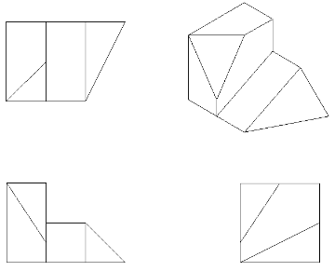
Figure 5.122 (37) Figure 5.122 (38) Figure 5.122 (39)
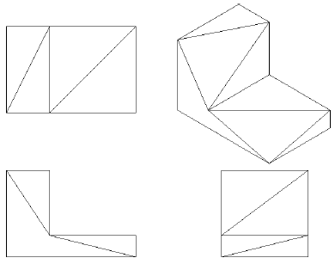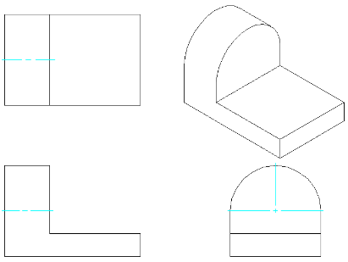
Figure 5.122 (40) Figure 5.122 (41) Figure 5.122 (42)
Figure 5.122 (43) Figure 5.122 (44) Figure 5.122 (45)
Figure 5.122 (46) Figure 5.122 (47) Figure 5.122 (48)
Figure 5.122 (49) Figure 5.122 (50) Figure 5.122 (51)
Figure 5.122 (53) Figure 5.122 (54) Figure 5.122 (55)
Figure 5.122 (56) Figure 5.122 (57) Figure 5.122 (58)
Figure 5.122 (59) Figure 5.122 (60) Figure 5.122 (61)
Figure 5.122 (62) Figure 5.122 (63) Figure 5.122 (64)
Figure 5.122 (65) Figure 5.122 (66) Figure 5.122 (67)
Figure 5.122 (68) Figure 5.122 (69) Figure 5.122 (70)
Figure 5.122 (71) Figure 5.122 (72) Figure 5.122 (73)
Figure 5.122 (74) Figure 5.122 (75) Figure 5.122 (76)
Figure 5.122 (77) Figure 5.122 (78) Figure 5.122 (79)
Figure 5.122 (80) Figure 5.122 (81) Figure 5.122 (82)
Figure 5.122 (83) Figure 5.122 (84)

5.2 Problem 5.21 (Figure 161.B)
Match the given surface letter from the pictorial drawing with the corresponding surface number from the multiview drawing for each view.
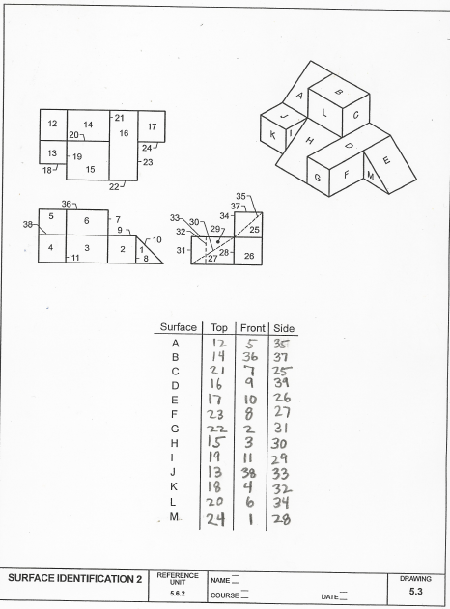

5.3 Problem 5.21 (Figure 162.A)
Match the given surface letter from the pictorial drawing with the corresponding surface number from the multiview drawing for each view.
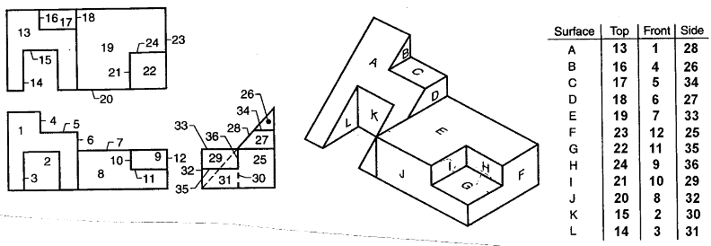

5.4 Problem 5.21 (Figure 162.B)
Match the given surface letter from the pictorial drawing with the corresponding surface number from the multiview drawing for each view.
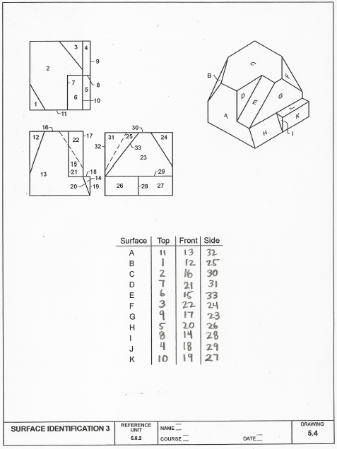

5.5 Problem 5.21 (Figure 163.A)
Match the given surface letter from the pictorial drawing with the corresponding surface number from the multiview drawing for each view.
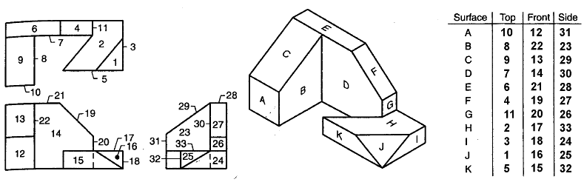

5.6 Problem 5.21 (Figure 163.B)
Match the given surface letter from the pictorial drawing with the corresponding surface number from the multiview drawing for each view.
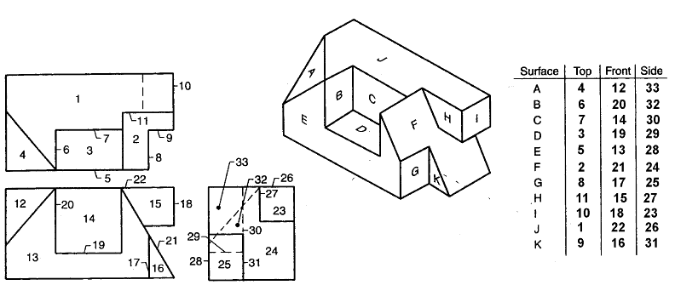

5.7 Problem 5.7 (Figure 5.124) Tool Block
Given the pictorials, sketch or draw using CAD the multiviews and 3-D CAD model.

5.8 Problem 5.7 (Figure 5.132) Cutoff
Given the pictorials, sketch or draw using CAD the multiviews and 3-D CAD model.

5.9 Problem 5.7 (Figure 5.135) Shaft Support
Given the pictorials, sketch or draw using CAD the multiviews and 3-D CAD model.

5.10 Problem 5.7 (Figure 5.136) Stop Base
Given the pictorials, sketch or draw using CAD the multiviews and 3-D CAD model.

5.11 Problem 5.7 (Figure 5.137) Tool Holder
Given the pictorials, sketch or draw using CAD the multiviews and 3-D CAD model.
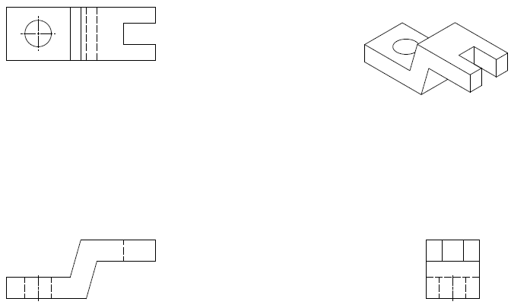

5.12 Problem 5.7 (Figure 5.141) Dial Bracket
Given the pictorials, sketch or draw using CAD the multiviews and 3-D CAD model.

5.13 Problem 5.7 (Figure 5.142) Bearing Block
Given the pictorials, sketch or draw using CAD the multiviews and 3-D CAD model.

5.14 Problem 5.7 (Figure 5.144) Pump Base
Given the pictorials, sketch or draw using CAD the multiviews and 3-D CAD model.

5.15 Problem 5.7 (Figure 5.149) Slide Base
Given the pictorials, sketch or draw using CAD the multiviews and 3-D CAD model.

5.16 Problem 5.7 (Figure 5.150) Retainer Clip
Given the pictorials, sketch or draw using CAD the multiviews and 3-D CAD model.

5.17 Problem 5.7 (Figure 5.151) Strike Arm
Given the pictorials, sketch or draw using CAD the multiviews and 3-D CAD model.

5.18 Problem 5.7 (Figure 5.155) Drive Collar
Given the pictorial, sketch or draw using CAD the multiviews and 3-D CAD model.
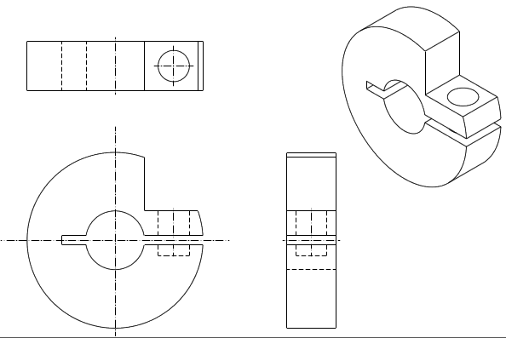

5.19 Problem 5.3 (Figure 5.120)
Given the two views of a multi-view drawing of an object, sketch or draw the given views or use CAD, and then add the missing view. As an additional exercise, create a pictorial sketch of the object.
Figure 5.120 (1) Figure 5.120 (2) Figure 5.120 (3)
Figure 5.120 (4) Figure 5.120 (5) Figure 5.120 (6)
Figure 5.120 (7) Figure 5.120 (8) Figure 5.120 (9)
Figure 5.120 (10) Figure 5.120 (11) Figure 5.120 (12)

5.20 Problem 5.4 (Figure 5.121)
Given the three incomplete views of a multi-view drawing of an object, sketch or draw the given views or use CAD, and then add the missing line or lines. As an additional exercise, create a pictorial sketch of the object.
Figure 5.121 (1) Figure 5.121 (2) Figure 5.120 (3)
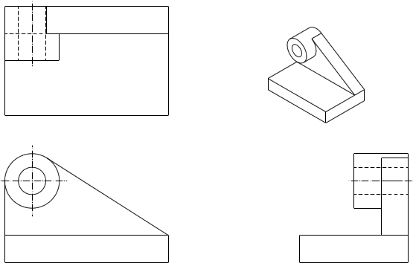
Figure 5.121 (4) Figure 5.121 (5) Figure 5.120 (6)

Figure 5.121 (19) Figure 5.121 (20) Figure 5.120 (21)
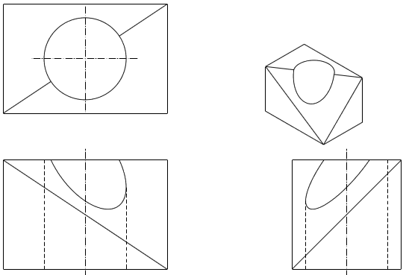
Figure 5.121 (22) Figure 5.121 (23) Figure 5.120 (24)

