Introduction to Computer Usage and Design | INTE 290
CCC

Concordia Cycling Collective
Project Proposal – Word Assignment

Table of Contents
Project Description 3
Timeline 4
Staffing 6
Inventory 6
Fundraisers 6
Opening Hours 7
Sustainability 7
Rules 7
Works Cited 8

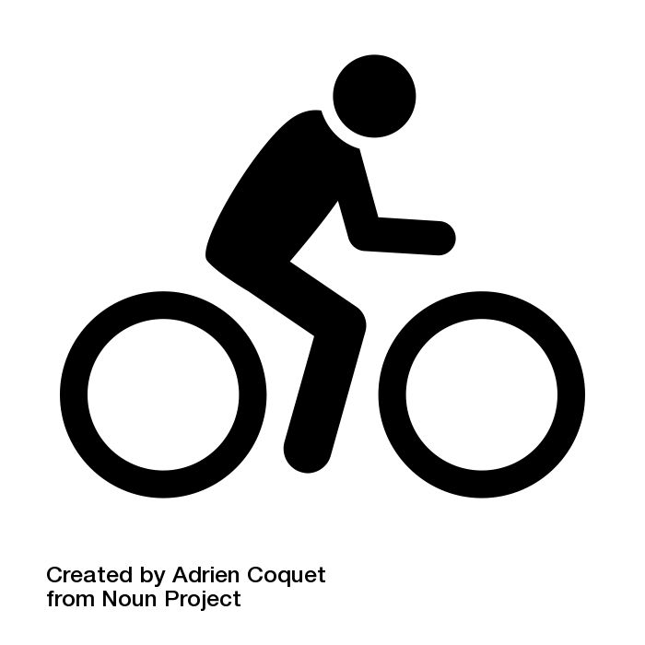

Project Description

The objective of the Concordia Cycling Collective is to build up a community of riders, commuters and racers alike and provide a space for bike maintenance and to host workshops. It will function

In a city such as Montreal, we go through four seasons. Many consider winter as a season to take public transit rather than to bike. At the Concordia Cycling Collective, we aim to change this vision by helping students ride their bikes year-round. By providing its members with the proper knowledge through workshops on evenings about bike safety and regulations along with mechanics guiding students on how to maintain their bikes, we could encourage a safe, effective and cost-efficient way for Concordia students to get around the city of Montreal.

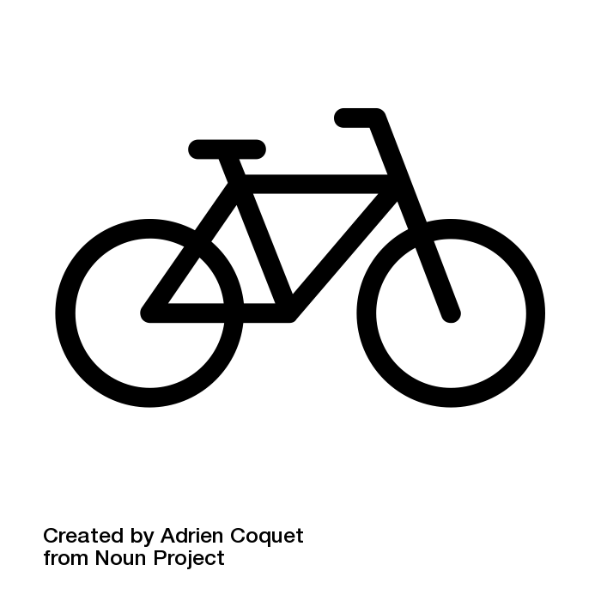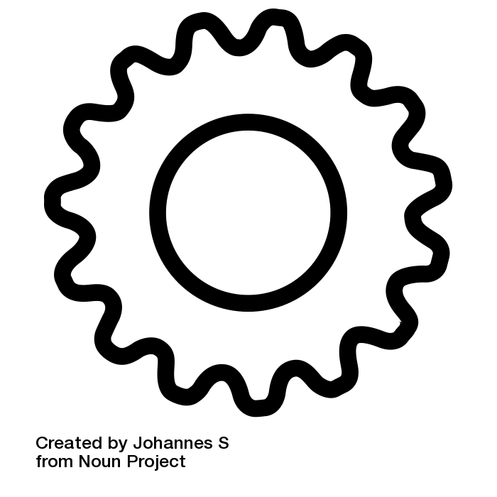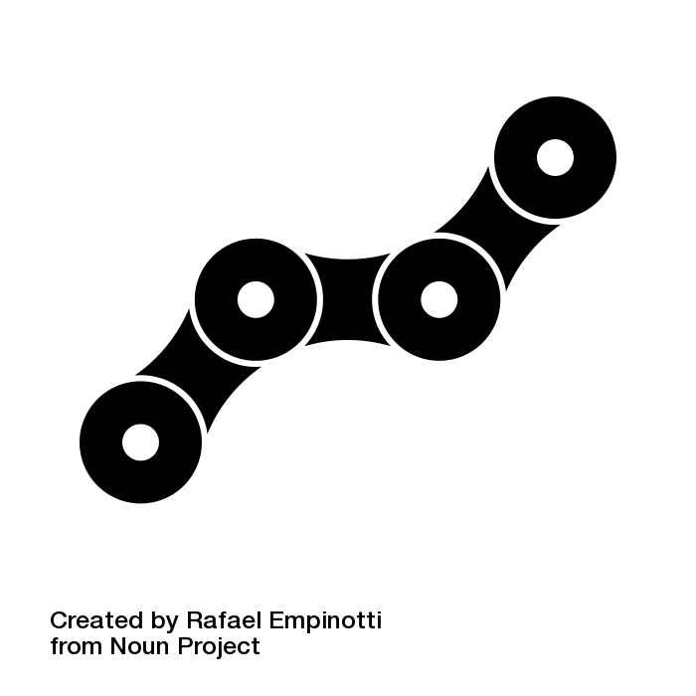

Given that the Downtown Campus already hosts the Concordia Cycling Club, it would be more justified to provide services on the Loyola Campus. The Loyola Campus is perfectly suited as the De Maisonneuve bike path begins right by the building. Promoting cycling in NDG for students can provide an alternative to commuting between the two campuses instead of taking the shuttle.
Timeline

October 16th 2017 | Begin Social Media Management
October 20th 2017 | Begin Volunteer Recruitment
October 23th 2017 | Begin Volunteer Training
October 27th 2017 | Begin Ordering Necessary Tools
November 3rd 2017 | Begin Collective Setup
November 15th 2017 | Grand Opening

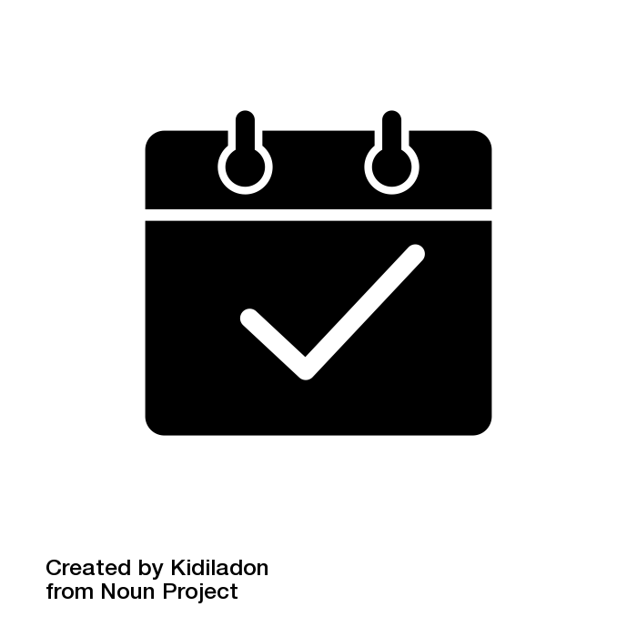

Timeline (cont.)
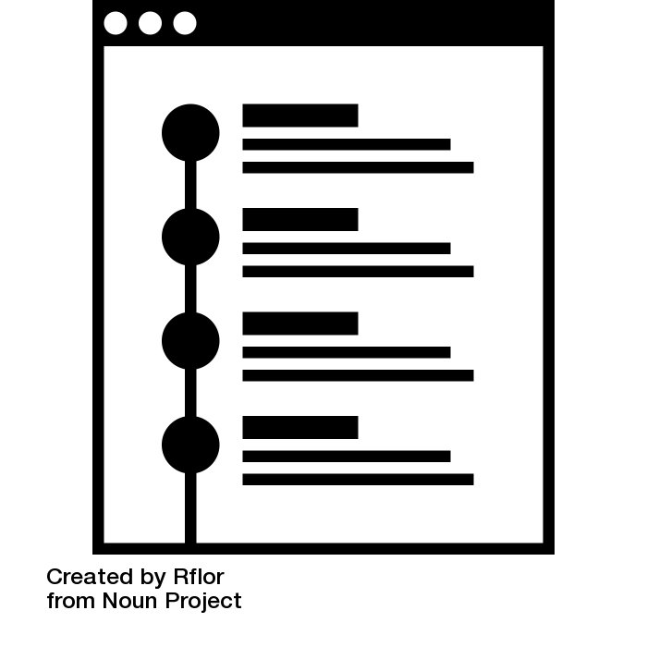
With winter coming, this doesn’t leave much potential to create a debut for the collective. What we, at the Concordia Cycling Collective intend to do is to provide a free workshop on how to prepare your bike for riding in the winter. We plan on teaming up with Recycle Cycle, located on 5501 De Maisonneuve West, conveniently located a 10-minute bike ride from the campus. It can provide parts and services to cyclists and provide parts and tools for home mechanics. A tentative date for the debut of the Concordia Cycling Collective and it’s first workshop would be on Wednesday, November 15th. This date marks the unofficial beginning of winter biking since a few bike paths in the city will be closed as of this day

In our first workshop, we plan to provide:
- Knowledge on how to properly lubricate components to prevent seizing and rust.
- How to properly dress in order to stay warm and dry.
- Components and accessories to consider purchasing.
- Safer routes to take in case of severe weather disruptions.

In addition to what we will be teaching the members of the Cycling Collective, we would provide those who assist our first workshop with a complimentary patch kit and rear fender, which comes to a total cost of roughly 10$ per participant. We estimate to have around 30 participants for our first workshop, bringing our total cost to 300$ in supplies.

Staffing
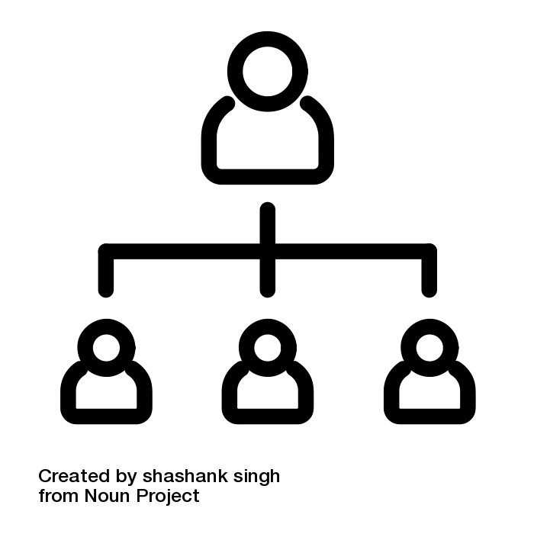
The Concordia Cycling Collective will be run entirely by volunteers. Similar to the Flat Bike Collective, McGill’s bike collective, we would hire volunteers by promoting the collective via flyers and social media posts targeted towards certain demographics and looking at, for example, pages liked by users.

Inventory


The Cycling Collective will carry common parts that are replaced over time such as inner tubes, tires, chains and bearings. We will also carry tools and products for cleaning and lubrication. We strive to provide its members with the ability to solve technical issues wherever they may be. To order parts, we will go through Live to Play Sports to receive these articles mentioned above.

Fundraisers
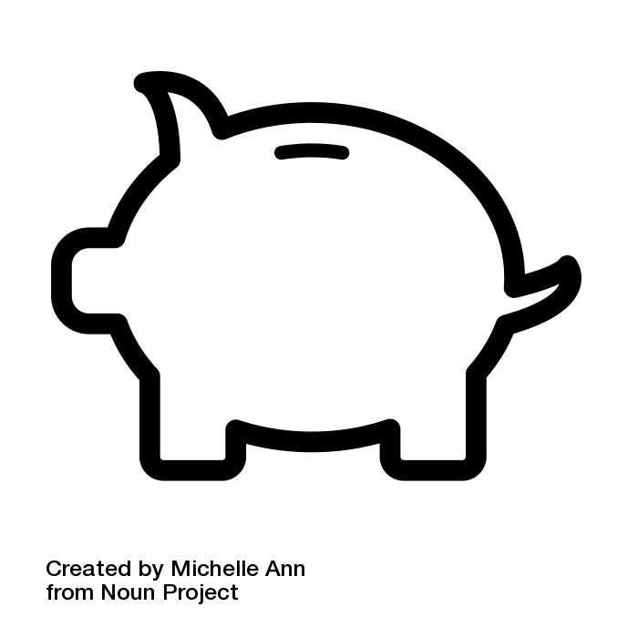
We will organise several rides where anyone can participate. In May, the Collective aims at hosting a bikepacking trip to Oka over a weekend. Members would receive a discount. We would love to host Sunday rides that will function on a pay-as-you-want manner.

Opening Hours

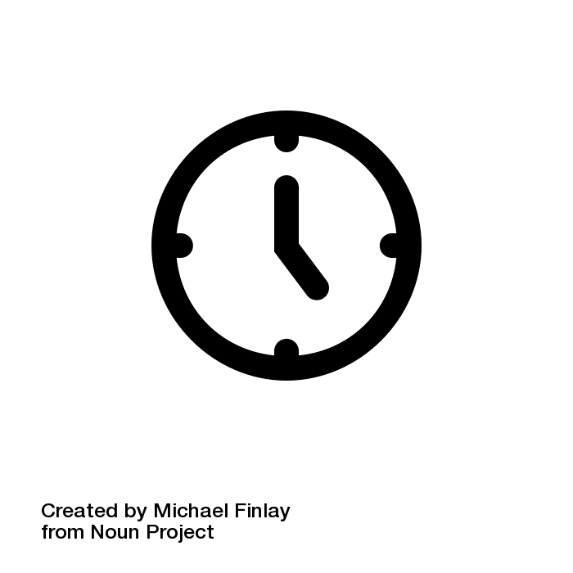
The CCC would like to be open from 6pm to 8pm every weekday in order to provide its volunteers with time of their own, and to provide the services after class times. Workshops would be held on Wednesdays. When the Collective will be closed, we will have an email address that is answered by volunteers in order to respond to questions before or after its opening hours. It could be anything from how to change a flat tire or how to install a bottom bracket. We will be there to help you!

Sustainability
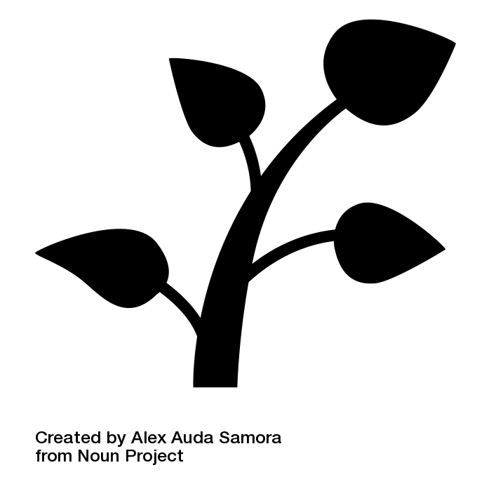
In order for a boat to stay afloat, it needs buoyancy. To maintain our facilities and provide the knowledge and tools to users, the Concordia Cycling Collective will require a 10$ membership paid yearly. This provides access to the CCC and entitles members to purchase parts and tools at a discount. Additional benefits we plan to add will be discounts at various bike shops nearby campus, group rides and seasonal raffles.

Rules
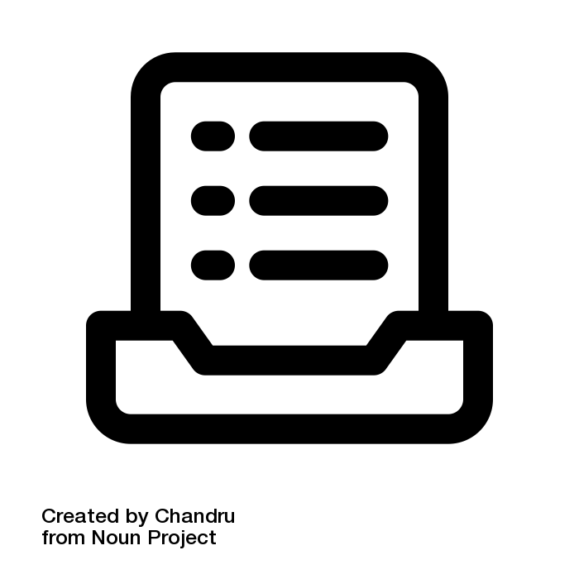
- Treat this space like your own.
- Do not use more than five tools at once.
- Talk to volunteers as you would your friends
- One bike per person inside the collective.
- The pump stays inside the Collective.
- We are not responsible for objects lost or broken.
- Ride on!

Works Cited

- Coquet, Adrien. “Bicycle.” The Noun Project, thenounproject.com. (Page 2)

- Coquet, Adrien. “Bicycle.” The Noun Project, thenounproject.com. (Page 3)

- B., Johannes. “Cog.” The Noun Project, thenounproject.com. (Page 3)

- Empinotti, Rafael. “Bike Chain.” The Noun Project, thenounproject.com. (Page 3)

- Kidiladon. “Timeline.” The Noun Project, thenounproject.com. (Page 4)

- Rflor. “Timeline.” The Noun Project, thenounproject.com. (Page 5)

- Singh, Shashank. “Staff.” The Noun Project, thenounproject.com. (Page 6)

- Mahira, Creative. “Inventory.” The Noun Project, thenounproject.com. (Page 6)

- Ann, Michelle. “Fundraiser.” The Noun Project, thenounproject.com. (Page 6)

- Finlay, Michael. “Clock.” The Noun Project, thenounproject.com. (Page 7)

- Auda Samora, Alex. “Sustainability.” The Noun Project, thenounproject.com. (Page 7)

- Finlay, Michael. “Clock.” The Noun Project, thenounproject.com. (Page 7)

- Chandru. “Rules.” The Noun Project, thenounproject.com. (Page 7)

All icons used in the making of this proposal are licensed under a Creative Commons Attribution 3.0 Unported (CC BY 3.0) license. All images are attributed to their respective creators.

