Introduction: Understanding Leadership

Leadership Defined/Explained
- leadership is the ability to influence,
- motivate and
- enable others
- to achieve a goal and
- to contribute towards the effectiveness of the organizations and the society in which they're members
LEADERSHIP AS A trait
- trait: distinguishing quality of a individual, often inherited
- “great man” theories; imply only some people are leaders:
  - intelligent, alert, responsible, persistent, social, self-confident
- To be effective, you need the right traits for the situation
LEADERSHIP AS AN ability
- ability: a natural capacity can also be acquired
- we can develop our abilities through hard work and practice
LEADERSHIP AS A skill
- Skill: knowing how to do something; being competent
- As a competency, leadership becomes available to everyone.
- If we can learn from experience, we can acquire leadership.
LEADERSHIP AS A behaviour
- Behaviour: what a person does; observable
- Task behaviours: focus on getting the job done
- Process behaviours: focus on improving the situation
- Effective leadership combines these two behaviours in an optimum way
- LEADERSHIP AS A relationship
- Relationship: a process of collaboration
- An unusual way of thinking of leadership
- Focuses on the communication between leaders and followers, rather than just the leader
- An interactive process; not top down
- Mutual purposes imply an ethical dimension
LEADERSHIP AS A Influence process
- The approach emphasized in Northouse;
- Defined: a process whereby an individual influences a group to achieve a common goal
- Interactive event; leaders affect followers
- Common goals imply an ethical dimension
VIDEO ON INDRA NOOYI, CEO OF PEPSI
- What are her points of view on leadership from each approach ?
- 5 C’s
- competency
  - ability, skill, behaviour, influence process
- courage and confidence
  - trait, influence process
- communication skills
  - ability, skill, behaviour, relationships, influence process
- consistency
  - behaviour
- compass (integrity)
  - trait

EVOLUTION OF LEADERSHIP
- from command and control to relational and dispersed leadership
- not commanding or control them but empower them to make choices
DARK SIDE OF LEADERSHIP
- If leaders have the ability to influence other people whats stopping them from influencing people in a negative way?
- The importance of ethics
- Dark leadership occurs when:
  - the leader is destructive
  - the followers are susceptible
  - the environments is conducive
SITUATIONAL LEADERSHIP
- what should a leader do to influence others?
- IT DEPENDS!
- you need to consider:
  - The person being influenced i.e. experience, characteristics
  - The situation i.e. task, time
WHEN PEOPLE ARE AT THEIR BEST AS LEADERS
- Kousez and Posner, Chapter 1
- Leadership begins when leaders seize the moment
  - small opportunities can become something much greater through leadership
- Leaders need to
  - start and keep going
  - practice
  - know their values
  - know values of others
  - transform values and goals into action

Traits and Strengths
- Six key traits
  - intelligence
  - confidence
  - charisma
  - determination
  - sociability
  - integrity
- since the 1800 researchers have tries to identify traits associated with leadership
- started with studying great men i.e. Lincoln, gandhi
- numerous traits have been identified over the years some more relevant than others
INTELLIGENCE
- intelligent individuals have good language skills, perceptual skills and reasoning ability
- it is hard to change your intelligence quotient (IQ) but it is possible to
  - obtain knowledge
  - learn about your job and environment
  - use info to become better leaders
CONFIDENCE
- confidence is a trait that has to do with feeling positive about ones self and ones ability to succeed
- confident people
  - feel self assured
  - believe they can accomplish goals
  - don’t second guess themselves
  - positive about self and ability
- how can we build confidence?
  - understand what is required i.e. reducing uncertainty
  - have a mentor show the way and provide feedback
  - practice !
CHARISMA
- magnetic charm and appeal that gives leaders exceptional powers of influence
  - not a common personality trait
- to increase the appearance of charisma
  - be a strong role model
  - be competent in leadership to gain trust
  - articulate clear goals and strong values
  - communicate high expectation and show confidence on followers ability
  - inspire others
- Dark side of charisma
- some people think charisma is emotional manipulation
  - tendency for followers to think emotionally, not logically
  - example: hitler, jim jones, Jordan Belfort (wolf of wall st.)
DETERMINATION
- someone who is determined
  - is focused and attentive to tasks
  - knows where to go and how to get there
  - takes initiative
  - persists in the face of obstacles
- easiest for leaders to acquire
  - focus on task, clarify goals, articulate vision, and encourage others to stay the course
SOCIABILITY
- the capacity to establish pleasant social relationships
- sociable individuals are
  - friendly, outgoing, courteous and diplomatic
  - sensitive to others
  - tries to get along with everyone
INTEGRITY
- honest and trustworthy people
- inspires confidence and creates trust
- loyal and dependable
- undergirds all the aspects of leadership
- to increase integrity be honest and open

Case 2.1: an emerging leader
- nature vs nurture
- intelligence and charisma are the hardest traits to develop
- there are certain traits that do influence leadership effectiveness
- although we do ted to think of traits as natural, they can be built through practice and other means
  - aspiring leaders should build these within themselves and also help their followers build them
  - in order to know what to build, we have to better understand ourselves
  - requires the open and honest input of others

Engaging peoples strengths
WHAT ARE STRENGTHS ?
- an attribute or quality of an individual that accounts for successful performance
- ability to consistently demonstrate exceptional work
- positive features of ourselves that make us effective and help us flourish
BREIF HISTORY
- a lot of psychological research focuses on what is wrong with people
  - but what about what is right with people ?
  - positive psychology, research by the gallup organization
- positive psychology is the scientific study of what makes life worth living
- Leadership challenges
  - how can we identify our strengths an those of others?
  - how can we use this info to improve our leadership?
INDENTIFYING STRENGTHS
- tools including
  - executing, influencing, relationship building and strategic thinking
- values in action and inventory of strengths
  - wisdom, courage, humanity, justice, temperance, transcendence

Case 3.1 Ready to be CEO?
- We all have strengths, but they sometimes go unrecognized or unused
- Understanding strengths and weaknesses is the first step, for ourselves and for others
- Once we know our strengths, we should use them as a basis for our leadership
- We can further develop our strengths by communicating them to others and investing time in to our talents
- We can further develop other peoples’ strengths by recognizing them (through communication or observation), engaging strengths, and giving feedback (more positive than negative)

Model the Way: Clarify Values and Set the Example
UNDERSTAND YOURSELF FIRST
- The first step you must take along the path to becoming an exemplary leader is inward
- Leadership is influenced by
  - who we are (traits);
  - what we are good at (strengths); and
  - what we believe in (values).
- In other words, Leadership is a means of personal expression
VALUES: WHAT ARE THEY?
- The things you believe are most important to you and the way you live, work and play
- Your heart’s deepest desire for how you want to live your life
- Different for everyone: there is no right or wrong value
WHY ARE THEY IMPORTANT?
- Values are your compass
  - Influence every aspect of your life
  - Guides your actions; helps with consistency
  - Sets the boundaries for our decision and our behaviours
- The best leaders are clear about their personal values
  - You can only model the way if you know where you are going
- When actions align with values, people are more satisfied and energized
  - R2 profiler: performance AND energy are important in determining your strength
  - Relates back to Tim T. from Case 2.1 (Northouse)
- Why do we need to know our values?
  - Impacts leader effectiveness
  - Leaders’ Values —> motivation & productivity —> trustworthiness, consistency, credibility
FIND YOUR VOICE
- How do you find out what’s important to you?
  - Self-exploration: the need to ask yourself deep questions
- The importance of being genuine
  - Show people the real you: it’s okay to be vulnerable
  - Don’t fake it
  - Is this value really mine?
SAY IT IN YOUR OWN WORDS
- Do:
  - Use your personal values as a starting point
  - Be inspired by quotes/songs/people that resonate with you
  - Use your own words
- Do not:
  - Use someone else’s words (remember to be genuine!)
  - Use complicated language
AFFIRM SHARED VALUES
- Everyone comes with their own values; if we share values (alignment), we can reap major benefits
- Alignment
  - Integrity of Decisions
  - Confidence in one another
  - Increased productivity and creativity
  - Communication Quality & Accuracy
- Understand your values, and those of others
  - Help your followers explore their values
  - Talk about values
- Use the common values to
  - Build a foundation;
  - Motivate people to work towards a common cause; and
  - Follow a common set of principles
- What if there are no shared values? How do you build alignment?
- Forge unity, don’t force it
  - Include your followers in the process
  - Give people reasons to care instead of demanding they do
- What traits and/or strengths might help forge unity?
SUMMARY
- There our endless amounts of things that we could value
  - Need honest and ongoing self-exploration
- Following our values has many positive outcomes
  - When values align with behaviour, we:
    - Are more satisfied, motivated, productive, etc.
    - Behave consistently, which builds our credibility, trustworthiness, etc.
- Forging (not forcing) shared values can improve the groups’ communication, confidence, integrity, etc.

Model the Way: Set the Example
- We have clarified our values, now what?
  - Do what you say you will do (be credible)
  - Walk your talk
  - Be the example
- In other words…. Align your behaviour with your values
LIVE THE SHARED VALUES
- Spend Your Time and Attention Wisely
  - If you don’t believe the messenger, you won’t believe
  - People watch a leader’s every move to see if they are serious about what they say
  - How you spend your time is the clearest indicator of what is important to you
    - Has a huge influence on those around you
- Watch your language
  - Language helps build the frame through which people view the world
  - Words have power to:
    - Shape thoughts and actions
    - Strengthen or diminish others
    - Affect every area of your life
  - Speak with authenticity, avoid buzzwords
  - E.g., Lacrosse team’s use of mottos, hashtags, etc.
- Ask purposeful questions
  - Questions frame issues – set up the perspective that you want others to take
  - Good questions and good listening communicate respect, make people feel involved, and build support for your direction
  - Go back to values when formulating your questions
- Seek Feedback
  - Credibility is based on other peoples’ perceptions of the leader
  - If you don’t ask, how else do you (honestly) know how you are doing?
  - Allows for self-reflection and builds trust
  - … but that doesn’t mean it’s easy
TEACH OTHERS TO MODEL VALUES
- Confront Critical Incidents
  - Chance occurrences that can be important teachable moments
  - Provide a unique opportunity for you to improvise while trying to stay true to the groups’ values
- Reinforce through Systems and Processes
  - All of the things you do send signals about what you value and what you don’t
  - Set up systems and processes to reinforce things you value
- For example:
  - Employee of the month
  - Reward systems
  - Open-door policy
SUMMARY
- Now that we have a clearer idea as to what our values are, we have to live those values as much as we can
  - You can do this through your own behaviours
  - Spend your time and attention wisely
  - Watch your language
  - Ask purposeful questions
  - Seek feedback
  - And by influencing others
  - Confront critical incidents
  - Tell stories
- Reinforce through systems and processes

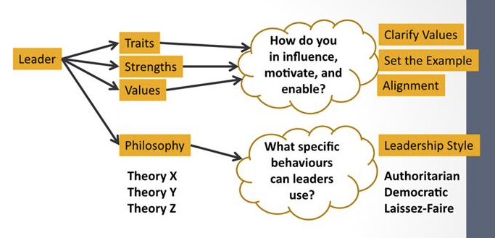
Understanding Philosophies and Styles

PHILOSOPHICAL QUESTIONS
- Are people basically good?
- Would people work if they didn’t have to?
- Is doing work as natural as play?
- Would people work as little as possible if given the chance?
- Are people inherently self-centred?
- Do people prefer security or responsibility?
PHILOSOPHY AND STYLE
- Philosophy: our beliefs and attitudes
- Style: our behaviours
- Influences
Style
- authorization
- democratic
- laissez-faire
Philosophy
- theory x
- theory y
- theory z

- In other words… our beliefs and attitudes about human nature influence how we behave as a leader
THEORY X & Y (&Z)
- Define each theory (“what”)
  - Assumptions about employees and human behaviour
- Understand the consequences of each theory (“so what”)
  - Positive and negative
- Recognize situations where each theory is the most appropriate (“when”)
  - Situational leadership
- Douglas McGregor, 1906-1964

THEORY X - KEY ELEMENTS
- Assumptions:
  - LEADERS are responsible for organizing resources
  - PEOPLE dislike work; resist work; and need to be controlled, rewarded, punished, and persuadedat every step in order to be productive.
- SO LEADERS NEED TO….
  - control individuals’ actions,
  - direct their efforts and
  - modify their behaviour.
- Other assumptions
- PEOPLE
  - work as little as possible
  - are inherently self-centered and indifferent to organizational needs
  - are resistant to change
  - are gullible, not very bright, and they are the ready dupe of others
  - want security, not responsibility
THEORY Y - KEY ELEMENTS
- Assumptions:
  - LEADERS are responsible for organizing resources
  - PEOPLE DO NOT dislike NOR resist work; if this is true, it’s their experiences that have made them this way…
- PEOPLE find work as natural as play;will show responsibility and commitment to goals; and will learn to accept and seek responsibility.
- SO LEADERS NEED TO….
  - create conditions so people can reach goals (e.g., remove obstacles and provide guidance).
LEADERSHIP STYLE
- Driven by your leadership philosophy
- You can use multiple styles in any situation; they are not exclusive
- Styles and Philosophies:
  - Authoritarian, largely reflects Theory X
  - Democratic, largely reflects Theory Y
  - Laissez-Faire, doesn’t really reflect either
AUTHORITARIAN
- Similar to Theory X
  - Exert influence and control over group members
  - Communication is top down
  - Agenda is set by the leaders
  - Praise/criticism is given freely, but it based on personal standards (not objective standards)
DEMOCRATIC
- Similar to Theory Y
- Leaders work with their employees enabling them to reach their goals
- Egalitarian view of the organization
  - The boss is NOT superior
  - EVERYONE’s voice should be heard
- Role is more of a teacher, providing guidance, support and making sure that employees have the resources to get the job one. Being the guide rather than the control
LAISSEZ-FAIRE
- A hands-off, let things ride approach
  - Abdicates responsibility
  - Delays decisions
  - Gives no feedback
  - Makes little effort to help followers satisfy their needs
- Is this actually leadership?
SUMMARY
- Our philosophy of human natures (theory x, y) influence our leadership style
- Authoritarian, democratic and laissez-faire are all different leadership styles; leaders will probably use some combination of each
  - Each style has its advantages and disadvantages
  - The best style to use depends on the person and the situation
  - Using the right style -> positive consequences
  - Using the wrong style -> negative consequences

Attending to Tasks and Relationships
TASK AND RELATIONSHIP STYLES
- Relationship-oriented
  - Consideration
  - Employee orientation
  - Concern for people
- Task-oriented
  - Initiating structure
  - Production orientation
  - Concern for production
TASK STYLE
- Focused on:
  - Achieving goals
  - Getting the task done
  - Structuring work and timelines
  - Defining responsibilities
  - Concerned with productivity and task performance
What are some examples of behaviours of a task-focused leader?
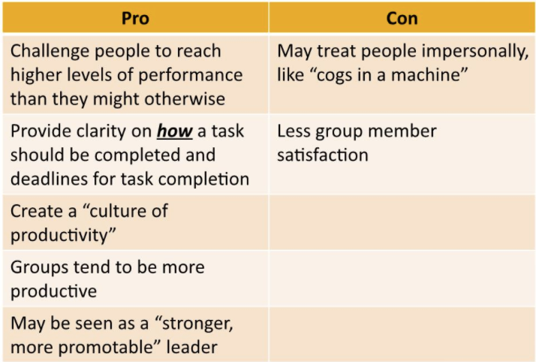
What are the strengths and weaknesses of a task-oriented leader?

task style - pros and cons
FUN FACT: FIRST BORN CHILDREN ARE MORE LIKELY TO TAKE ON A TASK STYLE OF LEADERSHIP

RELATIONSHIP STYLE
- Focused on:
  - Generally show a concern for people
  - On individuals
  - Show respect for employees (consideration behaviours)
  - Understanding and being sympathetic to the special needs and circumstances facing individuals
  - Valuing the unique contributions of individuals
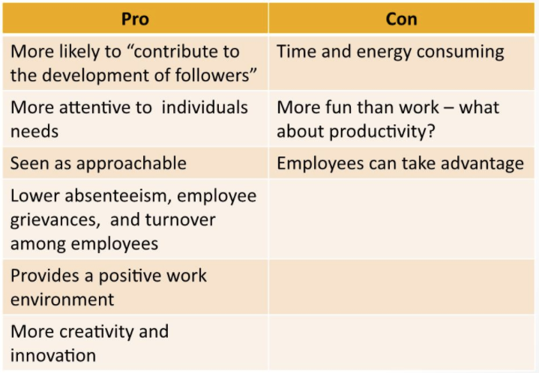
  - Demonstrating a sense of trust in individuals

Relationship Style – Pros & Cons
FUNDAMENTAL CHALLENGE: Find an optimal way to integrate tasks and relationship styles

IMPORTANT CONSIDERATIONS
- Do leaders:
  - Have the capacity to change their leadership style from a task to a relationship orientation and vice-versa?
  - Always assess correctly when you needed a relationship-orientation or a task orientation?
  - Create feelings of inequity between group members IF some group members were led with a task orientation while others were led with more of a relationship orientation?
SUMMARY
- Leaders can influence people by
  - Helping them complete tasks, achieve goals, etc.
  - Creating positive relationships, caring about others
- The KEY is to understand the situation and the needs of your followers
  - Can we train leaders to do this effectively? (maybe)
- Finding a balance between task and relationship behaviours will help

Developing leadership skills
RECALL: TRAITS VS SKILLS
- Trait: distinguishing quality of an individual, often inherited.
  - You either have it, or you don’t
- Skill: knowing how to do something; being competent
  - As a competency, leadership becomes available to everyone.
  - If we can learn skills, we can become a better leader.
SKILLS VS STRENGTH
- Strengths: areas in which we excel or thrive
  - Looked at themes across a few frameworks
  - Explained what we should do with our
    - Strengths – Realized vs. Unrealized
    - Learned behaviours
    - Weaknesses
  - Key point: it is important to know what we/other people are/are not good at
- Skills: learned competencies that help us perform well
  - What specific skills do leaders need to have?
  - Key point: There are specific skills that help a leader influence others
    - Some of these may (or may not be) aligned with our strengths
ADMINISTRATIVE SKILLS
- Help carry out the purposes and goals of the organization
  - Planning, organizing, co-ordinating
  - The mundane, but nonetheless important, aspects of leadership
- Three specific skill-sets:
  - Managing People;
  - Managing Resources;
  - Showing Technical Competence
MANAGING PEOPLE
- Connects with people, understands the tasks and skills required, as well as the overall environment
- Focused on getting people to:
  - Work as a team
  - Be motivated to do their best
  - Promote satisfying relationships
- Occupies most of a leaders time e.g. coach
MANAGING RESOURCES
- Besides people, there are many other resources to be managed, including:
  - Money
  - Supplies
  - Equipment
  - Space
- Key questions:
  - How do you get more resources?
  - How do you allocate resources?
SHOWING TECHNICAL COMPETENCE
- Having specialized knowledge about the work that needs to be done
  - Understands the intricacies of how the organization functions
  - Knowing how to do the activities your followers are doing
- Also called “functional competence”
- Varies for each context
- Don’t need to know EVERYTHING in EVERY SITUATION
INTERPERSONAL SKILLS
- People skills – help a leader work effectively with others to accomplish goals
  - E.g. subordinates, peers, superiors, customers, etc.
- Three specific skill sets:
  - Being Socially Perceptive
  - Showing Emotional Intelligence
  - Managing Interpersonal Conflict
BEING SOCIALLY PERCEPTIVE
- Understanding the unique needs, goals and demands of different individuals or groups
- Having insight and awareness in to things like:
  - What is important to others?
  - How they are motivated?
  - What problems do they face?
  - How do people react to change?
SHOWING EMOTIONAL INTELLIGENCE
- Emotional intelligence involves:
  - Understanding your emotions;
  - Understanding other people’s emotions;
  - Using this information in your actions
- Involves the ability to:
  - Perceive and express emotions
  - Use emotions to facilitate thinking
  - Understand and reason with emotions
  - Manage emotions effectively
- Be aware of your emotions
  - Self-awareness
- Be aware of other people’s emotions
  - Empathy
- Regulate your emotions
  - Self-regulation
- Put emotions in to use
  - How do they help/hinder you achieve your goals?
  - Relationship adeptness – induce emotions in others
MANAGING INTERPERSONAL CONFLICT
- Conflict is
  - A struggle between two or more people over perceived differences in substantive or relational issues
  - Usually uncomfortable
  - Not always bad
- When does conflict occur?
  - When something needs to change
  - After something has changed
- Managing conflict
  - Reduces stress
  - Increases problem solving
  - Improves group relations
CONCEPTUAL SKILLS
- Thinking or cognitive aspects of leadership
  - Concepts, ideas
- Three specific skill sets:
  - Problem solving
  - Strategic Planning
  - Creating a Vision
PROBLEM SOLVING
- A leader’s ability to take corrective action in a problem situation to meet desired objectives.
- Skills include the following:
  - identifying the problem
  - generating alternative solutions
  - selecting the best solution from among the alternatives
  - implementing that solution
STRATEGIC PLANNING
- Developing careful plans of action based on available resources and personnel to achieve a goal
- Boal & Hooijberg (2000) suggest that strategic leaders need to have:
  - the ability to learn - capacity to absorb new information and apply it towards new goals
  - the capacity to adapt - being able to respond quickly to changes in the environment
  - Managerial wisdom - deep understanding of people and the environment in which they work
CREATING VISION
- The capacity to challenge people with compelling visions of the future
- To create vision, a leader needs to:
  - Develop and communicate a picture of the future that is better than the present
  - Forge new ideals and values in to others that support the vision
  - Model the way (set the example)
LEADING VS MANAGING
- Administrative
  - Managing People
  - Managing Resources
  - Showing Technical Competence
- Interpersonal
  - Being Socially Perceptive
  - Showing Emotional Intelligence
  - Managing Interpersonal Conflict
- Conceptual
  - Problem Solving
  - Creating a Vision
  - Strategic Planning
SUMMARY
- Administrative, interpersonal, and conceptual skills play a major role in effective leadership.
- Complex situations require leaders to use all of these skills; they are all related to one another.
- Through practice and hard work, leaders can improve their skills in each of these areas.

Creating a vision
WHAT IS IT
- A mental model of an ideal future state
- Answer to the question: “what could be?”
WHAT DOES IT LOOK LIKE
- An image (picture?) of what the future could look like
- An emphasis on change and challenge
- Based on one’s own values, the values of others, and the values of the organization
- Provides a road map for the future
- Links the present to the future (Daft, 2011, p. 400)
- Helps to establish a standard of excellence and integrity (Daft, 2011, p. 401)
CONTINUED
1. An image (picture?) of what the future could look like
- Ideal picture of where an organization should be going
  - A future that is better than the status quo
  - Requires an act of faith by followers.
- Image may be more productive, confirming, or inspiring than the present
- Sometimes a leader’s vision is clear, sometimes it is only a general direction that gives a “bare bones” notion of where they are leading others and the final picture may not emerge for some time
2. An emphasis on change and challenge
- Represents a change in the status quo; toward something more positive in the future.
- Change can take many forms,
  - E.g., rules, procedures, goals, values, or rituals.
- It is not uncommon for leaders to experience resistance to their vision and be accused of “stirring up the pot”
3. Based on one’s own values, the values of others, and the values of the organization
- Need to understand everyone’s values now
- What values does your vision value most?
  - What are you putting more or less emphasis on?
4. Provides a road map for the future
- A map to guide people, to let them know when they are on- or off-track.
- A guiding philosophy that gives people meaning and purpose.
  - A sense of certainty and calmness when you know you’re on track
  - Easier for people to identify with organization
  - Understand and appreciate where they fit within the organization.
5. Links the present to the future (Daft, 2011, p. 400)
- It helps when individuals know how the future relates to the present
  - What’s going to change? What isn’t?
  - What strengths are we leveraging?
- Most individuals are rewarded for what they are able to achieve today BUT they also have to work on achieving a longer term vision
6. Helps to establish a standard of excellence and integrity (Daft, 2011, p. 401).
- Gives insight in terms of how to “measure” success
PERSONAL VISION STATEMENT
- Do you have a person vision for your future?
  - Academically
  - Professionally
  - Personally
6 ELEMENTS OF A VISION STATEMENT
- Involve Others
- Be Short and Sweet
- Choose Your Words Carefully
- Be Patient
- Adapt Your Vision to Your Audience
- Implement It
HOW TO CREATE A VISION
1. Involve Others
- It’s not just the leader’s vision!
- Consulting with others increases the chances the vision reflects and inspires others
- Remember: Leadership is a relationship
  - E.g., Laurier involved students, staff, faculty and alumni
2. Be Short and Sweet (i.e., Be Articulate)
- The best visions are inspirational, clear, memorable, and concise.
- You want people to remember it, right?
3. Choose Your Words Carefully
- Remember the power of language? (See K&P Ch. 2)
- Words should be inspiring and motivating
- Use inclusive words like “we” and “us” instead of “I” or “they”
- Use symbols, if appropriate
4. Be Patient
- It takes time to:
  - Consult with various groups
  - Prepare drafts of the vision
  - Get feedback
  - Approve a vision
5. Adapt Your Vision to Your Audience
- If it is too demanding, it will be rejected
- What degree of change are people willing to accept?
  - What is their latitude of acceptance?
- Hmmm…. this can be good advice, but others (Collins & Porras) say you should set ‘BIG HAIRY AUDACIOUS GOALS’
  - Very aggressive, long term goals that challenges people to revisit and challenge their beliefs
6. Implement the Vision
- The true test – takes continuous effort.
- Model the attitudes, values and behaviours set forth in the vision – be a living example of the vision – to build credibility for yourself and the vision
  - Remember K&P Ch. 3?
- Set high expectations for others; set challenging goals to motivate them

