Personality

FREUD AND PSYCHODYNAMIC PERSONALITY

Freud’s Early Life

Intro to Unconscious
Psychology was viewed as though it dealt exclusively with conscious experience. It emphasized the measurement of perception and sensation. The influence of the unconscious though, has always been present in psychology.
There doesn’t seem to be a limit to what can be stored in memory, but rather a physiological limit. Descartes and Espinosa all considered the unconscious which is often likened to an iceberg. No one before Freud had determined any scientific means to measure the unconscious, nor had they considered the motivational role it has.

Career
The view that Freud was exposed to in his career led him to absorb a Helmholtz view of mechanistic determinism. He was also exposed to Darwin and French views of association and disassociation. Not all of these major thinkers influenced the development of his theory, and there is likely a link between events in his personal life and his theories.
These views were heavily influenced by his work with patients, and not just his own perceptions. He was Czech (not German), and at age four, he lived in Vienna. At the time of his childhood, he was pretty much limited to being either a doctor or lawyer due to his Jewish heritage, but was inspired by Darwin to become a doctor. Freud was proficient in the reading and writing of four different languages. His desire to explore the aspects of non-medical curriculum like philosophy caused him to abandon his goal to become a teacher of medicine. He was a neurologist, and he was focused on speech. Freud coined the term agnosia, which means the inability to ascribe meaning to something.
Despite rumours to the contrary, all the evidence that pointed towards Freud having many affairs didn’t exist. It originated from slanderists who had problems with his views on sexuality. Shortly after he was married, Freud became associated with some guy named Breuer.

Hysteria
Anna O (pseudonym for Bertha Pappenheim) possessed a host of symptoms for hysteria. She exhibited different symptoms at different times such as speech difficulty, paralysis, and anxiety. These symptoms started when she gave up her nursing career to tend to her father. When she vented to Breuer, she referred to what happened as chimney sweeping or the talking cure, because it relieved her of her symptoms. We now know that this was a version of catharsis.
The issues she eventually brought up under hypnotism caused her to feel disgust when informed to her when conscious. Freud and Breuer concluded that she was just ill-equipped to deal with emotion, especially with the impending death of her father. Since she couldn’t express these hidden feelings, Freud theorized that these feelings were prevented from surfacing due to the fear of being ostracized by herself and others.

Working with Charcot
This sensitized him to the effects of the unconscious on his patients. Other physicians brought to his attention that many emotional stresses were due to sexual problems. Many of these patients had trouble functioning normally in life. Breuer and Charcot began treating hysteria, based on the assumption that only women could get it because it had something to do with womb jiggling.
While working with Charcot, Freud realized that all these cases with hysteria were similar to other male cases, so it turns out men can be hysteric too. When working in Vienna, he gave a lecture about male hysteria. This was a very poorly received lecture, since men cannot have wombs. He mentioned that he used hypnosis, which Germans further ostracized him for because they thought it was hokey. Despite the blacklisting he experienced, he kept performing hypnosis. He eventually replaced the technique with armchair psychology.

Free Association
One of Freud’s patients had problems with this, saying that Freud with interfering with his flow of thoughts. This was due to Freud interrupting his answers halfway through, after getting the info he needed. Instead of being affronted, Freud acknowledged this fact, and began a practice of free association: when Freud would just shut up and allow the patients to ramble on with a stream of conscious.
It didn’t matter what was being talked about, all thoughts had a reason for being there. The mind thinks about those things for some purpose, because humans are problem solvers. He noted that sometimes patients would halt, or backtrack. These points were where the problem points were located, and was near where Freud encouraged them to begin the next session. Freud noticed that when they didn’t dodge or backtrack, progress in their general adjustment would occur. Anxiety provoking thoughts were naturally avoided, and Freud referred to this avoidance as motivated forgetting. Patients would seal these thoughts up and freeze up when they naturally meandered into it.
Freud didn’t just perform free association, he would treat hysteria too. By applying electric currents to patients’ shoulders, he showed that there was nothing wrong with the limb because their hands would still move. Therefore, he would encourage them to bring to surface any trauma because that was the only explanation for their paralysis. He also continued with these patients via free association, and noticed that many of them would talk about their childhood memories. The importance of this observation is important in his psychodynamic theory.
Freud believed that Freudian slips and absent-mindedness were motivated.

Sexuality
Another topic that was frequently brought up was sexuality. No one knew that sexual issues had any relevance to general adjustment, and that sexual discussion had any value. This happened far too much to have been a joke or anything, so Freud kept noting it. Childhood and sex were the two prevailing topics.
In the 1890s, Freud reunited with Breuer to look at 5 case studies of very serious hysteria. On the release date of their book, psychoanalysis became noted as a viable form of treatment. Freud delivered another address on the causes of hysteria, and noted that all instances were linked to premature sexual incidences. The patients recalled those incidents were true, but almost unreal, like an out-of-body experience. This common belief caused him to start re-examining old patients, and Freud found that he couldn’t find any evidence to support those stories. It should be difficult, but not impossible to verify, so he considered them untrue.
After all the research and being freaked out by this phenomenon, and realized that he had gone on record to state that this was a common occurrence (despite not having proof). He freaked out again because he didn’t want to be outcast again. Instead of hiding or revealing his bungling, he asked why the fantasies always took the form of sex. Despite the unverifiable nature of these stories, he kept hearing those stories.

Dream Therapy
This meant that sexuality must have had something to do with his patients’ problems. He said that, although he cannot prove anything, he hears the patients talk about sex all the time and noted that society was very prudish at the time. He then wondered if his own unconscious could have adjusted his focus on his patients’ rambling. Unfortunately, he could not free associate himself. He noted that many of his patients had described having disturbing dreams, so he thought that maybe dream analysis had value as a measurement of unconscious.
Dreams are not constrained by reality/ ego, or morality/ superego, but anxiety still exists within them. There is latent (surface) and manifest (deep) content in dreams.
In 1899, Freud published the most important work that he ever did: The Interpretation of Dreams. DREAMS COULD BE TALL, REAL TALL. Most people at the time dismissed dreams. Other people were now given a guideline to perform some of Freud’s work. It opened the door to a scientific, objective way to examine the unconscious.
Freud found that his dreams contained unsatisfactory events from the day, called residual daily events. He theorized that dreams created a solution to unsolved problems. Freud realized that dream analysis isn’t sufficient all by itself. Dream analysis should be used as an extension of free association. Before attempting dream analysis, he would incorporate some aspect of association. He then found that, among his patients, there were certain symbols that would exist within their dreams:
- Money
  - Feces
- Journey
  - Death
- Kings
  - Father roles
- Steeple, Trees, Snakes
  - Penis
- Books, Boxes, Persons
  - Vaginas
- Twin Sisters
  - Boobies
Each would have a representation. They do not always mean those things though, and though the symbols had usual meanings, they
are not invariable.

Disciples
Freud’s reputations advanced, and students flocked to him. This became a weekly discussion group for those learning techniques, and contained a few prominent students:
- Carl Yung
  - Developed Analytic Psychology
  - Humans have both personal and collective unconscious
  - Memories are represented by archetypes, inherited tendencies to interpret experiences in certain ways
- Alfred Adler
  - Humans are motivated by social interest, a desire to advance the welfare of others
  - We also strive for superiority, drive to compensate for imagined defects (inferiority complex)
- Karen Horney
- Erik Erikson
  - Had the gall to believe personality changes throughout your lifetime as new challenges are overcome in various phases of life
He broke off his relationship with the first two, especially with Adler who went on about how people need to compensate for inferiority, which Freud thought was strictly conscious. Yung saw libido as a general tension, rather than sexual, and Freud thought he abandoned the real theory and sold out because he would leave out sexuality. Since he was talking about psychoanalysis but left out one of the most important parts to cater to the public, Freud got pissy, believing they sold out to make the theory more palatable.
These neoanalysts thought there was too much focus on infantile sexuality, and not enough on cultural and social aspects. They also believed that childhood events weren’t as influential as Freud thought they were on adult behaviour.

Object Relations
A perspective that focused on mental representations that people form of themselves and others early in life. The mother is seen as kind or malevolent, while the father is protective or abusive. These representations would become the models for later relationships.
People who view themselves and others more negatively tend to have a harder time maintaining relationships. This kind of mental image can cause a self-fulfilling prophecy.
This theory is used more often than Freudian psychoanalytics since it is easier to define and measure.

Attachment Theory
A branch of object relations formed by John Bowlby that relates mostly to childhood attachment.
- People with healthy romantic relationships tend to have positive early attachments
- Child-abusing parents saw their own parents as abusive
- Three types of attachments
  - Secure
  - Avoidant
    - Depressive
    - Poorer response to psychotherapy
  - Anxious/ Ambivalent
    - Depressive
    - Anxiety
    - Poorer response to psychotherapy

Freud’s Theory
Freud’s theory was actually a loosely integrated set of smaller theories that had been developed over the years, and was constantly being modified. It was constantly evolving, and involved:
- Conscious
- Preconscious
- Unconscious
Freud believed these terms too be unsuitable, and led him to modify them to reflect the dynamic aspects of personality:

Id
- Present at birth
- Unconscious, irrational
- Contains libido, which demands release
- Controlled by the pleasure principle
  - Maximize pleasure
  - Minimize pain
- The goal is the immediate satisfaction of need with consideration of life
- No direct involvement with the outside
- Only known by its intrusion to consciousness in dreams, and its interactions with ego
- May be released when ego is released
- Primary Process Theory
  - If needs cannot be met with reality, fantasy will do

Ego
- Conscious portion
  - Executive of the personality
- Only fully conscious part
- Operates on the reality principle
- Must channel and modify the drives of the id
- Awareness of self and executive functions that are required for mediation for the needs of the self and the id, as well as the superego
  - Executive of Personality
- Must remain in the constraints of reality
- Portions can become uncensorious due to repression
  - Memories can only be so when you are conscious, and consequently repression will bury a part of your conscious
  - A protection mechanism, also known as a flight mechanism
  - Requires a constant investment of energy to avoid anxiety
- Reality Principle
  - Tests reality to decide when the Id can safely discharge its impulses

Superego
- Last to develop
- Vehicle for conscious
- Interacts with ego like a parent with child
- When in line with ego, you feel pride
- When superego is dissonant from ego, it is guilt
- Conflict may occur in may situation, but they usually function in harmony
- Always tries to block gratification
- Moralism over realism regardless of the personal cost

Anxiety and Energy
- Reality anxiety: real world
- Moral anxiety: guilt, restriction from superego
- Neurotic Anxiety: Due to ID
- Personality is perceived to be an energy system, where psychic energy is generated by instinctual drives pressing for release.

Ego Mechanisms
All anxiety is a signal of danger. Each ego will use characteristic mechanism to defend itself from anxiety. The mechanism differs from person to person:
- Fixation
  - A state of arrested psychosexual development in which instincts are focused on a particular psychic theme, caused by deprivations or overindulgences
- Projection
- Introjection
  - Taking on characteristics or quirks of others and replicating them in your own behaviour
  - Ex. Wooow
- Repression
All of them maintain a certain peace and quiet, but is akin to a garrison suppressing revolt. At best, it is a stalemate, and at worst it becomes a neurotic eruption. This is because it constantly requires effort. Sublimations are the only completely socially acceptable ways to gratify libido (other than by doing it sexually).
The only time that the superego and the ego is noticeably different is when they are in conflict. The superego expresses moral imperatives, and holds ideals on how to behave. It allows for society, and Freud uses it to accommodate societal effects on personality. Unlike Adler, who thought of society as making one feel inferior and the self trying to compensate.

Defense Mechanisms
- Repression
  - Pushed to subconscious
- Denial
- Sublimation
  - Released in socially acceptable/ admired behaviour
- Projection
  - Attributing impulse to other people
  - Ex. He’s mean because he hates himself
- Regression
  - Mentally returning to an earlier, safer state
  - Ex. Bed wetting and thumb-sucking
- Intellectualization
  - Situation treated as intellectually interesting event
  - Blocking out emotion and only addressing the facts
- Reaction formation
  - Exaggerated opposite behaviour, where hostility often shows through
  - Ex. Acting like you hate someone that you actually love
- Conversion
  - Conflict converted into physical symptom
  - Ex. She was so ugly I went blind

- Displacement
  - Use a secondary goal as an outlet
  - Isn’t always negative
  - I hate White Power Bill
- Rationalization
  - Ex. I fucked up the test because the teacher is an idiot
- Isolation
  - Memories allowed back into consciousness, but without motives or emotion

Criticisms
- Most propositions have not held up in research
- Difficult to make clear cut behaviour predictions because the theory is overexplained [?]
- Unconscious processes have been proven important but are very different from Freud’s suggestions
- Limited data (small population) was used to build theory
- Psychoanalysts are not objective observers
- Terms are ambiguous and possibly untestable
  - Ex. How can you measure Id impulse?
- Thirsty subjects awoken during REM did not dream of thirst, so desires may not be represented
- The Oedipus complex is not culturally universal
However, Freud is important for coming up with the notion of internal conflict. Semantic processing is affected by priming effects, and repression does exist. Research has found that the unconscious does play a large role in our behaviour, even if they don’t work the way Freud thought they did (it’s a lot nicer than he thought). His theory was huge, covering many fields such as art and humour.

Experimental Proof
- David Wegner conducted an experiment in which participants were ordered to think of two people they knew, and to supress thoughts about one of them. The one they supressed would appear in dreams more than the other, indicating a psychodynamic influence

Developmental Stages
Psychosexual development causes changes influences by libido and changing modes of sexuality. It is explained by Freud as development of childhood sexuality. It is the underlying structure for a variety of sexual perversions.
- Oral stage
  - Birth to 2 years
  - Represents incorporation (making something other into you)
  - Narcissistic, because there is now distinction between you and others
    - Distinction made when infant needs are not immediately met
    - If the mother is clumsy, the world is bad
  - Incorporating develops introjection and projection
  - Oral sadistic phase changes from sucking to biting, when destructive tendencies take over
    - Feelings of hatred develop because mothers may not respond adequately enough
    - Anxiety is inevitable, and a consistent lack of gratification can contribute to a pessimistic person who depends on others for self-esteem
- Anal stage
  - Nothing about feces is repugnant to children
  - The infant believes the shit is a gift, but then it gets flushed
  - They then engage in toilet pay, when toys are flushed away
  - Two phases:
    - Expelling
      - Destruction
    - Retaining
      - Controlling
  - Child extends his capability from passive functions to active behaviour
  - The anal character type:
    - Orderliness
    - Parsimonious
      - Tightness with money and speech
    - Obstinacy
      - Immobility to the point of defiance
- Phallic stage
  - Interests are intensified
  - Touching and looking at genitals
  - The formation under normal circumstances is the Oedipus complex
    - The boy wants to sex up the mother
    - The boy becomes jealous towards the father, and sees himself as a rival towards
    - Massive anxiety because societal taboos against incest, causing fear of castration either through imagination or actual threat from parents
    - Cumulative pressures and feelings of hostility towards father are replaced by feelings of identification, saying that the more I like dad, the more I might get someone like my mom
    - How does this work for women?
      - She gives up attachment towards mother and lusts for the father
      - Cannot feel fear of castration, but develops penis envy, because she feels the castration has already been done, and seeks to gain it back through attachment to the father
  - Child identifies with parental views
  - Children are plagued with guilt, falling short of the ideals they adopted
    - In actuality, the male and female phallic characters are undeveloped and unable to perform intimacy, which they view instead as conquest
  - Latency Period
    - 5-10
    - No libido development
    - School causes sublimation
    - Quiet period in development
- Genital stage
  - 10 years of age due to prepubertal phase
  - Relies on Anne Freud’s work
  - Oedipal tendencies resurface
  - Disruption between ego, id, and superego
  - The sloppy and violent characteristics disappear eventually
  - Extensive use of sublimation to adjust ego
These stages overlap, and the characteristics of one may persist to the others. The process of psychoanalysis is that adulthood is an elaboration of childhood events. If these stages are left unfulfilled they will remain that way, and will intrude into adult life. However, the ideal is impossible to attain.
Freud discovered several clues, along with info from other sources, that led to his certainty about the development of his personality theory. Attached cruciality to childhood development. Behaviour is both biologically influenced and psychogenic.

Major Theorists Definitions of Personality
- Allport (1937;48) “the dynamic organization within the individual of those psychophysical systems that determine his or her unique adjustment to his or her environment”.
  - Dynamic points to influence from Freud
- Linton (1945; 84) “Personality is the organized aggregate of psychological processes and states pertaining to the individual”.
  - Psychological processes were not readily observable
- Cattell (1950;2) “That which permits a prediction of what a person will do in a given situation”.
  - Personality allows for prediction of a person’s future actions
- McClelland (1951;69) “The most adequate conceptualization of a person’s behavior in all its detail that a scientist can give at a moment in time”
- Guilford (1959; 5) “A person’s unique pattern of traits”
- Pervin (1984; 4) “Personality represents those characteristics of the person or of people generally that account for consistent patterns of behavior”.
  - Very similar to Cattell’s theory

Actual Definition
People differ from each other in meaningful ways | People see to show some consistency in behavior
Personality is defined as distinctive and relatively enduing ways of thinking, feeling, and acting.
- Allows us to distinguish people from each other
- Caused by internal factors
- Fits together

Humanistic Perspective
- Bugental (1967; 7) “Humanistic psychology has as its ultimate goal the preparation of a complete description of what it means to be alive as a human being.”
- Margenau (1950; 295) “Reality does change as discovery proceeds. I can see nothing basically wrong with a real world which undergoes modification along with the flux of experience.”
  - Personality and experience shape behavior
Recognizing this, Bugental (1967) confessed that the goal was unlikely to ever be achieved as
“The very process of describing the human experience changes that experience and that the more such a description approaches completeness, the more it is apt to be a basis for change in the very experience it describes“.
As we describe ourselves, the more accurate our descriptions get, the more likely it will serve as a way to change. Thus a major aspect of Humanistic psychology has been the recognition that “Man’s awareness about himself acts as a constantly ‘recycling’ agency to produce changes in himself” (Bugental (1967; 7).

Bugental’s Six Points of Humanistic Psychology
- Disavows as inadequate and even misleading descriptions of human functioning and experience based wholly or in large part on subhuman species
- Don’t rely on animal studies, because it’ll only really describe the animal
- Insists that meaning is more important than method in choosing problems for study, in designing and executing the studies, and in interpreting their results
- If something is going to provide meaningful information, then find a way to examine it rather than dismissing it
- Correlational studies
- Gives primary concern to man’s subjective experience and secondary concern to his actions, insisting that this primacy of the subjective is fundamental in any human endeavor
- Your subjective experience is important, since it helps to infer the motivational roots of behavior
- Sees a constant interaction between ‘science’ and ‘application’ such that each constantly contributes to the other and the attempt to rigidly separate them is recognized as handicapping to both.
- Is concerned with the individual, the exceptional, and the unpredicted rather than seeking only to study the regular, the universal, and the conforming.
- Seeks that which may expand or enrich man’s experience and rejects the paralyzing perspective of nothing-but thinking
- ONLY THE SITH DEAL IN ABSOLUTES
- Wants to stimulate this way of thinking so that exceptions can be found that prove to be beneficial

Kelly’s Personal Construct Theory
Humans’ primary objective is to make sense of the world. When they cannot, they feel uncertainty and anxiety. In the pursuit of understanding, they attempt to explain and understand events by testing their predictions.
Personal constructs are a method through which people construct reality. People naturally sort people and events into these cognitive categories, which is what Kelly believes accounts for difference in personality. Even since birth, stimuli are organized and given meaning in categories. Kelly reasoned that if the internal structure of someone’s constructs are known, their behaviour can be predicted. This explains why two people can view the same situation differently, and why someone could vote for Trump.
Kelly used his theory in his therapy, insisting to his patient that their constructs are only hypotheses and not necessarily correct. Once they realize this, they can begin to fix some of their maladaptive constructs. Developing a therapeutic technique called fixed-role therapy, Kelly wrote the patient a role that differed from what they normally are so that they can understand the constructs of others, and hopefully adopt the more positive ones.

Hadley Cantril
Excerpts from “A Fresh Look at the human design” (Cantril, 1967; 13-18 in Bugental, JFT, 1967, Challenges of Humanistic Psychology)
- Man requires the satisfaction of his survival needs
- Man wants security in both its physical and its psychological meaning to protect gains already made and to assure a beachhead from which further advances may be staged
- Man craves sufficient order and certainty in his life to enable him to judge with fair accuracy what will or will not occur if he does or does not act in certain ways
- Human beings continuously seek to enlarge the range and enrich the quality of their satisfactions
- Human beings are creatures of hope and are not genetically designed to resign themselves
  - Dystopia is based on that view
  - Wants to believe we are all freedom fighters
- Human beings have the capacity to make choices and the desire to exercise this capacity
- Human beings require the freedom to exercise the choices they are capable of making
- Human beings want to experience their own identity and integrity
  - Why we ask for feedback
- People want to experience a sense of their own worthwhileness
  - We want to believe we are making a difference in any way
- Human beings seek some value or system of beliefs to which they can commit themselves
  - Provides themselves a way to see how far they are from their goal
- Human beings want a sense of surety and confidence that the society of which they are a part holds out a fair degree of hope that their aspirations will be fulfilled.
  - Why dictators stomp out dissent

Maslow’s Hierarchy

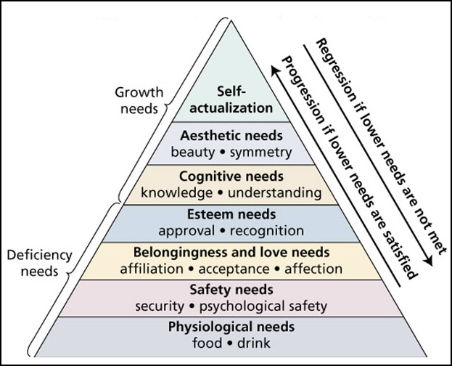

Carl Rogers
Behaviour is a response to one’s immediate conscious experience of oneself and the environment. Internal forces are not distorted or blocked, but a trusty guide that directs us towards self-actualization. Rogers’s theory is centred around the self, which plays a powerful role in guiding perceptions and directing behaviour. The self is slowly developed in childhood when an individual distinguished between themselves and the environment.
- We have needs for:
  - Self-consistency (absence of conflict/ cognitive dissonance between self-perceptions)
  - Congruence (consistency between self-perceptions and experience)
    - Anxiety comes from conflicts with self-concept
      - This prompts either a change in consistency or denial
      - People will try to interpret these situations in a self-congruent way
      - Harder for pessimists to accept success than vice versa
- Inconsistency evokes anxiety (Freud!) and threat
  - Well adjusted individuals can modify self-concept to deal with this
  - Otherwise, they will deny and distort the event as an outlier or some other justification
- We develop a need for positive self-regard
  - People usually place conditions of worth on us
    - Rogers believed these would lead to major incongruences
    - Dictate when we decide to feel good about ourselves, like the superego
  - Unconditional positive regard is important
    - A good parenting technique, as opposed to conditional positive regard (I only love you when you’re behaving)
    - Assume there is an explanation for an action, whether it is conscious or not
    - It is worthwhile to rehabilitate psychos
- Fully functional persons have achieved self-actualization, and don’t hide behind masks or artificial roles
  - Feel a sense of freedom and choice
  - Filled with DETERMINATION
  - Few conditions of worth, so they can accept events without having them modify their self-concept
  - Such an independent free-spirit

Culture and Gender
- Collectivistic people describe themselves with social identity terms, while individualistic people use more personal traits
- Gender schemas depend on culture, and tell us what an average man or woman should act like
  - Men are more individualistic
  - Women are more collectivistic

Self-Esteem
- How we feel about ourselves
- High self-esteem
  - Happier
  - Fewer interpersonal problems
  - Less vulnerable to pressure
  - Achieve higher
- Low self-esteem
  - Prone to psychological and physiological ailments
    - Immune system becomes depressed when you are
  - Problems with social relationships and underachievement
    - Always defensive and paranoid
    - Everyone secretly hates you
  - May be accurate sometimes, but not beneficial because it can become a self-fulfilling prophecy
    - Realizing this is helpful
  - Underachievers
- Failures seem even worse when you are trying to increase your self-esteem, and the emotional benefits of trying to improve esteem are short-term
  - In response to failure, low esteem people are less motivated to improve, and unlikely to improve their mood despite knowing how
  - Low esteem people also suppress positive events with sad thoughts
- Successes bolster those with high self-esteem, and cause doubt and anxiety in losers (and can somehow cause illness)
- Super high-esteem is even more damaging than low-self esteem
  - When their self-regard is threatened, they will act out aggressively to defend it
Self-Verification | Self-Enhancement
- People are motivated to maintain self-consistency and congruence  - If you keep yourself in low self-esteem, then you won’t reach self-enhancement  - We tend to recall info in line with how we view ourselves (confirmation bias) | - A tendency to gain and preserve a positive self-image  - Attributing successes to personal factors, failures to environmental ones  - Many would rate themselves better than average on socially desirable traits

Criticisms of Humanistic Perspectives
- Relies too much on self-report
- Impossible to define actualization
- Difficult to point out self-actualizing tendencies

Experimental Proof
- Carl Rogers conducted an experiment that measured the discrepancy between someone’s perceived self and ideal self
- It was found that this discrepancy would often shrink as therapy progressed

Personality Theories
Most personality theorists are not from the humanistic approach and instead concern themselves with trying to identify universal, enduring and stable aspects or ‘building blocks’ of Personality. Some theorists define personality as types while others focus upon traits, and some mix the two. Factor analysis can also be used to identify clusters of behaviour correlated with each other.
They also differ on how complex personality is as is evidenced by the number of building blocks they hypothesize and the complexity of their connections. Two major approaches distinguish theories and influence measurement techniques:
- Idiographic: Extensive studies of individuals
- Ex. Case studies on psychos
- Nomothetic: Studies of groups and broadly shared characteristics
- Ex. Looking at society’s effects in general

Early Theories
Early Greek philosophers (e.g., Theophrastus ca. 370-287 BC) Typed personalities according to four basic types:
- Melancholic
  - Sad, anxious, pessimistic, gloomy
- Choleric
  - Irritable, short tempered, readily angered
- Phlegmatic
  - Sluggish, dull, calm, controlled, boring
- Sanguine
  - Cheerful, easygoing, slow to anger

Sheldon’s Theory
A more recent Type theory based upon body types was offered by Sheldon (1942). Three main somatypes (body shapes) and their related personality categories. This theory has very little support.
- Endomorphs
  - Soft & round/ FAT
  - Visceratonia
  - Love of food and comfort, social, easygoing, agreeable
- Mesomorphs
  - Hard & square/ MUSCLE
  - Somatonia
  - Desire for power & dominance, aggressive and/or assertive
- Ectomorphs
  - Thin & fragile/ NERD
  - Cerebretonia
  - Self-conscious, private, over-reactive
This theory is often covered as a biological or genetic approach to personality.

Personality Trait Theories
Based on the notion that people are generally predisposed to act in a certain way and that traits and behaviors are organized systematically.
Ex. Sarah spends a lot of time with friends, goes to lots of social events, parties, concerts, movies, belongs to hiking club and is on a track team. Considered together these would represent a trait of Sociability. If she is president of the club and captain of the team she might also be considered to have the trait of Leadership.

Allport
Allport noted traits cannot be directly observed. Based on inference from observed behaviors. Observations must be based on frequency of occurrence and intensity of a behavior, range of situations, and reliability of measurement. After all this data is collected, it can be determined if it is a trait
Traits are “a generalized and focalized neuropsychic system (peculiar to the individual) with the capacity to render many stimuli functionally equivalent, and to initiate and guide consistent (equivalent) forms of adaptive and expressive behavior”
Thus, a trait is a readiness to respond in a specific way, developed by past exposures and feedback.

Commuist Phobia
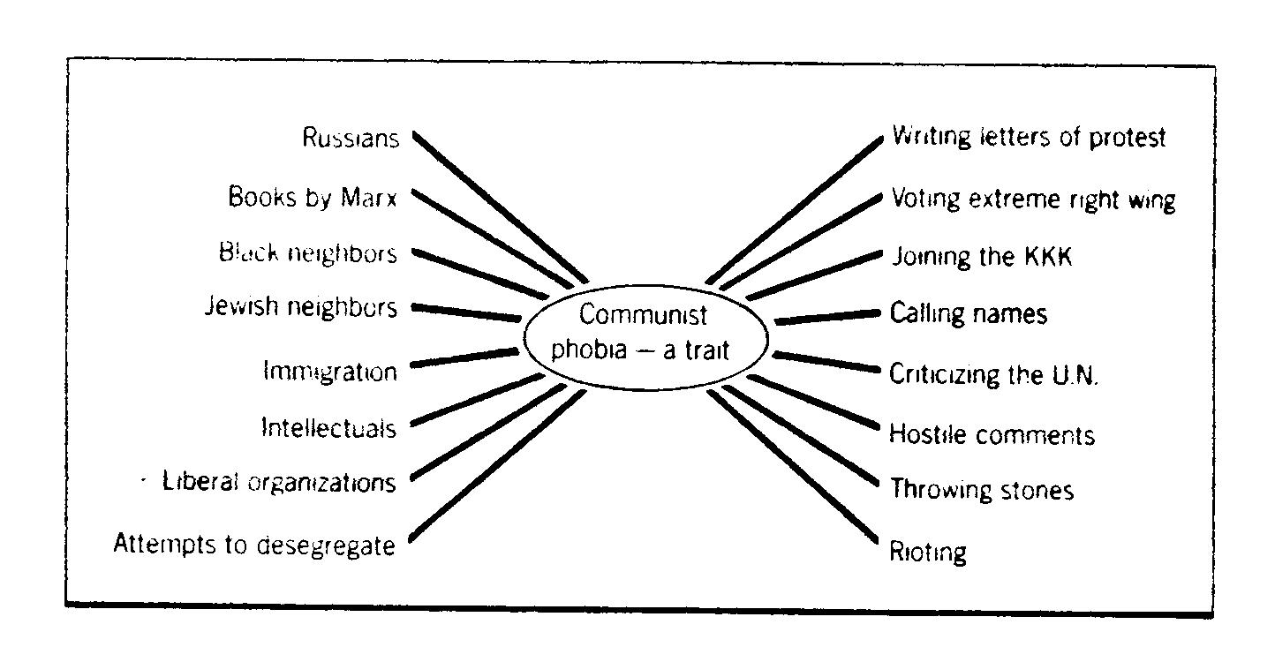

Types of Traits
Allport’s Theory follows the idiographic approach. Based upon his in-depth research of many individuals, he concluded that traits were nested.
At the top of his hierarchy were Cardinal Traits – few people have these but those who do are generally obsessed by them (e.g., Machiavellianism, Chauvinism [actually named after an extremely patriotic soldier])
Next are Central Traits which have a consistent influence on a person’s behavior: (ex. neatness/sloppiness, industriousness/laziness, trustworthiness/deceptiveness)
Finally, he noted Secondary Traits that do not have a broad influence on behavior and could be considered to express themselves as preferences (e.g., prefer blues to classical music, vanilla to chocolate)
Note: This theory proposed 4,504 traits

Cattell’s Factor-Analytic Trait Theory and Sixteen Personality Factors
Took on the Nomothetic approach. He separated his traits into surface and source traits.
- Surface Traits are those traits that to a casual observer seem to go together
- Source Traits are the basic underlying structures that provide coherence to personality
  - They are the traits used to explain behavior.
Using Factor analysis (a statistical procedure) Cattell was able to initially reduce Allport’s 4,504 traits down to 171. Further research allowed him to reduce this even further to 36 traits to which he then added another 10 for a grand total of 46 Surface Traits. Factor Analysis of the responses of large numbers of subjects to the questions based upon the 46 surface traits led Cattell to propose 15 source traits.
Cattell’s Conception of Traits
Surface Trait
Sociability, sentimentalism | vs. | Independence, hostility, aloofness
Responsive | vs. | Aloof
Affectionate | vs. | Cold
Social Interests | vs. | Lacking social interests
Dependent | vs. | Independent
Friendly | vs. | Hostile
Frank | vs. | Secretive
Even-Tempered | vs. | Sensitive
Source Trait
Dominance | vs. | Submission
Self-assertive, confident | vs. | Submissive, unsure
Boastful, conceited | vs. | Modest, retiring
Aggressive, pugnacious | vs. | Complaisant
Willful, egotistic | vs. | Obedient
The results of this endeavour are the 16pf questionnaire. This is possibly the most widely employed personality questionnaire ever developed. It has been used in many cultural settings, with many different people and reveals specific patterns on a number of dimensions.

Personality Factors

The Big Five Factors (McCrae & Costa, 1999)
- Openness
- Conscientiousness
- Extraversion
- Agreeableness
- Neuroticism man
Created because someone thought Eyesenck had two many factors. None of these factors ended up being able to predict behaviour though, so they added 6 categories under each factor called facets, measured by NEO-PI. Each factor contributes to a unique combination to determine personality.

Eysenck’s model of Personality
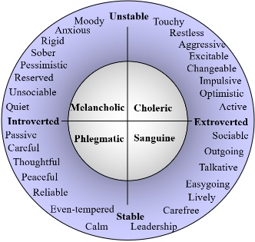
Eysenck’s model is a combined Type-Trait model. He argues personality is hierarchical, where the lowest level consists of Specific responses which may or may not be characteristic. Next level up is Habitual Responses, followed by the highest level, the Type, which is based upon interrelationships among traits.
Since the Unstable-Stable is on a different axis than Introverted-Extroverted, they are independent of each other. Knowing if someone is introverted or extroverted will not tell you if they are stable or unstable.
Like Cattell, Eysenck also used a Nomothetic approach and developed the EPQ to facilitate measurement of large numbers of people. Later came up with a third axis, psychoticism-self control. Psychoticism is defied as creativity, and tendency towards non-conformity, impulsivity, and social deviance.

Introversion Vs. Extraversion
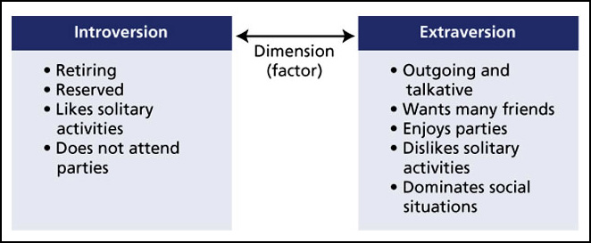

Biological Foundations
Although all the theorists we have examined assume that personality has a physiological basis only Eysenck has produced supporting evidence for the physiological bases of his personality types.
There is an optimal amount of arousal in the brain, but the brains of extreme introverts are over-aroused, and the brains of extreme extroverts are under-aroused (Eysenck, 1967). When there is a lack of external stimuli, introverts are still active enough to keep busy, and extroverts get bored. Stability-instability is related to autonomic nervous system. Those with extremely unstable nervous systems are more likely to experience emotional problems that require clinical help.
Introverts are more responsive to punishment while Extroverts seem more responsive to rewards. On a great number of characteristics, MZ twins are more similar than are DZ twins. Therefore, there is a genetic backing to this theory that none of the other theories have.
Cloninger has attempted to link three traits to specific neurotransmitters:
- Novelty-seeking
  - Dopamine
- Harm avoidance
- Reward dependence

Evolutionary Theory
Traits have been selected for physical survival and reproduction of the species.
Stability of Personality Traits
Little stability of behaviour across situations: | Stability over time:
This makes it difficult to predict behaviour from personality traits | There is good evidence for both stability of some traits and change in others over time, considering a capacity for change  - Introversion- Extraversion  - Emotionality  - Activity Level

Predicting Personality Traits
Personality traits interact with other traits as well as with characteristics of situations. Situational consistency is influenced by the importance of a trait for the person. For example, if honesty is central to one individual, they will consistently exhibit honest behaviours throughout many situations. High self-monitors act differently in different situations, while low self-monitors do not.
Self-Monitoring: One’s tendency to tailor behaviour to the situation. People who are proficient in self-monitoring can read the room and act appropriately. Otherwise, those will low self-monitoring will act upon their internal beliefs and attitudes.

Criticisms
- Researchers try to make specific predictions based on one trait
  - Need to account for traits interacting
- There is a difference between personality description and explanation
- Trait theories focus on describing and predicting rather than understanding

Personality and Health
- Type A personality
  - Demanding, have time urgency, high levels of competitiveness, ambition, aggressiveness, and hostility
  - The hostility component is related to coronary heart disease
- Type B personality
  - More relaxed, agreeable, less time urgency
- Type C personality
  - Tend to bottle up negative emotions
  - May be related to cancer proneness
Optimism | Conscientiousness
- Pessimists are at greater risk for depression and are more vulnerable to physical disease  - Optimists believe things will get better and try to learn from mistakes | - Keeping to your promises and taking responsibility for their own faults  - Conscientiousness is positively correlated with physical health and longevity because you have less to feel guilty about  - People might only be conscientious in one situation (ex. Stealing is ok, littering is not)

Social Cognitive Theories
These theories have a strong scientific base and explain apparent contradictions of consistency. They combine behavioural and cognitive perspectives into an approach that stresses human interaction and a social learning environment. Humans are seen as reactors to external events.
Reciprocal Determinism: Person, behaviour, and environment all influence each other.

Locus of Control/ Generalized Expectancy (Rotter)
- Internal locus of control
  - Life outcomes are under personal control to some extent
  - Positively correlated with self-esteem
  - Internals use more problem-focused coping
- External locus of control
  - Luck, chance, and powerful others control behavior
  - Just submitting to this will leave the person as a passive observer

Behaviour Determinants
- Self-efficacy
  - Beliefs concerning ability to perform behaviours needed to achieve a desired outcome
  - Four important determinants:
    - Previous performance attainments
    - Observational learning
    - Verbal persuasion
    - Controlling negative arousal
  - Why teaching things helps you learn them best
- Expectancy
  - How likely the consequences we expect to happen, will happen
- Reinforcement Value
  - How much we desire/ dread an expected outcome

Cognitive-Affective Personality System
People exhibit behavioural signatures, consistent ways of responding. Person variables responsible:
- Encoding strategies
- Expectancies and beliefs
- Goals and values
- Affect/ Caring
- Personal competencies and self-regulatory processes

Bandura
Human Agency: Humans are active agents in their own lives. We are self-reflective and self-regulatory.
Four processes that influence our behaviour:
- Intentionality
  - We plan, modify plans, and act with intention
- Forethought
  - We anticipate outcomes, set goals, actively choose behaviours
- Self-Reactiveness
  - Motivating and regulating our own actions
- Self-Reflectiveness
  - Evaluate our own actions

Self-Efficacy Beliefs
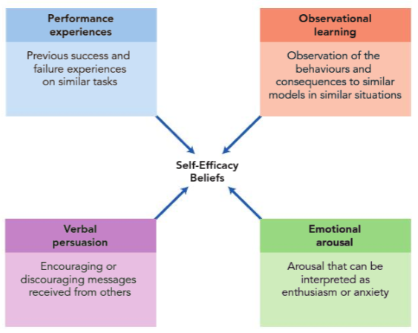

Mischel
- We need to consider individual ways of perceiving and understanding events
- Consistency Paradox
  - We expect and perceive high consistency of personality, but in reality, it varies greatly with situations
- Cognitive Affective Personality System
  - Both the person and the situation matter
  - If-then behaviour consistencies occur when there is consistency in behaviour in similar situations
    - When the if changes, so does the then
  - Ex. People act differently when they’re with friends than when they’re with God

Personality Assessment
- Structured interviews
  - Examine speech patterns, appearance, posture
  - However, the interviewers could be subjective, and the honesty of interviewee varies
  - Characteristics of the interviewer could change the behaviour of the interviewee
- Behavioural assessment
  - Preferred by social cognitive theorists
  - Probation Periods
  - Need to be accurate to determine causes
- Remote behaviour sampling
  - Using a pager to randomly ask respondents about their current feelings
  - Personality tests
  - Can be used to assess individuals over long periods of time
  - Enables the researcher to observe behaviour otherwise hidden that occurs in daily life
- Personality Scales
  - Preferred by geneticists and trait theorists due to objectivity and ability to collect data from multiple people simultaneously
  - However subject to honesty of the subject, so validity scales are developed to measure tendencies to respond in a way that makes them look suspiciously good or bad
  - Rational Approach:
    - Try to determine what people would say about themselves
    - Ex. Drake and Josh personality tests
  - Empirical Approach
    - Find out what introverts tend to say yes to, and whether it makes sense for them to do so
- Validity: is the test actually measuring the personality that it’s supposed to measure?
- Humanistic theorists prefer personality scales
- Biological personality researchers use emotional reactivity/ brain processes

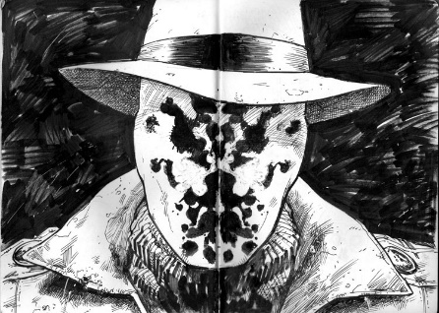
Projective Tests
- Person is presented with an ambiguous and stimulus
- Interpretation of the stimulus will be a “projection” of inner needs and feelings, because there is not enough objective meaning
- Preferred by psychodynamic theorists
- Examples include:
  - Rorschach Ink-Blot Test
    - What does the ink blot remind you of and why?
  - Thematic Apperception Test (TAT)
    - Given a picture, make up a story behind it
  - Draw-A-Person Test
- Difficult to objectively score

Objective Tests
- Objective personality tests
  - Better reliability and validity than projective tests
  - Include standard sets of questions that are scored using a specific scoring key
  - e.g. MMPI-II, EPQ, 16Pf

