Experiment 1: Verification of Boyle’s Law
Introduction:
Gasses are a unique state of matter in comparison to solids and liquids, specifically in terms of area. This is due to gasses being the only state of matter that can not only compress into very small spaces and containers, but also have the capability to expand into larger spaces and containers. With the compression or expansion of volume, the pressure of gas changes as well, decreasing with an increase in volume and increasing with a decrease in volume. Boyle’s law explains this relationship in a simple formula, stating that when dealing with an ideal gas where the temperature is held constant, the volume is inversely proportionate to the pressure.
C=PV
The only issue with this relationship in the real world is that ideal gasses do not exist, as they are gasses that consist of molecules taking up negligible space. Instead, through trials and tests, it is able to get close to the constant, but never perfectly reach it. When doing this experiment, it should result in a linear relationship between each increase in volume and pressure.
Castka, Joseph F.; Metcalfe, H. Clark; Davis, Raymond E.; Williams, John E. (2002). Modern
Chemistry. Holt, Rinehart and Winston.
Procedure:
- Prepared the Gas Pressure Sensor by connecting the gas pressure sensor to the LabQuest 2.
- Prepared the air sample by filling a syringe to the initial volume of 20 mL, using the first line of the plunger as measurement. Attached the syringe to the Gas Pressure Sensor and tightened with a half turn.
- Set up the LabQuest by tapping mode on the meter, and change to events. Set variable as volume, using mL as the units.
- Began trials by holding the plunger and 20 mL of air, and measured the pressure using the gas pressure sensor.
- Repeated step four 7 times, reducing the initial volume by 2 mL each trial. On the 8th trial, pressure was remeasured using the initial volume of 20 mL.
- All data was collected, and steps 2-5 were repeated for three more trials.
Observations:
As the volume of air in the syringe decreased, the resistance of the rubber stopper increased. As well, the syringe stayed clear throughout the process of the experiment, no change in colour was seen.

Table 1: Data and results in the verification of Boyle’s law
 |  | Pressure (kPa)
Volume (mL) | Trial 1 | Trial 2 | Trial 3
20.8 | 100.28 | 99.960 | 99.660
18.8 | 111.84 | 110.20 | 111.68
16.8 | 123.60 | 123.35 | 123.96
14.8 | 141.86 | 139.94 | 140.68
12.8 | 162.92 | 160.54 | 163.52
10.8 | 197.00 | 192.07 | 195.36
8.8 | 225.50 | 225.20 | 225.21
20.8 | 100.87 | 99.620 | 100.28

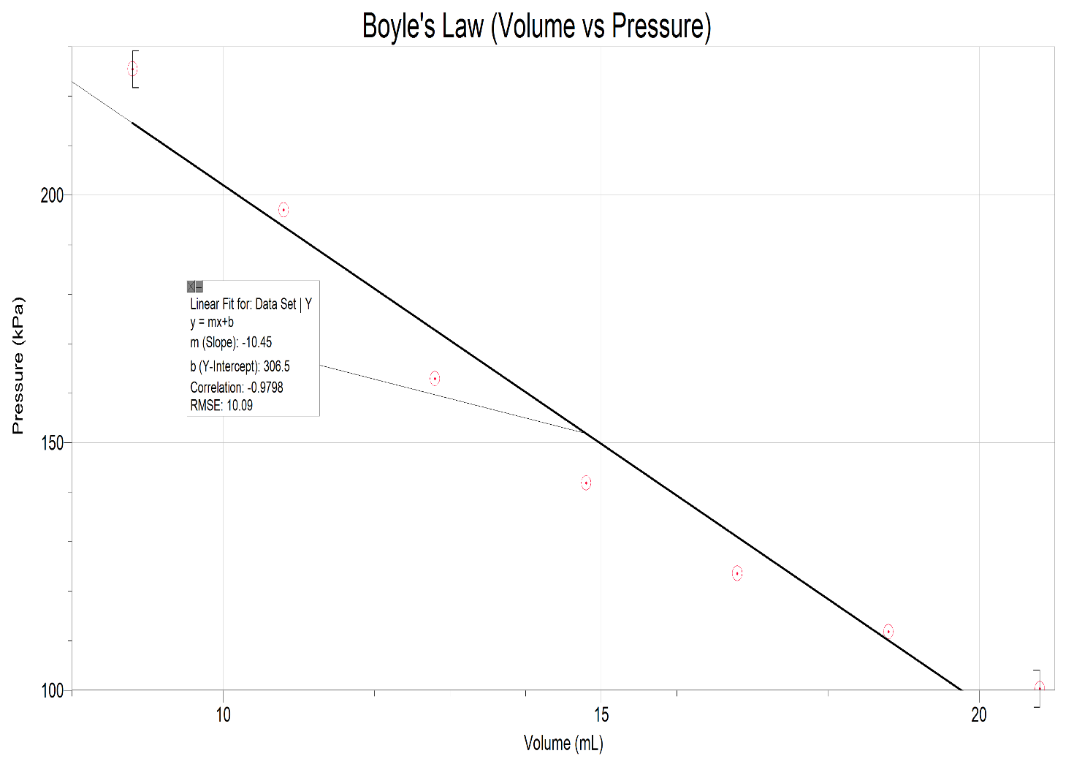
Figure 1: Graph of experimental data

Calculations:
$$P_{average}V=C$$
Using the volume 14.8 mL and an average of the pressure:
$$P_{average}=\frac{141.86+139.94+140.68}{3}$$
$$P_{average}=\frac{422.48}{3}$$
$$P_{average}=140.83 kPa$$
$$C=P_{average }V$$
$$C=140.83kPa(14.8mL)$$
$$C=2084.284$$
Discussion:
The constant that was calculated for C using the data collected is C=2070.91 kPa/mL. This was found by using an average of the three trials at each volume to calculate a constant specific to each volume, then calculating the average of all 7 trails. Boyle’s constant demonstrates the relationship between pressure and volume, and for this specific gas generating a formula of PV=2070.91 kPa/mL. While executing the experiment, it was important to take multiple readings of pressure for the same initial volume in order to ensure that the conditions throughout the experiment stayed constant. Since the values of pressure were close in number, it could be determined that the experiment was valid. As well, the initial value of pressure that was kept in the data was determined by the relativity of Boyle’s constant in comparison to the constant at another volume. The relationship shown in the experiment is similar to the hypothesis of the experiment, although not perfectly linear in comparison. This is due to the fact that there was no guarantee of a constant temperature, as well not entirely knowing what gas was tested. This effects the accuracy of Boyles law, as each gas has a different constant, and air is a mixture of many different gases- none of which are ideal gases either.
Conclusion:
In conclusion, the experiment validated that Boyle’s law is true. The constant that was calculated for air is C= 2070.91 kPa/mL. Although not completely accurate due to the lack of control over the temperature, a linear relationship was shown clearly throughout the trials.



