Biology 1A03
Midterm #1 Review
October 14, 2017
Theme 1 Module 1,2,3,4
Applied Lectures (1&2 3&4)
Theme 2 Module 1,2,3,4
Applied Lectures (1&2, 3&4)

Theme 1

Module 1

Human Microbiome: a population of micro biotic organism. Have prokaryotic cells and a small amount of eukaryotic cells
- Microbiotic are bacterial cells found in every part of our body
- Example of Microbiotic organisms:
- Streptococcus salivarius: a collection of bacteria that helps form dental plaque. It is also the first germ-free microbes in a newborn’s oral cavity and gastrointestinal tract.
Four Classes of Macromolecules
- Nucleic Acids (DNA/RNA)
- Hereditary material of the cell
- Protein
- Makes up structural elements such as flagellum (allows cell movements across a cell membrane)
- Polysaccharides
- Structural components such as the cell wall
- Stored energy/
- Phospholipids
- Main component of the cell membrane
- hydrophobic tails
- hydrophilic head
Phospholipids
- amphiprotic (has both hydrophobic and hydrophilic ends)
- hydrophilic head (polar) (water loving)
- hydrophobic tail (non polar) (water fearing)
- one saturated (straight) tail
- one unsaturated (bent) tail – bent because of double bond
- smallest out of the four macromolecules
Fluidity of the Cell Membrane can be affected by factors:
Membrane Fluidity: the ability of phospholipids to move.
- Unsaturated or saturated fatty acid
- Unsaturated (larger) reduces fluidity
- Number of carbon in the fatty acid tail
- Doubles bond will push away neighbors, increases fluidity
- Temperature
- High temp, more fluidity
- The presence or absence of cholesterol
- Without cholesterol the membrane is too solid
Types of Transports across the Cell Membrane
- Passive Diffusion
- Passive Transport
- Osmosis
- Active Transport
Passive Diffusion
- Movement of small of molecules
- Along (down) the gradient
- Gases
- Uncharged molecules
- No energy is required
- High to low concentration
Passive Transport
- Uses transport proteins
- Along (down) the gradient
- Movement of most lipid-soluble molecules
- Gases
- Uncharged polar
- Some water
- No energy required
Osmosis (passive transport)
- Movement of most water
- Moves from a hypertonic to hypotonic solution
- Hypotonic – less concentrated
- Hypertonic – more concentrated
- Moves along (down) the gradient
- No energy required
Active Transport
- Movement of charged molecules (large)
- Na+ and K+ (sodium and potassium)
- Moves against a gradient
- Involves proteins that are embedded in the cell membrane
- Requires energy from the hydrolysis of ATP
- Primary Active Transport: direct expenditure of ATP dependant
- Secondary Active Transport: if neighbors take advantage of products by the primary active transport to move their own solutes against the gradient
Fluid Mosaic Model
- Membranes consist of protein and carbohydrates embedded in a fluid phospholipid bilayer
- Barrels allow big molecules go through
- Has to be amphipathic (has both non-polar and polar regions)
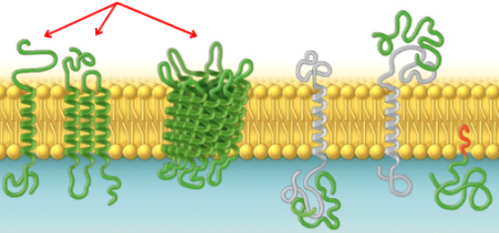

Module 2

Eukaryotes | Prokaryotes
Double bond membrane | Single bound membrane
has a nucleus | no nucleus
Has many membrane organelles | Few organelles
Single cell organisms
Has organelles and internal organelles
Mitochondria in animal
Chloroplasts in plants
Organelles: a tiny cellular structure that does specific functions in the cell. Example: nucleus is the part of the cell where the genetic material is found
Mitochondria: organelles that generates energy in the form of ATP.
Chloroplast: the place in plants where the conversion of light energy to glucose (where photosynthesis takes place in)

Mitochondria
- Produces chemical energy
- ATP = Chemical energy
- Has 2 membrane; inner and outer
- outer membrane surrounds organelles
- inner membrane connects to the sac-like series (crystal) where ATP is synthesised
- they have their own circular genome and produces enzymes for protein synthesis
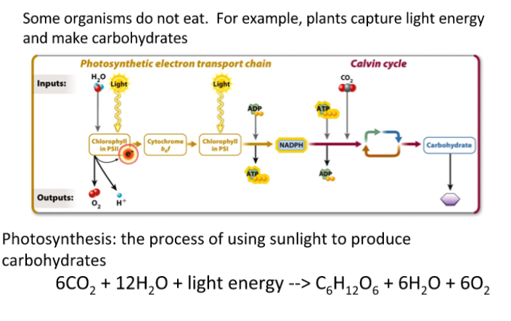
Chloroplast
- photosynthesis occurs
- conversion of light energy to glucose
- produces glucose and oxygen (bi-product).
- Then produces NADPH and ATP in the Calvin Cycle
Cellular Respiration
- Occurs in the mitochondria
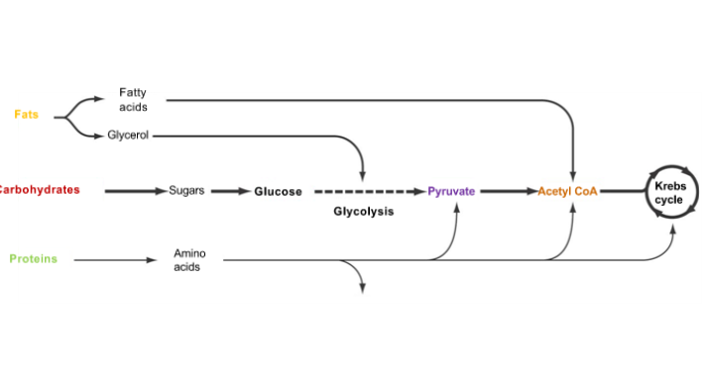
- Carbohydrates are the main source of ATP
- Process of ATP production
- Glycolysis (2 ATP)
- Pyruvate (NO ATP)
- Citric Acid Cycle (Krebs Cycle) (2 ATP)
- Electron Transport chain (32 ATP) (32 ADP)
- Oxidative phosphorylation and chemiosmosis
ATP is Important for Many Cellular Process
- Mechanical Work – contracting molecules
- Transport Work – Active transport
- Chemical Work – building a large molecule
- ATP = adenosine triphosphate
Hydrolysis Reaction: the addition of water molecule to break down a large molecule (water is part of the reaction)
Condensation Reaction: water molecule is taken out to make a larger molecule (wayer is on the product side)

Applied Lecture Theme 1 Module 1&2
The Camel’s Hump
- The camel hump is consisting of giant mounds of fat
- It weighs up to 80 pounds
- Allows the camel to survive up to 2 weeks with limited food
- Camels don’t store water; they store fat tristearin (potential energy)
Why are fats important for camels?
- Camels stock fat for ATP generation for the conversion of water
- They can minimize water lose by condensing water in the nostrils
- They excrete dehydrated material – combustive poo
Migrating Geese
- The constantly eat and stock fat
- Good metabolic process is very important
- The carbohydrates and lipids are high in the blood when flying
- Allowing to metabolize the stored fat
- The adipocutes are moved into blood and fatty acids grab onto proteins and the fat goes into the mitochondria and beta oxidation give ATP then energy for the bird is produce
- Fat creates more energy than anything else
- Lipids include fats, oils, waxes, certain vitamins, hormones and most of the non-protein membrane of cells
Locusts
- They store fat
- They are bugs
- Have mitochondria
- They tap into their fat reserves
- When flying their blood sugar drops blood fat (lipid) increase
- Same with humans
Ketone (derivative of fatty acids)
- Ketone bodies can be converted to acetyl CoA (energy) to push more of the Krebs cycle.
- This results to 38% more ATP than glucose produced
- Perfect for what athletics want
- deltG drink
- excess ketone can cause limited production of carbohydrates

Module 3

Proteins
Proteins have various functions:
Transport, signaling, enzymes, movement, structures, and a defence mechanism.
Transport Proteins: proteins that are embedded in the cell membrane that help move substances in the cell membrane.
Enzyme Proteins: proteins that helps to speed up the synthesis of carbohydrates and in the mitochondria that allows the release of energy of carbohydrates
Proteins that help with structure and movement: proteins make the large part of structures that allows the movement of an individual cell or many large cargo or molecules with the cell. Example: when actin and myosin slides pass each other through bundles of proteins.
Signaling Proteins: proteins that are embedded in the cell membrane that interacts with carbohydrates that helps further amplify cell to cell signal, which results with the most appropriate response.
Defence Mechanism Proteins: proteins that are made by immune cells and they serve as antibiotics that attacks and destroy disease-causing virus’ and bacterium
- Protein’s structures are related to their functions
Protein Synthesis
Prokaryotes:
- Transcribe information in the DNA (mRNA) into RNA through transcription
- Then translated into ribosomes
- Protein is made
mRNA carries the information to make proteins
Eukaryotes:
- Transcribe information into RNA through transcription
- Primary RNA transcript is proceed into mRNA
- mRNA moves to the cytosol
- then mRNA is translated into the ribosome (free ribosomes)
- Protein is made
- Free (detached) ribosomes: ribosome that are in the interior of the cell and are floating in the cytosol. Free ribosomes translated mRNA for proteins that will stay in the cell’s cytosol.
- Bound (attached) ribosomes: ribosomes that are on the exterior of an organelle called the endoplasmic reticulum. Bound ribosomes translate mRNA for proteins that will move out of the cell.
- It is in the nucleolus where RNA is transcribed
- All proteins are derived from 20 core Amino Acids
- Polypeptides is a strand of amino acid that are covalently bound to each other through a condensation reaction, which releases water (amino – amino)
- Polypeptides can be broken through hydrolysis reaction (adding water to the molecule)
- All proteins take on a 3D shape whether it is synthesized from free or bound ribosomes.
- once the mRNA is translated into a protein, the polypeptide strand begins to fold and that determines the function.
- When sorting pathway for proteins destined to be secreted from a cell the signal recognition particle (SRP) binds to the signal sequence at the amino-terminal synthesized protein soon after it appears out of the ribosome.
- Aquaporin is made out of 4 protein subunits that allows to water movement in the membrane
- Bacterial Porin are the prokaryotic version of aquaporin
- Cystic Fibrosis Disease is caused by a protein misfold which causes the thick accumulation of mucus in the lungs that can result bacterial infection. It is linked to a mutation that causes malfunction to the cystic fibrosis transmembrane conductance regulator (CFTR) ion channel protein.
Module 4
Nucleic Acids: DNA (deoxyribonucleic acid) and RNA (ribonucleic acid)
DNA:
- In prokaryotes the DNA is found in the nucleoid
- In eukaryotes the DNA is found in the nucleus
- Chromosome are double stranded DNA that contains the genetic material of the cell
- Eukaryote cell their chromosomes are large and linear
- Prokaryote cell their chromosomes are small and circular
- In the bacteria E.coli it has a supercoiled DNA
- Super coiling of DNA is an addition to the helical structure
DNA the hereditary material of the cell
Griffin’s Experiment
- S-strain virulent bacteria (virulent cells)
- R-strain nonvirulent bacteria (benign cell)
- When dead S-strain was injected to the mouse, the mouse was fine
- When S-strain was injected to the mouse, the mouse died
- When R-strain was injected to the mouse, the mouse was fine
- When dead S-strain and alive R-strain was injected to the mouse, the mouse died of pneumonia
- Griffin concluded that the benign cells had acquired information from the virulent cells.
Transformation: a change in cell behavior resulting from the incorporation of genetic material from outside of the cell. Requires the presence of DNA
- Avery and his colleague concluded that the absence of DNA there was no transformation.
- And therefore the hereditary material was in the macromolecule DNA
Structure of DNA
- Double helix
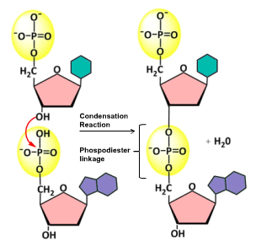
- Subunits: nucleotide, phosphate group, 5-carbon deoxyribose sugar, and a nitrogenous base
- Nitrogenous bases –
Pyrimidines (single rings): Cytosine (C) and Thymine (T)
Purines (two rings): Guanine (G) and Adenine (A)
- When assembling a DNA molecule, a condensation reaction forms a phosphodiester bond between two nucleotides
- Red (nucleotides) green (pyrimidines) purple (purines)
- New nucleotides are added on the 3’ end without the phosphodiester
- Purines pairs with pyrimidines
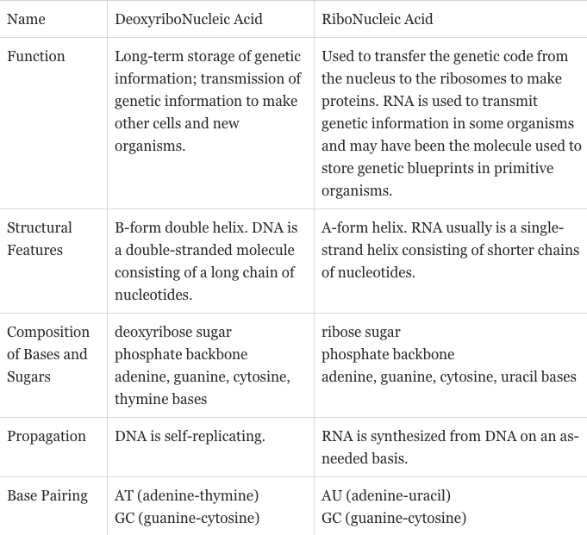
- G-C and A-T pairs
- Creates the double helix structure
- The 2 hydrogen bonds in A-T
- The 3 hydrogen bonds in G-C
Structure of RNA
Transcription of DNA
RNA can be classified into:
- mRNA (messenger RNA)
- rRNA (ribosomal RNA)
- tRNA (transfer RNA)
- RNA polymerase (enzymes that is
used to synthesize of other classes of RNA)
mRNA: carries information to make proteins
tRNA: matches mRNA with amino acids and brings
them to the ribosome during translation
rRNA: multiple rRNAs and proteins form the functional ribosome complex that perform translation of mRNA into proteins
DNA in Eukaryotic cell
- In the nucleus is where the genetic information of a cell is found
- Membrane-bound organelles such as chloroplast and mitochondria carry their own genetic material
- Linear
- Surrounded by proteins called histones
Module 3: Proteins
- Amino acid side chain properties have an effect on the conformation of the whole protein
Hydrophobic Amino Acids – non polar side chains
- Hydrocarbon chains
- Aromatic are hydrophobic
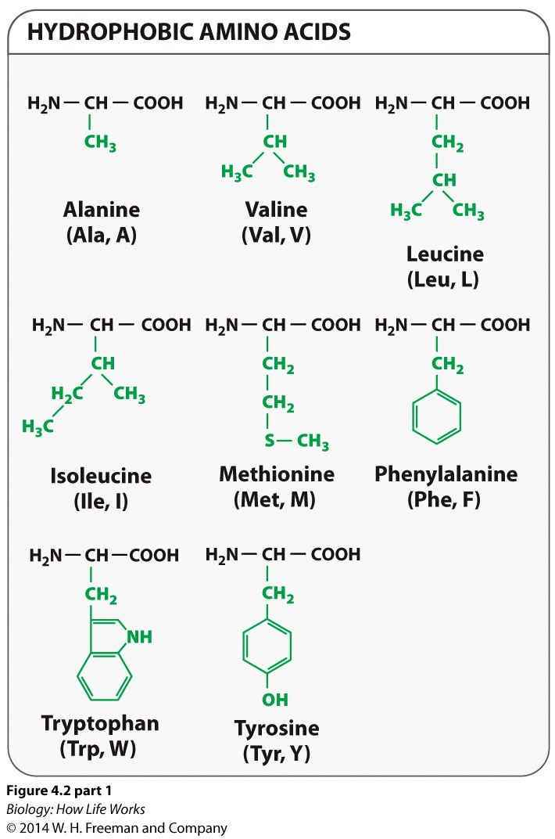
- Focus on the benzenes (rings)

Hydrophilic Amino Acids – polar side chains
- typically charge-polarized
- capable of hydrogen bonding
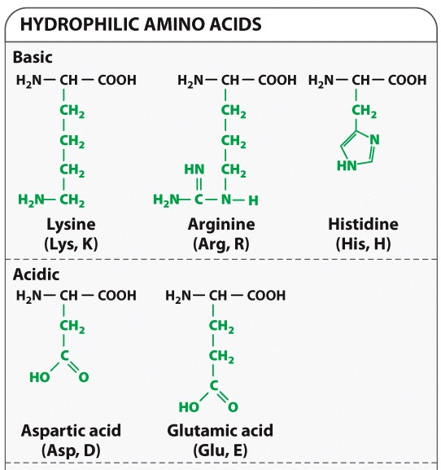

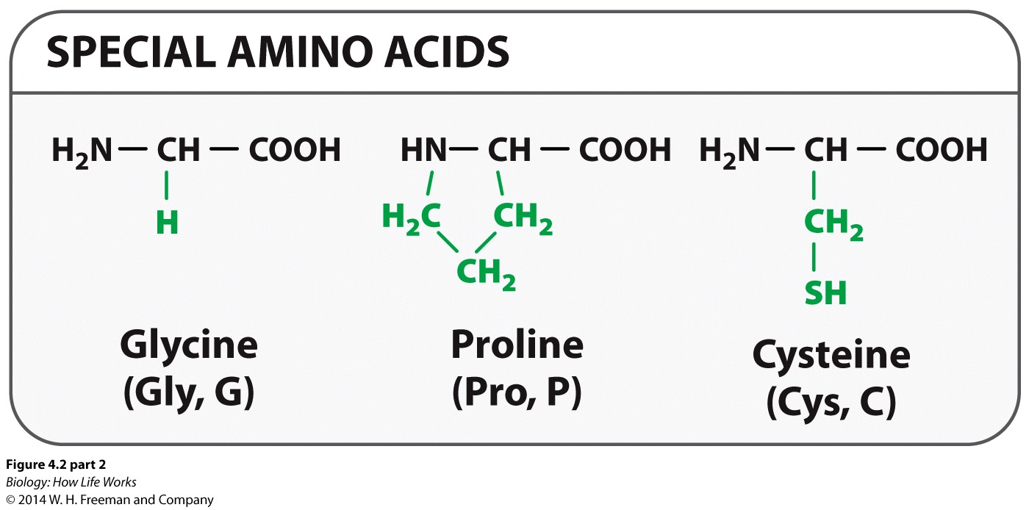
Polar Side Chains: Special Amino Acids:
Glycine (Gly, G): hydrophobic but slightly polar
Proline (Pro, P): hydrophobic
Cysteine (Cyt, C): slightly polar

Hemoglobin as an Example of Protein Folding
- sequence of amino acids is synthesized from mRNAs transcribed from the globin genes
- based on the amino acid the polypeptide chains fold into secondary structures (ex alpha helices and beta sheets)
- tertiary structure: forms from the interactions between the R groups of the amino acids with each other
- final step: the formation of the quaternary structure is the association of different polypeptide subunits to form the functional protein
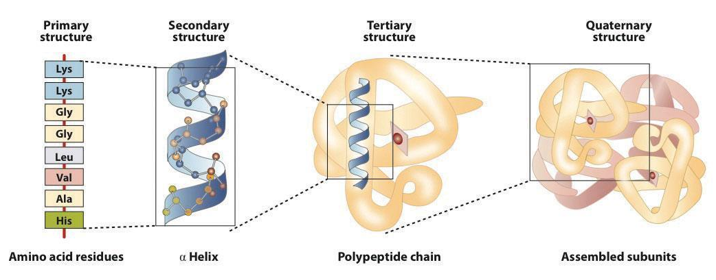
Module 4
Nucleic Acids
- the information in a gene (DNA) is transcribed into a copy (mRNA)
- DNA molecules carry the genes (hereditary information of the cell)
Understanding Griffith’s Experiment
Transformation: a change in cell behavior resulting from the cell taking genetic material from outside of the cell
Nitrogenous
base
5-carbon sugar
- The living non virulent cells (R-strain) took information from the dead virulent cell (S-strain) which killed the mouse
Nucleotide
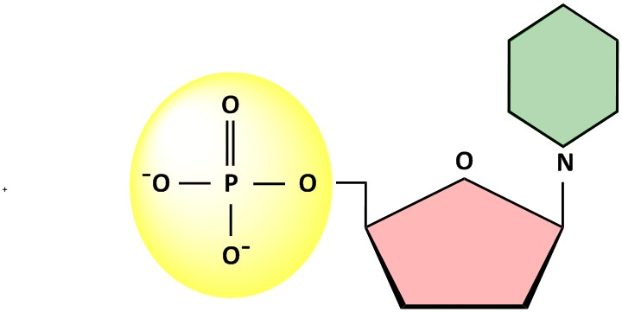
5’ carbon (deoxyribose) sugar
Nitrogenous
base
5-carbon sugar
Phosphate group group

DNA hold the blueprint for RNA synthesis
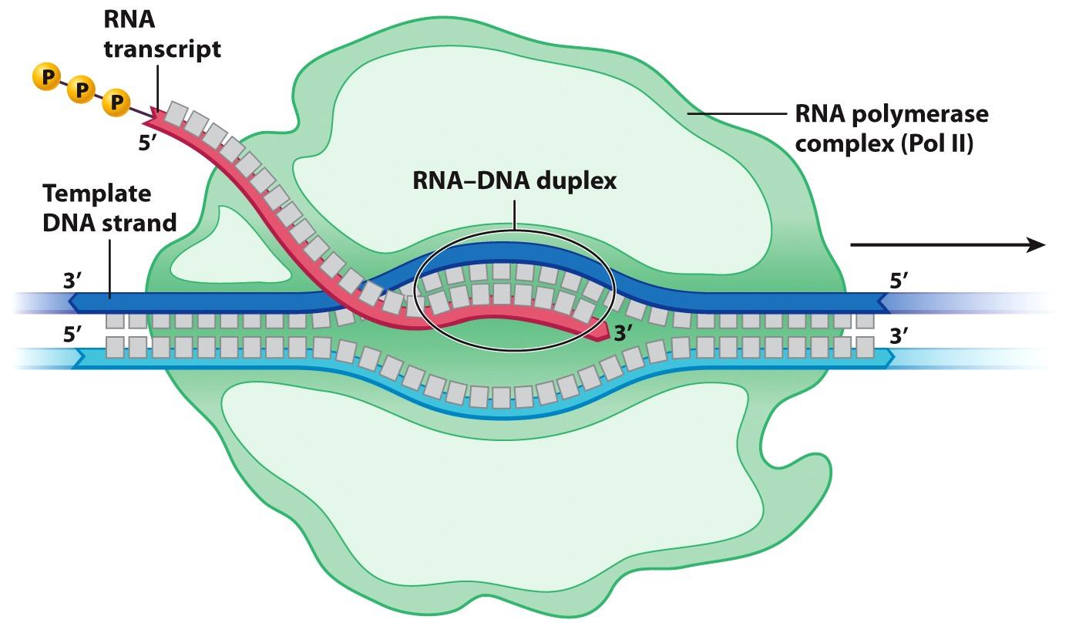

Two Stands of DNA Form a Double Heli
Guanine
Cytosine
Adenine
Thymine
Sugar-phosphate backbone
X

Applied Lecture Theme 1 Module 3&4
Look over power point sept 20 theme 1
Cystic fibrosis

Theme 2
Phosphate group

Module 1
Transcription
DNA: The Blueprint
- It contains thousands of genes that codes for proteins RNA molecules that has various functions in the cell
- Stored information can be interpreted and transmitted for cellular processes
- Genes are sections of the DNA molecule which contains information yjat is then transcribed into a RNA copy.
- Through process of translation RNA can be further interpreted as a mRNA and into amino acids that makes up many proteins in the cell
Central Dogma: the process of copying and interpreting genes into proteins
- Nucleotides are the language for mRNA
- Amino acids is the language for proteins
Gene Expression: the transition from DNA to mRNA to proteins and requires the transcription of information encoded in the DNA into RNA
Transcription in Prokaryotes
- DNA is transcribe from a template stand
- Transcription is similar between euk and pro
- DNA and RNA are quite similar except DNA contains deoxyribose sugar and has adenine (A) paring with thymine (T) while RNA contains ribose sugar and adenine (A) pairs with uracil (U).
- During transcription DNA is used as a template to generate a complementary and antiparallel RNA molecule
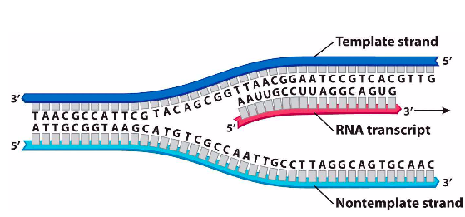
- Only ONE DNA strand for each gene will be the transcribe template stand
- RNA is transcribed as the complement of the template strand
- BASE PAIR “CODE”
- DNA: TTAACGGAATCCG
- RNA: AAUUGCCUUAGGC
- RNA polymerase: an enzyme that attaches to specific regions of
the DNA when RNA is transcribe from DNA
- Transcriptional starting point: indicates when RNA synthesis actially begins and are situated in the 5’ end
- 5’ end is for 5’ phosphate on a nucleotide
- 3’ end is for 3’ OH group of a nucleotide
- read in a 5’ to 3’ direction
- RNA polymerase moves in a 3’ to 5’ direction along the DNA until the it hits the terminator and it stops and releases the RNA transcript
- RNA molecule moves in a 5’ to 3’ direction
- DNA prokaryotes are found within a non membrane bound region
- TATAAT serves as part of the promoter region and start of transcription on the 5’ end
Transcription is initiated at a promoter sequence and ends at a terminator sequence. The transcription is synthesized in 5’ to 3’ direction.
Transcription: initiation, elongation, termination
- Process requires the association of RNA polymerase and with proteins called sigma factors
Sigma factors: proteins that facilitated to binding the promoter region of the DNA
- Initiation:
- Transcription start
- 5’ end
- Occurs when the RNA polymerase binds to a sigma unit to create a holoenzyme
- Holoenzyme: capable of binding to and unwinding the double stranded DNA helix to allow transcription to occur
The actual process of transcription occurs within the RNA polymerase enzyme. Once RNA polymerase binds to the specific promoter regions of the DNA, it is able to open up the double-stranded DNA, revealing the template and non template strand within a transcription bubble. The RNA polymerase can then begin to catalyze the production of an antiparallel RNA strand that is complementary to the template strand, creating an RNA-DNA duplex. Remember the template strand is being “read” in the 3’ to 5’ direction and the RNA is being synthesized in the 5’ to 3’ direction.
- Elongation:
- a single gene is able to be transcribed by several RNA polymerase molecules at a time
- allows for a cell to make RNA copies of a single gene in greater amounts
- singe gene can be transcribe by several RNA polymerase
- Ribonucleoside triphosphate is required to create phosphodiester bonds
- Elongation is irreversible (no going back)
- Termination:
- Located at the 3’ end
- End of coding sequence
- Enable the release of RNA transcript
- Releases transcription complex
- 2 types of Terminator
- Rho-independent: sequences of inverted nucleotides repeat. Near the end of transcription, they are transcribed and fold back into themselves to form a G-C rich hairpin loop along that same mRNA strand
- Rho-dependent: uses a specific prokaryotic protein or Rho factor which can bind and utilize ATP energy to move the RNA transcript while unwinding it from the DNA template and releases RNA transcript and transcription complex
Prokaryotes, transcription and translation
- Translating mRNA to polypeptide can be done before transcription is complete
- They don’t have nuclear envelopes that separates process of transcription and translation.
Transcription and mRNA in Eukaryotes
- Have promoter regions in the DNA sequence which indicates the starting point of transcription
- A number of proteins called general transcription factors are required to the binding of a RNA polymerase to a promoter and imitate transcription
- Transcription and translation are separated in the cell by nuclear membrane
- RNA polymerase reads a sequence of DNA and is able to produce a complementary/antiparallel strand of RNA
- Upon termination RNA is released from the RNA polymerase
- Primary mRNA transcripts must be modified in the nucleus to produce mature mRNA rRNA and tRNA
- Only modified RNAs can leave the nucleus
3 Types of RNA Polymerase
- RNA Polymerase I
- Transcribes the genes for ribosomal RNAs (rRNA)
- RNA Polymerase II
- Transcribes the messenger RNA (mRNA)
- Template for protein production
- RNA Polymerase III
- Transcribes transfer RNAs (tRNA) and other regular RNA
RNA polymerase
- Reads DNA sequence
- Produces complementary/antiparallel strand of RNA
- Releases RNA at termination
- The end process depends on the exact polymerase utilized
Post-transcriptional modification:
- Occurs at each end of the primary mRNA transcript
- Helps with:
- Export of mRNA
- Protection against ribonucleus enzymes
- Attachment of ribosomes
- Initiates translation
At the beginning of translation, the 5’ end of the primary RNA transcript involves with the attachment of a modified guanosine to the mRNA through an unusual 5’ to 5’ linkage.
PolyA tail
- Trabscribe mRNA have adenine added to the 3’ end and signal is transcribe
- mRNA cleaves
- Polyadenylation: when poly (A) polymerase is added to the 3’ end of the RNA
Termination
- Depends on RNA polymerase (I,II, II)
- Polymeerase (II):
- the 3’ end is modified by polyadenylation
- 3’ is occupied by termination
- Polymerasw (I)
- uses termination factor as prokaryotes
- rho-dependent
- Polymerase (III)
- uses termination factor similar to prokaryotes
- rho – independent
Processing RNA
- Protein coding DNA sequence of gene is interrupted by long noncoding nucleotides
- Sequences will not code for amino acids
- Sequences will code for proteins which is split into many segments
- Exons: sequences of the mRNA that are necessary for coding sequence of amino acids in the proteins
- Introns: intervening sequences
RNA Splicing and Spliceosome
- RNA splicing is catalyzed by a large molecule called spliceosomes
- Recognizes the splicing site within the introns
- Catalyzes a reaction that allows a for specific hydroxyl group to effectively “attack” and form new phosphodiester bond with nucleotide at the donor site
- Allows for the cut of the 5’ end of the intron
- Spliceosomes are composed of 5’ small nuclear ribonucleoproteins (snRNPs)
- Introns: removed/taken out of mRNA
- Exons: need to be joined together

mRNA out of the Nucleus
- mRNA goes to the cytoplasm of the cell
- facilitated by nuclear pore complex in the nucleus that acts as a gate way for molecule to move in/out of the nucleus
- -nuclear pore are protein-lined channels
- nuclear pores can also be transport proteins, carbohydrates and important signaling molecules into the nucleus
- make sure it’s a mature RNA
- make sure the message contained within the DNA blueprint is transmitted to code for the appropriate amino acids and contributes to the functionality of important cellular proteins
- mRNA template will contribute to accurate polypeptide synthesis
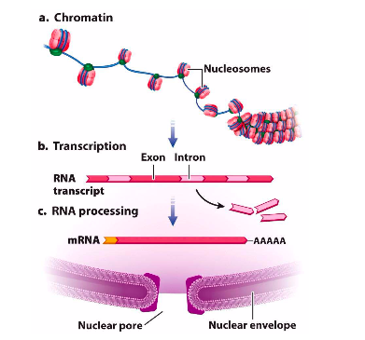
h

Module 2
The Genetic Code
Code in the mRNA
- Amino acid: nucleotide that code for codons
- 20 amino acids are coded with 4 nucleotides
Defining Codon
- 1 – base code would not be enough for all 20 amino acids just 4
- 2 – base code not enough for 20 amino acids, only 16 (4x4)
- 3 – base code is more than enough for 20 amino acids, makes 65 (4x4x4)
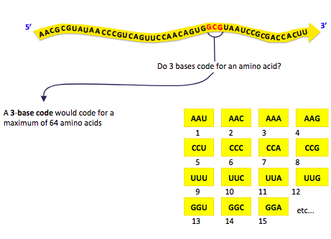
- this means that multiple unique triplets will code for the same amino acid

Converting the code
- Sequences of phenylalanine was produced from nucleic acids
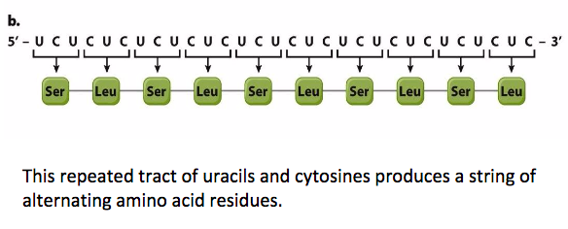
- 3 nucleotides codons will code for a specific amino acid in a protein

Standard Code
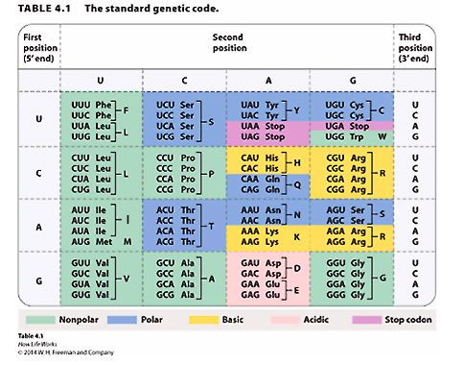
- coding template strand will have same codons as mRNA
- non coding template strand contains complementary anti-codons (tRNA)
- AUG only codes for Methionine
- START CODON
- Signals protein
- synthesis to begin
- UCG only codes for Tryptophan
- UAA, UAG, UGA
- STOP CODONS
- signals translation of mRNA to a polypeptide sequence is complete
- does not code for amino acids
- stops translation process
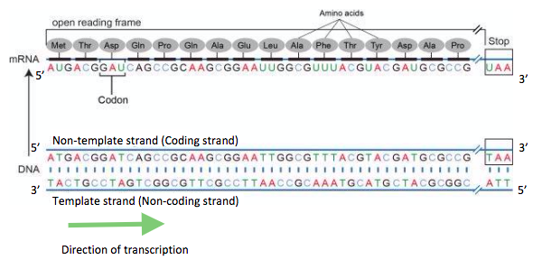
- Redundancy happens because 4 base codes for amino acid 61 out of 64 triplets
Reading Frames
- Coding Stand 5’ to 3’
- Non-Coding 3’ to 5’
- mRNA carries the U not T
- reading frames can alternate proteins
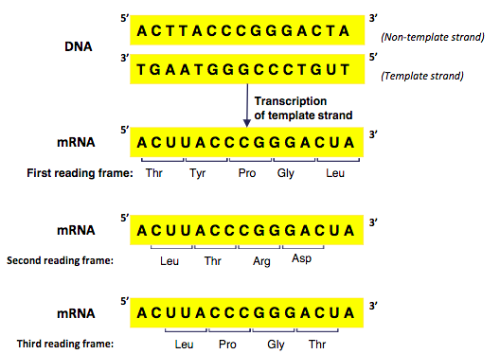
nj

- adding a single nucleotide (A,G,T,C) will disrupts the code
- adding or removing a single nucleotide will have a frameshift mutation
- removing 3 base code nucleotide (TTG, CCA) will keep the code
- removing 3 nucleotide has no frameshift mutation
RNA and the origins of life
- RNA turns into the components that make up the cell
- tRNA is the intermidiate between mRNA and polypeptide, they are the translators between the two codes
- rRNA is the machinery that facilitates the process
- RNA turns genetic information that are coded in the DNA into functional and necessary proteins
Applied Lecture Module 1&2
RNA splicing & Spinal Muscular Atrophy
- Primary transcript is process: remove introns
- When an intron is removed the 5’ cap does not get translated
- Look over power point sept 27 applied lectuue
Module 3
Translation
Molecular Components
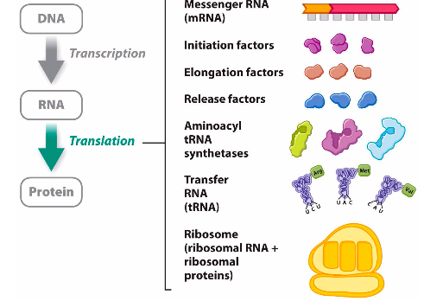

tRNA Structure
- tRNA are able to transfer amino acid from cytoplasmic situated amino acid to a polypeptide in the ribosome
- each tRNA are not identical results: translate mRNA to codons into amino acid
- tRNA are made out of a RNA strand between 7- to 90 nucleotides in length
- tRNA codon goes in a 3’ to 5’ direction
- mRNA codons go in a 5’ to 3’ direction
- stretches of the tRNA allows for the formation of the double helical
- terminal A (adenine) the point of attachment for an amoni acid during the process of tRNA molecule activation
- aminoacyl tRNA activation of tRNA molecule with a specific amino acid that is carried by this tRNA
- each aminoacyl tRNA binds to an amino aic
- 20 aminoacyl tRNA on for each
- some tRNA are able to bind to more than one
Translation Occurs in the Cytosol
Prokaryotes: translation – cytosol
Eukaryotes: transcription – nucleus translation – cytosol
Polypeptides synthesis
- As an mRNA molecule is shifted through a ribosome, specific mRNA codons are translated into amino acids one by one
- These amino acids are attached one by one to a growing polypeptide chain until translation is terminated.
- mRNA is translated to amino acid to polypeptide
Process of Translation
- translation will begin when a translation initiation complex forms towards the 5’ cap of mRNA until AUG has been encountered
- Shine Dalgarno sequence: the translation initiation ribosome binding site for prokaryotes
- Multiple regions of polycistronic allows prokaryotes to have a specific open reading frame for more than one protein”
Ribosomal large and small subunits will only happen when they are attached to mRNA
- Charged tRNA methionine and initiation factors will help with assembling the imitation complex
- Initation factors will bind to the 5’ cap of the mRNA
- GTP energy is released and next tRNA can join in
- A to P to E (tRNA)
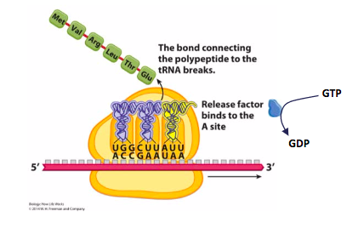
- The bond of polypeptide and tRNA break at the P-site

WATCH SLIDE 19

One gene, one enzyme hypothesis
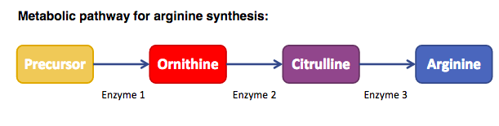
- study of Neurospora
- Becomes
- ONE GENE ONE POLYPEPTIDE
- Human genome
Module 4
The Complex Proteome
Genome to proteomic
Cells detect change in the environment
- Insulin receptor
- High glucose
- Detected in the pancreas and causes insulin to be released and is received to varies cell typed
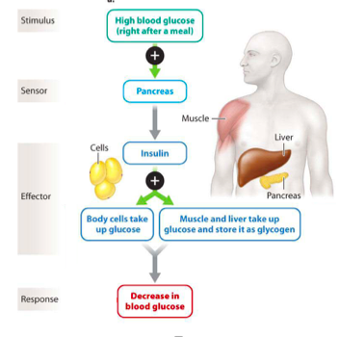

Insulin Processing
- Translated polypeptide coded in the insulin gene is 110 amino acids longs
- Functional insulin protein is made up of 2 chains: a – chain 21 amino acid b-chain 30 amino acids
- Translated 110 amino acid
- Two chains
- a chain + b chain = 51
- Amino acids are missing
- Why does it happen?
- The 100 polypeptide = pre-proinsulin has signal peptide export = secrete site
- Proinsulin 90 amino acid
- c is snipped out to just give a and b
Insulin induces the uptake of glucose
- Purple strand – polypeptide
- Receptors phosphates themselves and other proteins
- It becomes activate
- Kansas
- Phosphorylation are signal cascade
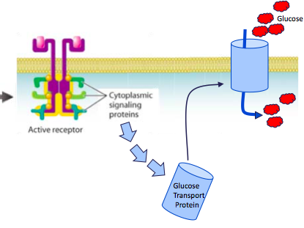
- End step
- Activation of glucose transport protein

Applied Lecture Theme 2 Module 3&4
Antibiotics
- Made by microbial organisms (fungi, molds and bacteria)
- Involves the formation of a chemical compound by a living organism
- Can also be produced
- Compounds that are made out of micro organism
- A result of biosephatic pathway
- Inhibits the grow of other organism that could kill the human/animal
- Why bother?
- blocks growth and multiplication of microbes
- for humans to live longer\
Antibiotics kill bacteria by inhabiting their features that are unique
Primary targets of Antibiotics
- Interfering with cell wall
- Disrupting bacterial protein synthesis at the ribosome
- Inhibiting the function of enzymes needed for DNA and RNA synthesis
Ribosomes and antibiotic functions
- The bacterial ribosome is the target of over 50% of widely used antibiotics
- What are possible targets that could stop ribosome function in the prokaryotic cell?
- take away inhabiting compound or actually inhibit the ribosome
Ribosomes Difference between Euk and Pro
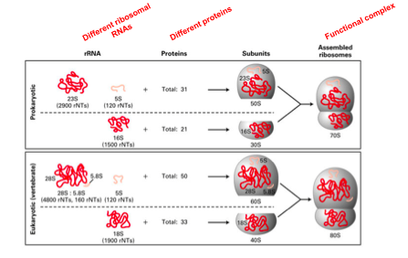
ribosome is the greatest target because it the main compound of translation
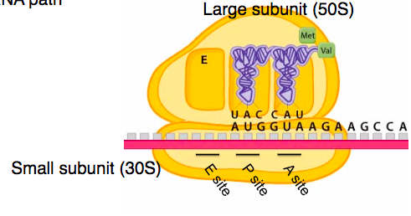
Small Ribosomal Unit 30S
Major Function Sites and Target site in the
Ribosome for Antibiotics
- tRNA binding site (A, P, E)
- mRNA path
3 Types of Antibiotics – all inhibits translation
Tetracycline
- blocking the A-site
- no new charge tRNA can enter the ribosome
- interfering with the delivery of tRNAs to the A-site by binding and distorting 30s ribosomal subunit
- anticodons of tRNA cannot align with codons of mRNA
Streptomycin 1&2
Streptomycin 1
- disrupting tRNA transfer
- prevents transfer of tRNA from A to P site
- therefore, no elongation of polypeptide chain
Streptomycin 2
- misreding and premature termination of protein elongation
- codons don’t match (GAG – CGC)
Large Ribosomal unit 50S
Major Function Sites and Target site in the Ribosome for Antibiotics
- ribosomal complex assembly
- the peptidyl transferase centre (PTC): Peptide bond formation
- peptide exit tunnel
Chloramphenicol
- blocking peptide bond formation
- sits in the PTC, blocking the peptidyl transferase reaction

Antibiotic Resistance
- the spread of resistance is process of natural selection
- resistance confers a selective advantage to the bacteria
- resistance can come from change in bacterial cell (e.g. mutation in rRNA)
- OR
- Bacterial cells acquire genes that reside on plasmids (small circular DNA molecules) from other bacteria
Ho can bacteria can target antibiotic challenges
- efflux pump – remove antibiotic from the cell
- enzymatic modification/degradation of antibioticby enzymes
- modification of target sites
small peptides that block antibiotic binding, change of shape antibiotic target etc.
Chloramphenicol Resistance
- rRNA mutations in large ribosomal subunit disrupt specifically of antibiotic binding in peptidyl transferase centre
or
- Bacterial Cfr rmethyltransferase enzyme: Methylation of the rRNA prevents antibiotic binding
Sharing resistance
Conjugation: the transfer of plasmids or small circular DNA containing resistant genes from one bacteria to another
Microbiomes and antibiotics target infectious diseases

