Key concepts: Population, Resources and the Environment

- The distinction between human impact on the environment and environmental impact on humans:

- Human impact on the environment: human actions toward natural environment based on our demands, which resulted in several environmental changes (mostly negative).

- Environmental impact on human: how the surroundings (both biotic and abiotic components on Earth) affect human life. (mostly positive)

- How human impact centres on changing natural flows of energy and matter:

- The natural environment was functioning long before the human species appeared,

- Why we impact the natural environment:

- We impact the environment due to the need of air, water, food, shelter, and everything else essential for living; therefore, we make actions toward environment to enrich our lives, bringing us longer life spans, better health, and greater material wealth, mobility, and leisure time.

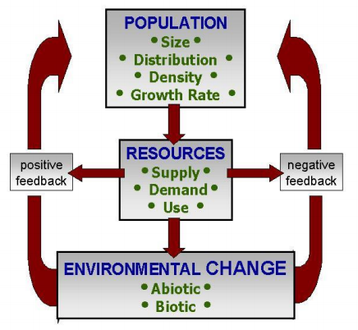
- The human-environment interaction model:

- Focused on humans, where population and the demand of resources causes environmental change.

- There are attributes in the three components which are variables the effect/influence the model (size, distribution, growth rate)

- Human population has shot up in the past hundred years or so and continues to grow exponentially.

- Every living thing on earth requires resources from the planet. (e.g. a tree impacts the planet by taking resources, however the impacts are minimal as the tree returns other resources to the environment)

- Negative feedback: A loop which results in stability by decreasing the disturbance, involving continuous cycle and is common in nature. (e.g. increased herbivore populations result in an increase in carnivores which maintain the population of herbivores)

- Positive feedback: A feedback that destabilizes systems, pushing them toward extremes; OR the amplification of an effect by its own influence resulting in exponential growth which is finite and destructive. (e.g. unregulated deer population which grows to 6000 until the population cannot be maintained)

- Attributes of the model’s components and examples:

- Population:
- Size: The most populous country in the world is China which has 1.39 billion people.
- Distribution: 80% of Canadians live within 160km of the US border.
- Density: The densest country in the world is Monaco with 19 thousand people/km², Canada has only 3.6 people/km².
- Growth rate: Growth rate can be positive or negative. Positive growth rate tends to indicate a younger population, whereas a negative growth rate tends to indicate an older average population.

- Resources:
- Natural attributes: Determined by nature.
- Supply: The amount of a resource available.
- Character: The nature of the resource.
- Human attributes: Determined by humans.
- Demand:
- Extraction: The extraction and transportation of the resource.
- Use:

- Environment change:
- Abiotic environment: non-living components of an environment.
- Biotic environment: living components of an environment.

“All resource attributes are affected by the population attributes, and ultimately this combination impacts on the environment to a greater or lesser extent”.

- Factors influencing the model’s components:

- Impact = Population x Affluence x Technology
- Countries with high populations (and low affluence and technology) are likely to have a high impact on the environment).
- Countries with high resource demand and high affluence (and low population) are also likely to have a high impact on the environment.

- Per capita consumption: while the U.S only makes up 4% of the population it demands 25% of the world’s minerals and petroleum and creates 25% of pollution/ trash and 28% of greenhouse gases. Comparatively, India makes up 17.6% of the world’s population and only uses 3% of the world’s minerals and petroleum and makes 3% of the world’s pollution/ trash and 5.4% of the world’s greenhouse gases.

- Public policy:
- Population: laws about immigration, birth control, health care and etc.
- Resources: taxes, logging laws.
- Environment: impacting nature reserves by taxing overconsumption, requiring environmentally friendly logging (etc.) procedures.

- Technology:
- Population: advancements in medical technology can increase population.
- Resources: collecting more resources, faster and in new environments.
- Environment: Using more environmental technology (e.g. electric cars vs natural gas).

- Culture/ Religion (midterm):
- Population:
- Resources:
- Environment:

- Terms such as externalities, common property resources:

- Externalities: “the environmental cost of producing or using an economic good or service which is not included in the market price of the good or service”.
- E.g. The greenhouse gases produced by laborers driving to work every morning to work in a factory; discharge of contaminants into the great lakes; increased skin cancer due to a reduced ozone layer.
- In some countries in Europe, companies are required to take back all packaging and so use less high impact packaging in order to reduce costs.
- Appliances that die go back to the company that produced it, therefore the company designs better appliances and create appliances that are more easily recycled.

- Common property resources: Resources which are free and accessible to all (e.g. atmosphere, oxygen, water from the great lakes). These resources are most commonly impacted by externalities.

- What is a resource? What are the challenges with its definition? What are various characteristics of resources? How may they be classified?

- Natural resources and human resources, non-tangible resources (knowledge, aesthetics, silence).

- Challenges with its definition:
- Anthropocentric definition: a resource that is not an object but a function. Emphasis is on how valuable it is to humans. That is, this definition of resources is defined by the needs and demands of humans. There is a value judgement that is often culturally defined.
- Every person sees different thing as resources and what we see as resources is based on STEP.
- STEP: Scientific knowledge, Technological knowledge, Economical knowledge and our Political knowledge.
- Biocentric definition: assumes the rights of non-human resources supersede human wants or needs.
(These two points of views conflict. E.g. if someone wanted to log an old growth forest for its value for logging, others would argue that the ecosystem has more value as it is.)
- Technocentric viewpoint: value system that is focused on technology and believe that human knowledge can surmount any problems that humans create.
- Ecocentric viewpoint: the belief that humans are part of the biosphere are subject to its laws rather our own. These people believe we should switch from managing ecosystems to the benefit of humans to controlling humans for the benefit of ecosystems.
- Cornucopians: Human ingenuity will solve any problem. (same as technocentric)
- Cassandras: Predict doom and disaster.

- Characteristics of Functional Resources:
- Resources are dynamic not static. (e.g. wood was once a very valuable resource as we used it for building and heating, however we do not use this resource to nearly the same extent; that is, the value of wood changed with need)
- Resources may be depleted/ degraded and or made obsolete. (e.g. fossil fuels, aqua turfs (depleting); pollution of water (degrading); extinction of species (made obsolete))
- Resources can be extended (or made to last longer) through technology and management. (e.g. recycling)
- Resources can be hazards. (e.g. nuclear waste, electricity (technological hazard); property on water is worth more (it is a resource) and yet these houses are more impacted by storms, erosion, etc. (natural hazard); aseptic in buildings (health hazards))

- Classification of Resources:
- Flow resources: can be depleted, sustained or increased on the basis of management. (e.g. soils, forests, wildlife, fish, water, etc.)
- Stock resources:
- Physically exhaustible. (e.g. coal, oil, uranium, natural gas)
- Depletable but capable of reuse. (e.g. metal)
- Continuous resources:
- Availability is endless and independent of human action. (e.g. solar energy, tidal energy)
- Availability is endless but affected by human action. (e.g. landscape amenity, air, ocean quality)

- What is an environmental impact? What are the challenges with its definition?

- The environmental impact: The definition reflects a “value judgement” based on human demands. (e.g. a community sees a forest as having no value, therefore destroying it and believing these was zero environmental impact)

- Challenges with its definition:
- The perception of an environmental problem varies between individuals and cultures. (e.g. pesticides are welcomed where malaria is present as it kills carrier mosquitoes, however it is not welcomed in Canada due to health risks)
- If there is an environmental impact depends on our personal STEP (scientific, technological, environmental and political knowledge), management is very difficult if we have no agreement on what is valuable and thus what needs to be protected.

- What is environmental sustainability? How may it be assessed? How may humans impact on environmental sustainability?

- Environmental Sustainability: Maintaining or restoring the quantity or quality of biophysical resources upon which humans depend.
- Two rules for assessing the environmental sustainability of human activities:
- Input rule:
- The harvest or consumption of renewable resources should be within the regenerative capacity of nature.
- The depletion rates of non-renewable resources should be equal or less than the rate we develop renewable substitutes.
- Output rule: The emissions that we release into the environment must be within the assimilative capacity of the environment into which the emissions are released.

- Types of Impacts affecting environmental sustainability:
- Change in the quality of the biophysical environment.
- Change in biodiversity.
- Changing the supply/storage of resources.
- Changes in physical structure of the environment. (e.g. changing wetlands into agricultural land)

- How are we attempting to solve environmental impacts (problem displacement)?

- Spatial displacement. (e.g. Sudbury’s smokestacks; Toronto waste shipped to Michigan)

- Displacement to another medium. (e.g. Brampton tried to incinerate landfill waste, reducing the volume of the waste while contaminating the air with toxins or creating toxic waste)

- Temporal displacement: leaving the problem for future generations to deal with. (e.g. burying landfills or contaminants which will leak into lakes/ groundwater; lifestyle is resulting in the extinction of plants and animals)

- The critical boundaries identified by scientists and where we stand in terms of their limits:

- The critical boundaries:
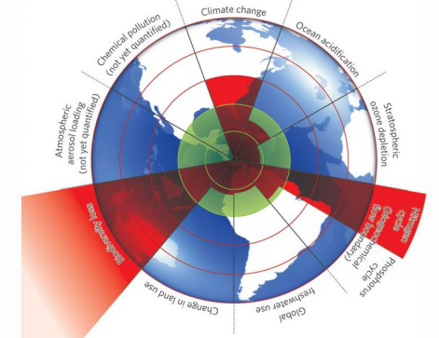

This is what a number of scientists put together globally to track our impact on the environment.
The green section in the center represents a sustainable level of use.
Three items go beyond that:
- Nitrogen: The release of nitrogen to the environment is much higher that can be sustained.
- Climate change
- Biodiversity loss.
Ocean acidification and Phosphorous cycle are moving towards the edge of what is sustainable.

