Unit 1: Key Concepts: Population, Resources and Environment
September 11, 2017
Introduction
Guelph, as part of the St. Lawrence lowlands, if left undisturbed, would return to deciduous forest.
20,000 years ago, Guelph was buried by a glacier 2km-4km thick; at this time, there was very little life in Canada. As the glacier receded, Guelph became a tundra. About 6000 years ago Guelph became a deciduous forest.
These changes occurred naturally, with no human impact (though they did live in North America at the time).
Flooding, hurricanes, wildfire and landslides are natural processes that occur without human interference. The earth is dynamic and change is natural.
What role then do humans play? While these processes are natural, their power may be changed by humans. We are initiating, accelerating, stopping, etc. natural processes.
Our life is dependent on the sustainability of the environment and its resources. All resources are finite at some scale.
Example of human impact on the environment:
- redirecting water from the Colorado river to agriculture in deserts resulting in the river no longer flowing to the ocean
- the extinction of the Ivory-billed woodpecker
- replacement of old growth forest with secondary growth
- pollution in the ice and snow in the artic- thousands of km from the nearest city
Human-Environment Interaction Model
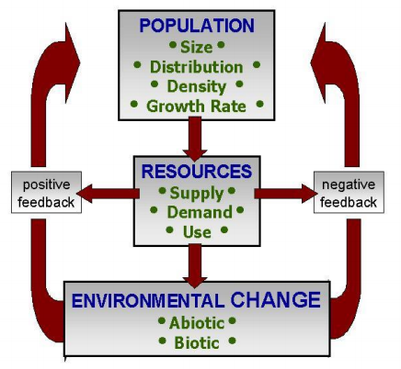
Human population has shot up in the past hundred years or so and continues to grow exponentially.
Every living thing on earth requires resources from the planet. A tree impacts the planet by taking resources, however the impacts are minimal as the tree returns other resources to the environment.
Negative feedback: A feedback which results in stability by decreasing the disturbance. Ex. increased herbivore populations results in an increase in carnivores which maintain the population of herbivores.
Positive feedback: amplification of an effect by its own influence resulting in exponential growth which is finite and destructive. Ex. unregulated deer population which grows to 6000 until the population cannot be maintained.
Attributes of the Model’s Components
Population:
- Size: The most populous country in the world is China which has 1.39 billion people.
- Distribution: 80% of Canadians live within 160km of the US border.
- Density: The densest country in the world is Monaco with 19 thousand people/km², Canada has only 3.6 people/km²
- Growth rate: Growth rate can be positive or negative. Positive growth rate tend to indicate a younger population, whereas a negative growth rate tends to indicate an older average population.
Resources:
Natural attributes: Determined by nature.
- Supply: The amount of a resource available.
- Character: The nature of the resource. How easy is it to aquire? How much impact do we make on the landscape in acquiring it.
Human attributes: Determined by humans.
- Demand:
- Extraction: The extraction and transportation of the resource
- Use:
Environment:
- Abiotic environment: non-living components of an environment
- Biotic environment: living components of an environment
"all resource attributes are affected by the population attributes, and ultimately this combination impacts on the environment to a greater or lesser extent"
Factors influencing the interaction of Population Resources and Environment
Impact =Population x Affluence x Technology
Countries with high populations (and low affluence and technology) are likely to have a high impact on the environment.
Countries with high resource demand and high affluence (and low population) are also likely to have a high impact on the environment.
Some factors influencing the interaction of population, resources and environment are:
- Per capita consumption: while the U.S only makes up 4% of the population it demands 25% of the worlds minerals and petroleum and creates 25% of pollution/ trash and 28% of greenhouse gasses. Comparatively, India makes up 17.6% of the world’s population and only uses 3% of the world’s minerals and petroleum and makes 3% of the worlds pollution/ trash and 5.4% of the worlds greenhouse gases.
- Public Policy:
  - Population: laws about immigration, birth control, health care and etc.
  - Resources:
  - Environment: impacting nature reserves, by taxing overconsumption, by requiring environmentally friendly logging (etc.) procedures.
- Technology:
  - Population: advancements in medical technology can increase population;
  - Resources: Collecting more resources, faster and in new environments.
  - Environment: Using more environmental technology (ex. electric cars)
- Culture/ Religion midterm
  - Population:
  - Resources:
  - Environment:
- Externalities: “the environmental cost of producing or using an economic good or service which is not included in the market price of the good or service"
  - Ex. the greenhouse gases produced by labourers driving to work every morning to work in a factory; discharge of contaminants into the great lakes; increased skin cancer due to a reduced ozone layer
  - In some countries in Europe, companies are required to take back all packaging and so use less high impact packaging in order to reduce costs.
  - Appliances that die go back to the company that produced it, therefore the company designs better appliances and create appliances that are more easily recycled.
  - Common property resources: Resources which are free and accessible to all (ex. atmosphere, oxygen, water from the great lakes). These resources are most commonly impacted by externalities.
Resources and Environmental Impact
Resources
- Anthropocentric definition: A resource that is not an object but a function. Emphasis is on how valuable it is to humans. That is, this definition of resources is defined by the needs and demands of humans. There is a value judgement that is often culturally defined.
  - Every person sees different thing as resources and what we see as resources is based on STEP.
  - STEP: Scientific knowledge, Technological knowledge, Economical knowledge and our Political knowledge.
- Biocentric definition: assumes the rights of non-human resources supersede human wants or needs.
These two points of views conflict. Ex. if someone wanted to log an old growth forest for its value for logging, others would argue that the ecosystem has more value as it is.
- Technocentric viewpoint: value system that is focused on technology and believe that human knowledge can surmount any problems that humans create.
- Ecocentric viewpoint: the belief that humans are part of the biosphere are so subject to it’s laws rather than our own. These people believe we should switch from managing ecosystems to the benefit of humans to controlling humans for the benefit of ecosystems.
Are things getting better or worse?
- Cornucopians: Human ingenuity will solve any problem. (same as technocentric)
- Cassandras: Predict doom and disaster.
How can you decide who is correct? Are the impacts limited to humans, or are other organisms or systems involved? Are the proponents thinking in the long or short term? Are they considering all costs and benefits?
Characteristics of Functional Resources:
- Resources are dynamic not static: ex. wood was once a very valuable resource as we used it for building and heating, however we do not use this resource to nearly the same extent; that is, the value of wood changed with need.
- Resources may be depleted/ degraded and or made obsolete: ex. fossil fuels, aqua turfs (depleting); pollution of water (degrading); extinction of species (made obsolete).
- Resources can be extended (or made to last longer) through technology and management: ex. recycling
- Resources can be hazards: ex. nuclear waste, electricity (technological hazard); property on water is worth more (it is a resource) and yet these houses are more impacted by storms, erosion, etc (natural hazard).; espestice in buildings (health hazards)
Classification of Resources
- Flow resources: can be depleted, sustained or increased on the basis of management. Ex. soils, forests, wildlife, fish, water, etc.
- Stock resources:
  - physically exhaustible. Ex. coal, oil, uranium, natural gas
  - deple7table but capable of reuse: ex. metal
- Continuous resources:
  - Availability is endless and independent of human action. Ex. solar energy, tidal energy.
  - Availability endless but affected by human action. Ex. landscape amenity, air, ocean quality.
Environmental change: The definition reflects a “value judgement” based on human demands.
- The perception of an environmental problem varies between individuals and cultures. E.g. pesticides are welcomed where malaria is present as it kills carrier mosquitoes, however it is not welcomed in Canada due to health risks.
- If there is an environmental impact depends on our personal STEP (scientific, technological, environmental and political knowledge). Management is very difficult if we have no agreement on what is valuable and thus what needs to be protected.
Environmental Sustainability and Problem Displacement
Environmental Sustainability: Maintaining or restoring the quantity or quality of biophysical resources upon which humans depend.
There are two rules for assessing the environmental sustainability of human activities:
- Input Rule:
  - The harvest or consumption of renewable resources should be within the regenerative capacity of nature.
  - The depletion rates of non-renewable resources should be equal or less than the rate we develop renewable substitutes.
- Output Rule: The emissions that we release into the environment must be within the assimilative capacity of the environment into which the emissions are released.
Types of Impacts Affecting Environmental Sustainability
- Change in the quality of the biophysical environment.
- Change in biodiversity.
- Changing the supply/storage of resources.
- Changes in physical structure of the environment; ex. changing wetlands into agricultural land
Problem Displacement
- Spatial displacement; ex. Sudbury’s smokestacks; Toronto waste shipped to Michigan.
- Displacement to another medium; ex. Brampton tried to incinerate landfill waste, reducing the volume of the waste while contaminating the air with toxins or creating toxic waste.
- Temporal Displacement: leaving the problem for future generations to deal with. Ex. burying landfills of contaminants which will leak into lakes/ groundwater; lifestyle is resulting in the extinction of plants and animals.
The Critical Boundaries
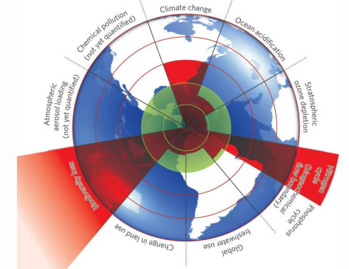
This is what a number of scientists put together globally to track our impact on the environment. The green section in the centre represents a sustainable level of use. Three items go beyond that:
- Nitrogen: The release of nitrogen to the environment is much higher than can be sustained
- Climate change
- Biodiversity loss.
Ocean acidification and Phosphorous cycle are moving towards the edge of what is sustainable.

