Lecture 1 – Introduction to Anatomy

- Anatomy quite literally means “dissect body”
- Started in Egypt, 1600 BC – identified heart, liver and spleen and knew blood vessels came from the heart
- Leonardo da Vinci was one of the founders of anatomy, dissected 30 bodies, 1st to do cross sectional drawings of the body but stopped by the pope and people did not approve
- Andreas Vesalius able to make dissection more acceptable to the public
- Ligament normally named after the bone they originate and end at

Anatomical terminology

Anatomical position

- Standing erect, palms facing forward and feet apart facing forward (when talking about the body, right and left are in reference to the person)
  - Supine position – facing up, palms down
  - Prone position – facing down, head to side and palms up

Planes of anatomy

- Midsagittal plane: down the midline dividing the body from right to left (sagittal: not through midline)
- Frontal plane (coronal plane): coming down through frontal plane dividing body into front and back – doesn’t have to be in the middle of the body (anterior from the posterior)
- Transverse: dividing body into upper and lower sections of the body – again, doesn’t have to be in the middle

Terms of direction/position

- Superior: higher up on the body
- Inferior: lower down on the body
- Medial: closer to midline
- Lateral: further away from the midline
- Proximal: closer to trunk
- Distal: further from trunk
- Anterior: more towards the front of body
- Posterior: more towards the back of the body

Terms of direction/position

- Ipsilateral: same side of body
- Contralateral: opposite sides of body
- Superficial: closer to surface/skin
- Deep: closer to organs

Anatomy

3 divisions

- Macroscopic (gross)
  - Regional – dissection
  - Systemic – nervous system, blood supply
- Microscopic (histology)
  - Study of tissues and cells
- Developmental (embryology)
  - Embryo and fetal

Body cavities

- Protect vital organs
  - Cranial cavity holds brain
  - Vertebral cavity holds spine
  - Thoracic cavity holds lungs
  - Diaphragm separates thoracic and abdominal cavity
  - Abdominal cavity holds stomach/intestines
  - Pelvic cavity holds sex organs
  - Dorsal body cavity = spine and brain
  - Ventral = everything else

Body compartments

- Separated by joints and fascia (CT)
- Share developmental origin
- Share similar function and innervation

Basic tissues

Tissues

- Created by groups of cells with similar structure
- Cells perform a common or related function
- Histology: study of tissues and cells – microscopic anatomy

Tissues of the body

4 types:

- Epithelial – covers
- Nervous – controls
- Muscle – produces muscle
- Connective – supports

Epithelial tissue

- Found all over the body
- Covers the body surface or lines in the body cavity
- Lines hallow organs, most of the GI tract, vessels
- Forms protective surface of skin

Functions

- Protect tissue beneath It from toxins, pathogens, trauma etc.
- Regulation of secretion and absorption of chemicals and nutrients between tissue and cavity
- Secretion of hormones, mucus and enzymes

Two classifications

- Number of layers
  - Simple = 1 layer
  - Stratified = 2+ layers
  - Pseudostratified = appears stratified but all cells contact membrane
- Shape of cells
  - Squamous = flat
  - Cuboidal = cube-like
  - Columnar = tall
- First name = layering and second name = shape (# of layers + shape = e.g. simple squamous epithelium

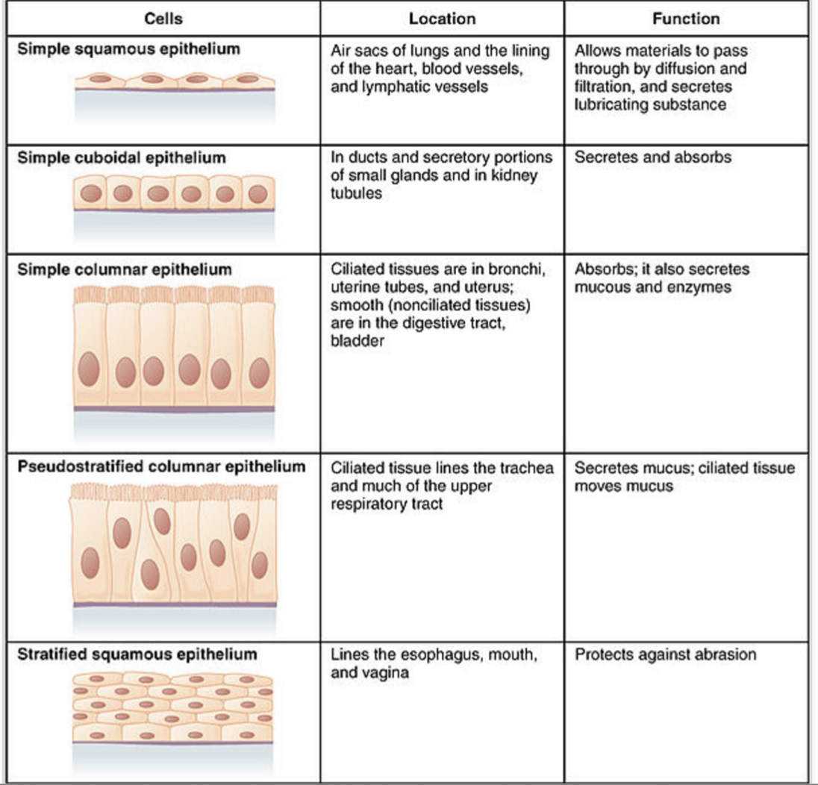

Nervous tissue

- Main component of brain, spinal cord and nerves
- Main cells are neurons and supporting cells (neuroglia)
- Neurones generate and conduct electrical impulses over long distances and are the longest cells in the body
- Neuroglia nourishes, insulates and protects the neurones

Muscle tissue

- Main function is to allow for movement and contraction
- Main cells are muscle fibres or myocytes
- 3 types of muscle tissue:
  - Skeletal: movement and support (voluntary)
  - Smooth: autonomic body regulation (involuntary)
  - Cardiac: propels blood from heart (involuntary)

Connective tissue

- Most abundant tissue in the body
- Provides structure and support
- Surrounds, protects and connects structure such as blood vessels, nerves and organs
- Composed of cells and fibres – lots of collagen

Classification of connective tissue

- Connective tissue proper
  - Loose
  - Dense
- Specialized connective tissue
  - Cartilage
  - Bone
  - Blood

Connective tissue proper

- Loose:
  - Adipose and reticular
  - Few fibres but many cells
  - Forms network and protects body
- Dense:
  - Regular and irregular
  - Many fibres but few cells
  - Forms tendons and ligaments or fibrous coverings of organs

Specialized connective tissue

- Cartilage:
  - Tough but flexible
  - Avascular and lacking innervation
  - 3 types of cartilage:
    - Hyaline – forms articular cartilage that lines joints and resists compressive forces and friction
    - Elastic – flexible but maintains shape
    - Fibrocartilage – great tensile strength, absorbs compressive shock
- Bone:
  - Supports and protects body
  - Stores fat and blood cells in cavities
  - Bone is the hardest compared to all the other substances (apart from enamel)
  - Abundant collagen fibres resist tension
  - Bone is alive with a rich capillary network
- Blood:
  - Does not support things
  - Functions for transport of respiratory gases, nutrients, waste and other substances

