Chapter 4: Elasticity

Part 1: Price of Elasticity Demand

Define Price Elasticity of Demand: is a units free measure of the responsiveness of the Quantity demanded of a good to a change in its price when all other influences on buying plans remain the same

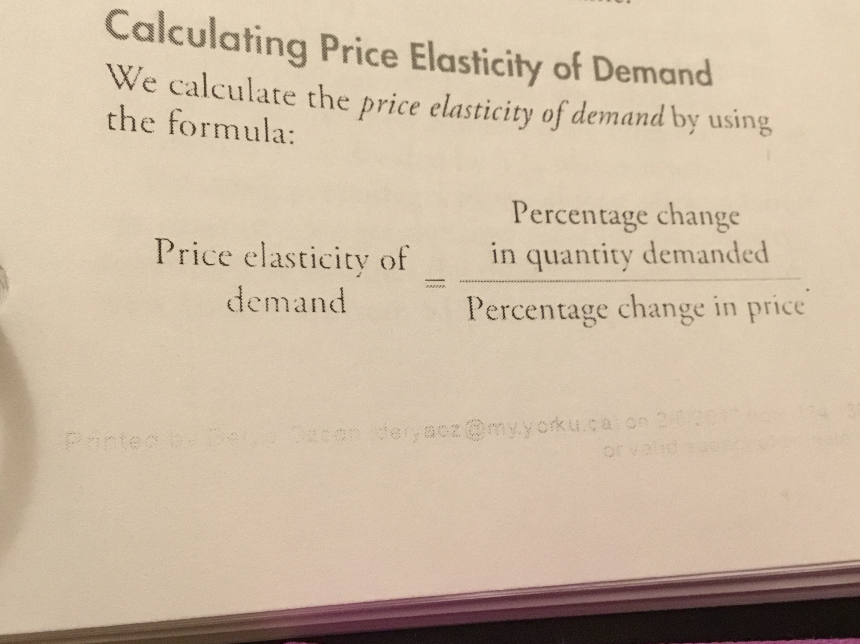
Calculating Price Elasticity of Demand Formula

1.Average Price and Quantity

2.Percentages and Proportions
A percentage change is a proportionate changed multiplied by 100.

3.A Units-Free Measure
Elasticity is a units free measure because the percentage change in each variable is independent of the units in which the variable is measured.

4.Minus Sign and Elasticity
When the price of a good rises, the Quantity demanded decreases. Because a positive change in prince brings a negative change in the Quantity demanded.

Inelastic and Elastic Demand
Define Perfectly Inelastic Demand: If the Quantity demanded remains constant when the price changes, then the price elasticity of demand is zero and the good is said to have a perfectly inelastic demand.
Insulin: one good that has a very low price elasticity of demand is insulin.
Define Unite Elastic Demand: if the percentage change in the Quantity demanded equals the percentage change in the price, then the price Elasticity equals 1 and the good is said to have a unit elastic demand
Define Inelastic Demand:the percentage change in the Quantity demanded is less than the percentage change in the price.
Define Perfectly Elastic Demand: if the Quantity demanded changes by an infinitely large percentage in response to a tiny price change then the price elasticity of demand is infinity and the good is said to have a perfectly elastic demand.
Define Elastic Demand:

The Factors that Influence the Elasticity of Demand
1.Closeness of Substitutes
2.Proportion of Income Spent on the Good
3.Time Elapsed Since Price Change

Elasticity Along a Linear Demand Curve

Total Revenue and Elasticity
Define and Provide example of Total Revenue:

Elastic and Inelastic Demand

Price Elasticities of Demand for Food

Your Expenditure and Your Elasticity

Part 2: More Elasticities of Demand

Income Elasticity of Demand
1.Income Elastic Demand
2.Income Inelastic Demand
3. Inferior Goods

Necessities and Luxuries

Cross Elasticity of Demand
1.Substitutes
2.Complements

Part 3: Elasticity of Supply

Define Elasticity of Supply:

Calculating The Elasticity of Supply
- Elastic and Inelastic Supply

The Factors That Influence Elasticity of Supply
- Resource Substitution Possibilities
- Time Frame for the Supply Decision (Momentary Supply, Short Run Supply, Long Run Supply)
Momentary Supply:
Short Run Supply:
Long Run Supply:

