Chapter 2: The Economic Problem

Definition of Scarcity: We want more than we can get. Our inability to get everything we want is called Scarcity

Part 1: Production Possibilities and Opportunity cost

Production Possibilities Frontier (PPF)

If we want to increase our production of one good, we must decrease our production of something else - we face a Tradeoff.

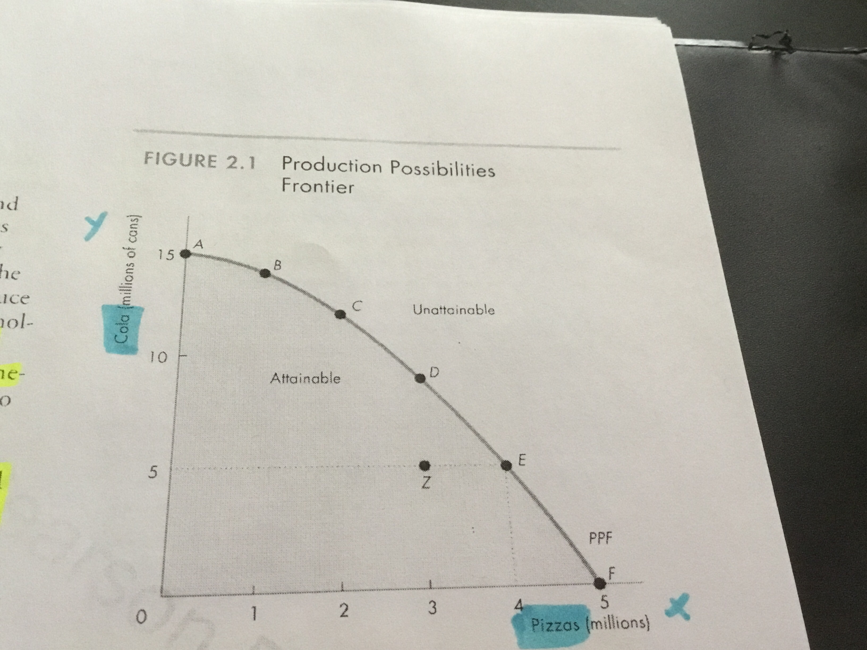
Define Production Possibilities Frontier (PPF) The boundary between those combinations of goods and services that can be produced and those that cannot.

When looking at this graph, Scarcity happens outside the points of production. The points outside the frontier are Unattainable.

However We can produce at any point inside the PPF or on the PPF. These points on the frontier are Attainable.

The dots on the graph are the scenarios. (A) (B) (C) etc

Production Efficiency
Define Production Efficiency: Producing goods and services at the lowest possible cost (The cheaper the more efficient)

Production Efficiency when looking at a graph, occurs at all the points on the PPF.
Points inside the PPF, production is inefficient (cost higher to produce) because we are giving up more than necessary of one good (Which leads to a tradeoff) to produce given quantity of another good.
-Points on PFF Cheaper to produce more efficient
-Points inside PPF Higher cost to produce inefficient

Trade off Along the PPF
Define Tradeoff: If we want to increase our production of one good, we must decrease our production of something else.
An Example of a tradeoff is; when you want a higher grade on your next test, you spend more time studying and less sleep or fun time. This leads to an opportunity cost.

Opportunity Cost
Define Opportunity Cost: The Opportunity Cost of an action is the highest value alternative forgone.

Example: There are only two goods on the PPF, so there is only one good we have to let go, To produce more pizza we must produce less pizza. The OPPORTUNITY COST of producing an additional pizza is the cost of the cola we must let go. & Vice versa if we wanted more cola instead of pizza.

1.Opportunity Cost is a Ratio
Opportunity Cost is a Ratio, It is the decrease in the quantity produced of one good divided by the increase in the quantity produced of another good
Provide example?

2.Increasing Opportunity Cost
The opportunity cost of a pizza increase as the quantity of pizzas produced increases
*-Outward bow shape of the PPF reflects increasing opportunity cost.

*Look at the scenarios in a table go upwards or downwards depending on that table depending on which good you want to produce more off.

-> Tradeoff --> Opportunity Cost

Your loss in something

Part 2: Using Resources Efficiently *****

Marginal Cost

Definition Marginal Cost: The Marginal Cost of a good is the opportunity cost (giving up pepsis to produce more pizza)
of producing one more unit of it.
*- Calculate the Marginal Cost on the Slope between the two scenarios Example. (A TO D)
Your cost of giving up something to produce another thing

Example, to produce 3 more rabbit furs you have to give up 20 berries the 20 berries becomes the marginal cost, and so on and so forth 4 rabbits give up 40 berries, etc. 40 berries becomes the marginal cost.

Preferences and Marginal Benefit

Marginal Benefit -
Define Marginal Benefit: The Marginal Benefit from a good or service is the benefit received from consuming one more unit of it.
Define Allocative Efficiency: When goods and services produced at lowest cost and in quantities that provide the greatest possible benefit.

Define and give example of Marginal Benefit Curve: The curve that shows the relationship between the marginal benefit from a good and the quantity consumed of that good.

The principle of decreasing marginal benefit is: The more we have of any good or service, the smaller its marginal benefit and the less we are willing to pay for an additional unit of it.
The reason marginal benefit decreases is because we like variety

Part 3: Economic Growth

The Cost of Economic Growth
Define Economic Growth: The expansion of production possibilities is called Economic Growth.
---- > Increases the living standards of living. Economic Growth comes from Technological change and Capital Accumulation.

Define and Provide Example of: Technological Change: is the development of new goods and of better ways of producing goods and services.
Define and Provide Example of: Capital Accumulation : is the Growth of capital resources including human population (human capital)

What is the opportunity cost of economic growth?
How does economic growth influence the production possibilities frontier?

Technological Change PROVIDE EXAMPLES

Capital Accumulation PROVIDE EXAMPLES

Part 4: Gains from Trade

Define Specialization: Producing only one good or a few goods
Define Comparative Advantage: a person has a comparative advantage if a person can perform the activity at a lower opportunity cost than anyone else.
Define Absolute Advantage: a person who is more productive than others has an absolute advantage.

Part 5: Economic Coordination

Define Economic Coordination: Specialize and produce millions of different goods and services, individual choices must be coordinated.

Decentralized Coordination is used and works best, and used with four complementary social institutions.
Firms, Markets, Property Rights, Money,

Define Firms: An economic unit that hires factors of production and organizes them to produce and sell goods and services.
Example: Loblaws buys or rents large building, equips them with storage shelves and checkout lanes, and hire labor. Loblaws direct the labor and decides what goods to buy and sell.

Define Markets: A Market is any arrangement that enables buyers and sellers to get information and to do business with each other.
Example: the oil market is not a place but a network of producers, consumers, and wholesales, and brokers who buy and sell oil.

Define Property Rights: The social arrangements that govern the ownership, use, and disposal of anything that people value are called Property Rights.
Examples
1. Real property: land and buildings
2. Financial property: Stocks and Bonds.
3. Intellectual property: Intangible product of creative effort, i.e., books, music, computer programs, anything protected by copy rights and patents

Define Money: is any commodity or token that is generally acceptable as a form of payment.

Circular Flows through Markets
Define Circular flows through markets: Trading in markets for goods and services and factors of production creates a circular flow of expenditures and incomes

Households specialize and choose quantities of labor, land, capital, and entrepreneurial services to sell or rent to firms.

Firms choose the quantities of factors of production to hire, These go through the Factor Markets.

Households choose the quantities of goods and services to buy,
Firms choose the quantities to produce. These flows good through the goods markets.

Coordinating Decisions
Define Coordinating Decisions: Markets coordinate Decisions though the price adjustments.

