Lesson 6 - Intro to Finance
June 23, 2017
14:52
What is Finance?

- "The science or study of the management of funds" - Webster's Collegiate Dictionary

The Goal of the Firm

- To create value for the firm's shareholders
- How? - Maximize price of existing common stock
- Good financial decisions -> increase stock price
- Poor financial decisions -> decline in stock price

Role of Management

- Serves as arbitrator & moderator b/w conflicting interest groups/stakeholders & objectives
- Creditors, managers employees & customers hold contractual claims against the company
- Contractual claims - amount that must be paid periodically to a buyer of a security; contractual claim may specify a time at which the principle must be repaid & other details (Have first rights to $/assets/anything of value if company goes bankrupt)
- Shareholders have residual claims against the company
- Residual claims - right of shareholder or some other party to the profit of a company after all prior obligations have been paid. (Equity claims - also called residual claims - are perhaps the most important if company is to be liquidated.)

Role of Finance in Business

- 3 basic issues addressed by study of finance
  - What long-term investments should the firm undertake? (capital budgeting decision)
  - How should the firm raise money to fund investments? (capital structure decision)
  - How to manage cash flows arising from day-to-day operations (operating decision)

Function of Financial Manager

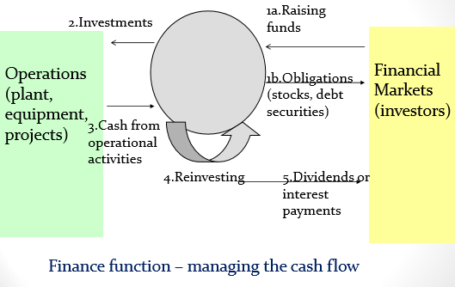
Principles of Finance

- Principle 1: Cash Flow is What Matters
  - Accounting profits ARE NOT equal to cash flows
  - It is possible for a firm to generate accounting profits but not have cash or to generate cash flows but not report accounting profits in the books
  - Cash flow, and not profits, drive the value of a business
  - Must determine additional cash flows when making financial decisions
- Principle 2: Money Has a Time Value
  - Dollar received today is worth more than a dollar received in the future
  - Since we can earn interest on the money received today, it is better to receive money sooner rather than later
  - Computation of Present Value
    - An investment can be viewed in two ways - its future value or its present value.
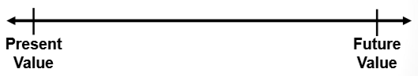
- Theory of Interest - Future Value
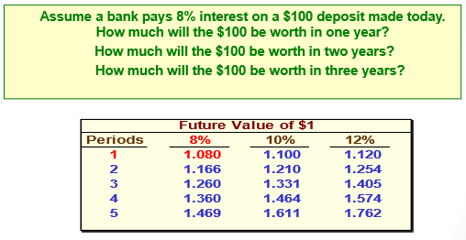
- Present Value - An Example
  - If a bond will pay $100 in two years, what is the present value of the $100 if an investor can earn a return of 12% on investments?
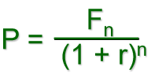
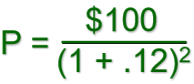


- This process is called discounting. We have discounted the $100 to its present value of $79.72. The interest rate of 12% used to find the present value is called the discount rate.
- Let's verify that if we put $79.72 in the bank today at 12% interest that it would grow to $100 at the end of two years.
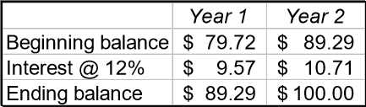



- Net Present Value Method
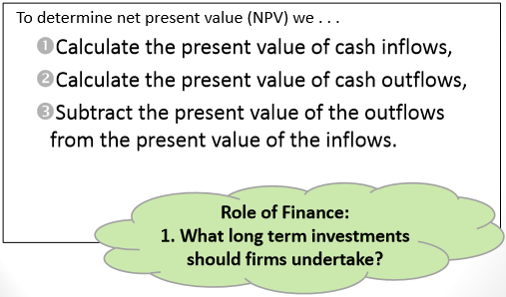

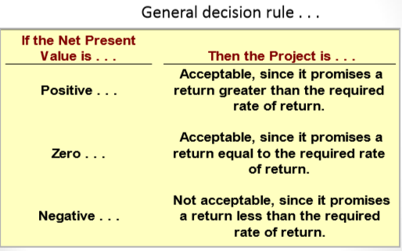

- Typical Cash Outflows and Inflows
  - Outflows:
    - Initial Investment (cash need to purchase asset)
    - Incremental operating costs
    - Repairs and Maintenance of new equipment
    - Additional investment in inventory
  - Inflows:
    - Incremental revenues
    - Reduction of operating costs
    - Salvage value
- Choosing a Discount Rate
  - Firm's cost of capital is usually regarded as minimum required rate of return
  - Cost of capital - avg. rate of return the company must pay to its long-term creditors and stockholders for use of their funds
- Net Present Value - Carver Tech Example
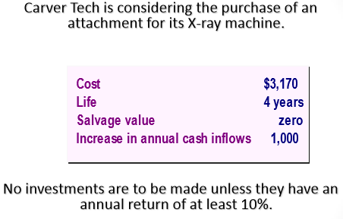
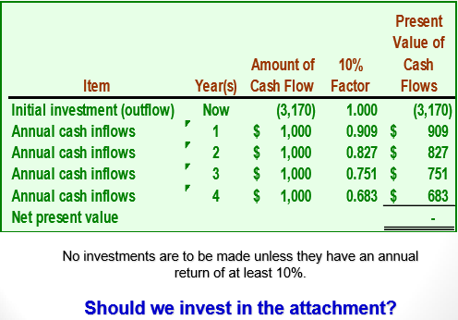
- Principle 3: Risk Requires a Reward
  - Risk - uncertainty about the outcome or payoff of an investment in the future
  - Rational investors would choose a riskier investment only if they feel the expected return is high enough to justify the greater risk
  - Diversification of Investments
    - All investment risk is not the same
    - Some risk can be removed or diversified by investing in several diff securities
      - Firm specific (unsystematic)
      - Market (systematic)
      - Economic (systematic)
- Principle 4: Market Prices are Generally Right
  - A financial market is "info efficient" if at any point in time the prices of securities reflect all info available to the public
  - When new information becomes available, prices quickly change to reflect it
  - Info efficient markets provide liquidity and fair prices
  - Note thee are inefficiencies in the market that may distort the market prices from value of assets
  - Such inefficiencies are often caused by behavioural biases
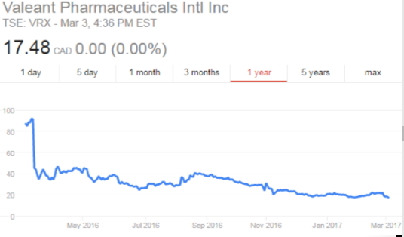
- Principle 5: Conflicts of Interest Cause Agency Problems
  - Separation of management and the ownership of the firm creates an agency problem
  - Owners or equity investors want to maximize the returns on their investments
  - Management vs. Owner Objectives
    - Management objectives may differ from owner objectives
    - Managers may make decisions that are not in the best-interest of the shareholders (principal-agent problem)
    - Managers may seek to emphasize the size of the firm sales, assets, or other perks
    - Dispersed ownership
    - Agency conflict is reduced through monitoring (ex. Annual reports) & compensation plans (ex. Stock options)
  - Corporate Governance
    - "Corporate governance is the system of rules, practices and processes by which a company directed and controlled. Corporate governance essentially involves balancing the interests of a company's many stakeholders, such as shareholders, management, customers, suppliers, financiers, government and the community."
  - Corporate Governance Functions
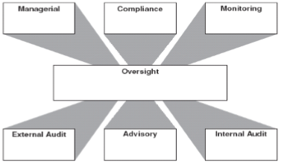
- Oversight - board of directos to oversee management
- Managerial - run company
- Compliance - laws, regulations, standards
- Internal Audit - assurance and consulting activity
- Legal and advisory - advice
- External audit - lend credibility
- Monitoring - elect or remove directors and management
- Principle 6: Ethics & Trust in Business
  - Ethical behaviour is doing the right thing! …but what is the right thing?
  - Sound ethical standards are important for business and personal success
  - Unethical decisions can destroy shareholder wealth

Financial Assets & The Financial System

- Real vs. Financial Assets
  - Real assets are tangible things owned by persons and businesses
    - Residential structures and property
    - Major appliances and automobiles
    - Office towers, factories, mines
    - Machinery and equipment
  - Financial assets are what one individual has lent to another
    - Consumer credit
    - Loans
    - Mortgages
- Functions of Money
  - Medium of Exchange
    - How transactions are conducted:
    - Something that is generally acceptable in exchange for goods and services. In this function, money removes the need for double coincidence of wants by separating sellers from buyers
  - Standard of Value
    - How the value of goods & services are denominated:
    - Something that circulates and provides a standardized means of evaluating the relative price of goods and services
  - Store of Value
    - How the value of goods & services are maintained in monetary terms:
    - The ability of money to command purchasing power in the future
- The Financial System
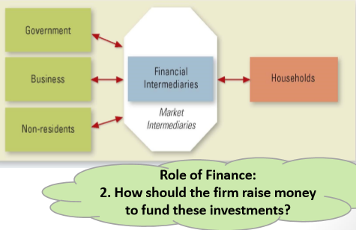
- Financial Intermediaries
  - Banks and other deposit-taking institutions
  - Insurance companies
  - Pension Funds
  - Mutual Funds
- Channels of Intermediation

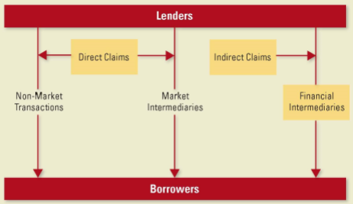
Quick Check

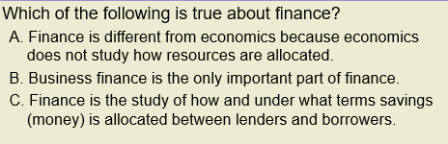

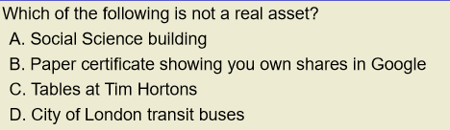

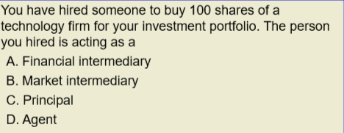

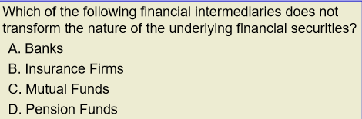

Financial Instruments and Markets

- Financial Markets

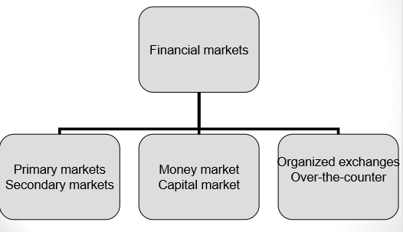

- Debt instruments issued by Corporations

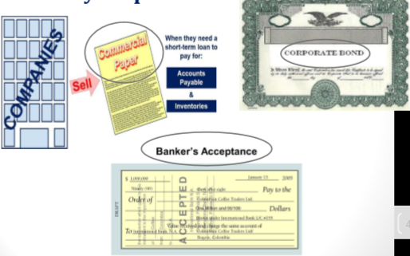
- Corporate Bonds
  - Debentures - unsecured debt, backed only by the general assets of the issuing corporation
  - Secured debt (mortgage debt) - secured by specific assets
  - Subordinated debt - in default, holders get payments only after other debtholders get their full payment
  - Senior debt - in default holders get payment before other debtholders get
  - Zero Coupon - pay face value at maturity only, sold at discount
  - Junk (high yield) bonds - bonds with below investment grade rating
  - Bond Features
    - Retractable
    - Callable (redeemable)
    - Convertible
    - Extendable
- Equity Instruments issued by Corporations: Common Stocks
  - Common stock holders are the owners of the corporation's equity
  - Voting rights
  - No specified maturity date and the firm is not obliged to pay dividends to shareholders
  - Returns come from dividends and capital gains
  - 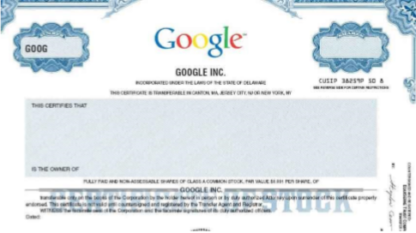
- Equity Instruments issued by Corporations: Preferred Stocks
  - Have face value, predetermined periodical (dividend) payments with priority over common stockholders
    - Cumulative
    - Non-cumulative
    - Participating
    - Non-participating
  - If dividend payment is not paid, preferred stockholders may get voting rights
- Derivative Securities
  - Securities whose value is derived from the value of some underlying asset
  - Most important derivatives are options and futures
  - Stock Options - not a tool of fundraising, it is a method of compensation

