Chapter 11 – Monetary Policy
LO1 – Define monetary policy and describe the Bank of Canada’s Monetary Policy Goals
- Monetary Policy – the actions the Bank of Canada takes to manage the money supply and interest rates to pursue macroeconomic policy goals
  - “in the best interests of the economic life of the nation”
  - But remember that the goal DOES NOT involve stabilizing prices in INDIVIDUAL MARKETS
    - Changes in conditions in individual markets typically AFFECT the RELATIVE prices of goods and services RATHER than the OVERALL price level
HOW DOES THE GOVERNMENT OF CANADA INFLUENCE THE CONDUCT OF MONETARY POLICY?
- The government can influence the conduct of monetary policy since the objectives of monetary policy in Canada are determined JOINTLY by the Department of Finance and the Bank of Canada. In​ fact, according to the​ "joint responsibility​ system" that dates back to the 1967 revision of the Bank of Canada​ Act, the Bank of Canada has instrument independence but not goal independence.
THE GOALS OF MONETARY POLICY
- The bank of Canada has four main MONETARY POLICY GOALS that are intended to promote a well-function economy:
  - Price stability
  - High employment
  - Stability of financial markets and institutions
  - Economic growth
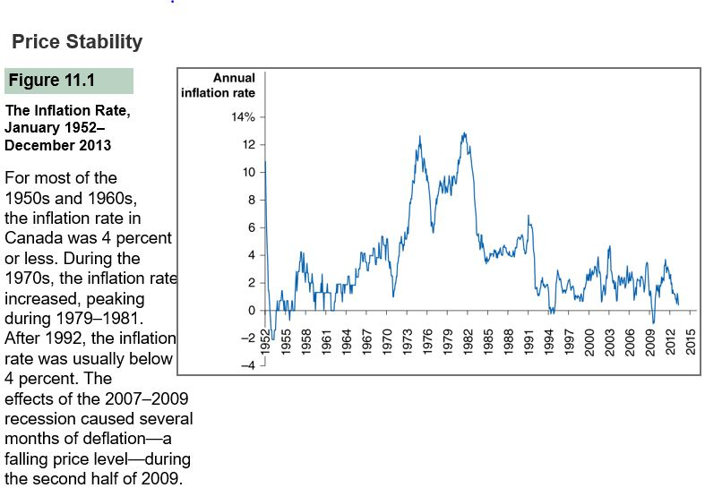

Price stability:
  - It’s important to maintain price stability because:
    - By achieving price stability, the bank of Canada also promotes economic growth
    - If inflation is low, the bank of Canada will have flexibility to lessen the impact of recessions
    - Rising prices erode the value of money as a medium of exchange and store of value
  - Inflation targeting – conducting monetary policy so as it commits the central bank to achieving a publicly announced level of inflation
    - High inflation:
      - Creates difficulties for the bank of Canada to conduct monetary policy
      - Reduces the real value of money
      - Reduces economic growth
  - Symmetric inflation targeting – the central bank of equally concerned about inflation rising above its target as it is about inflation failing below its target
    - Bank of Canada’s approach to inflation targeting is symmetric
  - Flexible inflation targeting – the central bank does not rely on mechanical rules to achieve its inflation target, but tries to meet the inflation target over some time horizon (typically a two-year horizon)
High employment:
  - Unemployed workers and underused factories and office buildings reduce GDP below its potential level
  - Unemployment causes financial distress and decreases the self-esteem of workers who lack jobs. The goal of high employment extends beyond the Bank of Canada to other branches of the government
Stability of financial markets and institutions:
  - The bank of Canada promotes the stability of financial markets and institutions so that an efficient flow of funds from savers to borrowers will occur
  - While the bank of Canada doesn’t regulate financial institutions, it does play a key role in providing liquidity to banks
  - By acting as a lender of last resorts, the bank of Canada reduces the risk of a financial – that is otherwise healthy – failing because it cannot access short-term funds
  - Investors bank can be subject to liquidity problems because they often borrow SHORT-TERM, sometimes as short as overnight, and INVEST the funds in LONGER-TERM investments
Economic Growth:
  - Policy markers aim to encourage stable economic growth because it allows households and firms to plan accurately and encourages the long-run investment that is needed to sustain growth
  - The government however, may be better able to increase saving and investment than the bank of Canada. For example, the government can change the tax laws to increase the return saving and investing
  - Some economist question whether the bank of Canada can play a role in promoting economic growth beyond attempting to meet its goals of price stability and financial stability
LO2 – describe the bank of Canada’s policy targets and explain how expansionary and contractionary monetary policies affect the interest rate
Monetary Policy Targets
- At times, the bank of Canada encounters conflicts between its policy goals. The main objective of the bank of Canada’s policy is to KEEP THE INFLATION RATE BETWEEN 1 AND 3 PERCENT
- Monetary policy targets – variables that it can directly influence and which, in turn, affect the inflation rate
- The two main monetary policy targets are THE MONEY SUPPLY and the INTEREST RATE
  - The Bank of Canada uses policy targets because it CANNOT AFFECT its policy goals directly, but must affect the goals INDIRECTLY through its policy targets
    - It can affect the interest rate and the money supply directly and these in turn can affect unemployment, GDP growth and the price level
- While the bank of Canada has typically used the interest rate as its target, this target was not central to the bank of Canada’s policy decisions during the global financial crisis
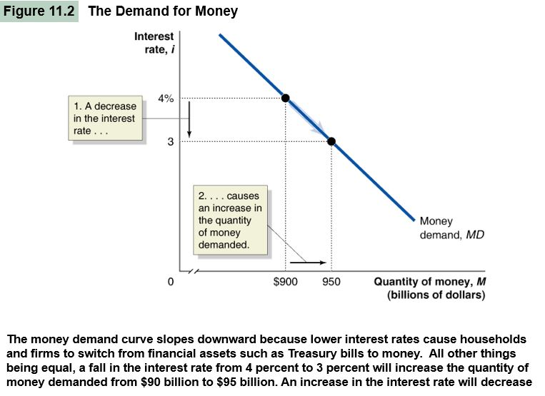
USING THE M1+ DEFINITION

THE DEMAND FOR MONEY
- When economist mean by the demand for money… they mean it is the amount of money – currency and checking account deposit – that individuals hold
- The advantage of holding money is Money can be used of buy goods, services or financial assets
- The disadvantage of holding money is money in form of currency or checking account deposits, earns either no or very low rate of interest
- To understand why the demand curve for money is downward sloping, consider that the households and firms have a CHOICE between HOLDING MONEY and HOLDING OTHER FINANCIAL ASSETS
- The CURRENCY in your WALLET earns NO interest and the MONEY in your CHEQUING account earns either no or very little interest
- When interest rates RISE on financial assets such as treasury bills, the amount of interest that households and firms LOSE by holding money INCREASES
- When interest rates FALL, the amount of interest households and firms lose by holding money DECREASES
- Remember that the opportunity cost is what you have to forgo to engage in an activity
- The interest rate is the opportunity cost of holding
- That being said…. When interest rates on treasury bills and other financial assets are LOW, the opportunity cost of holding money is LOW, so the quantity of money demanded by households and firms will be HIGH; when the interest rates are HIGH, the opportunity cost of holding money will be HIGH, so the quantity of money demanded will be LOW
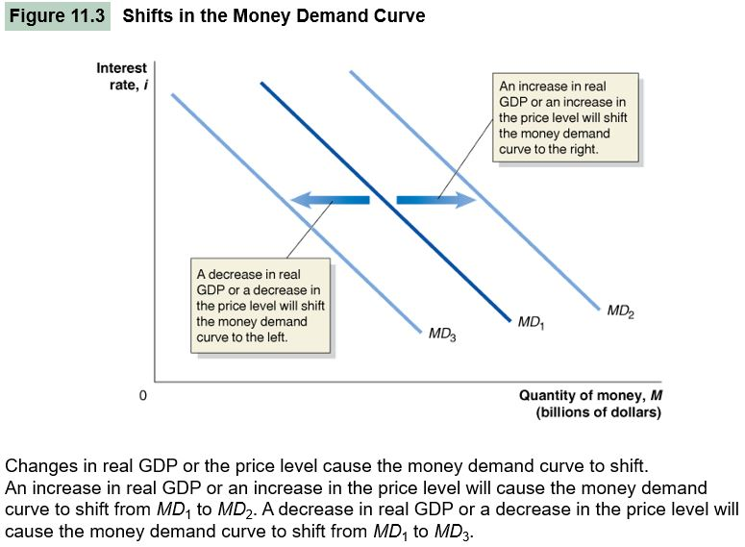

SHIFTS IN THE MONEY DEMAND CURVE
- Remember that changes in variables other than the PRICE cause the demand curve to shift
- In this context, changes in variables other than the INTEREST RATE causes the demand curve to shift
- The TWO most important variables to cause the money demand curve to shift are REAL GDP and the PRICE LEVEL
- An INCREASE in real GDP means that the amount of BUYING and SELLING of goods and services will INCREASE
  - This additional buying and selling INCREASES the DEMAND FOR MONEY as a medium of exchange
    - so the quantity of money HOUSEHOLDS and FIRMS want to hold INCREASES at each interest rate, shifting the money demand curve to the RIGHT
- A DECREASE in real GDP DECREASES the quantity of money demanded at each interest rate, shifting the money demand curve to the LEFT
- A HIGHER price level INCREASES the quantity of money required for a given amount of buying and selling
  - Meaning an INCREASE in price level INCREASES the quantity Of money demanded at each interest rate, shifting the money demand curve to the RIGHT
- A DECREASE in the price level DECREASES the quantity of money demanded at each interest rate, shifting the money curve to the LEFT
HOW THE BANK OF CANADA MANAGES THE MONEY SUPPLY: A QUICK REVIEW
- If the bank of Canada decides to INCREASE the money supply, it PURCHASES government of Canada securities
- The sellers of these securities DEPOSIT the funds they receive from the Bank of Canada in banks, which INCREASES the banks’ reserves
- Typically, banks loan out most of these reserves, which creates new chequing account deposit and expands the money supply
- If the Bank of Canada decides to DECREASE the money supply, it SELLS Canada securities, which decreases banks’ reserves and contracts the money supply
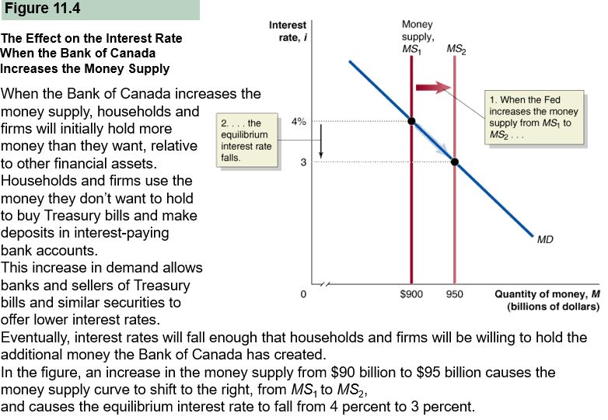

EQUILIBRIUM IN THE MONEY MARKET
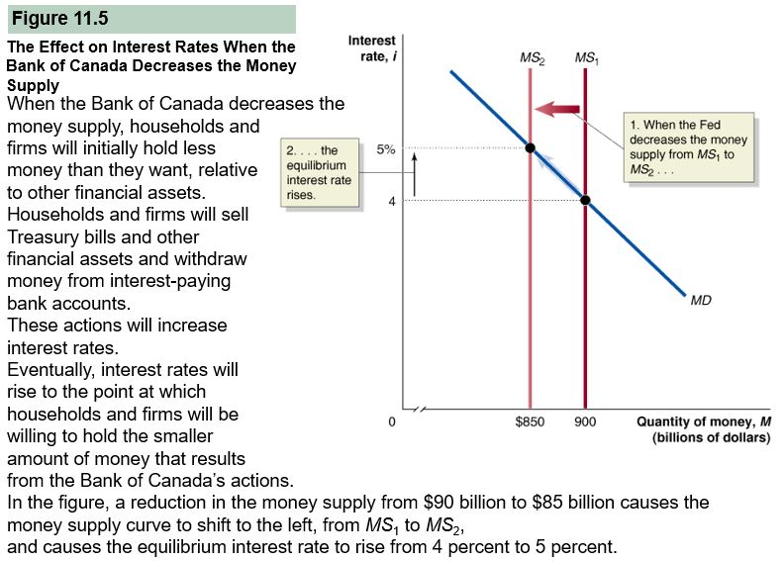
- Just as with other markets, equilibrium in the MONEY MARKET occurs when the money demand curve CROSSES the money supply curve
- When the Bank of Canada INCREASES the money supply, the short-term interest rate must FALL until it reaches a level at which households and firms are willing to hold the additional money
for simplicity, we assume that the Bank of Canada is able to completely control the money supply, therefore, the money supply curve is a vertical line and changes in the interest rate have no effect on the quantity of money supplied
A TALE OF TWO INTEREST RATES
- The loanable funds model is concerned with the long-term real rate of interest, and the money market model is concerned with the short-term nominal rate of interest, but there is often a close connection between their movements
- The long-term real rate of interest is the interest rate that is most relevant when:
  - Savers consider purchasing a long term financial investment
  - Firms borrow to finance long term investment projects
  - Households take out mortgage loan
- When conducting monetary policy, however, the short term nominal interest rate is most relevant because is the interest rate most affected by increases and decreases into the money supply
CHOOSING A MONETARY POLICY TARGET
- There are many different interest rates in the economy, but for purposes of monetary policy, the bank of Canada has targeted the interest rate known as the overnight interest rate
- Prime Lending Rate – the rate at which banks lend to their best customers
THE IMPORTANCE OF THE OVERNIGHT INTEREST RATE
- The bank of Canada pays banks a low interest rate in their reserve deposit which during normal times is the bank rate less 50 basis points, so banks normally have an incentive to invest reserves above the desired amount
- The overnight interest rate is the interest rate banks charge one another on loans in the overnight funds market
  - The loans in that market are usually very short term. Often just overnight
- The Bank of Canada does not set the overnight interest rate. Instead, it sets an operating band of 50 basis points wide for the overnight interest rate, and the rate is determined by the supply of reserves relative to the demand for them
- Very important for the Bank of​ Canada's monetary policy because the Bank of Canada uses the federal funds rate as a monetary policy target since it can control the rate through open market operations
LO3 – Use aggregate demand and aggregate supply graphs to show the effects of monetary policy on real GDP and the price level
- Open market buyback operations – agreements in which the bank of Canada, or another party, purchase securities with the understanding that the seller will repurchase them in a short period of time, usually less than a week
HOW INTEREST RATES AFFECT AGGREGATE DEMAND
- With the exception of government purchases, changes in interest rates will affect the components of aggregate demand in the following ways:
  - Consumptions – lower interest rates lower the cost of durable goods and reduce the return to saving, leading households to save less and spend more
    - Higher interest rates raise the cost of consumers durables and increases the return to saving, leading to households to save more and spend less
  - Investments – higher interest rates make t more expensive for firms and households to borrow, thereby decreasing investment
    - Lower interest rates increases the demand for stocks and make it less expensive for firms and households to borrow,. Thereby increasing investment
  - Net exports – if interest rates in Canada rise relative to interest rates in to their counties, investing in Canadian financial assets will become more desirable, causing foreign investors to increase their demand for dollars which will increase the value of the dollar
    - As the value of the dollar increases, net exports will fall. If interest rates in Canada decline relative to interest rates in other countries, the value of the dollar will fall, and net exports will rise
THE EFFECTS OF MONETARY POLICY ON REAL GDP AND THE PRICE LEVEL
- To reach its goal of high employment, the Bank Of Canada needs to carry out an EXPANDSIONARY MONETARY POLICY by increasing the money supply and decreasing interest rates. Lower interest rates cause an increase in consumption, investment and net exports, which shifts the aggregate demand curve to the right
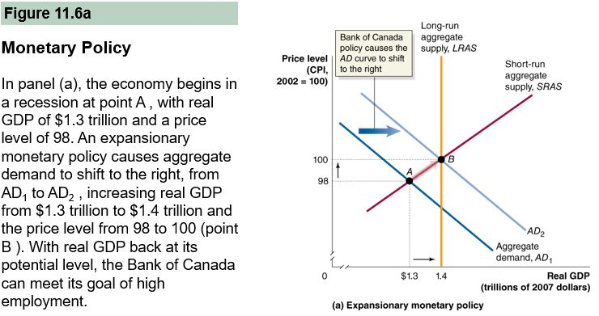
- To reach its goal of price stability, the Bank Of Canada needs to carry out a CONTRACTIONARY MONETARY POLICY by a decreasing the money supply and increasing interest rates. Higher interest rates cause a decrease in consumption, investment, and net exports, which shifts the aggregate demand curve
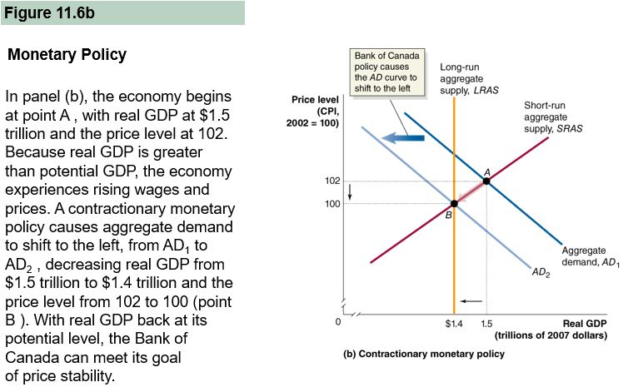
we assume that the economy is in short run equilibrium at point a where the ADC intersects SRASC. Real GDP is below potential real GDP, as shown by the LRASC, so the economy is in a recession, with some firms operating below normal capacity and some workers having been laid off
Sometimes, bank of Canada want to intentionally cause real GDP to decline because in the long run, real GDP cant continue to remain above potential GDP. Attempting to keep real GDP above potential GDP would result in rising inflation. As AD declines and real GDO returns to its potential level, upward pressure on wages and prices will be reduced, allowing the Bank of Canada to achieve its goal of price stability.
So in general, Bank of Canada can use monetary policy to affect the price level and, in the short run, the level of real GDP, allowing it to attain its policy goals of high employment and price stability.
Can the Bank of Canada Eliminate Recessions?
- Shifting the ADC back to full employment is very difficult for the Bank of Canada to achieve, as the length and severity of the 2007-2009 recession indicates
- The Bank Of Canada must recognize the need for monetary policy quickly
- If the Bank Of Canada is late in recognizing that a recession has begun or hat the inflation rate is increasing, it may not be able to implement a new policy soon enough to do much good. In fact, implementing a policy too late may actually destabilize the economy
- Procyclical Policy – Increases the severity of the business cycle
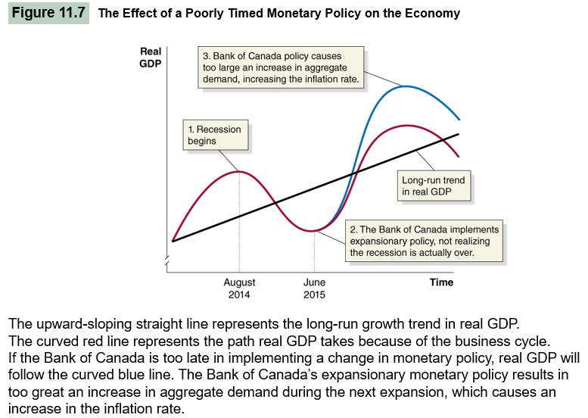
- Counter Cyclical Policy – reduces the severity of the business cycle, and which is what the Bank Of Canada intends to use
The straight line represents the long-run growth trend in real GDP in Canada. On average, real GDP grows about 3%. The actually path of real GDP differs from the underlying trend because of the business cycle, which is shown by the red curved line
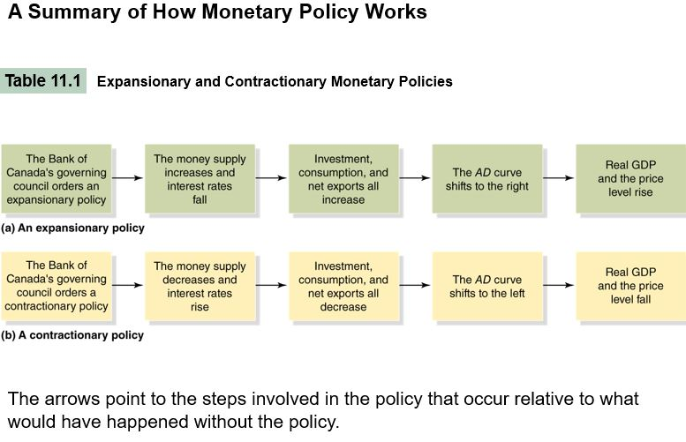

LO4 – Use the dynamic aggregate demand and aggregate supply model to analyze monetary policy
- The Bank of Canada can use monetary policy to affect AD, thereby changing the price level and the level of real GDP
- The discussion of monetary policy illustrated by figure 11.6 is simplified, however, because it ignores two important facts about the economy:
  - The economy experiences continuing inflation, with the price level rising every year
  - The economy experiences long-run growth, with the LRASC shifting to the right every year
- By taking into account these two facts, the dynamic aggregate demand and aggregate supply model can provide us with a more complete understanding of monetary policy
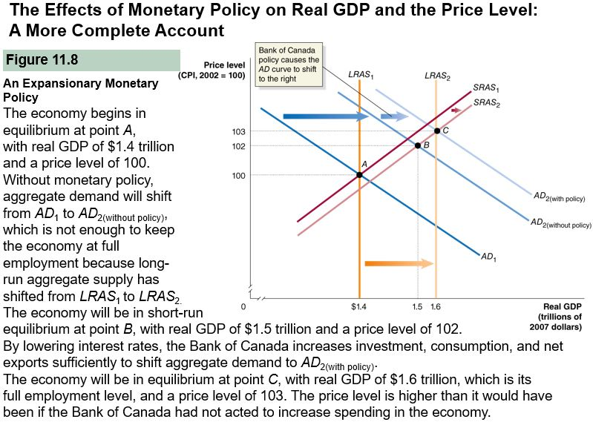
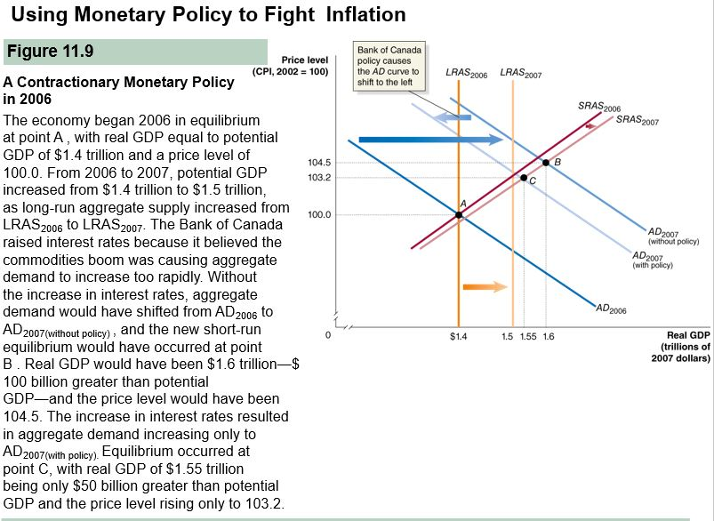

LO5 – Discuss the Bank of Canada’s setting of monetary policy targets
SHOULD THE BANK OF CANADA TARGET THE MONEY SUPPLY?
- Many economists who argue that the Bank of Canada should use the money supply rather than an interest rate as its monetary policy target belong to a school of thought known as monetarism, founded by Nobel Laureate Milton Friedman
- Skeptical About its ability to correctly time changes in monetary policy, Friedman and his followers believed that the Bank of Canada would greatly increase economic stability by replacing its policy with a monetary growth rule, which is a plan for increasing the money supply at a constant rate that doesn’t change in response to economic conditions
- If the Bank of Canada adopted this monetary growth rule, it would stick to it through changing economic conditions
- Friedman argued that the central bank should stick to the rule even during recessions because, he believed, active monetary policy destabilizes the economy, increasing the number of recessions and their severity
- Although during the 1970s some economists and politicians pressured the Bank of Canada to adopt a monetary growth rule, most of that pressure has disappeared in recent years
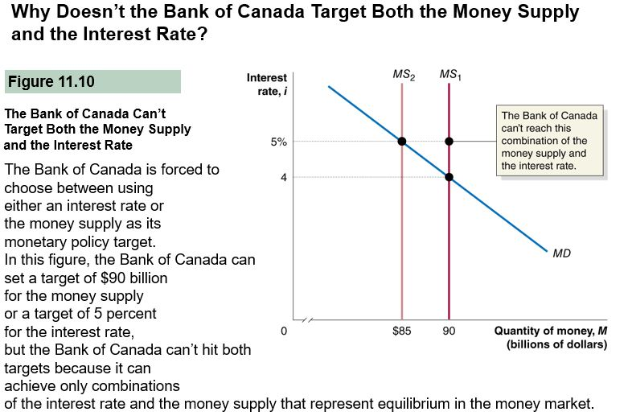

- Taylor Rule – a rule developed by John Taylor that links the Bank of Canada’s target for the overnight interest rate to so that is equal to the sum of the inflation rate, the equilibrium real overnight interest rate, and two additional terms: inflation gap and output gap
  - The inflation gap – the difference between current inflation and a target rate
  - The output gap – the percentage difference between real GDP and potential real GDP
- Inflation gap and output gap are each given “weights” that reflect their influence on the overnight interest rate target
- With weights of ½ for both gaps, we have the following Taylor rule:
  - Overnight Interest Rate Target = Current Inflation Rate + Real Equilibrium overnight interest rate + ( (1/2) x inflation gap + ((1/2) x Output Gap)
- The Taylor Rule includes expressions for the inflation gap and the output because the Bank of Canada is concerned about both inflation and fluctuations in real GDP
- Consider an example in which the current inflation rate is 1% and real GDP is 1% below potential real GDP
- In that case, the inflation gap is 1% -2%=-1% and the output gap is also -1%
- Inserting these values in the Taylor Rule, we can calculate the predicted value for the overnight interest rate target:
  - Overnight interest rate target: 1% + 2% + ( (1/2) x -1%) + ((1/2) x -1%) = 2%
- Although the Taylor rule does not account for changes in the target inflation rate or the equilibrium interest rate, many economists view the rule as a convenient tool for analyzing the overnight interest rate target
LO6 – Discuss the policies central banks used during the 2007-2009 recession
THE INFLATION AND DEFLATION OF THE HOUSING MARKET BUBBLE IN THE UNITED STATES
- Many economists believe that a stock market bubble can sometimes form when the prices of stocks rise to levels that are unjustified by the profitability of the firms issuing the stock
- Stock market bubbles end when enough investors decides stocks are overvalued and begin to sell
- Subprime loans are loans granted to borrowers with flawed credit histories
- Some mortgage lenders that had concentrated on making subprime loans suffered heavy losses and went out of business, and most banks and other lenders tightened the requirements for borrowers
- This credit crunch made it more difficult for potential homebuyers to obtain mortgages, further depressing the market
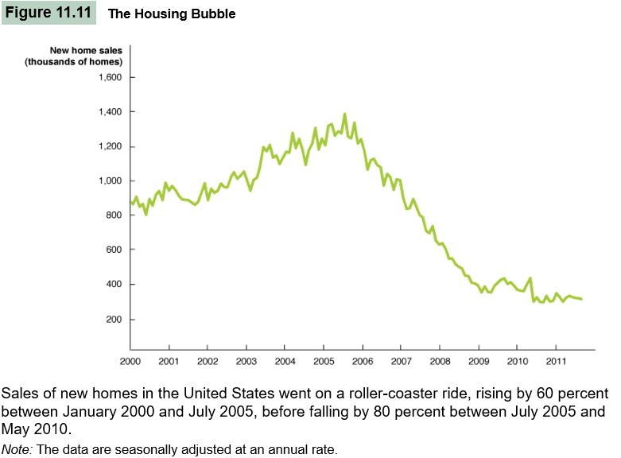

The Changing Mortgage Market in the United States
- Many Members of Congress believed that home ownership could be increased by creating a secondary market in mortgage, where banks and savings and loans could resell mortgages so individual investors could provide funds for them to grant more mortgages
- One barrier to creating this secondary market was the most investors were unwilling to buy mortgages because they were afraid of losing money if the borrower stopped making payments or defaulted on the loan
- To reassure investors, congress used to two government-sponsored enterprises (GSEs):
  - The Federal National Mortgage Association (Fannie Mae)
  - The Federal HOME Loan Mortgage corporation (Freddie Mac)
- By the 1990s, a large secondary market existed in mortgages, with funds flowing from investors through Fannie mae and Freddie mac to bank and ultimately to individuals and families borrowing money to buy houses

