Mark 453 final exam
Chapter 5
- What are the different goals an IMC campaign can try to accomplish?

- How can marketers use variability theory to improve the effectiveness of their marketing communications?
The article presents an encyclopedia entry for "variability theory," which suggests that seeing the same advertisement in different environments enhances its effectiveness and increases recall of a brand. Creative advertisers change the situational context of a specific advertisement when they utilize the variability theory.
What are the different parameters of an IMC campaign?
PARAMETERS
- Goals - objectives
- Media selection- Target Market
- Tagline- Big idea (should be something memorable that identifies the uniqueness of a brand or conveys some types of special meaning. (Just do it) nike.
- Consistency- Variability theory (variable encoding occurs when a consumer sees the same advertisement in different environment.
- Positioning- Linkage: Consistent product positioning = more likely the consumer will place the product in a cognitive map.
- Duration- Wear-out- Long term memory for the consumer.

- What are the different factors that can impact the effectiveness of the money spent on an IMC campaign?
No clear link between IMC expenditures and revenues

FACTORS
- Communications goal: Communication goals differ depending on the stage in the buying process. The hierarchy of effects model suggest that prior to making a purchase, a consumer goes through the stages of awareness, knowledge, liking, preference and conviction.
- Threshold effects: Occur at the point in which the advertising program begins to have a significant impact on consumer responses. (Innovation can improve)
- Diminishing returns: a circumstance will be reached in which a promotional campaign has saturated the market. At that instant, further expenditures product a minimal impact.
- Carryover effects: Recall occurs when the consumer has been expose to the company’s message for so long that when the time comes to buy, the individual remember the key company.
- Wear-out effects: An advertising or a particular campaign simply become old and boring. Consumers tend to ignore the advertisement. Some consumer may develop negative attitudes toward the brand if they become annoyed by the marketing communication.
- Decay effects: When a company stop advertising, consumers begin to forget the message.

- How can IMC attempt to impact each step of the hierarchy of effects?
The hierarchy of effect model helps to clarify the objectives of an advertising campaign. The model outlines six steps a consumer or a business buyer moves through when making a purchase. 1. Awareness, knowledge, Liking, Preference, Conviction and the actual purchase.

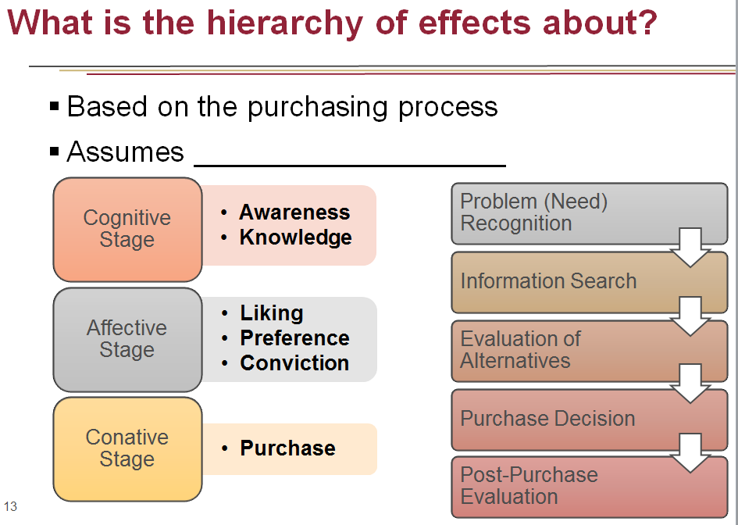
This effect allows the benefit of allowing marketers to identify common steps consumers and business take. Building loyalty requires all steps.
- As general guideline, cognitive-oriented ads work best for achieving brand awareness and brand knowledge. Think - Feel – Act. Affective-oriented advertisements are better at inspiring, liking, preference and conviction. Feel Act Think . Conative ads are normally best for suited to facilitating product purchases or other buying actions. Act Think Feel

- What is the means-end chain? How can a brand use it to develop its creative strategy?
Suggest that an advertisement should contain a message, or means, that leads the consumer to believe that using the product will help achieve a personal value. Advertisers can link the attributes of a product to specific benefits consumer can derive. (lead to attain personal value)
- What are the main components of a creative brief?
Objective: The creative reviews the main objective (or goal) before designing specific ads or the advertising campaign. The objective guide the advertising design and the choice of the execution.
The target: Who is the target audience?
The message theme: present an outline of key ideas that the advertising program convey.
The support : Support takes the form of facts that substantiate the message them.
The constraints: include any legal and mandatory restrictions placed on advertisements. (legal protection)
- When and why should a brand use (vs. not) crowdsourcing to help develop their marketing communications?
Crowdsourcing involves outsourcing the creative aspect of an advertisement or campaign to the public. Crowdsourcing can create a viral buzz as users view advertisements online, recommend or send favorites to friends and post link. Pretty much the same cost. Works best when targeted to current customers and customers who have high levels of brand loyalty. Sharing background information about the ad creator increases the persuasiveness of the consumer generated ad by establishing credibility and showing the similarities between the ad creator and consumers. Critics: no consistent message or theme results over time.

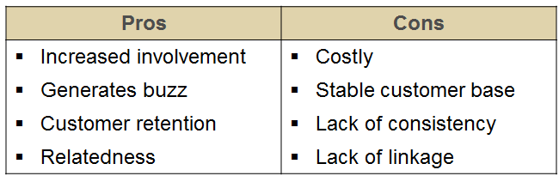
- What are the different types of message strategies? When is each type of message strategy most appropriate to use?
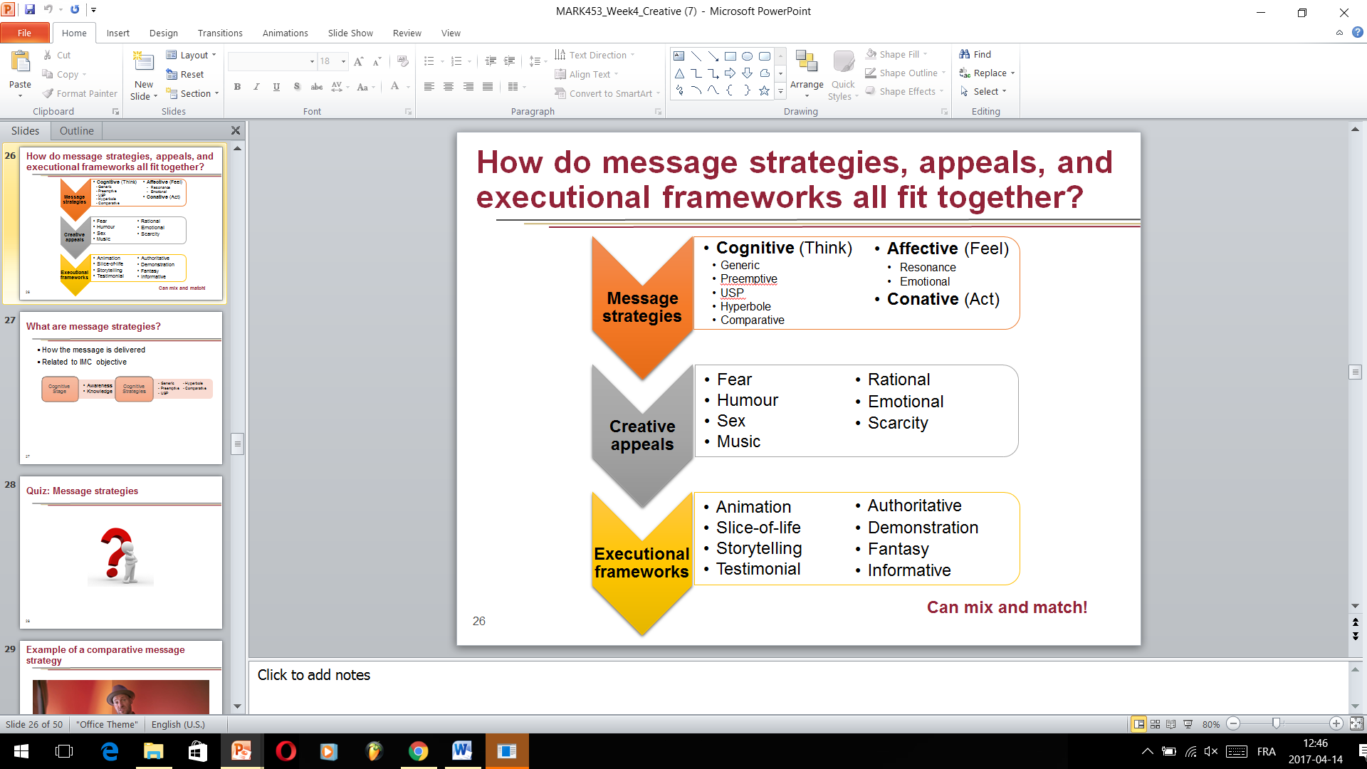
A cognitive message strategy presents the rational arguments or piece of information to consumer. The advertising message seeks to describe the product’s attribute.
Generic: An advertisement that directly promotes the product benefits without any claim of superiority transmits a generic message., which work best for a brand leader firm or one that dominate the industry.
Preemptive : A claim of superiority based on a product’s specific attribute or benefit with the intent of preventing the competition from making the same or similar statement. Which works best when the company states the advantage first .
Unique Selling Proposition: An explicit, testable claim of uniqueness or superiority that can be supported or substantiated in some manner.
Hyperbole: An untestable claim based on some attribute or benefits. The hyperbole approach often uses PUFFERY terms, such as best or greatest.
Comparative: Allows an advertiser to directly or indirectly compare a product to the competition on some product attribute or benefit. Captures the consumer’s attention. Low believability and negative consumer attitudes represent the potential downside. Comparing a brand with a low market share to the market leader works well, because the viewers concentrate more carefully on the advertisement’s content and message.
What needs to be considered when using a comparative message strategy?
Pros: Captures attention, Increase awareness, Message retention
Cons: Believability, Negative attitude, Trait transference.
Other: Viable competition, Misleading claims, Market share.
Advertisements trying to evoke feelings or emotions and match those feeling with the good, service or company feature affective message strategie. The message attempt to enhance the likeability of the product, recall of the appeal, or comprehension of the advertisement. (Affective-Conative-Cognitive)
Resonance: Connecting a brand with a consumer’s experiences in order to develop stronger ties between the product and the consumer is resonance affective advertising.
Emotional : The emotional affective approach attempts to elicit powerful emotions that lead to product recall and choice.
Conative Message theory: Seek to lead directly to a consumer response. They can support other promotional efforts, such as coupon redemption programs, cash back rebates, or encourage consumers to access a website. (Conative- cognitive-affective)

- What are the different types of creative appeals? What are the pros and cons of using each type of appeal? When is each type of creative appeal most appropriate to use?
- Fear: Life insurance companies focus on the consequence. Fear increases viewer interest in an advertisement and can enhance the ad’s persuasiveness.
- Humour: Captures attention, Holds attention, often wins creative awards, High recall scores, Consumers enjoy ads that make them laugh, Evaluated by consumers as likeable ads.
- Sex: Sexuality Approaches Used: Subliminal techniques, sensuality, sexual suggestiveness, nudity, overt sexuality.
- Music: A music theme connects with emotions, memories and other experiences. Music can be intrusive.
- Rational: Follow the hierarchy of effects stages. Rely on consumers actively processing the information presented in the advertising. Many B2B campaign. In general, rational appeals succeed when potential customers have high level of involvement and are willing to paid attention to the advertisement
- Emotional: 3 ideas; 1- Consumers ignores most advertisements. 2- Rational appeals go unnoticed unless the consumer is in the market for a particular product at the time it is advertised. 3- Emotional advertising can capture a viewer’s attention and create an emotional attachment between the consumer and the brand.
- Scarcity: Urge consumers to buy a particular product because of limitation.

- What are the different types of executional frameworks? When is each type of executional framework most appropriate to use?
An executional framework signifies the manner in which an ad appeal will be presented and a message strategy conveyed.
Animation: Increase in technology, high quality graphics. Price going lower and lower.
Slice of life: Provide solution on everyday problems. Encounter- Problem-Interaction and Solution.
Storytelling: link with an emotion, endless possibities.
Testimonial: B2B, More buyers believe what others says about a company.
Authoritative: seeks to convince viewers regarding a brand’s superiority
Demonstration: How a product works, effective ways to provide product’s benefits to viewers.
Fantasy: Lift the audience beyond the real world to a make-believe experience.
Informative: present information on a straightforward manners. (radio commercial)
- What are the different types of sources and spokespersons that can help convey a message in marketing communications? What are the pros and cons of using each type of source or spokesperson?
Sources
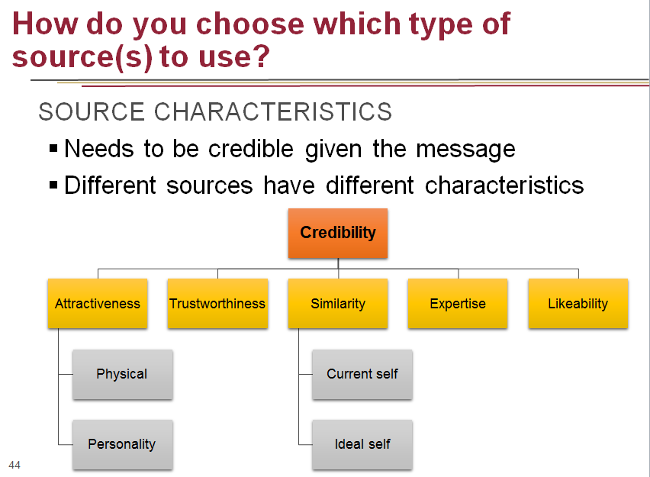
- Celebrities
  - Unpaid
  - Voiceovers
  - Dead
  - Social media
- CEOs
- Experts
- Typical persons
RISKS
- Overexposure
- Inappropriate behaviour

Advertising
- What information do marketers need when starting the media planning process?
Media planning commences with an analysis of the target market. It involves understanding the process customers use in making purchases and what influences their final decisions. MEDIA PLANNING
▪ Media usage of target market
▪ Role of media in consumer purchasing process (need for recognition, etc)
Components of a media plan : Marketing analysis. Advertising analysis. Media strategy. Media schedule. Justification and summary..
What is the difference between a target market and a target audience?
TARGET MARKET
- Who the product is marketed to
TARGET AUDIENCE
- Who the marketing communications
are directed to
Often the same, but sometimes different
- How do they differ from effective reach and effective frequency? What are the different approaches that can help you determine the optimal level of reach and frequency for an IMC campaign? What are the different elements that can impact the optimal level of reach and frequency for an IMC campaign?
How do you determine where to advertise?
TERMINOLOGY
- Reach: Number of members of your target audience. (how large)
- Frequency: Average number of times a member of your target audience is (how often)(recall)
… exposed to a particular advertisement
during a specific period of time
Determining optimal reach and frequency is… complicated
THEORIES
- Three-exposure hypothesis (need to be ear at least 3 times)
  - Intrusion value (messages have a certain level of intrusion) High- 1 is enough, More or less
- Recency theory (Near the purchase) Closest you are at the purchase decision, more efficient the ad will be
  - Variability theory
  - Continuous schedule
EFFECTIVE REACH
- Percentage of an audience that…
EFFECTIVE FREQUENCY
- Number of times a target audience…
… must be exposed to a particular message
to achieve a specific objective
DEPENDS ON
- Objective
  - Brand recognition - Reach
  - Brand recall- Frequency
- Size & placement of ad
- Number of media used
- Synergy between media

What is opportunity to see?
Opportunity to see (OTS)
- Cumulative exposure achieved in a given time period
Example
- Pizza Hut radio commercial played three times during the “back home” programming over three months
- OTS = 3/day x 5/week x 4/months x3= 180
PROBLEM
- OTS > actual exposure
- Assumed that OTS = exposure
What are gross rating points?
GRPs
- Measure of impact/intensity of media plan (vehicle’s rating x OTS) (Reach% x Frequency)
Example
- Pizza Hut radio commercial played 3 times during the “back home” programming, which reaches 50% of the target audience, over 3 months (radio, tv)
- Frequency = 3/day x 5/weeks x 4/months x 3= 180
- Reach = 50%
- GRP = 50*180 = 9 000 GRP
There are different ways to calculate the cost of an ad placement
Cost per thousand (CPM) (Printing world)(Digital)
- Dollar cost of reaching 1,000 members of the media vehicle’s audience
- Compare cost effectiveness of different ad placements
(Cost of media buy/Total audience) X 1,000

There are different ways to calculate the cost of an ad placement
HOW
- Relative efficiency of a media vehicle
- Proportion of target market exposed to a media vehicle
- Cost per rating point (CPRP)
- Weighted CPM
What are impressions? (How many times in total)
GROSS IMPRESSIONS
- Cumulative exposure of the audience to an advertisement
OTS X Total size of audience
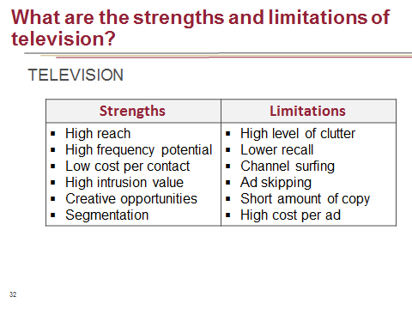
Advertising: Media Selection
RATING
- Number of H tuned to a program
Total number of H in a market
Share
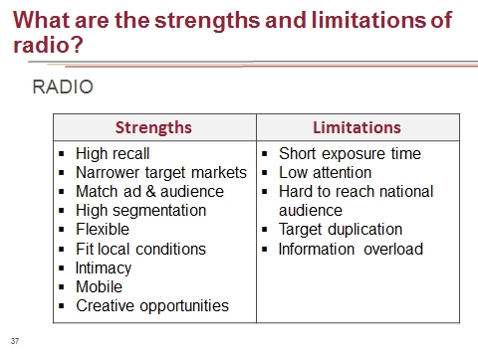
- Number of H tuned to a program
Total number of H with a TV on

Example of creative use of radio advertising
- University of Hannover’s Music Department
- Elite school for musicians
- Wanted to recruit people with perfect pitch
- Can identify a specific musical note without any other external assistance or context
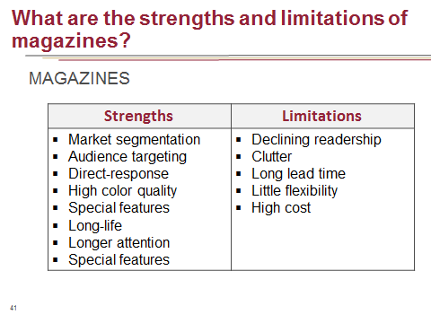
- Less than 3% of the population can do it
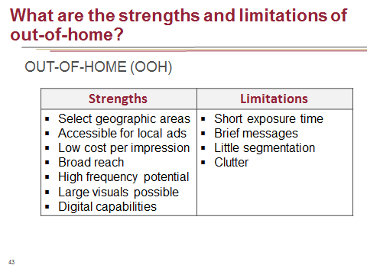
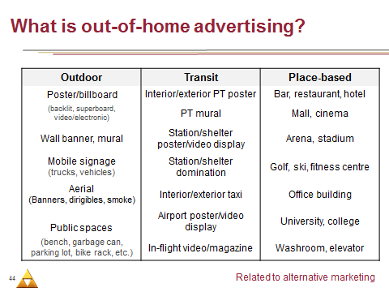
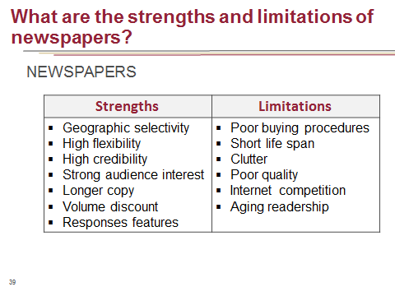
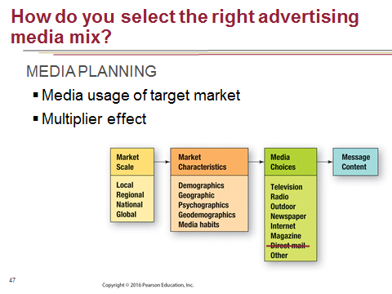

Sales promotion
Sales promotion consists of all the incentives offered to consumers and channel members to encourage product purchase. Sales promotions take two form: Consumer promotion and trade promotion. Companies offer consumer promotions directly to customers and potential customers. (Pull strategy) Trade promotions are only allotted in the distribution channel. Consist of the expenditures or incentives used by manufacturers and other members of the marketing channel to purchase good for eventual resale. (Push strategy)

What are the different types of consumer promotions?
Franchise-building promotions
- Focus on awareness and loyalty
  - Premiums: Prizes, gifts, or other special offers received for free when purchasing products. The consumer pays full price for the original good or service with a premium and receives something free.
Types : Free on mail: gifts individuals receive for purchasing products. (credit card) Long process.
In or on package: usually small gifts, such as toys in a cereal box.Must buy the product to see the gift.
Store or manufacture: Gifts given by either the retail store or the manufacturer when the consumer purchase the product. (Fast food)
Self-liquidating : requires the consumer to pay a small amount of money for the gift or the item.
Key successful: Should match the target market. Carefully select the premium. Integrate the premium with another IMC tool. No short term profits. Can enhance an image.

  - Contests & sweepstakes (must desires the price to participate)
Contest: require the participant to perform an activity. Look at the law first. Sweepstakes doesn’t require a purchase. Based on random draw. Increase the customer traffic. Games are exciting prospect.
Perceived value: Extrinsic value: the actual attractiveness of the price. Intrinsic value: The actual participation
  - Loyalty programs
  - Sampling : Sampling is the actual delivery of a product to consumers for their use or consumption. B2B. More than 1/3 of those who tried a sample purchase the item. Effective method of getting consumers to try and purchase a particular brand. Most popular type is in-store distribution: delivers the sample on site such as food. Effective way to introduce a new item. Generate interest in it. Collect information about the consumer. Good IMC tool, influence the trial. Targeting the right advertisement.
  - Bonus pack : Bonus pack reward customer loyalty by presenting, in effect, free merchandise. Can lead to brand switching if the consumer has used the brand previously. The packages present an advantage that competitive brands are not offering. Popular on manufactures, retailers and customers. Retailers gain an advantage because of the bonus pack offers a bargain or value through the retail outlet. Also build positive relationship with manufacturer that feature a bonus pack. Customer : feel like free stuff.
Sales-building promotions
- Focus on immediate sales
  - Coupons : Offer a price reduction to the consumer. Either percentage or amount. FSI (Print media)-The consumer makes a conscious effort to clip or save the coupons. Coupons also creates brand awareness. Encourage consumers to purchase brands on their next trip to the store.
Digital coupons: Increase in technology. Digital coupon user tends to be more affluent and better educated. Target market = 97 000$, well-educated.
Disadvantage : Customers who have a brand preference redeem approximately 80% of all coupons. Why giving coupons knowing customers are willing to pay full price. BUT: stock up the item (Buying more and not going to the competition) To avoid sending coupons to current customer, firms may send direct mail coupons to non-loyal customers.
  - Refunds & rebates: Cash returns given to consumers or businesses following the purchase of a product. A refund is a cash return on what are call soft good such as food and clothing. Rebates are cash return on hard goods, which are majors tickets item such as automobiles. The problem is the inconvenience associating with the rebate (Too long) Diminishing effectiveness because consumers have to expect them . Greatness success when the are perceived as new or original.
  - Price-offs
Temporary reduction in the price of a product to the consumer. (Canadian tire) Stimulate sales of existing product. Entice customers to try new product. Switch in brand parity situation. Encourage stockpiling of the product. Monetary savings, very easy to implement. May cause a negative impact on the company’s profit margin.
OVERLAYS
- Combination of sales promotions
TIE-INS
- Partnering with another product/company

Planning for consumer promotions : In planning the consumer promotions component of an IMC, the program should support the brand image and the brand positioning strategy. Look at the core values of the target audience and their opinions.
Promotion prone consumers: regulary responds to various consumer promotions and like to purchase product that are on deal. Clip coupon on a regular basis, enter contest and sweaptakes, purchase bonus pack.
Price-sensitive consumers: Price is important. Brand name are not important and individuals will ot pay more for them. Any type of promotion that reduce price.
Brand-loyal consumer: purchase only one particular brand and do not substitute, regardless of any deals offered.
More common are brand preference consumers : who consider a small set of brands for which they have a strong attachment. When promotion are offered for one of their brand, it becomes the one they purchased. Move consumer closer to brand loyalty

- How can the different types of trade promotions help support an IMC campaign? What are the concerns associated with using trade promotions?
TRADE
- Allowances provide financial incentives to other channel members to motivate them to make a purchase.
Off-invoice allowance : A per-case rebate paid to retailers for an order
Slotting fees : Money paid to retailers to stock a new product.
Exist fees: Money paid to retailers to remove an item from their SKU inventory.
In offering trade allowance to retailers, manufactures assume that a portion of the price reduction will be passed on to consumers.
.
- Contests: To achieve sales targets and other objectives, channel members sometimes provide trade contest.
- Incentives : Encourage the channel member either to push the manufacture’s brand or to increase purchases of that brand.
- Shows (Trades show) Discover potential customers and sell new product. Relation can be strengthen. Also help to investigate on the competition.

Direct marketing
CHARACTERISTICS
- Conversation between marketers and specific groups of consumers
- Not all audience members are equal
- Tailored messages
- Particularly effective at purchase and post-purchase stages
- Sometimes only means to reach very specific target audiences
GOALS
- Identify customers
- Build relationships
TYPES
- Database marketing: Involves collecting and utilizing customer data for the purpose of enhancing interactions with customers and developing customer loyalty. Emphasize identifying customers and building relationship with them.

What is at the heart of database marketing?

- Build a data warehouse : Either an operational database : holds the individual’s transaction with the firm and follow accounting principles and the marketing database : which contains information about the current customers, former customers and prospect.
- Internal
Personal identification data
Purchase and communication histories
Personal preferences profiles
- External Useful for new customers acquisition
Customer information companies
Geocoding

- Database coding and analysis
- Lifetime value analysis
  - Profit potential of a customer/market segment
  - Revenues, costs, and retention rates
  - Costs of new customer acquisition & retention
- Customer clusters
  - Based on different criteria
- Location-data tracking
  - Provided by mobile GPS technology
  - Based on behaviour

- Data mining
Involves using computer data analysis software to study data to find meaningful information and help build relationship. Two activities: Building customer’s profile and preparing models that predict the future purchase behaviors based on past purchase.

- Data-driven marketing communications

- Data-driven marketing programs

- Personal selling : Personal selling offers a face-to-face opportunity to build brand relationship with consumer. Personal selling may result in the acquisition of new customers in addition to influencing current customers to increase levels of purchase. Maintain existing relationship. Generating leads - qualifying prospect – knowledge acquisition- sales presentation – Handling objections – sales closing – follow-up.
Direct response marketing : One program closely tied to database marketing involves targeting products to consumers without the use of other channel members.
- Direct mail : most common form. Both consume and B2B. Two sources : firm’s internal database or a commercial list – repeat a purchase (not good for not being associate with junk mail)
- Catalogs: Many consumers enjoys catalogs and view them as their leisure. Long term impact because they are kept and shared. Low pressure direct response (give time to consider the good)More complete product information . When combined with an internet presence it build a strong connection with individuals.
- Mass media
- Internet and email
- Direct sales: It is usually conducted in a face-to-face manner – either where products are demonstrated to an individual , or to a group or where a catalogue is left with the consumer and where the direct seller call as later to collect orders. Unlike direct marketing or mail order, direct selling is based principally on personal contact with the customer.
- Telemarketing: Inbound or outbound Le télémarketing est une modalité d'action par laquelle le vendeur utilise de manière systématique le téléphone pour entrer - à distance, sans déplacement, au prix d'un faible coût
- Addressable TV

- [Brand X] wants to use direct marketing as part of its IMC strategy, but it is afraid to be associated with junk mail and spam emails. What would you recommend to [brand X]?
Permission marketing -> YouTube, Facebook, Email list, etc.
Higher response rate
Success depends on cost/benefit ratio to customer. Also, empowerment and reciprocity are crucial.
1. must make sure consumer has agreed to participate
2. emails must be relevant to the consumer
3. marketing team should monitor responses and alter the program to be more well-suited to the consumer

- [Brand X] wants to increase repeat purchase of its product among its current customers. What would be the best IMC tool to help accomplish this? Give an example of how [brand X] could use that tool.
Sales Promotion program in the form of a Loyalty Program:- reward customers for repeat purchases- enhance value of products- Source of customer data- motivate repeat purchase

- [Brand X] wants to increase post-purchase satisfaction about its product among its current customers. What would be the best IMC tool to help accomplish this? Give an example of how [brand X] could use that tool.
Direct marketing - Direct mail : most common form. Both consume and B2B. Two sources : firm’s internal database or a commercial list – repeat a purchase (not good for not being associate with junk mail) The company’s marketing parses an internal list and separates active members. Prospective new customers receive different mail pieces with messages designated to entice repeat purchase

- [Brand X] wants to design a new direct marketing campaign to promote its product. What are the different sources of data the brand could use for the campaign? What are the different types of data coding and analyses the brand could perform on the data?
Email and internet data, purchase and communication histories, personal preference profiles, customer information companies and geocoding.
Types of data coding: Lifetime value analysis: estimates the present value of future profits the individual or segment will generate over a lifetime relationship with the brand or the firm.
customer clusters : Group customers into clusters based on a wide variety of criteria
location-data tracking: data analytics is based on information provided by mobile GPS technology. (Cell phone)

Public relation
What are public relations?
WHAT
- Manage publicity and other communications with every group that is in contact with the company. The public relation department focuses on a variety of internal and external stakeholders, including employees, stockholders, public interest group, the government and society as a whole.
GOALS
- Encourage positive publicity
- Enhance overall reputation
- Play tactical role in IMC plan
What are the main functions of PR?
FUNCTIONS
- Identify stakeholders (internal and external)
- Assess reputation
- Audit CSR (corporate social responsibility)
- Image building
- Damage control
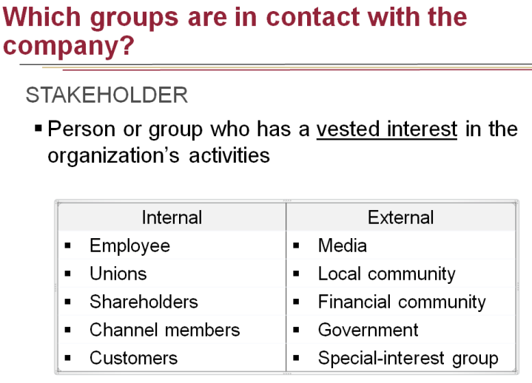

- [Brand X] wants to start managing the different types of stakeholders that could impact its company. Explain the different types of stakeholders [brand X] would have to take into account and give examples of each type.
- [Brand X] wants to implement corporate social responsibility (CSR) as part of its IMC strategy. Explain what CSR is. Give examples of CSR programs that would be appropriate for [brand X]. What are the challenges of using different types of CSR strategy?
CSR is an organization’s obligation to be ethical, accountable, and reactive to the needs of society. It means companies align values for the greater good of the society and take actions that have positive effects. A new trend in CRP, purpose marketing or pro-social marketing involves advertising that focuses on the values, behavior, and belief of the company.
- Positive imagine-building activities
Cause-related marketing :
- Ties marketing activities with a cause/charity
- Help increase brand loyalty
- Work best when cause is related to company

CHALLENGES :
- Balancing good intentions vs. commercial gain
- Skepticism
- GREEN MARKETING
- Development and promotion of products that are environmentally safe
CHALLENGES
- Consumers’ attitudes vs. behavior
- Segmentation, positioning, and current target market

- [Brand X] wants to put a damage control strategy in place in order to be prepared for potential negative events. What are the potential causes of negative events [brand X] would need to be aware of? Explain using examples. What are the different types of damage control strategies [brand X] could use before/after the negative event? Give examples of each type.
DAMAGE CONTROL
- Reaction to negative event
- Prevent damages to corporate and brand image

DUE TO
- Company error
- Consumer grievances
- Unjustified or exaggerated negative press

PROACTIVE PREVENTION
- Prevent negative publicity before it happens
  - Entitlings : are attempts to claim responsibility for positive outcome of event.
  - Enhancements: are attempt to increase the impact of desirable outcome of an event in the eyes of the public.
REACTIVE DAMAGE-CONTROL
- Reactions to unforeseen events
  - Internet interventions
  - Crisis management: The company either accept the blame for an event, offers apologies or refutes the charges in a forceful manner.
  - Apology strategy
  - Impression management

[Brand X] wants to connect with a wider audience through sponsorships as part of their IMC campaign. Explain what sponsorships are. What are the different objectives of sponsorships? What are the different elements [brand X] would need to consider when selecting an appropriate sponsorship? Suggest an appropriate sponsorship for [brand X] based on your analysis.
To build brand loyalty and other positive feelings toward a company, many marketing leaders utilize sponsorships and event marketing. These programs create situation where prospects, customers, vendors, and others in unique situations gathered together.
GOALS
- Build brand loyalty
- Generate positive feelings
- Better receptivity of message
WHAT
- Paying money to sponsor someone, some group, or something that is part of an activity
CRITERIA
- Audience size
- Exclusiveness
- Fit with brand image
OBJECTIVES
- Enhance image
- Increase visibility
- Differentiation
- Showcase
- Build relationships
- Sell excess inventory

Digital marketing
Digital marketing combines all of the components of E-Commerce, internet marketing and mobile marketing. It includes everything with a digital footprint.
How digital marketing is redefining marketing communications?
- Advertising
  - Banner or YouTube ads
  - Paid links or keywords
- Sales Promotion
  - E-coupons (groupon, tuango etc.)
  - Free at-home delivery
- Public relations
  - Blog posts
  - Social media
- Direct marketing
  - Emails, news lettes
  - Behavioural targeting

MOBILE MARKETING
- Various forms of marketing on mobile cell phone devices
HOW
- Understand the social and shopping nature of mobile phones
- Incorporate into firm’s mobile marketing strategy

- What are the different elements that [brand X] would need to take into account to improve its e-commerce platform? Explain using examples.
E-COMMERCE
- Selling goods and services online
HOW
- Consistent customer experience ; Consumers have nearly zero tolerance for poor website performance
- Channel integration: A company that offers a printed catalog or has a retail store should match the printed catalog with its web catalog.
- Brand engagement: Blogs, feedback applications and customer reviews.
- Shopping cart abandonment: hidden charges, difficulty in checking out, site that requires the consumer to register.
- E-commerce incentives: Cyberbait; includes any lures or attraction that brings people to a website. (financial incentives, convenience incentive, and value-added incentives)
- Privacy and security issues: credit card number has been stolen as well of identity theft.

- What are the different types of digital strategies that [brand X] could use for its digital marketing? Explain using examples.
- Interactive marketing: the development of marketing programs that create interplay between consumer and business. The program feature two-way communication and customer involvement.
- Content marketing: Consist of providing useful information and product-use solutions to potential customers. (Authentic, Sharable content, Update consistently)
- Location based advertising: Involves reaching customers where they are located by contacting their mobile phone communication device.
- Behavioral marketing : Marketers for some brands can target the individuals who are most likely to purchase the item rather than merely placing ads on websites. Utilizes web data to identify these potential customers. Behavioral targeting occurs in three different ways: Pages person visit on the internet. Keyword searches or content read and past visitors to a site.
- Video tactics : Product review, Producing cause-related videos, Producing informal videos, posting podcast video ads. Advertising on video.
- Blogs and Newletters : Blogs are online musings that cover a wide range of topic.
- Email Marketing: It cannot simply be a program where addresses are purchase and mass email to an individuals on the list. (Must be with another program channel to be effective)
- Augmented and Virtual reality

- [Brand X] is debating between using search engine optimization (SEO) and banner ads as part of its IMC campaign. Why and when should [brand X] use one over the other?
Banner ads can be embedded with videos, widget applications, or targeted display ads that increase the chance viewers will see and click on the icon. Now company can display banner ad only to individuals the company chooses. Advertisers develop messages for a specific audience. Prices can be set to entice the members of the audience who will see the banner ad.
PROBLEMS
- Clutter
- Viewability
  - Response rate
  - Ad blocking
  - Fraud
SEO: SEO
- Increasing the probability that particular information will emerge from a search
WHY
- Most web traffic begins with a search engine
HOW
- Paid search ads
- Paid search insertions
- Increase identification through organic results

SEO
- Places message in front of an audience that has self-identified as interest in a specific topic
- Useful when consumers know what they are looking for.
Banner
- Places message in front of an audience that may be interested in a specific topic
- Useful when consumers may not know know/remember what they are looking for

- The brand manager of [brand X] is a bit old school and doesn’t see the value of social media marketing. What are the different benefits of having a brand’s presence on social media?
WHY
- Increase traffic and enhance brand image
- Improve search rankings
- Customer intelligence
- Increase sales and build brand loyalty
- Two-way communication process (Collect information)

- What are the different types of social media strategies that [brand X] could use for its social media marketing? Explain using examples.
STRATEGIES
- Content seeding : involves providing incentives for consumer to share content about a brand.
- Real-time marketing: is the creation and execution of an instantaneous marketing message in response to an occurrence during a live event.
- Interactive blogs: permit visitors to send comments or posts, making them another important component of social media.
- Consumer-generated reviews:
- Viral marketing: takes the form of an email or a video posted to a personal blog and passed to other blogs or website such as youtube.
- Following brands on social media
- Tracking success using metrics: brand buzz, reach, facebook likes, traffic from social media

- [Brand X] wants to create a viral online video to promote its product, but is not quite sure how to do it. Explain what viral marketing is. What are the different elements that [brand X] would need to take into account in order to increase the success of its video? Explain using examples.
HOW
- Focus on product/brand
- Why would pass along message?
- Offer incentive
- Make it personal
- Track results and analyze data

Alternative Marketing
WHAT
- Reach consumers in new and innovative ways
GOALS
- Overcome clutter and declining attention
- Increase receptivity to the message
- Supplement or replace mass media communications with more targeted methods

- [Brand X] wants to generate buzz marketing for its product. Explain what buzz marketing is. What are the different ways through which [brand X] could generate buzz? Explain using examples. What is the main challenge that [brand X] will have to face when using buzz marketing?
- Buzz marketing or word-of-mouth marketing emphasizes consumers passing along information about a product. A recommendation by a friend, family member acquaintance carries higher level of credibility than an advertisement. Can be more powerful than a paid spokesperson.
- CONSUMERS WHO
- Like a brand
- Are sponsored by the brand (Brand ambassador)
- Are employees of the brand

Challenge
- Honesty
  - Relationship
  - Opinion
  - Identity

- [Brand X] is debating between using guerrilla, lifestyle, or experiential marketing as part of its IMC campaign. Explain what each of these are, and give an example of how you would use each of them to communicate about [brand X]’s product.
Guerilla marketing : utilizes alternative tactics and venues to focus on finding unique ways of doing things. Rely on creativity, quality relationship, willingness to try unusual approach. (touchpoint) Innovative (create a buzz). Interact with customes.
Lifestyle: involves identifying marketing methods associated with the hobbies and entertainment venues of the target audience. Finding a venue where consumers go for relaxation, excitement socialization, or enjoyment and then matching it with the brand’s target market constitutes the key to lifestyle marketing.
Experimental marketing: combines direct marketing, personal selling and sales promotions into a single consumer experience. Gives consumer the opportunity to question as well as gain hans-on experience with a brand, allowing them to be more intimate with it, leading to higher conversion rate.(engage with the brand)

- [Brand X] would like its product to be more present in popular entertainment, since an increasing amount of its target audience do not pay attention to advertisements. [Brand X] is debating between using product placement or branded entertainment to increase the visibility of its products. Explain what each of these are, and give an example of how you would use each of them to increase the visibility of [brand X]’s product. What would be [brand X]’s biggest challenge when using these tools?
PRODUCT PLACEMENT
Planned insertion of a brand or product into some media program. (into a movie, television, program) the goal is to influence the viewers. Advertisers believe product placement lead to increased awareness and more positive attitudes toward the brand. (no immediate impact on sales occurs). Low cost per viewer.

BRANDED ENTERTAINMENT
Embedding brands into the storyline of an entertainment medium. Nicorette was integrated into a story about a character who tried to stop smoking. (Hilton and American Airline)
Challenges

- [Brand X] received consumer insight that its target audience is hard to reach through traditional marketing communications media. [Brand X] is considering using alternative media to more effectively reach its target audience. Explain what alternative media are and how they would help solve [brand X]’s problem. Give an example of how [brand X] could use this tool to communicate about its product.
WHAT
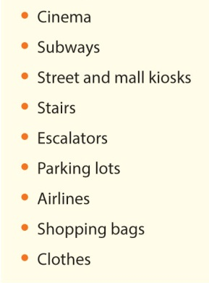
- Unusual and unlikely places that will attract attention
TYPES
- Video game advertising
- Other alternative media

- [Brand X]’s main marketing communications objective is to increase the sales of its product. [Brand X] is already using sales promotions as part of its IMC campaign, but is looking for another IMC tool that could help influence consumers’ purchase decisions. What would you recommend [brand X] to do? Explain using examples.
In store marketing. Understanding high potential shopper strike zone has become increasingly critical, given the intensified battle for consumer loyalty and share of mind in-store. According to consumer, end-aisle displays and merchandise display are the most engaging. QR Code (Social media) for instant coupons. Point of purchase marketing: which include any form of special exhibit that advertisers merchandise. Near cash register.

Evaluating an IMC program
Why?
- Return on investment vs. return on objective
- “is my brand delivering value to consumers, even to those who may not buy my product today”
When
- Before the campaign is launched (pre-test)
- After the campaign is completed (post-test)
How
- Message evaluation techniques : method used to examine the creative message and the physical design of an advertisement coupon or direct marketing piece
- Respondent behaviour evaluation: Method use to examine visible customer actions, including making store visits, inquiries, or actual purchase
- Online evaluation technique: Method use to examine online advertising and marketing campaigns.
How do you evaluate different IMC objectives?
How
- Match metric with objective
- Evaluate related objectives

How do you evaluate different IMC tool?
IMC TOOLS | INPUTS | OUTPUTS | OUTCOMES
Advertising | - Expected reach and frequency or GRP | - Actual reach and frequency | - Awareness  - Brand Recall  - Behaviour
Sales Promotions | - Number of coupons offered | - Number of coupons claimed  - Number of contests entries | - Sales resulting from sales promotion
Direct Marketing | - Number of mail/emails sent | - Number of mail/emails received | - Awareness  - Brand recall  - Behaviour
Public Relations | - Number of press releases sent | - Impressions | - Brand retention  - Likeability
Digital Marketing | - Number of banners  - Number of social media accounts | - Click through to websites | - Actual sales  - Awareness  - Brand recall

What are the different methods used to evaluate an IMC campaign?
Pre-Test | Post-test
Concept testing  Examines  - Proposed content of marketing communications  - Impact on potential target audiences  When  - Early stages (before production) production is expensive  How  - Focus groups  - Storyboard or mock ad  - Comprehension and reaction tests  Fake example of concept testing: New castle beer  - Copytesting  Tests used to evaluate a marketing piece that is finished or in its final stages prior to production.  Internet copy testing replaces the portfolio and theater test. Online copy testing costs less and provides more immediate results  CRITICISM  - Better for rational/cognitive  - Restrains creativity  - Consumers don’t know what makes an ad effective  - Waste of time and money  BENEFIT  - Additional, external support for campaign  - Emotional reaction test  EXAMINES  Emotional responses  HOW  Asking  Warmth monitor: scale : warm or cold  Biometrics: physiological reaction  WHY  Affect transfer  - Cognitive neuroscience  A brain-image measurement process that tracks brain activity. You can see the difference between two brands.  - Advertising tracking research  EXAMINES  Ads that have launched  WHAT  Brand performance  Advertising effectiveness  Relative impact  Competition  Time  WHY  Report card  Benchmark  Competition  Previous campaigns  Wear out  CONS  No diagnostics  Provides “how,” but not “why”  This in-market research method monitors a brand’s performance and advertising effectiveness. Compare to the competition and over time. | - Purchase simulation tests  HOW  Simulated shopping experience  Controlled laboratory environment  WHY  Does not rely on opinions and attitudes  Reduces social desirability bias  - Test markets  Allows company leaders to examine the effects of a marketing effort on a small scale before launching a national or international campaign. (effect in a new country)Advertisement can be modified, promotion revised and pricing policies revised before undertaking a more widespread program.  - Sales and response rates  What are sales and response rates?  Examines  - Behavioural impact of marketing communications  How  - Scanner data  Challenges  - Marketing communications vs. other factors  - External factors at point of purchase  - Delayed impacts  - Goal of IMC not always to increase sales  - Assessing responses other than sales

- [Brand X] is designing an IMC campaign that will be using a [rational/emotional] appeal and wants to make sure the campaign will be properly evaluated. Identify the best method that [brand X] can use to evaluate the campaign before its launch. Explain why you believe it is the best method and how [brand X] could implement it.
- [Brand X] came up with an IMC campaign that is using potentially controversial messages and appeals, but believes that it should be very effective with its target audience. Identify the best method that [brand X] can use to determine whether they have the right intuition about their customers. Explain why you believe it is the best method and how [brand X] could implement it.
- [Brand X] had to launch its IMC campaign without testing it due to intense competitive pressures. [Brand X] would however still like to know how its campaign is performing, and whether any modifications may be necessary to increase its effectiveness. Identify the best method that [brand X] can use to evaluate the campaign while it is ongoing. Explain why you believe it is the best method and how [brand X] could implement it.
Advertising tracking research
EXAMINES
Ads that have launched

WHAT
Brand performance
Advertising effectiveness
Relative impact
Competition
Time
WHY
Report card
Benchmark
Competition
Previous campaigns
Wear out

CONS
No diagnostics
Provides “how,” but not “why”

This in-market research method monitors a brand’s performance and advertising effectiveness. Compare to the competition and over time.
- Recommend [brand X] an evaluation method that would allow to test whether purchase behavior [will be/was] positively impacted by its IMC campaign. What are the different factors that [brand X] needs to take into consideration when using this evaluation method? Explain using examples.

Regulations and Ethics
- Brand X] is considering using puffery in its IMC. Give an example of a claim that [brand X] could use that would be considered puffery, but not deception. What distinguishes your claim from deception?
Puffery can be legally used in advertisements and marketing messages. Puffery exists when a firm makes a exaggerate statement about its good or service. It is not a factual statement. Friendliest, best, greatest and finest – our brand is the best. , our signature dishes use only the finest ingredients.
- [Brand X] wants to make sure its latest IMC campaign will not be accused of deception. What are the different elements that [brand X] needs to take into account in order to prevent this?
What marketing communication strategies are prohibited by the competition bureau?
Strategies
- False representations
- Bait and switch
  - Sale with unreasonable quantities
  - Intent to sell more expensive option
- Prices and pricing tactics
  - Fake prize/reward
  - Asks for money in exchange
CLAIMS MUST
- Be proven
- Be truthful
- Reflect customers’ typical experience
HOW
- Clearly substantiated
- Same product
- Supported by experts
- Supported by totality of evidence

- What are the different types of ethical concerns that IMC campaigns can raise?
- Cause to buy more than one can afford
- Overemphasizes materialism
- Increase cost of goods
- Perpetuate stereotypes
- Make unsafe products seem attractive
- Often offensive
- Children as a vulnerable population

- Which marketing tactics tend to raise ethical concerns? Why?
TACTICS
- Brand infringement: when a company creates a brand name that closely resembles a popular or success brand.
- Marketing of professional services: Viagra
- Gifts and bribery (B2B) billets de hockey
- Spam and cookies: track a company’s browsers.
- Ambush marketing: brands attempt to associate itself with a team or event without buying the right to do so.
- Stealth marketing: making a pitch and getting pay for friend (ACN)

