ANP1107- Anatomy and Physiology
Lecture 1
- The Digestive System
  - Differentiate between components of alimentary canal and accessory digestive organs
- 2 main groups
- Alimentary canal (Gastrointestinal tract or gut):
- mouth, pharynx, esophagus, stomach, small intestine, large intestine
- continuous muscular tube from mouth to anus
> digests food
> absorbs digested fragments through lining into the bloodstream
> excretes end products of digestion
- Accessory digestive organs:
- teeth, tongue, gallbladder, salivary glands, liver, pancreas
- all except teeth and tongue? are connected to the GI tract by ducts
- Most of these produce secretory products such as saliva, bile, enzymes to aid in the digestion of food
  - Describe the relationship between various digestive organs and the peritoneum
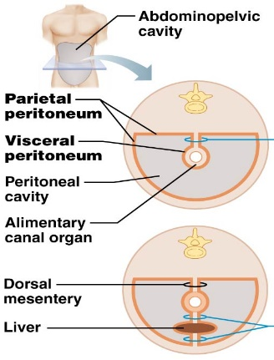
- Most digestive organs in abdominopelvic cavity which is lined with slick, friction-reducing serous membranes. The peritoneum is the most extensive of these:
- visceral peritoneum: covers external surfaces of digestive organs and is continuous with the parietal peritoneum: lines walls of abdominopelvic cavity
- peritoneal cavity: slit-like space between visceral & parietal peritonea - contains fluid secreted by the serous membranes
- mesentery: Fused double layer of parietal peritoneum. Carries blood vessels, lymphatic vessels and nerves to organs of the GI tract (dorsal and ventral mesentery)
- Most digestive organs keep a mesentery and remain in the peritoneal cavity (= peritoneal organs).
- Retroperitoneal organs: ex. pancreas, lose their mesentery during development and lie posterior to peritoneal cavity
- Peritonitis: inflammation of the peritoneum, one cause: stomach ulcer

  - Outline the blood supply serving the main components of the GI tract
- Splanchnic circulation: includes arteries that branch off abdominal aorta to serve digestive organs & the hepatic portal circulation
- Arteries: hepatic, gastric, splenic, sup & inferior mesenteric (receive ~1/4 of CO, increases after meal)
- Organs served: liver, stomach, spleen, small & large intestines
- Venous return from much of the abdominopelvic region is via inferior vena cava. However,
venous return from the digestive viscera is indirect via the hepatic portal circulation

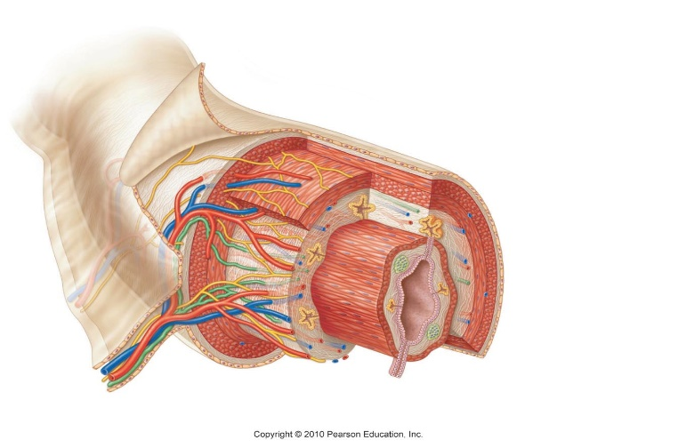
  - Describe histology of GI tract wall
Mucosa
Submucosa
Muscularis Externa
Serosa

Mucosa (innermost):
- secretion: mucus, digestive enzymes, hormones
- absorption: end products of digestion
- protection: against infection
- Mucosa consists of 3 sub-layers:
- surface epithelium: columnar epithelial + goblet cells (especially abundant in stomach), also cells that secrete enzymes and hormones in the stomach and small intestine
- lamina propria: loose connective tissue with capillaries, isolated lymph nodules; some bunches of these nodules (tonsils, appendix) in key areas
- muscularis mucosae: thin layer of smooth muscle cells - responsible only for local movements of mucosa + causes the mucosa to form extensive folds in the small intestine
- Goblet cells: produce mucin, major component of mucus
Submucosa:
- moderately dense connective tissue layer
- contains blood & lymphatic vessels, lymph nodules, nerve fibers
- Highly elastic – allows stomach to regain shape after large meal
Muscularis externa:
- mixing, propulsive movements of GI tract
- inner circular layer + outer longitudinal layer; thickens to form sphincters at organ-organ junctions
- Role of sphincter in the gut: prevents reflux of chyme
Serosa:
- outermost, protective layer = visceral peritoneum
- loose CT covered by single layer of squamous epithelial cells

- The esophagus (thoracic), surrounded by adventitia instead of serosa: fibrous connective tissue which “binds” the esophagus to surrounding tissues
- Retroperitoneal structures have both: serosa on the side facing the peritoneal cavity & an adventitia on the side against the dorsal body wall

1.2 Describe the functional anatomy of the GI tract
1.2.1 describe the functional anatomy of the mouth, pharynx and esophagus
Mouth:
• vestibule and oral cavity proper
Oral/buccal cavity; bounded by lips, cheeks, tongue and palate
- Tongue= stratified squamous epithelium; epithelium on gums, hard palate & back of tongue modestly keratinized
Lips & Cheeks:
• core of skeletal muscle
1) orbicularis oris - lips
2) buccinators - cheeks
• hold food in place during chewing; role in speech
• No sweat or sebaceous glands here and therefore must be moistened with saliva
• Red margin: from highly keratinized to less keratinized
Palate: hard palate anterior; soft palate posterior
hard palate underlain by palatine bones & palatine processes of maxillae; tongue pushes food against rigid surface during chewing
soft palate mostly skeletal muscle; closes nasopharynx when we swallow
palatoglossal/palatopharyngeal arches join soft palate to tongue and oropharynx
Tongue:
- interlacing masses of skeletal muscle fibers & taste buds + some mucous & serous glands
- important for chewing, mixing of food with saliva; forms a bolus to swallow
- important during speech
- -median septum: divides tongue into 2 identical halves
lingual frenulum attaches tongue to floor of mouth
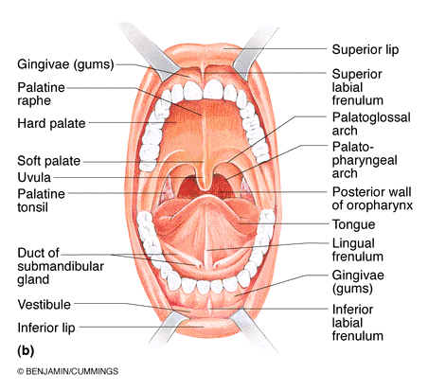
1) intrinsic skeletal muscles: within tongue, not attached to bone, 3 planes (transverse, longitudinal, vertical); function? Change shape of tongue
2) extrinsic skeletal muscles: attach bones of skull or soft palate to the tongue; function? Move the tongue in and out, up and down, side to side
3 types of papillae (projections) on tongue:
1) filiform papillae: conical, contain keratin, numerous in parallel rows. Provide friction for manipulating foods
2) fungiform papillae: mushroom-shape, widely scattered, vascular core with a reddish hue; contain taste buds
3) vallate papillae: V-shaped row at back of tongue; like fungiform but with an additional surrounding furrow; contain taste buds
- Salivary glands (3 pairs of extrinsic salivary glands):
- parotid glands - anterior to the ear, between masseter muscle & skin; parotid duct enters vestibule next to 2nd molar, upper jaw
- submandibular glands - along medial aspect of mandible; duct runs beneath mucosa of oral cavity floor; opens at base of lingual frenulum
- sublingual glands - under tongue; anterior to submandibular glands; opens via many ducts into floor of mouth
- 2 types of secretory cells in the salivary glands:
- (i) serous (watery secretion)
- (ii) mucous (thick mucin secretion)

Lecture 2
The Teeth:
- in sockets (alveoli) in gum-covered margins of mandible/maxilla
- primary dentition also called deciduous, milk or baby teeth (total = 20)
- permanent teeth - larger, deeper roots all but 3rd molars appear by end of adolescence; 3rd molars between ages 17 & 25 (total = 32)
- Teeth have specialized morphology reflecting different tasks:
- incisors: chisel-shaped for cutting
- canines: conical for tearing, piercing
Dental Formula: Permanent Dentition
2I, 1C, 2PM, 3M (upper, left or right side)
(X2 = 32 teeth)
2I, 1C, 2PM, 3M (lower, left or right side)
- premolars (bicuspids) and molars (4-5 cusps): grinding, crushing

- Primary dentition formula
2I, 1C, 2M (upper, left or right side)
(X2 = 32 teeth)
2I (lower, left or right side)

Tooth Structure:
• 2 major regions:
- crown:
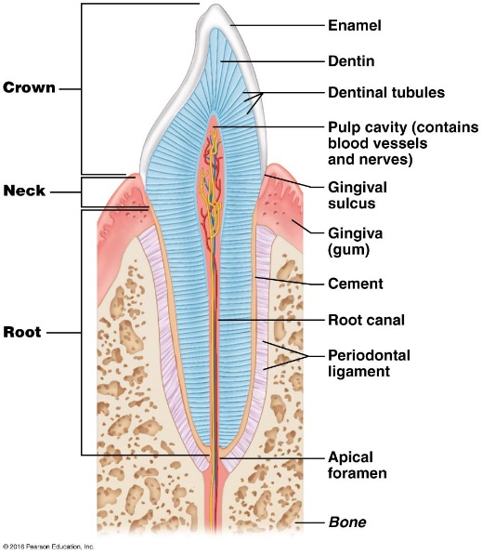
- above gingiva, covered by enamel (Ca⁺⁺ salts; hardest substance in body); but enamel-producing cells degenerate when teeth emerge - consequence? Cells that make enamel disappear once the teeth erupts. Once enamel is damaged, we cannot replace it
- root:
- embedded in jawbone; 1 root for I, C & PM (except 1st upper PMs – usually have 2), 2-3 roots for Molars
- outer surface of root covered by calcified connective tissue (cement) - attaches tooth to periodontal ligament
- gingiva adhere to enamel; with age, recede to sensitive cement
- Juxtaposition of the cement and periodontal ligament to keep our teeth in place
- Odontoblasts make dentin; respond to tooth injury by making more
- Dentin is softer and does not protect teeth
- Cell bodies of odontoblasts line the pulp cavity (contains connective tissue, blood vessels, nerve fibers)
- Pulp cavity extends into root, leading to the root canal
- Enamel, dentin, cement is all calcified & resemble bone, but are avascular
- Cement & dentin (but not enamel) contain collagen, more elastic
- Consequence of not having vascular network: makes teeth difficult to treat when it comes to things such as infections
- If there is an infected root, need to get a root canal. Drills in and kill nerve in the tooth and remove infected tissue
- Dental plaque: bacteria, food residue (sugars) and other insoluble compounds. If bacteria metabolize too much, they can produce acid and leach away calcium and enamel of the tooth and weakens the tooth. This leads to a cavity
- Tartar: long-term, build up of plaque
- Calculus (hard, calcified structure): more build-up, in sulcus of tooth and cause a reaction in body
- Inflamed gums= gingivitis (immune response)
- If progresses to certain stage= periodontitis
- Periodontitis: immune response has mounted and attack foreign invaders (bacteria) and tooth structure itself
- Can attach to osteoblasts which will attack tooth (cause tooth loss in adults)
- 85-90% of tooth loss in adults
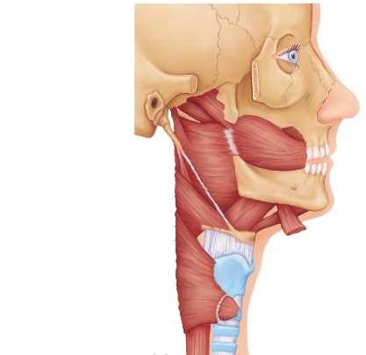
The Pharynx
- mouth ⇒ oropharynx ⇒ laryngopharynx; (common passageway)
- stratified squamous epithelium; pharyngeal muscle = skeletal muscle
Superior pharyngeal
constrictor
- The pharynx has an outer muscular region
Middle pharyngeal
constrictor
- Most of the GI tract, the muscular externa is smooth muscles
- 3 muscles (on right), these muscles contract when swallowing
Inferior
pharyngeal
constrictor
- They help drive the food down the esophagus

The Esophagus
- muscular tube ~25 cm; collapsed when empty
- straight down mediastinum of thorax; through diaphragm at esophageal hiatus & joins stomach at cardiac orifice (surrounded by gastroesophageal sphincter, a physiological sphincter); diaphragm also supports sphincter
- Gastroesophageal sphincter: flows unidirectionally (like other sphincters), muscularis externa not as developed
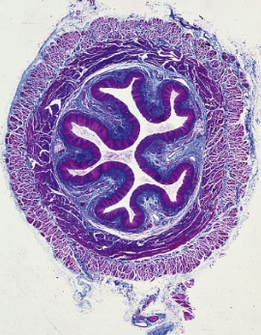
- 4 layers:
- mucosa = nonkeratinized stratified squamous cells mucosa & submucosa thrown into folds when esophagus empty; folds flatten during food transit. Stratified squamous columnar= transition from esophagus to stomach
- submucosa contains mucus-secreting esophageal glands
- muscularis externa is skeletal muscle in upper 1/3, then smooth muscle in lower 2/3
- fibrous adventitia instead of slippery serosa (fixes esophagus to surrounding tissue)
2.2 Describe the functional anatomy of the stomach
- Stomach acts as a temporary “storage tank”; initiation of protein digestion and converts contents to chyme
- “Fixed” at esophagus & small intestine but is movable in between
- Gross Anatomy:

- 25 cm long with a capacity of 50 ml to 4 L
- regions: cardia (initial region) ⇒ fundus ⇒ body ⇒ pyloric region (antrum to pyloric canal to pyloric sphincter)
- Oblique layer of muscularis externa important: helps stomach fold into U or V shape, helps physically pound food to convert to chyme
- Rugae: the folds when stomach is empty, when stomach is filled, they stretch out

Stomach is innervated by the autonomic NS:
1) sympathetic (fight or flight) fibers from thoracic splanchnic nerves
2) parasympathetic (resting and digesting) fibers from vagus nerve
2. Microscopic Anatomy:
- Surface epithelium is entirely goblet cells: produce mucous and an underlying bicarbonate-rich layer; in between millions of gastric pits, leading to gastric glands which produce gastric juice, the composition of which varies depending on the region of the stomach
- mucous neck cells: at necks of glands. Produce a different type of mucin (acidic) for unknown reasons
- parietal cells: Secrete HCl & intrinsic factor
- increase surface area, have a lot of mitochondria (energy needed to generate HCl and IF)
- chief cells: secrete pepsinogen (precursor of pepsin) a protease (cleaves protein)
- enteroendocrine cells: secrete hormones including gastrin, histamine, serotonin and somatostatin
- HCL: important for activating pepsin, denatures proteins for digestion, bacterioside, helps break down plant cell walls
- Intrinsic factor: vitamin B12 needs carrier, if do not get enough B12, do not get mature RBC (pernicious anemia)

- The lumen of the stomach is an extremely harsh environment containing high concentrations of HCl and proteases (in the form of pepsin) How does stomach protect itself?
- A mucosal layer; mucus and bicarbonate (to help neutralize acid that breaches mucus layer)
- Tight junctions between cells; prevent “leakage”
- Replacement of epithelial cells (every 3-6 days) by “stem cells” at gastric pit/gastric gland junction
- Why constant turnover? Can get damage even with 1 and 2, turnover helps stomach survive
- Damaged mucosal layer= ulcer perforated ulcers content of GI leak peritonitis
- Most are caused by H. pylori
- 10% of ulcer caused by taking too many drugs containing enzymes that injure stomach (ex. aspirin)
- How does Helicobacter pylori contribute to ulcers?
- Create a niche by neutralizing HCl
- Secrete cytotoxins – damages mucosa
- Disrupt cellular adhesion
- Cause inflammation and further tissue damage
- These events leave the mucosa highly vulnerable to HCl in the stomach, leading
to ulcers
Describe the macroscopic & microscopic anatomy of the small intestine
- Small intestine: major digestive organ and is responsible for absorption of virtually all nutrients and much of the water
- Extends from pyloric sphincter (stomach – duodenum) ileocecal valve
- In cadavers, 6-7 m long, 2 m long in life
Three sections:
- duodenum: (“12 finger widths long” =~25 cm)
- Mostly retroperitoneal
- shortest division, it is an important structure as it harbors the hepatopancreatic ampulla & sphincter (receives secretions from liver and pancreas)
- jejunum: (“empty”); ~2.5 m long; intra-peritoneal.
- ileum: (“twisted”); 3.6 m long ⇒ leads to large intestine; intra-peritoneal

- The jejunum & ileum suspended from posterior abdominal wall by a fan-shaped mesentery, and are “framed” by the large intestine
Innervation:
- sympathetic - thoracic splanchnic nerves
- parasympathetic - vagus nerve

Microscopic Anatomy of the Small Intestine
- 3 important structural aspects to maximize absorption (600 folds increase in SA)
- Circular folds (plicae circulares): deep (1 cm), permanent, circular folds in mucosa & submucosa; increase SA and slow rate of passage of chyme
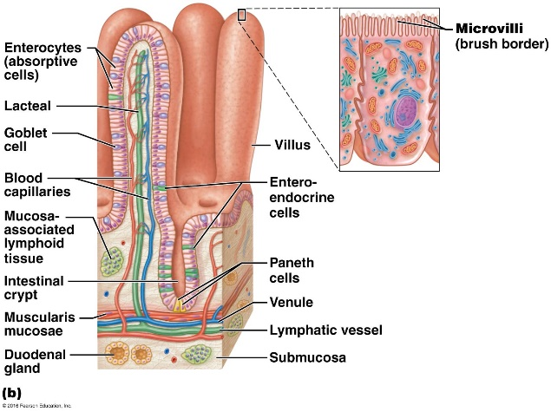
- villi: finger-like projections (>1 mm) of mucosa); longest in duodenum (greatest absorption)
- Duodenal (Brunner’s) glands secrete bicarbonate- if it does not, large outpouring of highly acidic content duodenal ulcers because duodenum cannot neutralize HCl
- microvilli: Comprises the “brush border” - Harbours brush border enzymes: contain proteases, involves enzymes to breakdown all components consumed (carbohydrates, lipids, proteins and nucleic acids)
- Lacteal: a structure, triglycerides and other fatty contents are passed through lacteal into lymphatic system
- Endpoints of digestion and end products can be absorbed by microvilli
- Intestinal crypts (crypts of Lieberkuhn): in between villi. Crypt cells secrete intestinal juice (mostly water/mucous, slightly alkaline- to help neutralize acid)
- Crypts also contain Paneth cells which secrete lysozyme – antimicrobial enzymes, help kill (first line of defense for bacteria)
- The epithelium of the villus “sheds” into intestinal lumen and is completely turned over every 4-6 days by “stem” cells at the base of the crypts (Paneth cells renew about every ~20 days)
- Anticancer drugs tend to cause diarrhea because cancer therapy targets rapidly dividing cells (most cells in body are not)
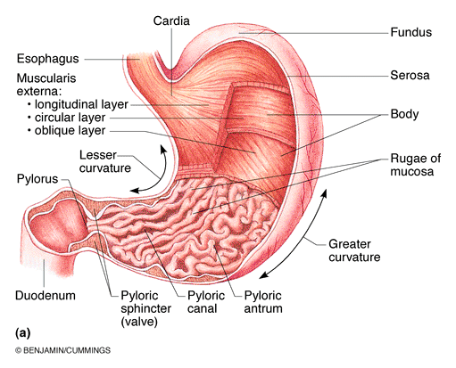

Lecture 2
Describe the functional anatomy of the liver & gall bladder
Gross Anatomy:
• largest gland in the body at ~1.4 kg; under diaphragm and protected by rib cage
• 4 lobes: right, left, caudate, quadrate
Microscopic anatomy of the liver
- The functional units composed of hexagonal lobules
- Within each lobule, hepatocytes radiate from a central vein
- At each of 6 corners, portal triad
- Composed of portal arteriole, portal venule and bile duct
- Venous (portal) and arterial blood bathe hepatocytes through “leaky” capillary system (sinusoids); blood collected by central vein hepatic vein vena cava
- Bile produced by hepatocytes drains via cuniculi opposite to blood flow, collected in bile duct collected in gallbladder or released to duodenum
Describe the functional anatomy of the liver & gall bladder
- Bile produced from the liver exits via multiple bile ducts that fuse to form the common hepatic duct
- This then fuses with cystic duct (which drains the gallbladder) to form the bile duct
- Then joins main pancreatic duct at the hepatopancreatic ampulla (controls release of bile and products released by pancreas), which enters the duodenum
- If bile not needed, stored in gallbladder
- Hepatocytes (other than produce bile)
- Process nutrients, store glycogen, synthesize plasma proteins
- Store fat-soluble vitamins
- Detoxify blood
The gallbladder:
- Thin-walled, green muscular sac ~10 cm long
- Major function: stores & concentrates bile for eventual secretion into the duodenum via the cystic duct bile duct
- Bile; Alkali substances containing bile salts/pigments, cholesterol, triglycerides, phospholipids and electrolytes
- Bile salts and phospholipids: emulsify fat; if have fatty compound in aqueous environment, it will not dissolve efficiently
- Gallstone: crystals of cholesterol. Occurs if too much cholesterol and not enough bile salts and phospholipids
Describe the functional anatomy of the pancreas
- Tadpole-shaped, largely retroperitoneal, gland extending across the abdomen from its tail (adjacent to spleen) to its head (encircled by duodenum)
- Produces pancreatic juice – contains wide range of digestive enzymes (acinar cells- manufacture and secrete enzymes important for digestion) and bicarbonate (duct cells- makes and releases bicarbonate to help neutralize acid) secreted via pancreatic duct to bile duct/hepatopancreatic ampulla empty in duodenum
- Accessory pancreatic duct empties into duodenum
- Zymogen: granules in pancreatic acinar cells (exocrine pancreas) contain digestive enzymes
- Can get signal to release enzymes readily instead of having to go through protein synthesis
- Acinar cells have abundant RER because RER makes protein
- Pancreatic islet (islets of Langerhans – endocrine pancreas) secrete insulin and glucagon – important for regulation of blood glucose
Describe the anatomy of the large intestine
- The large intestine extends from ileocecal valve to anus = 1.5m
- Absorbs water from indigestible food residues; eliminates rest as feces
1. Gross Anatomy:
• 3 distinguishing features:
- Longitudinal muscle layer reduced to 3 bands of smooth muscle (teniae coli). Tone causes wall to pucker into:
- Haustra: pocket-like bulges of large intestine
- Epiploic appendages: small fat-filled pouches of visceral peritoneum that hang from surface of large intestine. Nobody knows function
- vermiform appendix: blind, wormlike structure attached to posteromedial surface of cecum
- Contains masses of lymphoid tissue
- Twisted, blind, structure is also an ideal location for bacteria to accumulate & multiply appendicitis
- colon: ascending, transverse, descending, sigmoid; retroperitoneal except for transverse & sigmoid regions
- anal canal: external to abdominopelvic cavity; ~3 cm; involuntary internal anal
canal & voluntary external sphincter
2 superficial venous plexuses associated with anal canal - when inflamed, leads to haemorrhoids
no haustra in rectum or anal canal; muscular layers complete & well-developed so can expel feces – regulated by internal (smooth muscle) and external (skeletal muscle) anal sphincters.

2. Microscopic Anatomy:
• mucosa is simple columnar epithelium except in anal canal which is lined by stratified squamous epithelium; abundant crypts with many goblet cells (eases fecal passage and protection)
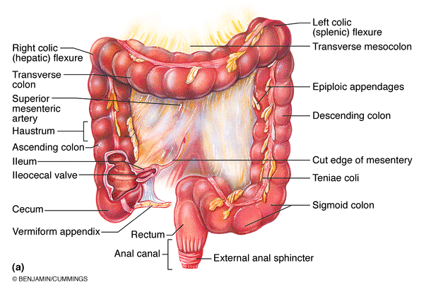
1.3 Describe the region-specific digestive activities of the GI tract and their regulation
1. List, define and provide examples of the 6 digestive processes
A. Ingestion: The taking in of food to the digestive tract normally via the mouth
B. Propulsion
- Mechanical process of moving food through alimentary canal: starts with swallowing
- Food is moved through the digestive tract via peristalsis, an involuntary process involving smooth muscle
- Note: while peristalsis involves directional movement of food, it also contributes some mixing due to alternate waves of contraction & relaxation of smooth muscles in the organ walls
C. Mechanical Breakdown
- Physical process - prepares food for chemical and/or enzymatic digestion. Often begins with chewing (and churning with tongue)
- Segmentation an additional example: mixes food with digestive juices. Increases absorption by repeatedly moving different parts of food mass over intestinal mucosa. Moves back and forth instead of a wave downwards (like peristalsis)
D. Digestion
- A series of catabolic steps used to break down complex food molecules into their basic “building blocks” – this is usually necessary for absorption
- Relies on enzymes which are either secreted into the lumen of the alimentary canal, or are found on microvilli (brush border)
- Begins in mouth with salivary amylase (secrete in saliva); breaks down carbohydrates

E. Absorption
- The process whereby the passage of digested end products, vitamins, minerals and water from the lumen of the GI tract through the mucosal lining via active or passive transport into blood or lymph.
- Most absorption takes place in the small intestine.
F. Defecation
- Elimination of fecal matter from the body via the anus
2. Summarize the basic concepts pertaining to the control of digestive function
- Regulatory mechanisms act to create optimal conditions in the GI lumen for both digestion and absorption of the products of digestion
- Work at neutral pH (stomach pH= below 2), need specialized enzymes (ex. pepsin)
- Need to be regulated to transition into small intestine (7-7.2)
A. Regulatory stimuli can be Mechanical or Chemical:
• mechano-, osmo- & chemoreceptors located in walls of GI tract organs to detect such stimuli
• key signals: (a) stretch of organ wall due to filling (mechanoreceptor)
(b) osmolarity & pH of contents, which change during food processing (osmoreceptor)
(c) substrates & end-products of digestion (chemoreceptor)
• stimuli activate receptors that result in reflexes leading to:
- Altered secretion (increase or decrease) of digestive juices/enzymes into GI lumen or of hormones into the blood stream
- Change in the mixing & propulsion of the contents of GI tract
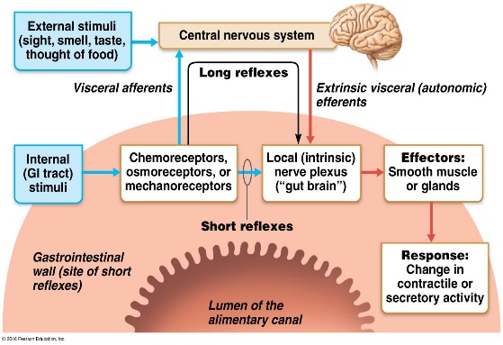
B. Regulation can be Extrinsic or Intrinsic:
• 2 kinds of nerve reflex activity:
short reflexes: mediated by local (enteric) plexuses in response to GI tract stimuli (intrinsic)
long reflexes: triggered by extrinsic or intrinsic stimuli, involve CNS centres & extrinsic autonomic nerves
- Reflexes typically converge on submucosal plexus and/or myenteric plexus
- Submucosal plexus: regulates secretion (ex. pancreatic enzymes)
- Myenteric plexus: regulates contraction (increase or decrease locally)
- Generally: Smooth muscle excitation by nerves secreting Acetylcholine or Substance P
and inhibited by nerves secreting Vasoactive Intestinal Peptide (VIP) or nitric oxide (NO)
- stomach & small intestine contains hormone-producing cells that respond to local chemical factors, signals from nerve fibres or to stretch
- hormones may act locally or travel via blood to adjacent organs to influence secretory or contractile activity

3. Describe the digestive activities of the oral cavity & their regulation
Mouth
- Only part of GI tract for ingestion
- Digestive functions of mouth by: teeth, tongue, salivary glands (mechanical, chemical)
- Mouth also begins propulsive act of swallowing food travels pharynx & enters esophagus
Digestive Processes in Mouth:
- Mechanical = chewing (mastication)
- Partly voluntary & partly reflexive, results in mechanical breakdown & mixing of food
- Chemical = enzymes secreted by products of the salivary glands
- Typically, no absorption in mouth (some exceptions such as nitroglycerine)
1. Salivary Glands & the Production of Saliva
Saliva: (i) cleanses mouth
(ii) dissolves food chemicals so they can be tasted
(iii) moistens & compacts food bolus
(iv) contains salivary amylase - begins digestion of starchy food
3 pairs of extrinsic salivary glands + small intrinsic buccal glands:
- parotid glands: predominantly serous cells, produce ~ 25% of saliva
- submandibular glands: serous & mucous cells ~70% of saliva
- sublingual glands: predominantly mucous cells ~5% of saliva
Lecture 4
Composition of Saliva:
- 97-99.5% water (therefore hypo-osmotic); pH 6.75-7
- osmolarity depends on stimulus for salivation and precise glands that are active
- contains: electrolytes (Na⁺, K⁺, Cl⁻, PO₄³⁻ & HCO₃⁻), amylase (initiates starch digestion), mucin (lubricates), urea & uric acid (metabolic waste products)
- Intrinsic salivary (buccal) glands secrete lingual lipase
- Additional secretions include: IgA antibodies, lysozyme and defensins = serving as first line of defence against pathogens that enter the mouth through food

Control of Salivation:
Average output = 1000-1500 ml/day
Intrinsic salivary glands (0.1 ml/min continuous secretion) keep mouth moist. Intake of food and/or other stimuli required to activate extrinsic glands (up to 4 ml/min)
Regulated by autonomic nervous system:
- Chemoreceptors & mechanoreceptors in mouth signal to the salivatory nuclei in brain stem (pons and medulla), results in increased parasympathetic activity via (facial & glossopharyngeal nerves [VII & IX]) to increase serous secretions
- Chemoreceptors activated most strongly by acids, while mechanoreceptors activated by any mechanical stimulus in mouth
- Sympathetic stimulation causes increase in mucous secretion. Strong stimulation constricts blood vessels serving saliva glands – dry mouth (xerostomia)
- Dehydration and medication cause inhibition of salivation
Salivation can also be triggered by sight, smell, or the thought of food
- Also by irritation (e.g. bacteria, spicy food, hyperacidity) in the lower GI tract because dilute the acid
4. Describe the voluntary & involuntary regulation of deglutition; define & indicate some potential causes of heartburn
A. Swallowing (Deglutition):
• coordinated activity of tongue, soft palate, pharynx, esophagus involving >22 separate muscle groups - 2 phases: buccal & pharyngeal-esophageal
Buccal Phase: occurs in mouth; voluntary
- Tip of tongue forced against hard palate
- Tongue is then contracted to force bolus of food into oropharynx
- In pharynx, food stimulates tactile receptors (mechanoreceptors)
Pharyngeal-esophageal Phase: Involuntary
- controlled by swallowing centre in medulla & lower pons through cranial nerves (including vagus)
- All routes except to stomach blocked off & food squeezed into esophagus by peristaltic contractions
What is Heartburn??
- burning, radiating substernal pain due to regurgitation of gastric juice into esophagus
- causes: gastric reflux - due to eating/drinking to excess, obesity or pregnancy, running; hiatal hernia, GERD

Multiple Choice Questions
- Which of the following statements about salivation is true?
- Salivation is stimulated mainly by the parasympathetic division of the autonomic nervous system
- Salivation can be triggered by chewing a rubber band.
- Salivation can be stimulated by bacterial toxins in stomach.
- a) and b)
- a), b) and c)
- During the pharyngeal-esophageal phase of swallowing:
a) the soft palate rises to close off the nasopharynx
b) swallowing is initiated voluntarily by the swallowing centre in the medulla/lower pons
c) the epiglottis lifts to uncover the opening into the esophagus
d) the larynx rises & the epiglottis covers the opening into the trachea
e) a) and d)
- Which of the following is NOT found in saliva?
a) Na⁺
b) intrinsic factor
c) amylase
d) mucin
e) lysozyme
5. Describe the digestive functions of the stomach and their regulation
Stomach
• a temporary « storage tank »
• chemical breakdown of proteins begins; food converted to chyme
Digestive Processes Occurring in Stomach
• Mechanical digestion via churning action of stomach (oblique muscles) and propulsion
• Protein digestion essentially only type of significant enzymatic digestion - primarily via pepsin. In children, stomach glands also secrete rennin which acts to digest casein
• lipid-soluble drugs such as alcohol & aspirin are easily absorbed by stomach mucosa; what can happen if there is considerable or regular movement of these drugs across the stomach lining? Erosion of stomach lining and eventually ulcers
• only stomach function essential to life is production of intrinsic factor – recall what this factor does, and why it is essential
• secretion of HCl facilitates reduction of food particles into chyme, denatures proteins & nucleic acids; transforms inactive pepsinogen into pepsin and destroys bacteria

Regulation of Gastric Secretion
• gastric mucosa secretes up to 2-3 L of gastric juice each day
• controlled by both neural & hormonal mechanisms
- Neural: long (vagus nerve-mediated) & short (local enteric) nerve reflexes
- Hormonal: GASTRIN (secreted by G cells of stomach and duodenum): stimulates secretion of pepsinogen & HCl

Stimuli acting at three distinct sites: the head, the stomach and the small intestine, impact on gastric secretory activity. Accordingly, there are three phases of gastric secretion: cephalic, gastric and intestinal
A. The Cephalic Phase:
• occurs before food enters stomach, short lived phase (a few minutes long)
- olfactory/taste bud inputs: hypothalamus vagal nuclei of medulla oblongata – leads to stimulation of secretion of gastric juice. Why would this phase be important in the digestive process? Primes the stomach so it’s ready at the time the food arrives
- visual/conscious thought inputs: conditioned reflex based on prior experience (significantly reduced if depressed/no appetite) triggered by smell, taste, sight or even thought of food
B. The Gastric Phase:
- 3-4 hrs long
- provides ~2/3 gastric secretions
- initiated by distension of stomach, peptides, low acidity
- distension: mechano-receptors local & long (vagal reflexes release of Ach and increases output of gastric juices)
- peptides & low acidity: more important trigger
- Leads to secretion of gastrin (by “G” cells), and histamine (by enterochromaffin-like (ECL) cells & mast cells)
- Gastrin increases gastric juice secretion, especially HCl by parietal cells
• caffeine also ⇑ gastrin secretion
- proteins are buffers – significance? Increase pH, which will increase gastric production
- gastrin secretion inhibited when gastric pH<2 (feedback) & by emotional upsets (via sympathetic NS)

C. The Intestinal Phase:
- an excitatory component followed by an inhibitory component
i) excitatory: mediated by intestinal gastrin from intestinal mucosal cells triggered by low pH and foodstuffs as chyme first enters duodenum
ii) inhibitory enterogastric reflex: occurs as duodenum continues to fill with H+, proteins, fats, etc. Result: a) vagal nuclei in medulla inhibited
b) local reflexes inhibited
c) sympathetic fibers activated - pyloric sphincter tightens
- Secretion of enterogastrones; secretin, cholecystokinin, vasoactive intestinal peptide (VIP), gastric inhibitory peptide
- result: gastric secretion decreases and gastric emptying slows
Beneficial effects:
- small intestine protected from excess acidity
- entry of chyme correlated with intestinal processing ability
Process of HCl Secretion:
- H⁺ actively pumped (against steep concentration gradient) into stomach lumen in response to gastrin + Ach + histamine
- H⁺ derived from carbonic acid
- Cl⁻ follows H⁺ to maintain electrical balance
- What is the other product of this reaction? Bicarbonate
- What is the alkaline tide? Venous return (from stomach) of bicarbonate
Gastric Problems
Ulcer:
• acid secretion by stomach overcomes protective mucus barrier & damages organ lining (esophagus, stomach or duodenum)
• more common in esophagus or duodenum – Why? Lack protective aspects stomach has
risk factors: smoking, habitual use of NSAIDs, alcohol, certain chronic diseases, infection with Helicobacter pylori
treatment: cimetidine (Tagamet) - inhibits histamine-H2 receptor interaction. How might Tagamet do this? Resembles histamine and binds to histamine receptor and inhibits activation. This is because all 3 of the factors are needed and without histamine, HCl production drops

Gastric Motility and Emptying: receptive relaxation of smooth muscle (fundus and body) – allows stomach to stretch without increasing tension
- Stomach contraction regulated by pacemaker region (interstitial cells of Cajal – basic electrical rhythm (BER)
- subthreshold depolarization every 20 sec.
- dependent on neural/hormonal factors to achieve depolarization
Regulation of Gastric Emptying
- Stomach empties completely within 4 hrs. after a meal, depending on volume of meal and contents
- Carbohydrate meal moves through quickly; fats slow movement by coating top of chyme & being digested slowly in duodenum – delays stomach emptying to up to 6 hours; rate of stomach emptying is largely dependent on signalling from the duodenum
Gastric Problems
Vomiting (Emesis):
• excessive stretching of stomach/intestine or presence of irritants ex. bacterial toxins, excessive alcohol, spicy foods, some drugs
• emetic centre in medulla is stimulated & motor responses elicited:
(i) skeletal muscles of abdominal wall & diaphragm contract
(ii) cardiac sphincter relaxes
(iii) soft palate rises to close off nasal passage
1. Match the following cell type with the correct secretory product:
a) chief cells iv) pepsinogen
b) enteroendocrine G cells v) gastrin
c) parietal cells i) HCl
2. The creation of an acidic environment in the stomach lumen:
a) is stimulated by histamine
b) is energy-requiring
c) involves movement of Cl into blood in exchange for bicarbonate
d) a and b
e) a, b and c

Lecture 5
6. Summarize the digestive roles of the liver and gallbladder & their regulation
1. Composition of bile:
- yellow-green, alkaline; hepatocytes produce 500-1000ml bile/day
- contains bile salts, bile pigments, cholesterol, neutral fats, phospholipids & electrolytes
What are cholic acid (on right) & chenodeoxycholic acid (on left)?
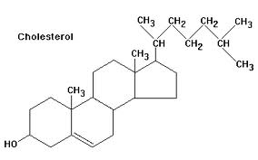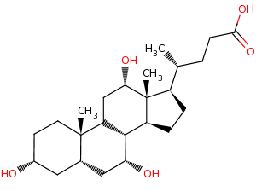
-main bile pigment is bilirubin (waste product of hemoglobin); intestinal bacteria convert bilirubin to stercobilin turns feces brown
• ONLY digestive function of liver: produce bile, a cholesterol derivative
• gallbladder: a storage organ for bile – contracts upon stimulus to release bile
• bile is a fat emulsifier: bile production and flow into the duodenum increases during digestion: a potent stimulus is fatty chyme
- Bile sats are amphipathic= hydrophilic and hydrophobic
- CH3 groups are hydrophobic (interfere well with fats)
- OH and carboxyl groups hydrophilic (interfere well with water)
2. Gallbladder
• Liver produces bile constantly. When digestion not occurring, hepatopancreatic sphincter is closed, bile “backs up” through the cystic duct; stored & concentrated in gallbladder
• Release of bile into duodenum occurs when muscular wall of gallbladder contracts, bile expelled into cystic duct bile duct
3. Regulation of Bile Release into Small Intestine
• when digestion not occurring, hepatopancreatic sphincter closed
• major stimulus for gallbladder contraction is cholecystokinin (CCK; (cholecysto = gallbladder and kinin = movement): secreted by enteroendocrine cells in response to fatty chyme. Secretin also increases bile synthesis by liver
CCK: (i) stimulates gallbladder contraction
(ii) stimulates secretion of pancreatic juice
(iii) relaxes hepatopancreatic sphincter
- bile salts are conserved by recycling (90-95%) through the enterohepatic circulation:
- Ileum (bile transporter) to blood to liver (via hepatic portal vein) to new bile
- Bile salts in portal circulation is the most important stimulus for bile secretion
Gallstones
- Caused by lack of balance of ratio between cholesterol and bile salts
- Painful because they are sharp crystals and bile ducts physically contract
- Can lead to obstructive jaundice (yellowing of skin and sclera of eye)
- Why yellow? Too much bilirubin
- Obstructive jaundice: lodging of bile duct and physically obstructed release of bile from gallbladder and liver
- Can block pancreatic duct pancreatitis
Gallstone treatments: dissolve with drugs, pulverize with ultrasound, vaporize with lasers, surgical removal of gallbladder
- Removal of gallbladder: body compensates by duct enlarging and serving as reservoir for bile
7. Describe the exocrine function of the pancreas and its regulation
• acini: groups of secretory acinar cells clustered around ducts
- Mediate exocrine function of the pancreas
• Produces a range of enzymes that digest all categories of food
- Amylase carbohydrates
- Lipase fats
- Nuclease nucleic acid
- Protease protein

1. Composition of Pancreatic Juice
• ~1200-1500 ml/day: water + electrolytes (bicarbonate; pH~8) + enzymes
• alkalinity allows it to:
- neutralize acidic chyme
- create optimal pH for intestinal & pancreatic enzymes
• proteolytic enzymes are produced & released in inactive, precursor form - activated once in duodenum because pancreas needs inactive form as protective mechanism
• amylase, lipases & nucleases secreted in active form but typically require ions or bile for optimum
• Proteolytic enzymes found in zymogen granules
• Trypsinogen, chymotrypsinogen, procarboxypeptidase released in pancreatic juice, reach small intestine
- enteropeptidase cleaves trypsin and feedbacks to make more trypsin
- Trypsin feed forward to activate other 2 precursors through cleavage
- Chief cells make pepsinogen – pepsin can cleave back and make more pepsin until gastric secretions are inhibited
• Bicarbonate production in stomach – alkaline tide
• Pancreas secretes bicarbonate to neutralize HCl in chyme extrusion of H+ into bloodstream by pancreas
- Counters bicarbonate secrete by stomach, neutralizing pH of venous flow return to hear
2. Regulation of Pancreatic Secretion
A. Hormonal (2 intestinal hormones):
(i) Secretin: filling of duodenum by substrates stimulates pancreatic duct cells to secrete watery, bicarbonate-rich juice
(ii) CCK: fatty chyme stimulates pancreatic acinar cells to secrete enzyme-rich juice
- Presence of both hormones results in substantial increase in pancreatic secretions
B. Parasympathetic Nervous System
• vagal stimulation of secretory activity
• primarily during cephalic & gastric phases of gastric secretion
8. Summarize the digestive functions of the small intestine and their regulation
- Body ’s major digestive organ; completes digestion and virtually all absorption (by absorptive cells through apical microvilli)
- Intestinal glands secrete 1-2 L intestinal juice/day: major stimulus is distension or irritation of intestinal mucosa by acidic chyme released from stomach
- There are very few enzymes in intestinal juice; most enzymes manufactured by intestine are brush border enzymes, which are physically affixed to the cell membrane
Intestinal juice is mainly water + mucus. Luminal enzymes, bile, and bicarbonate are supplied by liver and pancreas
Requirements for Optimal Intestinal Digestive Activity
- optimal liver & pancreatic function
- slow, measured delivery of chyme from stomach
Serves 2 major roles: (i) neutralize stomach HCl; (ii) contents of stomach are hypertonic (hypertonic intestinal lumen because too much chyme released too quickly; can have diarrhea, leading to dehydration, can have imbalances of ions)
2. Motility of Small Intestine
• segmentation most common motility pattern
• initiated by intrinsic pacemaker cells in circular muscle layer; operate at different frequencies: duodenum 12-14/min, ileum, 8-9/minute
• intensity of segmentation altered by long & short reflexes & by hormones
• once absorption almost finished, segmentation wanes release of motilin peristalsis starting in the proximal duodenum and running 50-70 cm.
• this process (migrating mobility complex) gets rid of debris and bacterium, repeating it is efficient way of emptying small intestine from indigestible things (takes 2 hours x2 – in small intestine and stomach)
• once chyme has passed through the small intestine, back pressure from cecum closes valve flaps
• Ileal motility increases, ileocecal sphincter relaxes in response to:
- gastroileal reflex = long reflex
- gastrin
1. Which of these statements about ulcers is/are TRUE?
a) gastric ulcers are more common than duodenal ulcers (false because protective mechanisms in stomach)
b) ulcers can be treated by giving antihistamines
c) ulcers can be caused by erosion of gastric mucus protection by Helicobacter pylori
d) a) and b)
e) b) and c)
2. Match the following terms with the correct description:
a) cholic acid i) liver cell C
b) bilirubin ii) crystallized cholesterol E
c) hepatocyte iii) metabolite of haeme B
d) fat emulsifier iv) metabolite of cholesterol A
e) gallstones v) chenodeoxycholic acid D
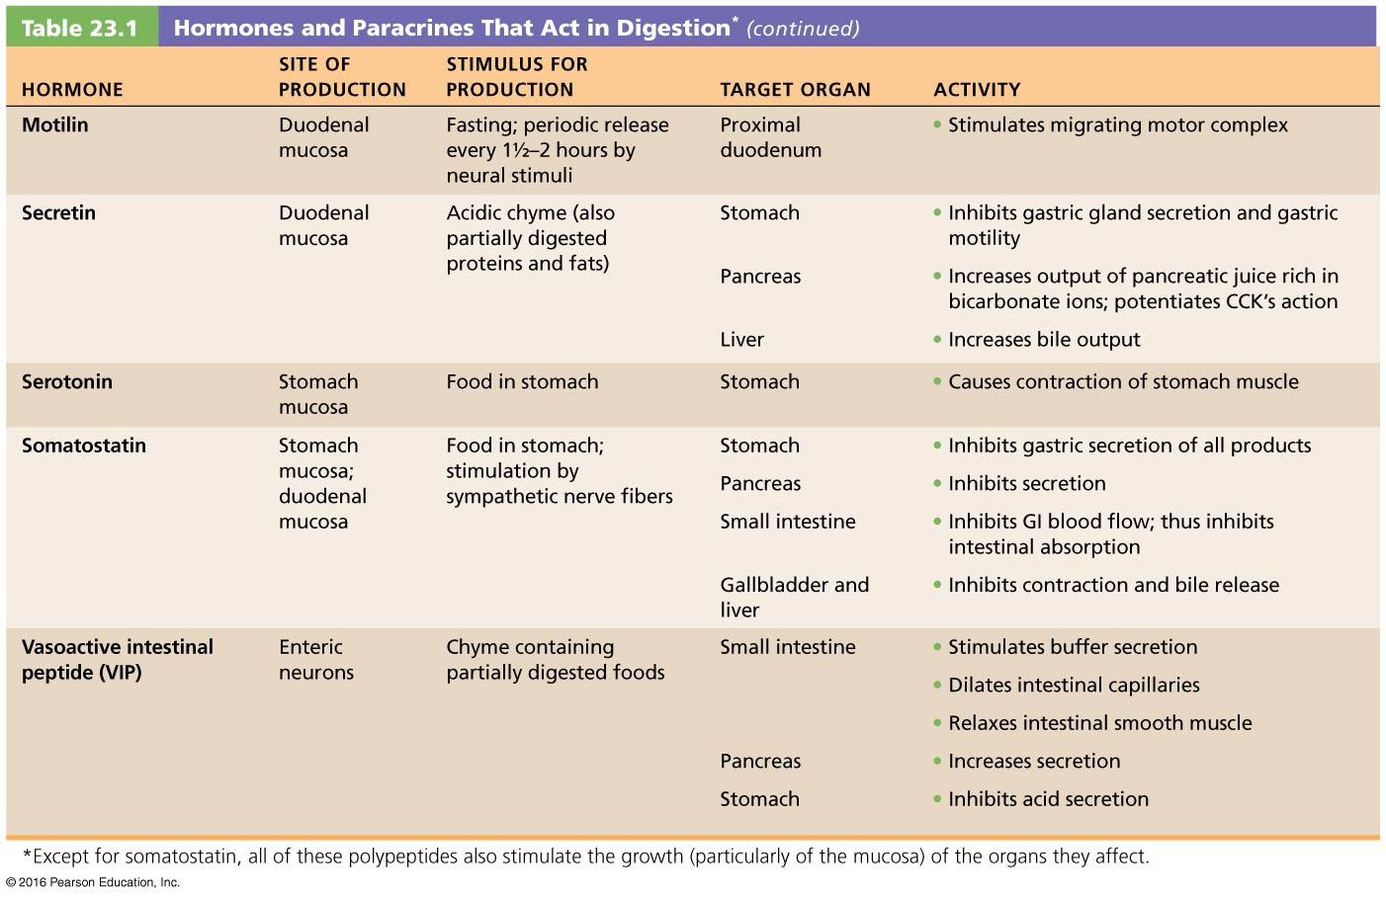
9. Summarize the chemical digestion of carbohydrates, proteins, lipids & nucleic acids
- Chemical digestion = catabolism
- Typically results in breakdown of food into subunits (often monomers) which can be adsorbed
- Chemical reaction for digestion of complex molecules involves hydrolysis
Carbohydrates (200-600 g/day)
Monomers = monosaccharides - absorbed directly in small intestine
Major dietary monosaccharides: glucose, fructose, galactose
- Glucose, fructose and galactose have same chemical composition = isomers
- Most digestible dietary carbohydrates in form of starch (complex carb)
- Common disaccharides:
- Sucrose = 1 glucose, 1 fructose
- Lactose = 1 glucose, 1 galactose
- Maltose = 2 glucose
• glycogen & starch = polysaccharides (branched glucose polymers)
- glycogen – common “storage” form for carbohydrates in muscle and liver – a lot of branches, many access points for digestion
- Starch is the common carbohydrate storage form in plants.
• cellulose: plant polysaccharide (glucose polymer) that cannot be digested; important as it provides fibre (important for passage of food)
Digestion of Carbohydrates:
(i) begins in mouth (amylase) reduces to oligosaccharides (~3-8 monomers) optimal at pH=6.75-7
- Salivary amylase inactivated by acidity in stomach; digested by pepsin
(ii) small intestine - pancreatic amylase reduces most starch to maltose (10 min)
(iii) intestinal brush border enzymes (dextrinase, glucoamylase, maltase, sucrase, lactase) completes digestion to monosaccharides for adsorption
- Lactose intolerance: cannot break down lactose because lactase no longer there; not uncommon that people develop this later in life
Lecture 6
Proteins
• dietary proteins (~125 g/day) + enzyme proteins (15-25 g/day) + protein from sloughed & disintegrating mucosal cells (15-25 g/day)
• digested to small peptides and (20) amino acids

Digestion of proteins
begins in stomach with pepsin secreted by chief cells; (pH 1.5-3.5); cleaves bonds with tyrosine & phenylalanine
- Hydrolyzes 10-15% ingested protein, inactivated by high pH of small intestine
- Generates polypeptides and a few amino acids
many proteolytic enzymes present in small intestine:
• pancreatic trypsin & chymotrypsin
• carboxypeptidase (2 sources: pancreas & brush border)
• aminopeptidase & dipeptidase (source? Brush border)
Sum of total of proteolysis –free amino acids and some di and tripeptides hydrolyzed in enterocytes to amino acids
Lipids (30 -150+ mg)
Primarily neutral fats (Triglycerides)
• small intestine only significant site of fat digestion (pancreatic lipases)
• fats emulsified with bile salts resulting in droplets of ~1 μm – in aqueous environment
• lipases cleave triglycerides to fatty acids + glycerol/2-monoglycerides
Nucleic Acids
DNA/RNA; represents a relatively small component of food
1) pancreatic nucleases RNAase & DNAase, reduces RNA and DNA to nucleotides
2) intestinal brush border nucleosidases & phosphatases; reduce nucleotides to free bases, pentose sugars + phosphate ions
Enter villi via carriers blood
10. Outline the processes by which the various nutrient breakdown products are absorbed by the small intestine
• ~10 L of food, drink & GI secretions enter GI tract/day - 0.5-1 L reach large large intestine
- Mostly GI secretion (contain a lot of water), 90-95% gets absorbed; very efficient
• most digestion and adsorption of digestion products complete by time chyme reaches ileum: the ileum recycle bile salts via portal circulation to the liver
• at end of ileum, some water, indigestible food materials (ex. cellulose) & millions of bacteria enter the large intestine via the ileocecal valve
• Intestinal cells joined by tight junctions; need transport mechanisms (mostly active transport)
- Active transport intestinal villous capillaries to hepatic portal vein liver
- Lipid digestion products passive diffusion lacteal (lymphatic system to blood)
1. Absorption of Carbohydrates
Must be monosaccharides
- common protein carriers move glucose & galactose into epithelial cells; 2⁰ active transport involving Na⁺
- movement of monosaccharides into blood capillaries by facilitated diffusion
- fructose moves entirely by facilitated diffusion; no requirement for ATP
2. Absorption of Digestion Products of Proteins
- Several types of amino acid carriers: secondary active transport (Na⁺); carriers recognize groups of amino acids (acidic, basic, neutral)
- some di- and tripeptides actively transported into epithelial cells and digested to single amino acids within cytoplasm. Amino acids then diffuse into capillaries
- Intestinal mucosa of infants is immature & may permit some uptake of whole proteins (missing tight junctions) lead to food allergies, transport of breast milk-derived IgA antibodies (temp. passive immunity)
3. Absorption of Lipids
- bile salts necessary for absorption of lipid digestion products
- monoglycerides, glycerol & FFA water-insoluble once generated by lipases, associate with bile salts & lecithin (a phospholipid) micelles (similar to emulsion droplets, but much smaller)
- micelles diffuse across lipid bilayer; FFA and glycerol are resynthesized into triglycerides
combined with proteins, phospholipids, cholesterol chylomicrons extruded by exocytosis enter lacteal/lymphatic system empties into venous blood via the thoracic duct in neck
- in circulation, lipoprotein lipase hydrolyze triglyceride on capillary endothelium of liver and adipose tissue; FFA and glycerol can enter cell for energy or storage as fat
- lipid absorption complete by ileum (if bile secretion disrupted, will not absorb fat, excrete into feces fatty stool)
4. Absorption of Vitamins
• fat-soluble vitamins (A, D, E, K): absorbed as part of micelles; important to ingest fat-soluble foods when taking a pill with these vitamins
• water-soluble vitamins (e.g. B vitamins & vitamin C): absorbed easily; exception is vitamin B₁₂ (very large, charged molecule) - requires intrinsic factor

5. Absorption of Electrolytes
• most ions actively absorbed along length of small intestine
• iron & calcium absorption regulated based on requirements - largely limited to duodenum
- sodium absorption coupled to that of glucose & amino acids
- anions primarily follow electrical gradient established by sodium
- chloride ions= active transport. In small intestine HCO₃⁻ actively secreted into lumen in exchange for Cl-
- potassium= simple diffusion in response to osmotic gradient (water absorbed - potassium follows concentration gradient) – if no absorption of K, water absorption impaired, get diarrhea and hypokalemia (form of electrolyte imbalance)
- iron= active transport. Into mucosal cells & binds to ferritin (mucosal iron barrier). Iron transported in blood bound to transferrin, but only if needed, otherwise lost when intestinal epithelial cells sloughed off
- calcium absorption related to blood levels of ionic calcium. Low plasma calcium triggers secretion of PTH from parathyroid gland - PTH activate vitamin D by kidneys increase uptake of calcium by small intestine
- To increase Ca²⁺ levels, increase bone resorption (osteoclasts) more than deposition
6. Absorption of Water
• ~9 L water, mostly GI tract secretions, enters small intestine/day
• 95% absorbed in small intestine by osmosis (300-400 ml/hr)
• water can move freely in both directions - active uptake of solutes like Na⁺ directs water from chyme to enterocyte to blood
11. Describe the digestive functions (& regulation) of the large intestine
1. Digestive Processes in Large Intestine
- Only a small amount of digestion by resident bacteria
- Remaining material spends 12-24h moving slowly through large intestine
- Some absorption of water & Na⁺ / Cl⁻
- Major function: defecation; large intestine NOT essential for life
2. Bacterial Flora of Large Intestine (over 700 species)
• most bacteria coming from small intestine have been killed (HCl, lysozyme, proteases), but not all; bacteria also enter via anus
(i) fermentation (ex. of cellulose) acids & gases (~500 ml gas/day)
(ii) synthesis of vitamins B & K
- Kept in GI lumen by dendritic cells and the MALT system

3. Motility of Large Intestine
• usually inactive; contractions sluggish & short-lived
• haustral contractions: every ~30 min. Moves luminal contents to next haustrum; under local control, stimulated by distention of lumen
• mass movements (gastrocolic reflex): long, slow-moving, powerful - move over large areas of colon 3-4 times/day - usually occur during or just after eating (coupled with gastroileal reflex in small intestine)
• stool in rectum consists of undigested food residues, mucus, sloughed epithelial cells, millions of bacteria & enough water for smooth passage
• ~ 500 ml of food residue enters cecum daily; ~ 150 ml becomes feces
• fibre in diet increases strength of colon contractions & softens stool
too little fiber: volume of stool is small & contractions increase pressure on walls diverticulosis = small herniation of mucosa through colon walls rupture and progress to diverticulitis (bacterium in large intestine escape and cause peritonitis)
12. Describe the neural regulation of defecation
Diarrhea: food residue passes too quickly for sufficient water reabsorption; prolonged diarrhea can lead to dehydration and electrolyte imbalances
Constipation: too much water absorbed & stool difficult to pass; ex. lack of fibre, not heeding need to defecate, lack of exercise, laxative abuse
If defecation delayed, reflex contractions end & rectal walls relax until next mass movement
defecation aided by Valsalva’s maneuver: closing glottis, contracting diaphragm and abdominal wall muscles and levator ani muscle to pull anal canal superiorly

Regulation of Metabolism and Body Temperature (Chapter 24)
6 classes of nutrients:
- Major: carbohydrates, lipids, proteins
- Others: vitamins minerals, water
Food Guide Pyramid from USDA (1992)
- Reduce animal fats (substitute by plant oils and nuts)
- Restrict red meat, sweets and starchy foods
- Min 8 glasses water/day
- 30 min/day moderate exercise
- Balanced diet: adequate source for 45-50 “essential” nutrients

Carbohydrates
A. Dietary Sources
• except for lactose & small amount of glycogen in meats, all dietary carbohydrates come from plants
Sugars: fruits, sugar cane, sugar beets, honey, milk
Starch: grains, legumes, root vegetables
Cellulose: most vegetables; provides roughage or fiber
B. Uses in Body
• glucose is the major body fuel used to make ATP
- galactose & fructose converted to glucose via isomerization
• neurons & RBCs rely almost 100% on glucose; other cell types can use fats
• blood glucose must be maintained for optimal brain function
• minor amount of sugars used in nucleic acids, glycoproteins, glycolipids
• blood glucose too high? - excess converted to glycogen (stored in muscles and liver) and fat (stored in adipose tissue)
C. Dietary Requirements
• ~100g/day for min. blood glucose levels (CNS function)
• 130mg/day recommended intake, complex carbs (who grains/vegetable) because they take time to breakdown
• Recommended 45-65% of daily caloric intake
If carb intake less than 50g/day, body will access glucose through glycogen (short-term) and fat (long-term)

Lipids
A. Dietary Sources
• most abundant dietary lipids are neutral fats or triglycerides
1) saturated fats in meat, dairy products, coconut
2) unsaturated fats in seeds, nuts, olive oil, most vegetable oils
• cholesterol (egg yolk, meats, milk products, shellfish) and phospholipids
• liver can convert one fatty acid to another except for linoleic & linolenic acids = essential fatty acids (they cannot be synthesized by body)
Lecture 7
B. Uses in Body
Dietary fats are essential for several reasons:
(1) absorption of fat-soluble vitamins
(2) TGs are the major fuel of hepatocytes/skeletal muscle
(3) phospholipids for myelin sheaths and plasma membranes
(4) fatty deposits: protective cushion; insulating layer beneath skin; concentrated source of energy fuel
(5) essential for production of ex. prostaglandins (linoleic acid), steroid hormones and bile salts (cholesterol), needed to stabilize plasma membrane
C. Dietary Requirements (American Heart Association):
- <30% caloric intake (presently >40% in US)
- saturated fats should be <10% total fat
- cholesterol < 300 mg/d (1 egg yolk; liver is capable of synthesizing cholesterol)
Proteins
A. Dietary Sources
• animal products: greatest amount & best ratios of essential amino acids
• eggs, milk, fish & most meat proteins=complete protein=all essential and non-essential aa
• legumes (beans & peas), nuts & cereals = protein-rich (not complete; ex. cereals low in lysine & legumes low in methionine)
- Soy beans and tofu contain all aa

B. Uses in Body
• structural: keratin of skin, collagen & elastin of connective tissue, muscle proteins
• energy: last resort – occurs in situation where carb/fat calories too low
• functional: enzymes, hemoglobin, peptide hormones
- All-or-none rule: if protein requires all 20 aa to be made, it will not be made until all 20 are available
- Nitrogen balance: whether a person is gaining or diminishing protein content.
- Positive: when building muscle, when growing adolescent
- Anabolic steroids/hormones cause muscle to build more protein
C. Dietary Requirements
• Most North Americans consume far more protein than they need
• Requirement dictated by age, size, nitrogen balance
• Recommend 0.8 g/kg body weight (~56 g/70-kg man; 48 g/58-kg woman)
• Small serving of fish + one glass of milk ~ 30g
Vitamins
• needed in minute amounts
• NOT used for energy but essential for use of proteins/carbohydrates in diet
• often coenzymes in metabolic reactions – ex. riboflavin and niacin essential for metabolism of glucose for energy (B2 and B3). Vitamin K essential cofactor for formation of clotting proteins
• most not made in body (exceptions: vit. D (skin), some B vitamins + vitamin K (intestinal bacteria)) Vitamin A can be converted by the body from b-carotene (a “provitamin)
• Vit A, C and E antioxidants: neutralize free radicals so can have anti-cancer activities and may help prevent atherosclerosis (broccoli, cabbage, brussels sprouts)
2 classes:
- fat-soluble: A, D, E, K; absorbed with dietary lipid; can be stored (except K). In excess, some vitamins, especially vitamin A, may be toxic
- water soluble: B-complex vitamins & vit C; absorbed with water (except vit B12 - must bind to intrinsic factor); not stored in body – significance: cannot store them so need to constantly replenish water-soluble vitamins
- Vitamins found in all major food groups – no one food contains all vitamins, hence the need for a balanced diet
- Liver: main storage site for fat-soluble vitamins

Minerals
4% body mass (mostly calcium and phosphorus).
moderate amounts of 7 needed: calcium, phosphorus, potassium, sulfur, sodium, chloride, magnesium
trace amounts: iron, iodine, manganese, copper, zinc, cobalt, fluorine, selenium, chromium
Minerals;
- give added strength (ex. bone/Ca)
- act as co-factors (ex. Fe - hemoglobin)
- electrolytes (Na & Cl - osmolarity/water balance),
- hormone production (ex. I – thyroid hormone)
Critical balance between intake & excretion; vegetables, milk & some meats are mineral-rich
Excess, ex. too much table salt (NaCl), can increase fluid retention and blood pressure
Water
• carries nutrients
• cleanses blood of wastes
• solvent for minerals, vitamins, amino acids, glucose, etc.
• actively participates in chemical reactions
• lubricant around joints
• shock absorber (eyes, spinal cord, joints, amniotic sac)
• aids in body temperature regulation
2.1 Review the metabolic pathways and their interactions
Metabolism – anabolism and catabolism
Used to: (i) construct bodies molecules
(ii) generate energy in form of ATP through cell. respiration (stages 2 and 3)
Three steps in processing energy-containing nutrients: glycolysis, Krebs cycle and ETC

- Most energy generated from body comes from oxidative phosphorylation (in cytosolic cells and mitochondria)
- Create proton gradient, pump protons out through ATP synthase, generating ATP
Carbohydrates:
- Metabolized first via glycolysis; produces some energy via substrate-level phosphorylation
- Followed by Krebs cycle; produces some ATP via substrate-level phosphorylation
- Most ATP produced via high energy electrons used in ETC via oxidative phosphorylation
C₆H₁₂O₆ + 6O₂ 6H₂O +6CO₂ + 32 ATP and heat
- Note: amino acids and glycerol (from fats) can also feed into glycolysis
- Need fructose 1,6-bisphosphate for subsequent degradation
- If not enough sufficient energy, NAD+ cannot be regenerated
- Pyruvic acid would be reduced to lactic acid
- Builds up in skeletal muscle (causes “burn” when exercising), can diffuse from cells and be sent to liver

- In Mitochondrial matrix entry via decarboxylation (– CO₂) of pyruvate to form acetic acid then conjugated to –CoA to form acetyl CoA.
- Oxaloacetic acid “picks up” Acetyl CoA
- Intermediates (keto acids) decarboxylated (X2) and Oxidized (X4)
- Oxaloacetate regenerated
- Some intermediates can be used to make amino acids or fats, and Krebs cycle can also burn triglycerides and, if needed, amino acids
- Oxidative Phosphorylation: FADH2 and NADH carry energy: must be converted to ATP
- Coupled to formation of water from electrons, oxygen and H+.
- STEPWISE passage of electrons coupled to H+ chemiosmosis gradient
- H+ reentry, drives a “motor” in ATP synthase which cconverts ADP + Pi to ATP. “Reverse” proton pump
- “burning” one molecule of glucose= ~32 ATP- approx. 38% energy recovery; rest lost as heat
- Generate approx. 55kg of ATP every day – constantly using it for biochemical reactions, need to regenerate large amount

- Glycogenesis: making glycogen (anabolic), occurs when have a lot of glucose so need to store excess
- Glycogenolysis: breaking down glycogen (catabolic), when in need of glucose
- Gluconeogenesis: making glucose from non-carbohydrate sources (amino acids, triglycerides etc.)
Fat – very efficient energy store; ~2x versus glycogen
Both glycerol and free fatty acid side chains can be used for energy
ONLY glycerol enters glycolytic pathway
Both fatty acids and glycerol products can enter Krebs cycle.
b-oxidation (2 carbon `snips`) of fatty acids yields acetic acid, converted to acetyl CoA – Krebs
Fatty acids cannot be used to generate glucose via gluconeogenesis

- Lipogenesis: reverse of lipolysis
- Acetyl CoA combine with oxaloacetic acid
- If blood glucose too low, body will salvage glucose from anywhere
- Oxaloacetic acid will get depleted, body is trying to make energy by burning fat, mostly through beta oxidation pathway, so making a lot of acetyl CoA but do not have enough oxaloacetic acid
- Convert acetyl CoA to ketone bodies: molecules like acetone, and cause breath to smell sickly sweet and can get metabolic acidosis

- Amino acids are not “stable” or stored; excess converted to fat or burned for energy
- Undergo transamination and deamination to generate keto acid –Krebs Cycle intermediates – as a source of energy (ex. ketoglutaric acid; some can convert to pyruvate - gluconeogenesis). Conversely, non-essential amino acids can be derived from Krebs cycle intermediaries
- Ammonia is generated via deamination as a byproduct of this cycle - converted to urea because ammonia is toxic

- Body in constant dynamic flux - can draw on nutrient pools to supply needs. Pools linked by key intermediates for interchangeability. Fat/carbohydrates more readily interchanged, and directly used for fuel - a common pool, and can be stored. Amino acids used for fuel indirectly and cannot be stored

2.2 Define the absorptive state and the key role of insulin in its metabolic regulation
1. Absorptive & Postabsorptive States: Events & Controls
- Absorptive State (fed state): time during and shortly after eating - nutrients entering circulation provide an energy supply
- Post-Absorptive State (fasting state): GI tract empty; energy needs are met by breakdown of food reserves
Metabolic controls act to equalize blood concentrations of nutrients during all time intervals associated with these 2 very different nutritional states

Lecture 8
Absorptive state:
- Anabolism exceeds catabolism
- Glucose major fuel
- Dietary amino acids and fats – used for anabolic processes (make new proteins/fat stores)
- Excess metabolites of all sources used to make fat once anabolic and energy demands are met
Hormonal Control:
Insulin
• directs all events of absorptive state
• produced by ß cells of pancreatic islets of Langerhans (endocrine pancreas; 2% of gland)
• Structure: small (51 aa) protein of 2 amino acid chains connected by disulfide bonds
- Synthesized as proinsulin; middle portion excised to make active hormone before release
- Primary stimulation for insulin secretion is a rise in blood glucose
• secretion also stimulated by increased blood amino acids, by glucose-dependent insulinotropic peptide (GIP – produced by GI tract) and parasympathetic stimulation
• Principal effect of insulin is to activate carrier-mediated facilitated diffusion of glucose into cells (increases 15-20-fold within minutes via translocation of glucose transporter)
• This is especially true for skeletal muscle/adipose tissue
• note: insulin is not needed for glucose entry into liver, kidney, brain, or intestinal epithelial cells. These cell types all readily absorb glucose irrespective of insulin levels
Insulin - regulates all aspects of the adsorptive state:
(1) Stimulates uptake of glucose and enhances glucose oxidation for energy
(2) Stimulates conversion of glucose to glycogen and triglycerides (in adipose tissue)
(3) Increases active uptake of amino acids & promotes protein synthesis
(4) Inhibits virtually all liver enzymes that promote gluconeogenesis and inhibits hydrolysis of glycogen to glucose (glycogenolysis)
- Insulin anabolic, hypoglycemic hormone; take glucose out of circulation and uses it for energy or converts to storage form
2.3 Define the post-absorptive state: describe the roles of glucagon and other supporting mechanisms in the maintenance of blood glucose
Postabsorptive State:
• between meals, blood glucose drops, net synthesis of fat, proteins, glycogen stops, and catabolism of these substances begins; primary goal: maintain blood glucose within homeostatic range (70-100 mg glucose/100 ml) during times of fasting
• important because brain must use glucose as its energy source
• most events geared toward
- sparing glucose for brain cells
- making more glucose available to the circulatory system
Making glucose available to the blood:
Potential sources: stored glycogen, tissue proteins, fat (only glycerol)
(i) Glycogenolysis in liver:
• liver has ~100 g of glycogen reserves = first source of glucose
• can normally maintain blood glucose for ~ 4 h during postabsorptive state
(ii) Glycogenolysis in skeletal muscle:
• again, ~100 g of glycogen reserves
• glycogen is oxidized to pyruvic acid or lactic acid (via glycolysis) ⇒ to blood ⇒ to liver ⇒ to glucose
• skeletal muscle does not have glucose 6-phosphatase, cannot directly provide glucose to circulation
- metabolize G-6-P by glycolysis to pyruvate or lactic acid, which enters circulation, and are taken up for conversion to glucose by the liver. In this way, skeletal muscle is an indirect source of blood glucose in the post-absorptive state
(iii) Lipolysis in adipose tissues and liver:
• adipose tissue & liver cells produce glycerol by lipolysis
• liver converts glycerol to glucose (gluconeogenesis)
• but free fatty acids can only feed into the Kreb’s cycle
B1. Making glucose available to the blood (continued)
(iv) Catabolism of cellular protein:
• last resort: used only if fasting is prolonged and during stress (due to the secretion of glucocorticoids)
• process requires deamination (removing amine group through transamination) of amino acids in liver to generate keto acid followed by their conversion to glucose
Glucose sparing:
• use non-carbohydrate fuel molecules for energy (especially: triglycerides) to conserve glucose
• as body moves into the post-absorptive state, all tissues & organs except brain switch to using fats as their major energy source:
(1) lipolysis in adipose tissue releases free fatty acid to cells, can be oxidized for energy via Krebs cycle/oxidative phosphorylation
(2) liver oxidizes free fatty acids to ketone bodies - released into blood & used by cells for energy
(3) if fasting is prolonged (4-5 days) the brain will also start to use some ketone bodies for energy
Hormonal & neural controls:
• interaction of sympathetic nervous system and hormones regulate post-absorptive state (can be variable in length)
• initiation of post-absorptive state: key is a change in blood glucose: drop in blood glucose signals entry into post-absorptive state, and leads to inhibition of secretion of insulin
• decreasing blood glucose stimulates secretion of glucagon

Glucagon
• 29-amino acid polypeptide hormone produced by alpha cells of pancreatic islets of Langerhans
• potent hyperglycemic agent (1 molecule can cause release of 100 million glucose molecules)
major target of glucagon is liver and adipose tissue
Promotes:
(a) glycogenolysis
(b) glucose synthesis from lactic acid and via gluconeogenesis from glycerol and amino acids
(c) in adipose cells, stimulates lipolysis release of FFA & glycerol into blood
• glucagon secretion inhibited when glucose levels rise
• if insulin gets released, get hypoglycemia (can be fatal if prolonged and untreated)
• glucagon counters the effects of insulin and prevents hypoglycemia
Sympathetic nervous system:
- responds to sudden drop in blood glucose
- other stimuli include bodily injury, anxiety, anger, other stressors associated with the “fight-or-flight response”: glucose levels rise, blood vessels constrict, heart beats faster, blood shunted to brain, heart, and skeletal muscle
- Sympathetic stimulation results in lipolysis & fat mobilization from adipose tissue and stimulates glycogenolysis (i.e. response is similar to glucagon)
Adrenal gland:
- responds to sympathetic stimulation as part of “fight or flight” response
- adrenal medulla contains chromaffin cells which secrete epinephrine & norepinephrins - stimulate glycogenolysis, lipolysis & fat mobilization, gluconeogenesis
- adrenal cortex secretes glucocorticoid cortisol - essential for life. Helps body adapt to external changes and intermittent food consumption by keeping blood glucose levels constant
» stimulates lipolysis & fat mobilization
» stimulates gluconeogenesis
» stimulates protein catabolism

