GNG1106 Fall 2017 - Assignment 4
Available: Sept 5
Due: Oct 15, 23:59

Instructions
This assignment is to be done INDIVIDUALLY. Use the following instructions to complete and submit this assignment.
- You will need to submit your assignment electronically to Brightspace. Prepare the following
  - An assignment report in a PDF file (this allows you to use your favorite editor to create the PDF file). For question 1, insert the programming models for parts (a) and (b) filled in as per the question instructions. You may fill in the programming model using drawing features of your editor or by hand on paper which is then scanned and inserted into your document. For Questions 2, insert in your assignment report the source code (take care of its appearance), and capture the output from running the program for all test cases. Also submit your source code files for question 2.
- Place all your files (PDF file and C source code files) in a directory A4_xxxxxxxx where xxxxxxxx is your student number.
- Zip your PDF document and the C source files in a zip file with the name A4_xxxxxx.zip where xxxxxx is your student number.
- Submit the zip file before the assignment deadline via Brightspace. In Brightspace, navigate to the Assignment page and click on “Click to submit Assignment 4” to reach the assignment 4 submission folder. You can also select the Assignment tab to see the Assignment folder pages. The Brightspace video “Assignments” (found in the page https://tlss.uottawa.ca/site/en/connection-to-the-lms#video-tutorials ) provides details to help you submit the zip file.
- The questions are provided in both PDF and Word files. You may use the Word file to enter your answers in the document. An rtf file is also provided so that you may edit the file with a word processor other than Word. Do save your file as a PDF file for submission.
- It is NOT permitted to use instructions such as branches and loops that have not yet been covered in the lectures.

Do start the assignment soon and do not wait until the last minute. You will be more efficient with a number of smaller efforts over a few weeks before the deadline than one large effort just before the deadline.

Marking Scheme (total 25 marks)
- Question 1: 10 marks
- Question 2: 15 marks

Question 1 (10 marks)
- (5 marks) The following programming model contains in its code memory the indicated C program composed of 2 functions. You will be showing how the working memory is used during the execution of the two functions. Each piece of working memory is associated to a function using a pair of lines. (Note: the first pair of lines associates the piece of working memory allocated to the function main and the second pair of lines associates the piece allocated to the function changeRealArray). Show how the given C program affects the contents of the working memory:
  - Show how the array and variables occupy space in the working memory for each function.
  - Show the values are assigned the variables and elements in the array by the assignment instructions. Be sure to show all values that are assigned and replaced. Record successive assignments to variables/parameters as follows (the ? shows an unknown value).
varName
?, 2, 6, 4, 10

- For the pointer variable, use adr1, adr2, adr3, etc. as address values assigned to the pointer variable and draw a dashed line showing to which location in memory the address is referring.
ptrName
?, adr1, adr2

- Using arrows show how values are copied between the working memory allocated to the function main and the working memory allocated to the function changeRealArray. It is not necessary to show how address values are copied to the parameters that are pointers (the dashed arrows will suffice).
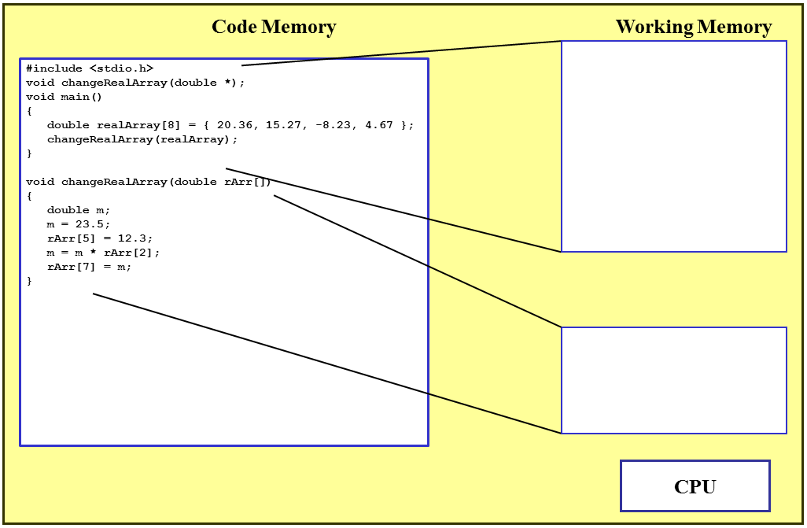

realArray
[0] 20.36
[1] 15.27
[2] -8.23
[3] 4.67
[4] 0.0
[5] 0.0 12.3
[6] 0.0
[7] 0.0 -193.405

rArr
m ? 23.5 -193.405

- (5 marks) The programming model on the following page contains in its code memory the indicated C program composed of 2 functions. It demonstrates how a function can be called to fill in a structure variable. You will be showing how the working memory is used during the execution of the two functions. Each piece of working memory is associated to a function using a pair of lines. (Note: the first pair of lines associates the piece of working memory allocated to the function main and the second pair of lines associates the piece allocated to the function getInput). Show how the given C program affects the contents of the working memory:
  - Show how the variables occupy space in the working memory for each function.
  - Show the values are assigned the variables and elements in the array by the assignment instructions. Be sure to show all values that are assigned and replaced. Record successive assignments to variables/parameters as follows (the ? shows an unknown value).
varName
?, 2, 6, 4, 10

- For the pointer variable, use adr1, adr2, adr3, etc. for address values assigned to the pointer variable and draw a dashed line showing to which location in memory the address is referring.
ptrName
?, adr1, adr2

- Using arrows show how values are copied between the working memory allocated to the function main and the working memory allocated to the function getInput. It is not necessary to show how address values are copied to the parameters that are pointers (the dashed arrows will suffice).
- Show the text displayed on the console. Note that both input and output are shown on the console. Assume that the user enters the following values: color of circle is “Red”, color of border is “Brown”, thickness of the border is 0.5 mm, and radius of circle is 3.2 cm.
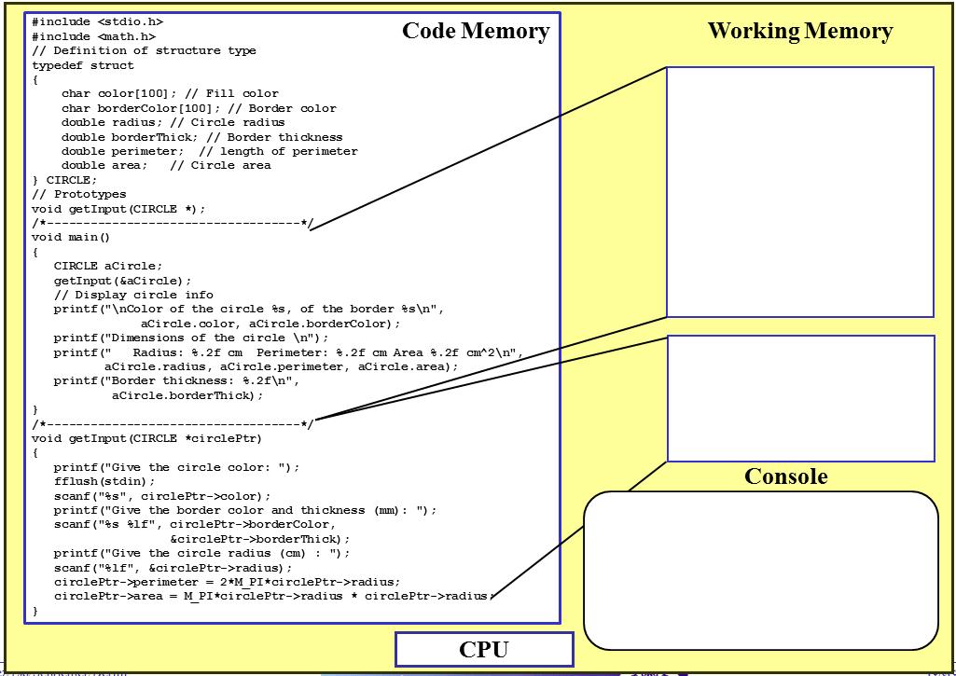
Give circle color: Red
Give border color and thickness (mm): Brown 0.5
Give circle radius (cm): 3.2

Color of circle Red, the border Brown
Dimensions of circle
Radius: 3.20 cm Perimeter: 20.11 cm Area 32.17 cm^2
Border thickness: 0.50

circlePtr ? adr1 adr2 adr3 adr4
adr5 adr6

aCircle
color ? Red
borderColor ? Brown
radius ? 3.2
borderThick ? 0.5
perimeter ? 20.11
area ? 32.17

Question 2 (15 marks)
The upward velocity of a rocket can be computed by the following formula:
where v = upward velocity,
u = the velocity at which fuel is expelled relative to the rocket,
m₀ = the initial mass of the rocket at time t = 0,
q = the fuel consumption rate,
g = the downward acceleration of gravity (assumed constant = 9.81 m/s²), and
t is time in seconds (s).

Develop a program that presents the characteristics of four different rockets and requests to user to select one of the rockets to compute the velocity of the rocket for a given time. The program then displays results.

The characteristics of the four rockets are
Name | u (m/s) | m₀ (kg) | q (kg/s)
Rocket 1 | 2000.0 | 150000.0 | 2700.0
Rocket 2 | 1596.0 | 300000.0 | 5367.0
Rocket 3 | 3267.0 | 543135.0 | 8900.0
Rocket 4 | 984.0 | 5468.0 | 89.5

Respect the following guidelines in creating your program.
- Use a C structure:
  - Define a structure type ROCKET which contains a member for each rocket characteristic, that is a member name for the rocket name, a member u (initial velocity, a member m0 (initial rocket mass), and a member q (rate of fuel consumption).
  - In the function main, create an array of structure variables (of type ROCKET). The array should contain 4 elements. You can initialise the array in its declaration as follows:
ROCKET rockets[4] =
{
{"Rocket 1", 2000.0, 150000.0, 2700.0},
{"Rocket 2", 1596.0, 300000.0, 5367.0},
{"Rocket 3", 3267.0, 543135.0, 8900.0},
{"Rocket 4", 984.0, 5468.0, 89.5}
};
  - DO NOT include the speed v or the time t in your structure.
- Define a symbolic constant G as 9.81 (gravity acceleration).
- The function main shall call the function selectRocket to display the contents of the array and ask the user to make a selection (i.e. using a number from 1 to 4). The address to the array is passed to the function. The function returns the index of the element in the array selected by the user.
- The main function then requests from the user a value for the time t which is passed to the function computeSpeed as well as the array element selected by the user (i.e., the structure variable which contains the characteristics of the selected rocket) to compute the speed of the rocket at the given time t. The value of this speed is returned by the function computeSpeed.
- In main display the results of the computed speed.
- The interaction of the program with the user should resemble the following (the characters in green are type in by the user):
Rocket 1: u = 2000.00 m0 = 150000.00 q = 2700.00
Rocket 2: u = 1596.00 m0 = 300000.00 q = 5367.00
Rocket 3: u = 3267.00 m0 = 543135.00 q = 8900.00
Rocket 4: u = 984.00 m0 = 5468.00 q = 89.50
Please select a rocket (1 to 4): 1
Give the time t (s): 11.3
Selected rocket:
Name: Rocket 1
Speed of fuel u: 2000.00 m/s
Initial mass m0: 150000.00 kg
Rate of fuel consumption: 2700.00 kg/s
After 11.30 seconds, the speed v of the rocket is 343.952 m/s
- The following table provides test cases to be used for testing your software.
Rocket | Time (t) | Speed v (m/s)
1 | 11.30 | 343.9522
2 | 31.20 | 997.5815
2 | 45.60 | 2252.5314
3 | 15.20 | 786.7077
4 | 0.12 | 0.757429

To answer this question, provide:
- The source code to your program in a C file (also insert the source code into your assignment file).
/*------------------------------------------------------------------
File:
Author:
Description: This program calculates
---------------------------------------------------------------------*/
#include <stdio.h>
#include <math.h>
#define G 9.81

//Structure Prototype
typedef struct
{
char name[8]; //rocket name
double u; //initial velocity (m/s)
double m0; //initial rocket mass (kg)
double q; //rate of fuel consumption (kg/s)
} ROCKET;
// function prototypes
int selectRocket(ROCKET *);
double computeSpeed(ROCKET, double time);
/*---------------------------------------------------------------------
Function: main
Description: Requests from the user the
------------------------------------------------------------------------*/
void main()
{
// Variable declarations
int index;
double speed;
double time;
ROCKET rockets[4] =
{
{"Rocket 1", 2000.0, 150000.0, 2700.0},
{"Rocket 2", 1596.0, 300000.0, 5367.0},
{"Rocket 3", 3267.0, 543135.0, 8900.0},
{"Rocket 4", 984.0, 5468.0, 89.5}
};

// Instructions
printf("Rocket 1: u = 2000.00 m0 = 150000.00 q = 2700.00\n");
printf("Rocket 2: u = 1596.00 m0 = 300000.00 q = 5367.00\n");
printf("Rocket 3: u = 3267.00 m0 = 543135.00 q = 8900.00\n");
printf("Rocket 4: u = 984.00 m0 = 5468.00 q = 89.50\n");

index=selectRocket(&rockets);

printf("Give the time t (s): ");
scanf("%lf",&time);

speed=computeSpeed(rockets[index],time);

printf("Selected rocket:\n Name: %s\n Speed of fuel u: %.2lf m/s\n Initial mass m0: %.2lf kg\n Rate of fuel consumption: %.2lf kg/s\n",
rockets[index].name, rockets[index].u, rockets[index].m0, rockets[index].q);
printf("After %.2lf seconds, the speed v of the rocket is %.3lf m/s\n", time, speed);

}
/*-----------------------------------------------------------------------
Function:
Parameters:

Return: The value returned
Description: This function first
------------------------------------------------------------------------*/
int selectRocket(ROCKET *rkt)
{
// Variable declarations
int ind;

// Instructions
printf("Please select a rocket (1 to 4): ");
scanf("%d",&ind);
ind = ind - 1;
return(ind);
}
/*-----------------------------------------------------------------------
Function:
Parameters:

Return: The value returned
Description: This function first
------------------------------------------------------------------------*/
double computeSpeed(ROCKET rockets, double t)
{
// Variable declarations
double s;
// Instructions
s = rockets.m0/(rockets.m0 - rockets.q*t);
s = rockets.u*(log(s));
s = s - G*t;

return s;
}
- Insert the output for each test case in the above table in your assignment file.


