MANA 366
Ch 3 History of the Canadian Union Movement

History of the Canadian labour movement
Canadian characteristics that have shaped labour history:
- Physical Geography
- Cultural mix
- Economic system
- Political structure

Physical geography (Influence how union developed?)
1) Size organization: Spacey/ Hard to organize
- Canada is a large country, and it has expected greatly since beginnings in the 1867 merger of modern –day Ontario and Quebec with Nova Scotia and New Brunswick. It currently encompasses 10 provinces and 3 territories within a total area of almost 10 million sq km.
- The extreme conditions in the northern part of the country make much of the land within Canada unsuitable for agricultural and other primarily resource-based activities; as a consequence, the majority of Canadians live in the southern part of the country, close to the US border.

- Resource and seasonal industries (Hard to form union for 4 months of work)
These circumstances have made successful union organizing difficult because of the isolation and lack of permanent employment in these industries.

- Proximity to the US- At various times in Canadian history, that American workers have completed with Canadian workers in the Canadian labour market, and that American unions have exerted influence on Canadian workers.

2) Cultural mix
Influence of various cultures
Difficulty in accepting racial diversity

- Immigrants from Europe, Asia, Central America, South America and other regions around world have also been attracted to Canada. These immigrants have settled throughout the country and brought the influence of their own cultures to their new home, Canada’s proximity to the US has also allowed the pervasive influence of American culture.

- The mix of multiple cultural influences has had both positive and negative effects on Canadian union history. Immigrants with experience with union or union-like organizations in their country of origin assisted in the development of some early Canadian unions. However, Canadian unions have not always been successful in addressing the challenges of organizing or representing a culturally diverse workforce; in fact, some Canadian unions have a sad history of racial or cultural discrimination… Canadian unions and workers have been affected by American unions and workers’ easy access to this country.

3) Economic system
- Move from primary industries (Agriculture, forestry, fishing and mining) secondary industries (manufacturing, construction and steel production, which process or use the products of resource-based industries). Agriculture has also been an important industry in those parts of Canada where the land is suitable for farming.

- International trade-Tertiary industries (service industries) increased in the Canadian economy. Another important sector of the Canadian economy is international trade, particularly with the US. This reliance with other countries means that Canada’s economy is more susceptible to the influence of external events than the economy of a country less dependent on external trade relationships would be.

- International trade has also challenged Canadian unions by providing employers with the opportunity to move jobs outside the country and by pressure to establish work conditions that are internationally competitive.

4) Political structure
Confederation system (different labour law between provinces)
US influence

- The importance of this division between federal and provincial jurisdictions will become more apparent as we discuss how Canadian labour legislation has developed. While there are both federal and provincial labour codes, labour relations is primarily a provincial responsibility.

- In contrast, labour relations in the US is primarily a federal responsibility. The basis for this structure in the US was the desire to provide a single law that would create identical frameworks for union-employer relationships across country and ensure the same basic rights for all workers.

- The Canadian structure of different jurisdictions in each province, while causing difficulties for employers and unions that operate in more than 1 province has allowed for experimentation and reform to meet the particular needs of each jurisdiction.

Early Canadian Unionism: the 1800s
Informal worker’s groups formed as early as 1827.
The period of “local unionism”

Followed the craft union model because of:
Craft union model (specialize in their professions: base on craft like shoemakers) the earliest attempt to organize union in Canada were limited to specific geographic areas and small groups of workers, usually those in particular trade or occupation.

1) Geographic size of Canada: the difficulties of transportation and communication over long distances made organizing a local union much more practical than attempting to organize a regional or national union. Different unions representing the same types of workers emerged at roughly the same time in different parts of Canada. The focus on organizing workers in a specific geographic area also meant that issues specific to that group could be the main focus of the union’s activity; the union did not have to attempt to balance the varied concerns that would have emerged in a union encompassing workers in different regions.

2) Ease and interest to protect wages for skilled workers to control their markets (Create their own monopolies: eg., plumber cost $100 just to come in)
This factor was particularly important in areas where tradepeople’s expertise could not easily be replaced by the work of unskilled immigrant labourers. Forming a union was a means for tradespeople to control the market for their skills and thus to control wage rates.

3) Canada’s role as exporter increased the demand for skilled workers.
Canada’s economic role as an exporter, rather than importer, of goods has been identified as another factor in the predominance of the craft union model of organizing . Many of skilled craftpeople involved in Canada’s first nations were employed in trades such as shipbuilding and carpentry, which “ benefited from the economic strategy of export-led growth.

Craft unionism deterred widespread unionism
Did not encourage non-skilled workers or non-trade organizations.

Industrial unionism also emerged with a focus on:
A “strength in numbers”
Mass recruiting to maximizing power
-Limited by craft unions

Industrial unionism: While craft unions could control the regional labour market for the particular skills of their members, as well as ensuring consistent quality of work by controlling training, their membership was restricted to practitioners of the craft. This model of organizing did not encourage unionization of less-skilled workers or workers in non-trade occupations.

This form of unionism focuses on “strength in numbers” and maximizing power by recruiting as many union members as possible, regardless occupations, rather than concentrating solely on membership within a particular occupational group.

In contrast, several early Canadian craft unions, such as the early miners’ union in B.C were deliberately established along craft lines to exclude workers who were seen as threats to their members’ living standards (e.g., immigrant Chinese labourers who were perceived to be undercutting miners’ wage rates).

Expansion came about through international unions (the continental movement)
International influences were informally present in many of the early Canadian unions. Immigrant workers from Britain brought their experience in the British trade union movement to Canadian workplaces, and there is evidence that the first international unions in Canada were British unions of engineers and carpenters that established affiliated locals in southern Ontario in the mid-1800s.

Continental movement of American-based international unions entering central Canada. These unions either formally affiliated with existing Canadian unions or recruited members into new Canadian locals of the American unions. However, the continental movement was restricted primarily to Ontario and other regions with trade links to the US.

- A philosophical change towards common goals
- Nine-hour movement (1872)- the standard working day in most trades at this time was 10 to 12 hours long, and in Britain and US, a movement was underway to pass legislation restricting the working day to 9 hours. It was argued that a shorter working day would produce better-quality work, because workers would not be exhausted, and that society as a whole would benefit by freeing up time that workers could spend with their families and communities.

- Criminal law forbid union organization as monopolies until 1872 in Canada
- These laws were originally designed to stop merchants or traders from colluding with each other for the purpose of controlling or dominating a product market. British legislators expanded the application of the laws, defining unions as a method of monopolizing the labour market.
- Under the monopoly laws, unions could be considered a means to restrain trade, and “ criminal conspiracy” charges could be laid against union organizers.

- 1881 Knights of labour first international industrial union
- which had successfully organized railway workers in the US. The Knights’ entry into Canadian union movement began with the organization of a small group of workers in Hamilton. The knights of labour had a significant impact on the Canadian labour movement because they organized workers in occupations that most existing Canadian unions considered too challenging to organize, such as railway work, mining and forestry. They even succeeded in organizing workers in “company towns”, where simple matters such as getting access to the town itself were challenging the employer who controlled the town would usually forbid even preliminary visit from a union organizer.

- Trade and labour congress (TLC) was formed in 1883
TLC was effective in lobbying for reforms to labour legislation that would benefit all workers.
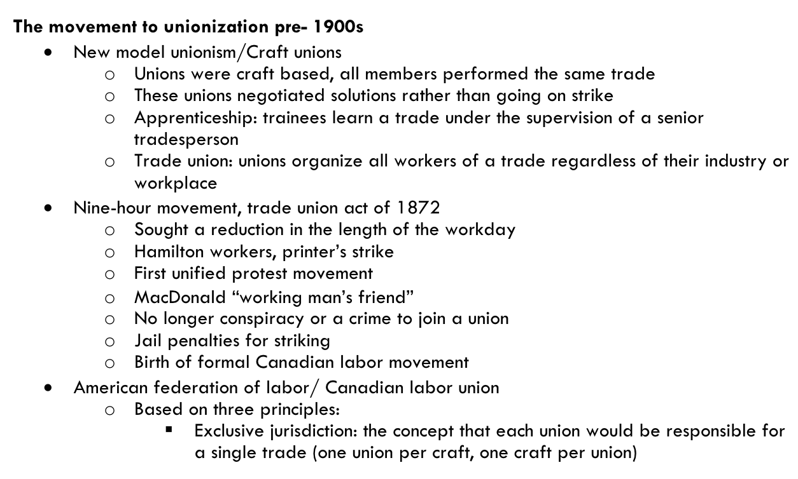
The industrial ages: the early 1800s
Industrial disputes investigation act (1907)-this legislation required that industrial disputes under federal jurisdiction be submitted to a neutral 3rd party, who then would either make recommendations or by prior agreement of the parties, impose a binding decision to end the dispute.

4 major forces saw the growth of unions in this period, which encouraged the passage of the Industrial Disputes Investigation Act in 1907:

The first world war era
2 Historical events made unionization more attractive to Canadian workers:
The 1st factor was the increased production needed to supply the war effort. Dissatisfaction grew in workplaces as workers were pressured to improve their rate of production but did not receive any corresponding improvement in wages.

The 2nd factor was the continuing mechanization of production. This further reduced the labour market value of skilled craftpeople, as tasks formerly performed by craft workers were taken by machines.

Finally, the federal government expanded the jurisdiction of the industrial Disputes Investigation Act to include munitions industries. The expanded jurisdiction limited the ability of workers in those industries to strike in support of their demands.

1st event: the death of Albert “Ginger Goodwin”- a labour organizer in B.C. Goodwin worked in the province’s coal mines, mills and smelters and organized unions in several of those industries…when the first-world war began, Goodwin actively opposed conscription. He hid in the woods of Vancouver Island to avoid being forced into military service, and when his hiding place was discovered, he was shot and killed…as a consequence, many union supporters believed that the officer was under special military orders to shoot Goodwin because of his union organizing activity…Goodwin’s death caused a one-day general strike of protest in Vancouver, and he is still considered a martyr by many in the union movement.

2nd event: Winnipeg General strike
- was the 1st extended, large scale general strike involving many different unions
- 30000-35000 unionized and non-unionized
- committee of 1000 tried to force strikers back to work

The strike, which began in May 15,1919, is particularly significant in Canadian labour history because it was the 1st extended , large-scale general strike involving workers from different occupations and unions. Previous large strikes either had been short strikes or had involved workers from a single union, occupation, or employer…this general frustration boiled over in Winnipeg, where some workers, primarily in the metal and building trades, were being denied right to collective bargaining because employers were refusing to respond to contract demands.

Parliament passed:
Amendment to the immigrant act
Broadened the criminal code allowing police to arrest on basis of simple suspicion
Placed the burden of proof of innocence on the accused rather than the state
Strike ended June 25 (with an agreement establishing limited collective bargaining rights for the metal and building trade workers. However, the divisions and resentments caused by the strike did not quickly dissipate, even after the strikers returned to work).

The first World War Era (Cont’d)
- The Quebec experience
- Confederation des travailleurs catholiques du Canada(CTCC)
- The confederation des syndicats nationauz (CSN)

Many unions in Quebec founded with the encouragement of Catholic leaders, who saw involvement in unionization as 1 way to re-establish the Church’s influence over the “laboring poor.” Unionization by Quebec-based and controlled unions was also perceived as a way to resist the influence of international unions, which might not sensitive to issues of QC independence and autonomy. (called Catholic unions)

This federation became extensively involved in organizing workers in Quebec, and , although its formal links with the Catholic Church gradually dissipated, it was increasingly militant in defending workers against the “practiced ethnocentrism” of American owned forms.

After the war
Canadian union faced many difficulties after the First World War, including:
- Widespread unemployment and wage cuts.
- Promoting unionization was difficult when most workers were grateful just to have a job and did not want to threaten that status by antagonizing their employers.
- There was also disunity in the Canadian labour movement, with fighting between Canadian and international unions, craft and industrial unions, and unions with different regional concerns.
- A poor agricultural market, the crash of American stock market in1929, and the subsequent Depression made life difficult for most Canadian workers and even more difficult for those who were unable to find or keep work that paid enough to live on.

The Wagner Act (1935)
It guaranteed 3 basic rights to American workers:
- The right to organize
- The right to collective bargaining
- The right to strike without employer harassment
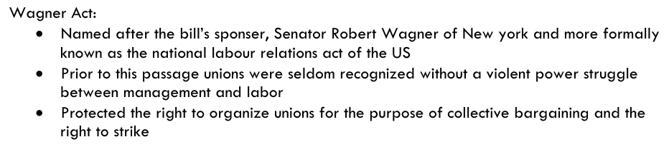
Under the Wagner Act, employers could not refuse to acknowledge a union as the workers’ representative if a vote indicated the union had majority support among the workers. Once a union was recognized, the employer was compelled to bargain with the union and could not refuse to meet with it or simply ignore its demands.

The second world war
Solidification of unions in Canada
Establishment of 2 national labour federations:
- Canadian Congress Labour (CCL)-which maintained its affiliation with the American industrial union-based CIO.
- Trades and Labour Congress (TLC)-was historically affiliated with American craft union-based American Federation of Labour (AFL).

The government was also encouraged to be more supportive of workers by some significant provincial and federal electoral wins CCF; these wins clearly indicated that workers were prepared to vote for political parties friendly to labour, and might vote against governments that did not support workers’ interests.

The second world war (Cont’d)
- Professional organization and striking
- Co-operative commonwealth federation (CCF) gains acceptance
- P.C. 1003 Adopted: a wartime order-in-council (similar in effect to a law passed by parliament in peacetime) modeled on the American Wagner Act. The provision of P.C. 1003 included compulsory collective bargaining and the right of “employee representatives” to be certified as bargaining agents by a labour relations board, if the representatives could prove that they had sufficient support among employees in a workplace.
- Led to further union organizing because of the legislative recognition of employee and union rights, and Quebec and B.C passed similar acts at the provincial level.

The Ford Windsor strike 1945
At the Ford Motor Company plant in Windsor went on strike over the issue of job security, motivated by concerns about post-war downsizing and demanded a “closed shop”, where union if they wanted to work in the plant. The dispute over the issue of the closed shop went to arbitration, and justice Ivan Rand was chosen to make a decision was that union dues would be automatically deducted from every workers’ paycheque. In exchange, the union would allow individuals to formally opt out of union membership if they so desired. The automatic deduction of union dues was awarded in recognition of the union’s activities in representing the interests of all workers to management.

The 1950s and 1960s
Period of growth and development for unions and was remarkably free from labour conflict.
But three main factors strengthen Canadian unions:
Three concerns existed:
- 1 issue of concern to many people in the labour movement during the period was the increasing bureaucratization and centralization of the predominantly international unions. Most large unions had a centralized office and paid staff, usually located in Ottawa or in a provincial capital to facilitate interactions with government.

- Particularly in unions that had membership across the country, that this structure did not work well in a country with significant regional differences. The centralization of major operations and paid staff in a single location was thought to make union executive officers and staff members less sensitive to issues in other locations.

- Those at the top of the centralized union structures were more focused on formalizing and strengthening their own power than on addressing the needs of the membership.

The 1970s and 1980s
Challenges:
Developments:

In the 21st century
The future can be views negatively or positively for unions
Negative perspective
- The negative perspective would include the power of internationalization, perhaps greater now than at any time in Canada’s past, and the pressures it may exert in Canada’s industrial relations system.

- The negative perspective might also view the slow decline in unionization rates and the weakening representation of unions’ interest in the political arena as forces that will further erode the power of unions in Canada.

Positive perspective
- Compare the Canadian industrial relations experience to the American industrial relations experience and note that Canada’s unionization rates have remained steady while American rates have declined sharply and show little signs of recovering to previous levels.

- How the actors in the Canadian industrial relations system have continually been successful in sharping the system to adapt to whatever challenges have developed.

- The positive perspective would suggest that the Canadian function for well over a century and that there is no reason to expect that is adaptability will not continue.

