Name: Aisha Ali
Lab 2
Student Number: 040908978
Course: CST8101 Computer Essentials
Due: Friday September 22, 2017

Question 1 Make and Model of Laptop
Make: Acer
Model: Aspire E5-575G-55NW
Question 2 Operating Systems and Edition Type:
Operating system: Windows 10 Home
Version: 1703
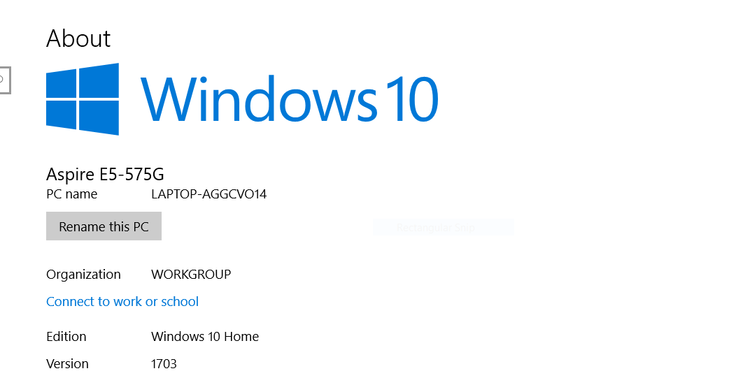
Figure 1: Operating System and Edition Type

Question 3 Processor Type
Processor type: i5-7200U CPU @ 2.50 GHz , max speed: 2.70 GHz
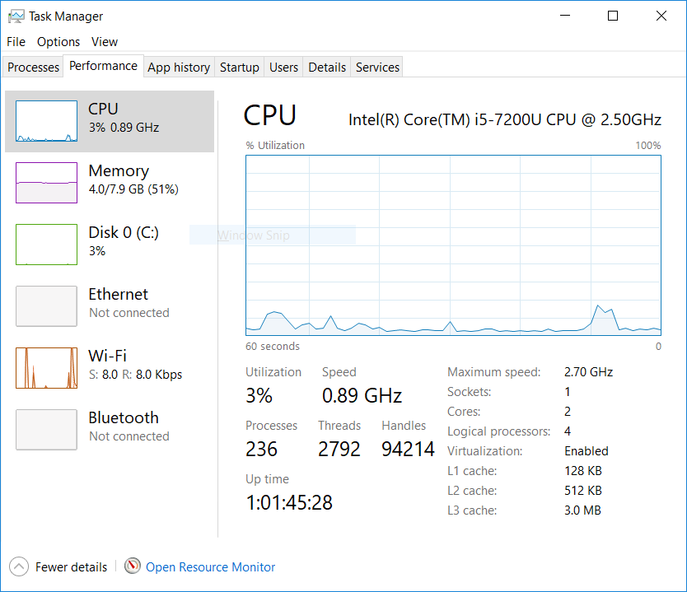
Figure 2: Task Manager, Performance
Question 4 Number of processor cores
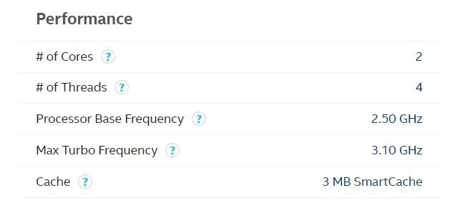
Figure 3 Performance
$$\begin{aligned}logical cores=no. of threads ×physical cores\end{aligned} \\ logical cores=2 ×4=8$$

Question 5 Virtualization Enabled

Refer to Figure 2 Task Manager, it shows that virtualization is enabled and Figure 4 below.
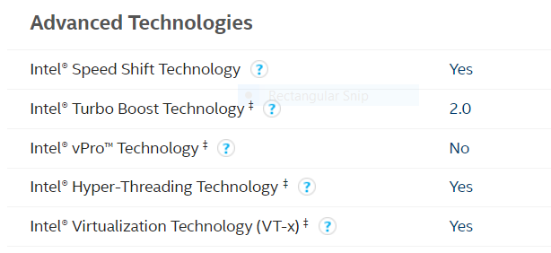
Figure 4: intel specifications
Question 6 Installed memory (RAM)
Installed RAM: 8GB
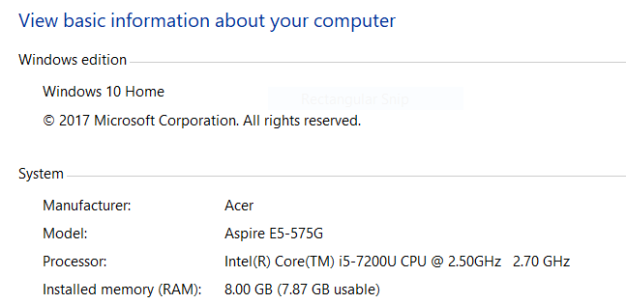
Figure 5 : RAM

Question 7 Storage Capacity
Capacity: 237GB
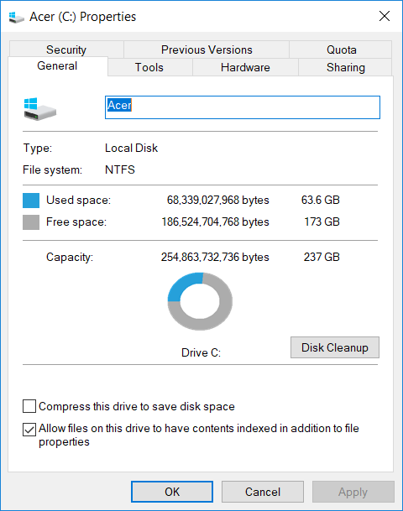
Figure 6: Storage Capacity

Question 8 Storage Types
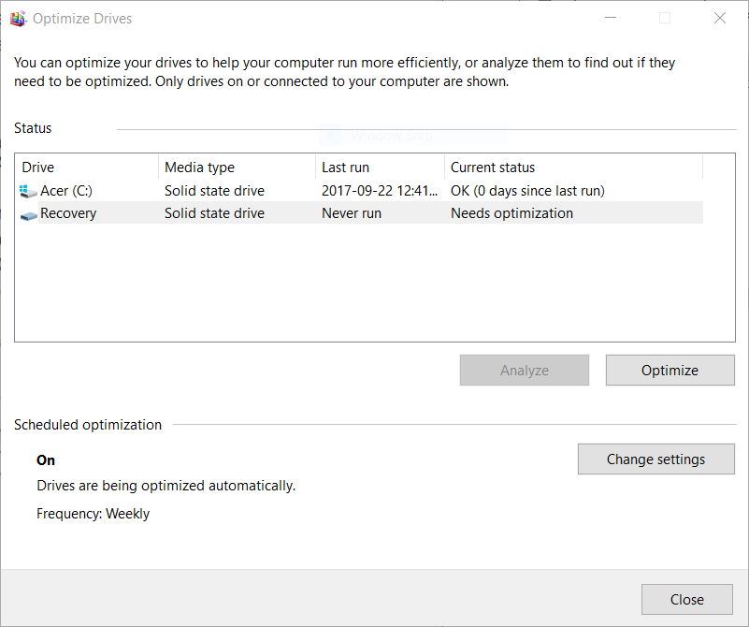
Figure 7 : Media Type

Question 9 Optical Drive
Yes
DVD, multi recorder
Question 10 Optical Drive Type

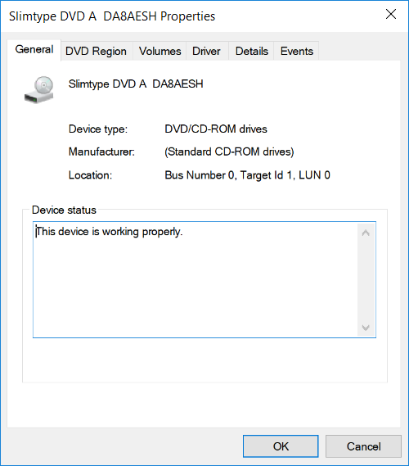
Figure 8: Optical Drive
Question 11 USB Port
3 USB Ports
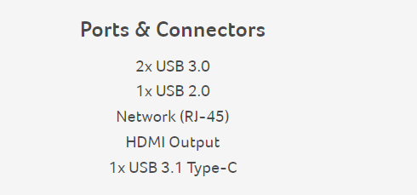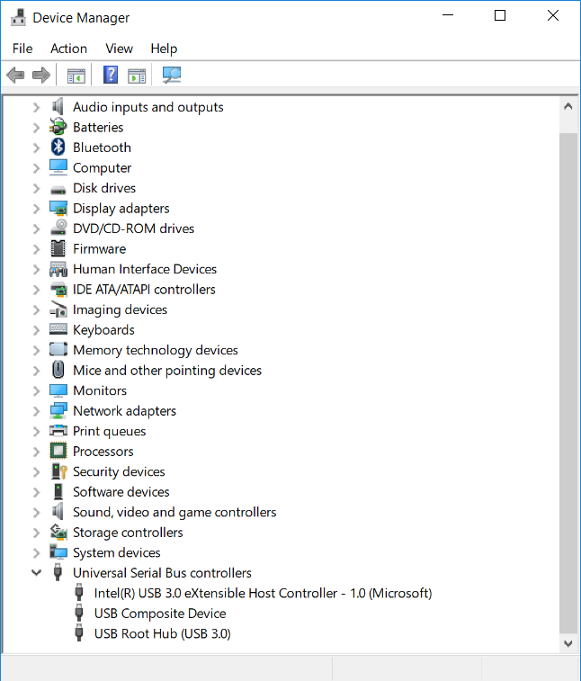
Figure 9 : USB ports

Question 12 VGA Port
Yes
Question 13 HDMI Port
Yes
Question 14 Web Camera
Yes
Question 15 Ethernet Port
Yes
Question 16 Separate Graphics Card

Figure 10: Graphics
Question 17 Screen size
15.6’’
Question 19
I like the fast boot and I think it’s pretty fast and I just recently bought my laptop so I don’t have anything I dislike about it yet.

