GENERAL PROPERTIES

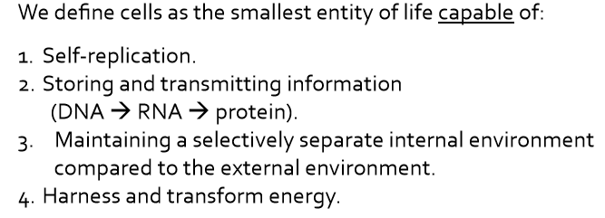
The cell is the simplest entity that can exist as an independent unit of life.

CELL THEORY:
- all organisms are made up of cells
- the cell is the fundamental unit of life
- cells come from pre-existing cells
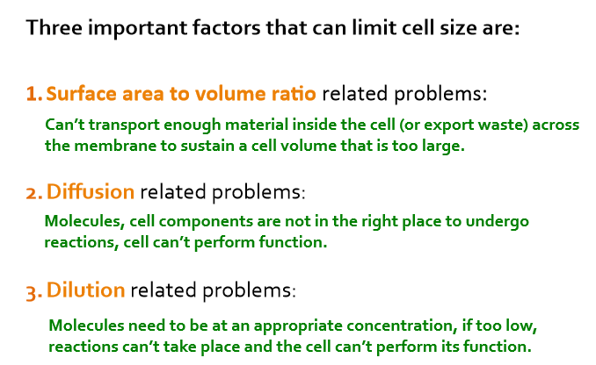
- Inward folding or outward protrusion of the membrane to increase SA.
- Cytoplasmic streaming in plant cells, vesicle/organelle trafficking in animal cells (microtubule highway system)
- Compartmentalization of cellular functions in eukaryotic cells.
ENDOSYMBIOTIC THEORY: eukaryotes are thought to have evolved from one primitive cell engulfing another primitive bacterial cell
MACROMOLECULES
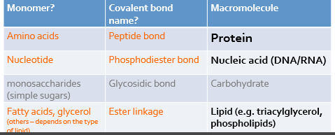
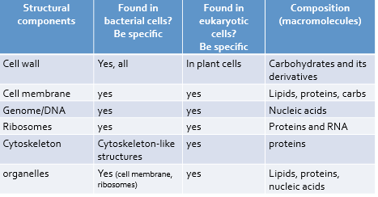
Proteins: provide structural support and act as catalysts that facilitate chemical rxns (monomers join from C terminus)
Nucleic Acids: encode and transmit genetic info (monomers join from 3’ side)
Carbohydrates: provide a source of energy and make up the cell wall (monomers join to the carbon on the right)
Lipids: make up cell membrane, store energy, act as signaling molecules
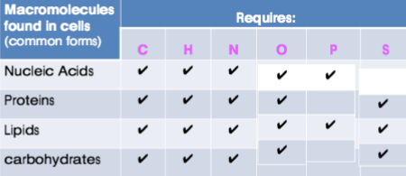
macromoleculer assembly= non covalent bonds
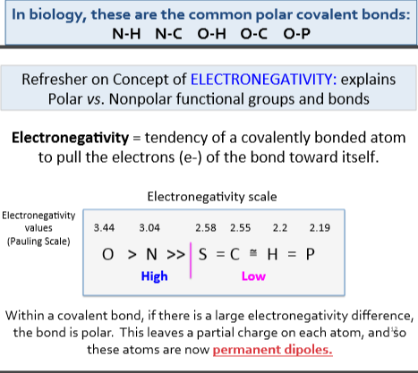
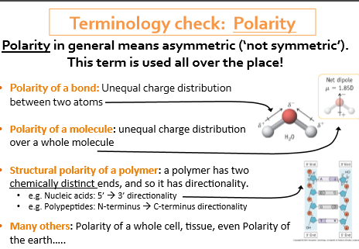
CHEMISTRY

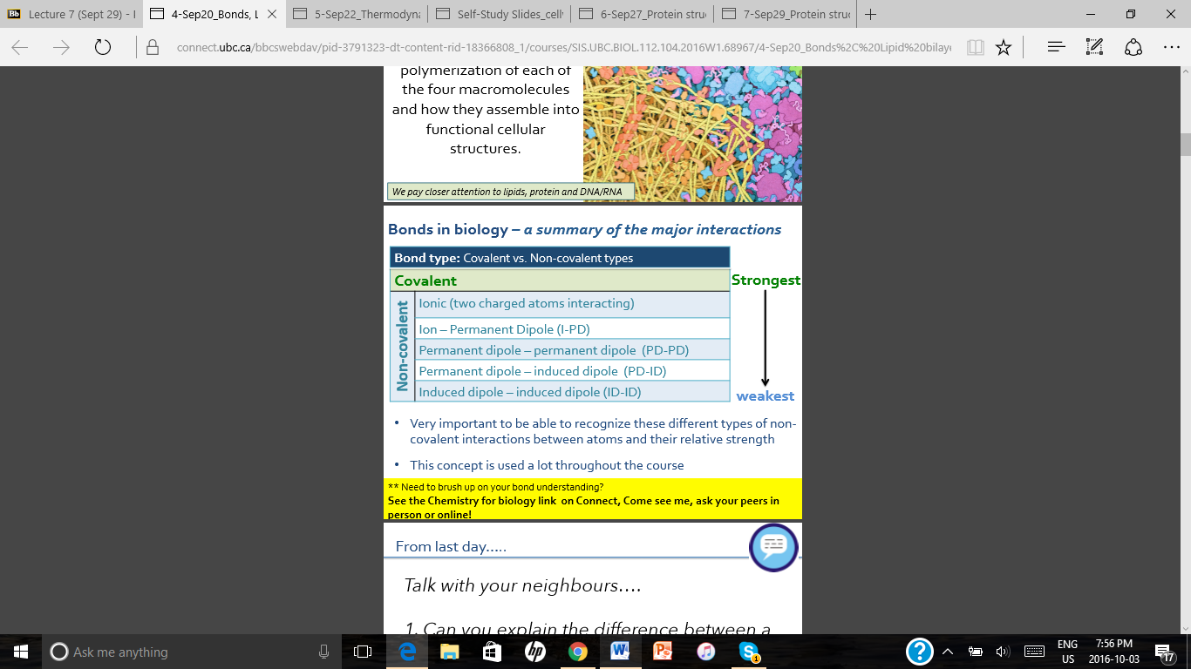
Permanent dipole: large electronegativity difference between atoms = polar= partial charge on atom

PHOSPHOLIPIDS

- Amphipathic: molecule with both hydrophobic and hydrophilic regions in one molecule
- Fluid Mosaic Model: states that the lipid bilayer is a fluid structure within which molecules move laterally, and is a mosaic of lipids and proteins
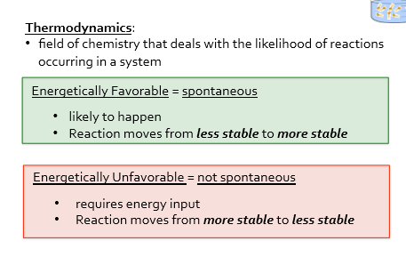
Polar head with water: ionic-PD, PD-PD
Fatty acid tails with water: ID-PD
Polar heads with polar heads: repel
Polar head with fatty acid tail: ionic-PD, PD-ID
Fatty acid with fatty acid: ID-ID

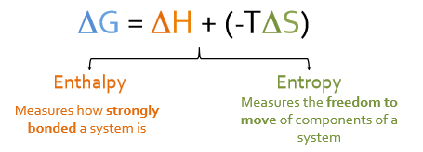
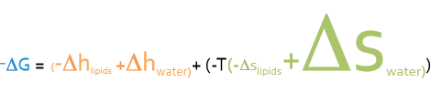
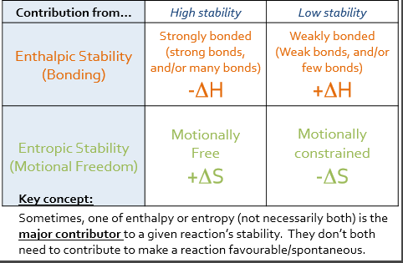
THERMODYNAMICS
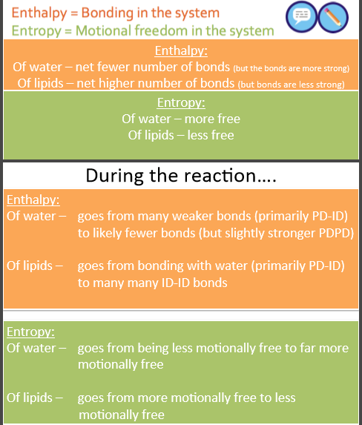
- major reason why lipid bilayer forms is because of increased motional freedom of water – LARGE negative delta G
- HYDROPHOBIC EFFECT: burying non polar groups away from water increases system stability by increasing delta S of water (maximizes entropy- motional freedom of water)
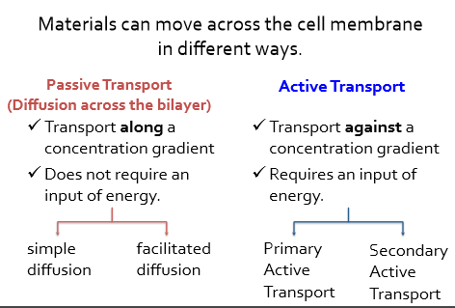
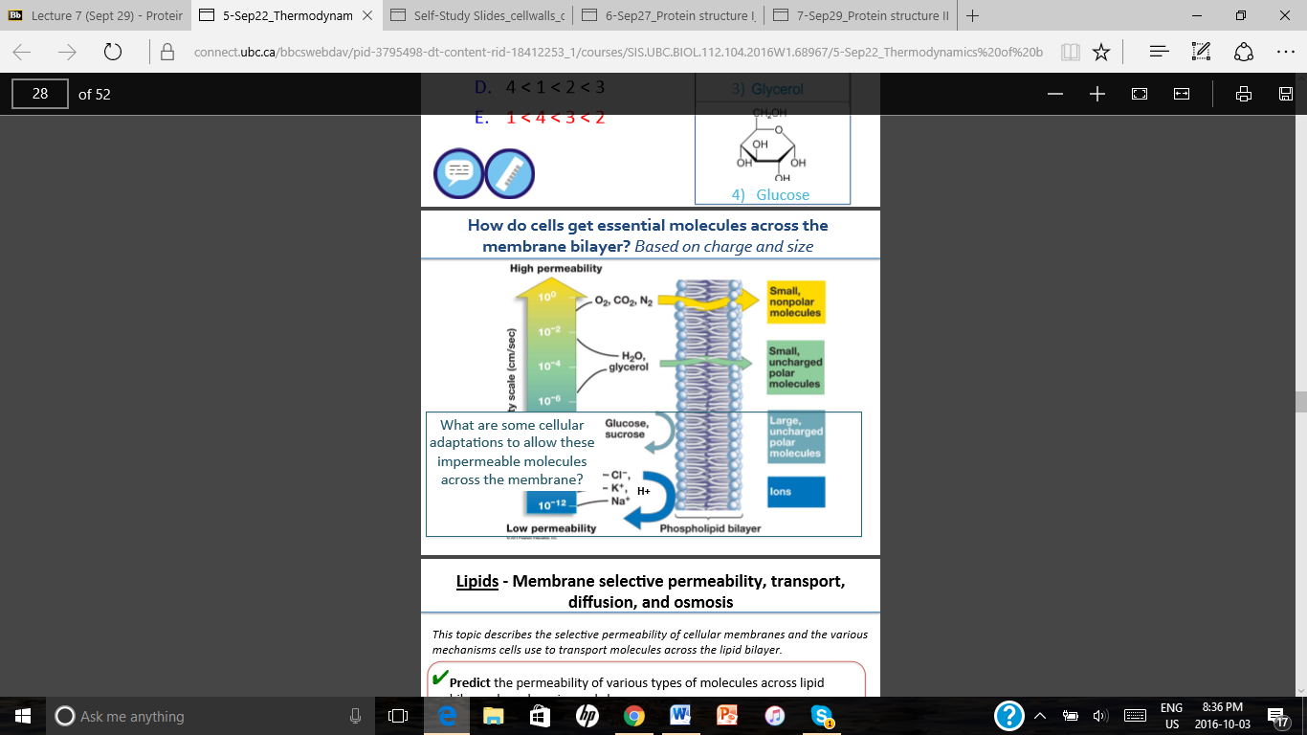
- Macromolecular assembly of proteins, DNA, and other structures are all spontaneous processes, are driven by the hydrophobic effect, and increase motional freedom of water
MEMBRANE TRANSPORT
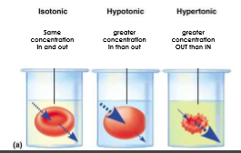
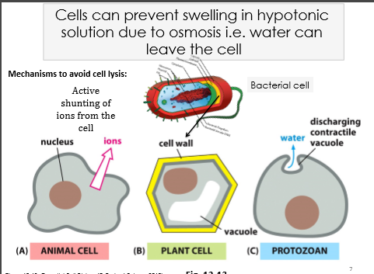
- Diffusion: random movement of molecules (continues even after reaching equilibrium)
- Facilitated diffusion: requires membrane transporter
- Osmosis: net movement of solvent across a selectively permeable membrane (can move by passive diffusion or facilitated diffusion using protein channels)
- A cell wall can help prevent osmotic lysis (resists cell expansion)
- Primary active transport: uses energy in the form of ATP to directly move molecules
- Secondary active transport: 1) active transport to pump an ion (usually proton) which generates an electrochemical gradient 2)a second channel uses the energy from the electrochemical gradient to actively move a second molecule
- Electrochemical gradient: gradient that has both charge and chemical components
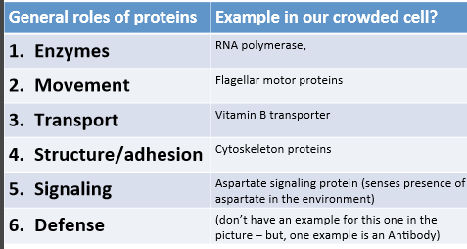
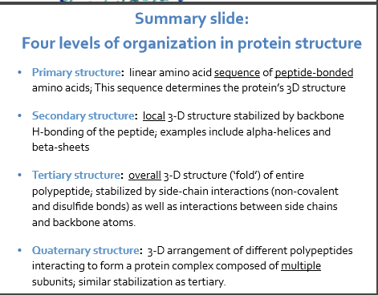
PROTEINS
Proteins fold spontaneously based on the hydrophobic effect
PROTEIN SEQUENCE DETERMINES STRUCTURE

PROTEIN STRUCTURE DETERMINES FUNCTION

- Most transmembrane domains are alpha helices, some are beta barrels
- Hydrophilic, polar backbone of the polypeptide chain faces the interior of the helix
- Hydrophobic side chains face the fatty acid tails
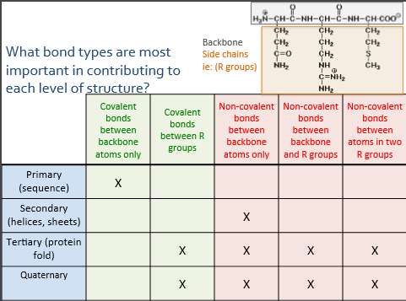
- To make a pore, need multiple helices or a beta barrel (no room in single alpha helix for anything to transport through)

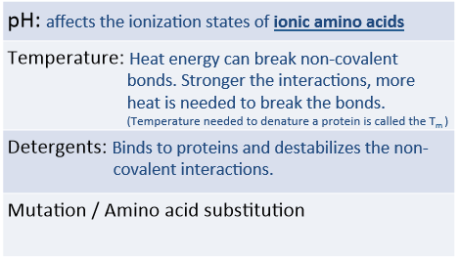
Denaturing

