OB notes

September 7th

What are the 3 factors on the individual and on group behavior in organizations
-Individual (personality, values, morals, expectations)
This influences how we act/perform at work
-Relational (Connections/interactions with boss/employees/customers)
-Organizational (Culture of organization, hierarchy/egalitarian)

Levels of Analysis
Circles that go from
Individual
Groups
Organization

What are organization?
Social constructs for grouping individuals together in pursuit of a common goal.

We achieve these social constructs through the efforts of the group.

Goals/ definition of OB
-Understand (behavior)
-Explain (why people do things at work)
-Improve (attitudes/behavior in the work space)

Research Methods for OB

Theory-> Hypotheses-> Data-> Verification-> Theory….. repeat

September 11th
Job Performance

The Comcast case:
Definition- Retention of customers
Measured- customer retained
Rewarded- Small hourly wage + (payout- penalty)

TWO ELEMENTS OF JOB PERFORMANCE
Results is the “Objective measures of outcomes”
Pros:
-Easy to assess
-Objective/ you can rank employees
Cons:
-Bottom line focus
-Not always controllable
-Not focusing on the why

Behavior is the “Specific behaviors employees engage in”
Task performance
The actions that make up the core aspects of your job
Aka a “Job Description”

THREE SUBTYPES:
Routine- habitual responses to predictable tasks
Adaptive- thoughtful responses to unpredictable tasks
Creative- novel and useful ideas

Citizenship behaviors
Voluntarily going above and beyond the job description in pursuit of achieving organizational goals by improving the work context

Can be Interpersonal or Organizational

SUBTYPES:
Helping/ultraistic- Showing kindness in the work place
Courtesy- mindful/respectful of others
Sportsmanship- attitude towards dealings with problems
Voice- mentioning construction solutions to problems
Civic Virtue- Understanding the organizations culture
Boosterism- representing the organization in a good light when off the job

Counter-productive behavior
Intentional behaviors that are going to harm the organization’s goals, opposite of citizen behaviors
Property Deviance: Sabotage/theft
Production Deviance: wasting resources/ Substance abuse
Political Deviance: Gossiping/Incivility
Personal Aggression: Harassment/abuse

Can be Interpersonal or Organizational

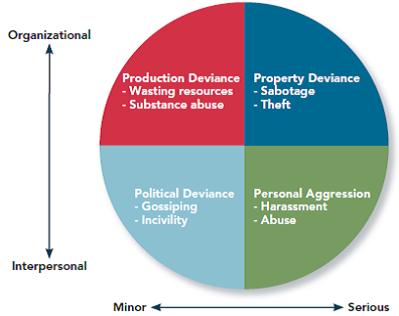

Example of questions

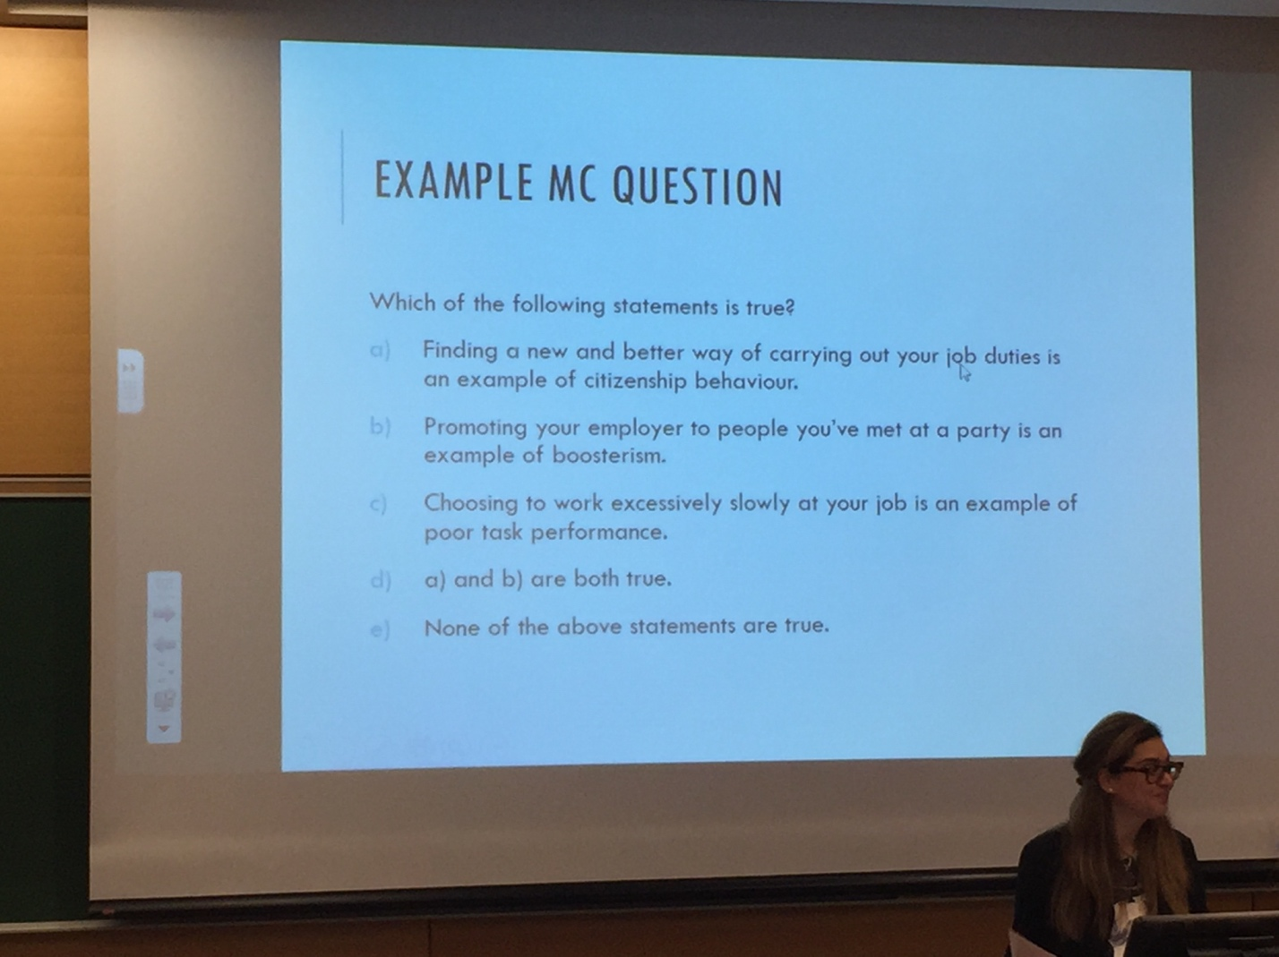

September 14th

Commitment
Why is matters?
-turnover is costly
-unengaged employees (useless people)

Definition of commitment; the desire to stay in the organization
Why remain?
-community
-compensation

3 Subtypes of commitment: (Overall organizational commitment)
Affective (Emotional Based)-Sad
-Emotional attachment to the job
-Staying because you want to stay

Negative reasons we want to leave is because of:
-Erosion- the people who have the fewer bonds are more likely to leave
-Social influence- good workers leave and lowers moral

Continuance (Resource Based)-Anxiety
- Perceptions of costs associated with staying vs leaving (not just momentary cost) Job title, family moving, lost pay
-Staying out of necessity

Negative reasons
-Lack of alternatives
-Embeddedness (either in the organization or community or both)

Normative (Obligation Based)-Guilt
The moral obligation to remain loyal

How do employees respond to negative situations?
Loyalty
Voice

Neglect (Psychological Withdraw)
Examples: Daydreaming, looking busy, Cyber loafing, Socializing, Moonlighting “having a second job”
Exit (Physical Withdraw)
Examples: Tardiness, Missing meeting, long breaks, absenteeism, QUITING

PYSCHOLOGICAL CONTRACT

Transactional
If I do this then I get this. Or mutual benefits

Relational
Based on trust and emotional give and take

September 17th 2017
JOB SATISFACTION
What are attitudes?
-Fairly stable (un)favorable evaluations
Specific objects/situation/people
-Components: ABC’s
Affective (feel): When the prof hears about a horror film she shutters
-Cognitive (think):

Cognitive + Affective = behavior

Job satisfaction definition
A pleasurable emotional state resulting from the appraisal of one’s job.

How one feels and thinks about one’s job. (Affective/Cognitive)

What determines satisfaction
-Disposition (who we are at our core)
Some individuals are predisposed to be more satisfied.
-Does the job satisfy my personal values
-Value fulfillment
(Value percept theory)

Dissatisfaction is having less than what we want. Dissatisfaction= (Vwant- Vhave)* (Vimportance)

Psychological contracts: what we feel we have been promised

Overall Job Satisfaction
(how satisfied are you with your job)

Facets of satisfaction
(pay)
(promotions)
(supervisors)
(coworkers)
(work task/work itself)

The work itself
- Job Characteristic theory
-meaningful/ fits in the system of value
-Responsibility/accountability
-Knowledge of results

What factors make these three components work
-Variety
variation of tasks performed
-Identity
Completing the job to the end
-Significance
Is the job meaningful
-Autonomy
Responsibility of work
-Feedback
Having constructive feedback from your employer
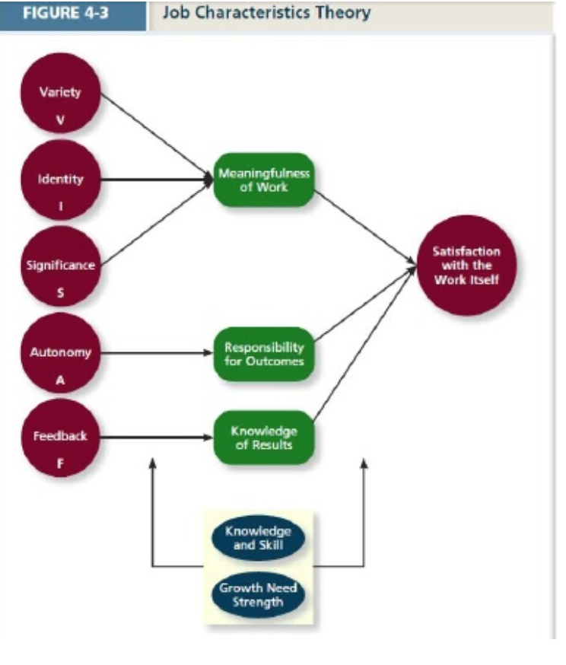
Moods and emotions
-length of time
-whether they have a target

Affective Events Theory:
Workplace events -> emotional reaction
(Positive/negative)
Emotional reactions -> Satisfaction and behaviors

Satisfaction fluctuates on a daily/hourly based on events going on around you

Measuring job satisfaction
Emotional labor
Emotional Contagion
P.157-158

September 21th 2017
Case Study

September 28th, 2017
Stress

Process
-Concepts
-Stressors
-Appraisal
-Strains

Work Hindrance Stressors
-Role overload (Work load)
-Role Conflict
-Unclear expectations
-Daily hassles

Work Challenge Stressor
-Time pressure
-Work complexity
-Work responsibility

Non-Work Hindrance Stressors
-Work Life Conflict
-Time based conflict
-Strain Based
-Behavior- Based

Non-Work Hindrance Stressors
-Negative life events
-Family (friends) time demands
-Positive life events
-personal development activities

Strain
-Stress reaction
-Stains can be:
Psychological
(Anger, Anxiety, Frustration, Depression, Affective commitment, Difficulty concentrating)
October 5th
Chapter 1 will only have 1-2 multiple choice questions on the midterm

Physical
(Dizziness, headaches, tight muscles, pounding heart, stomach distress, difficulty sleeping, shortness of breath, Illness, death)
Behavioral
(Accidents at work, Performance changes, Coping mechanism/ substance abuse, absenteeism and turnover)
Burn out
-Exhaustion:
Emotional
Mental
Physical

-Cynicism
-Low self-efficacy

Productive Stress reaction

Behavior Methods
Problem focused:
Working harder, seeking assistance, acquiring resources
Emotional focused:
Engaging in alternate activities, seeking support, venting anger
Cognitive Methods
Problem focused:
Strategizing, self motivation
Emotional focused:
Avoiding, looking to see if it is as bad as you think

Reducing and Managing stress
-Work Planning
-Decreased/compressed work weeks
-Flextime (giving wiggle room, morning people come in early)
-Flexplace/Telecommuting
-Personal days/hours (ex. Sick days)
-Job sharing (two people sharing a full-time position)
-Part-time work

-Health and Wellness program

Pages 188-190 READ about type A personality Quiz on page 205
∫What is Motivation?

-Effort:
-Intensity
-Persistence
-Direction (working smart/ productively)
-Goals
-Engagement
- “What” Motivates
-Needs:
-Remember the determinants of satisfaction
-“How” to Motivate
-Process
-expectancy
-goal setting
-equity
-psychological empowerment
-job characteristic
-Job design as a motivator

MANAGERIAL PRINCIPLES
Employees needs
-CLEAR RELASTIONSHIP between effort, performance, desirable outcomes

Expectancy Theory: Tasks
-are possible to accomplish
-lead to valued outcomes

THREE CORE COMPONENTS
-EXPECTANCY:
belief that effort ->performance
-INSTRUMENTALITY:
belief that performance->outcome
-VALENCE:
Degree to which an outcome is valued

Extrinsic: Motivate by what my performance will lead to
Intrinsic: Motivated by the work itself

-GOALS

-Treated fairly

-JOB DESIGN is a powerful motivator
October 12th
Equity Theory is not a part of the midterm

Goals:
-Specific and measureable
-Time sensitive
-Difficult (not impossible)
-People are committed to them (Self-set goals, public statements, rewards)
-Feedback

SMART GOALS Do not use this on an exam for explaining goals

Goal Setting Theory:
Pitfalls-
Goals can narrow our focus
Ordonez et al (2009):
-aggressive goals = higher chance for unethical behavior
-Strong oversight, cost of cheating greater than benefits

Midterm Review
Breakdown-
10 multiple choices, 6 short answers
MNT 203

Tips-
Review ted talks/ other class vids
Understand key terms

Chapter 1
-Goals of OB
-Level of Analysis
-Organizations and organizational behavior
-Definition and goals of OB
-Research Methods (terms)
-Evidence-based management
Chapter 2
-Elements of job performance
-results
-behaviors
-Total Performance
-Task performance
-Routine, adaptive, creative
-Citizenship behaviors
-Helping, Courtesy, Sportsmanship, voice, civic virtue, boosterism
-Counterproductive behavior
-Political deviance, personal aggression, production deviance, property deviance
Chapter 3
-Organizational commitment
-knows forms, definitions, and mechanisms
-Affective
-erosion, social influence models
-Normative
-Continuance
-alternatives, embeddedness

-Responses to negative work events
-voice, loyalty, neglect, exit
-Withdrawal
-psychological, physical
-Trends that influence commitment (book)
Chapter 4
-Definition
-Big five factors of personality (CANOE):
-Conscientiousness
-Agreeableness
-Neuroticism
-Openness to Experience
-Extraversion

-Big 5 and
-Task performance, Citizenship behaviors, counterproductive work behavior, training
-Situational Strength
-Other traits: Self-monitoring, positive/negative affect, self-esteem, generalized, self-efficacy

-Values
-Culture
-Organizational
-Personal

-Abilities
-Cognitive ability
-Emotional ability
-Physical
Chapter 5
-Definition of (general) attitudes
-ABC’s of attitude
-Definition of job satisfaction

-Determinants of satisfactions
-disposition
-value fulfillment (value-percept theory)
-5 facets of satisfaction
-Job Characteristic Theory
-Characteristics:
-Variety, identity, significance, autonomy, feedback (feedback from the job, not the supervisor)
-Critical psychological states:
-meaningfulness of the work, responsibility of outcomes, knowledge of results
-Fill out the questionnaire at the end of the chapter

-Determinants of satisfaction
-Moods and emotions
-Affective events theory

-Measuring Job Satisfaction

-Emotional labor, emotional contagion
Chapter 6
-The Stress Process
-Primary Appraisal vs Secondary
-Stressors
-Work Hindrance: Role overload
-Work Challenge: Time pressure
-Non-Work Hindrance: Negative life events
-Non-Work Challenge: Family time demands

-Strains
-Psychological, physical, behavioral
-Coping
-Problem-focused vs emotion focused; behavioral vs cognitive method
-Reducing and managing stress
-Work planning; Work Training
-Type A Behavior pattern (book)

Chapter 7
-Characteristics
-intensity, persistence, direction, goals

- What (needs) vs How (process) to motivate

-Expectancy Theory
Expectancy, instrumentality, valence

-Extrinsic vs Intrinsic motivation

-Goal Setting Theory
-Specific + Measurable, time sensitive, difficult (not impossible), goal commitment, feedback on progress

