H₂COLD
Ammonium Chloride Cooling Process
Lab Partners:
Date Performed:
Date Submitted:
CHM 1311

Question: Will ammonium chloride (NH₄Cl) act as a good cooling agent when mixed with water?
Hypothesis: If ammonium chloride is mixed with water, then the temperature of water will decrease due to the endothermic reaction.

Materials:
- Calorimeter (Can inside of styrofoam cylinder)
- Scale
- 250 mL beaker
- 150 mL beaker
- 232 mL of water
- Ammonium chloride
- Thermometer
- Stop watch
- Lab quest (optional)
- Pencil
- Paper

Variables
- Independent: The amount of energy it takes for to make a -5 degree temperature change
Dependent: The amount of water used in the calorimeter
- Independent: The amount of Ammonium Chloride needed
Dependent: The mole ratio of the amount of energy used for 233 mL of water to make a -5 degree temperature change multiplied by the molar mass of ammonium chloride
- Main Independent: The water temperature change
Main Dependent: The Endothermic reaction between the ammonium chloride and water solution
- Controlled
- 150 mL beaker
- 250 mL beaker
- 232 mL of water
- Calorimeter (Can inside of styrofoam cylinder)
- Scale
- Thermometer
- Stop watch (5 min timing)
- Lab quest (optional)
- Pencil
- Paper

Procedure:
- Put the Calorimeter on the Scale
- Set the scale mass to zero “0” while the calorimeter sits atop
- Fill the 150 mL beaker with water
- Pour the water in the can inside of the calorimeter until the scale measures 100 g/mL
- Set the scale measurements to zero “0” while the calorimeter still sits atop
- Fill the 150 mL beaker with water again
- Pour the water into the calorimeter (space between the can and styrofoam) until it measures 132 g/mL (approximately ¾ of the outside of the can is surrounded by water)
- Bring the Calorimeter with the water total of 232 mL to the experiment area
- Find the calculation for how much energy it would take for the totaled 232 mL of water in the calorimeter to cool down the water solution by 5 degrees
- Find the calculation for the enthalpy of solution for ammonium chloride
- Find the mole ratio of ammonium chloride
- Find the calculation for the molar mass of ammonium chloride
- Find the calculations for the mass of ammonium chloride needed to cool down the 232 mL of water by 5 degrees (mole ratio* molar mass)
- Place the 250 mL beaker on the scale
- Set the scale measurements to zero “0” while the beaker still sits atop
- Pour the amount of ammonium chloride needed (between 15-16g found in measurements) into the beaker
- Bring beaker with aluminum chloride to experiment area where the calorimeter is
- Optional: plug thermometer into labquest to record data
- Place the thermometer into the water inside of the can in the calorimeter
- Record the initial temperature of the water
- Pour all of the aluminum chloride into the calorimeter (space between the can and styrofoam)
- Place the thermometer through the lid into the water in the can inside of the calorimeter immediately
- Start the stopwatch time for 5 minutes immediately after the thermometer is submerged into the calorimeter
- Slightly shake the calorimeter during the 5 minutes to allow the ammonium chloride to dissolve better
- Stop shaking the container when the time ends
- Place the calorimeter on the experiment table and record the final temperature of the water
- Repeat steps 1-26 two more times until 1 of the 3 trials results in an approximate -5 degree temperature change

Introduction:
The purpose of this experiment is to cool 100 mL of drinkable water to a final temperature that is 5 degrees (Celsius) lower than the initial temperature of the water, using ammonium chloride as the cooling agent. In order to complete this task, concepts such as Specific Heat Capacity, Calorimetry, and Enthalpy of Solution were used. Using the Specific Heat Capacity of water, one can determine the amount of Heat energy needed to cool the mass of water using the equation:
Q=mc∆T
Where Q is the amount of heat energy needed, m is the total mass of water, c is the specific heat capacity, and ∆T is the change in temperature of the system. The Specific Heat Capacity used in this experiment is that of water, which is 4.18 J/gºC. The Specific Heat Capacity is defined as the amount of heat (in Joules) needed to raise 1 gram of substance by a temperature of 1 ºC.
Using the calculated amount of energy needed, it is possible to find the amount of substance used to cause the reaction to be exothermic, or in this case endothermic. In order to do this, the Enthalpy of Solution is necessary for the calculation of mass. The Enthalpy of Solution is the amount of energy needed to transform a compound into its respective gaseous ions plus the energy needed to turn the gaseous ions into soluble ions. In this case, the NH₄Cl compound was dissolved into NH₄⁺ and Cl⁻ ions, and its Enthalpy of Solution was determined at 17 kJ/mol. This value can now be used to determine how many mole of ammonium chloride used to heat the mass of water using the relationship:
n_{(salt)} ∆H_{(salt)} = Q_{H2O}
Where n is the number of moles of ammonium chloride, ∆H is the enthalpy of solution of ammonium chloride, and Q is the heat energy of water. This can be derived further to solve for the number of moles of salt needed to complete the cooling process:
n = Q/∆H
After calculating the number of mole of substance needed to complete the desired reaction, the operation must be completed in a calorimeter to ensure that there remains a consistent system with little to no loss of energy to external sources. By doing this, the reaction is completed as accurately as possible to ensure accurate results that follow the calculations carried out. In this experiment, a Styrofoam cup calorimeter is used. An aluminum can with a mass of water you want to cool is place in a body of water contained by a Styrofoam cup and a reaction takes place around the inner can. A calorimeter is a device used to measure the quantity of heat transferred to or from an object. All of these key concepts are needed and utilized to complete the task of cooling a body of water by a desired temperature, and are critical skills needed to completely understand the processes that are happening inside the system.
Quantitative Observations
Trial 1
Time (s) | Temperature (℃)
0.0 | 22.5
300.0 | 17.6
*Trial 1 did not collect data points throughout the experiment since the group failed to connect the LabQuest2 to the system.

Trial 2
Time (s) | Temperature (℃)
0.0 | 22.5
10.0 | 20.8
20.0 | 20.2
30.0 | 20.2
40.0 | 18.9
50.0 | 19.1
60.0 | 18.2
70.0 | 17.6
80.0 | 18.0
90.0 | 19.9
100.0 | 18.9
110.0 | 19.1
120.0 | 19.8
130.0 | 20.5
140.0 | 20.2
150.0 | 20.0
160.0 | 20.2
170.0 | 20.3
180.0 | 20.1
190.0 | 19.7
200.0 | 19.7
210.0 | 19.5
220.0 | 19.4
230.0 | 19.6
240.0 | 19.2
250.0 | 19.1
260.0 | 18.9
270.0 | 19.1
280.0 | 19.1
290.0 | 18.8
300.0 | 18.7
Trial 3
Time (s) | Temperature (℃)
0.0 | 21.0
10.0 | 20.4
20.0 | 19.8
30.0 | 20.1
40.0 | 19.3
50.0 | 19.1
60.0 | 19.5
70.0 | 19.3
80.0 | 18.8
90.0 | 18.8
100.0 | 18.7
110.0 | 18.6
120.0 | 18.6
130.0 | 18.5
140.0 | 18.7
150.0 | 18.6
160.0 | 18.6
170.0 | 18.7
180.0 | 18.4
190.0 | 18.4
200.0 | 18.4
210.0 | 18.3
220.0 | 18.3
230.0 | 18.2
240.0 | 18.2
250.0 | 18.4
260.0 | 18.2
270.0 | 18.0
280.0 | 18.0
290.0 | 17.9
300.0 | 17.9

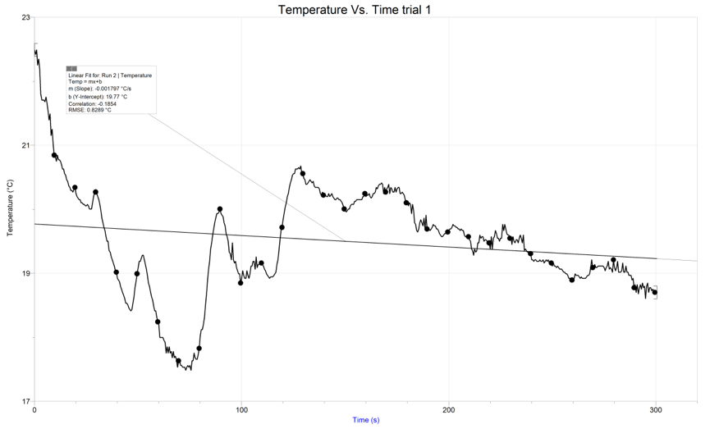

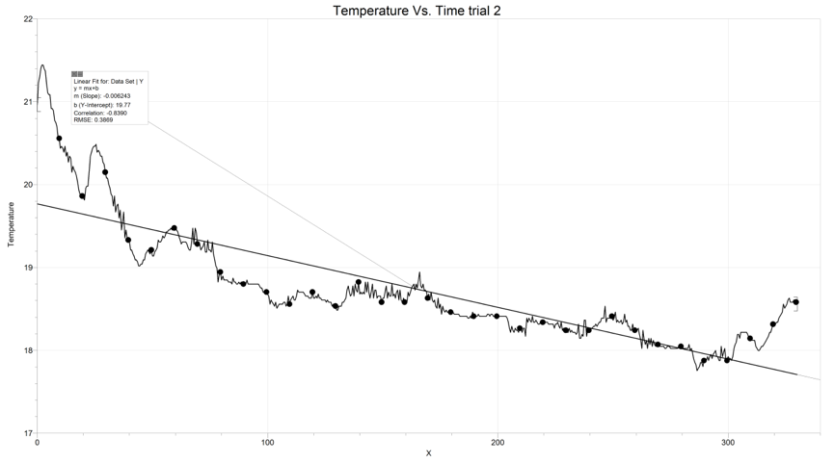
Qualitative Observations:
Substance | Description
ammonium chloride | white granular solid
water | clear colourless liquid

Calculations:
Part 1: 100g of water
Q=MCT
Q=100g * 4.18Jg-1K-1*(-5)K
Q=-2.1kJ
17kJ/1 molNH4Cl = 2.1kJ/ n molNH4Cl
n=0.12 mol
MNH4Cl=53.5g*mol-1
m=n*M=0.12*53.5=6.4g of NH4Cl

Part 2: Given the volume of the outer layer is 132.32mL, calculations using 232.32g of water
Q=MCT
Q=232.32g * 4.18Jg-1K-1*(-5)K
Q=-4.85kJ
17kJ/1 molNH4Cl = 4.85kJ/ n molNH4Cl
n=0.2856 mol
MNH4Cl=53.5g*mol-1
m=n*M=0.2856mol*53.5gmol-1=15.28g of NH4Cl
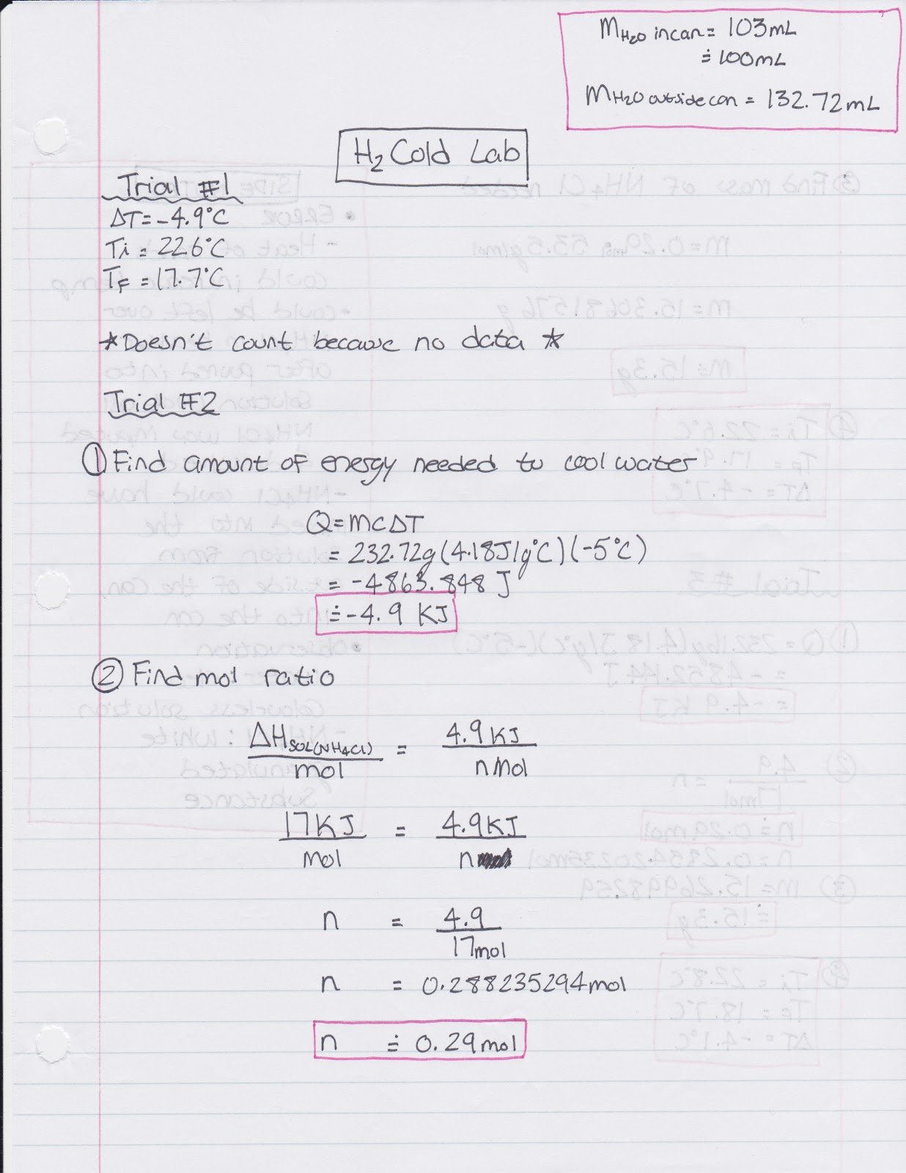
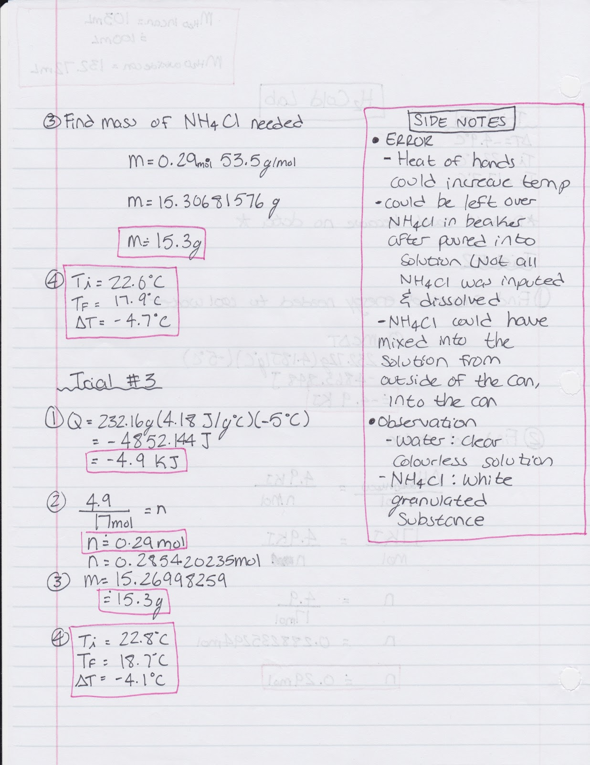

Discussion:
The purpose of the lab was to investigate whether ammonium chloride would act as a cooling agent when mixed with water. In order to determine this, the amount of ammonium chloride needed for the experiment was calculated. The value of 37.2 g NH₄Cl given in the lab manual was the solubility for NH₄Cl in 100 mL of water. However, we needed the value of NH₄Cl that would simply create a temperature change and therefore not all 37.2 g would be used in the experiment. The amount of ammonium chloride needed was then calculated to be 15.3 g using our knowledge of heat capacities, calorimetry and enthalpy change.
The data results recorded through the LabQuest2 show that the ammonium chloride did in fact cool the water. It was hypothesized that if ammonium chloride is mixed with water, then the temperature of water will decrease due to the endothermic reaction. This was proved to be true as when the ammonium chloride was added, the temperature of the water in fact decreased, concluding that ammonium chloride could act as a sufficient cooling agent for this product. For trial 1, the temperature of the water started at 22.5 ℃ and ended at 17.6 ℃, having a total temperature change of 4.9 ℃. For trial 2, the water started at a temperature of 22.5 ℃ and after five minutes, it had a temperature of 18.7 ℃, having a total temperature change of 3.8 ℃. For trial 3, the water started at a temperature of 21.0 ℃ and ended with a temperature of 17.9 ℃, having a total temperature change of 3.1 ℃. This gives an average temperature change of 3.5 ℃. The goal was to achieve a temperature change of 5 ℃, we got close to this goal but did not achieve it successfully. Our first trial was the closest, but since the data was not collected properly, the data is not comparative to the other trails and therefore to the conclusions of the experiment. That leaves trial 2 as being our closest set of values to the goal. Since we did not achieve 100% of the temperature change, this means that some energy was lost to external factors.
Looking at trial 2’s data, at 10 s, the temperature was 20.8 ℃, then at 70 s, the temperature decreased to 17.6 ℃ and finally at 130 s, the temperature increased back to 20.5 ℃. This corresponds on the graph with the visible “dip” in the data where the temperature decreases and then increases again. These dips happen several times along the data. Due to this observation, we believe that there were great factors of error. Some areas of potential error that could explain the varying temperature changes are the fact that the calorimeter was not a completely closed system, the leftover crystallized NH₄Cl and the heat transfer from the group member’s hands who was holding the calorimeter. The calorimeter used did not have a tight seal for the thermometer, therefore some of the energy escaped from the system, increasing the temperature in the can. Also, after cleaning the can and calorimeter after the first trial, the group noticed some left over crystalized NH₄Cl from previous group’s uses. This could have had a factor in the reaction and therefore changed the effectiveness of the experiment. For further trials, the crystals were attempted to be removed, however, it was impossible to clean it completely. Finally, another error was that one group member was holding the system in their hands and they gently mixed the solution inside the calorimeter during the experiment. Therefore, there was heat transferred from the person’s hands to the system, increasing the temperature.

Conclusion:
In conclusion, the results from the experiment were not as accurate as expected. The results showed that the reaction did not cool the entire 5ºC, and our group only achieved a temperature change of 4.7ºC. This can be due to multiple external factors, some of which are human error, but larger sources of error may be due to the atmosphere and calorimeter efficiency. The calorimeter was not a perfectly closed system as there was a whole on the top for the thermometer to be placed. Another source of error could be the way the solution was agitated. Shaking the calorimeter to achieve a fully dissolved solution could have elicited a heat increase from the body heat of the hand or the heat of friction of the table. Overall, the experiment was completed as accurately as possible and observations showed that it is possible to complete the process even more accurately than the data in our groups observations.

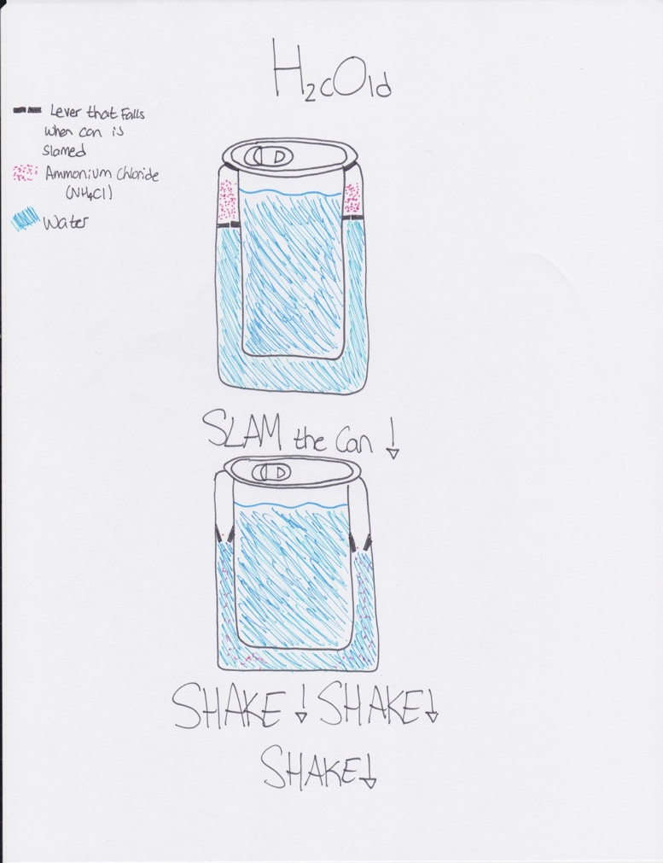

References:
Calorimeters and Calorimetry. (n.d.). Retrieved October 06, 2017, from http://www.physicsclassroom.com/class/thermalP/Lesson-2/Calorimeters-and-Calorimetry
(n.d.). Retrieved October 06, 2017, from http://www.chemguide.co.uk/physical/energetics/solution.html

Raw Data:
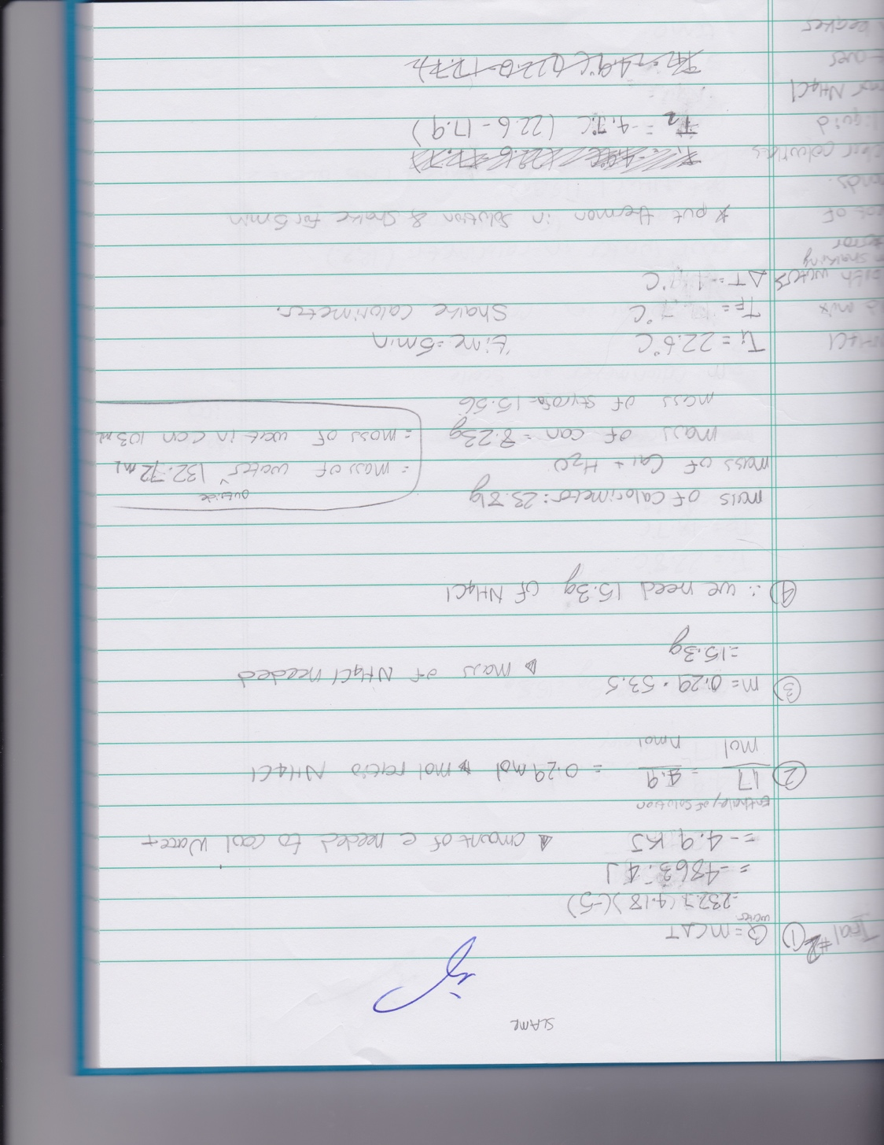

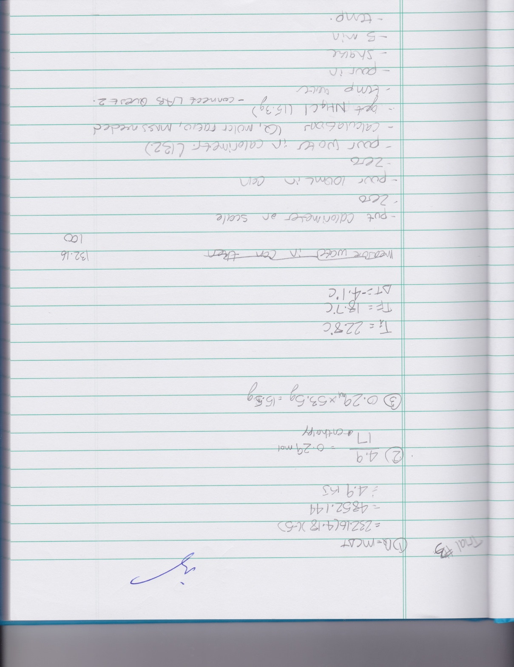

Assessment Criteria for Planning A Tall Cold Drink of Water

TA Name: |  | Names of Students in Group: | a.
 |  |  | b.
 |  | Date:
Criteria: | Marks | Assessment
 | Possible | Self | TA
1. Identify the problem and state it clearly in a way that can be tested. | 1
2. Use proper apparatus, techniques and safety precautions. | 1
3. Materials are easily available. | 1
4. Plan to vary only one independent variable at a time. | 1
5. Controls on other variables are clearly stated. | 1
6. Measurement errors are minimized by appropriate procedures or apparatus. | 1
7. The methods are clear enough to be followed by other students. | 1
8. No invalid assumptions are made. | 1
9. Reagents that need accurate measurement are identified. | 1
10. Lab trials are stated. | 1
11. Repeats are stated. | 1
12. Chemistry vocabulary is used correctly. | 1
13. Limitations of the experimental design are described. | 1
TOTAL: | 13

