Psychology
Midterm 1 Review
Lecture 1
What is Psychology: Informal def’n- A science that seeks to answer questions about us all – how and why we think, fell, and act as we do.

Major Questions Pschologists ask:
- Nature versus Nurture
- What do genes contribute to behaviour?
- How are we shaped by our homes and environment?
- This question has been controversial over time
- Interpersonal Differences and similarities
  - How are we the same?
  - How are we different?
  - How does race, culture, sexual orientation etc. affect this
- Why do we dream
  - Lots of speculation- to consolidate memory, just physiological
  - No one really knows
- What do babies think
  - How do babies perceive the world
  - Why do infants enjoy peek-a-boo
- What is intelligence
  - Are some people born smarter
  - Does being smart relate to other activities
  - Are there different kinds of intelligence
  - Is there a general intelligence
- How is electronic media affecting us
  - How do electronic devices influence our thinking, learning, and relationships
  - This is very controversial
- Psychological disorders
  - What triggers good and bad moods
  - What is the line between mood swings and a disorder
  - When should help be requested
Lecture 2
The birth of Psychological Science:
- Aristotle:
- Used observation and questioning when he was trying to understand the body-psyche relationship
- He was technically a philosopher because that is what they were called back then but nowadays he would be considered a psychologist
- It took 2000 years for the SCIENCE of psychology to develop
- Wilhelm Wundt:
- He defined Psychology as the “science of mental life”
- He was the first to use a lab and experimentation to prove his thoughts quantitatively
- He added two elements to psychology 1.) carefully measured observations 2.) experiments
- Most famous experiment is the reaction time experiment using a modified telegraph machine to measure reaction time
- Problem with this is that the subjects know they are being tested which can skew results.
Two Main Schools of Thought:
- Structuralism:
  - Made by Edward Titchener; who was mentored by Wundt
  - Relied on self reported data
  - Encouraged introspection: reporting on sensations and other elements of experience in reaction to a stimuli
  - Used these introspective reports to build a view of the mind
  - In Titcheners lab: a machine would present a stimulus and then people who were trained on how to report their feelings and thoughts would report them
  - The issues with this lab set up is that there is too much data, to much variation in the data, people lie, and bias because they were trained by him
- Functionalism:
  - Founded by William James Reid
  - Studied human thoughts, feelings, and behaviours
  - He asked what function they might serve
  - How they might have helped our ancestors
  - He did not use many experiments
  - Wrote a lot Book= principles of psychology
  - Thoughts and feelings might help us survive
  - Very ahead of his time
  - Thought psychology should be treated as a natural science
Women in Psychology
- At one point in time females were not allowed to be professors
- Women couldn’t vote until 1921
- Indigenous women until 1960
First Woman in Psychology
- Mary Whiton Calkins
  - Became memory researcher and first female APA president
  - Studied with James but denied PhD
  - Fought for the right to vote
  - Specifically she was denied Harvard PhD despite doing all the work she was offered one from the sister school
  - Other people quit the lab because she was there
- Margaret Floy Washburn
  - Became second APA president
  - Wrote the animal mind
  - Studied with Titchener but barred from his experimental organization
  - She was not allowed to have her masters published in the USA so Wundt published it for her
Early Psychological Science 1920s to 1960s
- Behaviourism:
  - Defined psychology as the scientific study of observable behaviour without reference to mental processes
  - Two main people behind this stream of thinking
  - John B. Watson (classical conditioning)
  - B.F. Skinner (Operant Conditioning) dismissed introspection
  - They did not care about what is going on inside the head only cared about behaviour and how information could be inferred from it
  - Watson and Rayner conducted famous little albert experiment where they conditioned an 11 month old baby to fear white rats
  - This was completely unethical
- Freudian Psychology:
  - Fathered by Sigmund Freud
  - Related childhood experiences to later behaviour
  - Was second major force until 1960
  - He was revered for a wild
  - Now people have disregarded many of his theories
  - Thought that the mind was reason for all emotion
- Humanistic Psychology
  - Revived interest in a study of mental processes
  - Focused on ways current environments nurture or limit growth potential
  - Led by Carl Rogers and Abraham Maslow
- Cognitive psychology
  - Known as the cognitive revolution in the 1960s
  - Scientifically explored ways in which information is perceived, processed and remembered
  - Cognitive neuroscience ties this field and the study of the brain
Contemporary Psychology
- Modern definition of Psychology: science of behaviour and mental processes
- The field of Psychology is growing and globalizing
- Psychology’s pioneers have come from many fields: Physiology, medicine, biology, philosophy
- Advances come from all over the world
- The big nature nurture question is popular here
- There are periods where one is favoured over the other but realistically they are a healthy balance

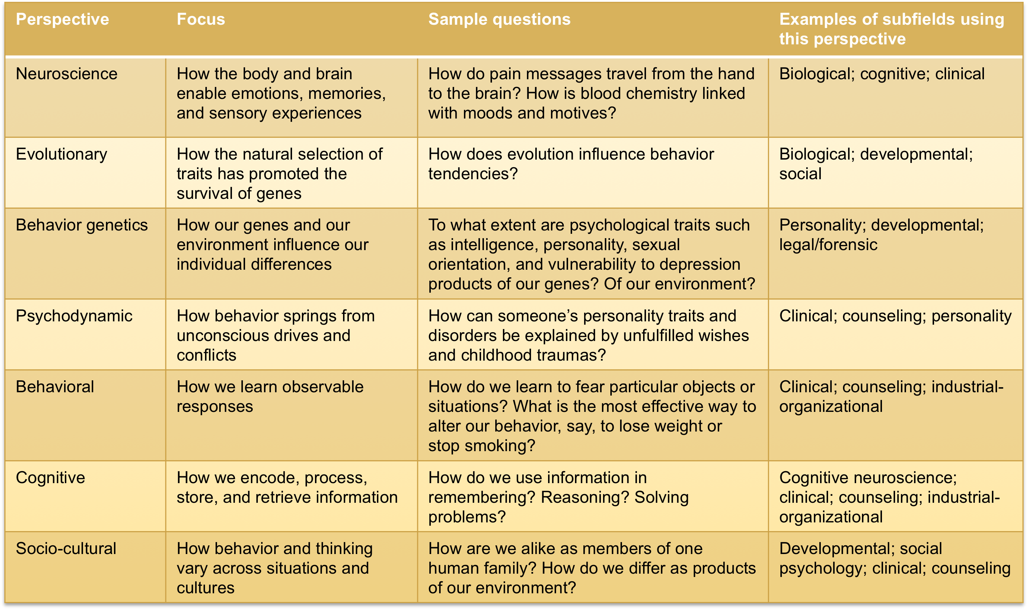

Lecture 3
The need For Psychological Science
- Intuition and common sense can be useful but humans cannot solely rely on them
- Three phenomena highlight this: Hindsight bias, judgemental over confidence, tendency to perceive patterns in random events
- Hindsight Bias:
  - Tendency to believe, after learning an outcome, that we could’ve predicted it
  - Known as the I-Knew-It –All-Along phenomenon
  - This can be seen with the deepwater horizon accident oil industry employees took shortcuts and shit went down
- Overconfidence:
  - Decca not signing the beatles
  - People always overestimate their abilities but in reality they may not be able to do what they say they can
- Perceiving Order in Random Events:
  - People see patterns to make sense of the world
  - Even in random unrelated data people can see patterns
  - People trust their intuition but intuitive thinking is flawed
- Why we need Psychological Science
  - Because these three highlighted phenomena cause us to overestimate our intuition
  - But scientific inquiry can help us discern what is reality and what is illusion

Scientific Attitude and Critical Thinking
- Qualities associated with scientific attitude
  - Curiosity- to enquire or take interest in
  - Skepticism- to be doubtful
  - Humility- to be humble and modest
- Scientific Attitude
  - Curiosity- includes a passion to explore and understand the world without being misled
  - Curiosity+Skepticism- leads to questions like what do you men and how do you know
  - Humility- allows us to admit when e are wrong
- Critical Thinking
  - Basically smart thinking
- Characteristics of critical thinking
  - How do they know that
  - What is the agenda
  - Is the based on gut feeling or is there evidence
  - Is there sufficient cause
  - Are there other explanations
- Critical thinking when paired with the scientific method it constitutes a more effective way of studying what people feel, think and do
The Scientific Method
- A process of testing out ideas about the world by setting up experiments and formulating hypothesises
- Making observations
- Analyzing whether the data fits our ideas
- Research strategies in Psychology
  - Hypotheses are tested using three key methods
    - Description
    - Correlation
    - Experiments
  - Description:
    - Descriptive research is a systematic, objective observation of people
    - The goal is to provide a clear, accurate picture of people’s behaviors, thoughts, and attributes
    - Three main kinds of descriptive research:
      - Case Study
      - Naturalistic Observation
      - Survey
  - Correlation:
    - The relationship between two traits specifically whether or not there is one
    - A measure of how well you can predict ne based on the other
    - Positive correlation indicates a direct relationship
    - Negative correlation indicates an inverse relationship
    - Correlation coefficient indicates how closely to things are correlated the closer to |1| the stronger the correlation
    - Correlation does not equal causation
Lecture 4
Scientific Method Cont:
- Research Strategies:
  - Experimentation
    - Experiments are concerned with isolating cause ad effect relationships
    - With experiments researchers can focus on the possible effects of one or more factors by
    - Manipulating the factors of interest
    - Holding a constant value
  - Eliminating bias by using the double blind procedure
    - Neither participants or researchers know which group is receiving the treatment
    - The treatments actual effect can be separated from the potential placebo effect
  - Placebo Effect
    - Effect involves results caused by expectations alone
    - If someone thinks the drug will work then a physical effect will be observed
  - Predicting real behaviours
    - Experiment purpose- test theoretical principles not the recreation of exact behaviours
    - Resulting Principles- help explain everyday behaviour, not specific findings
    - Psychological science- focuses on seeking general principles that help explain many behaviours
    - Psychological science- focuses on seeking general principles that explain many behaviours not just specific behaviour
Research Ethics
- Ethics is a moral philosophy
- Established set of rules of conduct
- Values in ethics determine the importance of a rule
- Animal Research
  - We study animals because we are one
  - We are interested in them
  - We can do many medical treatments on them
  - Investigate systems like our own to better understand our own
  - There is debate on whether or not this is ethical
  - Two main questions arise from this
    - Is it right to place the well being of humans above that of other animals
    - The response varies by country in Canada it is seen as acceptable but in Britain not so much
    - The second question is what safeguard should protect animals
    - Most researchers agree that they need to be protected
  - Protecting the animals involved in studies
    - Universities have rules and boards of approval
    - BPS: British Psychological society has rules
    - APA: has rules and standards
    - Parliament has rules and standards
- Human Participants
  - Must have informed consent
  - Protect them form harm and discomfort
  - Keep information confidential
  - Fully debrief people
  - Values in research affect what is studied, how it is studied and how the results are interpreted
  - Can colour facts
  - Can be influenced by popular application of psychology
Statistical Reasoning in Everyday Life
- Describing Data;
  - Mode: most frequently occurring score
  - Mean: arithmetic average of a distribution
  - Median: middle score in a distribution
- Measures of variation reveal similarity or diversity in scores
  - Range: difference between highest and lowest score
  - Standard Deviation: computed measure a number of how much scores vary around the mean score
  - Normal curve: symmetrical bell shaped curve that describes distribution of many types of data most scores fall near the mean

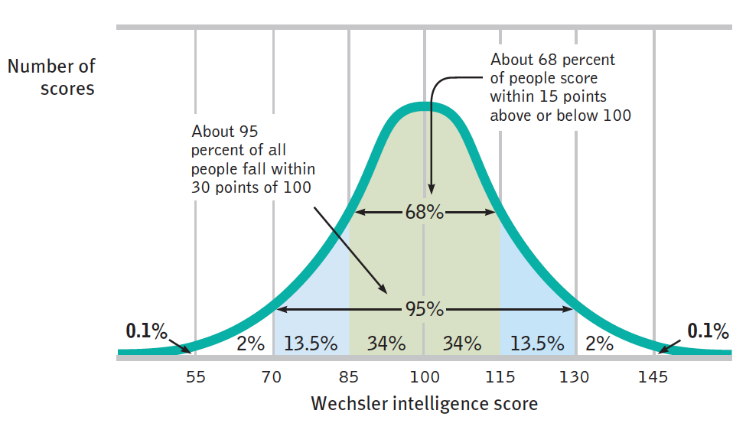

- Significant differences:
  - When is an observed difference reliable:
    - Representative samples are better than biased samples
    - Less variable options are more reliable than those that are more variable
    - More cases are better than fewer
  - When is an observed difference significant
    - When the difference is large and the sample averages are reliable
    - It is not due to chance
    - Proof beyond reasonable doubt
Lecture 5
Neural and hormonal systems: Biology, Behaviour, and Mind
- Everything psychological is biological
- Psychologists working from a biological perspective try to study the links between biology and behaviour
- Humans are biopsychosocial animals
- Understanding the relationship between the brain ad the mind has evolved over time
  - Plato: mind is in the spherical head
  - Aristotle: mind is in the heart
  - Gall: thought that phrenology could reveal mental abilities
- Franz Gall
  - Psychologist and neuroanatomist
  - Interested in localizing function to parts of the brain
  - Chose the skull because he thought the bumps reflected the surface of the brain
  - Thought there were 27 fundamental faculties
  - Everything from music to murder could be investigated
  - This is called Phrenology
  - He was wrong but headed in the right direction
- During the past century researchers discovered that
  - Nerve cells conduct electricity
  - Specific brain systems serve specific functions
  - The brain is wired by experience
- Neurons Structure and function
  - Neurons are the building blocks and functional unit of the nervous system
  - 3 basic parts
    - Dendrites: receive messages from other cells
    - Cell body: the cells life support center
    - Axon: passes messages away from cell body to other neurons
  - 86-100 billion neurons in the body
  - 100,000 trillion connections between them
  - 70% of all neurons are in the cerebellum
  - neurons last your entire life
- Glial Cells
  - Known as support cells
  - Lots of different types and locations
  - Lots of functions
- Action Potentials:
  - A brief electrical charge that moves down an axon
  - An all or none response the neuron fires or it doesn’t no in between
  - Neurons can do this many times a second
  - How does this happen:
    - Sodium rushes into the negative charged inside of the cell and makes it more positive if it reaches the threshold an action potential happens
    - This triggers a domino effect all the way down the axon
    - In myelinated neurons the charge skips from node to node
  - After the AP there is a refractory period where the cell cannot fire again this is when the cell is restoring its resting potential
  - How is the message sent
    - Through neurotransmitters across a synapse
    - Extra neurotransmitter is taken up by the cell, broken down by enzymes or drifted away
    - Acetylcholine is a popular neurotransmitter
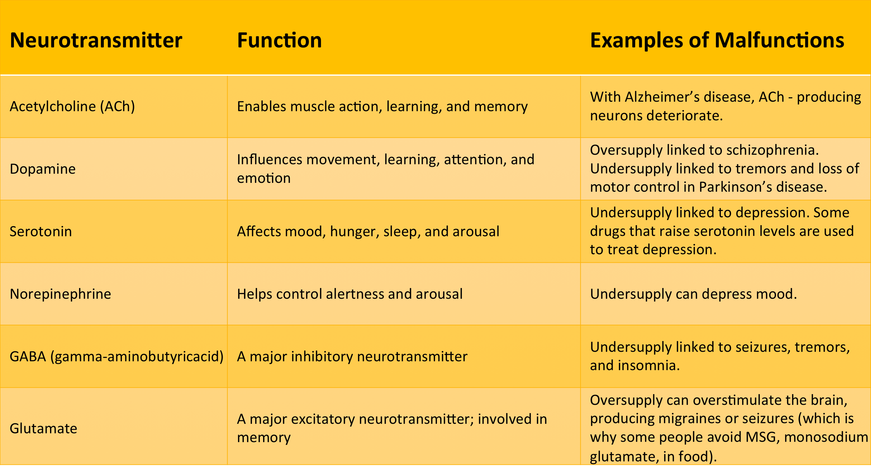
- How drugs alter the neurotransmitters effects
  - they are one of two things
  - Agonist: increases neurotransmitter function
  - Antagonist: decreases neurotransmitter function
  - Drugs try to imitate neurotransmitters and disrupt the cell

Lecture 6
- More about Neurons
  - Sensory
    - Carry information from the sensory receptors to the cns
    - They are afferent
  - Motor
    - Carry instructions from the cns to the muscles and glands
    - They are efferent
  - Interneuron
    - Processing between the sensory and motor neurons
    - The most abundant
  - Neurons fire together and are wired together
  - Means they work together
  - Neurons operate in groups called neural assemblies
  - Neural networks may affect learning
  - The cells improve their connections through experience
- Nervous System
- What’s a Nerve
  - A bundle of axons that forms a cable
- Is the communication center of the body
- Central Nervous System
  - Consists of the brain and the spinal cord
  - Decision making
- Peripheral Nervous System
  - The connection between cns and the rest of the body
  - Motor and sensory neurons
  - Somatic and autonomic
- Enteric Nervous System
  - Connection between gut and cns
  - Sometimes considered part of the PNS
  - Sheets of neurons lining digestive system
- Autonomic has sympathetic and parasympathetic
- About the CNS
  - Brain accounts for 2% of body weight
  - Uses 20% of all energy
  - Allows for reflexes
  - If severed spinal cord the rest of the body loses function
The Endocrine System
- Very important and there is a lot that we don’t know about it
- It interacts with the nervous system
- It acts slowly
- The structures are glands and chemical messengers called hormones
- Hormones travel the body through the blood
- Intricate feedback system to the hypothalamus
- Hypothalamus influences the pituitary gland
- Pituitary influences all the other glands it is the “Master Gland”
- Feedback is a result of a stressor in the environment
- Methods:
  - Looking at the brain
  - Older Methods
    - Notice injury somewhere was associated with a particular deficit
    - Post mortem studies showing the persons deficit
    - EEG and CT scans
  - Experimental methods
    - Scientists can selectively manipulate the brain
    - Destroying tissue to form lesions
    - Stimulation
  - Brain Imaging
    - EEG measures activity from the surface of the scalp
    - PET radioactive glucose is injected and then the gamma rays are monitored while person does something
    - MRI head in magnetic field temporary misalignment of atoms then when they reorient a signal is sent
    - fMRI records blood flow to different areas
The Old Brain
- Structures:
  - Less complex brain in primitive vertebrates handle basic survival functions
  - More complex brain in advanced mammals contain new brain systems
  - Brainstem and related areas are similar in all mammals
  - The brainstem is an extension of the spinal cord, the thalamus is attached at the top
  - The brain stem is the oldest and innermost brain region
  - Medulla is at the base of the brain stem and controls heart beat and breathing
  - Pons above medulla help coordinate movement
  - The brain is cross wired
  - Reticular Formation:
    - involves nerve network
    - Plays an important role in arousal
  - Thalamus:
    - Area at the top of the brain stem directs sensory messages and replies
  - Cerebellum
    - Aids in judgement of time sound and texture
    - Coordinates voluntary movement
    - Helps process and store info
  - Limbic system
    - Consists of
    - Amygdala: emotion
    - Hippocampus: maintence activities
    - Hypothalamus: linked to explicit memory and reward center
Lecture 7
Old Brain
- Cerebellum
  - Aids on time sound and texture distinction
  - Coordinates voluntary movement
  - Helps store information outside of awareness
New Brain
- The cerebral Crotex
  - A thin layer of interconnected neurons
  - Two hemispheres
    - Each has 4 lobes
    - Frontal: speaking and muscle, planning, and judging
    - Parietal: spatial things
    - Occipital: Vision
    - Temporal: Receiving info from ears
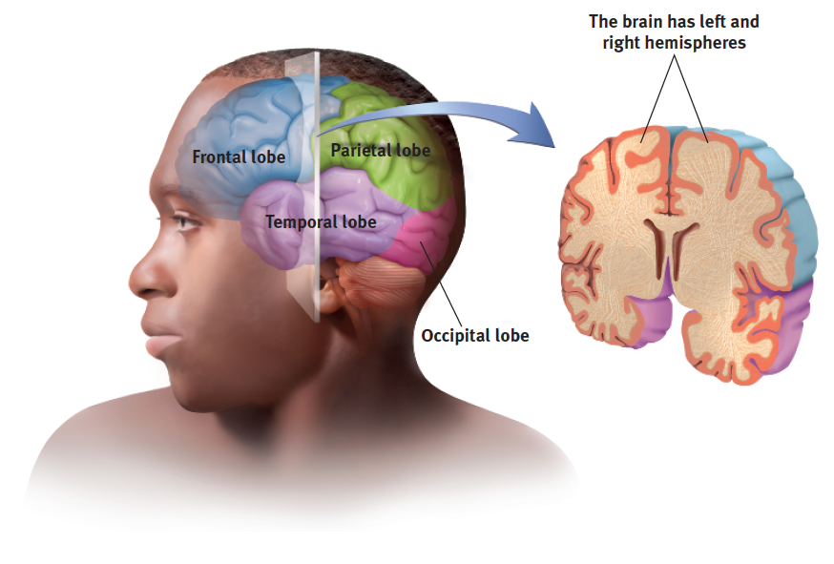

- The Motor Cortex
  - Rear of frontal lobes
  - Control movement
  - The more sensitive the tissue the larger amount of the motor cortex it takes up
- Somatosensory cortex
  - Somatosensory cortex processes information from skin senses and body parts (for feedback on movement)
  - Specialized receptors receive this information (as we saw in previous lectures) and pass this information on to the brain
  - With some processing and integration along the way, the information makes its way to somatosensory cortex
- The Cerebral Cortex
  - The brain computer interface
  - There can be a sort of mind reading done here by seeing what the neural firing pattern looks like
  - Currently being looked in to for prosthetics
- Functions of the cortex
  - Primarily sensory functions
  - Visual cortex controls vision auditory controls hearing
  - Damage to association areas causes loss of function to what they are associated with
- Phineas Gage
  - He had a spike through the brain
  - He retained all function but his personality changed
- The brains Plasticity
  - Brain damage can be severe and irreversible but this depends on the nature of the injury and when it happens (developmentally)
  - The brain can compensate for the injuries
  - The younger the more the brain is able to recover
  - Can happen after stroke
  - Hemispherectomy: when one half of the brain is removed to stop seizures in young children
  - Remarkably the children only have minor motor deficits
- The corpus callosum
  - Joins the two hemispheres
  - data is communicated to both sides of the brain
  - when severed info is not shared
  - there are right left distinctions
  - the visual system is crossed and allows for the individual questioning of each hemisphere
- Handedness
  - Genetic
  - World is setup for righties
  - There are minor deficits to being left handed
Lecture 8
The place of consciousness in psychology’s history
- 1880s: psychology was the description of different states of consciousness
- first half of 1900s: observation of behaviour
- 1960s consciousness nearly lost
- after 1960s: consciousness altered by drugs hypnosis meditation
- today: consciousness is important are of research
The biology of consciousness
- cognitive neuroscientists: explore and map cortex function and can sometimes read minds
- suggests consciousness arises from synchronized brain activity
Dual Processing
- the principle that information is often simultaneously processed on separate conscious and unconscious tracks
- Blindsight awareness
  - Condition where a person can respond to visual stimulus without experiencing it
  - A blindsight patient will wander around obstacles in an empty hallway
Consciousness and selective attention
- Selective attention
  - Focusing awareness on a particular stimulus
  - Cocktail party effect
  - Note taking
- Parallel processing
  - Processing many aspects of a problem simultaneously
- Inattentional blindness
  - Failing to see a visible object when paying attention to something else
What is sleep
- Periodic natural loss of consciousness
- Resulting from a coma, general anaesthesia, or hibernation
- Biological 24 hr rhythm 90min sleep cycle for young adults
- Circadian rhythm:
  - 24hr natural clock
  - Body temp rises with morning peaks during day dips in afternoon and drops at night
  - Altered by age and experience
- Phases of sleep
  - REM(rapid eye movement): sleep stage that vivid dreams occur
  - REM rebound: tendency for REM sleep to increase after REM deprivation
- Sleep/ awake waves:
  - Alpha waves: relatively slow brain waves of a relaxed awake state
  - Hallucinations: False sensory experiences, such as seeing something in the absence of an external visual stimulus (in NREM-1)\
  - Delta Waves: Large, slow brain waves associated with deep sleep (NREM-3) deep sleep
- What affects our sleep patterns
  - Genetic and cultural influences
  - Bright morning light activates light-sensitive proteins that trigger suprachiasmatic nucleus (SCN) to cause decreased production of melatonin in morning and increased production in the evening.
  - Social jet lag may occur when sleep routines are disrupted during weekends.
Why do we sleep?
- Sleep may have played a protective role in human evolution by keeping people safe during potentially dangerous periods.
- Sleep also helps restore and repair damaged neurons.
- REM and NREM-2 sleep help strengthen neural connections that build enduring memories.
- Sleep promotes creative problem solving the next day.
- During deep sleep, the pituitary gland secretes a growth hormone necessary for muscle development.



