Chapter 1 – Marketing: Creating and capturing customer value

Successful companies have one thing in common: strongly customer focused and heavily committed to marketing.

What is marketing? (LO1)
Deals with customers. Definition: Marketing is managing profitable customer relationships. Goals: attract new customers with superior values and keep current.
For profit and for non-profit organizations use marketing

Marketing defined
Not only selling and advertising but satisfying customer needs.
Peter Drucker: “The aim of marketing is to make selling unnecessary”
Marketing is a social and managerial process where individuals and organizations obtain what they need and want through creating and exchanging values with others. For business, it involves profits. Marketing: the process by which companies create value for customers and build strong customer relationships in order to capture value from customers in return.

The marketing process

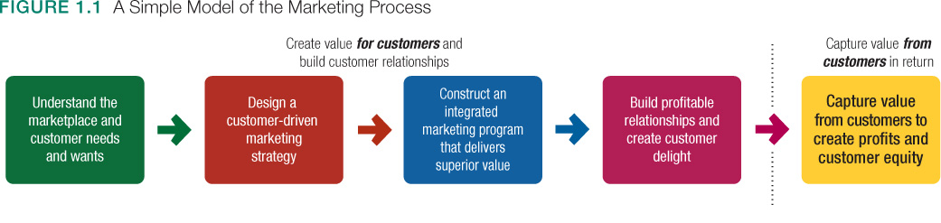

Understand the marketplace and customer needs (LO2)
Customer needs, wants, and demands
Human needs: states of felt deprivation. Physical (food, clothing, warmth, and safety), social (belonging and affection) and individual (knowledge and self-expression).
Wants: The form human needs take as they are shaped by culture and individual personality.” Human needs food but wants burger. “
Demands: Human wants that are backed by buying power. Given their wants and resources, people demand products and services with benefits that add up to the most value and satisfaction.

To understand customer’s needs, wants and demand, organizations conduct research, analysis and observations.

Market offerings – Products, services, and experiences
Marketing offerings: some combination of products, services, information, or experiences offered to a market to satisfy a need or want. Includes physical product, entities (persons, places, organizations), and services (banking, hotel, retailing).
Marketing myopia: The mistake of paying more attention to the specific products a company offers than to the benefits and experiences produced by these products. Lose sight of customer’s needs.

Customer values and satisfaction
Customers form expectations and buy accordingly. Satisfy customers buy again and tell others. Dissatisfy customers will change to competitors and disparage the product. Must set expectation right. If too low, won’t attract enough. If too high, buyers will be disappointed.

Exchanges and relationships
Exchanges: The act of obtaining a desired object from someone by offering something in return.
Marketing consist of creating, maintaining and growing desirable exchange relationships with product, service, ideas… build strong relationships by delivering superior customer value.

Markets
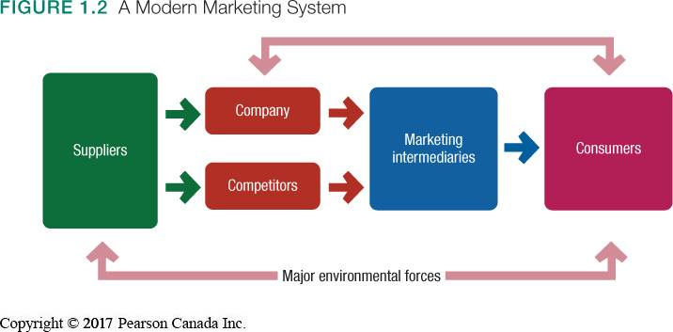
Market: The set of all actual and potential buyers of a product or service. Sellers must search for buyers, identify their needs, design good market offering, set price, promote, store and deliver. These are core marketing activities. It is now a two-way relationship because customers also search for companies to buy product.

Designing a customer-driven marketing strategy (LO3)
Marketing management: The art and science of choosing target markets and building profitable relationship with them. What customers will we serve? How can we serve these customers best?

Selecting customers to serve
Divide market into segment and select which one we will go after. Select those whom it can serve well and profitably. Marketing management is customer management and demand management.

Choosing a value proposition
How it will differentiate and position itself. A brand’s value proposition is the set of benefits or values it promises to deliver to consumers to satisfy their needs. It differentiates one brand from another.

Marketing management orientations
What philosophy should guide these marketing strategies?
Production concept: The idea that consumers will favour products that are available and highly affordable; therefore, the organization should focus on improving production and distribution efficiency. May lead to marketing myopia.
Product concept: The idea that consumers will favour products that offer the most quality, performance, and features; therefore, the organization should devote its energy to making continual product improvements. Can lead to marketing myopia.
The selling concept: The idea that consumers will not buy enough of the firm’s products unless the firm undertakes a large-scale selling and promotion effort. This creates sales transactions rather than building relationship.
The marketing concept: A philosophy in which achieving organizational goals depends on knowing the needs and wants of target markets and delivering the desired satisfactions better than competitors do. “Find the right product for your customers” rather than “find the right customers for your product” type of philosophy.

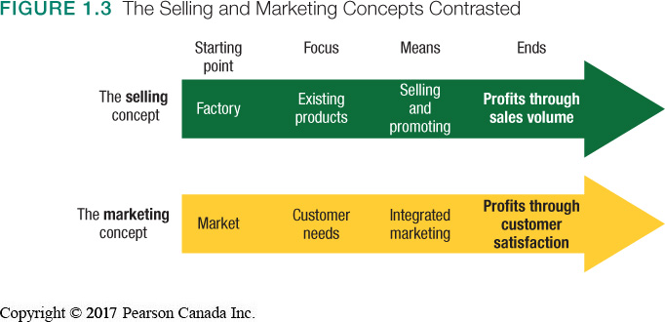
The societal marketing concept: The idea that a company’s marketing decisions should consider consumers’ wants, the company’s requirements, consumers’ long-run interests, and society’s long-run interests.

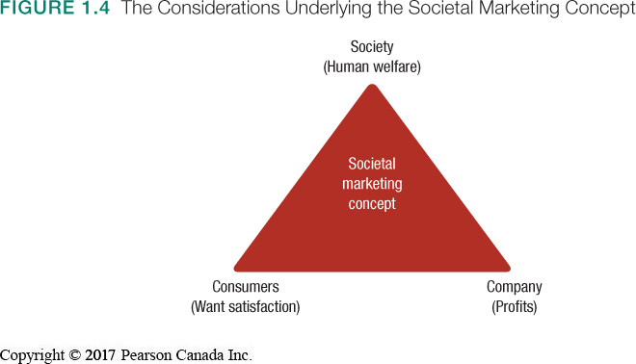
Preparing an integrated marketing plan and program
Next, we take action with marketing program. Marketing mix: the set of marketing tools the firm uses to implement its marketing strategy. (4 Ps: Product, price, place and promotion.)

Building customer relationship (LO4)
Customer relationship management
Customer relationship management: the overall process of building and maintaining profitable customer relationships by delivering superior customer value and satisfaction.

Relationship building blocks: Customer value and satisfaction:
Customer-perceived value: The customer’s evaluation of the difference between all the benefits and all the costs of a marketing offer relative to those of competing offers.
Customer satisfaction: the extent to which a product’s perceived performance matches a buyer’s expectations.

Customer Relationship Levels and tools:
Basic relationship: company with low-margin customers
Full partnerships: company with few customers and high margin.
Frequency marketing programs: rewards customers who buy frequently or in large amount.
Club marketing programs: offer member special benefits and create member communities.

Engaging customers
Customer- engagement marketing: Making the brand a meaningful part of consumers’ conversations and lives by fostering direct and continual customer involvement in shaping brand conversations, experiences, and community. (social media, internet)
Today, customers are better informed and engaged (customer-managed relationship)
Companies cannot use intrusion anymore, but rather attraction.

Consumer-generated marketing:
brand exchanges created by consumers themselves – both invited and uninvited – by which consumers are playing an increasing role in shaping their own brand experiences and those of other consumers. (sharing ideas, videos, blogs) consumers are playing a growing role in shaping their own and other consumers’ brand experiences, they have a say.

Partner relationship management
Companies don’t only have to work well with customers, but with partners also.
Partner relationship management: working closely with partners in other company departments and outside the company to jointly bring greater value to customers. No matter what your job is in the company, you must understand marketing and be customer focused. We have to link all the departments. (supply chain management)

Capturing value from customers
Creating customer loyalty and retention
Customer lifetime value: The value of the entire stream of purchases a customer makes over a lifetime of patronage. Loyal clients are profitable.

Growing share of customer
Share of customer: The portion of the customer’s purchasing that a company gets in its product categories.
To increase share, company should offer greater variety to current customers or create programs to cross-sell or up-sell.

Building customer equity
Customer equity: the total combined customer lifetime values of all the company’s customers. Measure of the future value of the company’s current and potential customer base. This measure a better performance than sales.
Companies should see customers as asset that need to be managed and maximized.
However, some loyal customers can be unprofitable and non-loyal be profitable.
Different type of customers requires different relationship management.

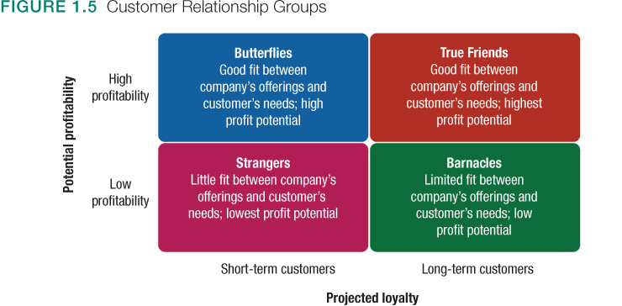
The changing marketing landscape (LO5)
The digital age: online, mobile, and social media marketing
The consumer love affair with digital and mobile technology makes it fertile ground for marketers trying to engage customers.
Digital and social media marketing: the use of digital marketing tools such as websites, social media, mobile apps and ads, online video, email, and blogs in order to engage consumers anywhere and at any time via their digital devices. For companies, 10% of marketing budget is using social media as advertising. Marketers use mobile channels to stimulate immediate buying, make shopping easier, enrich the brand experience, or all of these.

The changing economic environment
After the recession of 2008-2009, people are buying less, saving more and their income increases. There is a mind-set of less debts and more do-it yourself project. Therefore, companies changed their strategy for this new economy. They focus on the value-of-the-money, and durability of their product.

The growth of non-for-profit marketing
Government agencies make advertising for energy conservation, there are advertising for school, hospital, museums, zoos…

Rapid Globalization
Managers in countries around the worlds are increasingly taking a global view of the company’s industry, competitors and opportunities.

Sustainable marketing: the call for more environmental and social responsibility
Corporate ethics and social responsibility have become hot topics for almost every business.

