PSYC 255 QUIZ 1: mc + short answers
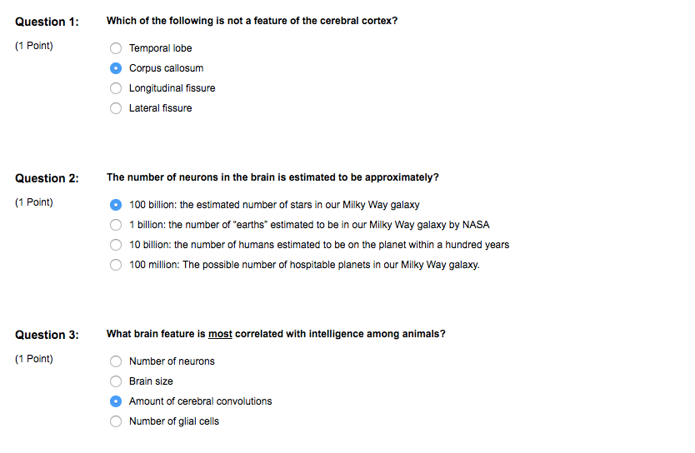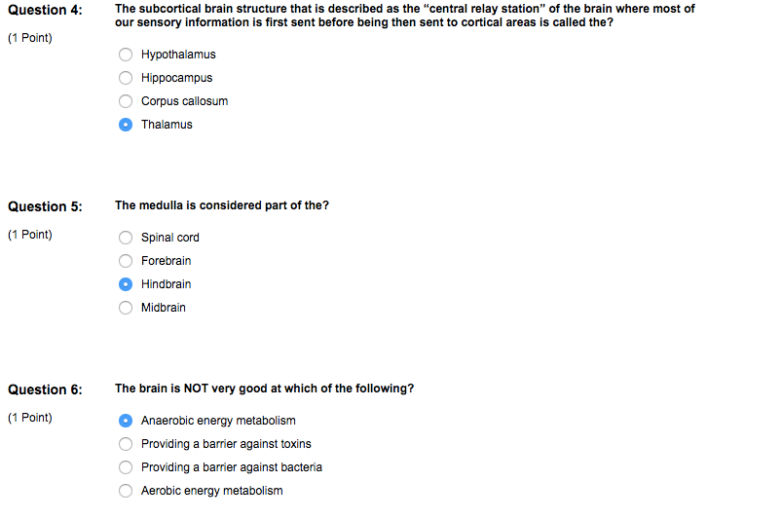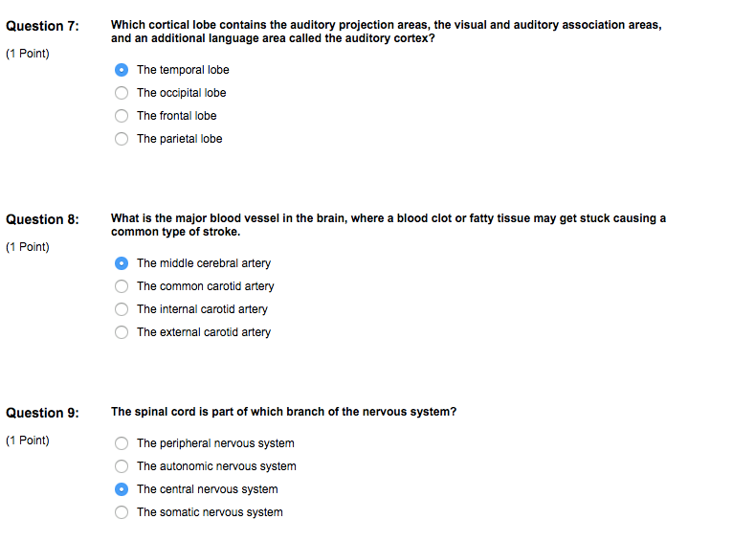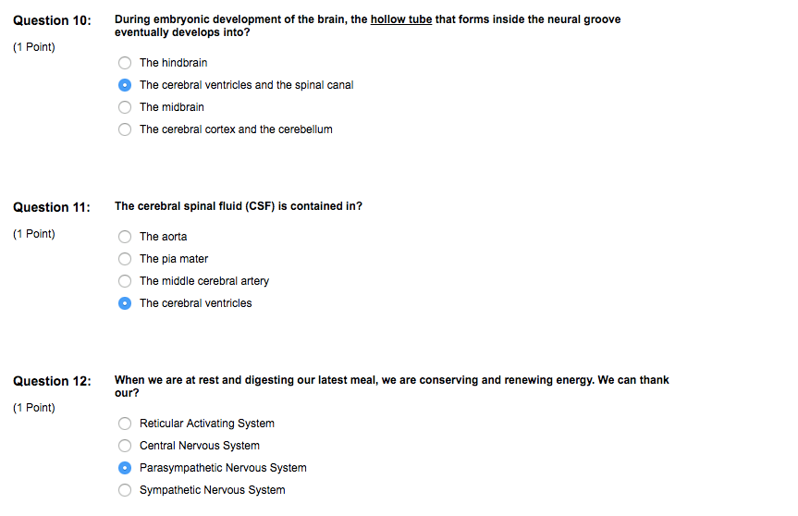
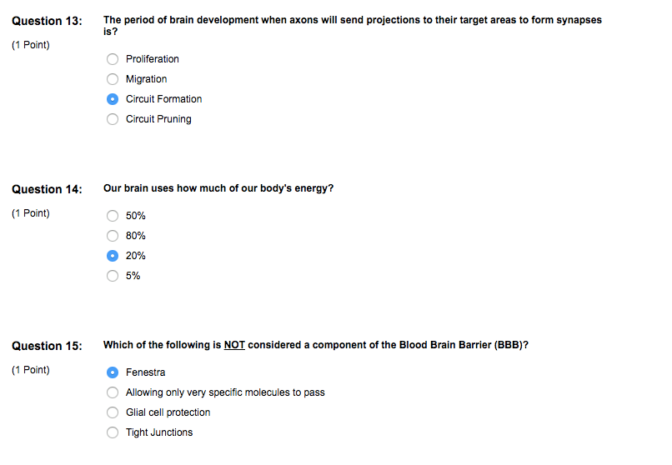

Short answers:
Unit 1 quiz 1

Question 1A:
Describe and name 1 characteristic of the brain that is relevantin terms of intelligence, and 1 that is not. How is this evidenced bycomparing a human brain to that of other animals?
Higher/smarter brains are more convoluted with the greater number of gyri, which relates to a greater cortex. (2 pts)
Across species, brain size is more related to body size than to intelligence. It is a brain’s complexity, not its size, that determines its intellectual power. (2 pts)
Monkeys are smarter than armadillos, chimpanzees are smarter than monkeys, and humans are smarter than chimps. The more intelligent the animal, the more convoluted the cortex. (1 pt)

Question 1B:
What type of short-term and long-term effects are likely to develop if a right-handedchild experiences brain damage to both Wernicke and Broca areas of the brain?
Short-term: If both Wernicke and Broca areas are damaged, the child would have trouble understanding speech (Wernicke area) (1 pt), and producing speech (Broca area) (1 pt)
Long-term — Thanks to brain plasticity (0.5 pt), the child can still manage to develop speech later in life (1 pt) because the right cerebral hemisphere will take over and the ability to speak and understand spoken words will develop in the right hemisphere (1.5 pts)

Question 2A:
Lucille packs lunchfor her son Buster to eat at school. While eating his lunch, Buster’s teacherMr. Gob notices that he is only eating his food from the right side of hislunch box. Out of concern for Buster’s well being, Mr. Gob takes him to theschool’s medical staff to be examined. As the school’s medical staff, explainwhat has occurred for Buster to be behaving this way.
Buster has had a stroke where his right middle cerebral artery was blocked. (2 pts)
This resulted in damage to the right parietal lobe which contains the somatosensory cortex, and process information about the body’s position and movement. (2 pts)
Due to the damage in his parietal lobe, Buster has hemineglect (or spatial neglect) and is unaware of what’s on the left side of his plate, hence why he is only eating food from the right side of his plate. (1 pt)

Question 2B:
Name three structures that are part of the forebrain. Describe the possible behavioral consequences if a stroke damaged those brain areas.
Corpus callosum - the left and right sides of the body would not communicate, and thus are uncoordinated.
Thalamus - sensory information would not be delivered to their respective cortical areas
Hypothalamus - emotional and motivated behaviors (eating, drinking, sex) would be dysregulated
Pituitary - the hormonal system would also be dysregulated
Frontal lobe - Issues with motor skills
Parietal lobe - Somatosensory issues
Temporal lobe - Issues with audition or language
Occipital lobe - Issues with vision
(2 pts for naming three structures, 3 pts for describing their respective effect of damage)

