Psych 1XX3 –Notes on Neuroscience 1

- Descartes- Mind and brain are separate entities (separate the mental processes of the brain and the physical processes of the brain as formalized)=> dualist framework; the mind was seen as a separate entity existing outside of our biology, yet in control of our actions and thoughts.
- The physical brain was serve, in part, as a connection between mind and body.
- Challenge in modern times for neuroscience is to understand how the biological brain produces the mental processes of the minds
- Some neuroscientist work in the space where psychology and neuroscience intersect: conduct their work at number of different levels, studying molecules, cells, systems of the brain to elucidate the mechanisms that underlie your sophisticated mental abilities

The Neuron
- Cells are specialized for different functions: some secrete hormones, others join to form protective barriers such as your skin, and still others contract and form the muscles in your body. Neurons fall in the category for communications
- Each of your 100 billion neurons is organized into signaling pathways to communicate via synaptic transmission. What makes neurons good at communication is their unique structure.
- A typical neuron contains two distinct zones to receive signals from other neurons, and transmission zone designed to pass on signals to other cells. The receptive zone is made up of the dendrites branching out from the cell body, while transmission zone is made up of the axon and terminal boutons.
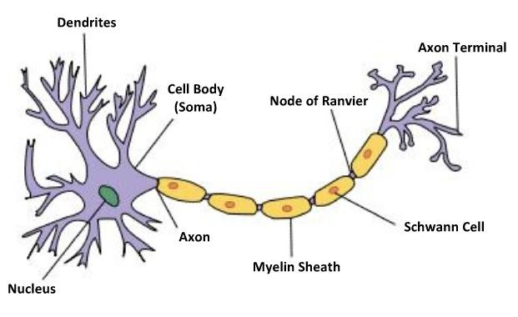

The receptive zone of the neuron begins with the cell body. The cell body contains most of the vital organelles, which keep the cell functioning. Branching form the cell body are number of projections called dendrites which look a lot like the long, stretching branches of a tree. The dendrites reach out to other neurons and receive signals to be relayed through the dendrite branch to the cell body, where some signals will go on to be conveyed down the axon.
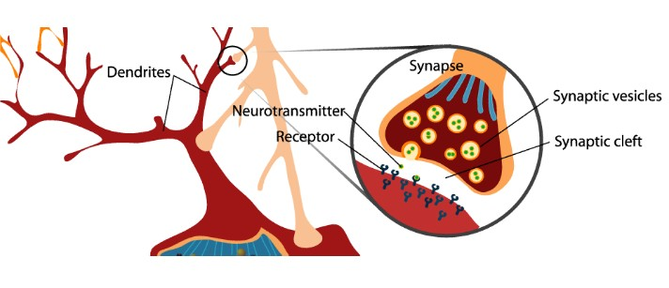
Once a neuron receives a signal in the receptive zone, it is passed down a long fiber called the axon, which can vary in length.
Some neurons have very short axons, while others have axons that can be 1m, in length as they extend from your spine to the bottom of your feet.
At the end of the axon, approaching the transmission zone of the neuron, is another cluster of branches; these branches at the end of the neuron look like little feet and are called end-feet or terminal boutons or terminal ends. The terminal boutons reach out and make connections with receptive zone of nearby neurons to transmit the signal further.
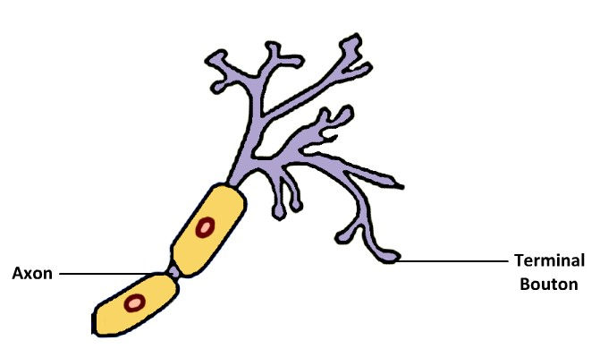
A network is built. Each neuron can receive inputs from thousands of other neurons through their dendrites and terminal boutons to form complex network of information to transfer.
Glial cells provide the structural support, nourishment, and insulation needed by the high profile neurons. The glial cells and neurons work together, resting in a bath of ions, chemicals and blood vasculature make up the entity of your brain.

The Action Potential
- A neuron’s cell membrane separates the intracellular fluid, which fills the neuron, and the extracellular fluid, which surrounds it. Each contains different concentrations of important ions, including sodium, potassium, and chloride.
- The cell membrane is selectively permeable, preferentially allowing different ions to pass through it with various levels of ease.
- The cell membrane also contains a number of protein channels which act as passageways for ions to pass through. Important channels to consider include the potassium channel and the sodium channel.
- The selective movement of ions across the cell membrane into and out of the neuron is critical for neural communication.
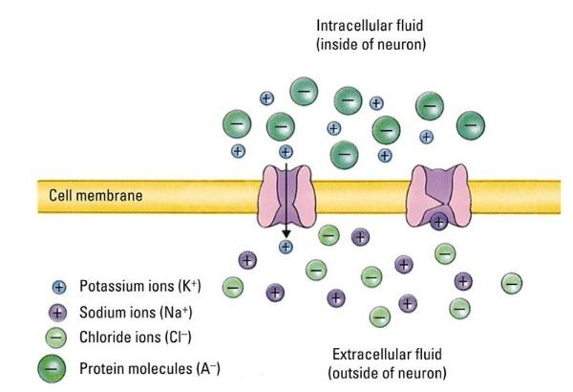
If you add up all the charges, the starting baseline for the differing concentration of ions produces an electrical imbalance between the outside and inside of the neuron. In fact, the inside of a typical neuron starts off at -70mv relative to the outside of the cell. This baseline imbalance is called the resting potential of the neuron.

The Resting Potential:
Def’n of Diffusion: The tendency for molecules to distribute themselves evenly in a medium. Def’n of Electostatic Force: The repulsion between ions with the same charge.
  - Why does the inside of the neuron start off at -70 mv compared to the outside? The resting potential of a neuron is controlled by two forces – diffusion and electrostatic force. This diffusion force interacts with the electrostatic force between charged ions.
  - When two similarly charged ions meet, they repel each other and when two oppositely charged ions meet, they attract. It’s the net result of the diffusion and electrostatic forces that leads to an overall resting potential of -70mv outside the cell compared to the inside.
  - The negatively charged large protein molecules w/I the neuron are so large they cannot pass though the cell membrane so they remain trapped inside. The K, Na and Cl ions are mobile.

Two different types of K channels – the so-called leaky channel and the voltage gated channel.
  - The leaky channel is like a tap that is always open, allowing positively charged potassium to pass through the cell membrane out of the neuron. is the major contributor to maintaining the resting potential of the neuron.
  - The 2nd type of K channel is the voltage gated channel which is an important player for the action potential.
  - The negatively charged Cl ions are also mobile and the electrostatic force of the negatively charged protein molecules keeps them primarily on the outside of the cell.
  - Voltage gated Na channels are closed in the resting state of the neuron and so the positively charged Na ions flow in only very low concentrations into the cell. Despite this subtle inward flow, most of the sodium ions remain resting on the outside of the cell and the flow of sodium is
  - far less important to the resting state of the neuron than K.
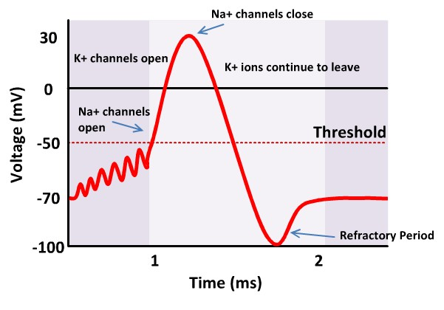
The Threshold:
  - The forces governing the distribution of ions are not rigidly stuck in place, and in reality, the resting voltage of the neuron is constantly fluctuating somewhere around -70 mv. This is shown in the figure as a squiggly line fluctuating around the -70 mark.
  - Under the influence of nearby neurons and random ion flow, sometimes, a large enough change in the resting charge will occur to reach an important threshold level. The threshold of -50mv is reached, and the action potential is triggered.

The Action Potential:
  - The action potential is the fundamental unit of communication for neurons. When the -50 mv threshold is reached, a cascade of events is triggered. It starts with the Na channels along the cell membrane beginning to open.
  - With the Na channels now open, the force of diffusion causes the positively charged Na ions to begin rushing into the neuron, rapidly causing the charge on the inside of the cell to become more positive relative to the outside.
  - As the positively charged Na rushes into the cell, the electrostatic force begins to push some of the positively charged K ions out of the cell through the leaky K channels.
  - Overall, the net effect is to still increase the positive net charge building up inside the cell to the point where the voltage gated K channels open which allow more positively charged K ions to rush out of the cell.
- After reaching a peak charge of about +40 mv on the inside of the cell, the Na channels close.
  - This means that Na stops entering the cell, but the K continues to rush outward though the still- open voltage gated K channel.
  - The inside of the cell begins losing positive charge and continues to fall and actually overshoots the baseline -70mv resting potential. At this point, the voltage gated K channels have completely closed.
  - With the rush of ions complete, the cell slowly returns to -70 ma and a short refractory period occurs where the neuron cannot fire another action potential until it settles and recovers from a previous cascade/
Sodium potassium pump: has the role of removing sodium from the cell and replacing potassium. expels three sodium ions from the intracellular fluid and replaces them with two potassium ions.
The sodium/potassium pump moves slowly and utilizes extensive energy, therefore playing little role in the action potential itself. It is however an important part of maintaining the ion balance of the neuron and recovering from action potential cascades.
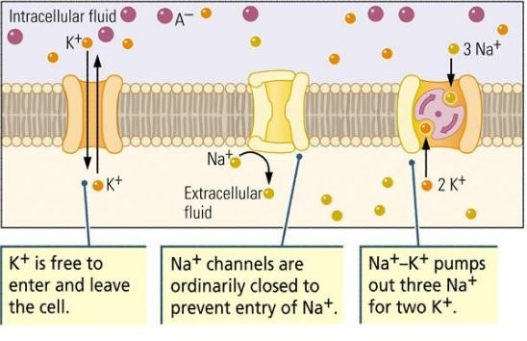

The action potential begins in the receptive zone of the neuron The rapid changes that occur here cause changes in the ion concentrations surrounding nearby channels, leading to an action potential in the adjacent location action potentials cascade along the axon toward the terminal boutons.
- This process of cascading action potentials along the axon maintains the signal, but it can be too slow for efficient communication
- Solution: special glial cells coat axons with a type of fatty, insulating tissue called myelin. These special cells are the Oligodendrocytes in the Central Nervous System and Schwann cells in the Peripheral Nervous System,
- The insulating layer of myelin allows the action potential to travel down the axon much faster.
- When an action potential reaches a myelin sheath, it jumps across it through a process called saltatory conduction,
Between the segments of myelin are open regions on the axon called the Nodes of Ranvier
they are very important because as the electrical signal jumps through the myelin sheath, it
weakens. At the nodes, the signal can be strengthened again through ion channel cascades before continuing along and jumping through the next myelin sheath. TF: a signal can travel through long axon very rapidly without any loss of strength.
(See image on next page.)
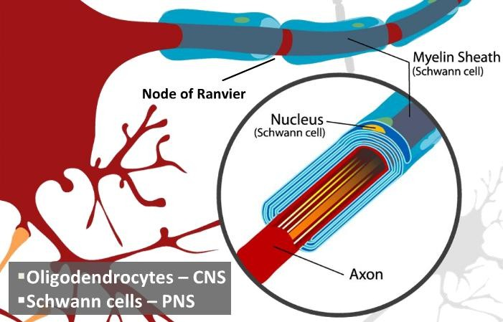

Sending a Signal:
  - All action potentials produced by a given neuron are roughly identical in strength and duration and proceed in an all or none fashion. (Once the threshold is reached, the action potential proceeds to completion without fail; there‘s no such thing as a half action potential)
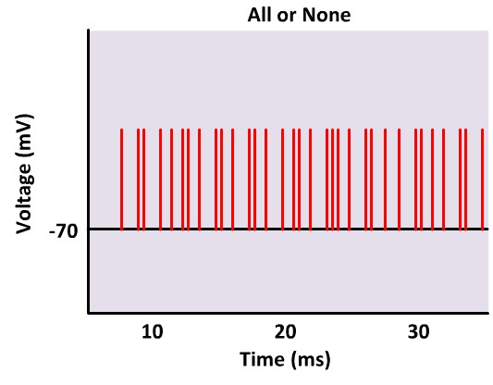
This is shown on the oscilloscope record here; each red line represents an action potential spike of the same magnitude.
How are different types of messages encoded? Messages are encoded by frequency (how often an action potential fires). Recall that immediately following an action potential is refractory period during which another action potential cannot begin; however shortly thereafter the neuron can potentially fire again. triggering another action potential cascade.
A strong signal will lead to many sequential action potentials, while a weak signal will lead to fewer action potentials in the same period of time. This frequency and pattern encodes the message to be passed on to the neighboring cell.

Once an action potential travels along an axon, it reaches a terminal bouton, where it can connect to nearby neurons.
This area of connection between the terminal bouton of neuron A, and the receptive zone of neuron, B, is called the synapse. (See image on next page.)
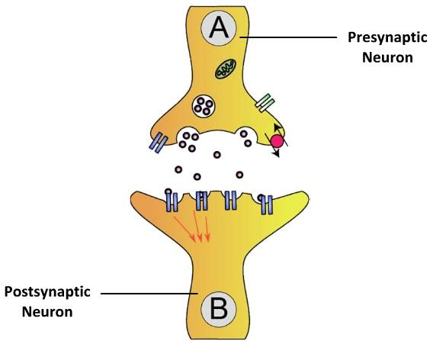
The Synapse:
  - The synapse is not a direct physical connection special mechanisms exist to transmit a signal from the presynaptic neuron to the receiving postsynaptic neuron.

Neurotransmitters:
  - Within the terminal bouton of the presynaptic neuron are a variety of chemicals collectively known as neurotransmitters. These neurotransmitters are found within small intracellular containers called vesicles.
  - As the action potential reaches the terminal boutons, some of the vesicles move toward the cell membrane of the presynaptic neuron.
  - The vesicle fuses with the membrane of the presynaptic neuron and opens, spilling neurotransmitter molecules into the extracellular fluid.
  - There are different neurotransmitters that may be released, and include: glutamate, GABA, serotonin, dopamine, and more, each performing a different function.
  - A single neurotransmitter can also have multiple functions, depending on the receptor on the postsynaptic neuron that it binds to.

The Synaptic Cleft:
  - Once neurotransmitters released, they enter the space between two neurons, called the synaptic cleft.
  - The neurotransmitter molecules float freely in the cleft along with a number of other molecules which can have direct effects on the neurotransmitter
The Postsynaptic Neuron
  - Along the membrane of the receiving postsynaptic neuron are a number of receptors designed to receive specific types of neurotransmitter molecules. The free neurotransmitter molecules in the cleft can bind to their specific receptors to continue the process of signal transmission by a number of possible actions.

The Excitatory Postsynaptic Potential (EPSP):
  - One of the most common actions is to modify the ion channels nearby. During an excitatory post-synaptic potential, or EPSP, Na+ channels open, allowing some positively charged sodium ions to flow into the cell.
  - This depolarizes the cell moving it away from the -70mv resting potential and bringing it closer to the -50mv threshold to fire
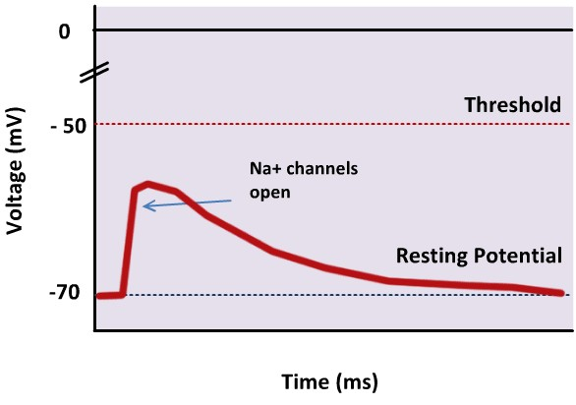
A single EPSP has a very small effect To reach the -50 mv threshold for an action potential to be fired, a number of EPSPs must occur.
These can occur: (1) one after the other from the same presynaptic connection causing a slow climb towards threshold (Temporal Summation) or (2) multiple EPSPs can occur simultaneously from several different presynaptic connections with the receptive zone of the postsynaptic neuron (Spatial Summation)

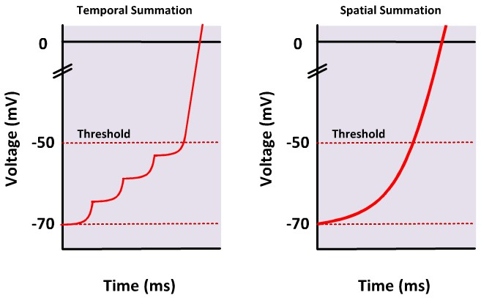

The Inhibitory Post-Synaptic Potential (IPSP)
  - Multiple EPSPs can also occur simultaneously from several different presynaptic connections with the receptive zone of the postsynaptic neuron (Spatial Summation)
  - Naturally, not every receptor binding event leads to an EPSP If it did, neurons would fire uncontrollably with far more noise than signal leading to little relevant information being communicated.
  - The system becomes more refined with the addition of a second mechanism that inhibits the transmission of a signal through an IPSP.
  - When an IPSP occurs, chloride channels on the cell membrane open, allowing some negatively charged chloride ions to enter the cell. This neuron is said to be hyperpolarized as the action brings the resting potential of neuron to be even more negative and further away from its threshold to fire. (See image on next page.)
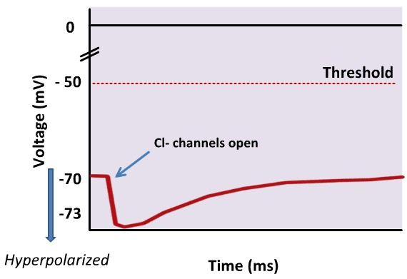

Receiving a Signal:
  - Fundamentally, this is the method (the synapse) your brain uses to communicate through complex patterns and networks to control everything from your thoughts, emotions, and behaviors.

Neural Development:
  - During the peak period of your developing brain, roughly 250,000 neurons were made every minute through the process of neurogenesis.

The Development of Neurons:
o Def’n of Neurogenesis: Birth of neurons.
o Def’n of Migration: The travelling of neurons to their correct location.
o Def’n of Differentiation: The transformation of unspecified cells into specialized cell
types that differ in structure and function.
All three are challenges faced by each neuron.

Neurogenesis: (See diagram on next page.)
  - The development of the nervous system begins as early as 18 days after conception, when the outer layer at the back of the embryo begins to thicken, forming a plate.
  - The edges of this thick plate then curl upwards and begin to fuse together by day 21, forming the neural tube.
  - The neural tube is completely closed by day 28, and will eventually become the central nervous system, with the brain at the top of the tube and spinal cord making up the bottom.
- By week 20, this mass of cells actually starts looking like a brain.
  - So how do neurons form in the neural tube? Inside the neural tube is the ventricular zone which is lined with founder cells that begin dividing as soon as the tube is closed at day 28.
  - From day 28 to around day 42, cell division is said to be symmetrical as the division of each founder cell leads to two identical founder cells.
  - However from around day 42 to day 125, cell division is now asymmetrical, as the dividing founder cell now produces one founder cell that stays put, along with a cell that will become a neuron or a glial cell which migrates outward from the ventricular zone.
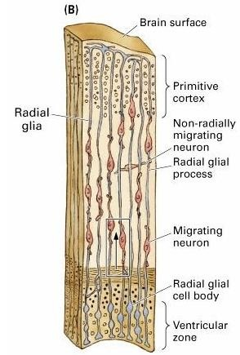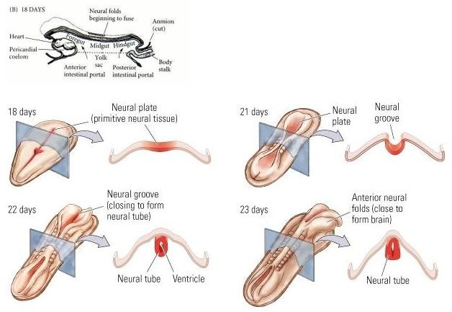

Migration:
  - Neuronal migration begins almost immediately after the first neurons are born at day 42, and continues for about 6 weeks after the last neuron is born.
  - Neurons are almost always produced before glial cells, which support the neurons. One exception to this rule: radial glial cells are produced before neurons.
  - The radial glial cells are fibers that extend outward from the ventricular zone like a form of scaffolding, and they end at the outer layer of the cortex. The neurons use the radial glial cells to migrate from the ventricular zone to the surface of the cortex.
  - The brain grows from the inside out, with the deepest layers of the brain being formed before the outer
  - most layers. As the brain increases in thickness with the addition of more and more neurons, the radial
  - glial cells grow as well so that they always end at the outermost surface.
  - Neurons born later have to travel a lot farther and push their way through other neurons to reach their final resting place; a journey that took a day for the
  - first neurons but could take as long as two weeks for
the last neurons.
Differentiation:
  - After a neuron reaches its final destination, it differentiates (takes on a specific function) which is partly determined by genetics. For example, some founder cells may be pre-wired to become part of the visual cortex because of where these cells came from in the ventricular zone, whereas others may be set to become part of the frontal cortex.
- BUT It would be a disadvantage for the brain to be completely prewired, because it wouldn’t
  - allow the brain to change with experience.
- Neuronal differentiation is sensitive to the input a neuron receives from its connections with
  - other neurons. If an emerging neuron is connected with a neuron from the visual cortex, then that neuron will end up doing something related to processing vision.

  - Environmental input also plays an important role in cell differentiation. Example: Lets suppose that you have a group of neurons that were meant to process binocular information from both eyes, but the child was born with a cataract in one eye. In that case, those neurons that were "reserved" for binocular vision would not develop correctly because they lacked the essential neural inputs that are needed to differentiate properly. This group of neurons would likely be recruited to perform another task. TF, the neuron's role is determined by both genetic and environmental factors.

Making Connections:
  - After neurons have differentiated, they need to mature by growing dendrites, axons, and synapses.
  - This last phase of neural development begins as soon as the neurons reach their final destination after migration and continues into adulthood. Making connections with other neurons is a matter of survival, because the ventricular zone produces many more neurons than are needed.
  - Neurons that fail to make connections are pruned away like a gardener cutting away branches of a bush that are sticking out.
  - All neurons receive neurotrophic factors from other neurons, which you can think of as food for the neuron - take away the neurotrophic factors and a neuron will die. However there is only a limited amount of the neurotrophic factor in the brain, and all the neurons are competing with
  - each other for it. TF: only the neurons that make connections will survive, and thus 20-80% of available neurons are eventually trimmed away.

  - Neural connections are also pruned. Many more synaptic connections are formed during this stage than are present later on in development. Example, in the visual cortex, the number of synapses doubles between 2 and 4 months of age, and then continues to increase until it reaches its peak at around 1 year of age. After that, the number of synapses begins to decline for the rest of the life span.
  - This increases the processing efficiency of the brain and retains only the most useful connections.

Case Study: Depression
  - In recent years, two neurotransmitters in particular have become implicated in our understanding of depression - serotonin and norepinephrine.
  - These two neurotransmitters gained prominence with the advent of tricyclic antidepressants in the 1950s.
- These drugs inhibit the reuptake of serotonin and norepinephrine back to the presynaptic neuron.
  - Reuptake is a normal process of recovering neurotransmitter so inhibiting this process increases the availability of serotonin and norepinephrine in the brain and in some case, it can dramatically alleviate the symptoms of depression. (Molecules on next page.)
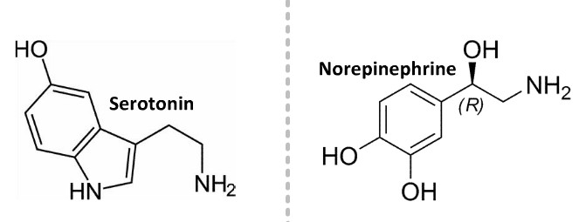

Monoamine Oxidase Inhibitors (MAOIs):
  - Tricyclic antidepressants were the most popular treatment for depression until the arrival of MAOIs. Monoamine oxidase is normally found in the synapse to break down serotonin. So MAOIs inhibit the action of monoamine oxidase, preventing the breakdown of serotonin making it more available.

Serotonin Re-Uptake Inhibitors (SSRIs):
- A drawback for both of the pharmacological treatments is relatively severe side effects.
  - The newest and currently most popular category of antidepressant drugs are selective serotonin reuptake inhibitors (SSRIs), which are more specific to the reuptake of serotonin, and seem to have less side effects. Common example: Prozac

Neurotransmitters:
  - The dramatic and highly publicized success of antidepressant medications has popularized the notion that depression can be reduced to a simple deficit in neurotransmitter levels which can be corrected.
  - However, in recent years, research into depression has demonstrated that the picture is far more complex. There are a number of other biological and psychological components of depression that are just beginning to be understood.
  - Neurogenesis is usually considered as a process that occurs only early in development, in some select areas of the brain, new neurons continue to grow throughout your lifetime However, in severely depressed individuals, this neurogenesis seems to be stunted, and the organization of neurons in some of these areas is disrupted.
  - This may be due to a compound known as brain-derived neurotrophic factor (BDNF) which is vital for the growth and survival of neurons.

