Psych 1XX3 – Evolution I and II

Def’n of Adaptation: Biological traits or characteristics that help an individual survive and reproduce in its habitat. Adaptations are always “for” something, they perform specific functions that make an organism better suited to its environment.
Examples: Eyes enable us to recognize and respond effectively to things, and raccoons have good night vision, their front paws are so sensitive they can virtually see with them to scavenge for food.

To understand how we manage to see, hear, respond to stimuli scientists break these problems down into sub-tasks: how do you detect edges? How do you assess the speed of an object or perceive a threat? Then… you can look for processes that are capable of
those tasks (relevant adaptations).

Scientists categorized as “adaptationists” use this label to describe how hypotheses about
adaptive function guide their investigations.

What about “higher” mental processes… selective attention, memory encoding, memory retrieval, etc? They refer to the adaptive functions of mental activity. The adaptive functions evolved like all other adaptations – through natural selection.

Adaptations emerge in development as a result of activation of relevant genes in interaction with relevant aspects of the environment.

Def’n of Natural Selection: Differential survival and reproduction of organisms as a
result of the heritable differences between them.
Three Essential Components:
1. Individual differences: There is variation among individuals for any given characteristic.
2. Differential Reproduction: This variation affects chances of survival; some individuals will produce more offspring than others
3. Heritability: The offspring of successful reproducers will resemble their parents.

Selective Transmission: Occurs over successive generations when one trait is more favourable than another. Eventually the entire population contains only the most favoured trait.

Stabilizing Selection: Selection against any sort of departure from the species typical adaptive design.

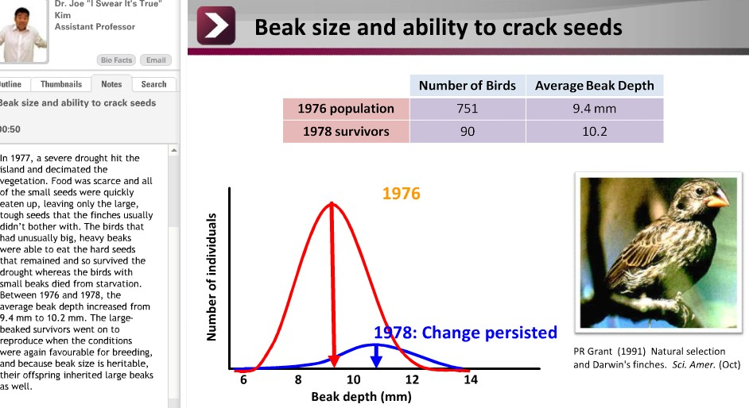

The example above was not permanent: After the drought was over and plants produced smaller seeds again, the avg beak depth of the finches returned to pre drought sizes. However… sometimes changes that arise thru natural selection are more permanent and form a potential foundation for diversification of related species.

Key point: What natural selection favours is not simply those individuals who are best at
surviving. It’s those who are best at reproducing.

Def’n of Darwinian Fitness: Average reproductive success of a genotype relative to alternative genotypes. (Note that fitness has nothing to do w/ biggest, strongest, fastest I.E. physical fitness)

Def’n of Evolution: A change in gene frequency over generations.

Def’n of Sexual Selection: The component of natural selection that acts on traits that
influences an organism’s ability to obtain a mate.
- Example 1: Peacock’s tail. The tail is no help with respect to physical survival it’s energetically expensive, and makes it harder for him to escape predators, however, Darwinian fitness isn’t a ratter of survival, and it’s a matter of reproduction. The tail increases his chances of mating. this trait elevates mortality, but can still evolve under the countervailing pressure of sexual selection.. female mating preferences in this case.
- Example 2: Stags (male deer) have horns to fight for mating purposes. However, carrying around all this weaponry makes them more vulnerable to predators than females because they don’t have as much stamina for running and are more likely to get stuck in the snow. Similar to the peacocks, the trait has a negative effect on survival, but perists anyways because it has a big positive effect on the male’s chance of mating.
Differences: Peacocks don’t use tails to fight with. Females are dazzled by the male’s tail. However, female elk do not care about the size/appearance of the stag’s antlers.
Therefore, there are two different ways of getting more access to mates than your rivals: (1) Being chosen by the opposite sex (attractiveness) and (2) beating up on your rivals in mating combat. The evolution of the peacock was by female choice, where as the evolution in the case of the stag was success in combat.

Note: It has been shown experimentally that female peacocks prefer more eyespots and more symmetry. They may have these preferences because they want to pick out mals with the greatest resistance to locally prevalent diseases, so a female may be making sure that the father of her children gives them the best available genes.

Species-Typical Behaviour and the Comparative Approach

- Behaviours are an evolved characteristic of a given species
- Test hypotheses about adaptive functions

Example: 3 different types of sandpipers: Sanderling, Semipalmated and Dunlin each behaviour is different (I.E. in how they forage for food)

Behaviour Genetics experiments: you can keep animals in captivity and breed those who are most or least aggressive, those who like water/hate water, etc and change the animal’s typical behaviour in a few generations.

Evolution II:

Intro to Social Behaviours

Organisms evolved to maximize their fitness and reproductive success however, there are examples in humans/social animals where individuals behave altruistically (helping others at the cost to themselves)
- Example: Almost all honey bees don’t reproduce, but help the queen raise eggs
- and die defending predators.
- Example: Squirrels frequently give alarm calls to warn others that there is a predator in area, but then draw attention to themselves are alerting themselves to the predator
- Example: Humans aren’t selfish; they help others

Concept of Selfish Gene: How evolution (working at the level of genes) favours those genes that contribute to an individual’s fitness and will consequently get replicated more often, increasing in frequency each generation

Table of social behaviours on next page if someone does something that helps himself and others, the behaviour is a cooperative one, etc.

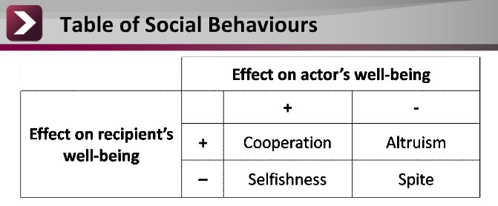

Example: You have 6 players on team, but Billy isn’t very good at playing. You can invest time and resources to teach Billy to play better. On the surfact it looks like you’re unselfishly doing extra work, but it may pay off (I.E. team may win more games).
In language of evolution, increasing the fitness of others can sometimes improve your own fitness prospects.

Group Selection:
Common misunderstanding (Key point): adaptations aren’t for the food of the group/species, they are for the good of the gene. (I.E. in the previous example, helping Billy do better isn’t a good enough reason evolutionarily… what matters is that the increase in group success translates into better success for the metaphorical helping gene)

Example:
Geese forage for food in groups this is because multiple individuals are looking
around for food, so if you happen to be the lucky one to find the food, some may be taken from you, but more often you’re taking from others. HOWEVER, there is another reason why geese do this. While some birds forage, others are vigilant in order to prevent being surprise attacked by predators.

Image on following page: As the flock size increases, the number of times a each bird looks up (being vigilant) decreases. Does this mean larger flocks are more susceptible to attack? No. The number of head jerks for the ENTIRE FLOCK increases. This means, even thought each individual is looking up less, the group as a while is being more vigilant than any one individual alone.
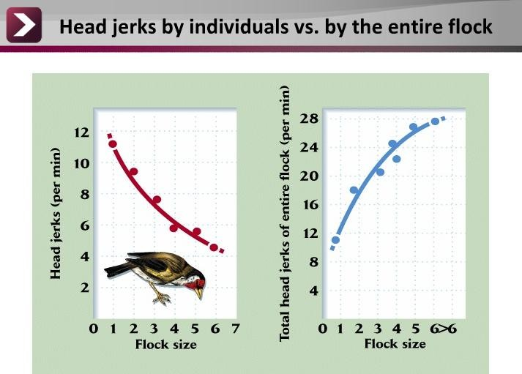

Key point: Can selection be good for the group and bad for the gene? No.

Def’n of Altruism: Behaviour in which the actor incurs a cost to provide a benefit to a
recipient.
- Not Altruism:
  - Foraging/vigilance in groups because actor gains directly from behaviour. (The goose, and bird example are not examples of altruism.

Individuals that behave altruistically decreases its own fitness by definition, whereas an
individual that behaves selfishly won’t.

Example: Lemmings don’t commit suicide for the good of the population. In terms of genes, there would be one gene for altruistic suicide and another for selfish restraint. The one that leads to altruism will die in the bodies of their suicidal bearers every time the population gets too large, whereas the other gene will live on. So unless the genes leading to altruism produce more copies of themselves than other genes, they don’t lead to altruism. the good of the group cannot explain the evolution of altruism.

Inclusive Fitness (proposed by Hamilton):
Eusocial Hymenoptera: Most individuals spend their lives serving the colony w/o reproducing (ants, bees, wasps, etc)
- How did such altruistic behaviour come to be favoured by natural selection? Answer: Genes for altruism could be successful if they helped identical copies of themselves.
Def’n of Direct Fitness: Fitness from personal reproduction.
Def’n of Inclusive Fitness: Fitness from the reproduction of close genetic relatives.
Direct fitness + Indirect Fitness = Inclusive Fitness
- This means that you can increase your fitness by helping kin to successfully raise their offspring, sometimes even when doing so has negative effects on your own direct fitness.
- Because of inclusive fitness, natural selection can not only favour bavahiours that increase an individual’s own reproductive success but also behaviours that increase the reproductive success of close genetic kin.

Hamilton’s Rule: The reproductive benefit to the recipients (B) multiplied by the probability that the recipients actually have identical copies of the same gene, or coefficient of relatedness (r), must be greater than the productive cost to the actor (C).

rB>C, for when altruistic acts will be favoured

Coefficient of relatedness (r):
  - Def’n of Relatedness:
- Probability that actor and recipient share gene in question
- Depends on how genes were inherited
  - Example: In humans we inherit two copies of every gene one from mom and one from dad, however these copies are not always identical. Moreover, the one you pass to your offspring and the ones mom and dad pass to your siblings will also not necessarily be the same two you received.

Full Siblings:
  - 0.5 probability you inherited gene from Mom and 0.5 probability of copy in sibling
- Therefore, 0.5 x 0.5 = 0.25 probability of shared genes from each parent.
  - So… relatedness to grandparents, aunts and uncles is 0.25 and relatedness to first cousins is 0.125
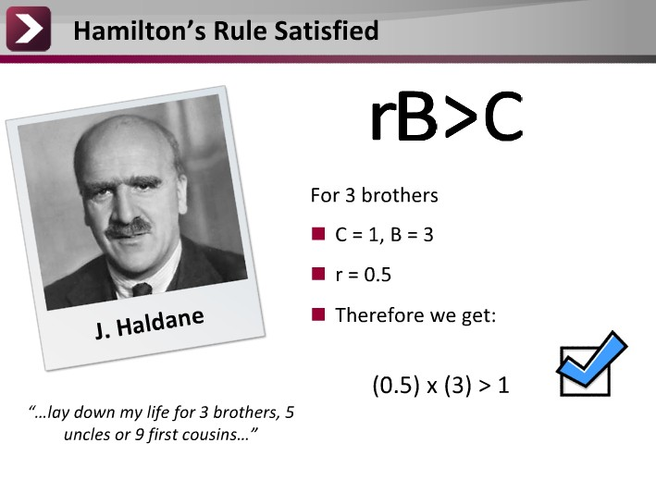
Referring back to the Hymonptera:
So why do some not reproduce?
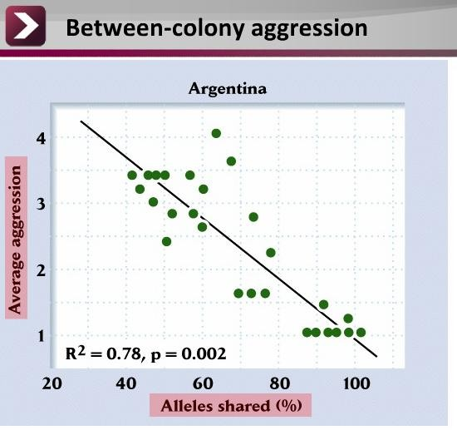Relatedness: colonies are often very closely interrelated (made up of close relatives), this means it pays to help your colony, especially when you’re competing with neighbouring colonies who you are not closely related to. (Relatedness also helps to explain levels of aggression btw colonies)

Example: Shown in graph

Argentine ants: aggression decreases as the proportion of alleles shared increases, just as you would predict from inclusive fitness theory and Hamilton’s Rule.

Violence and Relatedness in Humans: Detroit, MI 1972
- 25% of homicides committed by “relatives” (include. Bfs, gfs, etc)
- Only 6% of homicides committed by GENETIC relatives.

Child Abuse: Rates of child abuse are higher amongst stepchildren than biological children.

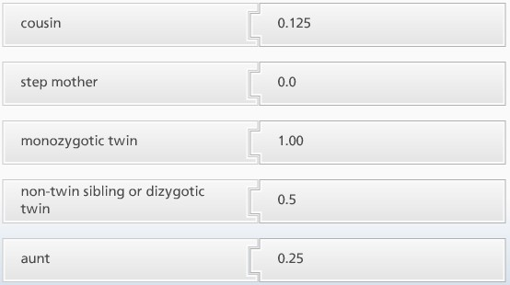
Kin Recognition: How do you actually know who your kin is?
  - In organisms w/ limited migration following maturity, neighbours are most likely to be close kin rule: be altruistic towards individuals that are spatially close to you (I.E. in this way individuals don’t need to “recognize” kin at all)

  - What about when animals grow up/move away? Recall example where squirrels call out an alarm to alert squirrels nearby. Female squirrels stay in their natal territory for life while the males disperse to establish their own territories. It was found that females give alarm calls more often than males.

Cues of Kinship (How do children know their mother/siblings)
- Mother’s association (rearing, breastfeeding, etc)
- Co-residence with other children
Key point: For altruism to be a successful strategy, it is optimal to direct it towards the individuals you are reared with.

Phenotype Matching (another cue): An evaluation of relatedness between individuals based on an assessment of phenotypic similarity. (Some animals, other than humans, are known to do this monkeys, hamsters, squirrels)
- Phenotype matching isn’t necessarily a conscious comparison, and importantly, the unconscious process can affect your social behaviours.

If phenotype matching in humans influences your actions, then you might expect that individuals would exhibit more pro-social behaviours, such as trusting and sharing with interacting with those who resemble them.
- Study (DeBruine): Player 1 (P1) and Player 2 (P2) are playing a game over the internet. P1 is given $4 and she can make one of two choices. If she is untrusting of P2 she can simply choose to divide the money equally between them, giving both herself and player 2 $2. But P1 has the possibility of earning more money if she chooses to “trust” P2. In this case, P2 is given control of a larger pot of money, say $5 and can no choose to share the larger pot anyway he wants.
- DeBruine predicted that individuals would exhibit more pro-social behaviours, such as trusting when interacting with people who resemble kin. (I.E. P1 will be more trusting of P2 that looks like him)
- In the experiment, P2 wasn’t another student, but instead a computer generated strategy subjects played a total of 6 rounds as player 1, and in each round they saw a picture of their “partner”. P2 could be an image of a complete stranger OR one that looked more like their kin (using a digitally morphed picture of themselves).
- Results: As predicted, subjects were more trusting of P2 when P2 resembled them. These results demonstrate that facial resemblance, a form of phenotype matching, can modulate behaviour in ways predicted by Hamilton’s Inclusive Fitness Theory.

Key Point: People don’t act altruistically only to kin or those exhibiting cues of kinship.
Def’n of Direct Reciprocity: Refers to situations in which individuals help each other and both benefit. In some circumstances, individuals who reciprocate acts of generosity can have a selective advantage over others who do not.

Def’n of Indirect Reciprocity: Refers to individuals who help those who have helped others. By helping another, you establish a good reputation for yourself and overall will get more help from neighbours, compared to individuals who never helped at all.

Note: People who are selfish are often punished by others. Also, not surprisingly, research suggests that people are more generous and less likely to break the rules when observed by others.

Key Point: The only reason that altruism exists is because such pro-social behaviours have been adaptive over evolutionary history. Behaviours that appear altruistic from the perspective of the individual are actually selfish from the gene’s perspective.

