Psychology 1XX3 Notes – Development I and II – Jan 4, 2010

Development / Evolution / Neuroscience

Def’n of Development: Refers to the changes and continuities that occur within the
individual btw conception and death.
  - Developmental psychologists are not only interested in understanding how you change over time, but also how you stay the same.

Def’n of Maturation: The biologically-timed unfolding of changes within the individual; how that plan unfolds in influenced by specific environmental conditions that shape the genetically-determined processes

Def’n of Learning: The acquisition of neuronal representations of new information.; Relatively permanent changes in out thoughts, behaviours and feelings as a result of our experiences.
  - Thru learning processes, you avoid touching a hot stove, look both ways before crossing road, etc – these learned processes can be controlled but can also become so practise as to be automatic
  - Example: As an adult you automatically look to the left then look to the right when crossing a road, however this strategy is not optimal behaviour in places where cars drive on the other side of road – you have to overcome your past learning to use the optimal strategy

Interactionist Perspective: The view that holds that maturation and learning interact during development.
How does maturation affect learning?
  - Some essential systems must be in place before learning proceeds – you won’t learn to walk until you’ve developed muscles in your torso and limbs and the ability to balance
  - Trying to teach a 4 mo old to walk will not work – they aren’t physically mature
How does learning affect maturation?
  - I.E. a child given proper nutrition but isolated in a dark room, unable to play or interact w/ anyone – you would expect problems developing normal vision, speech, motor and social skills
  - Without some minimal level of input to learn from the outside world, maturation will be absent or delayed

Note: Changes that are earlier in life, are much more dramatic than those occurring later in life. – Many researchers believe that the developmental changes that take place during these early years play an especially important role in shaping who you become.
4 Ways to Measure Abilities in Infants:

1. Habituation Procedure:
  - Repeatedly presenting an infant with the same stimulus, while measuring changes in physiological responses (like heart rate, breathing) or behavioural orienting responses (head/eye movements)
  - When a novel stimulus is presented, an infant will initially show a burst of
  - activity – as the same stimulus is repeatedly presented, the infant’s responses will return to baseline levels – at this point the infant has demonstrated habituation to the stimulus
  - Def’n of Habituation: A decrease in the responsiveness to a stimulus following it’s repeated presentation
  - Def’n of Dishabituation: An increase in the responsiveness to a stimulus that is somehow different from the habituated stimulus.

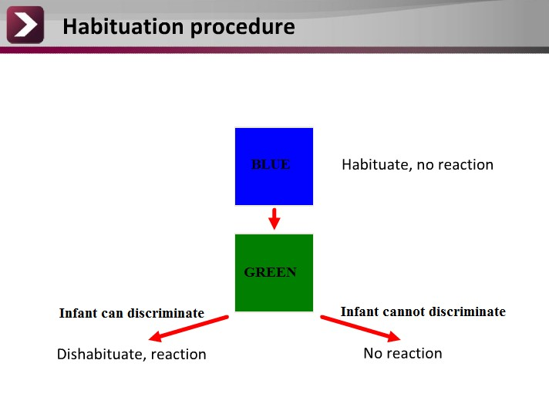

2. Event Related Potentials: A measure of the brain electrical activity evoked by the presentation of stimuli
  - To measure event related potentials, a special cap with an array of electrodes is placed on scalp – these sensitive electrodes can detect changes in electric activity across a population o neurons in the brain – the particular behaviour being
  - measure will evoke changes in various brain regions of interest
  - I.E. if you’re presenting visual stimulus changes in activity in occipital lobe of
  - brain, if you’re presenting auditory stimulus, changes in temporal lobe region
3. High-Amplitude Sucking Method:
  - In procedure, you first measure the baseline sucking rate for the infant in the absence of relevant stimuli – during the shaping procedure, the infant in given control over the presentation of a stimulus to be tested (I.E. musical notes)
  - If the infant sucks on the pacifier at a raster rate than baseline, a switch is activated in the pacifier that causes the stimulus to be presented
  - If the infant can detect the musical notes and likes what she hears, she can keep the musical notes playing for longer by increasing her sucking rate – but if the infant doesn’t like the sounds she can stop sucking sooner and end the presentation

4. Preference Method:

  - The infant is put in a looking chamber to simultaneously look at two different stimuli – the researcher can accurately measure the direction that the infant is looking to tell if more attention is being directed to one stimulus over the other
  - I.E. infants prefer looking at big patters w/ lots of black/white contrasts, as well as human faces

Limitations:

Competence-Performance Distinction: An individual may fail a task not because they lack those cognitive abilities, but because they are unable to demonstrate those abilities.

Introduction to Developmental Research Designs:
Developmental studies are often concerned with repeated measures over time – I.E. a typical study on memory might look specifically at the performance for remembering a list of numbers in an undergraduate population at a single test point. A developmental study would look at how remembering a list of numbers changes with age.

Def’n of Longitudinal Design: A developmental design in which the same individuals are studied over some subset of their lifespan – researchers examine the abilities and characteristics of the same individuals repeatedly over a subset of their lifespan

Disadvantages:
- Expensive and time consuming
  - Selective attrition: some participants may quit, become unfit to continue, or die – the remaining participants may only reflect the skills of a subset of truly enthusiastic subjects
- Practice effects: participants’ performance may improve based on prior exposure
  - alone, rather than on natural development
  - These challenges mean that the longitudinal study is used less frequently in the real world
- Def’n of Cross-Sectional Design: A developmental research design in which individuals from different age groups are studied at the same point in time.

Disadvantages:

- Cannot distinguish age effects from generational effects (I.E. do 25 year olds remember more numbers compared to 50 year olds because of decline in cognitive ability or because 25 year olds had more PIN, phone and locker numbers to remember)
- Cannot directly assess individual development change – instead you’re making an
  - inference on trends in group data

Development II

Hereditary Transmission:
  - Cell contains 46 chromosomes, 23 from each parent – results from the HGP show we have between 30k to 40k genes
  - Each parent can produce more than 8 million different genetic combinations, each couple can produce 64 trillion genetically distinct offspring
  - Exception: Twins. Monozygotic twins contain the same sperm/ovum and are genetically identical. Dizygotic twins contain different sperm/ovum and share approx 50% of genes
- Genotype: An individual’s inherited genes
- Phenotype: The expression of an individual’s genotype in terms of observable
  - characteristics

4 Patterns of Genetic Expression
- Simple Dominant-Recessive Inheritance: A pattern of inheritance in which the expression of a trait is determined by a single pair of alleles
- Polygenetic Inheritance: When multiple genes are involved in the expression of a trait – it is safe to say that no single gene can account for most complex behaviours
- Codominance: two dominant alleles are fully and equally expressed to produce a phenotype that is a compromise between two genes
- Sex-Linked Inheritance: a pattern of genetic expression which involves genes expressed on the X chromosome (some recessive genes are expressed on the X chromosome and are responsible for disorders like colour blindness and haemophilia.)

The Interactionist Perspective: genetics and environmental factors contribute to how a person develops
- Extreme Behaviourist POV: The belief that nurture was all important and that a
  - person’s development was largely independent of genetic factors
  - Genetic POV: The believe that who you became was largely predetermined by inherited genes and that the environment had minimal effect
Canalization Principle:
- Genotype restricts the phenotype to a small number of possible developmental outcomes
- Some developmental processes are buffered against environmental variability
- Example: Infant Babbling despite the incredible range of language cultures a child may be born into, all infants babble in the same way making similar sounds; this universal phonemic sensitivity is independent of the environment

The Range of Reaction Principle: Genotype establishes a range of possible responses to different kinds of life experiences.

I.E. Height your final height is determined by a number of factors, however, the potential range of your height across poor and optimal conditions is determined by genetic factors

Just as the environment influences the expression of genes, your genes can influence the type of environment that you see out:

Passive Genotype/ Environment Correlations:
- The environment that parents choose to raise their children in was influenced by
  - the parents’ own genes
  - I.E. a couple with high intelligence might design an environment rich with intellectual stimulation the environment chosen by the parents is likely to mesh well with the inherited genetic potential of the child

Evocative Genotype / Environment Correlations:
- The traits that we have inherited affect how others react to and behave towards us
- I.E. a child with a difficult temperament may more likely evoke negative responses from caregivers, whereas a child with a sunny disposition may evoke more positive responses from the same caregivers
- Your natural temperament may influence how others behave towards you

Active Genotype / Environment Correlations:
- Our genotypes influence the kinds of environments that we seek
  - A person with a sensation seeking temperament may actively choose environments which satisfies these thrill-seeking urges

Note: The influence of each of these gene-environment interactions changes across life span. Early in life, passive correlations influence you the most when you cannot choose your own environment. Active correlations begin to play a larger role in your development in childhood and continues into adulthood as you have more opportunities to make decisions. The way that your inherited traits affects how others respond to you via evocative correlations can be influential throughout your lifespan.

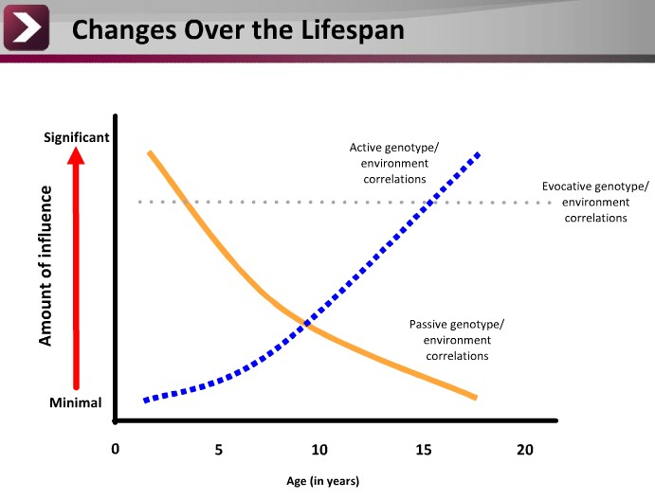

The Logic of Twin Studies:
- A useful population to study, when one is interested in understanding the relative contribution of factors for a particular trait
- The average correlation of intelligence for monozygotic twins is quite high at
- 0.86, but for dizygotic twins it is only 0.6 (when raised together). Such
- differences may suggest the degree to which genes or environment contribute to a particular trait.
- Monozygotic twins raised apart still have higher correlation for intelligence (0.72)
- than dizygotic twins raised together. This pattern suggests that genetic factors may play a larger role than environmental factors for this trait.

Introduction to Critical Periods:
  - Def’n of Critical Period: A window of opportunity within an individual’s development in which particular environmental stimulation is necessary in order to see permanent changes in specific abilities.
- I.E. Visual deprivation in kittens (see diagram on next page)
  - Kitten 1: No amount of visual stimulation following this critical period can help them regain normal vision abilities.
  - Kitten 2: Visual abilities are unaffected by the period of deprivation because normal visual pathways have already been established.
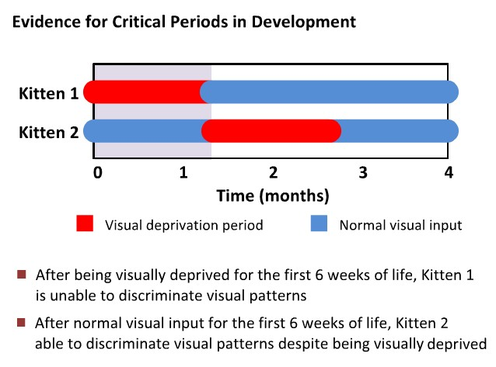
Such studies suggest without a normal level of environmental stimulation, the brain
may not fully develop some of its functioning to it’s full potential.

Implications of Critical Periods:
    - Likely to affect parental decisions (I.E. parents can over-stimulate their children)
  - Could affect decisions to adopt (I.E. adopting neglected children)
    - Affects public policy on child intervention (I.E. when to intervene when a child is found to be off the normal course)

Note: The kitten study was extreme subjects either were raised with vision or no vision. However, consider that in a natural environment, perhaps a minimal amount of input is all that is needed to achieve normal development. It is also possible that “enriched” environments are perhaps more comparable to the normal stimulation an animal would experience in its natural habitat.

Extra stimulation is not always better:
While it’s possible that these activities may build positive habits and attitudes, it’s also certainly possible that children exposed to extra stimulation before they’re ready may actually withdraw and lose interest in learning

Def’n of Experience-Expectant Brain Growth: Our brains have evolved to expect a certain amount of environmental input, and with this input, out brains develop normally
(Ordinary levels of visual, auditory and social input ensure that the brain develops properly)

Def’n of Experience-Dependent Brain Growth: Out brains develop according to out own personal experiences. (This type of brain growth is specific to each individual and reflects the more subtle changes in brain structure across individuals based on their varied experiences)

The term sensitive period has replaced critical period:

Def’n of Sensitive Period:
- Brain maintains some capacity for change and growth in adulthood; our brains develop according to our own personal experiences
- Flexibility in the timing and type of stimulation is required for normal development

