Logic and proofs
By Michel Balamou

Proposition | A declarative sentence that is either true or false, but not both.
Propositional variables | Variables that represent propositions
Truth value | Either True or False

Negation | $$¬$$ | not
Conjunction | AND $∧$ | and  but
Disjunction | Inclusive OR $∨$  Exclusive OR $⊕$ | or
Conditional statement | $$→$$ | if p, then q  if p, q  p is sufficient for q  q if p  q when p  a necessary condition for p is q  q unless $¬$p  p implies q  p only if q  A sufficient condition for q is p  q whenever p  q is necessary for p  q follows from p

p | q | $$p∧q$$ | $$p∨q$$ | $$p⊕q$$ | $$p→q$$ | $$p↔q$$
T | T | T | T | F | T | T
T | F | F | T | T | F | F
F | T | F | T | T | T | F
F | F | F | F | F | T | T

The mathematical concept of a conditional statement is independent of a cause-and-effect
relationship between hypothesis and conclusion

Conditional  statement | $$p→q$$
Converse  switch | $$q→p$$
Contrapositive  switch and negate | $$¬q→¬p$$
Inverse  negate | $$¬p→¬q$$
Biconditional | $$p↔q=(p→q)∧(q→p)$$  p if and only if q, it means that p and q have equivalent truth values  $p→q$ is True when $q→p$ is True, and false otherwise, that’s why we denote it as $↔$

Tautology | Compound proposition that is always true independent of the value of its propositional variables ($p∨¬p$)
Contradiction | Compound proposition that is always false ($p∧¬p$)
Contingency | Compound proposition that is neither a tautology or a contradiction
Logically equivalent | $$p≡q if p↔q is a tautology$$  If two compound propositions have the same truth values in every possibility they are logically equivalent

De Morgan’s Law
$$¬ (p ∧ q)≡¬p∨¬q$$
$$¬ (p ∨ q)≡¬p∧¬q$$

Notation:
$$\bigvee_{j=1}^{n}{p_{j}}=p_{1}{∨p}_{2}∨…∨p_{n}$$

$$\bigwedge_{j=1}^{n}{p_{j}}=p_{1}∧p_{2}∧…∧p_{n}$$

De Morgan’s Law:
$$¬ (\bigwedge_{j=1}^{n}{p_{j}})≡\bigvee_{j=1}^{n}{{¬p}_{j}}$$

Equivalence | Name
$$p∧T≡p$$  $$p∨F≡p$$ | Identity Laws
$$p∨T≡T$$  $$p∧F≡F$$ | Domination Laws
$$p∨¬p≡T$$  $$p∧¬p≡F$$ | Negation laws
$$p∨p≡p$$  $$p∧p≡p$$ | Idempotent laws
$$¬\left(¬p\right)≡p$$ | Double negation law
$$¬\left(p∧q\right)≡¬p∨¬q$$  $$¬\left(p∨q\right)≡¬p∧¬q$$ | De Morgan’ laws
$$p∨\left(p∧q\right)≡p$$  $$p∧\left(p∨q\right)≡p$$ | Absorption laws  $$A+(AB)=A$$  $$A(A+B)=A$$
$$p∨q≡q∨p$$  $$p∧q≡q∧p$$ | Commutative Laws  $$A∙B=B∙A$$ | Easy Stuff
$$(p∨q)∨ r≡p∨(q∨ r)$$  $$(p∧q)∧ r≡p∧(q∧ r)$$ | Associative laws  $$A∙(B∙C)=(A∙B)∙C$$ | Easy Stuff
$$p∨\left(q∧ r\right)≡(p∨q)∧(p∨r)$$  $$p∧\left(q∨ r\right)≡(p∧q)∨(p∧r)$$ | Distributive laws  $$A∙\left(B+C\right)=\left(A∙B\right)+(A∙C)$$ | Easy Stuff

Conditionals | Biconditionals
$$p→q≡¬p∨q$$  $$p→q≡¬q→¬p$$  $$p∨q≡¬p→q$$  $$p∧q≡¬(p→¬q)$$  $$¬\left(p→q\right)≡p∧¬q$$  $$\left(p→q\right)∧\left(p→r\right)≡p→(q∧r)$$  $$\left(p→r\right)∧\left(q→r\right)≡\left(p∨q\right)→r$$  $$\left(p→q\right)∨\left(p→r\right)≡p→(q∨r)$$  $$\left(p→r\right)∨\left(q→r\right)≡\left(p∧q\right)→r$$ | $$p↔q≡\left(p∧q\right)∨\left(¬p∧¬q\right)$$  $$p↔q≡\left(p→q\right)∧\left(q→p\right)$$  $$p↔q≡¬p↔¬q$$  $$¬(p↔q)≡p↔¬q$$

Satisfiable | a compound proposition that is true under some values of its variables.
Unsatisfiable | a compound proposition that is always false.
Solution | to a satisfiability problem is a particular assignment of variables that makes it true.
Dual | of a compound proposition: contains only $∨$, $∧$ and $¬$. The operator $∨$ is replaced by $∧$, and $∧$ by $∨$.
Disjunctive normal form
Functionally complete

P 34. Exercises

NAND and NOR operators are called Sheffer stroke and Peirce arrow
$p | q≡¬(p∧q)$
$$p↓q≡¬(p∨q)$$

p | q | $p | q$  p NAND q | $p↓q$  p NOR q
T | T | F | F
T | F | T | F
F | T | T | F
F | F | T | T

Predicates & Quantifiers
Predicate logic

“x>3” or “x is greater than 3”, here x is the variable and “is greater than 3” is the predicate (denoted as P(x)).
P is also called a propositional function.

Only once x has a specific value the whole statement can be either false or true. For example:
P(4) is “4>3” which is FALSE
P(2) is “2>3” which is FALSE

Also can have statements with more than one variable:
“x = y+3” or Q(x, y)
Q(1, 2) is False

P is also called n-place predicate and n-ary predicate

Valid inputs are called preconditions
And Valid outputs are called postconditions

Example:
Tmp=x
X=y
Y=tmp

P(x, y) is “x=a and y=b” precondition
Q(x, y) is “x=b and y=a” postcondition

Quantifiers
In English, the words all, some, many, none, and few are used in quantifications.

UNIVERSAL QUANTIFIER  $$∀$$ | Domain of discourse (or the universe of discourse) – or simply domain  “P(x) for all values of x in the domain”  $∀x P(x)$ “for all x P(x)”, “for every x P(x)”  An element for which P(x) is false is called a counterexample of $∀x P(x)$  Ex:  P(x)=”x+1>x” and$∀x P(x)$ be on the domain of real numbers, then  Since P(x) is true for all real numbers then the quantification $∀x P(x)$ is true.  Q(x)=”x<2” on the domain of real numbers, because Q(3) is false, it is a counterexample for the statement $∀x Q(x)$, which is false.  When all the elements in the domain can be listed $x_{1}, x_{2}. .. x_{n}$, the universal quantification is the same as the conjunction: $P(x_{1})∧P\left(x_{2}\right)∧… ∧P(x_{n})$  $$∀x P\left(x\right)≡P(x_{1})∧P\left(x_{2}\right)∧… ∧P(x_{n})$$
EXISTENSIAL QUANTIFIER  $$∃$$ | “There exist an element x in the domain such that P(x)”  $$∃xP(x)≡P(x_{1})∨P\left(x_{2}\right)∨… ∨P(x_{n})$$
THE UNIQUENESS-  QUANTIFIER  $$∃!$$ | “There exists a unique x such that P(x) is true”  $∃!x\left(x-1=0\right)$ is a true statement, since x=1 is the only answer.  $$∃!xP(x)≡\bigvee_{j=1}^{n}{\left(\bigwedge_{i=1}^{j-1}{¬P(x_{i})}∧P(x_{j})∧\bigwedge_{i=j+1}^{n}{¬P(x_{i})}\right)}$$  $$∃!xP\left(x\right)≡\left(P\left(x_{1}\right)∧¬P\left(x_{2}\right)∧… ∧¬P\left(x_{n}\right)\right)∨$$  $$\left(¬P\left(x_{1}\right)∧P\left(x_{2}\right)∧… ∧¬P\left(x_{n}\right)\right)∨…∨$$  $$(¬P\left(x_{1}\right)∧¬P\left(x_{2}\right)∧… ∧P\left(x_{n}\right))$$  $$∃!xP\left(x\right)≡∃x(P\left(x\right)∧∀y(P\left(y\right)→y=x))$$

DOMAIN RESTRICTIONS
$$∀x<0(x^{2}>0)$$ | $$∀x(x<0→x^{2}>0)$$ | The square of all negative numbers is positive
$$∀y≠0(y^{3}≠0)$$ | $$∀y(y≠0→y^{3}≠0)$$ | The cube of all non-zero numbers is a non-zero
$$∃z>0(z^{2}=2)$$ | $$∃z(z>0{∧z}^{2}=2)$$ | There is a positive square root of 2

Bound Variables – when a quantifier is used on a variable
Free Variables – a variable that is NOT bound by a quantifier
Scope – the part of an expression which a quantifier is applied to.

$∃x\left(x+y=1\right)$ where x is bound by the existential quantification $∃x$, the variable y is free

De Morgan Laws for Quantifiers:
$$¬∀xP(x)≡∃x¬P(x)$$
$$¬∃xP(x)≡∀x¬P(x)$$

0 | 0 | 0 | 0
0 | 0 | 1 | 1
0 | 1 | 0 | 1
0 | 1 | 1 | 0
1 | 0 | 0 | 1
1 | 0 | 1 | 0
1 | 1 | 0 | 0
1 | 1 | 1 | 0

A’B’C+A’BC’+AB’C’

0 | 0 | 0 | 0 | 0
0 | 0 | 0 | 1 | 1
0 | 0 | 1 | 0 | 1
0 | 0 | 1 | 1 | 0
0 | 1 | 0 | 0 | 1
0 | 1 | 0 | 1 | 0
0 | 1 | 1 | 0 | 0
0 | 1 | 1 | 1 | 0
1 | 0 | 0 | 0 | 1
1 | 0 | 0 | 1 | 0
1 | 0 | 1 | 0 | 0
1 | 0 | 1 | 1 | 0
1 | 1 | 0 | 0 | 0
1 | 1 | 0 | 1 | 0
1 | 1 | 1 | 0 | 0
1 | 1 | 1 | 1 | 0

A’B’C’D+A’B’CD’+A’BC’D’+AB’C’D’

Nested Quantifiers
$$∀x∀yP(x,y)$$ | 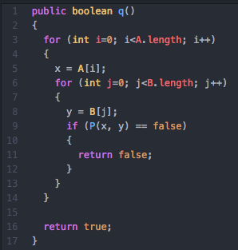
$$∀x∃yP(x,y)$$ | 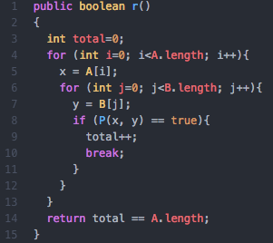
$$∃x∀yP(x,y)$$ | 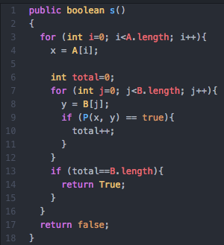
$$∃x∃yP(x,y)$$ | 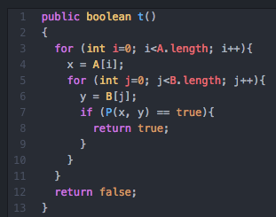

For $Q\left(x,y\right)="x+y=0"$
$∃y∀xQ(x,y)$ – False (y depends on x)
$∀x∃yQ(x,y)$ – True (y is independent of x)

$∃y∀xQ\left(x,y\right)≠∀x∃yQ(x,y)$

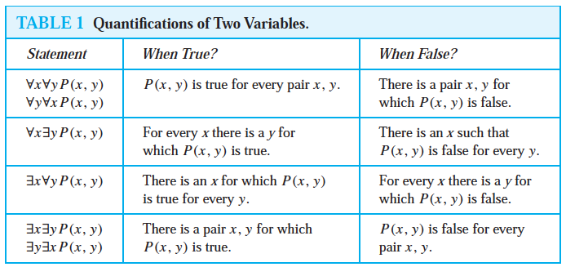

Limits | $$\lim_{x→a}{f\left(x\right)=L}$$  $$∀ϵ∃δ∀x(0<\left|x-a\right|<δ→f\left(x\right)-L<ϵ)$$
Negating quantifiers | $$¬\left(∀x∃y\left(xy=1\right)\right)≡ \\ ∃x¬\left(∃y\left(xy=1\right)\right)≡ \\ ∃x∀y¬\left(xy=1\right)≡ \\ ∃x∀y(xy≠1)$$
Combing quantifiers | $$∀xP\left(x\right)∧∃yQ\left(y\right)≡∀x∃y(P\left(x\right)∧Q(y))$$  $$∀xP\left(x\right)∨∃yQ\left(y\right)≡∀x∃y(P\left(x\right)∨Q(y))$$
Prenex Normal Form | $$Q_{1}x_{1}, Q_{2}x_{2},…Q_{k}x_{k}P(x_{1},x_{2},x_{3},…,x_{k})$$  Where $Q_{i}$ is either $∀$ or $∃$,  $P(x_{1},x_{2},x_{3},…,x_{k})$ is a predicate involving no quantifiers

1.6 Rules of interference
Argument | A sequence of statements that end with a conclusion
Valid | The conclusion or the final statement must follow from the truth of the preceding statements
Premises | Preceding statements

$p→q$ (if u have the current password, then u can log onto the network)
$p$ (You have a current password)
$∴q$ (Therefore, you can log onto the network)

This argument is formally valid, because every instance of arguments constructed using this scheme are valid.

If $p→q$ and p are both True, then q must be True (because $p→q$ cannot be true when $T→F$)
The conclusion of a valid argument is true only if all the premises are true.

Resolution: $(\left(p∨q\right)∧\left(¬p∨r\right))→(q∨r)$

Rules of interference for Quantified Statements
Universal instantiation | $$∀xP\left(x\right)$$  $$∴P(x)$$
Universal generalization  We have no control over c and cannot make any other assumptions about c other than it comes from the domain (basically c is just an arbitrarily chosen variable from the domain) | $$P\left(c\right)$$  $$∴∀xP(x)$$
Existential instantiation | $$∃xP\left(x\right)$$  $$∴P\left(c\right) for some element c$$
Existential generalization | $$P\left(c\right)for some element c$$  $$∴∃xP(x)$$

Universal modus ponens:
$$∀x\left(P\left(x\right)→Q\left(x\right)\right)$$
$$P\left(a\right), for a particular element$$
$$∴Q(a)$$

